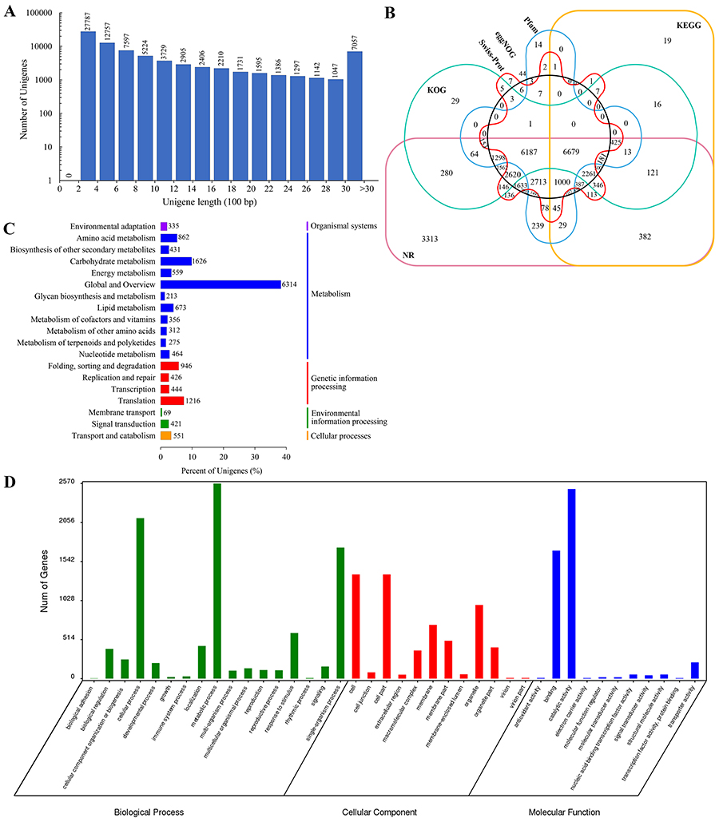
Additional file 3: Fig. S1. Unigenes length distribution and annotation statistics. a Length distribution of the assembled unigenes. b Venn diagram for the number of unigenes annotated by six different databases – NR, KOG, KEGG, Swiss-Prot, eggNOG and Pfam. c KEGG classification of unigenes. d Gene ontology classification of unigenes.

