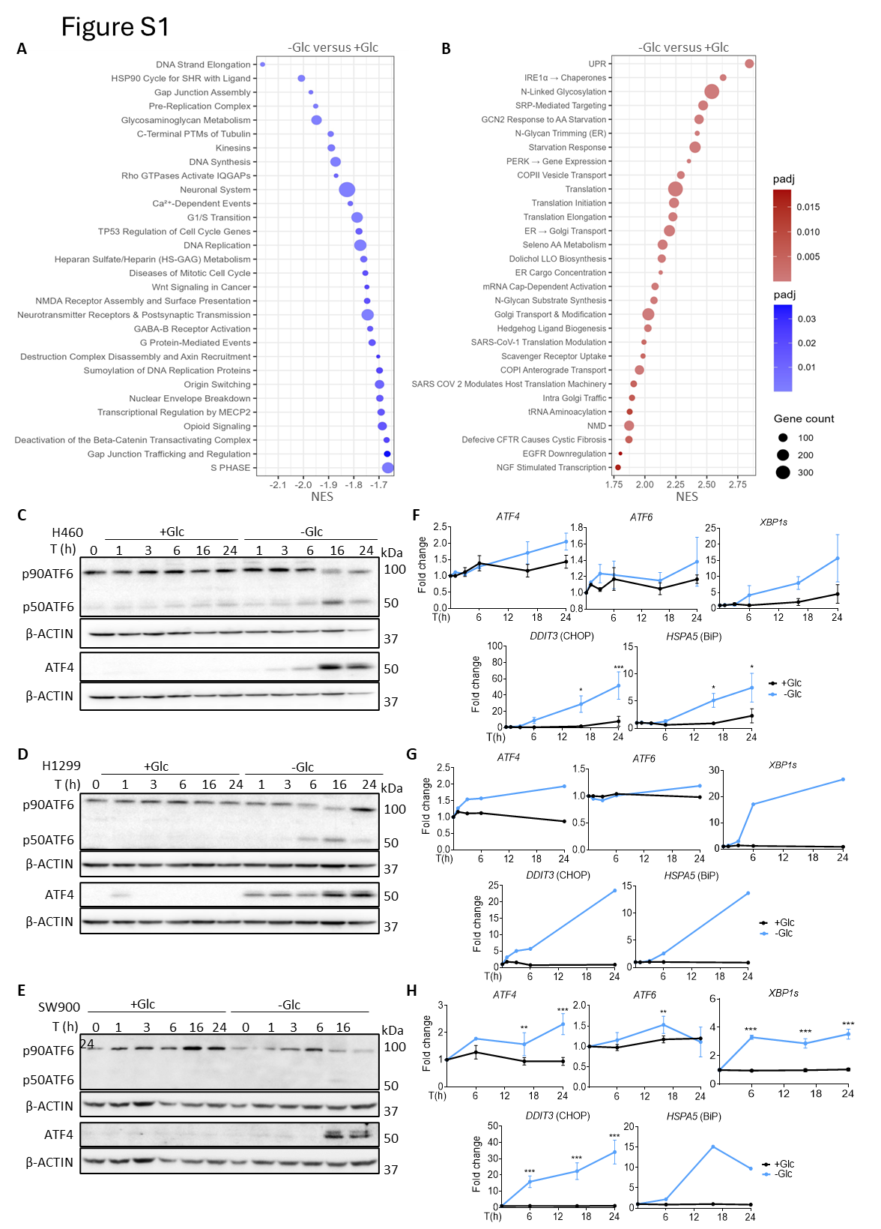

Figure S1. Glucose deprivation induces the Unfolded Protein Response in NSCLC. A-B). A549 cells were incubated with glucose-free media (-Glc) or glucose-rich media (+Glc) for 6h. mRNA extracts were analysed by RNA-Sequencing. The top 30 Reactome Pathways organised by Normalised enrichment score (NES) after 6h of glucose deprivation are shown. A, Upregulated pathways NES>0, B, Downregulated pathways NES<0. C-H) H1299, H460 and SW900 cells were incubated with (+) or without (-) Glc for the indicated time points. Cells without treatment were used as T0 control. C-E) Whole cell extracts were analysed by immunoblotting. Representative western blots are shown for ATF4, ATF6α and β-actin as loading control. D-H) mRNA extracts were analysed by qPCR for ATF4, ATF6, XBP1s, DDIT3 (CHOP) and HSPA5 (BiP). Results are shown normalised to their housekeeping gene L32 and then as fold change vs T0. Statistical analysis performed using One-way ANOVA with multiple comparison tests within samples (n=2-3). P-value: *p<0.05, **p<0.01, ***p<0.001.

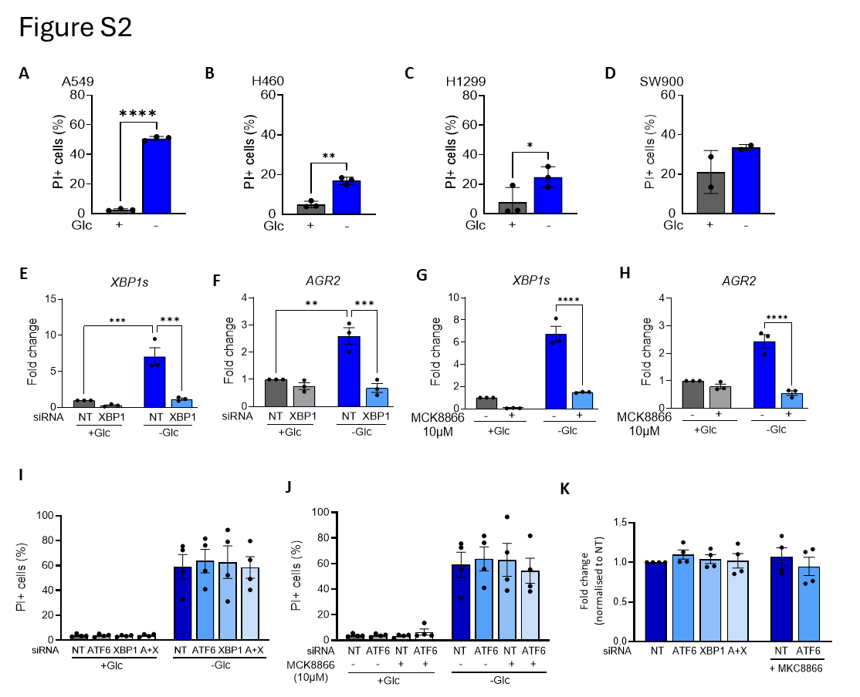Figure S2. Glucose deprivation induces cell death in NSCLC.
A-D) A549, H460, H1299 or SW900 cells were incubated with medium with (+) or without (-) Glc for 48h. The cells were subsequently collected, stained using propidium iodide (PI) and analysed by flow cytometry. Bar graphs show percent of PI positive cells (Mean ± SEM) (n=2-3).C-F) A549 cells were transfected with the indicated siRNA. After incubation for 24h, mRNA extracts were analysed by qPCR for the indicated genes. Results are shown normalised to their housekeeping gene L32 and then as fold change vs NT siRNA or non-treated control. Mean ± SEM (n=3). G-H) A549 cells were pretreated with IRE1 inhibitor MKC8866 (10µM), then washed and incubated with medium with (+) or without (-) Glc in the presence of the inhibitor. After incubation for 24h, mRNA extracts were analysed by qPCR for the indicated genes.I-K) A549 cells were transfected with siRNA for ATF6, XBP1, a mix of ATF6 and XBP1 siRNA (represented as A+X); or non-targeting sequence (NT) and incubated with (+) or without (-) Glc for 48h and subsequently collected, stained using propidium iodide (PI) and analysed by flow cytometry. Bar graphs show percent of PI positive cells (Mean ± SEM) (n=3).J) A549 cells were transfected with siRNA for ATF6, or non-targeting sequence (NT) and pretreated with IRE1 inhibitor MKC8866 (10µM), then washed and incubated with medium with (+) or without (-) Glc in the presence of the inhibitor. After incubation for 48h the cells were collected, stained using propidium iodide (PI) and analysed by flow cytometry. Bar graphs show percent of PI positive cells (Mean ± SEM) (n=4).
K) PI positive percentage for cells without (-) glucose from J-K expressed as a fold-change vs NT siRNA or non-treated control. Mean ± SEM (n=4). Statistical analysis performed using One-way ANOVA with multiple comparison test within samples (n=3). P-value: *p<0.05, **p<0.01, ***p<0.001

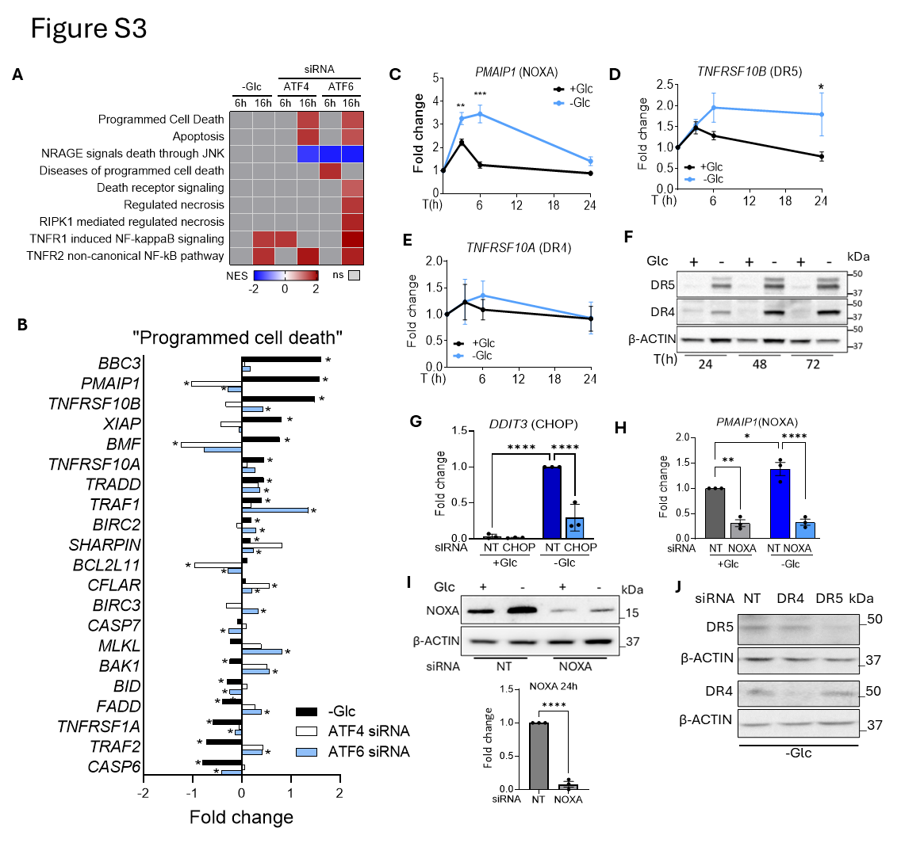
Figure S3. ATF4 regulates apoptotic genes with minor or no involvement in cell death by glucose deprivation. A) A549 cells were transfected with the indicated siRNA or non-targeting sequence (NT) and incubated with medium with (+) or without (-) Glc. A) A549 mRNA extracts were analysed by RNA-Sequencing. The heatmap shows cell death-related Reactome pathways regulated by glucose or/and by the siRNAs after 6 or 16h of glucose deprivation. Upregulated pathways upon silencing the gene (NES>0) are shown in red, downregulated pathways (NES<0) in blue; non-significantly regulated pathways in grey. B) Bar graph with a selection of cell death-related genes expressed in fold change (FC) is shown. C-F) A549 cells were incubated with medium with (+) or without (-) Glc for the indicated time points. C-E) mRNA extracts were analysed by qPCR for indicated transcripts. Results are shown normalised to their housekeeping gene L32 and then as fold change vs T0 (n=3). F) Whole cell extracts were analysed by immunoblotting. Representative western blots are shown for DR4, DR5, β-actin as loading control. G-J) A549 cells were transfected with the indicated siRNA and incubated for 24h. mRNA extracts were analysed by qPCR primer for DDIT3 (CHOP) (G), PMAIP1 (Noxa) (H). Results are shown normalised to the housekeeping gene L32 and then as fold change vs NT siRNA with glucose (n=3). I-J) Whole cell extracts were analysed by immunoblotting. Representative western blots are shown for Noxa (I) Right panel: densitometry analysis (n=2); DR4 and DR5 (J), with β-actin as loading control are shown.

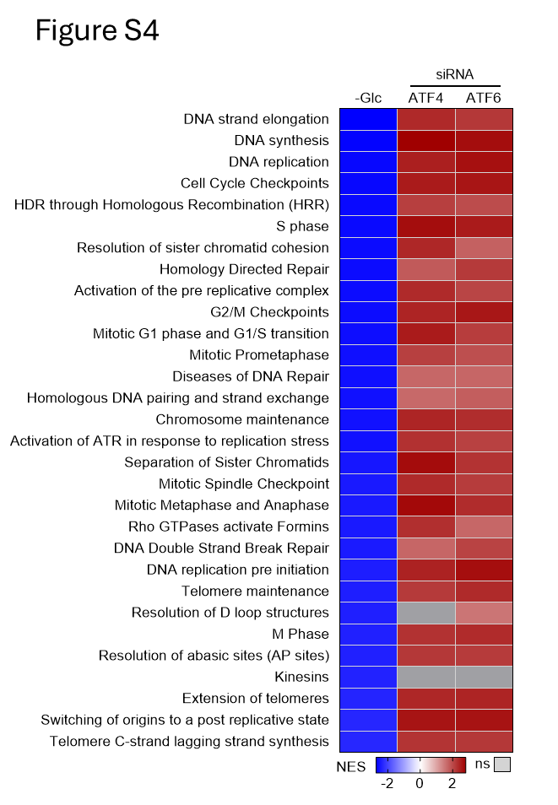
Figure S4. Transcriptional pathways downregulated by glucose deprivation and upregulated by siRNA against ATF4 or ATF6.
A549 cells were transfected with ATF4, ATF6, or non-targeting sequence (NT) siRNAs. After 48h, the cells were incubated with (+) or without (-) Glc for 16h. The heatmap shows the 30 most downregulated Reactome pathways when comparing -Glc vs +Glc. Pathways are organised by the lowest normalised enrichment score (NES). The second and third columns indicate further significant regulation with siRNA against ATF4 (comparing ATF4 siRNA vs NT siRNA in -Glc) or siRNA against ATF6 (comparing ATF6 siRNA vs NT siRNA in -Glc).

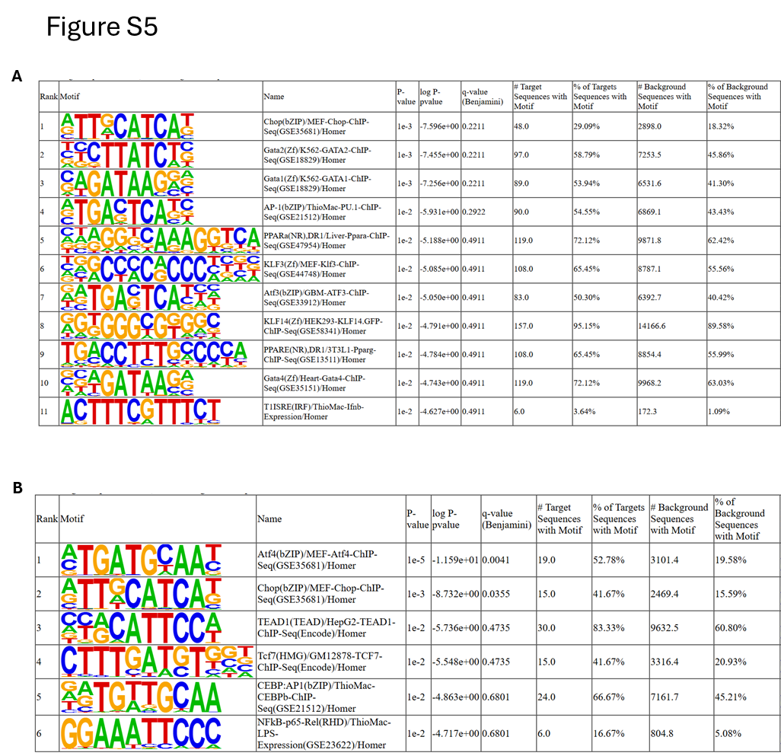
Figure S5. Motif enrichment analysis (HOMER) of genes shown in Figure 6A.
A) 166 genes downregulated by siRNA against ATF4 or ATF6.
B) 35 genes downregulated by siRNA against ATF4 but upregulated by siRNA against ATF6.
Other quadrants (genes upregulated by both siRNA, genes downregulated by siRNA against ATF6 but upregulated by siRNA against ATF4) did not show significant enrichment.

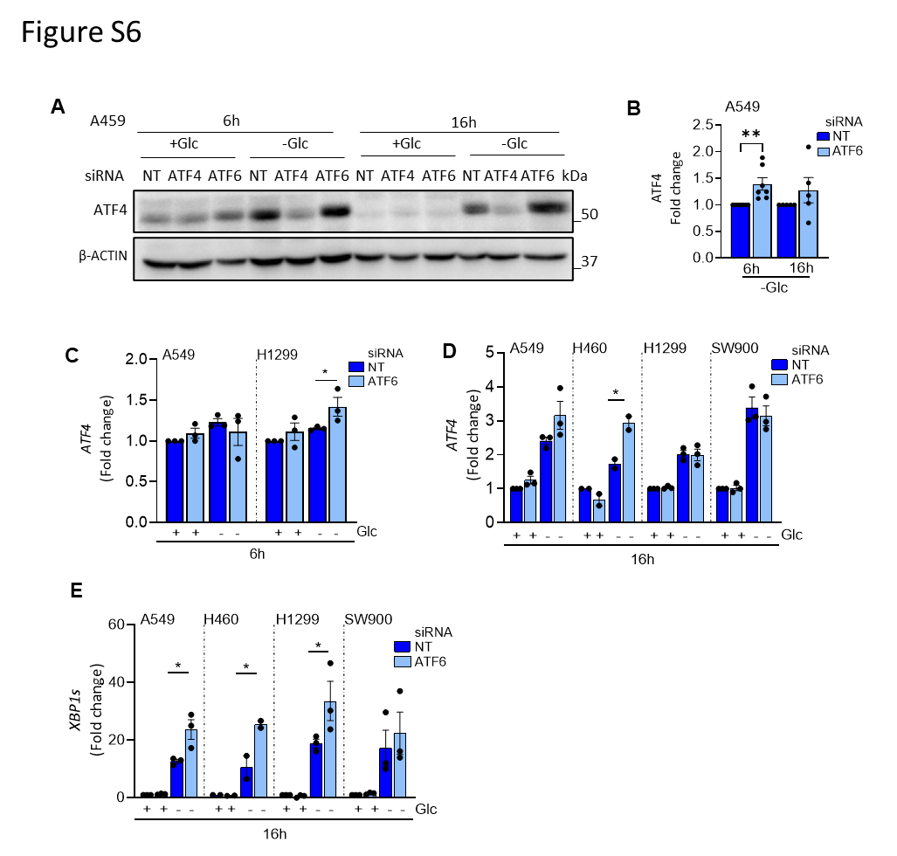Figure S6: Silencing ATF6 further stimulates ATF4 and XBP1s induction.
A549 cells were transfected with siRNA against ATF4, ATF6, or a non-targeting sequence (NT). After 48h, cells were incubated with (+) or without (-) Glc media for 16h.
A) Whole cell extracts were analysed by immunoblotting. Representative western blots are shown for ATF4, and β-actin as a loading control.
B) Densitometry analysis of the blots in A, expressed as fold expression vs NT in glucose-free medium, for each time. Mean ± SEM (n=5).
C-D) mRNA extracts were analysed by qPCR for ATF4 and XBP1s. Results are shown normalised to their housekeeping gene L32 and then as fold change vs NT in +Glc, for each time. Mean ± SEM (n=2-4). Statistical analysis performed using One-way ANOVA with multiple comparison test within samples. P-value: *p<0.05, **p<0.01, ***p<0.001

