Learning environments are associated with developmental trajectories of thalamocortical attention circuits in childhood
SUPPLEMENTARY MATERIAL

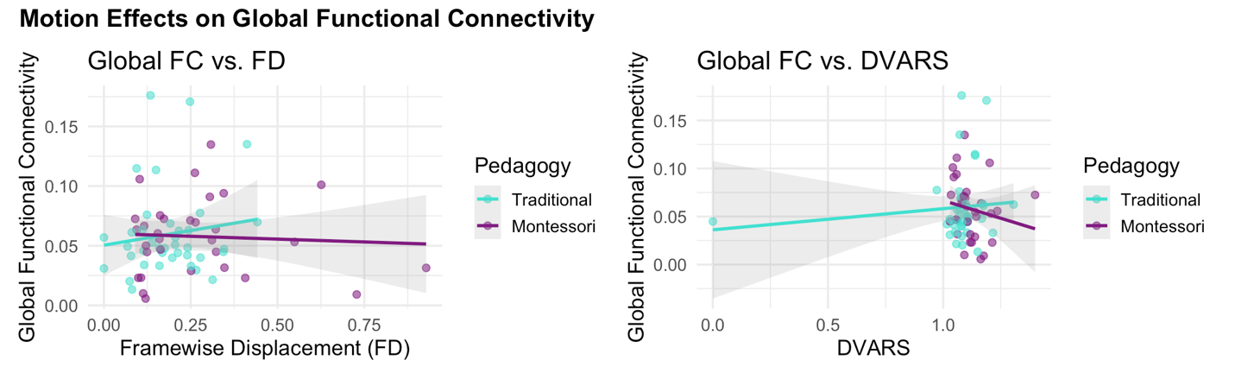
Figure S1. Motion parameters do not account for global functional connectivity differences. Scatterplot and regression lines showing the relationship between global functional connectivity (FC) and motion metrics; framewise displacement (FD; left) and DVARS (right). Neither FD nor DVARS significantly predicted global FC (both p > .69), and neither modulated the observed effects of Pedagogy, Age, or Gender on FC. These results confirm that group differences in FC are not attributable to motion artifacts. Shaded areas represent 95% confidence intervals.

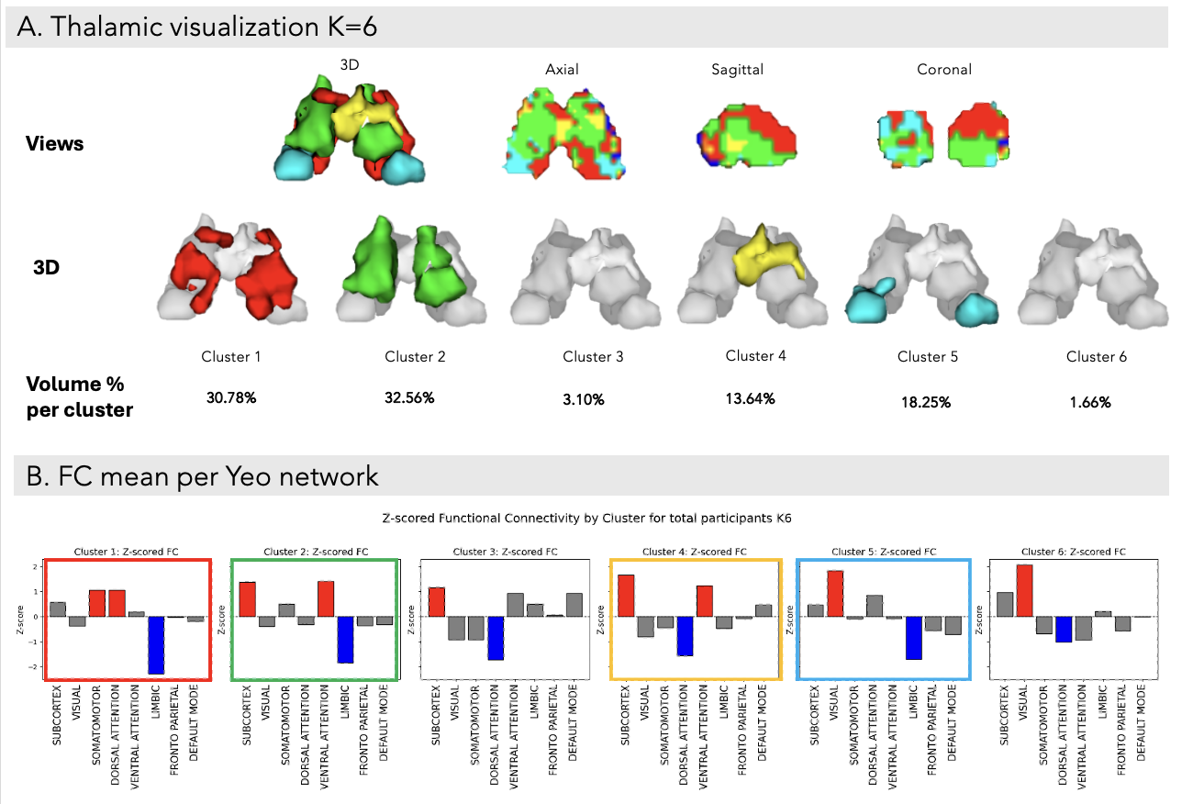

Figure S2. Thalamic Segmentation Using K = 6 Clustering Across the Full Cohort. Top panels display the spatial organization of the six thalamic clusters in axial, sagittal, coronal, and 3D views, alongside their respective relative volumetric proportions (%). Bottom panels show the z-scored functional connectivity profiles for each cluster across major cortical and subcortical networks. The four most prominent clusters are outlined and color-coded to match their anatomical representations above.

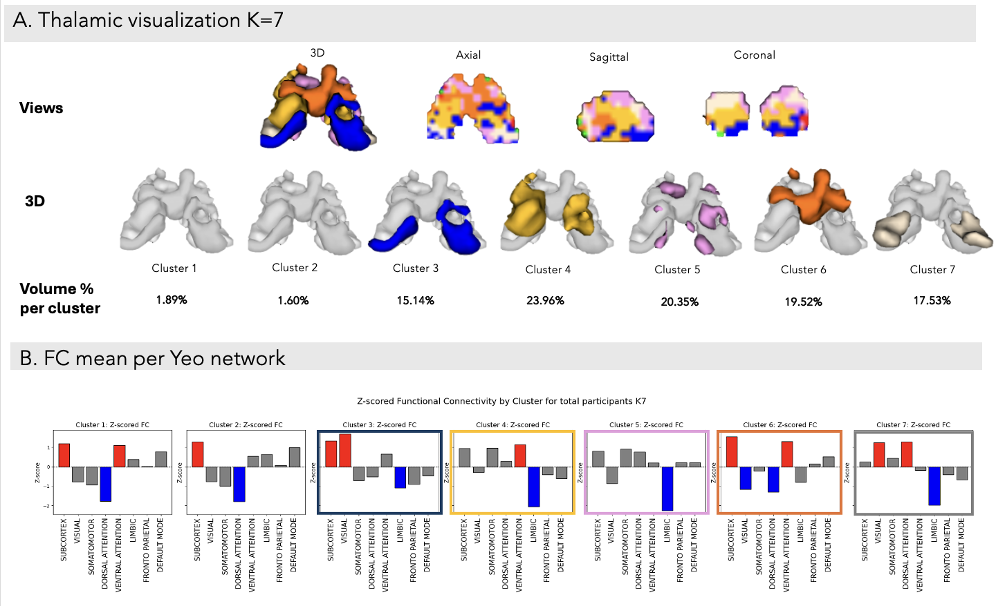
Figure S3. Thalamic Segmentation Using K = 7 Clustering Across the Full Cohort. Top panels show the spatial distribution of the seven thalamic clusters in axial, sagittal, coronal, and 3D views. Each cluster is also visualized in isolation within the 3D rendering to highlight its anatomical extent. Relative volumetric proportions (%) are provided for all clusters. Bottom panels present the z-scored functional connectivity profiles for each cluster.

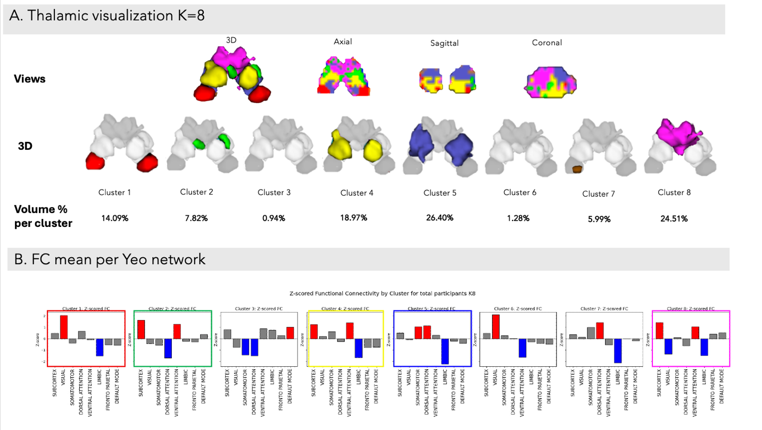
Figure S4. Thalamic Segmentation Using K = 8 Clustering Across the Full Cohort. Top panels show the spatial distribution of the eight thalamic clusters in axial, sagittal, coronal, and 3D views, along with their corresponding relative volumetric proportions (%). Bottom panels display the z-scored functional connectivity profiles for each of the eight clusters across large-scale brain networks. The five most prominent clusters are highlighted using color coding consistent with the anatomical segmentation.

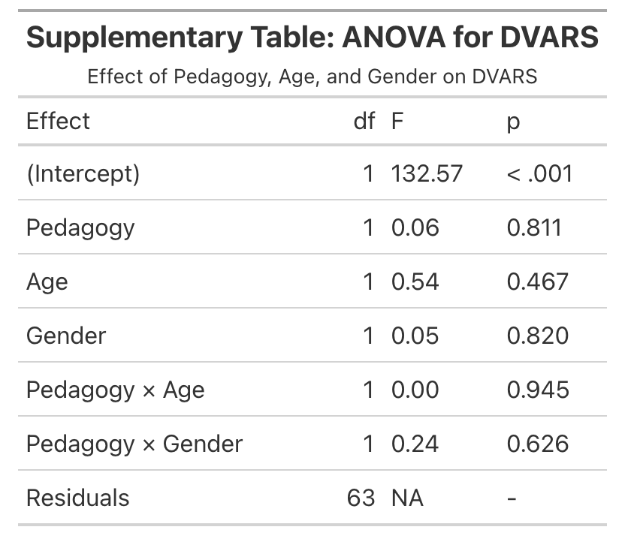
Table S1. ANOVA results for DVARS. Delta variation in signal intensity (DVARS) was tested as a function of Pedagogy, Age, and Gender. No significant effects were observed, indicating that signal variability did not differ systematically across experimental groups.

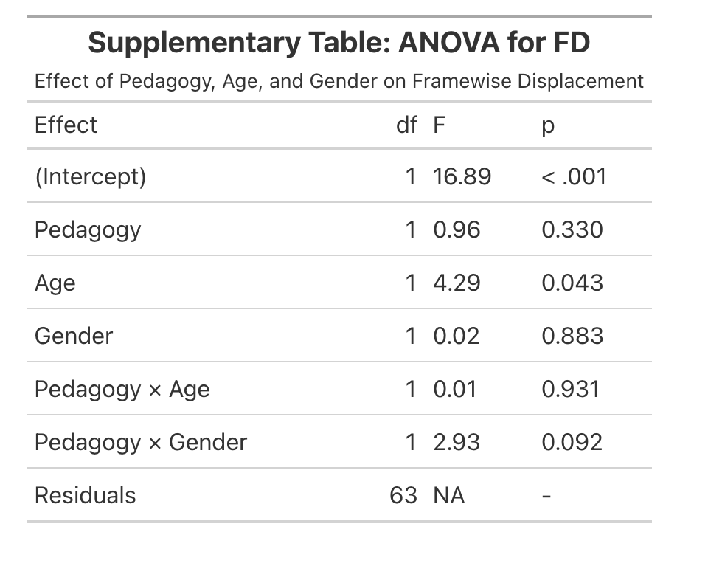
Table S2. ANOVA results for framewise displacement (FD). Mean head motion, indexed by framewise displacement, showed a significant decline with age. No differences were found as a function of Pedagogy or Gender, suggesting that motion was not a confounding factor in group comparisons.

Supplementary Table: ANOVA Results
Per Cluster – FDR-Corrected
Cluster | Effect | F | df | p (fdr)
Cluster1 | Pedagogy | 2.38 | 1 | 0.261
Cluster1 | Gender | 2.65 | 1 | 0.261
Cluster1 | Pedagogy × Gender | 2.05 | 1 | 0.261
Cluster1 | Pedagogy × Age | 1.55 | 1 | 0.272
Cluster1 | Age | 1.08 | 1 | 0.301
Cluster1 | Residuals | NA | 66 | -
Cluster2 | Pedagogy | 8.26 | 1 | 0.027
Cluster2 | Pedagogy × Age | 6.45 | 1 | 0.034
Cluster2 | Age | 2.39 | 1 | 0.188
Cluster2 | Gender | 1.77 | 1 | 0.188
Cluster2 | Pedagogy × Gender | 1.78 | 1 | 0.188
Cluster2 | Residuals | NA | 66 | -
Cluster4 | Pedagogy | 3.36 | 1 | 0.255
Cluster4 | Gender | 2.09 | 1 | 0.255
Cluster4 | Pedagogy × Age | 2.65 | 1 | 0.255
Cluster4 | Age | 1.23 | 1 | 0.272
Cluster4 | Pedagogy × Gender | 1.43 | 1 | 0.272
Cluster4 | Residuals | NA | 66 | -
Cluster5 | Pedagogy | 5.69 | 1 | 0.082
Cluster5 | Pedagogy × Age | 4.75 | 1 | 0.082
Cluster5 | Age | 2.68 | 1 | 0.177
Cluster5 | Gender | 1.81 | 1 | 0.229
Cluster5 | Pedagogy × Gender | 0.98 | 1 | 0.327
Cluster5 | Residuals | NA | 66 | -
Cluster8 | Gender | 3.52 | 1 | 0.163
Cluster8 | Pedagogy × Gender | 4.55 | 1 | 0.163
Cluster8 | Pedagogy | 2.00 | 1 | 0.270
Cluster8 | Pedagogy × Age | 1.39 | 1 | 0.304
Cluster8 | Age | 0.08 | 1 | 0.779
Cluster8 | Residuals | NA | 66 | -

Table S3. Cluster-wise ANOVA results for thalamocortical functional connectivity (FDR-corrected). Type III ANOVAs were conducted separately for each thalamic cluster to assess the effects of Pedagogy (Traditional vs. Montessori), Age, Gender, and their interactions on aggregated functional connectivity values. P-values were corrected for multiple comparisons within each cluster using the false discovery rate (FDR). Significant effects were observed in Cluster 2 for Pedagogy and the Pedagogy × Age interaction, indicating differential developmental trajectories of thalamocortical connectivity as a function of educational context. No other effects survived FDR correction across the remaining clusters.

