Supplementary Information for
Nanoscale-to-atomic unraveling of sequential etching pathways in metal-semiconductor heterostructures

Yong Lu¹, Simin Peng¹, Wenlong Wang¹, Bin Chen^{1,2,3*}
¹Center for Ultrafast Science and Technology, School of Chemistry and Chemical Engineering, Shanghai Jiao Tong University, Shanghai 200240, China
²State Key Laboratory of Synergistic Chem-Bio Synthesis, Shanghai Jiao Tong University, Shanghai 200240, China
³Zhangjiang Institute for Advanced Study, Shanghai Jiao Tong University, Shanghai 201203, China

E-mail: cbcce@sjtu.edu.cn

Contents
Supplementary Figs. 1-6
Supplementary Tables 1-6
Supplementary Movies 1-6

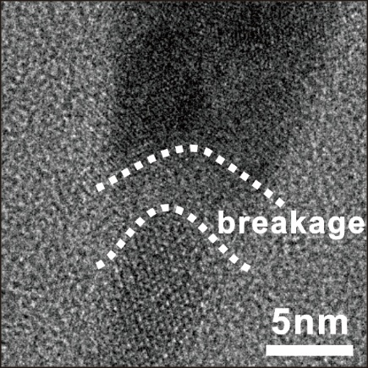
Supplementary Fig. 1 High-resolution TEM image of the junction in AuSe-CdSe heterostructure. The detachment of the tip AuSe nanocrystal (NC) from the CdSe nanorod (NR) was observed.
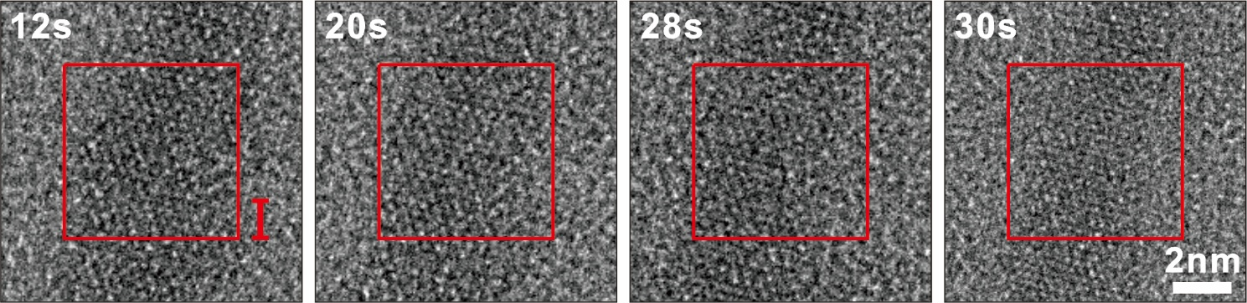
Supplementary Fig. 2 The amorphization process at the neck region. During the necking process, the region I was gradually transformed from the crystalline state to the amorphous state.
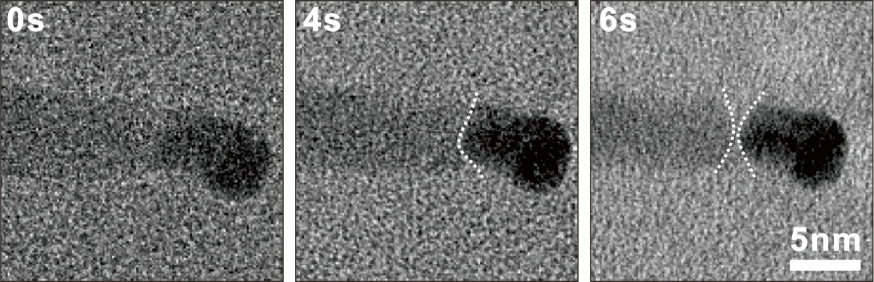
Supplementary Fig. 3 Rapid separation at the junction region. No significant etching occurred for the CdSe NR during the initial stage, while the rapid detachment of the tip from the NR was observed.

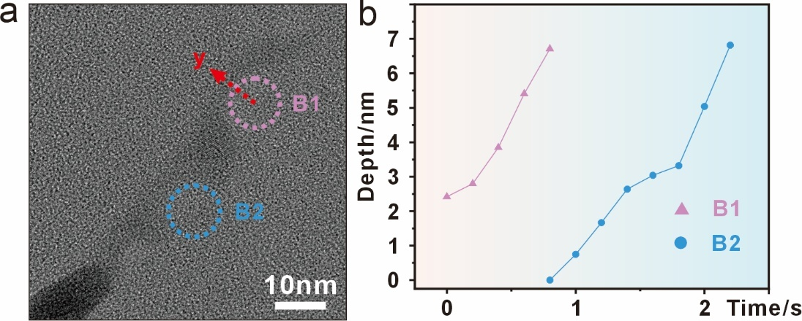
Supplementary Fig. 4 Nanobubble-induced etching by multiple nanobubbles. a TEM image showing the etching of the CdSe NR by two nanobubbles along the y direction. b Time-dependent etch depth caused by the B1 and B2 nanobubbles. They show the similar slope, suggesting the almost identical etching rates.
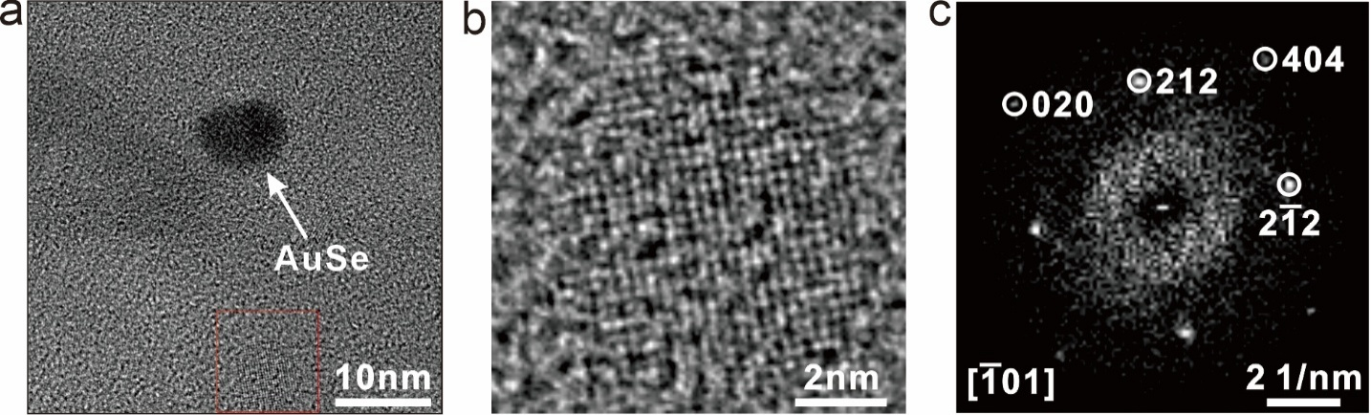
Supplementary Fig. 5 The byproduct generating from the etching of AuSe tip. a TEM image of the AuSe tip and the corresponding byproduct (marked by the square). b High-resolution TEM (HRTEM) image of the byproduct. c Fast Fourier transform (FFT) pattern of the byproduct.
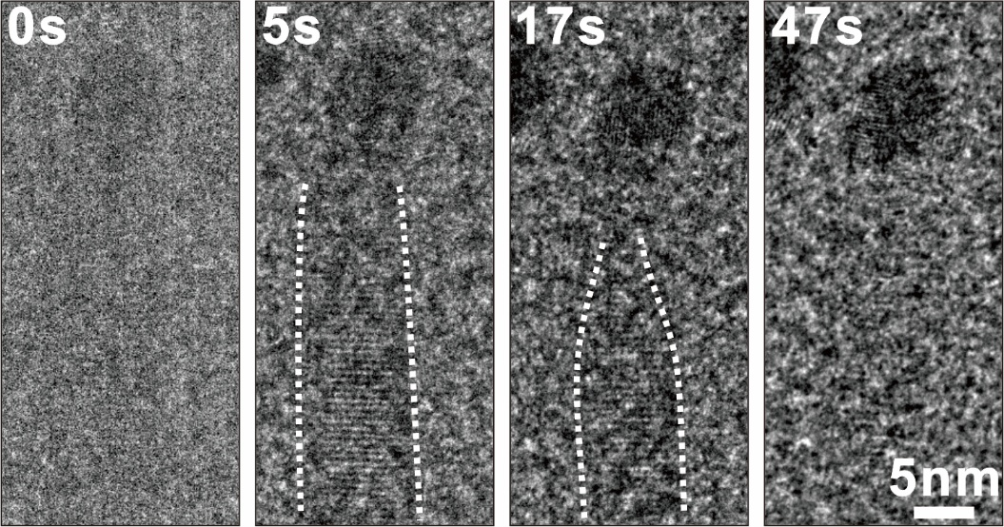
Supplementary Fig. 6 Etching process in the oil-phase Au-CdSe heterostructure. The behavior, e.g., the occurrence of necking, was similar to that observed in the water-phase heterostructure.

Supplementary Table 1 Comparison between reference and measurement values of interplanar spacings and angles for Au. The reference values are from the X-ray diffraction (XRD) pattern of Au in the COD database (ID# 9008463, see also Fig. 1c).
Plane | Reference/Å | Measurement/ Å | $\left|Δ\right|$/%
($11\overline{1}$) | 2.355 | 2.36 | 0.212
($00\overline{2}$) | 2.039 | 2.05 | 0.539
($\overline{1}\overline{1}\overline{1}$) | 2.355 | 2.39 | 1.486
($\overline{2}\overline{2}0$) | 1.442 | 1.46 | 1.248

Angle | Reference/° | Measurement/° | $$\left|Δ\right|$$
($11\overline{1}$)/($002$) | 54.736 | 54.04 | 0.696
($00\overline{2}$)/($\overline{1}\overline{1}\overline{1}$) | 54.736 | 55.10 | 0.364
($\overline{1}\overline{1}\overline{1}$)/($\overline{2}\overline{2}0$) | 35.264 | 35.70 | 0.436
($\overline{2}\overline{2}0$)/($11\overline{1}$) | 144.736 | 144.84 | 0.104

Supplementary Table 2 The reference and measurement values of interplanar spacings and angles for AuSe. The reference values are from the XRD pattern of AuSe in the COD database (ID# 1510297, see also Fig. 1d).
Plane | Reference/Å | Measurement/ Å | $\left|Δ\right|$/%
($212$) | 2.359 | 2.35 | 0.382
($212$) | 1.387 | 1.38 | 0.505
($\overline{3}12$) | 2.436 | 2.40 | 1.478
($\overline{5}00$) | 2.376 | 2.35 | 1.094

Angle | Reference/° | Measurement/° | $$\left|Δ\right|$$
($212$)/($212$) | 29.731 | 30.05 | 0.319
($212$)/($\overline{3}12$) | 30.809 | 30.76 | 0.049
($\overline{3}12$)/($\overline{5}00$) | 61.311 | 60.63 | 0.681
($\overline{5}00$)/($212$) | 121.851 | 121.44 | 0.411

Supplementary Table 3 Comparison between reference and measurement values of interplanar spacings and angles for AuSe. The reference values are from the XRD pattern of AuSe in the COD database (ID# 1510294, see also Fig. 5b).
Plane | Reference/Å | Measurement/ Å | $\left|Δ\right|$/%
($2\overline{1}\overline{2}$) | 2.229 | 2.39 | 7.223
($00\overline{3}$) | 2.006 | 2.15 | 7.178
($\overline{2}1\overline{1}$) | 2.312 | 2.46 | 6.401
($\overline{4}21$) | 1.376 | 1.47 | 6.831

Angle | Reference/° | Measurement/° | $$\left|Δ\right|$$
($2\overline{1}\overline{2}$)/($00\overline{3}$) | 54.027 | 54.36 | 0.333
($00\overline{3}$)/($\overline{2}1\overline{1}$) | 57.096 | 56.80 | 0.296
($\overline{2}1\overline{1}$)/($\overline{4}21$) | 35.160 | 35.00 | 0.160
($\overline{4}21$)/($2\overline{1}\overline{2}$) | 146.283 | 146.15 | 0.133

Supplementary Table 4 The interplanar spacings and angles of Au₂(SeO₃)₂(Se₂O₅) measured from HRTEM. The reference values are obtained from the XRD pattern of Au₂(SeO₃)₂(Se₂O₅) in the COD database (ID# 7209411, see also Supplementary Fig. 5).
Plane | Reference/Å | Measurement/ Å | $\left|Δ\right|$/%
($\overline{2}1\overline{2})$ | 2.953 | 2.94 | 0.440
($\overline{4}0\overline{4}$) | 2.112 | 2.10 | 0.568
($\overline{2}\overline{1}\overline{2}$) | 2.953 | 2.95 | 0.102
($0\overline{2}0$) | 2.065 | 2.06 | 0.242

Angle | Reference/° | Measurement/° | $$\left|Δ\right|$$
($\overline{2}1\overline{2})$/($\overline{4}0\overline{4}$) | 45.639 | 45.51 | 0.129
($\overline{4}0\overline{4}$)/($\overline{2}\overline{1}\overline{2}$) | 45.639 | 45.59 | 0.049
($\overline{2}\overline{1}\overline{2}$)/($0\overline{2}0$) | 44.360 | 44.48 | 0.120
($0\overline{2}0$)/($\overline{2}1\overline{2})$ | 135.639 | 135.59 | 0.049

Supplementary Table 5 The reference and measurement values of interplanar spacings and angles for Au. The reference values are from the XRD pattern of Au in the COD database (ID# 9008463, see also Fig. 5d).
Plane | Reference/Å | Measurement/ Å | $\left|Δ\right|$/%
($020$) | 2.039 | 2.05 | 0.005
($\overline{2}20$) | 1.442 | 1.45 | 0.005
($\overline{2}00$) | 2.039 | 2.05 | 0.005
($\overline{2}\overline{2}0$) | 1.442 | 1.45 | 0.005

Angle | Reference/° | Measurement/° | $$\left|Δ\right|$$
($020$)/($\overline{2}20$) | 45.000 | 45.00 | 0
($\overline{2}20$)/($\overline{2}00$) | 45.000 | 45.00 | 0
($\overline{2}00$)/($\overline{2}\overline{2}0$) | 45.000 | 45.00 | 0
($\overline{2}\overline{2}0$)/($020$) | 135.000 | 135.00 | 0

Supplementary Table 6 Comparison between reference and measurement values of interplanar spacings and angles for Au₂(SeO₃)₂(SeO₄). The reference values are obtained from the XRD pattern of Au₂(SeO₃)₂(SeO₄) in the COD database (ID# 4311594, see also Fig. 5c).
Plane | Reference/Å | Measurement/ Å | $\left|Δ\right|$/%
($020$) | 3.151 | 3.16 | 0.286
($\overline{5}2\overline{1}$) | 2.221 | 2.24 | 0.855
($\overline{5}0\overline{1}$) | 3.130 | 3.16 | 0.958
($\overline{5}\overline{2}\overline{1}$) | 2.221 | 2.24 | 0.855

Angle | Reference/° | Measurement/° | $$\left|Δ\right|$$
($020$)/($\overline{5}2\overline{1}$) | 45.185 | 45.00 | 0.185
($\overline{5}2\overline{1}$)/($\overline{5}0\overline{1}$) | 44.815 | 45.00 | 0.185
($\overline{5}0\overline{1}$)/($\overline{5}\overline{2}\overline{1}$) | 45.815 | 45.00 | 0.815
($\overline{5}\overline{2}\overline{1}$)/($020$) | 134.815 | 135.00 | 0.185

