Structural and evolutionary analysis of of non-specific lipid transfer proteins (nsLTPs) in Cereus (Cactaceae)
Cardoso, M.I.O¹, Teodoro, J.A.¹, Costa-Silva, T.A.¹, Amaral, D.T.^{1,*}
¹Centro de Ciências Naturais e Humanas, Universidade Federal do ABC (UFABC), Santo André, São Paulo, Brazil.
*Corresponding author. Avenida dos Estados, 5001, bloco A, Lab. 504-3, Santo André, 09210-580, Brazil. E-mail address: danilo.trabuco@ufabc.edu.br

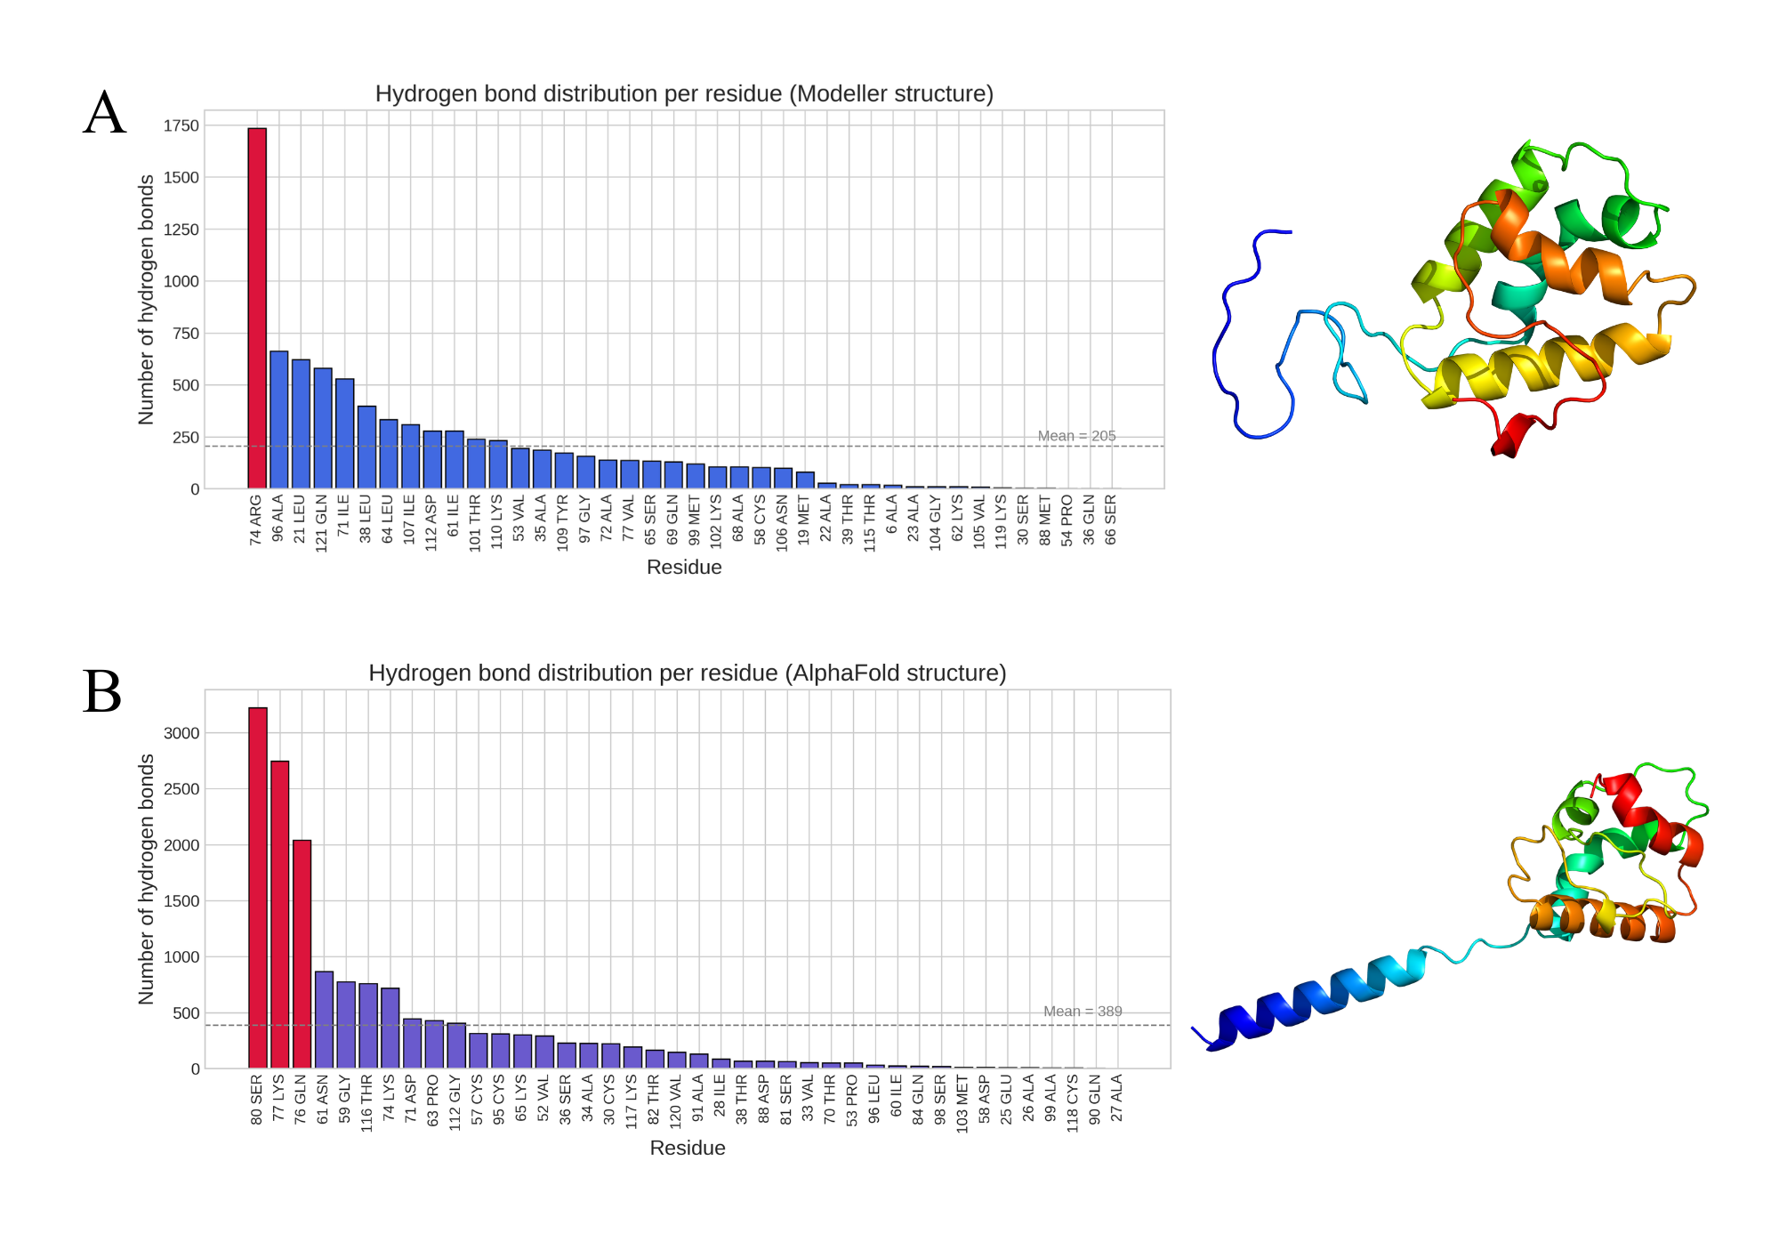
Figure S1. Hydrogen bond interactions predicted by FTMAP in the protein structures. (A) Table of H-bond interactions for the structure predicted by MODELLER. (B) Table of H-bond interactions for the structure predicted by AlphaFold. Residues forming hydrogen bonds and their interaction frequencies are indicated, highlighting the most probable binding sites.

Table S1. Main features of the probes used in FTSite and FTMap.
Molecule | ID | Physicochemical characteristics |  |  | Structure
Molecule | ID | Functional Group | Polarity | H-binding capacity | Structure
Acetamide | ACD | Amide | Polar | Donor and acceptor | 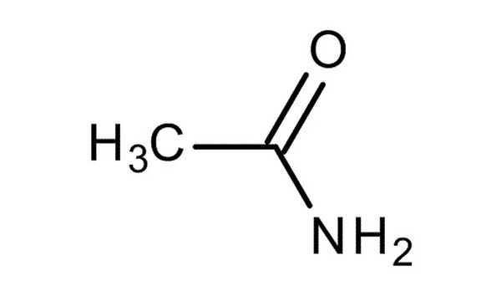
Acetonitrile | ACN | Nitrile | Polar | Acceptor | 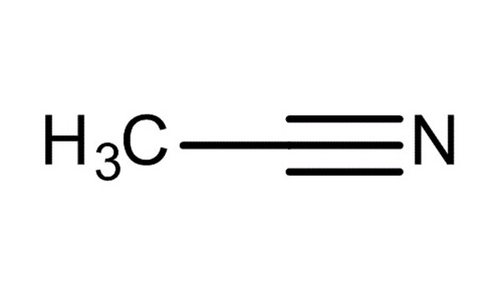
Acetone | ACT | Ketone | Polar | Acceptor | 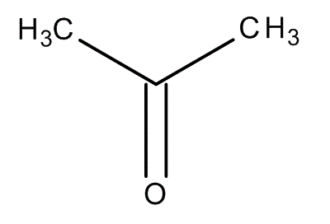
Acetaldehyde | ADY | Aldehyde | Polar | Acceptor | 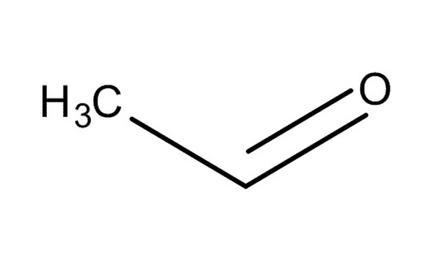
Methylamine | AMN | Primary amine | Polar | Donor and acceptor | 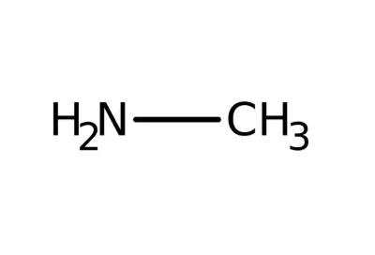
Benzaldehyde | BDY | Aromatic aldehyde | Polar | Acceptor | 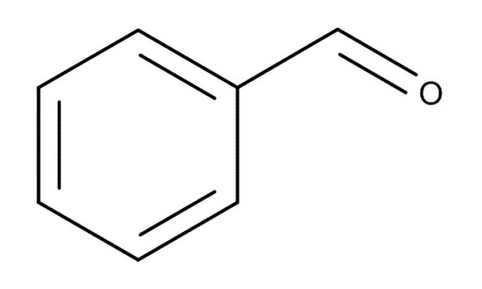
Benzene | BEN | Aromatic | Nonpolar | None | 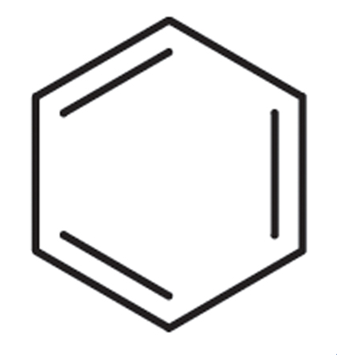
Isobutanol | BUT | Alcohol | Polar | Donor and acceptor | 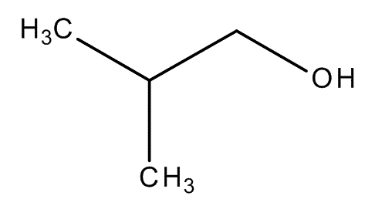
Cyclohexane | CHX | Alkane | Nonpolar | None | 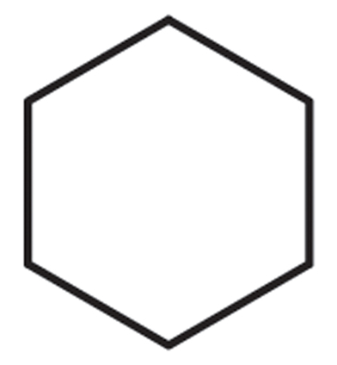
N,N-dimethylformamide | DFO | Tertiary amide | Polar | Acceptor | 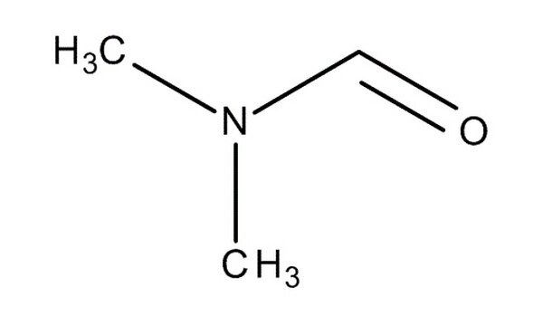
Dimethyl ether | DME | Ether | Slightly polar | Acceptor | 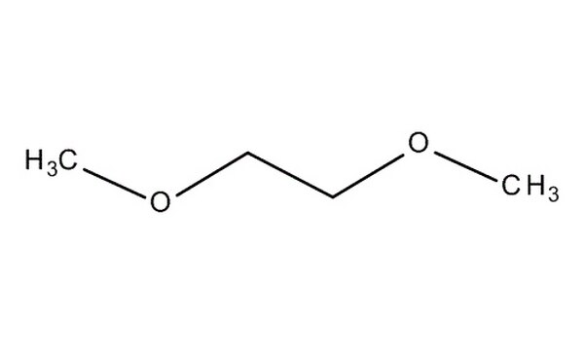
Ethanol | EOL | Alcohol | Polar | Donor and acceptor | 
Ethane | ETH | Alkane | Nonpolar | None | 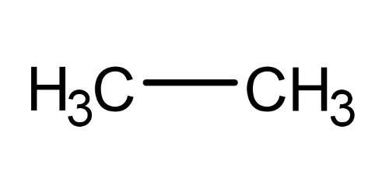
Phenol | PHN | Aromatic alcohol | Polar | Donor and acceptor | 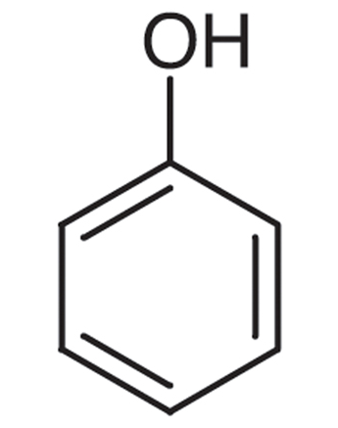
Isopropanol | THS | Secondary alcohol | Polar | Donor and acceptor | 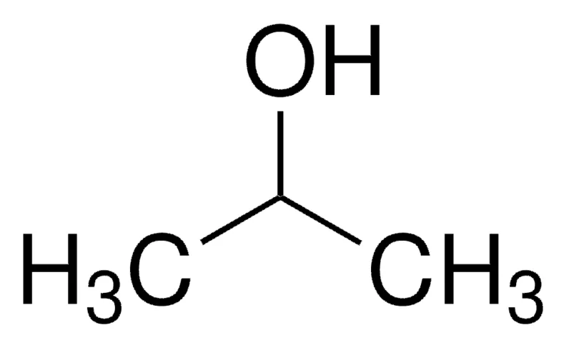
Urea | URE | Amide | Polar | Donor and acceptor | 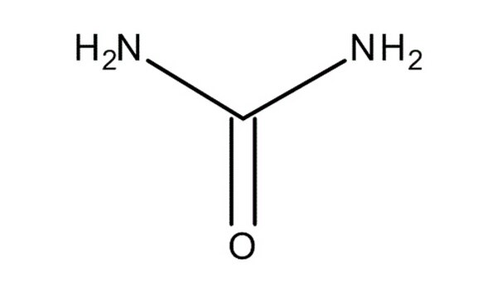

Table S2. Codon sites tested for episodic diversifying selection using MEME. Episodic diversifying selection was assessed using MEME implemented in Datamonkey. Sites with p ≤ 0.1 are shown.
Codon | α | β⁺ (positive class) | LRT | p-value | Branches
2 | 1.007 | 1787.64 | 22.13 | 0.0099 | 2
9 | 0.001 | 31.60 | 9.39 | 0.0099 | 0
20 | 2.130 | 109.82 | 5.99 | 0.0297 | 0
34 | 0.817 | 293.78 | 3.55 | 0.0396 | 1
88 | 0.000 | 7.48 | 5.94 | 0.0198 | 1
100 | 1.206 | 74.05 | 7.44 | 0.0099 | 1
112 | 4.552 | 24.98 | 7.15 | 0.0495 | 1
131 | 0.000 | 43619.53 | 10.09 | 0.0099 | 1
132 | 2.886 | 9373.63 | 73.80 | 0.0099 | 3

