Supplementary Information
Determining the depth of surface charging layer of single Prussian blue nanoparticles with pseudocapacitive behaviors
Ben Niu, Wenxuan Jiang, Mengqi Lv, Sa Wang, and Wei Wang *
State Key Laboratory of Analytical Chemistry for Life Science, Chemistry and Biomedicine Innovation Center (ChemBIC), School of Chemistry and Chemical Engineering, Nanjing University, Nanjing, Jiangsu 210023 (China)
Corresponding author: weiwang@nju.edu.cn

Table of Contents
1. Synthesis and characterizations of Prussian blue nanoparticles
2. Optical imaging device and scattering spectra of PBNP
3. The long-time cyclability of PBNPs during electrochemical modulation
4. Discrimination of Faradaic component and the extraction of optical amplitude and phase
5. Extracting the depth of surface charging layer
6. The calculation of optical coefficient $a$
7. The calculation of equivalent circuit model of a single PBNP
8. The equivalent circuit model of the entire ITO electrode
9. Scattering intensity and equivalent radius of different PBNPs

1. Synthesis and characterizations of Prussian blue nanoparticles
The Prussian blue nanoparticles (PBNPs) were synthesized according to a reported ultrasonic method¹. 422 mg K₄[Fe(CN)₆]·3H₂O (1mmol) powder was added into 0.1 mol/L HCl solution. After immerging into water bath at 37 °C for 85 minutes under ultrasonic condition, the solution was cooled down to ambient temperature. The blue-green product was centrifuged at 14800 rpm to collect the deposit. Finally, the obtained colloidal was washed with deionized water (DIW, 18 MΩ·cm, Milli-Q, Thermo Fisher) three times and dried in the vacuum oven at 30°C for 12 hours.
The UV-vis extinction spectrum of PBNPs aqueous solution was measured by a Cary series UV-vis spectrophotometer (Agilent Technologies). The morphology was characterized by the scanning electron microscope (S-4800, Hitachi) and transmission electron microscope (JEM-2800, JEOL). The elemental analysis was done by X-ray photoelectron spectroscopy (PHI5000 VersaProbe).
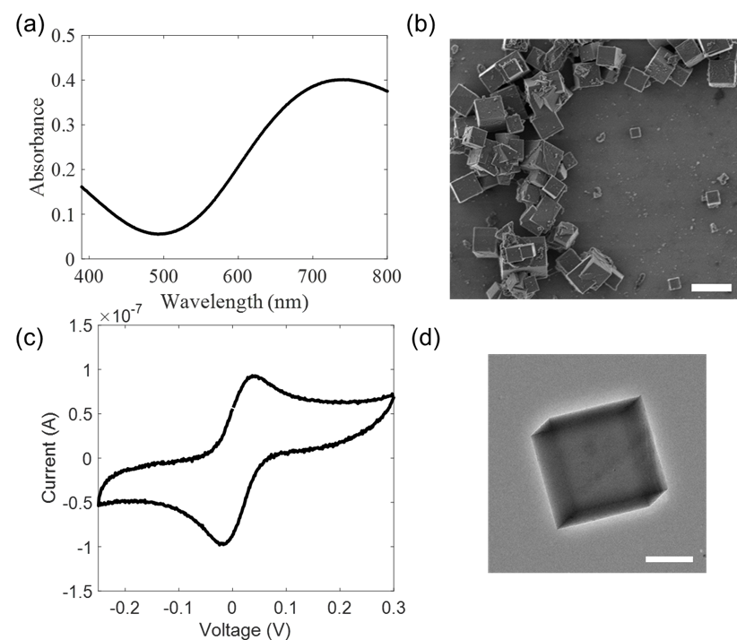
Supplementary Fig. 1 (a) UV-Vis spectrum of PB colloidal with a wide absorption band around 700 nm. (b) The SEM image of as-prepared PBNPs. Scale bar: 1 μm. (c) The cyclic voltammetry of PBNPs-deposited ITO electrodes with two-electrode system. (d) The TEM image of PBNPs. Scale bar: 200 nm.
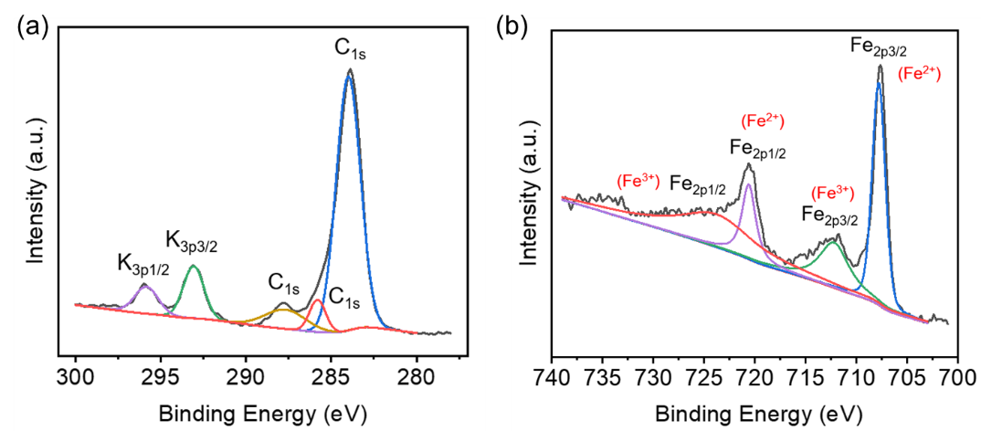
Supplementary Fig. 2 XPS spectra of synthesized PBNPs; (a) K_{3p} signals (K_{3p1/2}: 295.8 eV, K_{3p3/2}: 293.1 eV), C_{1s} signals (287.8 eV, 285.8 eV, 284.0 eV), and (b) Fe_{2p} signals (Fe_{2p1/2}: 725.0 eV, 720.6 eV, Fe_{2p3/2}: 712.2 eV, 707.8 eV).
2. Optical imaging device and scattering spectra of PBNPs
The preparation of the electrochemical cell and electrodes were described in our previous work²⁻³. The thickness of ITO-coated glass slide was 1.1 mm (8 ohms/square, Wuhan Jinge-Solar Energy Technology Co. Ltd.). 150 μL droplet of 5 times diluted PBNP solution was dropped on the surface and dried under vacuum condition (12 hours). Two Cu wires were clung to the ITO slides respectively for connecting with electrochemical workstation. Voltage was applied by the potentiostat (Autolab PGSTAT302N, Metrohm AG) and modulated via an external waveform function generator (RIGOL, DG1000Z). A data acquisition card (USB-6281, National Instruments) was utilized to synchronize the voltage from potentiostat and transistor-transistor logic signals from the camera.
The optical image of PBNPs was obtained with an inverted microscope (Eclipse Ti-U, Nikon), which was installed with an oil-immersed dark-field condenser (NA = 1.20-1.43), an objective lens (40x, NA = 0.6), and a 660 ± 20 nm light-emitting diode (M660L3-C1, Thorlabs) as the light source (Supplementary Fig. 3a). The image was collected by a CCD camera (Stingray, Allied Vision Technologies). In this condition, we can visualize single PBNPs as small as 100 nm with sufficient contrast in DFM (Supplementary Fig. 4).
A grating spectrometer (Acton Spectra Pro SP-2300, Princeton Instruments) with slit was used to capture the scattering spectra. Supplementary Fig. 3b shows the scattering spectra of PB and PW states at different voltage, with maximum scattering wavelength near 700 nm. When applying negative voltage, the blue-colored PBNPs can be transformed into colorless PWNPs with an obvious decrease in the scattering intensity.
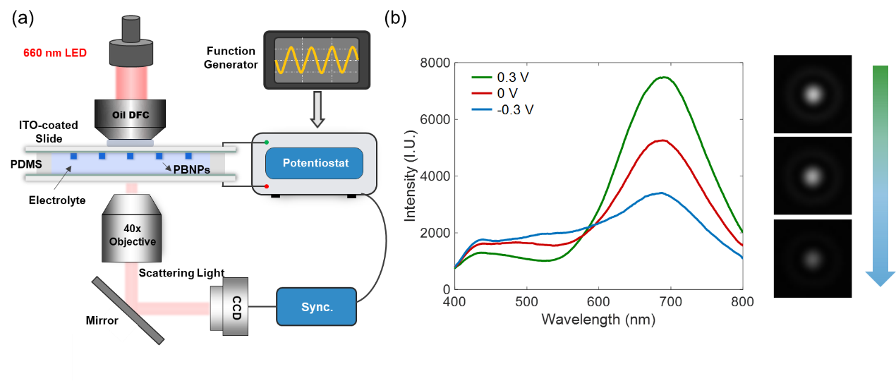
Supplementary Fig. 3 (a) Detailed schematic diagram of the optical-electrochemical combined device. (b) Dark-field scattering spectra of a single PBNP under different voltage conditions.
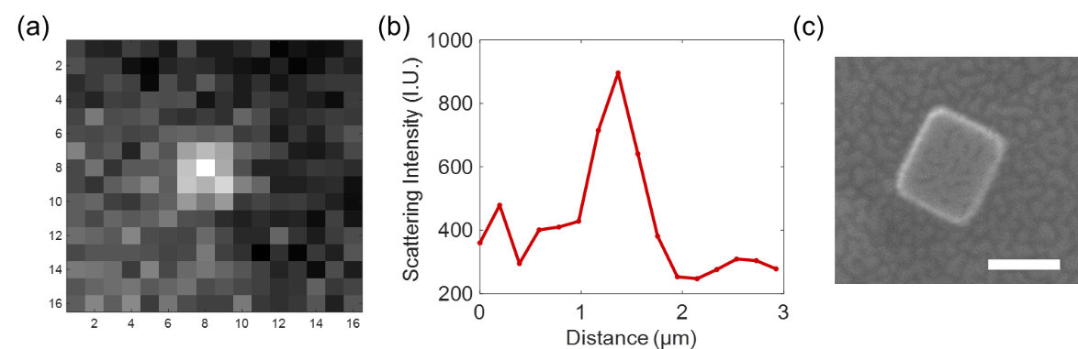
Supplementary Fig. 4 The smallest nanoparticle that can be visualized by our monochromatic dark-filed microscopy. (a) Dark-field scattering image. (b) The corresponding intensity profile of the dark-field image. (c) The corresponding SEM image (scale bar: 100nm).
3. The long-time cyclability of PBNPs during electrochemical modulation
In order to demonstrate the stability of PBNPs during the long-time experiment, PBNPs were modulated during 1000 consecutive cycles at a frequency of 1 Hz. The Fourier transform was utilized to extract the optical amplitude. We exemplified the Fourier transform results by calculating the 400-500th cycles (the green box in Fig. 1f).
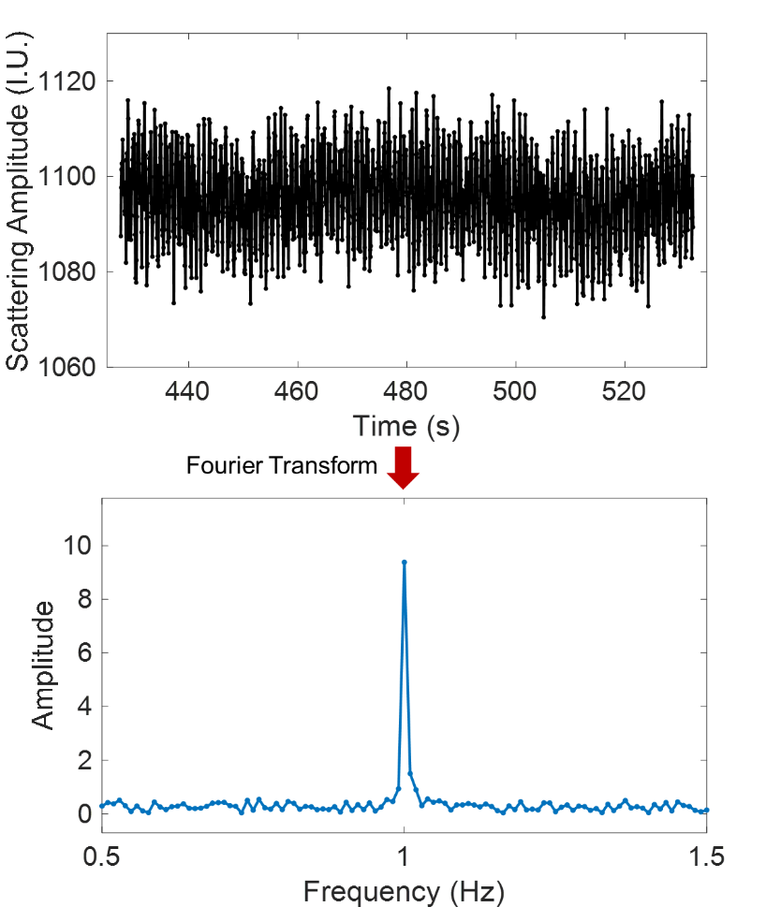
Supplementary Fig. 5 The cyclability of single PBNPs during 100 consecutive cycles of potential modulations (1 Hz), the diagram below was the amplitude after Fourier transform.
4. Discrimination of Faradaic component and the extraction of optical amplitude and phase
The dark-field imaging method can effectively distinguish Faradaic and non-Faradaic components. When a sinusoidal voltage was applied, the scattering intensity of particles could change with the voltage, while the intensity of the ITO electrode remained unchanged (Supplementary Fig. 6). The redox reaction of PBNP and charging/discharging process of electric double layer can easily be distinguished, only by selecting scattering intensity fluctuation at the position of single PBNPs.
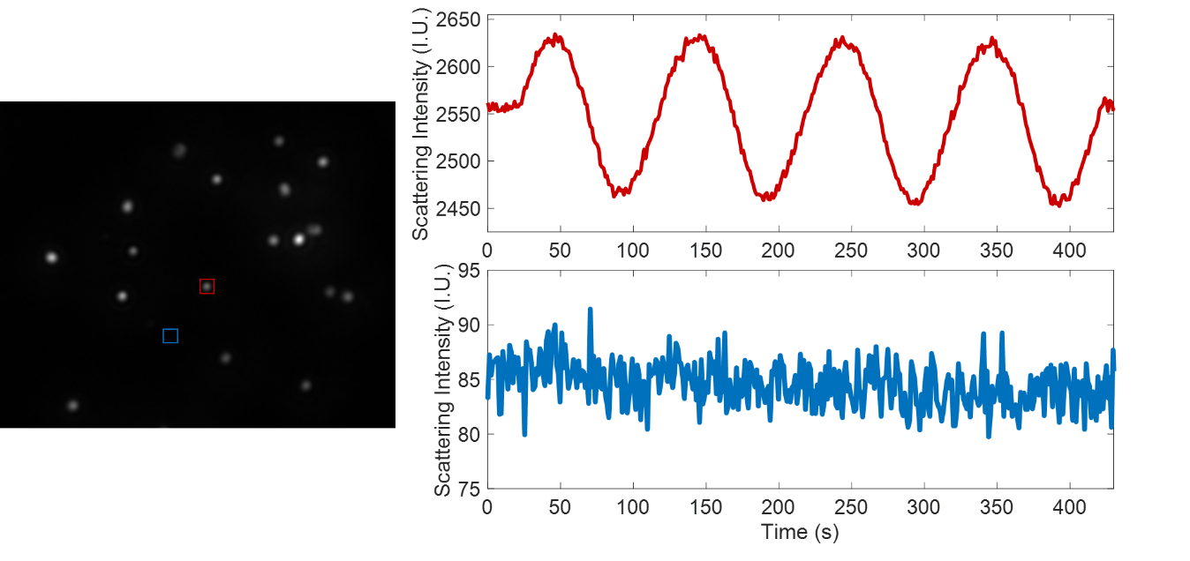
Supplementary Fig. 6 The scattering intensity of PBNP and surrounding background when a sinusoidal voltage was applied. The red area represents a single PBNP, the blue area is the background of ITO electrode. On the right is the corresponding intensity fluctuation. The modulation frequency was 0.01 Hz and the amplitude was ±20 mV.
It should be noted that in order to ensure the linear response of system, the amplitude of the modulation signal need to be small. However, a wake voltage will also cause the poor signal-to-noise ratio of optical amplitude. Under this limitation, we optimized the modulation voltage at each frequency. In the low-frequency region, the voltage was small, while in the high-frequency region, the voltage required to be larger. Here, we had selected four representative frequencies, 0.1 Hz (Supplementary Fig. 7a), 1 Hz (Supplementary Fig. 7b), 10 Hz (Supplementary Fig. 7c) and 100 Hz (Supplementary Fig. 7d), to show the fluctuations of scattering intensity under different voltages.
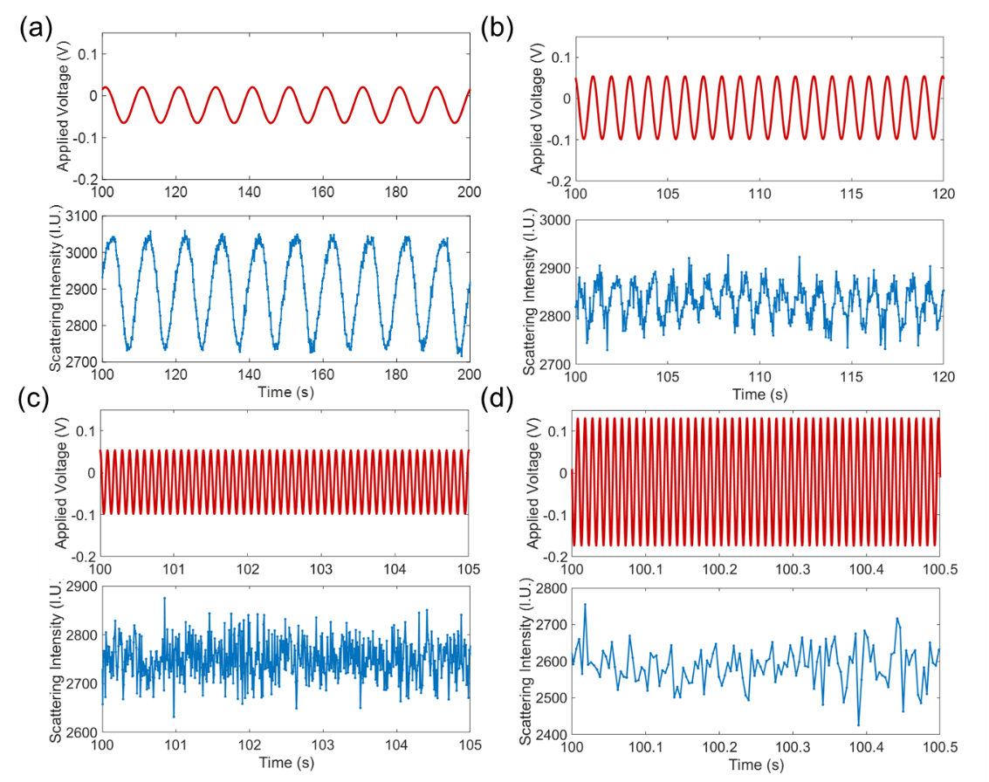
Supplementary Fig. 7 (a) Schematic diagram of the fluctuation of the scattering intensity when the modulation frequency is 0.1 Hz and the voltage is ±45 mV; (b) The modulation frequency is 1 Hz and the voltage is ±80 mV; (c) The modulation frequency is 10 Hz and the voltage is ±80 mV; (d) The modulation frequency is 100 Hz and the voltage is ±160 mV.
The Fourier transform was utilized to extract the optical amplitude and phase. Whether it was at low frequency (0.1 Hz) or high frequency (100 Hz), good signal noise ratio could be obtained. All data processing was completed in Matlab R2016a.
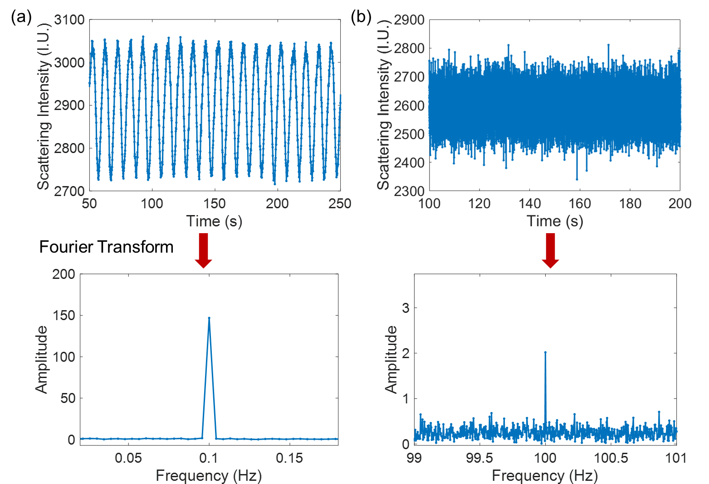
Supplementary Fig. 8 The optical amplitude obtained by Fourier transform when the modulation frequency is (a) 0.1 Hz; (b) 100 Hz.
5. Extracting the depth of surface charging layer
In order to further prove that the ∆I ∝ f⁻¹ in high frequency region and ∆I ∝ f^{-0.5} in low frequency region, we compared the double logarithm graph. The slope of 1 indicated that the optical amplitude conformed to the following formula:
$∆I=k_{1}∙\frac{1}{f}, \lg\left(∆I\right)=lgk_{1}+lg⁡(1/f)$.
The slope of 0.5 indicated that the optical amplitude conformed to the following formula:
$$∆I=k_{2}∙(\frac{1}{f})^{0.5}+b, \lg\left(∆I-b\right)=lgk_{2}+0.5×\lg\left(1/f\right).$$
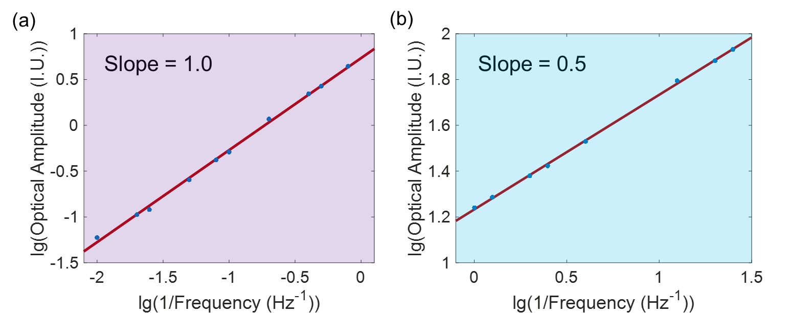
Supplementary Fig. 9 The double logarithm diagram confirming that the ∆I ∝ f⁻¹ in high-frequency region (a) and ∆I ∝ f^{-0.5} in low-frequency region (b).
In Figure 3c-d, the fitted result in high-frequency was:
$$I=5.4∙\frac{1}{f} ,$$
the fitted result in low-frequency was:
$$I=17.2∙(\frac{1}{f})^{0.5}-12.$$
Through these two sets of equations, we can accurately calculate the conner frequency that they intersected, 1.1 Hz. So the contribution from surface charging (Q_{s}) was calculated to be 5.0 IU. Since the total charge capacity fitted (Q_{t}) is 82.2 IU, the contribution percentage of pseudocapacitive behavior is 6.1%.
The single PBNP has regular cuboid geometry that is well characterized by its length (215 nm), width (200 nm) and height (215 nm). Since that PBNP exhibits a face-centered cubic structure and its crystalline size is 1.02 nm, the total number of cells in PBNP are $(\frac{215}{1.02})×(\frac{215}{1.02})×(\frac{200}{1.02})$. Therefore, the number of cells at near-surface region must reach $2.1×\left(\left(\frac{215}{1.02}×\frac{215}{1.02}\right)×4+\left(\frac{200}{1.02}×\frac{215}{1.02}\right)×2\right)$. That was to say, the depth of surface charging layer is around 2.1 unit cells.
The corresponding SEM and AFM images of six PBNPs mentioned in Figure 3a-f were shown in Supplementary Fig.10. The six individual was selected to cover different sizes ranging from 105 to 290 nm, and their height and length were on the same level. They all exhibited capacitor-like behavior in high-frequency range and battery-like behavior in low-frequency range.
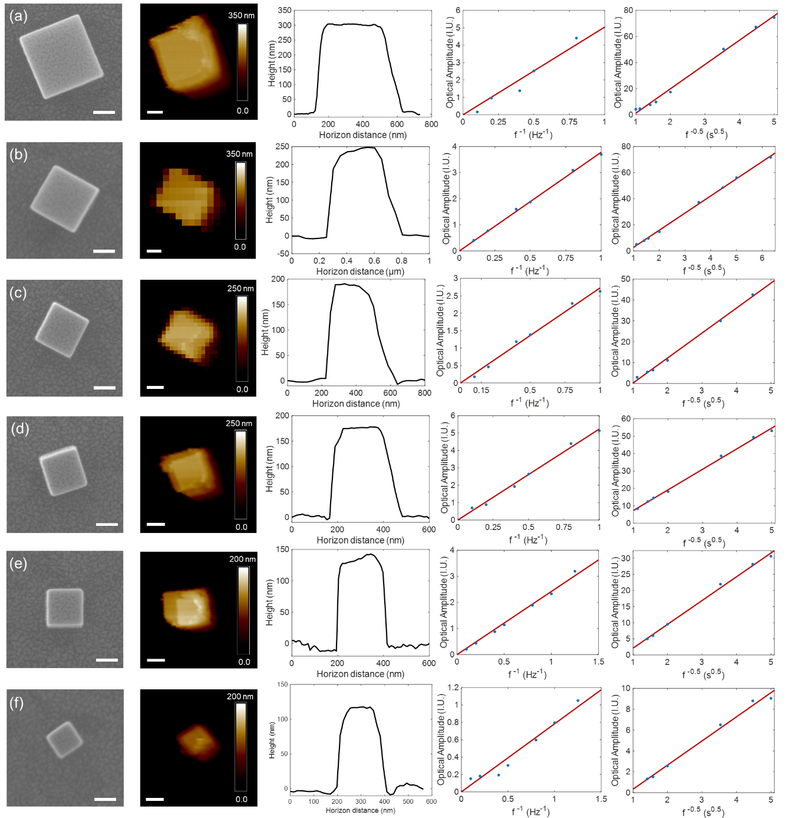
Supplementary Fig. 10 a) - f) The geometry and fitting results of six PBNPs. From left to right: SEM image (scale bar: 100 nm), AFM image (scale bar: 100 nm), the corresponding height profile, fitting results of optical intensity in high frequency region and low frequency region, respectively.
6. The calculation of optical coefficient $a$
Assuming that PBNP can completely convert to PWNP when a sufficiently negative potential was applied, we can see that the scattering intensity of the particle was reduced by 2095 IU in Fig. 1c. Since the following reaction occurred in the one unit cell of PBNP:
$K_{4}{Fe}_{4}^{III}\left[{Fe}_{4}^{II}{\left(CN\right)}_{24}\right]+4e^{-}+{4K}^{+}=K_{8}{Fe}_{4}^{II}\left[{Fe}_{4}^{II}{\left(CN\right)}_{24}\right]$,
this means that one unit cell accepts 4 electron and ions. The total number of cells in PBNP are $(\frac{215}{1.02})×(\frac{215}{1.02})×(\frac{200}{1.02})$ , so the total amount of transferred charge was $4×(\frac{215}{1.02})×(\frac{215}{1.02})×(\frac{200}{1.02})$. By virtue of these above, we can establish an optical electrochemical signal conversion model to obtain the photoelectric conversion coefficient $a$: 6.0×10⁻⁵ IU/charge.
7. The equivalent circuit model of the whole entire ITO electrode
We measured the impedance of the whole electrochemical cell (two identical ITO electrodes) with the voltage amplitude of 10 mV, ranging from 0.005 Hz to 10000 Hz. The equivalent circuit diagram (Fig. 4a) is composed of electric double layer capacitance C_{dl}, electrolyte solution resistance R_{s}, polarization resistance R_{p}, and Warburg impendence Z_{w}. The total impedance is:
$$Z=R_{s}+\frac{1}{1/(R_{p}+Z_{W})+jωC_{dl}}, Z_{W}=(\frac{1}{jωR_{W}})^{n}.$$
Here, n is an adjustable constant and R_{W} is a constant. When n is 0.5, this indicates ideal Warburg impendence. The Nyquist plot shows a deviation from a line with a slope of 1 and the phase angles is higher than -90° when frequency is very low. This is due to mass transfer in the low-frequency region. From the simulation results, we can find there is no significant voltage drop in the frequency ranging from 0.01 Hz to 100 Hz (Fig. 4c).
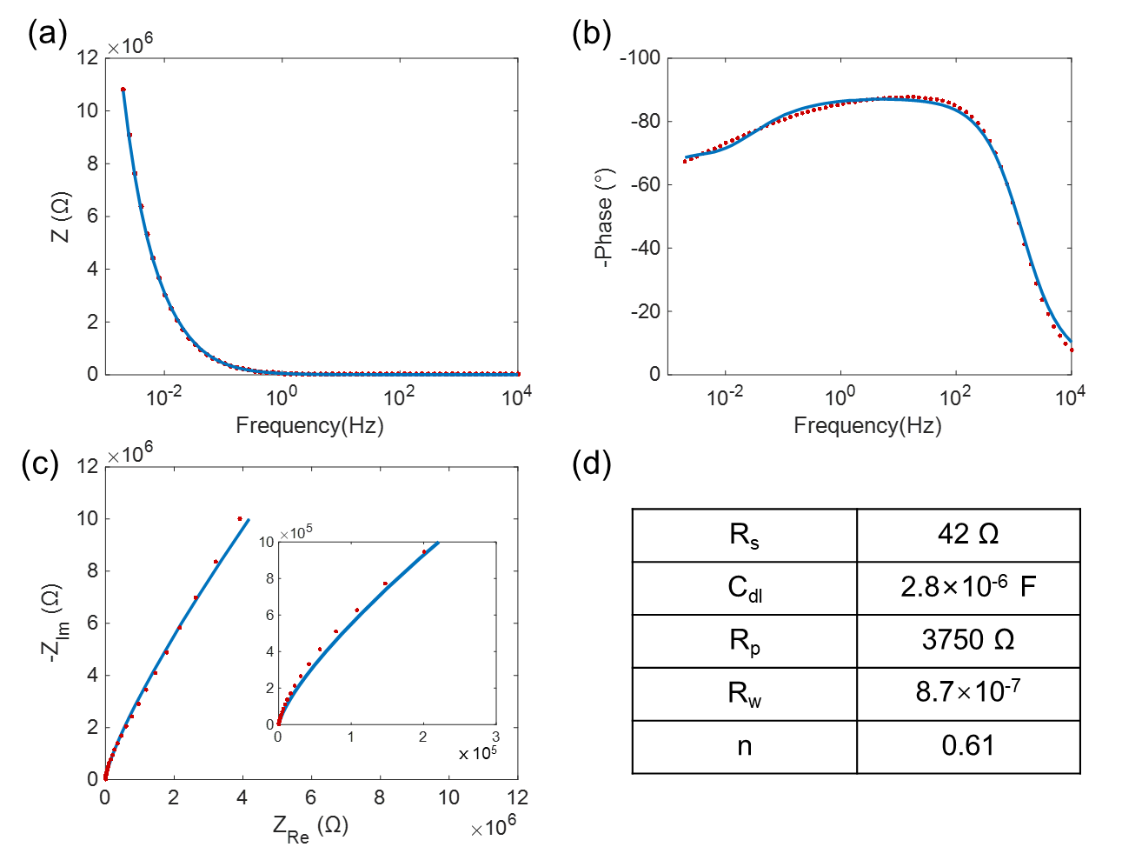
Supplementary Fig. 11 Bode plot of impedance amplitude (a) and phase (b) of the overall electrochemical cell. (c) The corresponding Nyquist plot, the left is high-frequency region. (d) Parameter values of the equivalent circuit.
8. The calculation of equivalent circuit model of a single PBNP
It can be seen from the equivalent circuit (Fig. 4b) that impedance can be written as:
$Z_{F}= R_{NP}+\frac{1}{ jωC_{NP} }$.
When a voltage with amplitude of V₀ was applied, the current is:
$I_{F}= \frac{V_{0}}{ Z_{F }}= \frac{V_{0}}{R_{NP}-j\left(\frac{1}{ωC_{NP}}\right)}=\frac{V_{0}ωC_{NP}}{R_{NP}ωC_{NP}-j}=\frac{V_{0}ωC_{NP}\left(R_{NP}ωC_{NP}+j\right)}{(R_{NP}ωC_{NP})^{2}+1}$.
The real and imaginary parts of the current can be written as:
$$I_{F,Re}= \frac{V_{0}ω^{2}{C_{NP}}^{2}R_{NP}}{{(R}_{NP}ωC_{NP})^{2}+1}，I_{F,Im}= \frac{V_{0}ωC_{NP}}{{(R}_{NP}ωC_{NP})^{2}+1}.$$
The amplitude and phase of the current are:
$$\left|I_{F}\right|= \sqrt{{I_{F,Re}}^{2}+{I_{F,Im}}^{2}}=\sqrt{\frac{{(V}_{0}ωC_{NP})^{2}\left((R_{NP}ωC_{NP})^{2}+1\right)}{{ ((R}_{NP}ωC_{NP})^{2}+1)^{2}}}=\frac{V_{0}ωC_{NP}}{{ ((R}_{NP}ωC_{NP})^{2}+1)^{1/2}}.$$
$$tan⁡(I_{F,Phase})=\frac{I_{F,Im}}{{ I}_{F,Re }}=\frac{1}{ωC_{NP}R_{NP}}.$$
According to the current, the amplitude and phase of the charge can be obtained:
$$Q_{f,amp}=\left|\frac{I_{F}}{2πf}\right|，Q_{F,Phase}=-\frac{π}{2}+I_{F,Phase}.$$
Finally:
$$Q_{F,Amp}=\frac{V_{0}C_{NP}}{{(1+\left(2πC_{NP}R_{NP}∙f)^{2}\right)}^{1/2}}{，Q}_{F,Phase}=\tan^{-1}\left(\frac{1}{2πC_{NP}R_{NP}∙f}\right)-\frac{π}{2}.$$
9. Scattering intensity and equivalent radius of different PBNPs
The length and width of PBNPs can be obtained from the scanning electron microscope, and the equivalent radius is calculated by the following formula to assess the volume of PBNP:
$$r=\sqrt{S/π},$$
which is considered as the radius of a virtual circle with the same projection area of the nanoparticle. In the 12 nanoparticles which the length was ranging from 105 nm - 300 nm, an obvious linear relationship between the scattering intensity and r³ was observed (Supplementary Fig. 12h). This revealed that the volume of nanoparticles (r³) was proportional to the scattering intensity. So we can use the scattering intensity instead of the actual volume of particles, which is difficult because AFM imaging takes a long time, for further statistics.
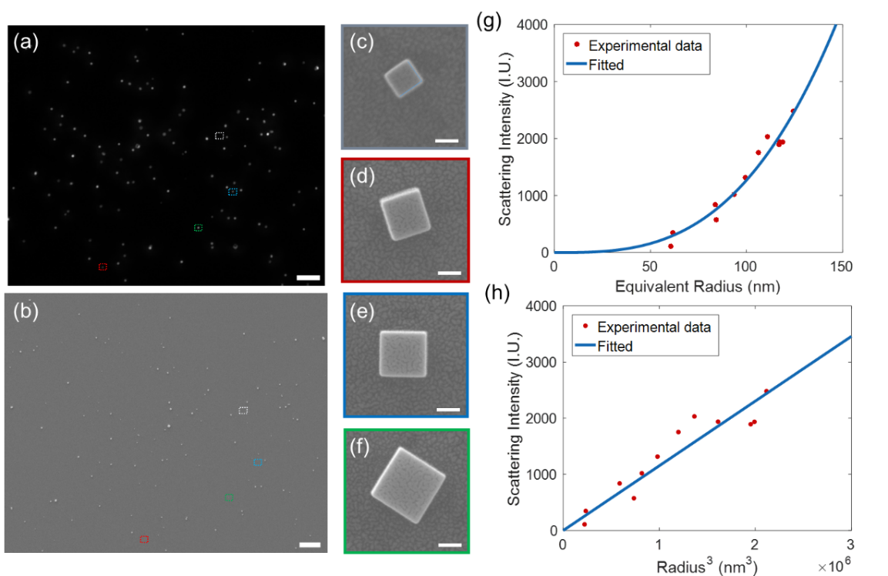
Supplementary Fig. 12 (a) Scattering intensity image of corresponding imaging area, scale bar: 10 μm; (b) SEM image of dark field imaging area, scale bar: 10 μm; (c) - (f) SEM image of single PBNP in (a), indicating the grey, red, blue and green area respectively, scale bar: 100 nm. The scattering intensity of individual PBNPs verse (g) equivalent radius r and (h) r³ estimated from SEM results.

References
1 Wu, X.; Cao, M.; Hu, C.; He, X., Sonochemical Synthesis of Prussian Blue Nanocubes from a Single-Source Precursor. Cryst. Growth Des. 6, 26-28(2006).
2 Liu, T.; Li, M.; Wang, Y.; Fang, Y.; Wang, W., Electrochemical impedance spectroscopy of single Au nanorods. Chem. Sci. 9, 4424-4429(2018).
3 Jiang, W.; Wei, W.; Yuan, T.; Liu, S.; Niu, B.; Wang, H.; Wang, W., Tracking the optical mass centroid of single electroactive nanoparticles reveals the electrochemically inactive zone. Chem. Sci. 12, 8556-8562(2021).

