Molecular convolutional neural networks with DNA regulatory circuits
Supplementary information
Xiewei Xiong^{1,3}, Tong Zhu^{1,3}, Yun Zhu¹, Mengyao Cao¹, Jin Xiao¹, Li Li¹, Fei Wang², Chunhai Fan² and Hao Pei¹*
¹Shanghai Key Laboratory of Green Chemistry and Chemical Processes, School of Chemistry and Molecular Engineering, East China Normal University 500 Dongchuan Road, Shanghai 200241, China
²School of Chemistry and Chemical Engineering, and Institute of Molecular Medicine, Renji Hospital, School of Medicine, Shanghai Jiao Tong University Shanghai 200240, China
³These authors contributed equally: Xiewei Xiong, Tong Zhu
Corresponding authors*: peihao@chem.ecnu.edu.cn
Contents
S1. Molecular design 2
S2. Robustness of weight multiplications 6
S3. Independent molecular weight multiplication systems 10
S4. The DNA implementation of multiply-accumulate operation 12
S5. A DNA-based ConvNet for one of two rotated molecular patterns recognition 14
S6. A DNA-based ConvNet for one of eight molecular patterns recognition 18
S7. The DNA-based hierarchical network for one of 32 molecular patterns recognition 22
S8. Cyclic freeze/thaw approach as drivers of DNA circuits 26

S1. Molecular design
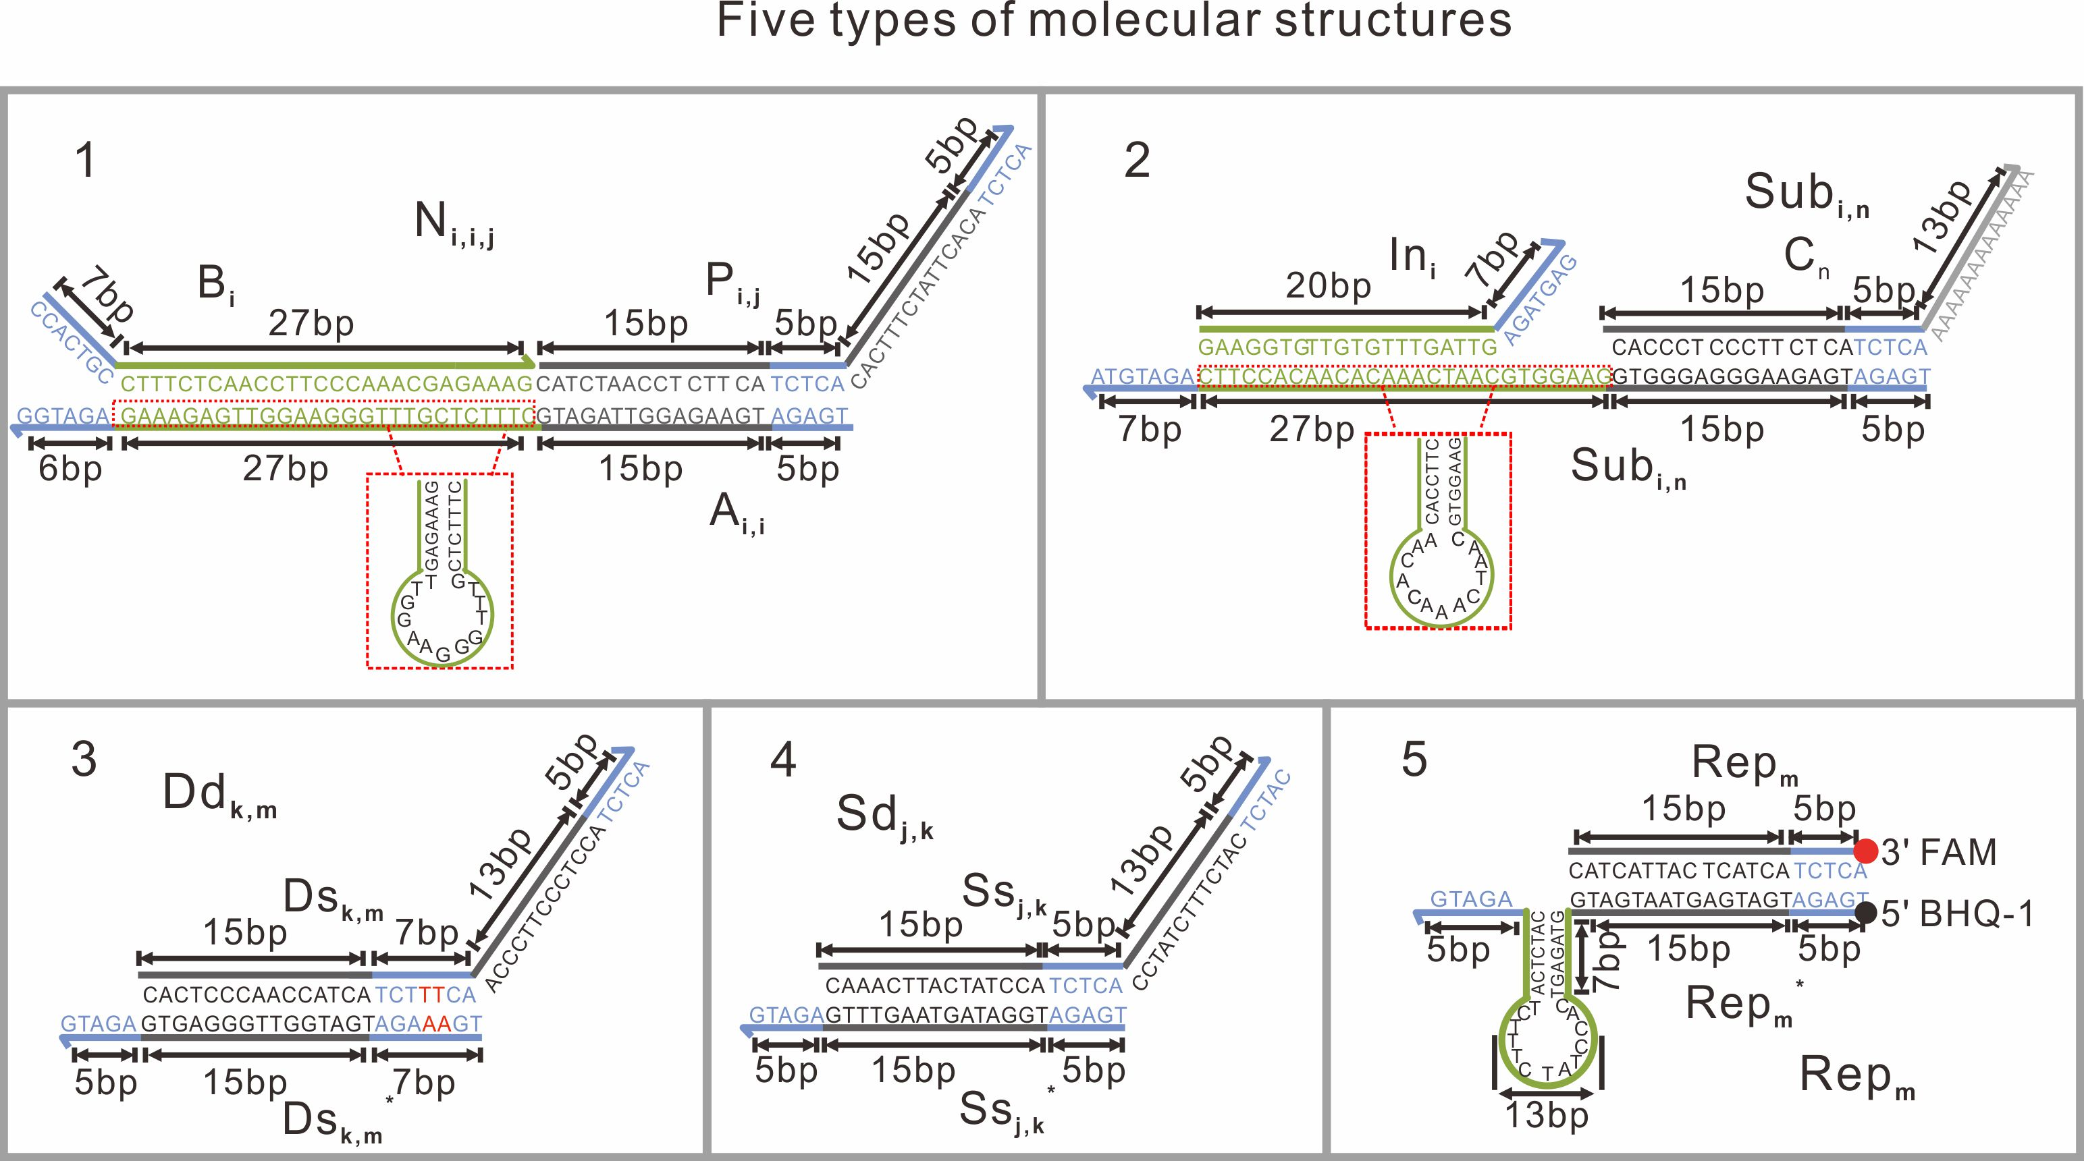
Supplementary Fig. 1| Five types of molecular structures used in networks. 1, The weight substrate molecules N_{i,i,j} consist of three single strands. N_{i,i,j} can interact with corresponding weight tuning molecule W_{i} through strand displacement reaction to form the hairpin loop structure. The complexes Sub_{i,n} and double-stranded complexes Dd_{k},_{m} were used for the subtraction (2 and 3). 2, Sub_{i,n} consists of three single strands. In order to simplify the sequence design, we shortened the length of the inhibitory strand In_{i} that enable the rigid and double helix structure of Sub_{i,n}, to ensure that it can fully react with the upstream output strand. 3, Dd_{k,m} can react with upstream strands to release the intermediate species Ds_{k,m}. Note that Ds_{k,m} would interact with the reporter Rep_{m} with hairpin loop structure, and we added the spacer domain (‘TT’- red colored words) to ensure the binding energy. 4, The summation gate Sd_{j,k} is used to sum up all upstream weighted inputs from the same neuron. Sd_{j,k} is implemented as a Dd_{k,m}-like DNA complex without the spacer domain. 5, Rep_{m} could convert the upstream single strand to concentration-dependent fluorescent reporting signals by toehold-mediated strand displacement.

Reporter Crosstalk test. We have tested the crosstalk to verify the lack of signiﬁcant interference between four diﬀerent ﬂuorophores before the ﬂuorescence kinetics experiment (Supplementary Fig. 2). We mixed four reporters together, and prepared four solutions. Then, we added corresponding trigger strands to activate one reporter only. As displayed in Supplementary Fig. 2c, each channel only responded to the signal strand that triggers the corresponding reporter. Little crosstalk was observed in 10 h, with only ~6% crosstalk between the channels of FAM and HEX, which was still neglectable.
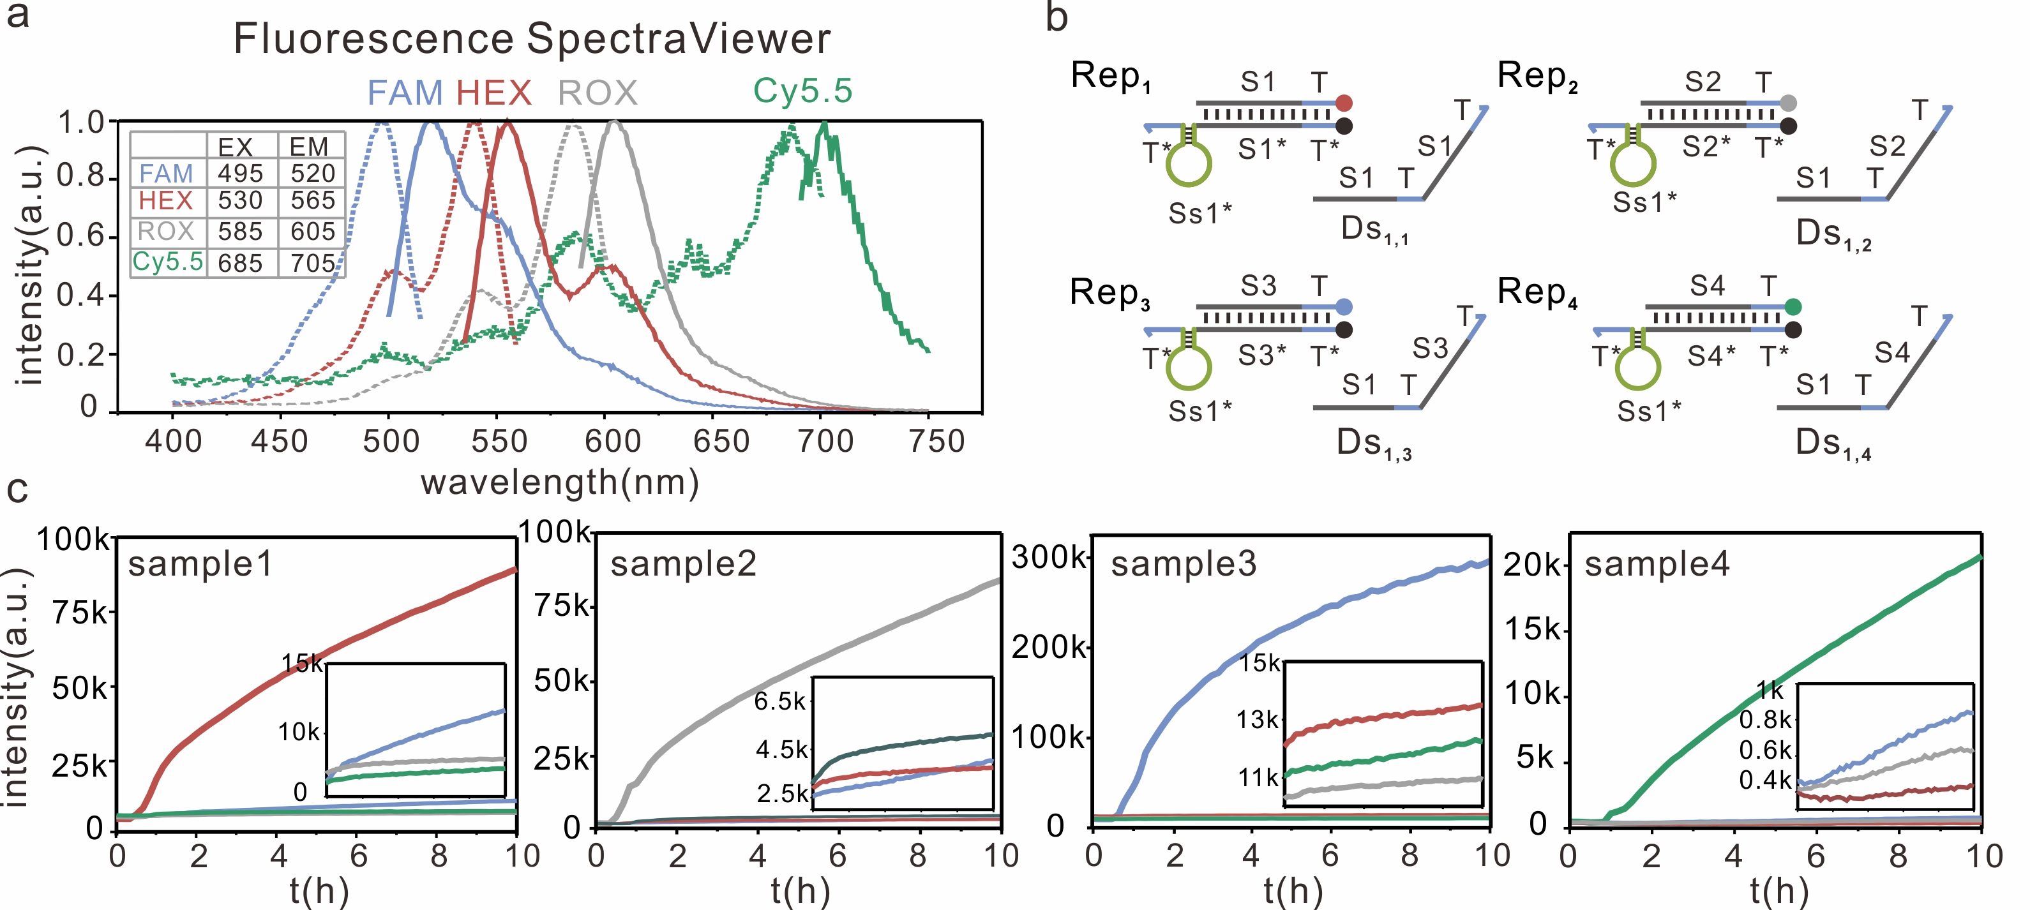
Supplementary Fig. 2| Crosstalk test among four reporters with distinct ﬂuorophores. a, Fluorescence spectra (dotted curves: excitation spectra, solid curves: emission spectra) of FAM, HEX, ROX and Cy5.5. The inset table lists four sets of excitation and emission wavelengths that were determined to minimize the interference among diﬀerent ﬂuorophores. b, Four reporters with ﬂuorophores FAM, HEX, ROX and Cy5.5, and four signal strands that can trigger the four reporters, respectively. c, Four parallel kinetics experiments to test the crosstalk among the four reporters. Four channels were set with the wavelengths listed in the inset table in Supplementary Fig. 2a. All four reporters were added to each of four cuvettes at the beginning of the experiment (t=0). Four signal strands were then added to four cuvettes separately (roughly t=25 mins). Matching colors were used to visualize corresponding trajectories and outputs.

Four subfunctions. Different inputs undergo weight multiplication (y=w_{i} × x_{i}), where w_{i} is an analogue weight and x_{i} is a binary input (Supplementary Fig. 3a). In this design, the weight tuning domain undergoes a spontaneous intramolecular-conformational-switch upon hybridization with a specific single-stranded DNA signal, allowing to stoichiometrically exchange the activity of DNA signals. On this basis, weight multiplication is implemented with cascaded reactions: input species X_{i} only convert an activated weight substrate molecule N_{i,i,j}* to an intermediate product P_{i,j}, in which N_{i,i,j}* is generated from the interaction between weight substrate molecule N_{i,i,j} and weight tuning molecule W_{i}. In the absence of X_{i}, no P_{i,j} will be generated; in the presence of X_{i}, then the final concentration of P_{i,j} will be determined by the concentration of N_{i,i,j}*, thus setting the value of the weighted multiplication y. As shown in Supplementary Fig. 3b, the fluorescence steady-state signals of weighted multiplication y are linearly proportional to the concentration of W_{i}, demonstrating the successful molecular implementation of the weight multiplication.
Second, all intermediate species P_{i, j} in the same neuron are summed (y=∑x_{i}) to yield common weighted-sum species Ss_{j,k} through strand displacement (Supplementary Fig. 3c). The sum of their contributions can be computed simply using the same output sequence for all intermediate species‒that is, the total concentration of Ss_{j,k} is proportional to the sum W₁ × X₁ +...+ W_{i} × X_{i}. The positive weighted-sum species Ss_{j,k} and negative weighted-sum species‾Ss_{i,n} are implemented with concentrations of two different DNA sequences. We tested the summed concentrations of P_{1,2} and P_{2,2}, and observed correct signals that are linearly proportional to the sum P_{1,2} + P_{2,2} (Supplementary Fig. 3d).
Third, subtraction is implemented with annihilation reaction that compares positive and negative weighted sums (y=x_{i} - x_{j}) (Supplementary Fig. 3e). All positive weighted-sum species Ss_{j,k} generated from the previous step can convert the double-stranded complex Dd_{k,m} to an intermediate species Ds_{k,m}. All negative weighted-sum species‾Ss_{i,n} produced from the previous step can bind to a toehold of the inhibitory strand In_{i} and branch-migrate to form inert waste species without exposure of toehold at the same time, resulting in reactive annihilation species Sub_{i,n}* through intramolecular-conformational-switch. The Sub_{i,n}* will then react with Ds_{k,m} and transform them to waste molecule. By this way, only after Sub_{i,n}* is completely consumed, then Ds_{k,m} will interact with the downstream complex for signal transmission; otherwise Ds_{k,m} will be continuously consumed and the signal cannot flow through. This design suggests that only positive weighted-sum species Ss_{j,k} could activate the downstream reactions ‒ a feature that nonlinear activation function shares, known as Rectified Linear Unit (ReLU) used in this model. We verified this design by using 36 different weighted-sum
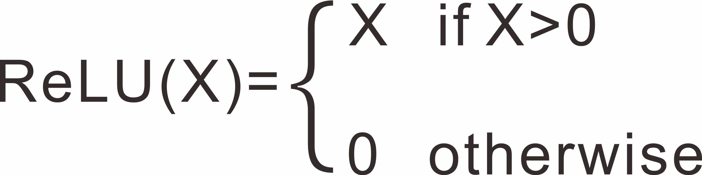
(S₁ and‾S₂) combinations (Supplementary Fig. 3g). As expected, the signal was indeed gradually attenuated as‾S₂ was increased, while higher signals were observed with higher initial concentrations of S₁, which agrees well with the circuit design.
Fourth, reporting reaction is implemented to convert the upstream output to a fluorescent signal, from which the input pattern can be classified (Supplementary Fig. 3f).
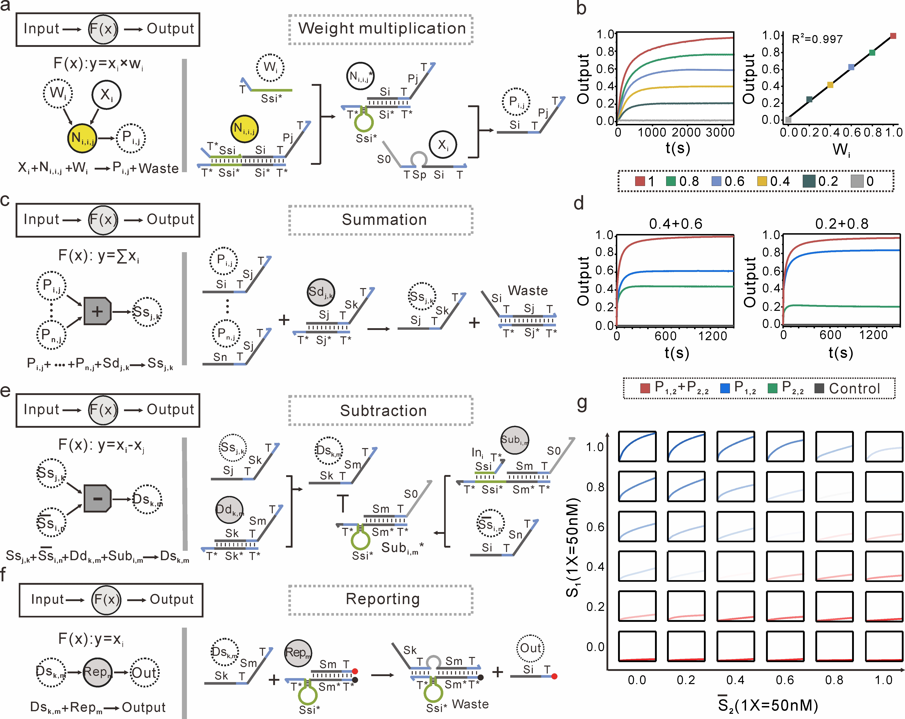
Supplementary Fig. 3| The DNA implementation of subfunctions and its experimental characterization. a, c, e, f, Each subfunction can be implemented with a simple chemical reaction (listed in the left) and DNA strand displacement process (listed in the right). Note that common reactants involved in the subtraction and downstream reactions, toehold with different lengths are used here to control their reaction order¹. The toehold lengths of Sub_{i,n}* and In_{i} are 7 nt, while toehold lengths of the complex Dd_{k,m} and the reporter Rep_{m} are 5 nt. Experimental characterization of each subfunction: b, Fluorescence kinetics (left) and steady-state fluorescence response (right) of different concentrations of W_{i}, while different weights (w= 0.0, 0.2, 0.4, 0.6, 0.8 or 1) were implemented with the concentration of W_{i}. The initial concentration of N_{i,i,j} and X_{i} is 2×. d, Fluorescence kinetics of P_{1,2}, P_{2,2} alone and their sums (P_{1,2} + P_{2,2}). The initial concentration of Sd_{j,k} is 2×, the concentration of P_{1,2} are 0.4× and 0.2×, the concentration of P_{2,2} are 0.6× and 0.8×. g, Subtraction behavior for different combinations of positive weighted-sum S₁ and negative weighted-sum‾S₂. The x axis in each small graph is time (from 0–10 h) and the y axis is the normalized signal (from 0–1). The initial concentration of Dd_{k,m} and Sub_{i,n} are 1× and 2×, respectively. The standard concentration is 1× = 50 nM.

S2. Robustness of weight multiplications
We have tested the DNA implementation of weight multiplication under different conditions, including the length of toehold domains (toehold A and toehold B), the length of stem domains (stem domain St), and the length of spacer domains (spacer domain Sp) (Supplementary Figs. 4 and 5). As shown in Supplementary Fig. 4c, we observed the linear relationship between the fluorescence response of weighted multiplication y and concentration of W_{i} (R² > 0.98) for various domain lengths. Note that we used 15-nucleotide loop domain in initial experiments (Supplementary Figs. 4 and 5). We also verified the DNA implementation of weight multiplication with 13-nucleotide loop domain design (Supplementary Fig. 6). For the simplification of sequence design, we used 13-nucleotide loop domain for the rest experiments. Furthermore, we observed the linear relationship between the concentration of weight tunning molecule W_{i} and the fluorescence response of weighted multiplication y under different temperatures (25 ℃ and 20 ℃) (Supplementary Fig. 7) and molecular concentrations (Supplementary Fig. 8). These results lead to three main observations: First, switching function‒ weight substrate molecule N_{i,i,j} is OFF unless the addition of weight tunning molecule W_{i}. Second, the value of weights can be facilely regulated by the concentration of W_{i} without changing the components. Third, the sequence of weight tuning domains can be independently designed and only associated with the assignment of weights. Collectively, these features may prove essential for constructing complex yet robust molecular circuits.
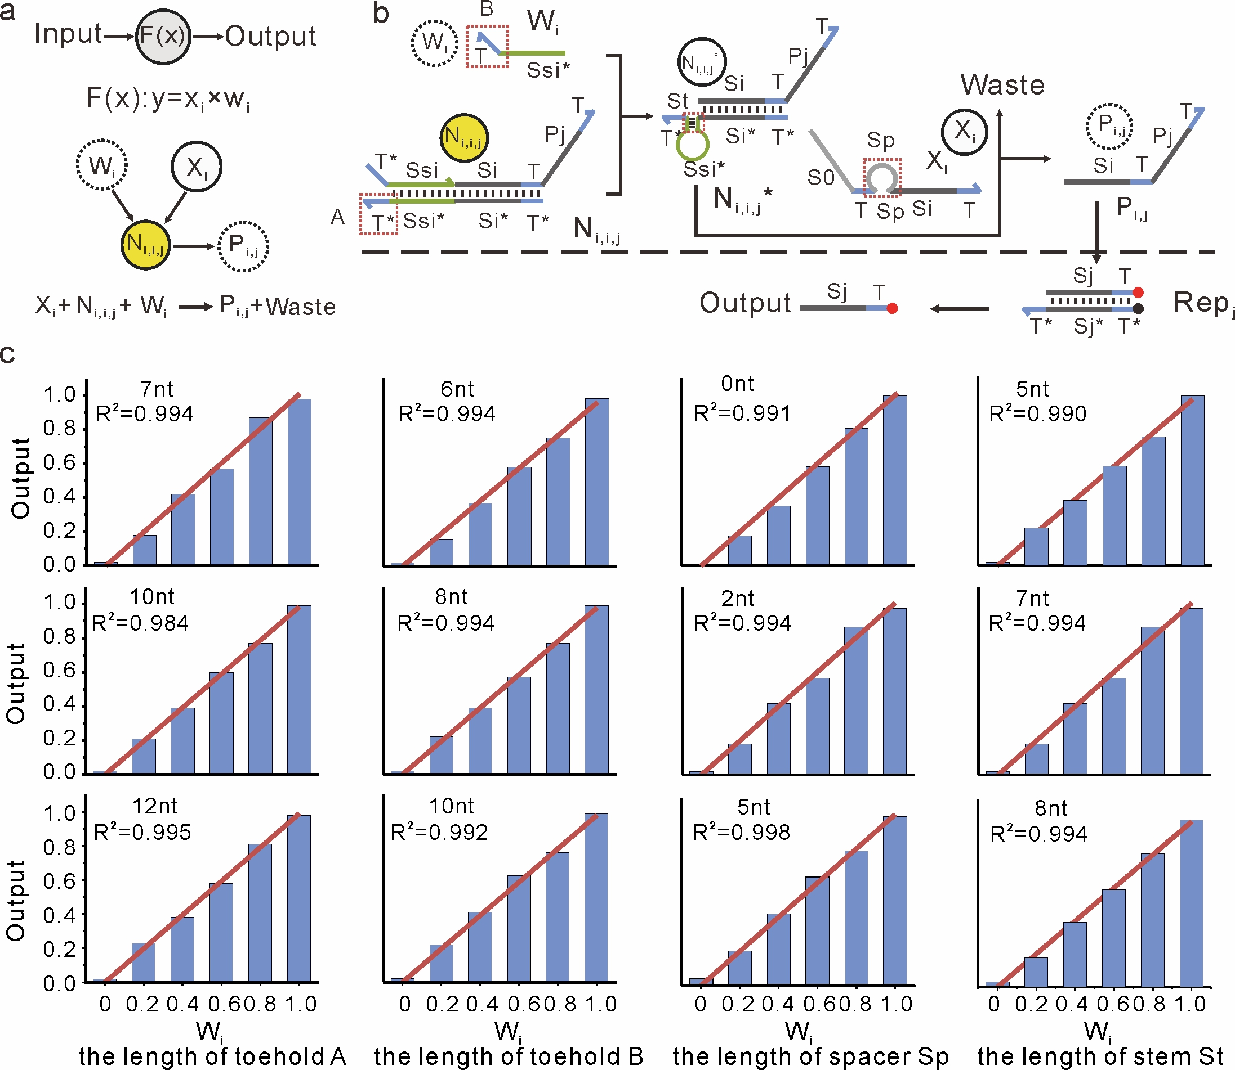
Supplementary Fig. 4| The DNA implementation of weight multiplication under different conditions. a, The abstract schematic of the weight multiplication. b, The DNA implementation of weight multiplication, with 15-nucleotide loop domain. c, Kinetics experiments of different length of domains on the operation of the weight multiplication. The concentration of the weight substrate molecule N_{i,i,j} and input X_{i} are 2×, and the concentration of the reporter Rep_{j} is 2×. The standard concentration is 50 nM (1× = 50 nM).

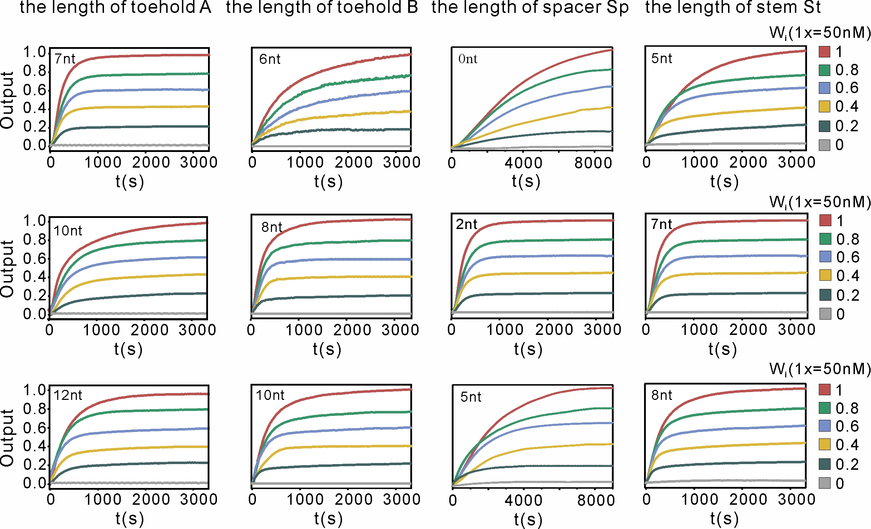
Supplementary Fig. 5| Fluorescence kinetics data of the weight multiplication shown in Supplementary Fig. 4. All fluorescence kinetics data are shown over the course of 3600s.

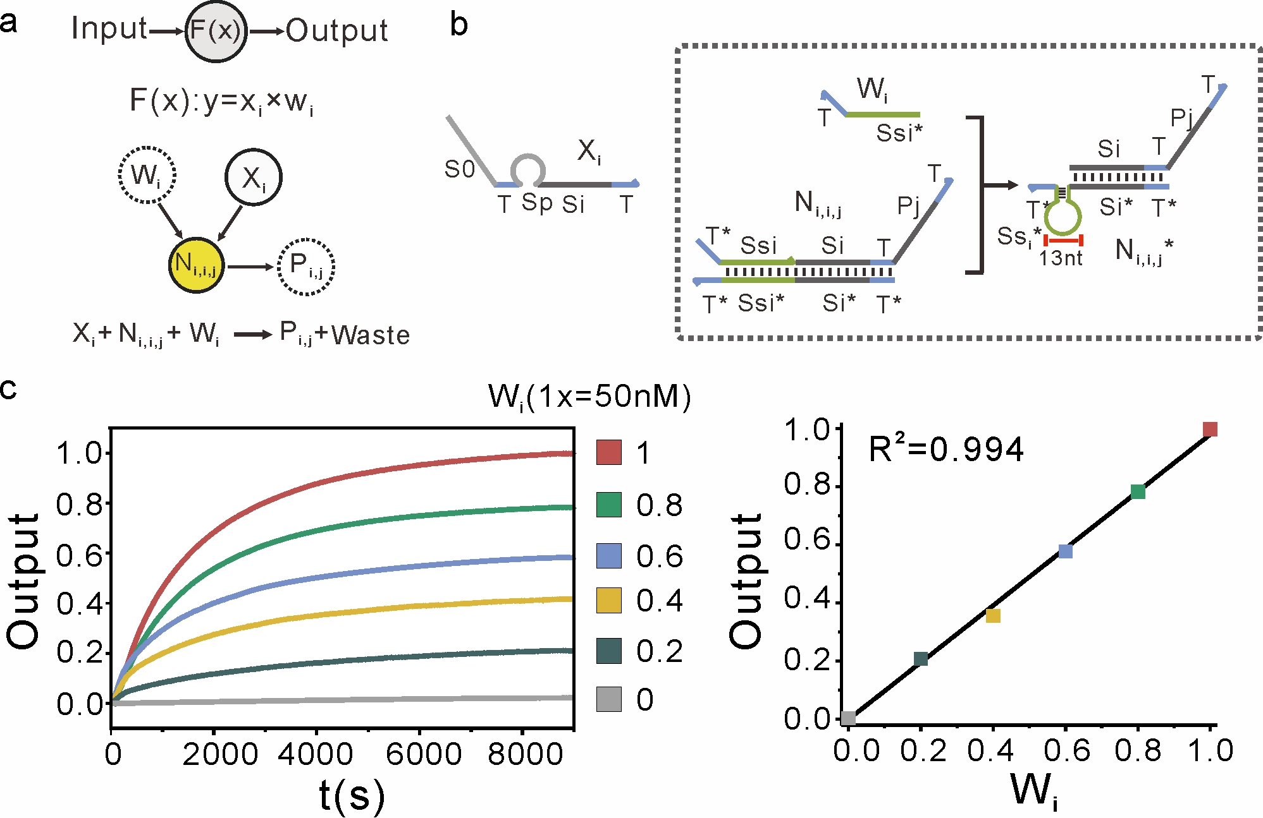
Supplementary Fig. 6| The DNA implementation of weight multiplication. a, The abstract schematic of the weight multiplication. b, The DNA implementation of weight multiplication, with 13-nucleotide loop domain and 6-nucleotide toehold domain. c, Fluorescence kinetics data (left) and the steady state fluorescence response (right) of the weight multiplication. The concentration of weight substrate molecule N_{i,i,j} and input X_{i} are 2×, and the concentration of the reporter Rep_{j} is 2×. The standard concentration is 50 nM (1× = 50 nM).

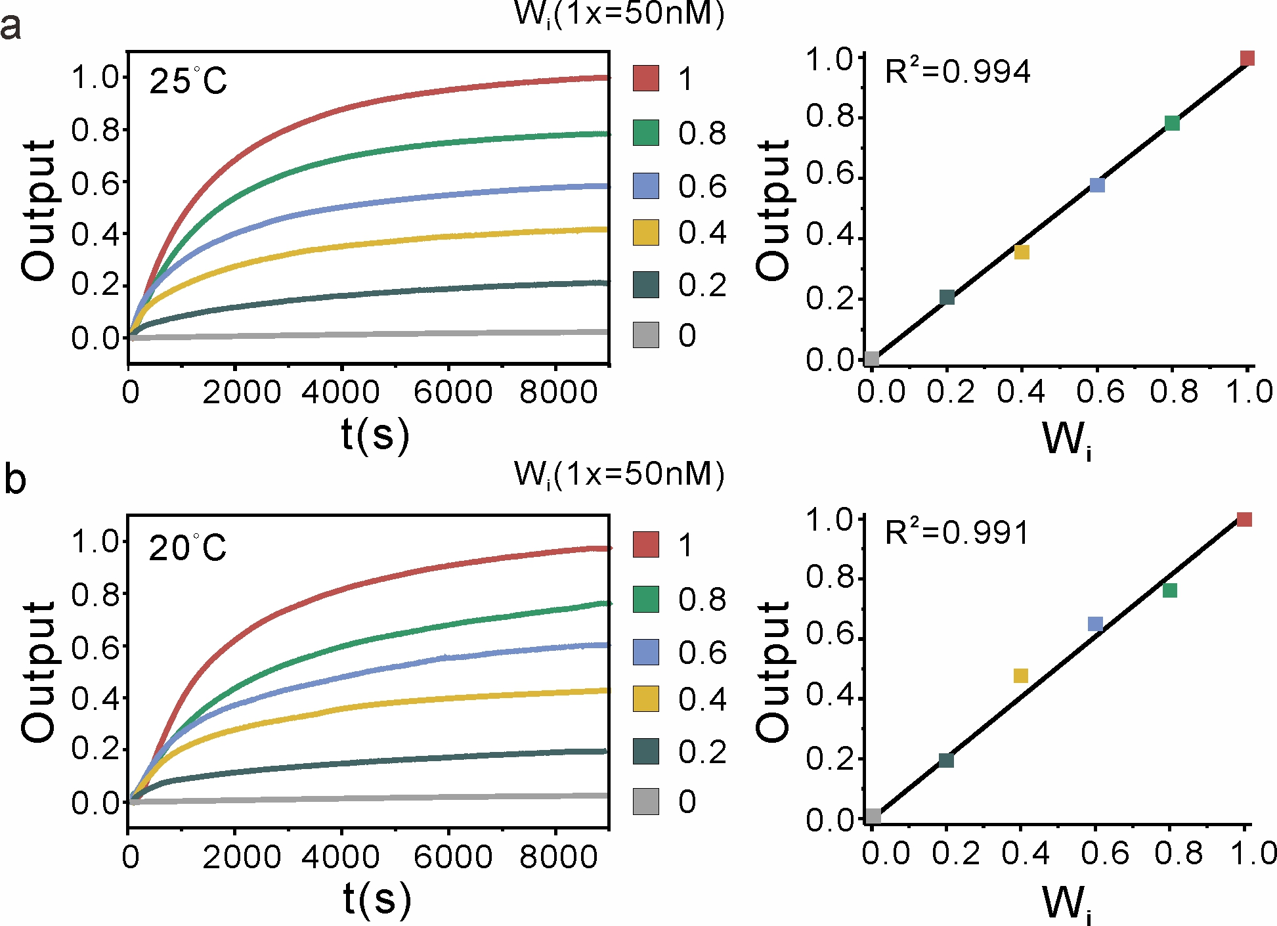
Supplementary Fig. 7| Kinetics experiments of reaction temperature (a) 25 ℃ and (b) 20 ℃ on the operation of the weight multiplication shown in Supplementary Fig. 6a. Fluorescence kinetics data (left) and the steady state fluorescence response (right) of the weight multiplication. The concentration of weight substrate molecule N_{i,i,j} and input X_{i} are 2×, and the concentration of the reporter Rep_{j} is 2×. The standard concentration is 50 nM (1× = 50 nM).
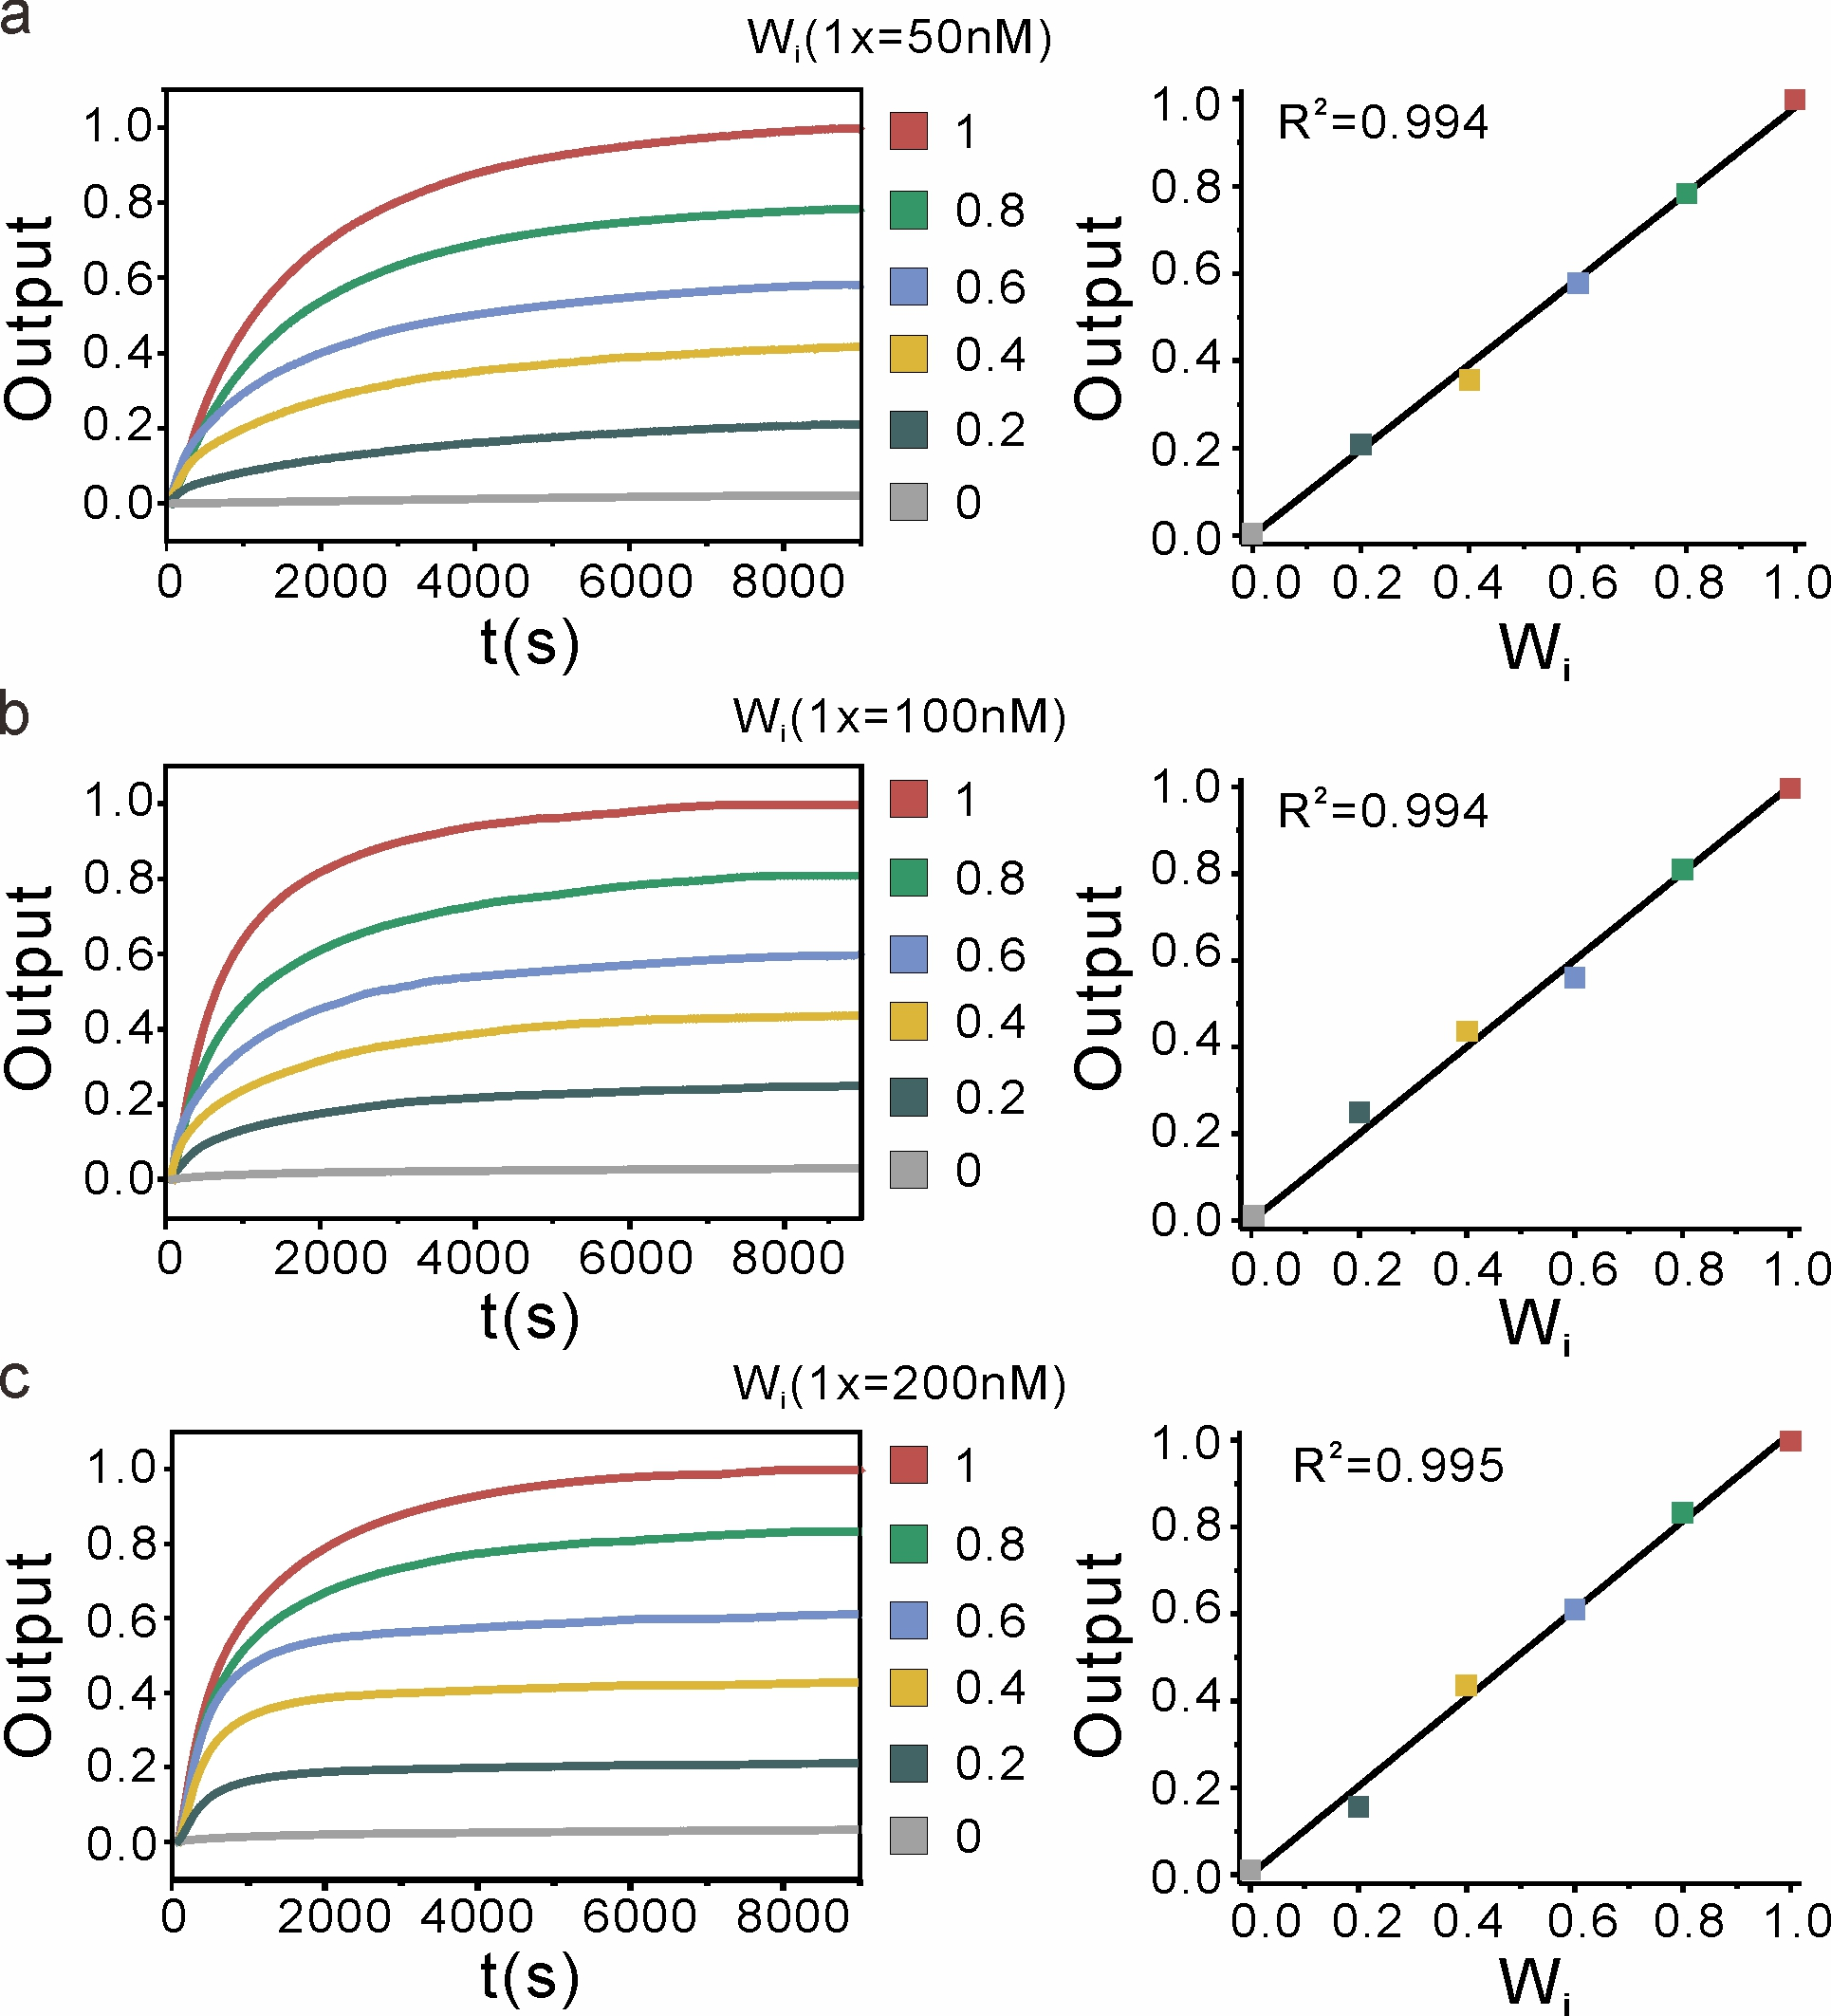
Supplementary Fig. 8| Kinetics experiments of different concentrations on the operation of the weight multiplication shown in Supplementary Fig. 6a. (a-c) Fluorescence kinetics data (left) and the steady state fluorescence response (right) of the weight multiplication. The concentration of weight substrate molecule N_{i,i,j} and input X_{i} are 2×, and the concentration of the reporter Rep_{j} is 2×.

S3. Independent molecular weight multiplication systems
For scaling up to large circuits, independent molecular weight multiplication systems must have negligible crosstalk. Two independent weight multiplication systems (y₁=w₁ × x₁ and y₂=w₂ × x₂) were designed and tested in the same solution (Supplementary Fig. 9a). The values of two weights w₁ and w₂ are determined by concentrations of two different weight tunning molecules W_{i} (Supplementary Fig. 9b). Two distinct fluorescent reporters (FAM and ROX) were used to report corresponding outputs (y₁ and y₂). As shown in Supplementary Fig. 9c, two fluorescence steady-state signals (y₁ and y₂) are linearly proportional to the concentration of W_{i} (W₁ and W₂). These results suggest that each appliance functions modularly, not aﬀecting or being aﬀected by the function of others.

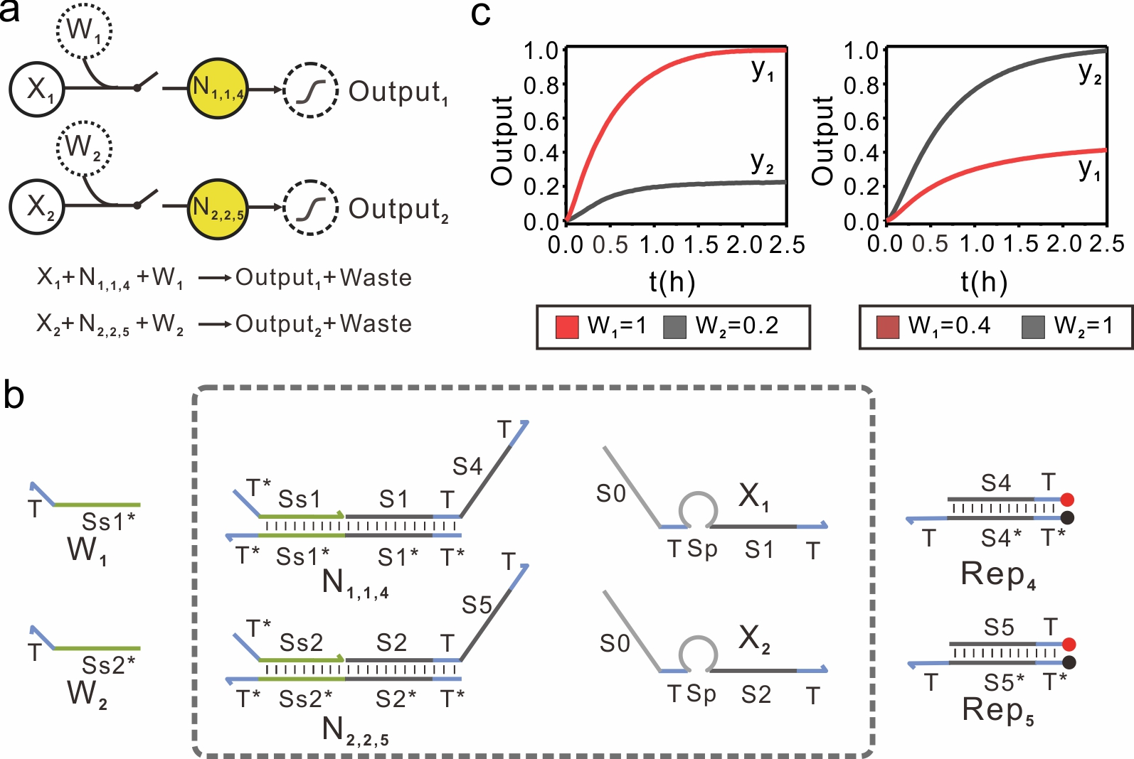
Supplementary Fig. 9| Two independent weight multiplication systems. a, The abstract schematic of two independent weight multiplication systems. b, The DNA implementation of two independent weight multiplication systems. c, Fluorescence kinetics data of two independent weight multiplication systems with different concentrations of W₁ and W₂. Concentrations of weight substrate molecules N_{i,i,j} and inputs X_{i} are 2×, and concentrations of reporters Rep_{j} is 2×. The standard concentration is 50 nM (1× = 50 nM).

Given that the sequence of weight tuning domains is independently designed and correlated with the assignment of weights, independent weight multiplication systems can thus be built with different weight tuning domain sequences design. As shown in Supplementary Fig. 10a, two independent weight multiplication systems that can interact with the same input X₁ were designed and tested in the same solution. The values of two weights w₁ and w₂ are determined by two different weight tunning molecules W_{i} (Supplementary Fig. 10b). As shown in Supplementary Fig. 10c, two fluorescence steady-state signals (y₁ and y₂) were found to be linearly proportional to the concentration of W_{i} (W₁ and W₂). Collectively, these results suggest that the assignment of weights is only associated with the weight tuning domain sequences, wherein different assigned weights can be realized by simply changing sequences of the weight tuning domain.

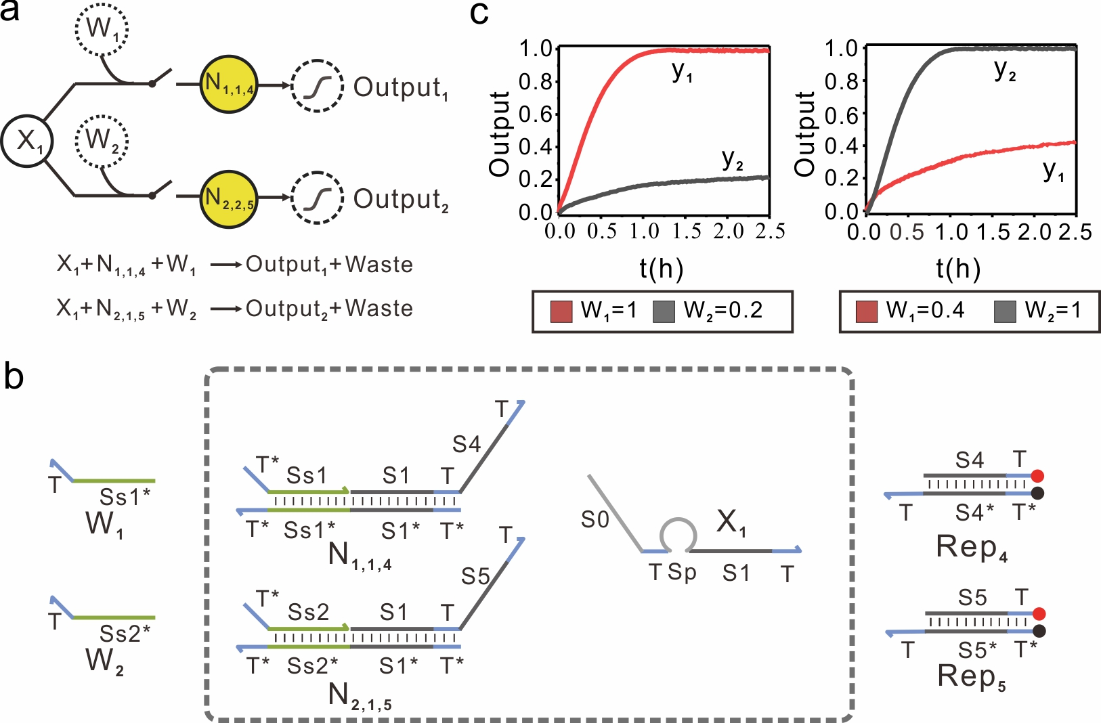
Supplementary Fig. 10| Two independent weight multiplication systems. a, The abstract schematic of two independent weight multiplication systems. b, The DNA implementation of two independent weight multiplication systems. c, Fluorescence kinetics data of two independent weight multiplication systems with different concentrations of weight tunning molecules W₁ and W₂. Concentrations of weight substrate molecules N_{i,i,j} and input X_{i} are 2×, and concentrations of reporters Rep_{j} is 2×. The standard concentration is 50 nM (1× = 50 nM).

S4. The DNA implementation of multiply-accumulate operation
We combined a weight multiplication layer and summation layer into the circuit, which can achieve the DNA implementation of a simple multiply-accumulate (MAC) computation. First, we can implement the two-species MAC operation (y=w₁ × x₁ + w₂ × x₂) at the molecular level (Supplementary Fig. 11a). This is achieved by adding a summation species Rep₄ that can react with the intermediate species P_{i,j} resulted from the weight multiplication (Supplementary Fig. 11b). Two different weight tunning molecules W_{i} with different sequences of weight tuning domains were designed to set the value of weights. As expected, the fluorescence steady-state signal of output y is linearly proportional to concentrations of W₁ and W₂, demonstrating the effective molecular implementation of two-species MAC operation (Supplementary Fig. 11c, d).
Furthermore, more complex MAC operation y=w₁ × x₁ + w₂ × x₂ + w₃ × x₃ can be implemented at a molecular level (Supplementary Fig. 12a). Three different weight tunning molecules W_{i} with different sequences of weight tuning domains were used to set the value of weights, while the same output sequence of the intermediate species P_{i,j} was designed to sum up weighted inputs (Supplementary Fig. 12b). As shown in Supplementary Fig. 12c, the output signal y was proportional to the weight assigned to each input, suggesting that the circuit was performed correctly. Taking these results together, we believe this summation operation can accurately determine the weighted sums from the same neuron.
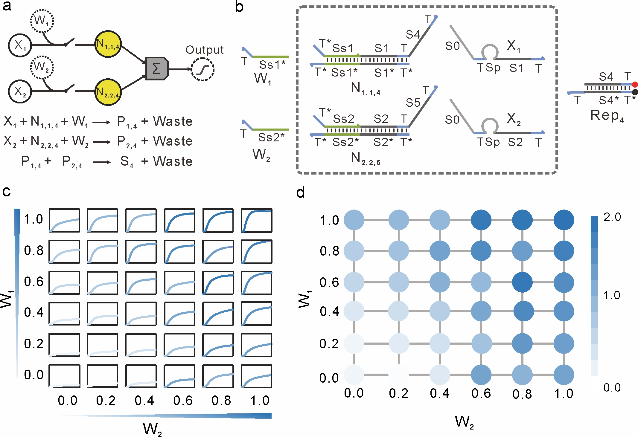
Supplementary Fig. 11| The DNA implementation of a two-species MAC operation. a, The abstract schematic of the MAC operation. b, The DNA implementation of two-species MAC operation. c, Fluorescence kinetics data of two-species MAC operation with different concentrations of weight tunning molecules W₁ and W₂. d, The steady fluorescence response of output y at 2.5 h with different concentrations of weight tunning molecules W₁ and W₂. Concentrations of weight substrate molecules N_{i,i,j} and inputs X_{i} are 2×, and concentration of the reporter Rep_{j} is 4×. The standard concentration is 50 nM (1× = 50 nM).

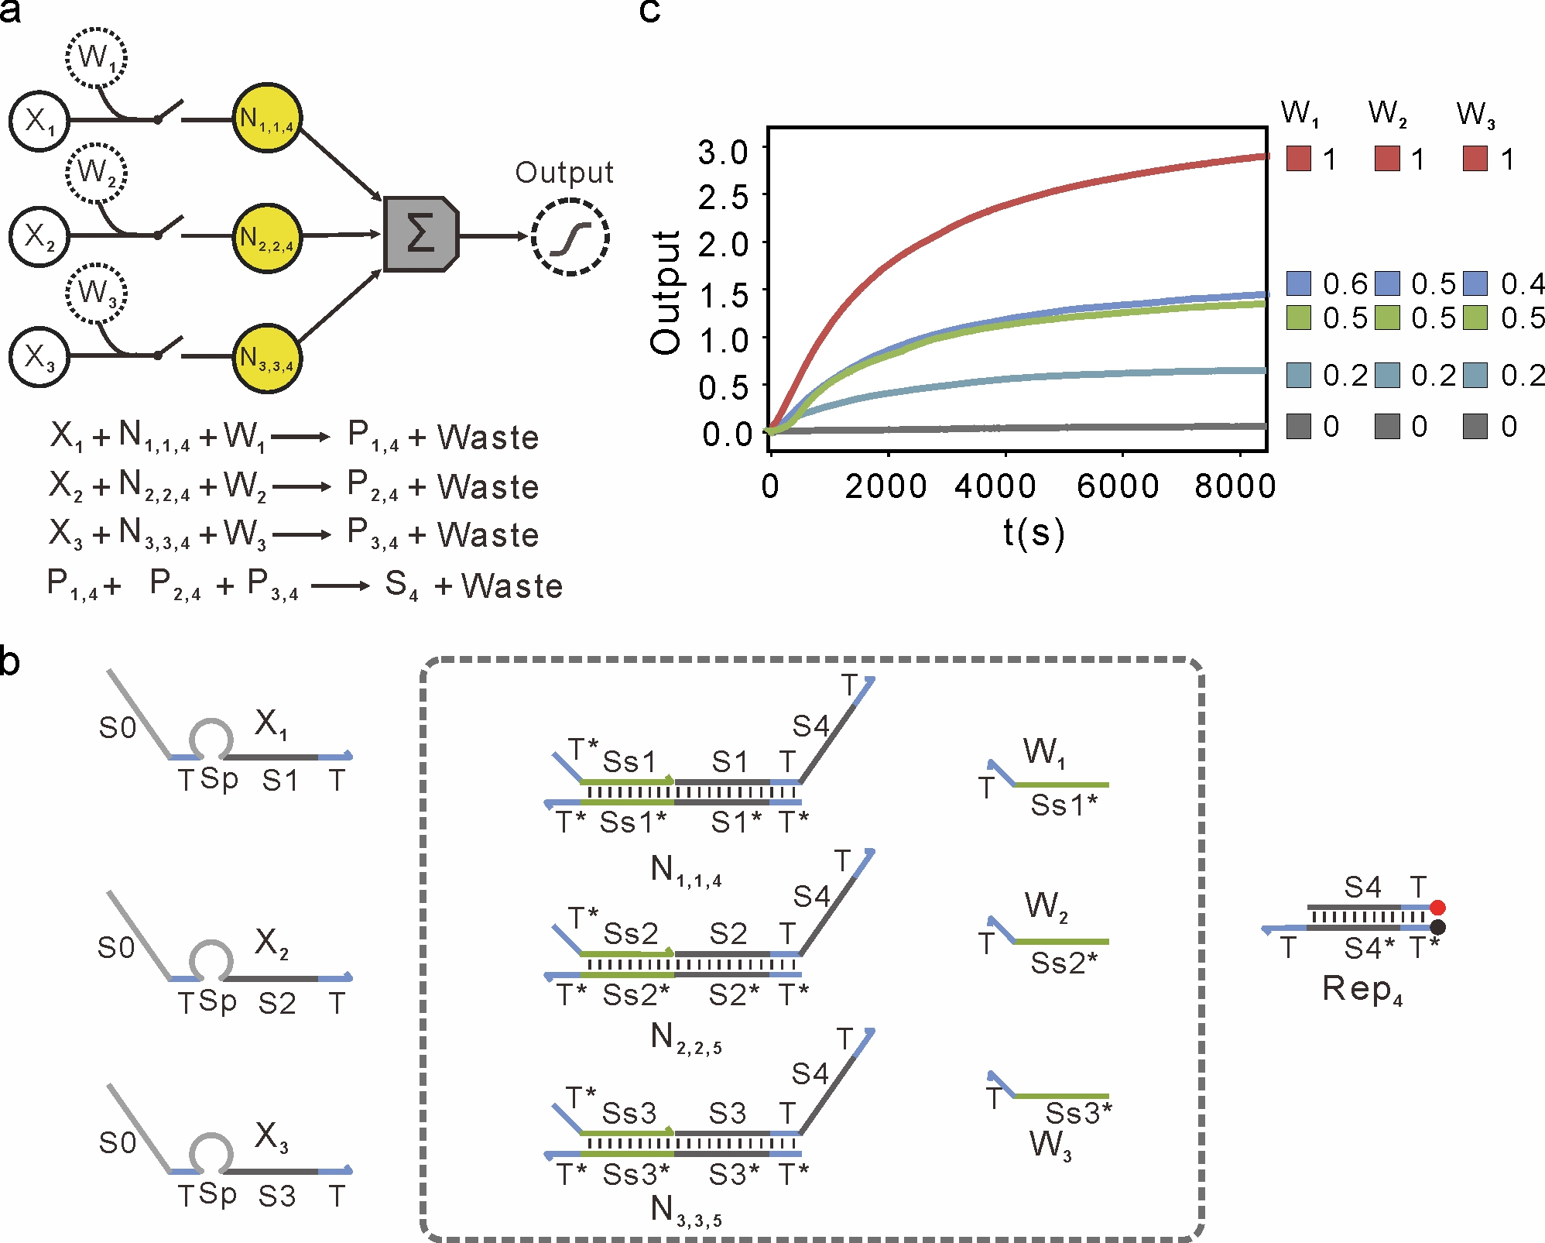
Supplementary Fig. 12| The DNA implementation of three-species MAC operation. a, The abstract schematic of three-species MAC operation. b, The DNA implementation of three-species MAC operation. c, Fluorescence kinetics data of three-species MAC operation with different concentrations of weight tunning molecules W₁, W₂ and W₃. Concentrations of weight substrate molecules N_{i,i,j} and inputs X_{i} are 2×, and concentration of the reporter Rep_{j} is 6×. The standard concentration is 50 nM (1× = 50 nM).

S5. A DNA-based ConvNet for one of two rotated molecular patterns recognition
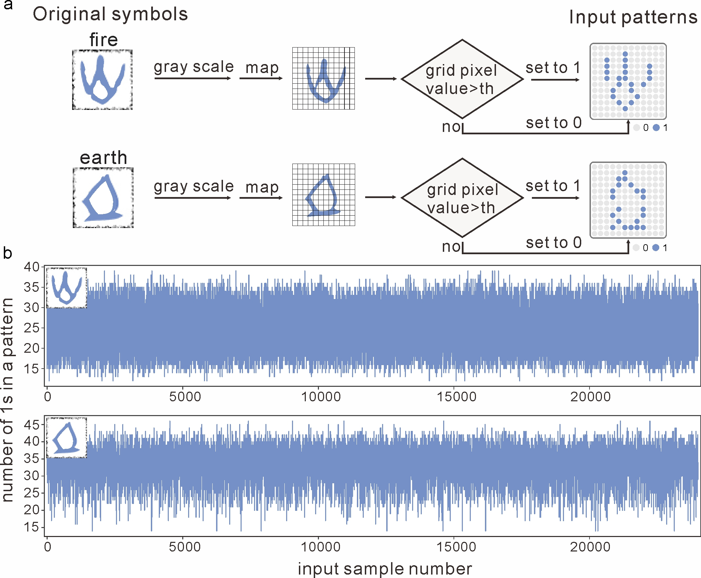
Supplementary Fig. 13| Determination of two input patterns. a, The symbols were rescaled to a 12×12 grid. The bits whose grid pixel value were larger than a threshold was set to 1, while the remaining bits were set to 0. Then binary input patterns of ‘fire’ and ‘earth’ were obtained. b, The number of 1s in each input pattern. The number of 1s in the ‘fire’ input pattern is mostly between 15 and 35, while the number of 1s in the ‘earth’ input pattern is mostly between 25 and 40.

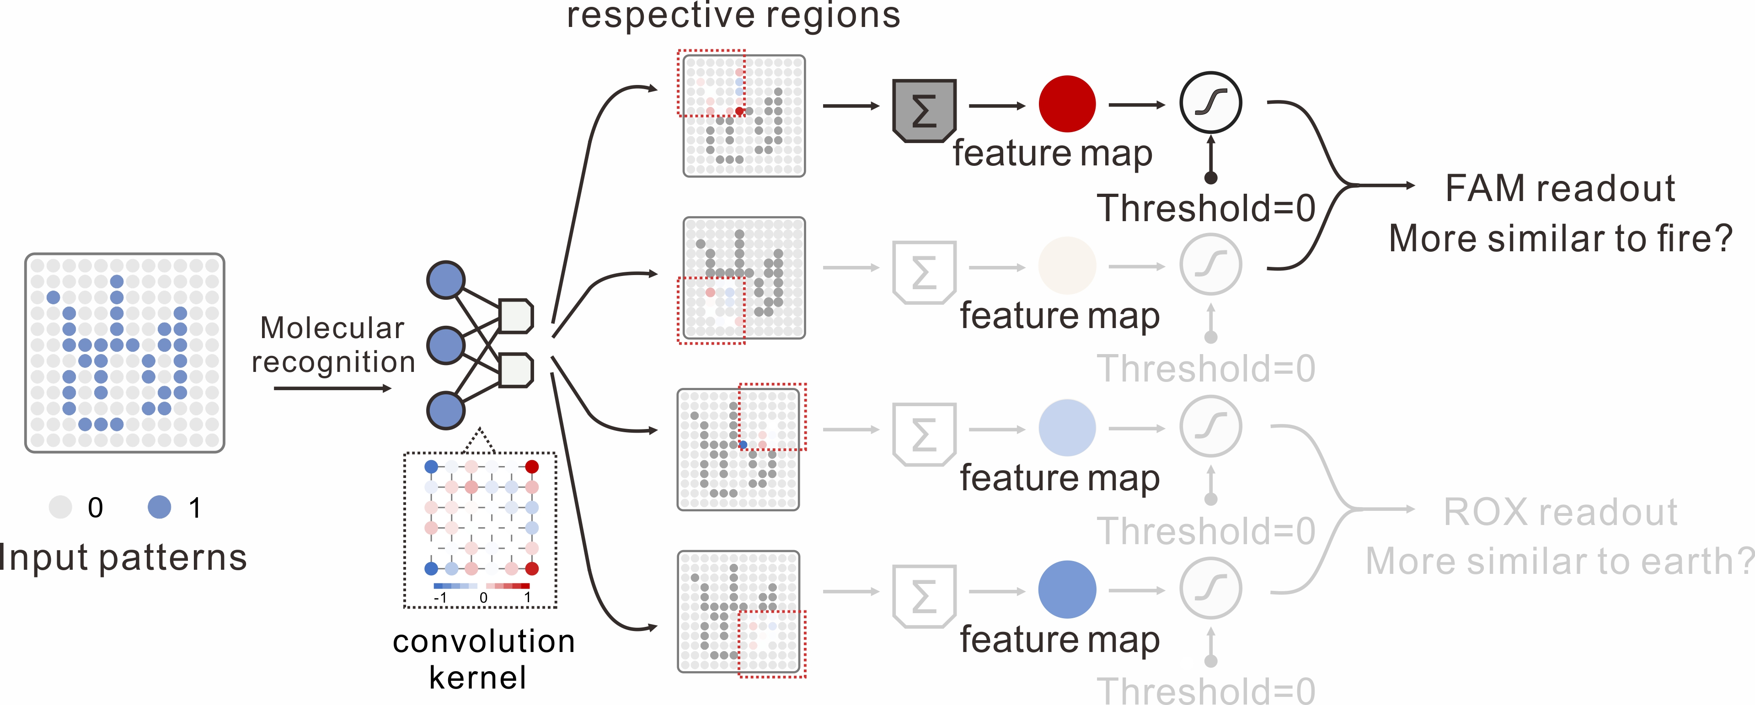
Supplementary Fig. 14| The recognition process of oracle ‘fire’ with the DNA-based ConvNet. Each receptive region of a ‘fire’ can interact with same kernel function to export feature maps through a set of reactions. Then, max-pooling process can reduce feature map size by annihilating the smaller one between two pixels through cooperative hybridization (Supplementary Fig. 15b). Finally, reporting gate is used to output signals by comparing with a threshold (the threshold value here is set to zero). A fluorescent channel of FAM was associated with ‘fire’, while a fluorescent channel of ROX was associated with ‘earth’.

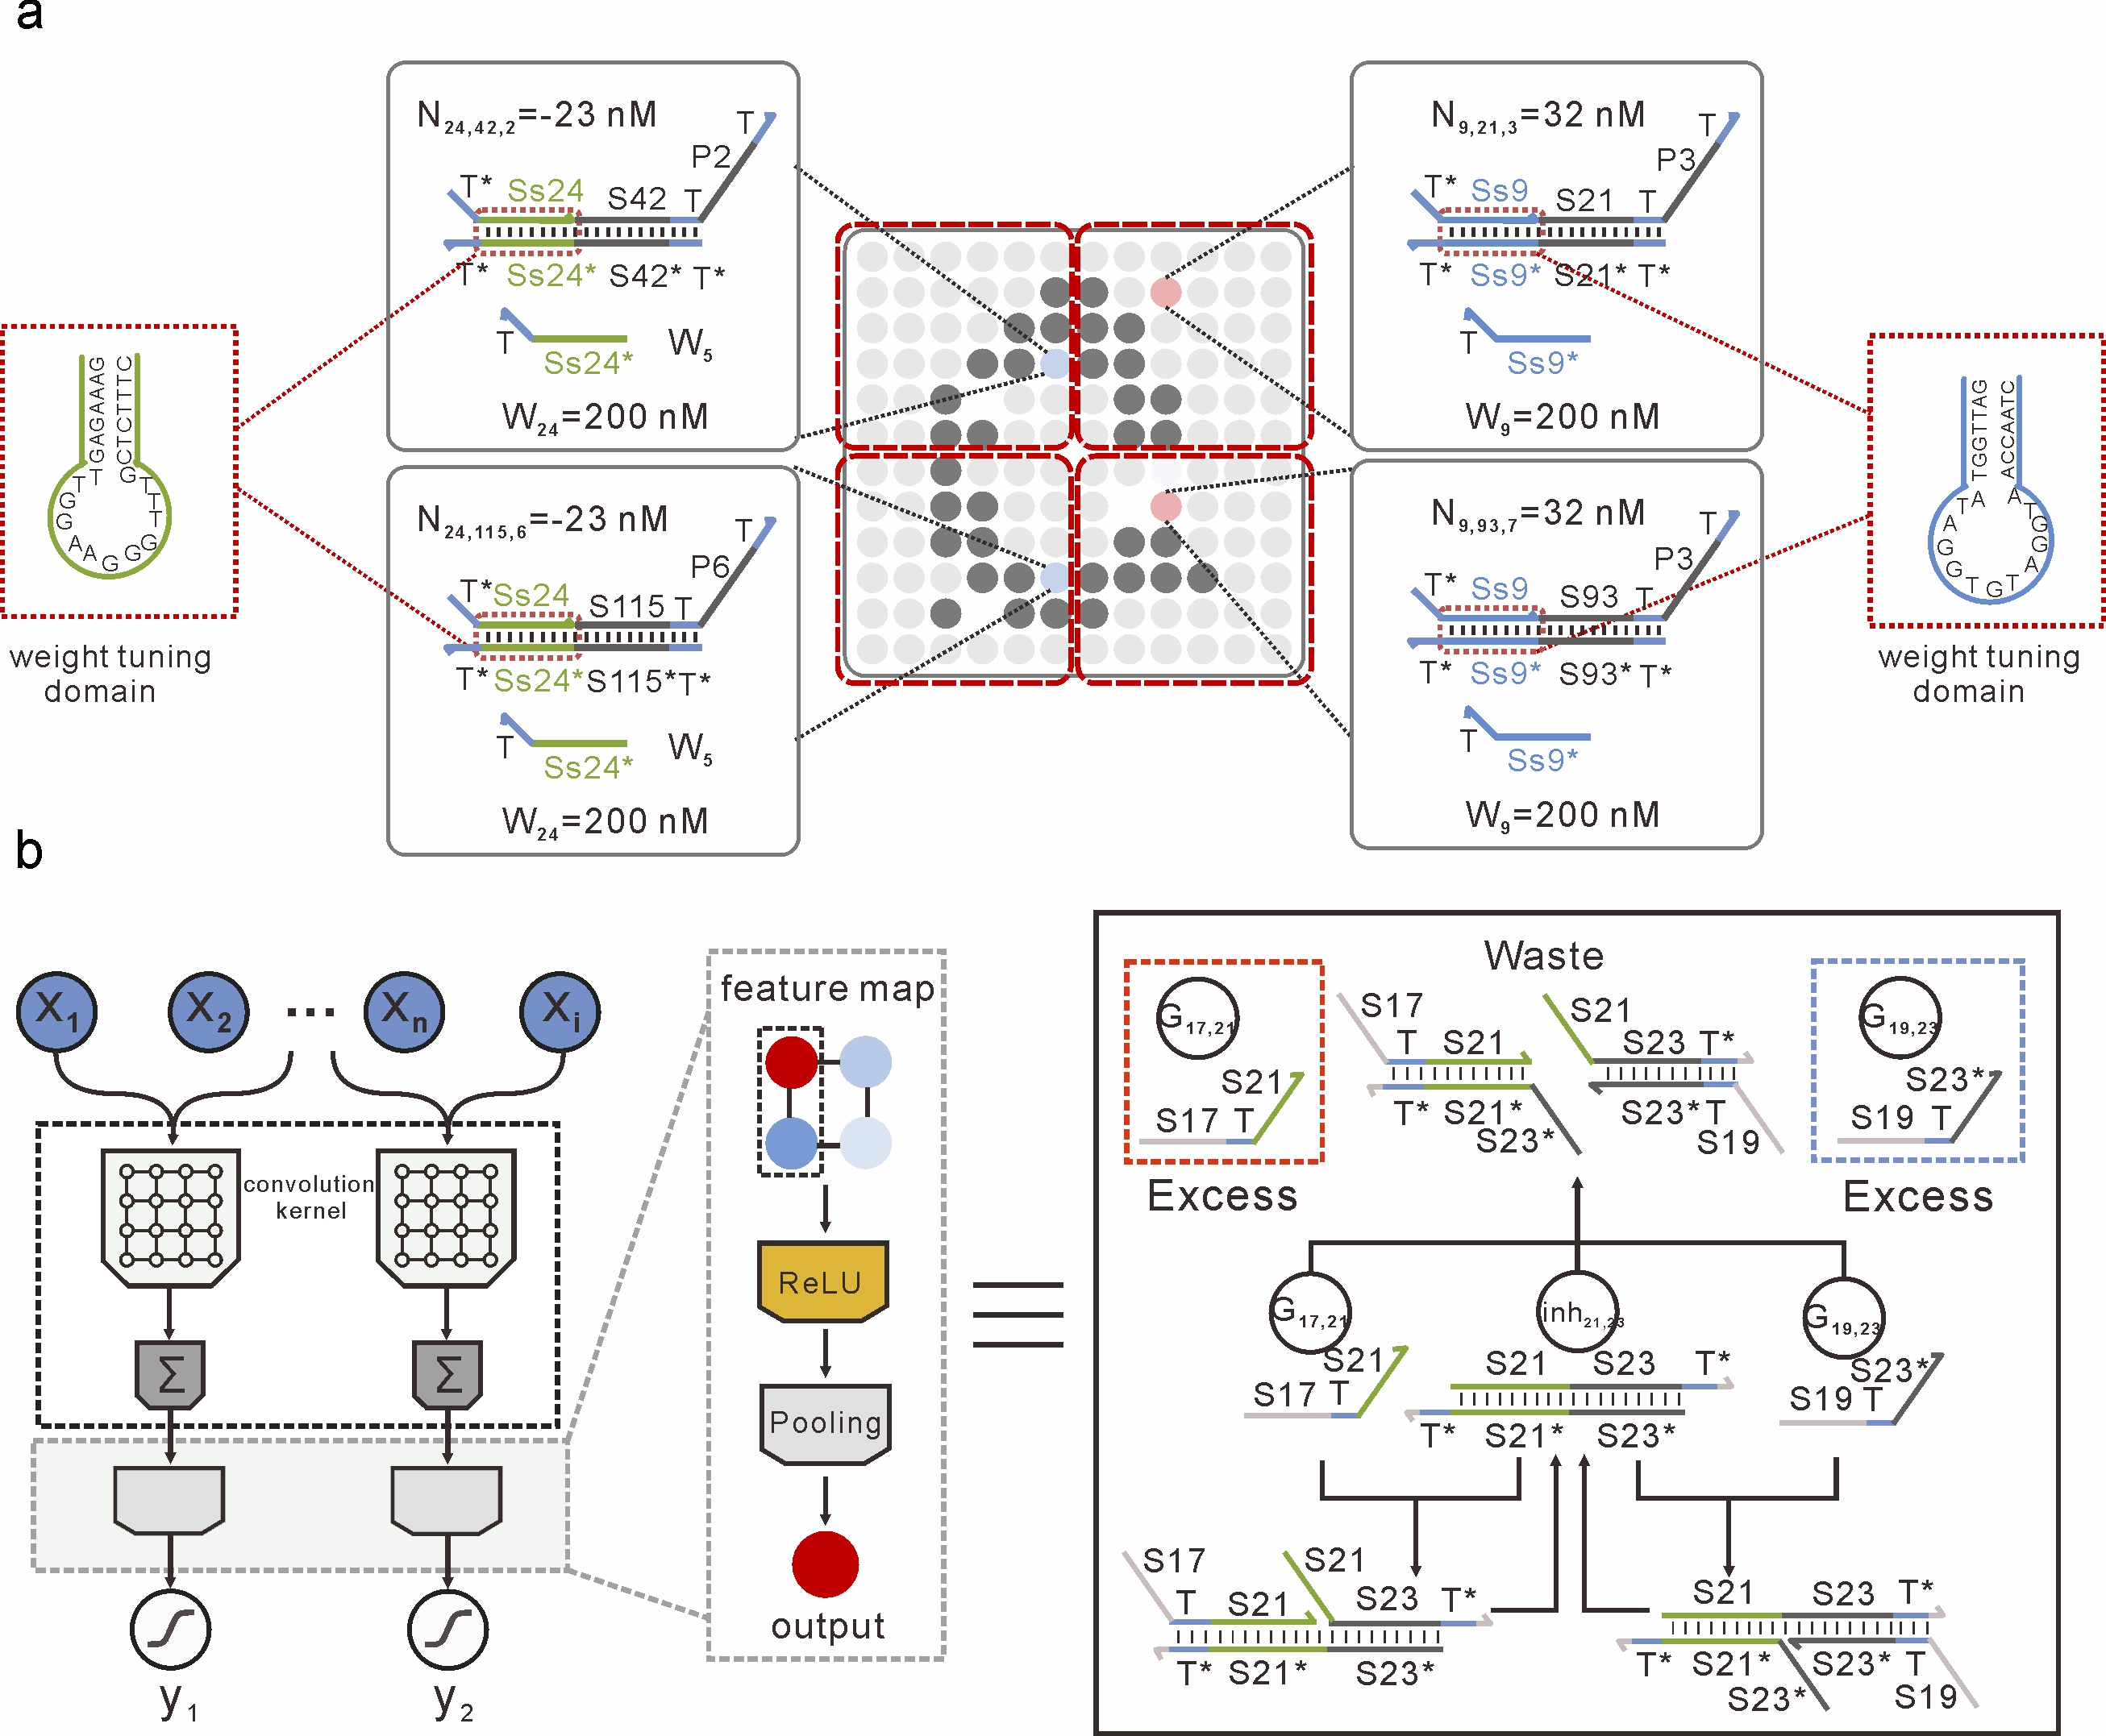
Supplementary Fig. 15| a, The shared convolution kernel reacts with each receptive region to implement the weight multiplication. The value of each pixel in each receptive region was used to determine concentrations of each weight substrate molecules. For example, -23 nM for the 24th pixel and 32 nM for the 9th pixel. Different weight substrate molecules have distinct weight tuning domains (for example, N_{24,42,2} and N_{9,21,3}). Because of the shared convolution kernel, the sequence of weight tuning domains (green region) of weight species is the same for each pixel that interacts with the same kernel function in different receptive regions (for example, N_{24,42,2} and N_{24,115,6}). b, The pooling layer reduces feature map size by taking the maximum value from a few contiguous pixels. Here, we used pooling computing to help identify which memory the pattern is the most similar—using the overall statistical characteristics of the adjacent output of a location to replace the output of the network at that location (pooling size 2×1, stride = 1). To realize the pooling computation, the two contiguous pixels—represented by concentrations of two distinct nucleic acids sequences—need to be compared to determine which is the largest. Note that the ‘annihilator’ gate in pooling layer was built based on the cooperative hybridization mechanism introduced by Qian².

One desirable feature of the molecular weight multiplication is switching function, which in theory can improve the interference robustness of the DNA molecular network. This allows DNA circuits to be able to switch a specific reaction pathway in the convolution layer when exposed to a specific pattern. A quantitative model has been proposed to verify the interference robustness of DNA reaction network (Supplementary Fig. 16). It assumes crosstalk is unavoidable, that is, non-specific displacement may occur when two different domains hybridize to their respective complements in the DNA reaction network (the reaction rate constant for single strand and non-target complex is K_{d}, and set as 2×10³).
In the quantitative model, we gradually scale up the network by cascading the weight multiplication in parallel and in series (Supplementary Fig. 16a, b). As shown in Supplementary Fig. 16b, the reaction rate constant for single strand and non-target complex is K_{d} and K_{l} for networks that were all activated and partially activated, respectively. For partial activation, weight substrate molecule N_{i,i,j} is inactivated, resulting in only zero-toehold strand displacements with the non-specifically target domains. Two networks were simulated in Visual DSD³, in which the embedded stochastic simulator yields the concentration trajectories of two outputs, using corresponding rate constants K_{m}, K_{d} and K_{l}. As shown in Supplementary Fig. 16c, we found that the signal loss of circuits is only about 20% when the cascading layer is 5 (i=5, n=5) with partial activated reaction pathway. However, the signal loss of circuit is up to 54% when the cascading layer is 5 (i=5, n=5) with all activated reaction pathway. These results revealed that activating a specific set of wires in the reaction network could yield a better anti-interference behavior.
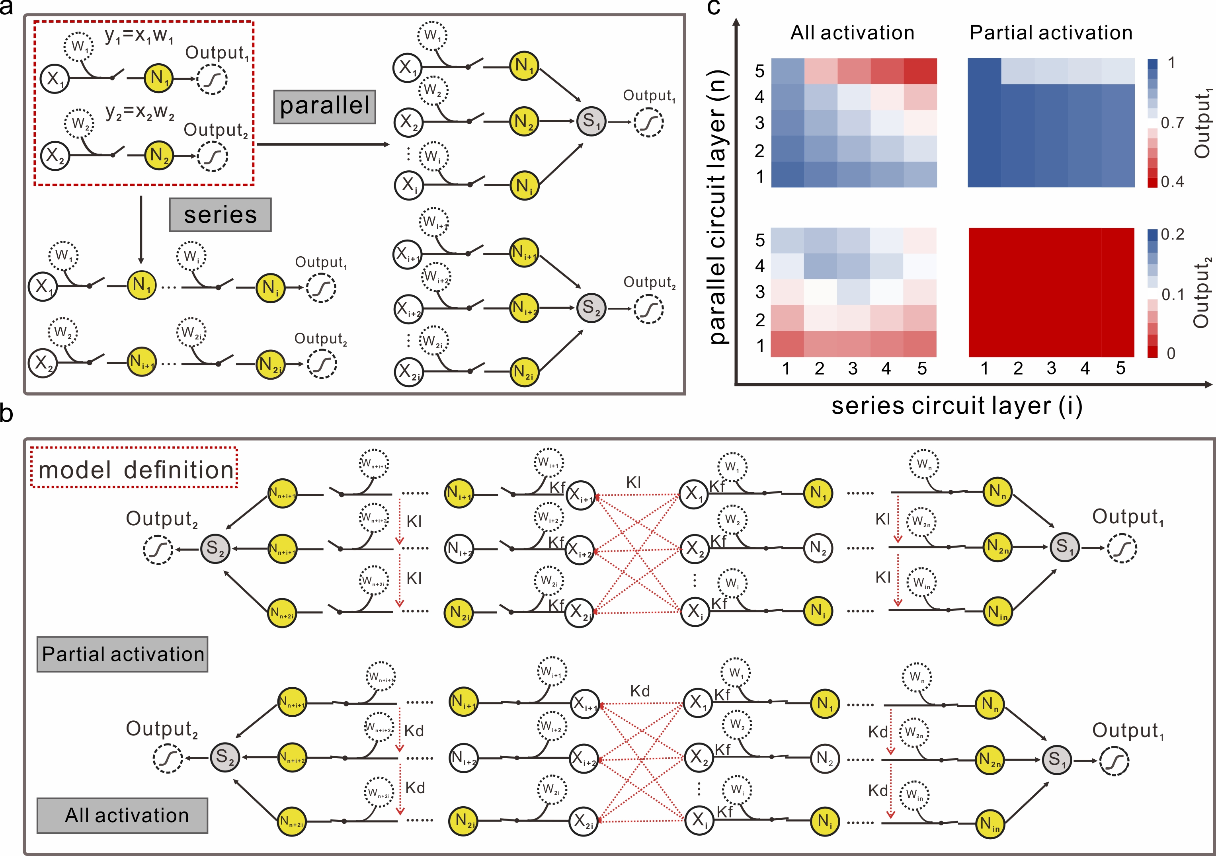
Supplementary Fig. 16| A quantitative model has been proposed to verify the interference robustness by Visual DSD. a, The network can be scaled up by cascading the weight multiplication in parallel and in series. b, The model definition. The desired reaction rate between the target domains K_{m}=1.5×10⁵ M⁻¹s⁻¹, the reaction rate between non-target strands K_{d} = 2×10³ M⁻¹s⁻¹, and the reaction rate of zero-toehold strand displacement K_{l}=1 M⁻¹s⁻¹. c, The standard signals of two outputs with increasing circuit layers. Two networks were simulated in Visual DSD, the embedded stochastic simulator plots the concentration trajectories of two outputs, using corresponding rate constants K_{m}, K_{d} and K_{l}.

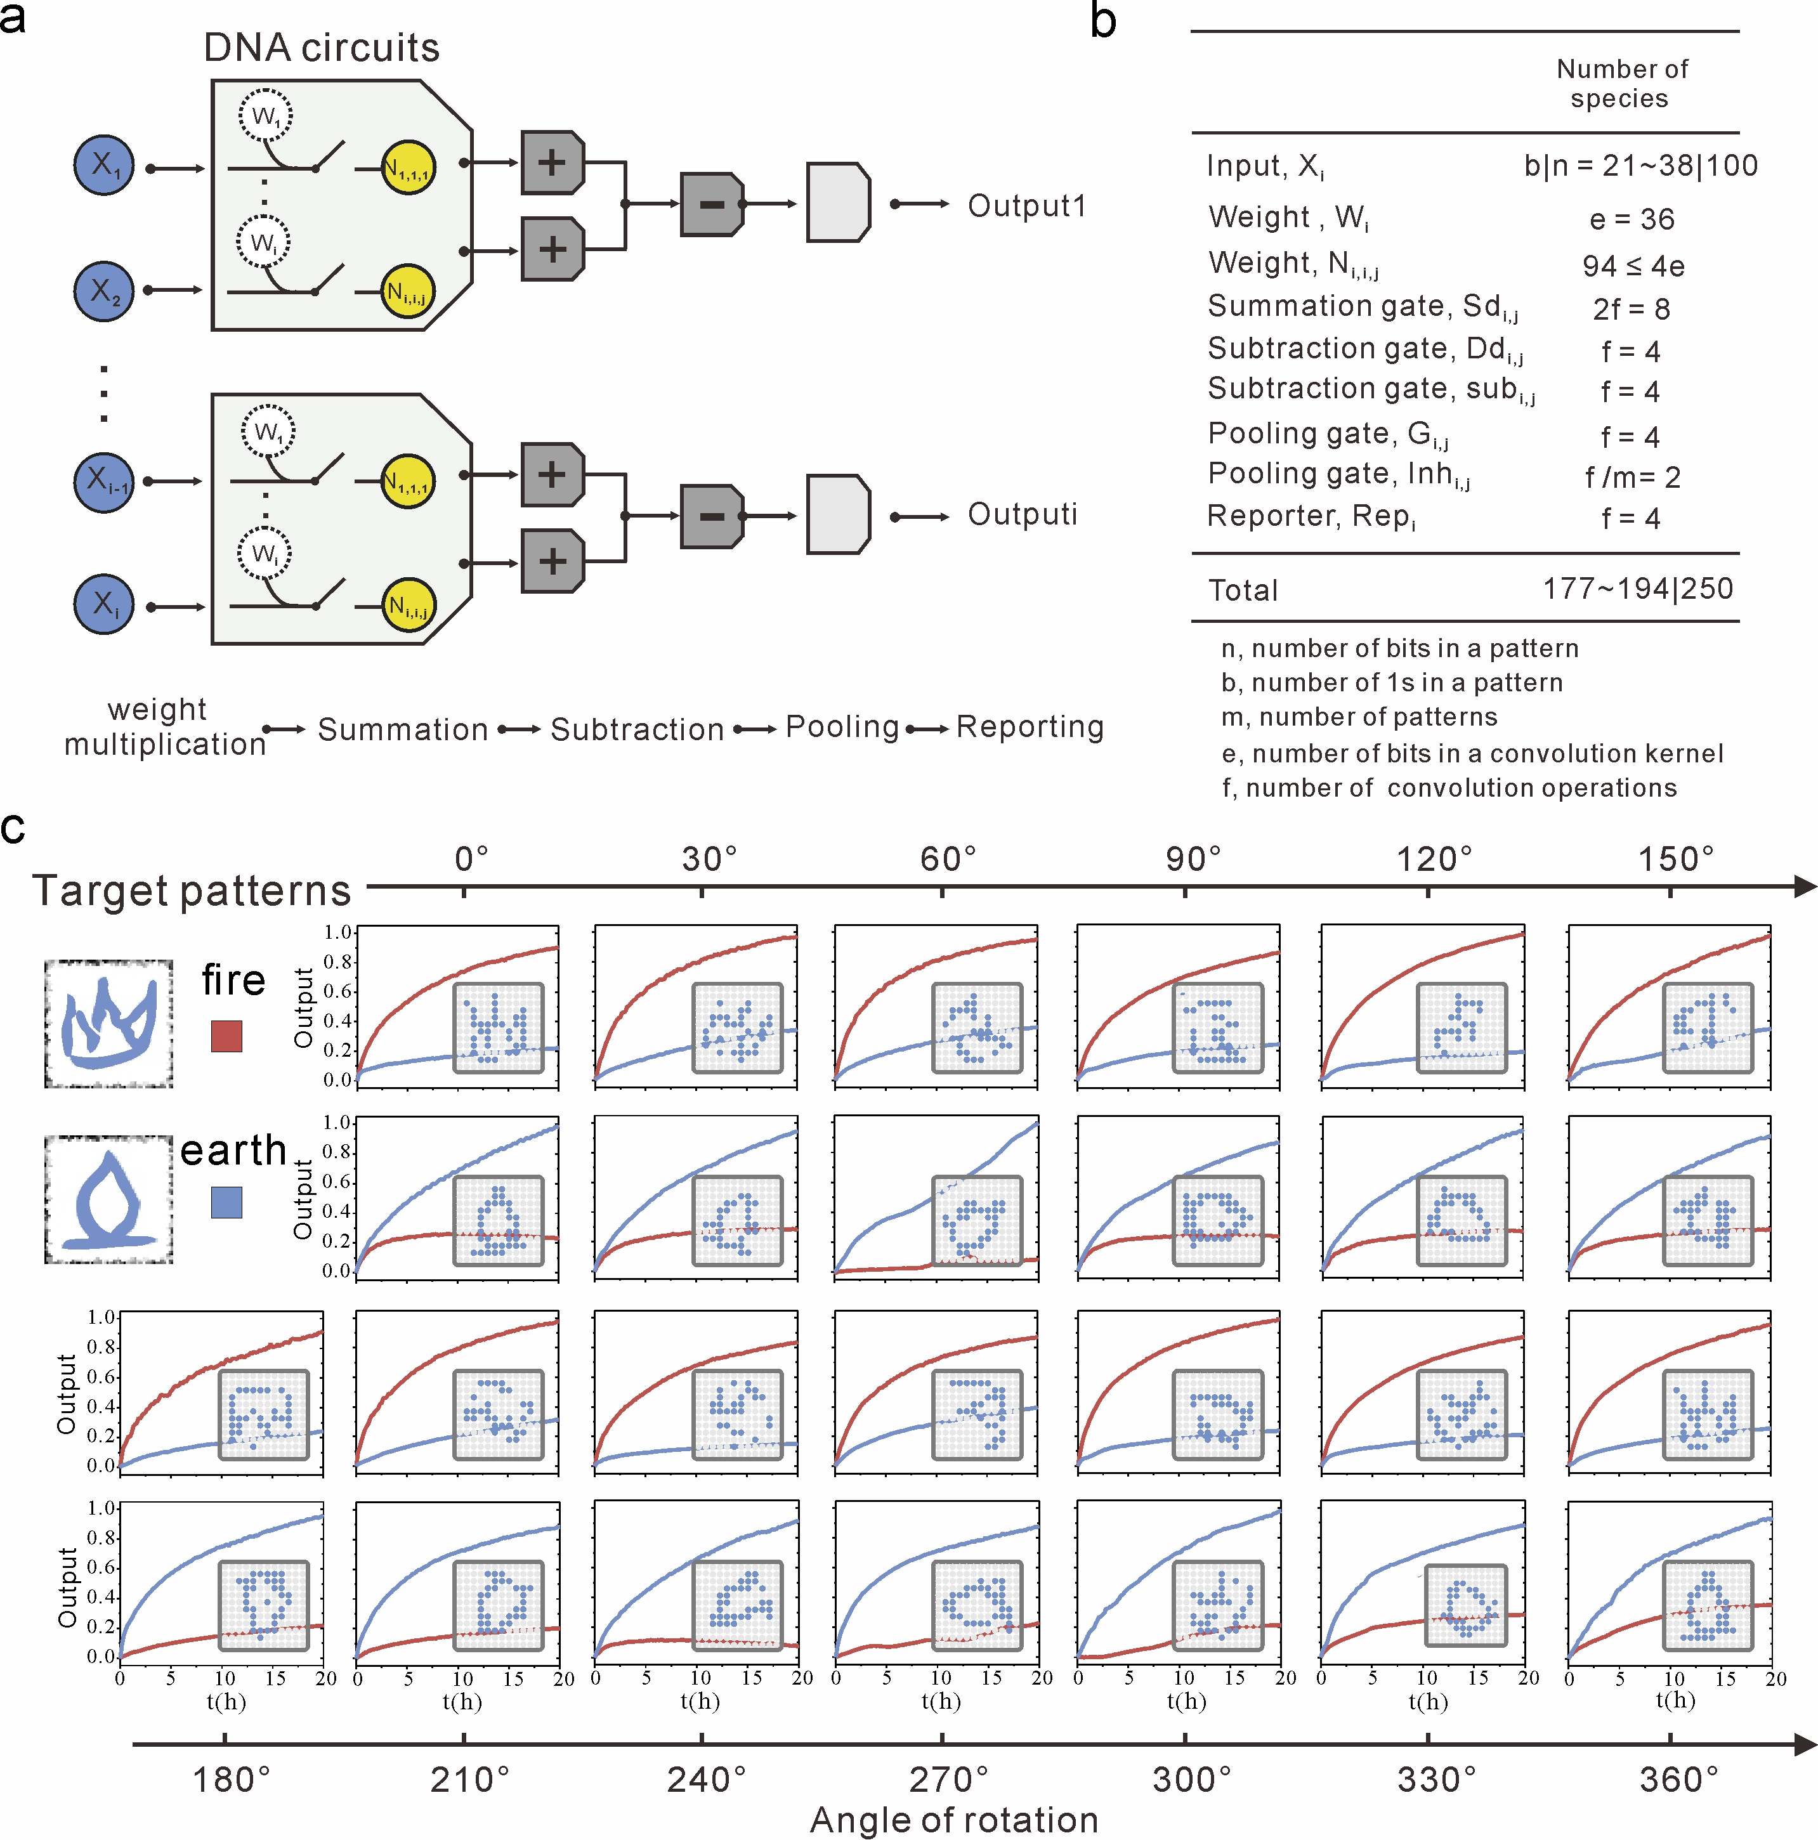
Supplementary Fig. 17| A DNA-based ConvNet for molecular patterns recognition. a, Circuit diagram of the DNA-based ConvNet for patterns recognition. b, The number of distinct species in the circuit. The bottom row lists the number of species for a specific number of inputs (left) and for all possible inputs (right). c, Fluorescence kinetic experiments to characterize the recognition behavior of ‘fire’ (red curves) and ‘earth’ (blue curves) with rotation angle from 0° to 360° with the DNA-based ConvNet.

S6. A DNA-based ConvNet for one of eight molecular patterns recognition
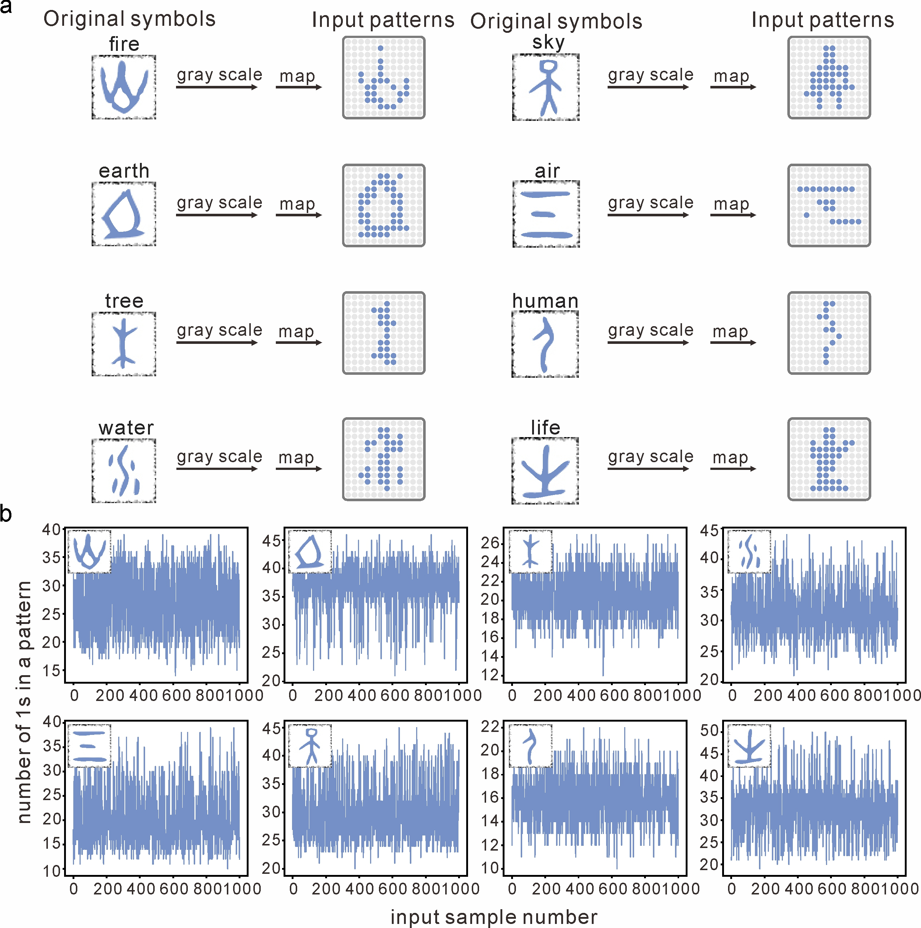
Supplementary Fig. 18| Determination of eight input patterns. a, The symbols were rescaled to a 12×12 grid. The bits whose grid pixel value were larger than a threshold were set to 1, while the remaining bits were set to 0. Then, the binary input patterns of eight oracles were obtained. b, The number of 1s in each input pattern. The number of 1s in the ‘fire’ input pattern is mostly between 20 and 35. The number of 1s in the ‘earth’ input pattern is mostly between 35 and 40. The number of 1s in the ‘tree’ input pattern is mostly between 18 and 23. The number of 1s in the ‘water’ input pattern is mostly between 28 and 35. The number of 1s in the ‘sky’ input pattern is mostly between 15 and 25. The number of 1s in the ‘air’ input pattern is mostly between 25 and 35. The number of 1s in the ‘human’ input pattern is mostly between 14 and 18. The number of 1s in the ‘life’ input pattern is mostly between 25 and 37.
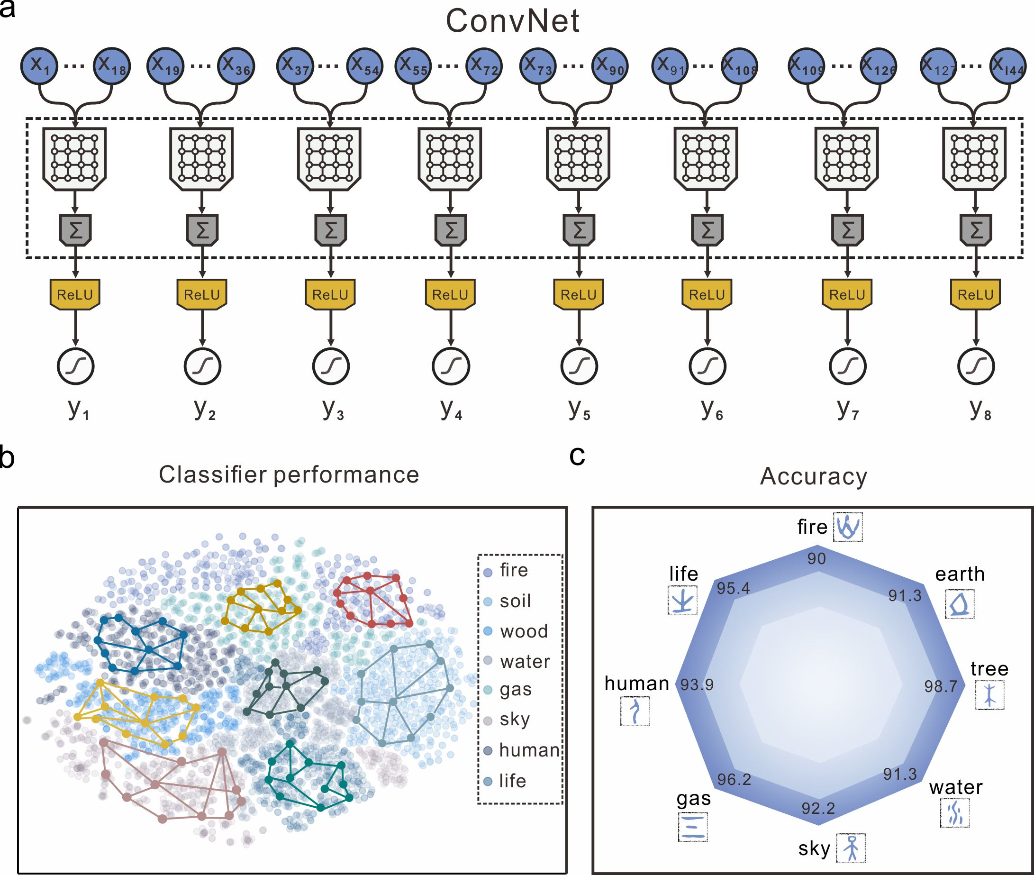
Supplementary Fig. 19| The ConvNet for one of eight molecular patterns recognition. a, Circuit diagram for recognizing eight distinct patterns. b, Performance of the ConvNet in silico for the reference dataset with eight oracles. c, The radar map of the accuracy of the ConvNet. where 90.0%, 91.3%, 98.7%, 91.3%, 92.2%, 96.2%, 93.9%, and 95.4% of ‘fire’, ‘earth’, ‘tree’, ‘water’, ‘sky’, ‘gas’, ‘human’ and ‘life’ were recognized correctly in theory.

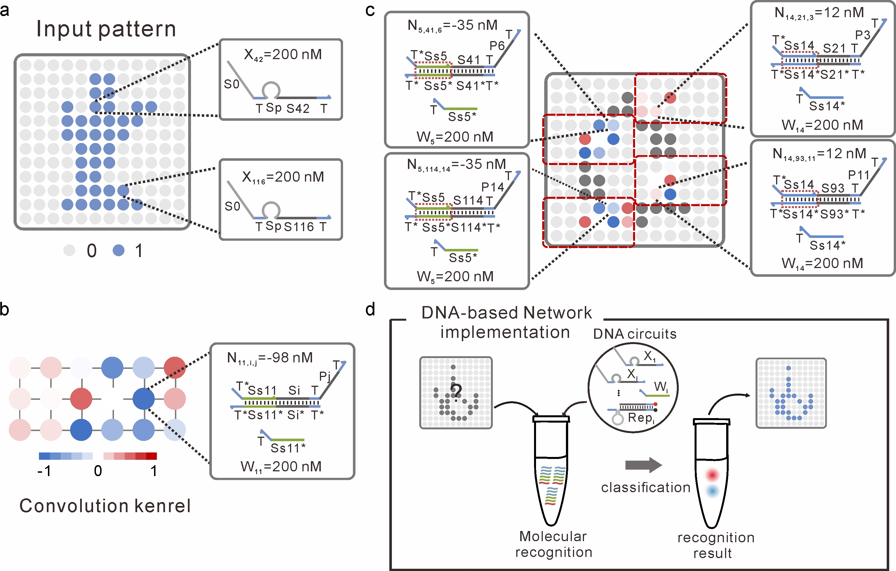
Supplementary Fig. 20| a, Example binary inputs with each 1 and 0 corresponding to the presence and absence of an input strand, respectively. The concentration of each input strand is 200 nM. b, The DNA implementation of the convolution kernel. The concentration of each weight substrate molecule (for example, -98 nM for the 11th pixel) was determined by the weight value of the convolution kernel. c, The shared convolution kernel reacts with each receptive region to implement the weight multiplication. The value of each pixel in each receptive region was used to determine concentrations of each weight substrate molecule. Because of the shared convolution kernel, the sequence of weight tuning domain (green region) of weight species is the same for each pixel that interacts with the same kernel function in different receptive regions. d, Unknow input pattern was added to the solution, upon addition of the DNA circuit, fluorescence signals were readout to report recognition results.

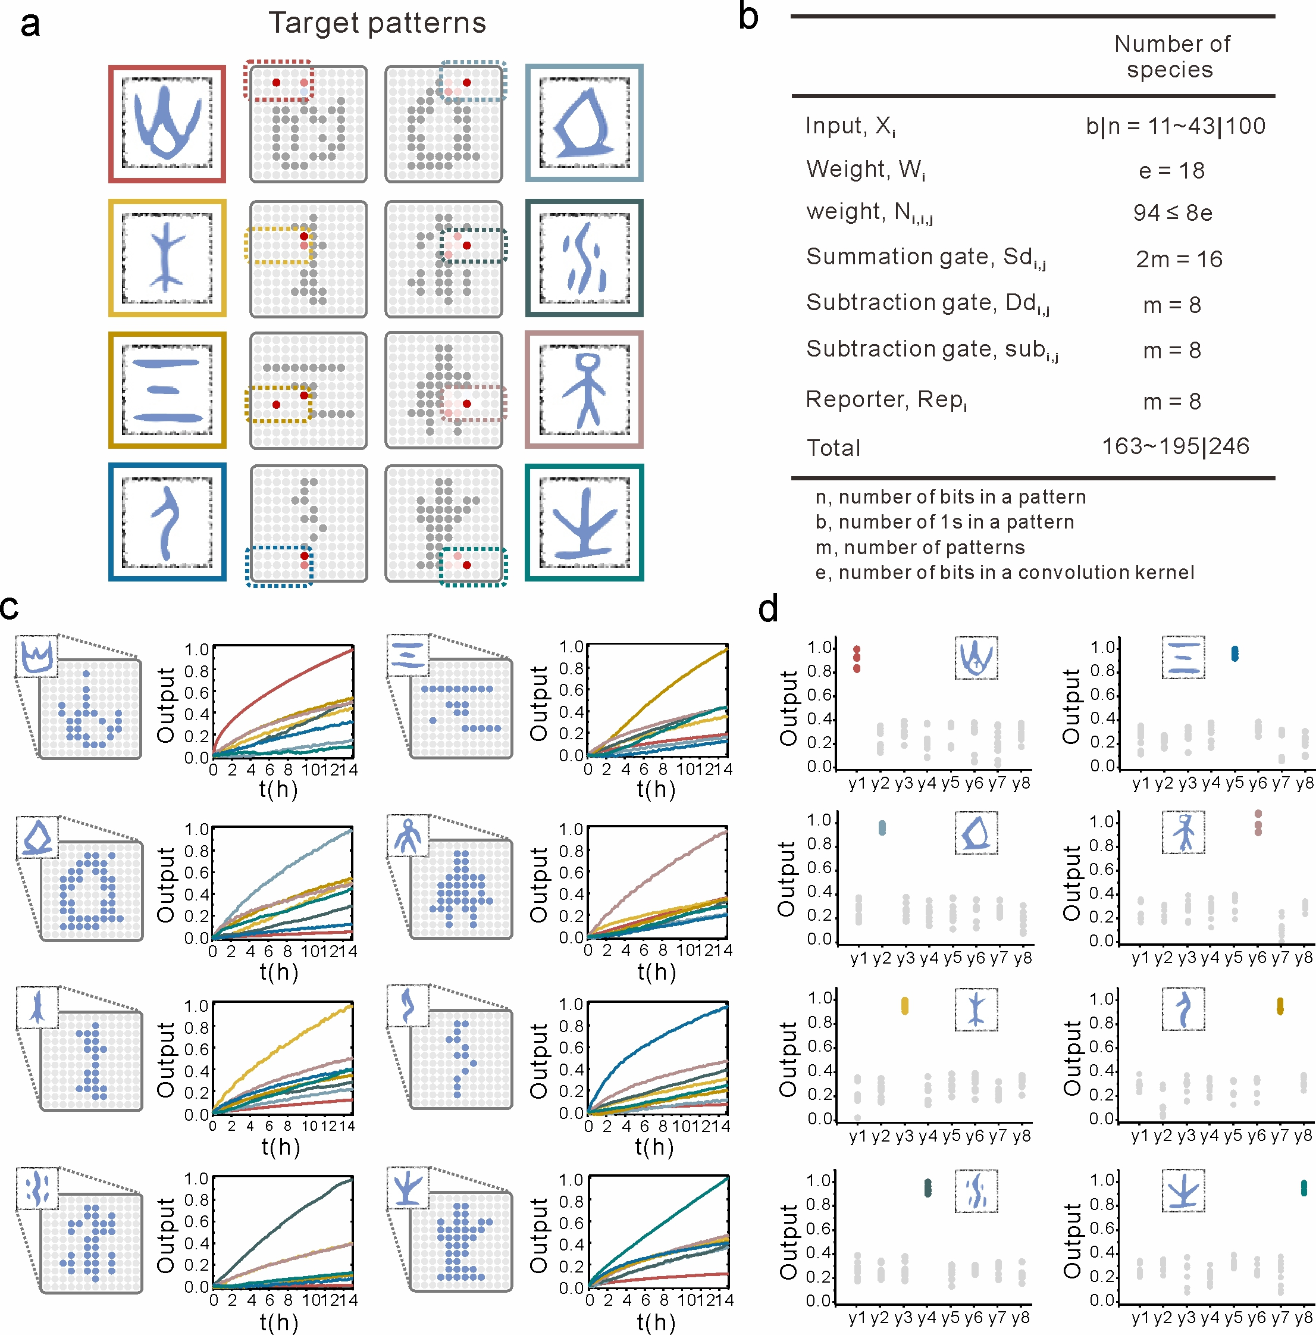
Supplementary Fig. 21| A DNA-based ConvNet for one of eight molecular patterns recognition. a, The characteristic receptive region of different target patterns (colors are associated with respective output trajectories in c and d). b, The number of distinct species in the circuit. The bottom row lists the number of species for a specific number of inputs (left) and for all possible inputs (right). c, Fluorescence kinetics data of the DNA-based ConvNet behavior with eight input patterns. d, Fluorescence level of each pair of outputs at 24 h after the inputs were added, collected from 88 experiments with 11 example patterns per oracle. Each colored point corresponds to an example pattern, each grey point corresponds to an out-of-class example pattern. The output will be 1 when the fluorescence is greater than the threshold of 0.6, otherwise output will be 0. As expected, all output signals reached ideal ON state, while the other fluorescent signals were at ideal OFF state.

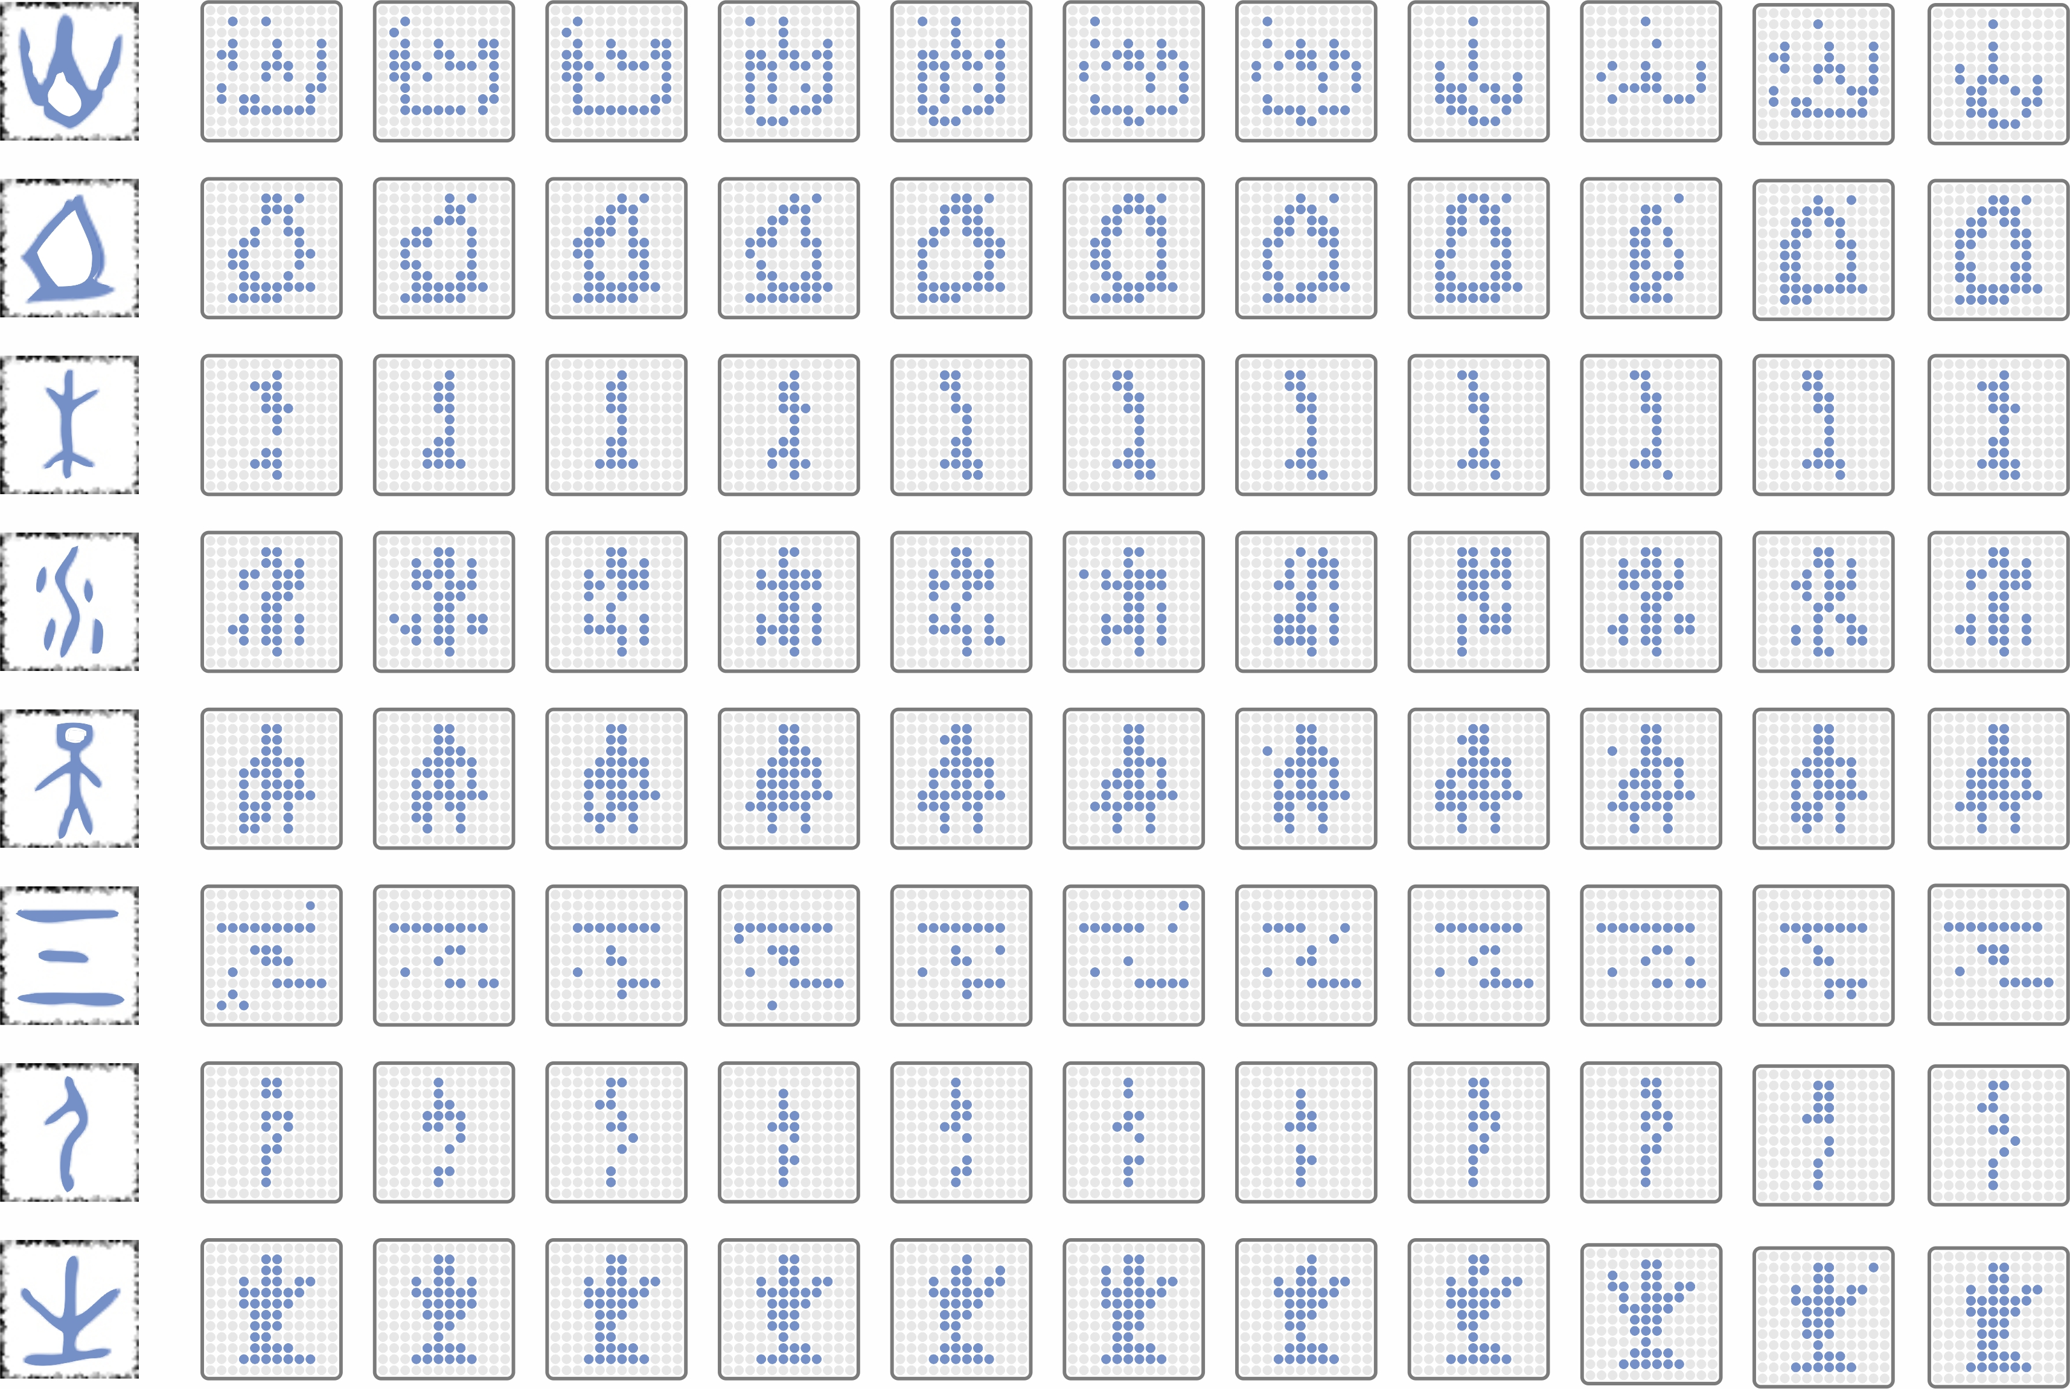
Supplementary Fig. 22| Eleven representative input patterns from the reference dataset.

S7. The DNA-based hierarchical network for one of 32 molecular patterns recognition
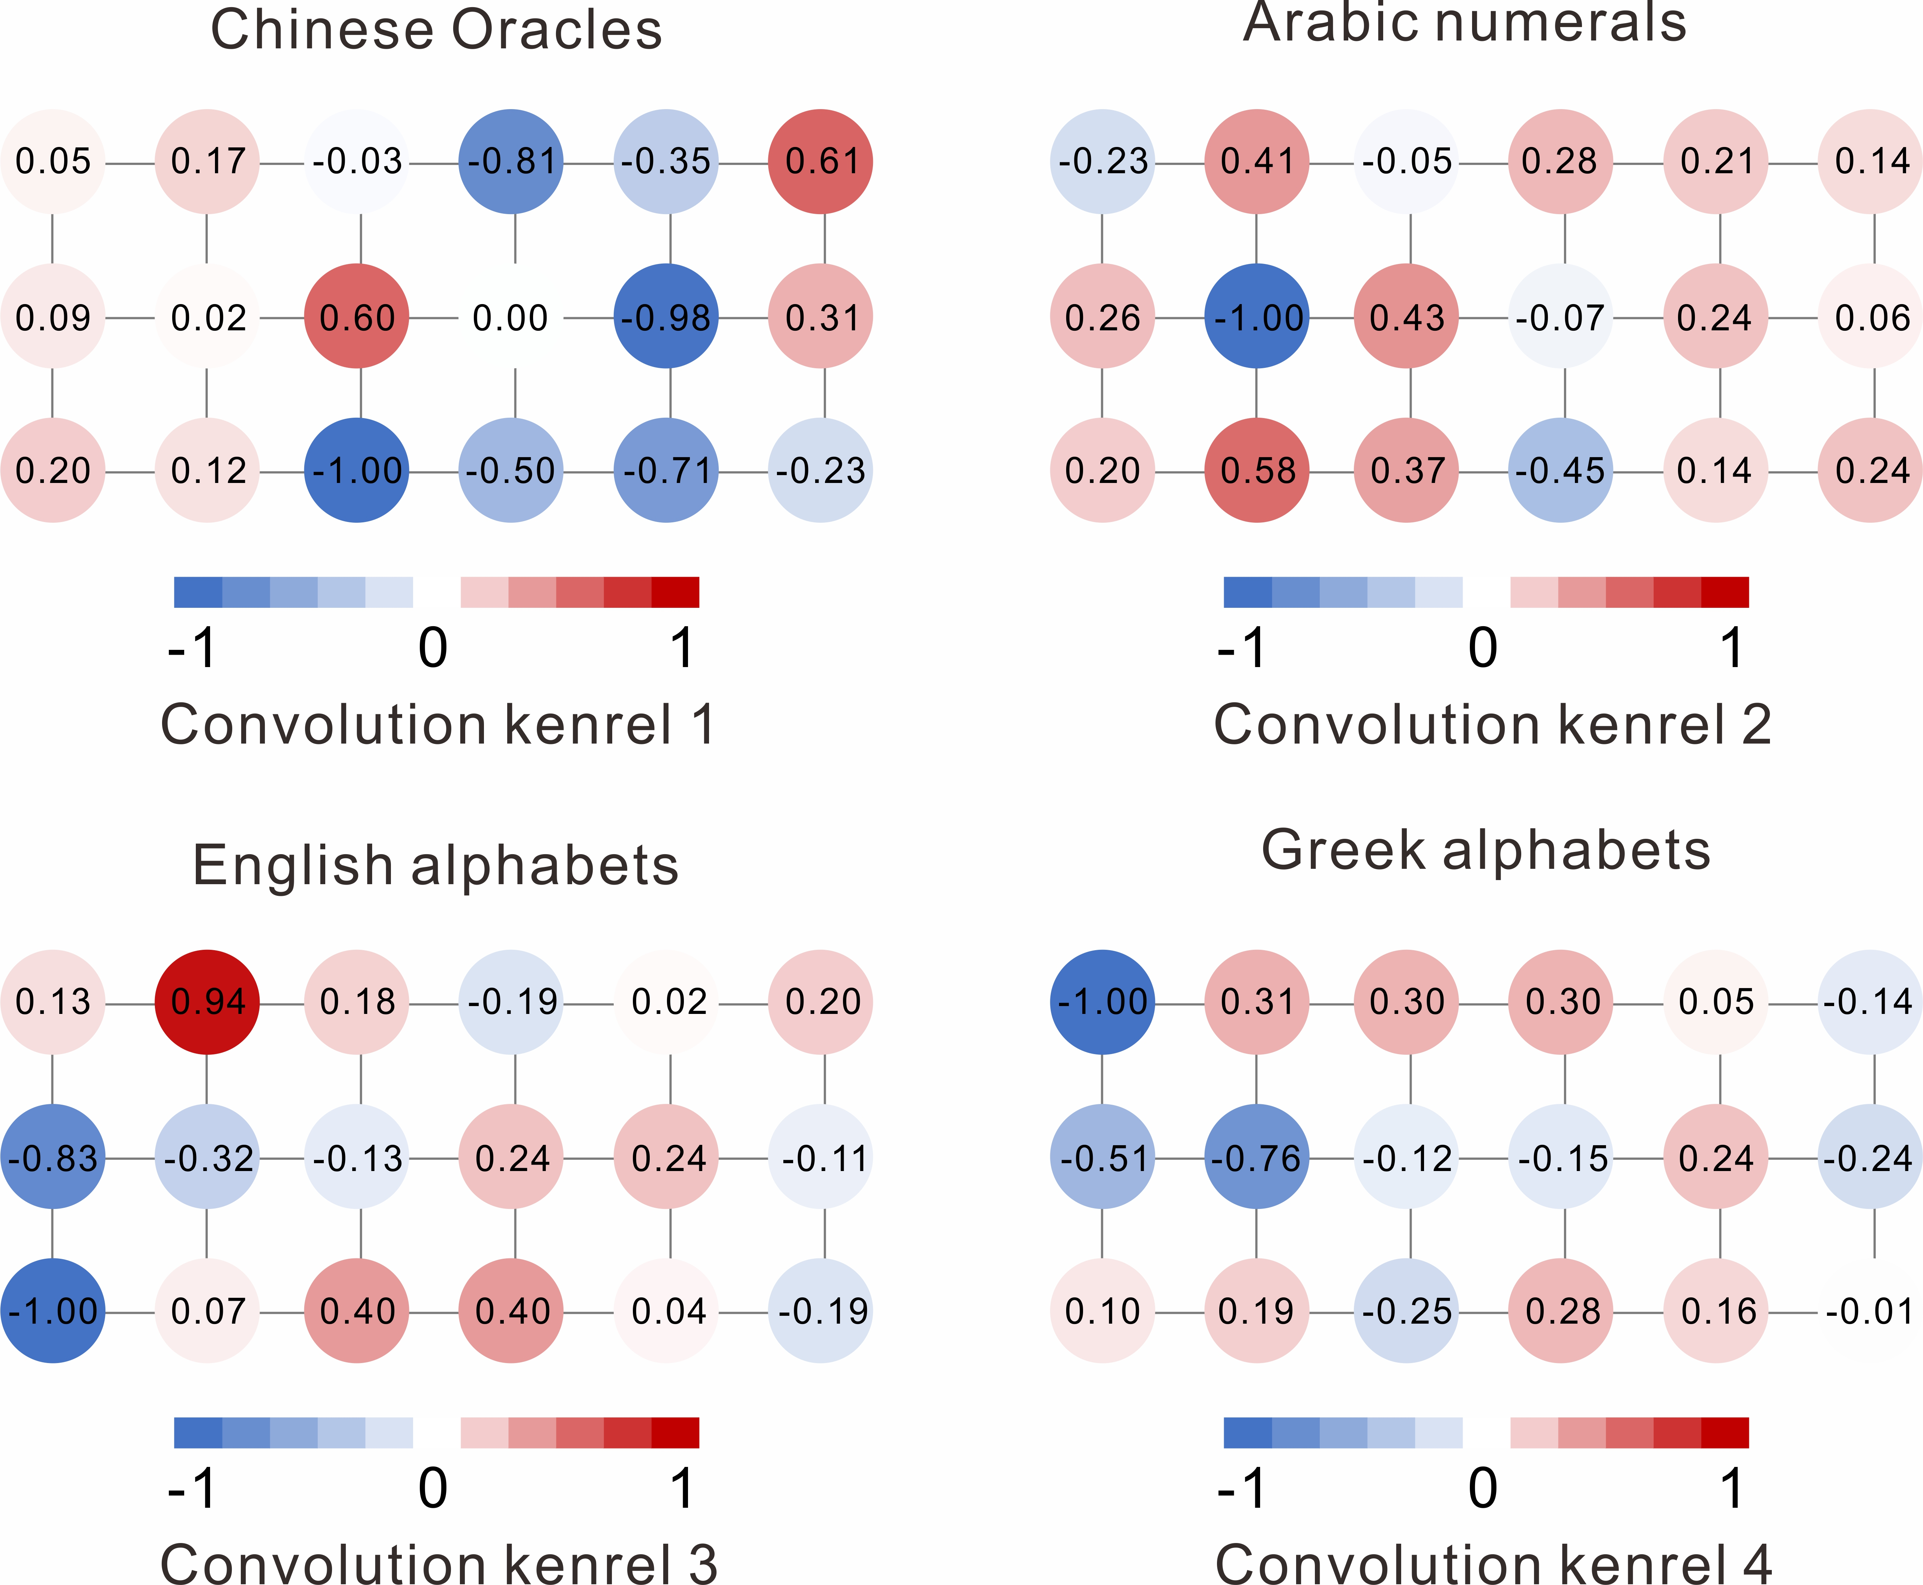
Supplementary Fig. 23| 32 patterns were divided into four groups, and each group was trained in silico separately. Once the optimal models were obtained, the value of weights was determined by four convolution kernels.

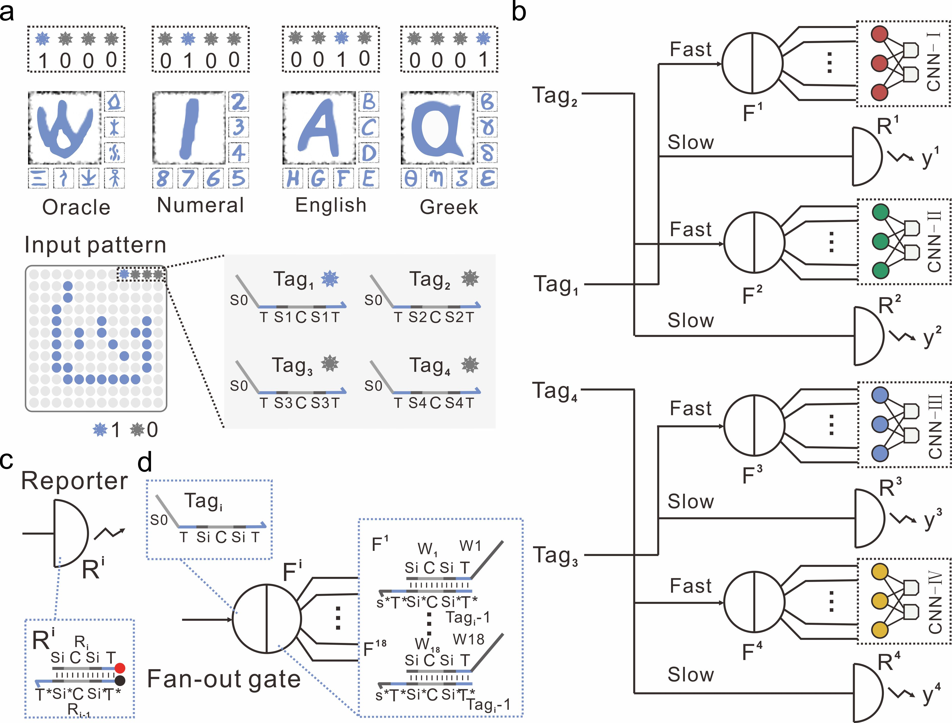
Supplementary Fig. 24| DNA logic circuits for classifying molecular patterns at coarse level. a, Binary tags were attached to input patterns, in which 1000 corresponds to Chinese oracles, 0100 corresponds to Arabic numerals, 0010 corresponds to English alphabets, and 0001 corresponds to Greek alphabets. Binary tags with each 1 and 0 corresponding to the presence and absence of a tag strand Tag_{i}, respectively. b, The abstract diagram of DNA logic circuits that react with input Layer 1. For correctly computing the output for all classifiable patterns, the circuit requires 4 reporter gates and 4 fan-out gates. c, Abstract diagram for reporter gate R; red circle and black circle denote fluorophore and quencher, respectively. d, Abstract diagram for a fan-out gate F. Each output strand from fan-out gates contains a different recognition domain on the 3’ end to connect to downstream DNA neural networks.

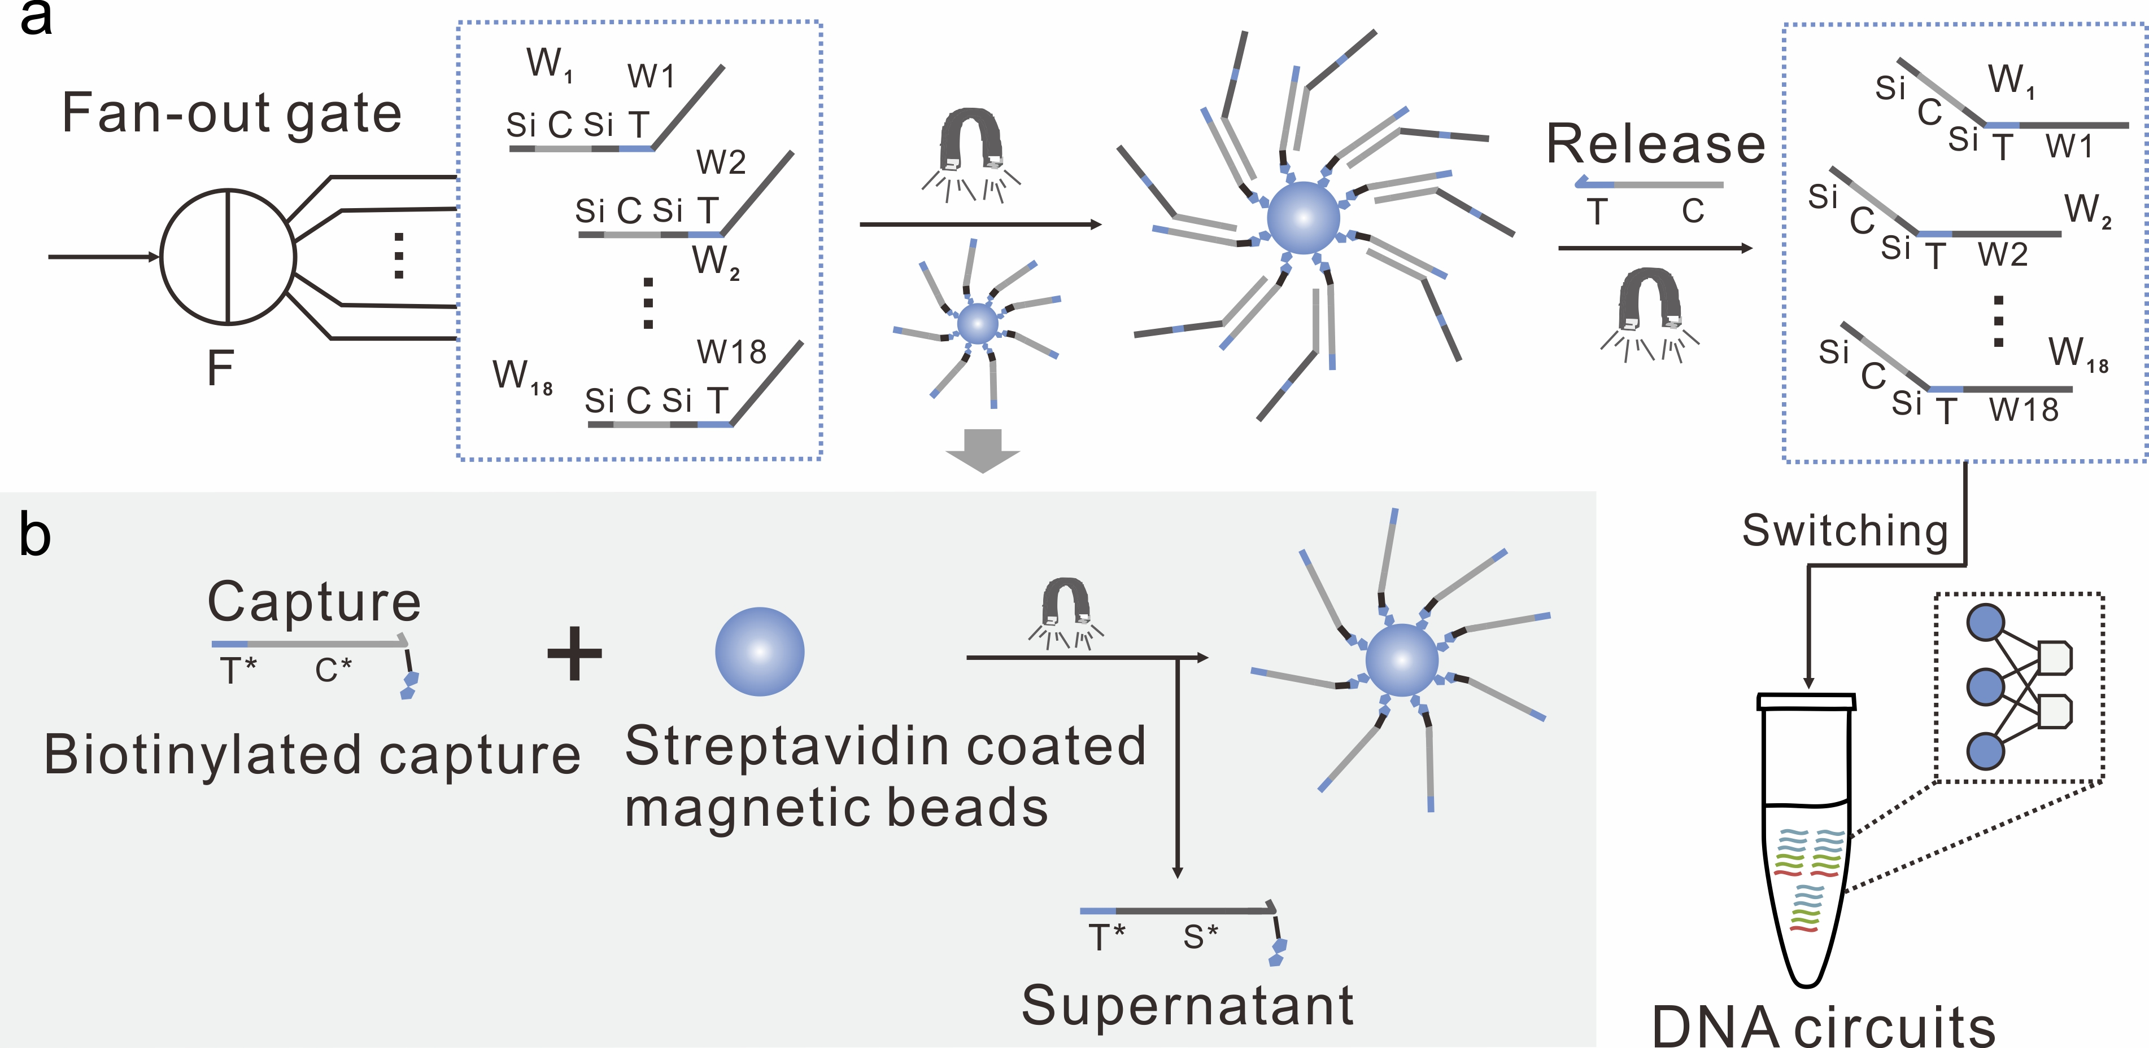
Supplementary Fig. 25| Workflow of separation and purification of weight tunning molecules W_{i}. a, Weight tunning molecules W_{i} that were resulted from the fan-out gate, can be captured from total DNA strands using magnetic beads through hybridization reaction by biotinylated capture probes. Then, the beads were separated with a magnet for 3 mins, and washed 3 times to remove the supernatant, followed by resuspension in a buffer. The invader strand (Release) was then added to displace the weight tunning molecules W_{i} from the beads. The supernatant was collected to switch on the DNA circuits to implement molecular pattern recognition. b, Immobilization of the capture probe (Capture) onto the streptavidin-functionalized magnetic beads.

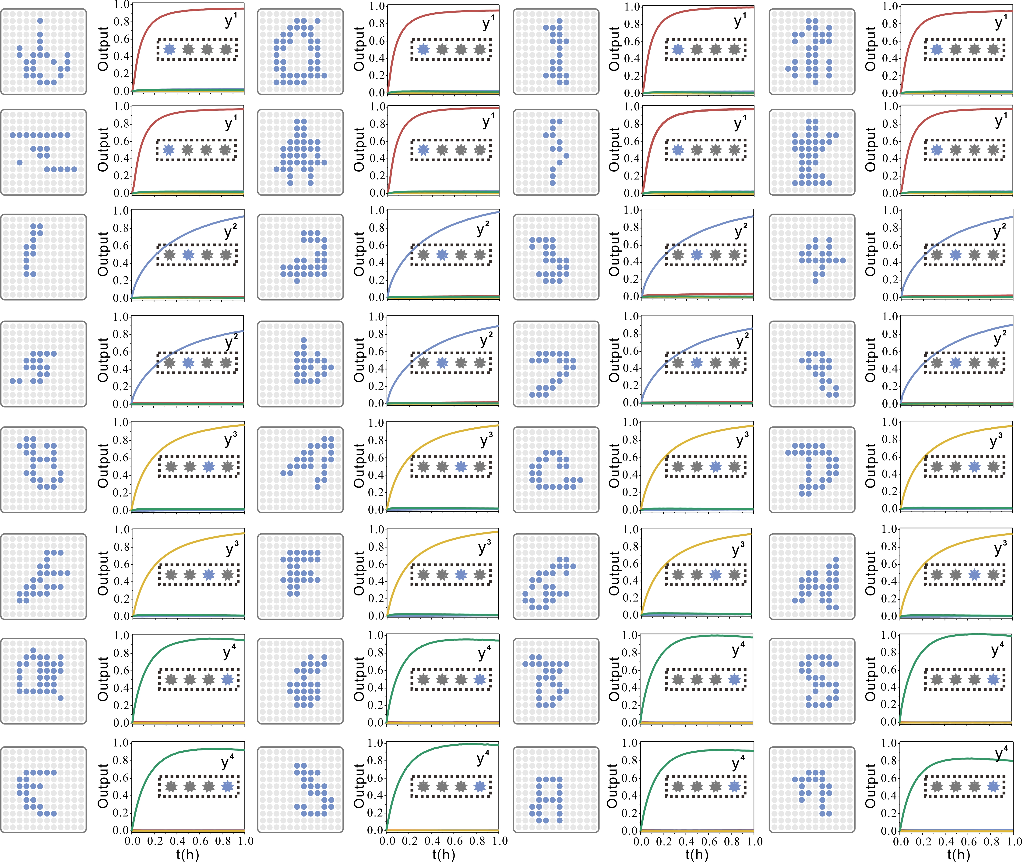
Supplementary Fig. 26| Fluorescence kinetics data of the circuit behavior of Layer 1 with 32 representative input patterns. Matching colors were used to visualize corresponding trajectories and outputs.

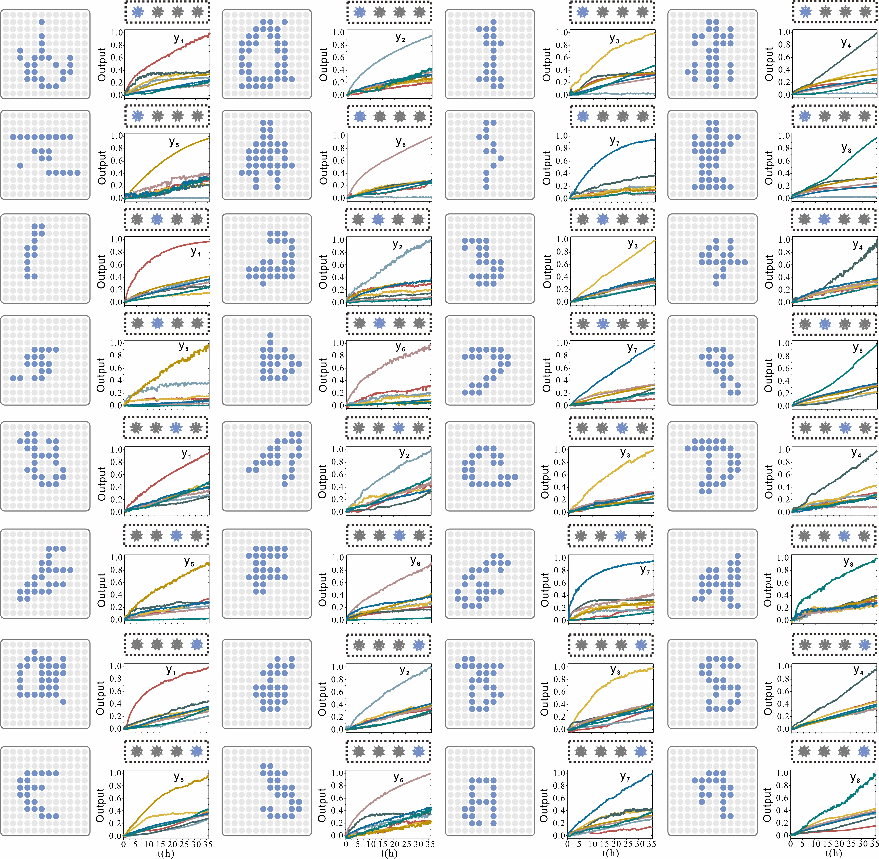
Supplementary Fig. 27| Fluorescence kinetics data of the circuit behavior of Layer 2 with 32 representative input patterns. Matching colors were used to visualize corresponding trajectories and outputs.

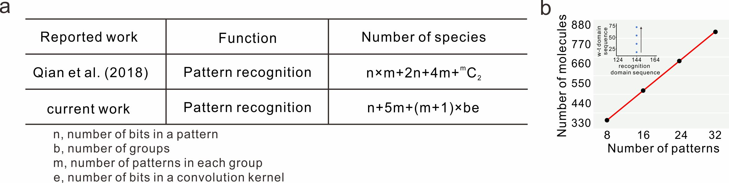
Supplementary Fig. 28| Maximum number of species of neural networks implementation for pattern recognition with the two-step classification approach. a, The size of a DNA-based WTA and a DNA-based ConvNet implementation scales up for an increasing number of patterns. In general, constructing a DNA-based ConvNet that can remember b×m distinct n-bit patterns with e-bit kernel size requires n input strands X_{i}, b×e weight tunning molecules W_{i} and b×e×m weight substrate molecules N_{i,i,j} for weight multiplication, 2m summation gates Sd_{i,j}, m complex Dd_{i,j} and m annihilation species Sub_{i,n} for subtraction, and m reporters Rep_{m}, totaling maximum n+5m+(m+1)×b×e molecules. b, On the basis of hierarchical network model, the number of molecules used to construct the neural network increased linearly as the number of patterns was scaled up. Moreover, the inset graph shows that the number of w-t (weight-tuning) sequence domains are increased linearly while the number of recognition sequence domains can remain unchanged, which could potentially lead to more scalable and complex DNA sequence design.

S8. Cyclic freeze/thaw approach as drivers of DNA circuits
We discovered that a cyclic physicochemical process (freeze/thaw cycling) can be a potent driver for strand displacement. During freezing, the steep increase in DNA concentrations could trigger the generation of a subpopulation of active complexes; during thawing, the steep drop in DNA concentrations could disassemble active and unproductive complexes. We ﬁrst sought to study whether a basic strand displacement can be speeded up with freeze/thaw cycling (Supplementary Fig. 29). Once the invader strand Ds_{i} was added, the freeze/thaw cycling was completed by two steps (Supplementary Fig. 29a): (1) the solution was frozen using liquid nitrogen in 1 min. (2) The tube was transferred to a water bath for thawing in 5 mins at 37 °C, then the tube was frozen by liquid nitrogen again. We found that the steady state fluorescence rapidly increased after just one freeze/thaw cycle. For two freeze/thaw cycles of 12 minutes, the extent of reaction was equivalent to that of 15 hours at 25 °C, which corresponded to nearly 75 times increase of the average reaction rate (Supplementary Fig. 29b). In this case, we can shorten the response time of the reaction from 15 hours to 12 minutes. As the number of cycles increased, the reaction gradually tended to be completed (Supplementary Fig. 29c). We further explored the effect of freezing temperature and freezing time on DNA strand displacement. The data shows that the speed of DNA strand displacement is faster at -196 °C (Supplementary Fig. 30a), and there is no significant increase in speed when increasing freezing time (Supplementary Fig. 30b).

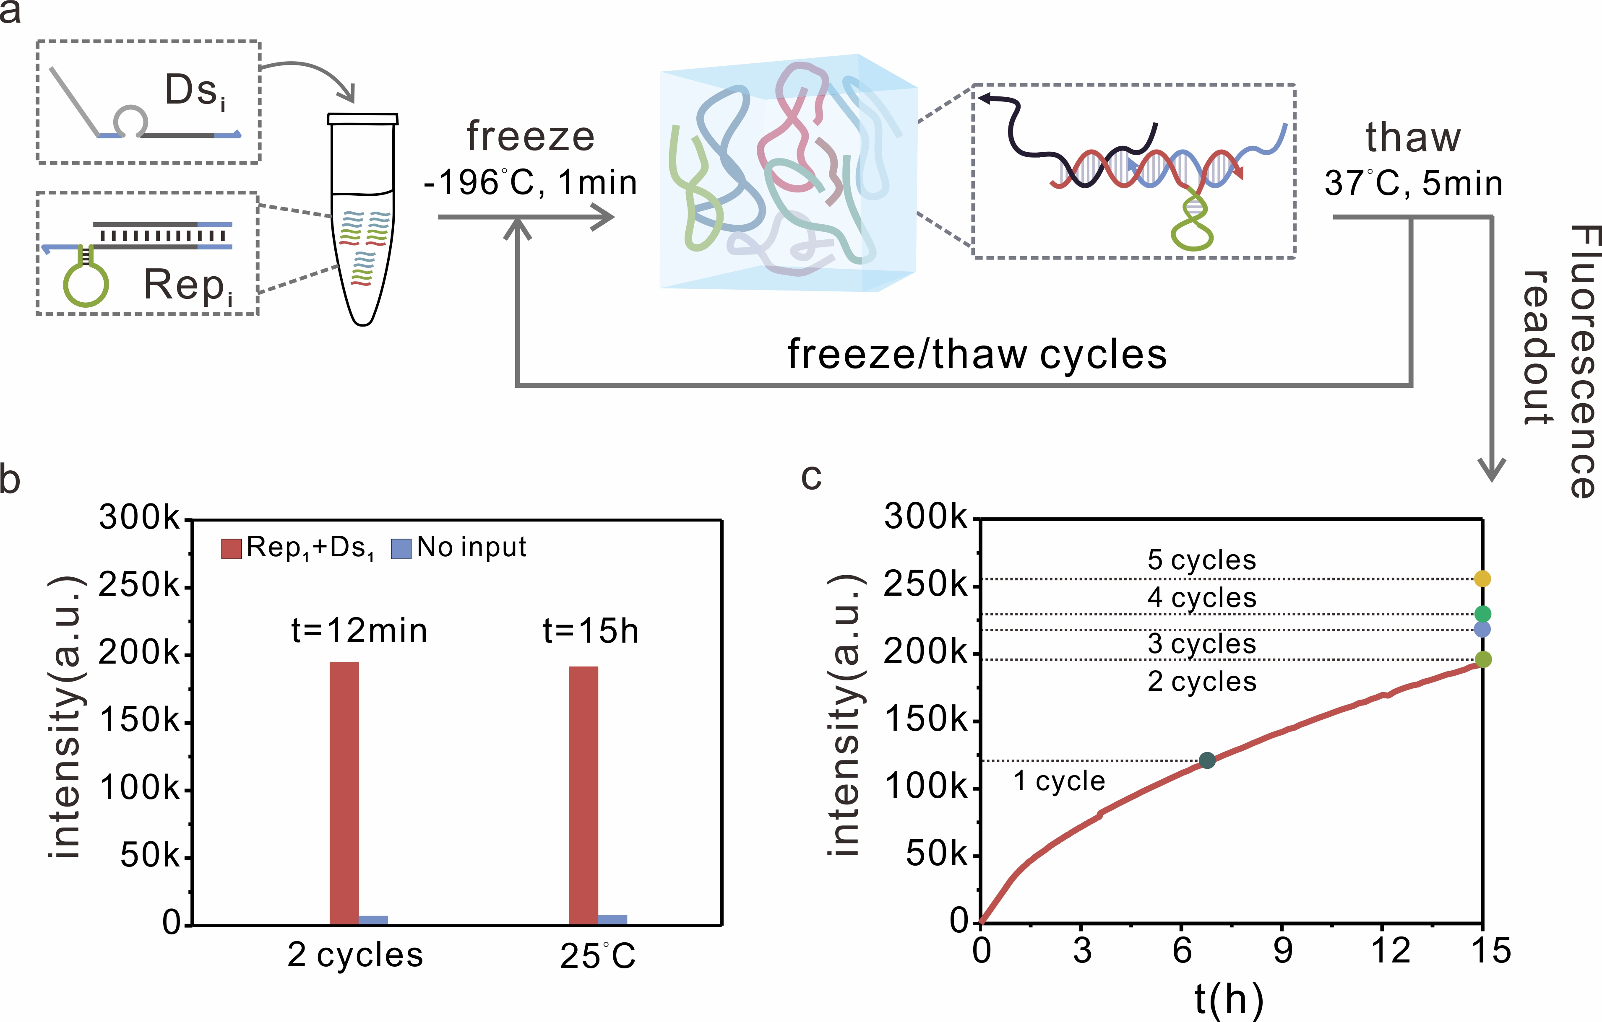
Supplementary Fig. 29| Cyclic freeze/thaw approach as drivers of DNA strand displacement. a, The schematic diagram of freeze/thaw cycles process. b, The fluorescence levels of strand displacement after two freeze/thaw cycles (12 min) and 15 h at 25 °C. c, The fluorescence levels of strand displacement performed at 25 °C and with repeated freeze/thaw cycles, respectively. Red curve corresponds to kinetic trajectory for corresponding experiment carried out at 25 °C. Colored dots correspond to the fluorescence levels of strand displacement after different cycles.

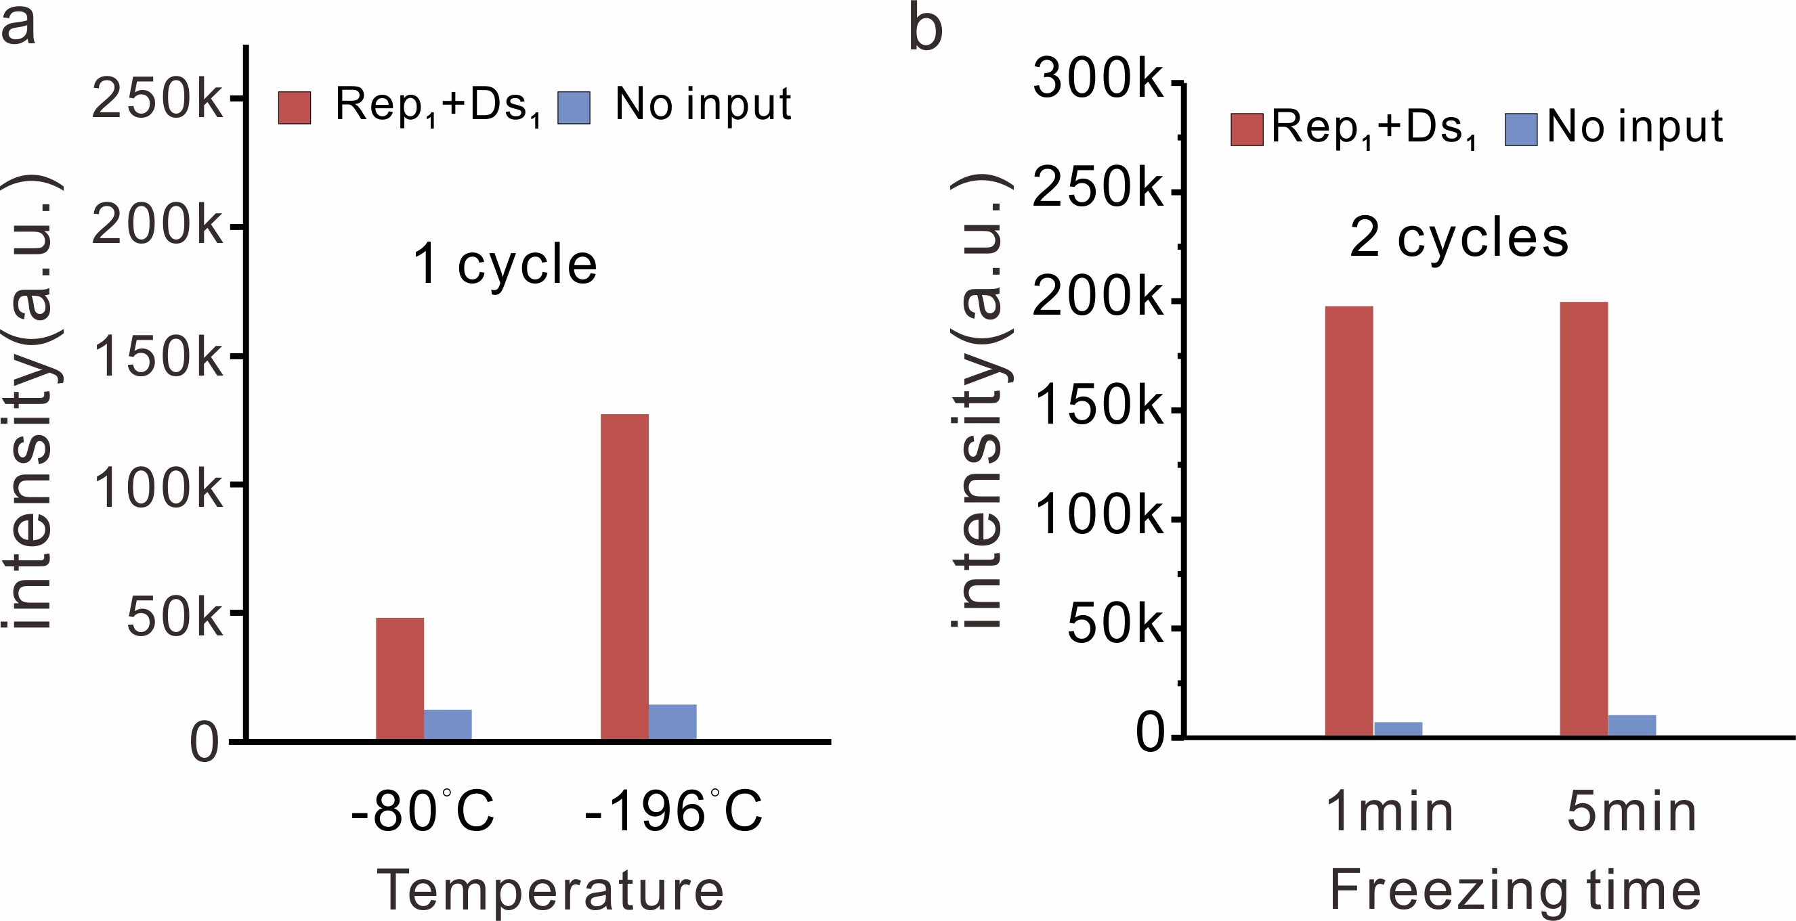
Supplementary Fig. 30| a, The fluorescence level of strand displacement with one freeze/thaw cycles at -80°C and -196°C, respectively. b, The fluorescence level of strand displacement with two freeze/thaw cycles at -196°C, with different freezing time.

Reference
1 Zhang, D. Y. & Winfree, E. Control of DNA strand displacement kinetics using toehold exchange. J. Am. Chem. Soc. 131, 17303–17314 (2009).
2 Cherry, K. M. , & Qian, L. Scaling up molecular pattern recognition with DNA-based winner-take-all neural networks. Nature 559, 370–376 (2018).
3 Phillips, A. Visual DSD: a design and analysis tool for DNA strand displacement systems. Bioinformatics 27, 3211–3213 (2011).

