Supplement Material

Table S1. Eigenvalues and explained variance from exploratory factor analysis of the six-item core symptom set (n = 150)
Component | Eigenvalue | % of variance | Cumulative %
1 | 3.389 | 56.48 | 56.5
2 | 0.743 | 12.39 | 68.9
3 | 0.592 | 9.86 | 78.7
4 | 0.566 | 9.43 | 88.2
5 | 0.425 | 7.08 | 95.3
6 | 0.285 | 4.75 | 100.0
Note. A single-factor solution was retained based on the eigenvalue >1 criterion and the scree plot.

Table S2. Inter-item correlation matrix for the six-item core symptom set (n = 150)
 | Insomnia | Fatigue | Nausea | Constipation | Cough | Shortness of breath
Insomnia | 1
Fatigue | 0.533** | 1
Nausea | 0.421** | 0.497** | 1
Constipation | 0.382** | 0.577** | 0.421** | 1
Cough | 0.369** | 0.461** | 0.362** | 0.303** | 1
Shortness of breath | 0.438** | 0.577** | 0.454** | 0.422** | 0.497** | 1
Note：* p < 0.05, ** p < 0.01.

Table S3 Item-fit statistics for the graded response model
item | S_X2 | df.S_X2 | RMSEA.S_X2 | p value
Insomnia | 59.082 | 40 | 0.055 | 0.026
Fatigue | 38.993 | 32 | 0.038 | 0.184
Nausea | 63.814 | 38 | 0.066 | 0.005
Constipation | 35.472 | 38 | 0.000 | 0.587
Cough | 31.473 | 34 | 0.000 | 0.592
Shortbreath | 33.452 | 32 | 0.017 | 0.397

Table S4 Discrimination and threshold parameters for the graded response model
Item | Discrimination | Threshold
Item | Discrimination | 1 | 2 | 3 | 4 | 5 | 6 | 7 | 8 | 9 | 10
Insomnia | 1.766 | -1.365 | -0.906 | -0.440 | 0.061 | 0.615 | 1.192 | 1.403 | 1.851 | 2.526 | 2.875
Fatigue | 3.226 | -1.366 | -0.815 | -0.445 | -0.036 | 0.420 | 0.919 | 1.205 | 1.629 | 2.115 | 2.485
Nausea | 1.514 | -0.736 | -0.206 | 0.338 | 1.008 | 1.476 | 1.865 | 2.442 | 2.955 | 3.412 | 4.290
Constipation | 1.691 | -1.352 | -0.911 | -0.363 | 0.419 | 0.863 | 1.460 | 1.768 | 2.187 | 2.747 | 2.924
Cough | 1.416 | -1.080 | -0.399 | 0.094 | 0.950 | 1.713 | 2.537 | 2.923 | 3.335 | 3.668 | 4.292
Shortbreath | 1.966 | -1.192 | -0.545 | 0.030 | 0.825 | 1.433 | 1.850 | 2.172 | 2.687 | 2.895 | 3.747

Note. The discrimination parameter (usually denoted as a) reflects how well an item differentiates between individuals with different levels of symptom burden. The threshold parameters (Threshold 1 to 10, typically denoted as b_1 to b_{10}) represent the latent trait level required to have a 50% probability of endorsing a given response category or higher on the 0–10 scale.
Table S5. Residual correlations (Yen’s Q3) among items of the six-item core symptom set under the graded response model
Item | Insomnia | Fatigue | Nausea | Constipation | Cough | Shortbreath
Insomnia | 1.000 | -0.231 | -0.118 | -0.120 | -0.133 | -0.177
Fatigue | -0.231 | 1.000 | -0.244 | -0.103 | -0.222 | -0.367
Nausea | -0.118 | -0.244 | 1.000 | -0.103 | -0.090 | -0.050
Constipation | -0.120 | -0.103 | -0.103 | 1.000 | -0.260 | -0.246
Cough | -0.133 | -0.222 | -0.090 | -0.260 | 1.000 | 0.042
Shortbreath | -0.177 | -0.367 | -0.050 | -0.246 | 0.042 | 1.000
Note. Yen’s Q3 statistic was used to assess local dependence among items. Values > 0.30 typically indicate potential local dependence violation. All pairwise residual correlations in this table are below this threshold, supporting the local independence assumption.

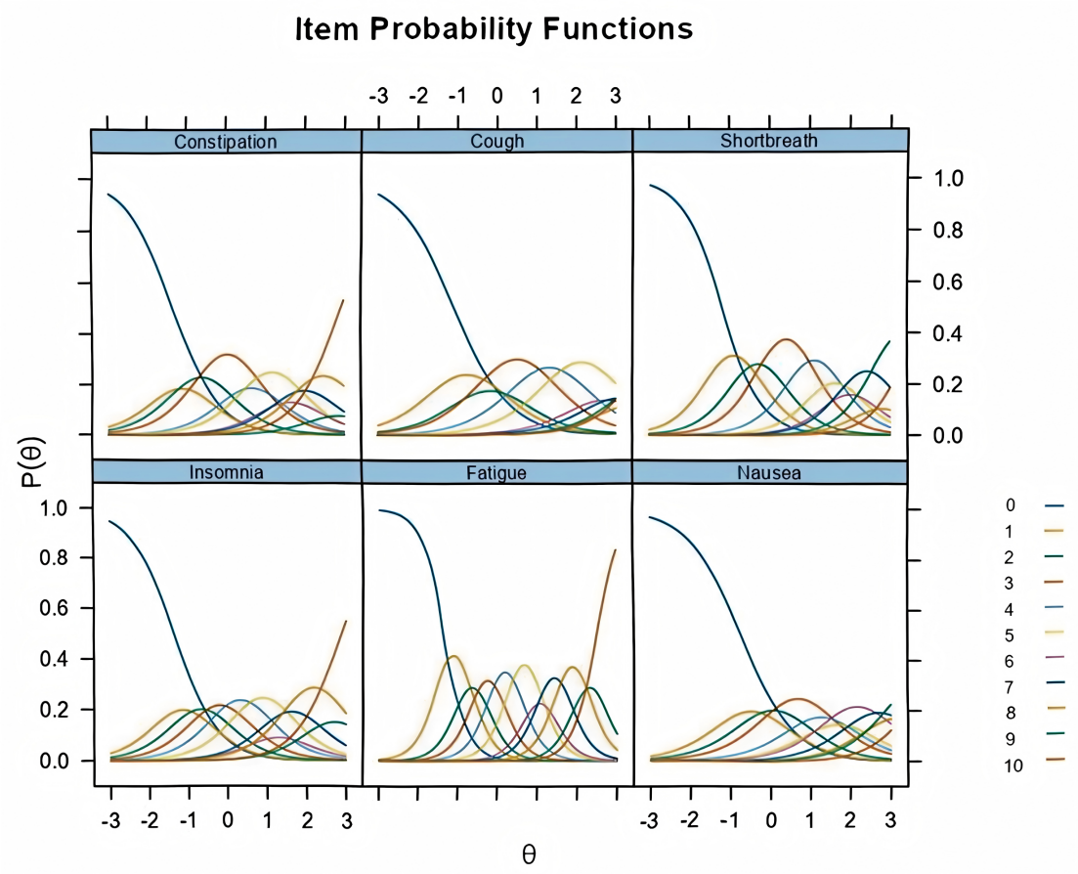
Figure S1 Category characteristic curves for each item under the graded response model.

Note. The x-axis represents the latent symptom burden (θ), and the y-axis represents the probability of endorsing a specific response category, P(θ). Each colored line corresponds to one of the 11 response options (0 to 10) for the item.
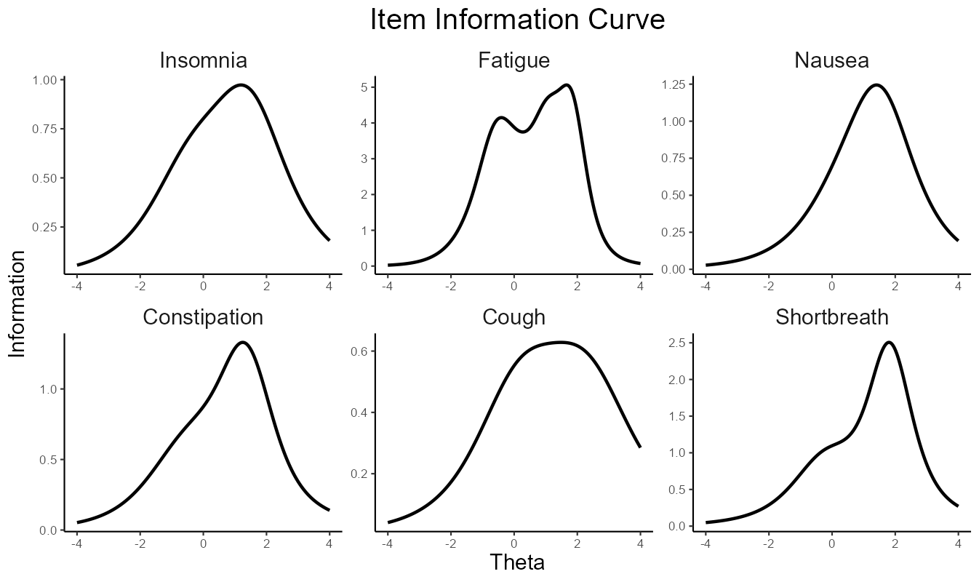
Figure S2. Item information functions for each item under the graded response model.
Note. The x-axis represents the latent symptom burden (θ), and the y-axis represents the amount of information provided by the item. Higher peaks on the curve indicate greater measurement precision at that specific level of the latent trait. For example, 'Fatigue' provides the most information across a broad range of symptom burden compared to other items.

