Supplementary Information
Heritablity and Genetic Correlations for Hormone-Sensitive Cancers in the UK Biobank: A Molecular Evidence of Shared Aetiology

Supplementary Note
Heritability estimates:
Heritablity (h²) is defined as the proportion of traits variation stastcially attributed to additive genetic effects. The h², is estimated by using a linear mixed-effect model. Usually, such model decomposes the phenotypic variance into genetic and residual variance components. It can be estimated using genetic relationship matrix from common SNPs for unrelated individuals. We have applied two methods in estimating the univariate heritablity of grouped level of cancers. First, we applied the univairate GREML analysis (1) in individual-level genotype data in the UKB (UK Biobank). Then, the summary statistics-based estimates in univeriate ldsc is applied (2). In both the applied methods the greml estimates of SNP-based heritabiliy was higher as compared to the estimate from ldsc. In the present study we showed that the phenotypic variance for cancer traits were also captured by common SNPs. Among these, we quantified the genetic correlation between traits explained by the common SNPs. This provides an estimate of the heritability explained by common variants because of presumed lesser linkage disequilibrium between the common SNPs and the rest of the genome as compared to related individuals.
GREML-Univariate to estimate heritability
Genomic-relatedness-matrix restricted maximum likelihood refers to the statistical method that estimates the amount of variance in one or more phenotypes that is attributable to a collection of observed genetic polymorphisms. The method is so named because it models phenotypic similarity among individuals in terms of one or more genomic-relatedness matrices (GRMs, described below), and estimates such models via restricted maximum likelihood. GREML was first implemented in the software GCTA (3), and studies using it have shown that common single-nucleotide polymorphisms (SNPs) can account for a substantial proportion of variance in complex human traits such as height.
In estimating the genetic correlation (r_{g}) using bivariate LDSC, we use the pre-computed LD score for white Europeans. The GWAS summary statistics are reformatted using the script munge_sumstats.py to work with ldsc. As we use an imputed quality control (QC) dataset of the UKB, we did not filter the summary statistics to HapMap3 SNPs using - - merge-alleles flag in ldsc. The sample size for each trait is assigned using - -N flag in the script. In each procedure, we checked for any warning message in each log file. To estimate the genetic correlation between the two hormone-sensitive cancer types [Thyroid and Ovarian cancers] with other types of cancers, the summary statistics for the two caners had a mean chi-square value below 1.02 from the .munge_sumstats.py warning message due to the smaller sample size. This suggests the data were not suitable for LD score regression and we did not include the genetic correlation from the bivariate LDSC estimate for these two cancer traits. The results for bivariate LDSC genetic correlation are shown in the Supplementary Table 8. The output log file is included in the supplementary file (Supplementary Table 10 and Table 11).
Post-GWAS analysis:
After association analysis to examine the overall genome-wide distribution of test statistics, we constructed the quantile-quantile (QQ) plot for hormonal cancers in each case [all hormonal cancers Vs prospective hormonal cancer cases only] and quantified the degree of genomic inflation factor (lambda=λ) i.e., how best the observed data points fit to expected, in the post GWAS analysis. The QQ plots in each case showed the bulk of the distribution is in the lower tail of the graph. For all hormonal cancer cases, we observed a low genomic inflation factor (λ = 1.068365) and similarly for prospective hormonal cancers low genomic inflation factor (λ =1.043601). This further suggests the data follows the normal chi-squared distribution (no inflation) with little population stratification. Usually, λ scales with the sample size, we rescaled the lambda estimate for an equivalent sample size of 1000 cases and controls for better information on the inflation/deflation of the value (See main method). Finally, the rescaled λ for hormone-sensitive cancers is 1.0025325, and for incidence hormone cancers the rescaled λ is 1.00337594, which is closer to 1 in both cases.
The genomic inflation factor is calculated by getting the median p-value first, convert the p-value into chi-squared statistics and finally we calculated the inflation factor using the equation of the following.
$$λGC=\frac{χ² median}{0.456 }$$
We corss checked the value from the plink output of genomic inflation factor using adjust command during GWAS analysis. The manual computation of the genomic inflation factor is in R using the following script.
Covariates
In this study, we used basic sociodemographic, lifestyle-behaviour, and disease information from the UKB baseline assessment. The covariates were age, sex, BMI level, educational status, alchol consumption, smoking histiry. All were self reported at baseline, with the exception of BMI, which is derived from body weight and hieght measurment calculated as body weight [in kilograms] divided by hieght squared [in meters]. Socioeconomic status was assessed using the Townsend deprivation index. Each particpant was assigned a score corresponidng to socioecnomic data attributed to their postcode, this was derived from the preceding UK census of population and housing.
Phenotype and Genetic correlation
As cancer phenotype may be modulated by genetic and non-genetic modifiers, we first determine the phenotype correlation of hormone-sensitive cancers with other non-cancer traits. The genetic correlation is a quantitative genetic parameter that describes the genetic relationship between two traits and has been expected to reflect pleiotropic action of genes or correlation between causal loci in two traits. Studies of genetically correlated traits improve our understanding of complex traits including cancer because they can reveal genetic variation that contributes to complex disease, improve genetic prediction and inform therapeutic interventions.
In a general quantitative genetic model, in which, for each individual, two traits (x and y) are each defined as the sum of a genetic value (g) and a residual value (e, with residual simply meaning the difference between the trait value and the genetic value).
$x=g_{x}+e_{x}$ (1)
$y=g_{y}+e_{y}$ (2 )
The genetic correlation (r_{g}) of the traits is defined as :
$ρ_{g}=\frac{σg_{x},g_{y}}{\sqrt{σ_{g_{x}}^{2}σ_{g_{y}}^{2}}}$ (3)
Where $σg_{x},g_{y}$ is the covariance of the genetic values and $σ_{g_{x}}^{2}σ_{g_{y}}^{2}$is genetic variance of the two traits in the population. As a result, $ρ_{g}$ ranges from –1 to 1. Following convention, the Greek letters emphasize parameters ($ρ_{g}$), which are replaced by Roman letters for estimates (r_{g}).
Estimation of the genetic correlation from individual level genotype data involves a bivariate extension of the univariate GREML that uses a genomic relationship matrix (GRM) to estimate SNP-based heritability. As for traditional epidemiology data, this approach uses an LMM, in which the phenotype is modelled as a function of the genetic values of individuals, but the variance–covariance structure of genetic values is described by genetic relationships in the GRM constructed from observed genome-wide SNP data rather than from pedigree data. SNP-based heritability is expected to be lower than heritability estimated from epidemiological family records because it aims to capture only causal variation that is in linkage disequilibrium (LD) with the measured SNPs.
In the analysis between hormone-sensitive cancers and non-cancer traits using GWAS summary statistics a nominally significant correlation has been found. For example, IGF-1 positively correlated with the development of hormone-sensitive cancer in all combined cases [prospective and retrospective cases of hormone-sensitive cancer]. This suggests IGF-1 is a common factor that directly affects hormone-sensitive cancer risk as well as increasing height. Furthermore, a slightly significant negative genetic correlation with SHBG (rg = -0.1141, se=0.0465; (P=1.42E-02)) was observed. Even though the estimates were non-significant for the rest of the non-cancer traits, there was slightly higher and a meaningful direction of estimates in comparison to previous observational studies. For example, a slightly higher positive genetic correlation was found between hormone-sensitive cancers and menopausal status (rg =0.1183, se=0.1027; (P=2.49E-01)); T2D status (rg =0.0839, se=0.0628; (P=1.82E-01)); baseline LDL cholesterol measurement (rg = 0.0695, se=0.0635; (P=2.74E-01)); WHR adjusted for BMI (rg =0.0675, se=0.0446; (P=1.30E-01)); alcohol consumption (rg =0.0531, se=0.0857; (P=5.36E-01)); and apolipoprotein B (rg =0.0638, se=0.0596; (P=2.84E-01)). In contrast, evidence of higher negative genetic correlation has also been observed between hormone-sensitive cancers and in non-cancer traits such as diastolic blood pressure (rg = -0.0512, se=0.0487; (P=2.93E-01)); BMI (rg = -0.0504, se=0.0417; (P=2.27E-01)); testosterone (rg = -0.0461, se=0.0477; (P=3.36E-01)) and apolipoprotein A1 (rg = -0.0390, se=0.0428; (P=3.62E-01)). The genetic correlations estimate between hormone-sensitive cancer and other non-cancer traits is presented in Supplementary Table 8.
Gene environment interaction (GxE)
GxE tests can explain novel biology along two distinct, complementary axes. First, GxE can identify unappreciated genetic effect that elude linear models, which can increase GWAS power and has recently received attention as a partial answer to the missing heritability question. Second, GxE test can demonstrate that an environmental measurement is biologically trait relevant and quantify its impact, which can be important for public health and can illuminate intrinsic traits biology.

Supplementary Tables
The following supplementary results are from the detailed analysis we tested in each section of the main text. They are presented here for further references.
Supplementary Table 1: Meta-analysed SNP-based Heritability estimates using Univariate GREML for subgroups of cancer in UKB [n=288,837]
Univariate GREML SNP-h² of cancer [incident and prevalent cases ]in the UK Biobank UKB-1
 | Liability scale
Cancer Types | h² | SE | χ² test | Sig.
Overall Cancer | 0.0438 | 0.0031 | 194.524 | 3.27E-44
Non-obesity cancer | 0.0169 | 0.0048 | 12.246 | 4.66E-04
Obesity-related | 0.0527 | 0.0048 | 120.648 | 4.56E-28
Hormonal Cancer | 0.1006 | 0.0070 | 204.565 | 2.11E-46
Non-hormonal Cancer | 0.0307 | 0.0307 | 18.048 | 2.15E-05
The observed heritability is transformed into the liability scale in MTG2.17 using the prevalence (k) of cases in each subgroup of cancer. The model is adjusted for batch effect, assessment centre, the 10 ancestry-informative principal components (PCs), birthplace, age, sex, smoking, alcohol, education & TDI
Supplementary Table 2: SNP-based Heritability estimates for subgroups of cancers in the UKB using LDSC [n=288,837]
Univariate LDSC SNP-h2 of cancer [incident and prevalent cases ]in the UK Biobank
 | Liability scale
Cancer Types | h² | SE | χ² test | Sig.
Overall Cancer | 0.0330 | 0.0046 | 51.46503 | 7.29E-13
Non-obesity cancer | 0.0149 | 0.0113 | 1.738664 | 1.87E-01
Obesity-related | 0.0413 | 0.0065 | 40.37136 | 2.10E-10
Hormonal Cancer | 0.0699 | 0.0083 | 70.92481 | 3.71E-17
Non-hormonal Cancer | 0.0300 | 0.0101 | 8.822664 | 2.98E-03
The observed heritability is transformed into the liability scale in MTG2.17 using the prevalence (k) of cases in each subgroup of cancer. The model is adjusted for batch effect, assessment centre, 10 ancestry-informative principal components (PCs), birthplace, age, sex, smoking, alcohol, education & TDI

Supplementary Table 3: Meta-analysed SNP-based Heritability estimates using univariate GREML for subgroup of incident cancers in UKB [n=288,837]

Univariate GREML SNP-h2 of incident cancers in the UK Biobank (Liability Scale) UKB
Cancer Types | h² | SE | χ² test | Sig.
Overall Cancer | 0.0438 | 0.0031 | 194.5240 | 3.27E-44
Non-obesity cancer | 0.0169 | 0.0048 | 12.2462 | 4.66E-04
Obesity-related | 0.0526 | 0.0047 | 120.6483 | 4.56E-28
Hormonal Cancer | 0.1006 | 0.0070 | 204.5651 | 2.11E-46
Non-hormonal Cancer | 0.0306 | 0.0072 | 18.0485 | 2.15E-05
Adjustment is made for batch effect, assessment centre, 10 ancestry-informative principal components (PCs), birthplace, age, sex, smoking, alcohol, education, & TDI.

Supplementary Table 4: SNP-based Heritability estimates for subgroups of incident cancers in the UKB using LDSC [n=288,837]
Univariate GREML SNP-h2 of incident cancers in the UK Biobank (Liability Scale) UKB-1
Cancer Types | h² | SE | χ² test | Sig.
Overall Cancer | 0.0184 | 0.0072 | 6.530864 | 1.06E-02
Non-obesity cancer | 0.0097 | 0.0250 | 0.150544 | 6.98E-01
Obesity-related | 0.0169 | 0.0089 | 3.605732 | 5.76E-02
Hormonal Cancer | 0.0560 | 0.0158 | 12.56209 | 3.94E-04
Non-hormonal Cancer | 0.0066 | 0.0158 | 0.174491 | 6.76E-01
The observed heritability is transformed into the liability scale in MTG2.17 using the prevalence (k) of cases in each subgroup of cancer. Adjustment is made for batch effect, assessment centre, 10 ancestry-informative principal components (PCs), birthplace, age, sex, smoking, alcohol, education, & TDI.

Supplementary Table 5: Summary of the SNP-based heritability estimates using GREML and LDSC for both all cases and Incident only cases in the UKB
 | Prevalent and incident cases |  |  |  |  |  |  |  | Incident cases only
Method | Observed scale |  |  |  | Liability scale |  |  |  | Observed scale |  |  |  | Liability scale
GREML(UKB) | h² | SE | Wald | p-value | h² | SE | Wald | P-value | h² | SE | Wald | p-value | h² | SE | Wald | p-value
Overall-Cancer | 0.0180 | 0.0013 | 193.1707 | 6.46E-44 | 0.0438 | 0.0030 | 194.5240 | 3.27E-44 | 0.0088 | 0.0014 | 41.8902 | 9.65E-11 | 0.0313 | 0.0048 | 41.9656 | 9.29E-11
Obesity-related | 0.0148 | 0.0014 | 119.3296 | 8.87E-28 | 0.0526 | 0.0047 | 120.648 | 4.56E-28 | 0.0066 | 0.0014 | 22.4836 | 2.12E-06 | 0.0343 | 0.0072 | 22.5215 | 2.08E-06
Non-Obesity | 0.0049 | 0.0014 | 12.2655 | 4.61E-04 | 0.0169 | 0.0048 | 12.2462 | 4.66E-04 | 0.0008 | 0.0014 | 0.3368 | 5.62E-01 | 0.0043 | 0.0075 | 0.32828 | 5.67E-01
Hormonal | 0.0204 | 0.0014 | 203.7643 | 3.15E-46 | 0.1006 | 0.0070 | 204.565 | 2.11E-46 | 0.0077 | 0.0014 | 28.8187 | 7.95E-08 | 0.0592 | 0.0110 | 28.84536 | 7.84E-08
Non-Hormonal | 0.0059 | 0.0014 | 18.0814 | 2.12E-05 | 0.0306 | 0.0072 | 18.0485 | 2.15E-05 | 0.0032 | 0.0014 | 4.9695 | 2.58E-02 | 0.0326 | 0.0146 | 4.97122 | 2.58E-02
LDSC | h² | SE | Wald | p-value | h² | SE | Wald | p-value | h² | SE | Wald | p-value | h² | SE | Wald | p-value
Overall | 0.0136 | 0.0019 | 51.23546 | 8.19E-13 | 0.0330 | 0.0046 | 51.46503 | 7.29E-13 | 0.0051 | 0.0020 | 6.5025 | 1.08E-02 | 0.0184 | 0.0072 | 6.5308 | 1.06E-02
Obesity-related | 0.0133 | 0.0021 | 40.1111 | 2.40E-10 | 0.0413 | 0.0065 | 40.37136 | 2.10E-10 | 0.0038 | 0.0020 | 3.61 | 5.74E-02 | 0.0169 | 0.0089 | 3.6057 | 5.76E-02
Non-Obesity | 0.0029 | 0.0022 | 1.737603 | 1.87E-01 | 0.0149 | 0.0113 | 1.738664 | 1.87E-01 | 0.0007 | 0.0018 | 0.15123 | 6.97E-01 | 0.0097 | 0.0250 | 0.1505 | 6.98E-01
Hormonal | 0.0176 | 0.0021 | 70.24036 | 5.25E-17 | 0.0699 | 0.0083 | 70.92481 | 3.71E-17 | 0.0067 | 0.0019 | 12.4349 | 4.21E-04 | 0.0560 | 0.0158 | 12.562 | 3.94E-04
Non-Hormonal | 0.0062 | 0.0021 | 8.716553 | 3.15E-03 | 0.0300 | 0.0101 | 8.822664 | 2.98E-03 | 0.0008 | 0.0019 | 0.1772 | 6.74E-01 | 0.0066 | 0.0158 | 0.1744 | 6.76E-01

Supplementary Table 6: Genome-wide significant SNP for hormone-sensitive cancers in the UKB
No | CHR | SNP | BP | A1 | TEST | NMISS | BETA | STAT | P | Gene name | Genomic region | Trait Association
1 | 2 | rs13387042 | 217905832 | G | ADD | 237570 | -0.003843 | -5.64 | 1.70E-08 | AC007749.1 | 2q35 | Breast Cancer
2 | 8 | rs10086908 | 128011937 | C | ADD | 236744 | -0.004774 | -6.406 | 1.50E-10 | PCAT1 | 8q24.21 | Prostate Cancer
3 | 8 | rs16901898 | 128015092 | C | ADD | 236819 | -0.00475 | -6.377 | 1.81E-10 |  |  | None
4 | 8 | rs9297750 | 128022973 | G | ADD | 236791 | -0.00512 | -6.494 | 8.35E-11 |  |  | None
5 | 8 | rs17762878 | 128025053 | G | ADD | 237572 | -0.004702 | -6.312 | 2.76E-10 |  |  | None
6 | 8 | rs7823764 | 128026262 | G | ADD | 237501 | -0.004753 | -6.38 | 1.78E-10 |  |  | None
7 | 8 | rs7842175 | 128026317 | C | ADD | 237507 | -0.00474 | -6.362 | 1.99E-10 |  |  | None
8 | 8 | rs1016343 | 128093297 | T | ADD | 237567 | 0.004683 | 5.536 | 3.09E-08 | PRNCR1 | 8q24.21 | Prostate Cancer
9 | 8 | rs16901949 | 128107153 | C | ADD | 237553 | 0.01063 | 5.616 | 1.96E-08 |  |  | None
10 | 8 | rs16901959 | 128109530 | G | ADD | 237549 | 0.01057 | 5.586 | 2.33E-08 |  |  | None
11 | 8 | rs7830341 | 128109930 | A | ADD | 237497 | 0.01058 | 5.585 | 2.34E-08 | CASC19 | 8q24.21 | BMI
12 | 8 | rs16901966 | 128110252 | G | ADD | 237519 | 0.01061 | 5.604 | 2.09E-08 |  |  | None
13 | 8 | rs16901970 | 128112715 | G | ADD | 237549 | 0.01057 | 5.586 | 2.33E-08 |  |  | None
14 | 8 | rs7824785 | 128114710 | T | ADD | 237464 | 0.01052 | 5.565 | 2.62E-08 |  |  | None
15 | 8 | rs16901979 | 128124916 | A | ADD | 237573 | 0.01046 | 5.536 | 3.10E-08 | CASC19 | 8q24.21 | Prostate Cancer
16 | 8 | rs10505483 | 128125195 | T | ADD | 237573 | 0.01048 | 5.55 | 2.87E-08 | CASC19 | 8q24.21 | Prostate Cancer
17 | 8 | rs7817677 | 128125504 | G | ADD | 237543 | 0.01056 | 5.581 | 2.40E-08 |  |  | None
18 | 8 | rs6989838 | 128129372 | C | ADD | 237551 | 0.01053 | 5.574 | 2.49E-08 |  |  | None
19 | 8 | rs10505477 | 128407443 | G | ADD | 237573 | -0.003757 | -5.508 | 3.63E-08 | POU5F1B | 8q24.21 | Colorectal & Prostate
20 | 8 | rs6983267 | 128413305 | T | ADD | 237573 | -0.003998 | -5.859 | 4.67E-09 | POU5F1B | 8q24.21 | Colorectal & Prostate
21 | 8 | rs4242382 | 128517573 | A | ADD | 237573 | 0.006448 | 5.722 | 1.06E-08 | AC104370.1 | 8q24.21 | Prostate Cancer
22 | 8 | rs4242384 | 128518554 | C | ADD | 237573 | 0.00649 | 5.746 | 9.16E-09 | AC104370.1 | 8q24.21 | Prostate Cancer
23 | 8 | rs7814837 | 128522202 | T | ADD | 237341 | 0.006404 | 5.66 | 1.52E-08 |  |  | None
24 | 8 | rs7824868 | 128524414 | T | ADD | 235426 | 0.006156 | 5.489 | 4.06E-08 |  |  | None
25 | 10 | rs10993994 | 51549496 | T | ADD | 237568 | 0.004194 | 6.01 | 1.86E-09 | MSMB | 10q11.22 | Blood protein & Prostate
26 | 10 | rs10736303 | 123334457 | G | ADD | 236037 | 0.004702 | 6.856 | 7.08E-12 |  |  | None
27 | 10 | rs11200014 | 123334930 | A | ADD | 236681 | 0.005077 | 7.295 | 2.99E-13 | FGFR2 | 10q26.13 | Prostate Cancer
28 | 10 | rs2981579 | 123337335 | A | ADD | 237572 | 0.005131 | 7.388 | 1.50E-13 | FGFR2 | 10q26.13 | Breast Cancer
29 | 10 | rs1078806 | 123338975 | G | ADD | 236200 | 0.005161 | 7.407 | 1.30E-13 | FGFR2 | 10q26.13 | ECG & Breast cancer
30 | 10 | rs2981575 | 123346116 | G | ADD | 237572 | 0.005487 | 7.863 | 3.76E-15 | FGFR2 | 10q26.13 | Breast & Prostate cancer
31 | 10 | rs1219648 | 123346190 | G | ADD | 237572 | 0.005456 | 7.815 | 5.51E-15 | FGFR2 | 10q26.13 | Breast Cancer
32 | 10 | rs2912774 | 123348662 | T | ADD | 236629 | 0.005355 | 7.66 | 1.87E-14 | FGFR2 | 10q26.13 | Breast Cancer
33 | 10 | rs2420946 | 123351324 | T | ADD | 236506 | 0.005036 | 7.174 | 7.31E-13 | FGFR2 | 10q26.13 | Breast Cancer
34 | 10 | rs2162540 | 123352136 | C | ADD | 237281 | 0.004956 | 7.068 | 1.58E-12 |  |  | None
35 | 10 | rs2981582 | 123352317 | A | ADD | 237573 | 0.004969 | 7.088 | 1.37E-12 | FGFR2 | 10q26.13 | Breast Cancer
36 | 11 | rs4255548 | 68973970 | A | ADD | 231722 | -0.004173 | -5.887 | 3.93E-09 |  |  | None
37 | 11 | rs7929962 | 68985583 | C | ADD | 236975 | -0.004097 | -6.009 | 1.87E-09 | AP003071.2 | 11q13.3 | Prostate Cancer
38 | 11 | rs7109672 | 68991110 | A | ADD | 237475 | -0.003999 | -5.867 | 4.45E-09 |  |  | None
39 | 11 | rs7931342 | 68994497 | T | ADD | 237573 | -0.004042 | -5.932 | 3.00E-09 | AP003071.2 | 11q13.3 | Prostate Cancer
40 | 11 | rs10896449 | 68994667 | A | ADD | 237566 | -0.004077 | -5.974 | 2.32E-09 | AP003071.2 | 11q13.3 | Prostate Cancer
41 | 11 | rs7130881 | 68995958 | G | ADD | 237570 | 0.005563 | 6.15 | 7.75E-10 | AP003071.5 | 11q13.3 | Prostate Cancer
42 | 11 | rs9787877 | 68996509 | T | ADD | 237336 | -0.004082 | -5.989 | 2.11E-09 |  |  | None
43 | 11 | rs11603288 | 68996782 | A | ADD | 227932 | -0.004617 | -5.512 | 3.54E-08 |  |  | None
44 | 11 | rs7939250 | 69002950 | G | ADD | 235313 | -0.004053 | -5.92 | 3.23E-09 |  |  | None
45 | 11 | rs10896450 | 69008114 | A | ADD | 234368 | -0.004109 | -5.989 | 2.12E-09 |  |  | None
46 | 11 | rs12799883 | 69010651 | T | ADD | 232146 | -0.004056 | -5.881 | 4.08E-09 |  |  | None
47 | 16 | rs17271951 | 52538040 | C | ADD | 234844 | 0.005202 | 6.566 | 5.19E-11 |  |  | None
48 | 16 | rs4784223 | 52575907 | G | ADD | 236768 | 0.005134 | 6.56 | 5.41E-11 | TOX3 | 16q12.1 | Breast Cancer
49 | 16 | rs3803662 | 52586341 | A | ADD | 237573 | 0.004882 | 6.261 | 3.83E-10 | CASC16 | 16q12.1 | Breast Cancer
50 | 16 | rs4784227 | 52599188 | T | ADD | 237573 | 0.005807 | 7.267 | 3.70E-13 | CASC16 | 16q12.2 | Breast & Parkinson's
51 | 16 | rs12922061 | 52635000 | T | ADD | 235775 | 0.005089 | 6.198 | 5.73E-10 | CASC16 | 16q12.2 | Breast Cancer
52 | 17 | rs4430796 | 36098040 | G | ADD | 237530 | -0.003838 | -5.611 | 2.01E-08 | HNF1B | 17q12 | Endometrial, Prostate & T2D
53 | 17 | rs11651755 | 36099840 | C | ADD | 233456 | -0.003835 | -5.571 | 2.54E-08 | HNF1B | 17q12 | Ovarian & T2D
54 | 17 | rs11263763 | 36103565 | G | ADD | 232849 | -0.003894 | -5.642 | 1.68E-08 | HNF1B | 17q12 | Endometrial and Prostate
55 | 19 | rs17632542 | 51361757 | C | ADD | 237572 | -0.00831 | -6.359 | 2.03E-10 | KLK3 | 19q13.33 | Prostate Cancer
None means the identified SNP is not found in GWAS catalogue
Supplementary Table 7: Genome-wide significant SNPs for incident hormone-sensitive cancers in the UKB
No | CHR | SNP | BP | A1 | TEST | NMISS | BETA | STAT | P | Trait Association | Cross-Traits |  | Other Population
1 | 8 | rs10086908 | 128011937 | C | ADD | 229054 | -0.003004 | -5.597 | 2.19E-08 | Prostate
2 | 8 | rs16901898 | 128015092 | C | ADD | 229127 | -0.003008 | -5.609 | 2.04E-08 | None
3 | 8 | rs9297750 | 128022973 | G | ADD | 229094 | -0.003338 | -5.882 | 4.05E-09 | None
4 | 8 | rs17762878 | 128025053 | G | ADD | 229856 | -0.002971 | -5.539 | 3.05E-08 | None
5 | 8 | rs7823764 | 128026262 | G | ADD | 229788 | -0.003011 | -5.612 | 2.01E-08 | None
6 | 8 | rs7842175 | 128026317 | C | ADD | 229793 | -0.003011 | -5.612 | 2.00E-08 | None
7 | 8 | rs1016343 | 128093297 | T | ADD | 229851 | 0.003468 | 5.69 | 1.27E-08 | Prostate
8 | 8 | rs16901949 | 128107153 | C | ADD | 229838 | 0.007865 | 5.762 | 8.31E-09 | None
9 | 8 | rs16901959 | 128109530 | G | ADD | 229835 | 0.007862 | 5.76 | 8.40E-09 | None
10 | 8 | rs7830341 | 128109930 | A | ADD | 229787 | 0.007959 | 5.824 | 5.75E-09 | Prostate
11 | 8 | rs16901966 | 128110252 | G | ADD | 229805 | 0.007884 | 5.774 | 7.74E-09 | None
12 | 8 | rs16901970 | 128112715 | G | ADD | 229835 | 0.007862 | 5.76 | 8.40E-09 | None
13 | 8 | rs7824785 | 128114710 | T | ADD | 229751 | 0.007881 | 5.78 | 7.47E-09 | None
14 | 8 | rs16901979 | 128124916 | A | ADD | 229857 | 0.007712 | 5.657 | 1.54E-08 | Prostate
15 | 8 | rs10505483 | 128125195 | T | ADD | 229857 | 0.007815 | 5.739 | 9.53E-09 | Prostate
16 | 8 | rs7817677 | 128125504 | G | ADD | 229828 | 0.007923 | 5.806 | 6.41E-09 | None
17 | 8 | rs6989838 | 128129372 | C | ADD | 229835 | 0.007818 | 5.738 | 9.61E-09 | None
18 | 8 | rs10505477 | 128407443 | G | ADD | 229857 | -0.002831 | -5.762 | 8.31E-09 | Prostate
19 | 8 | rs6983267 | 128413305 | T | ADD | 229857 | -0.002841 | -5.78 | 7.50E-09 | Prostate | Colon
20 | 8 | rs7014346 | 128424792 | A | ADD | 229857 | 0.002789 | 5.495 | 3.92E-08 | Prostate
21 | 8 | rs1447295 | 128485038 | A | ADD | 229856 | 0.004518 | 5.565 | 2.63E-08 | Prostate
22 | 8 | rs1447296 | 128495359 | T | ADD | 228589 | 0.004558 | 5.605 | 2.09E-08 | None |  |  | Prostate and colon
23 | 8 | rs4242382 | 128517573 | A | ADD | 229857 | 0.004903 | 6.036 | 1.58E-09 | Prostate
24 | 8 | rs4242384 | 128518554 | C | ADD | 229857 | 0.00495 | 6.081 | 1.20E-09 | Prostate
25 | 8 | rs7814837 | 128522202 | T | ADD | 229628 | 0.004893 | 6.001 | 1.96E-09 | None |  |  | Prostate and colon
26 | 8 | rs7824868 | 128524414 | T | ADD | 227776 | 0.004772 | 5.903 | 3.58E-09 | None |  |  | Prostate and colon
27 | 8 | rs9656816 | 128534654 | G | ADD | 226576 | 0.004829 | 5.457 | 4.86E-08 | None |  |  | Prostate and colon
28 | 8 | rs7837688 | 128539360 | T | ADD | 229857 | 0.004446 | 5.489 | 4.04E-08 | Prostate
29 | 10 | rs10993994 | 51549496 | T | ADD | 229852 | 0.002802 | 5.574 | 2.50E-08 | Prostate
30 | 11 | rs7130881 | 68995958 | G | ADD | 229854 | 0.003862 | 5.923 | 3.16E-09 | Prostate
31 | 17 | rs4430796 | 36098040 | G | ADD | 229818 | -0.00291 | -5.907 | 3.49E-09 | Prostate | T2DM | Endometrial
32 | 17 | rs11651755 | 36099840 | C | ADD | 225879 | -0.002834 | -5.712 | 1.12E-08 | Ovarian | T2DM
33 | 17 | rs11263763 | 36103565 | G | ADD | 225280 | -0.002853 | -5.737 | 9.67E-09 | Prostate | Endometrial

Supplementary Table 8: Phenotypic and Genetic correlation for Hormone-sensitive cancers and other non-cancer traits using Bivariate LDSC in the UKB
Traits | All hormone-sensitive cancer cases combined (prospective and retrospective) |  |  |  |  |  |  | Incident hormonal cancers cases
Traits | Phenotypic correlation |  |  | Genetic correlation |  |  |  | Phenotypic correlation |  |  | Genetic correlation
Glycaemic Traits | r_{p} | SE | p-value | r_{g} | SE | p-value |  | r_{p} | SE | p-value | r_{g} | SE | p-value
T2D | 0.0084 | 0.0020 | 4.49E-05* | 0.0839 | 0.0628 | 1.82E-01 |  | 0.0072 | 0.0021 | 9.33E-04* | 0.0830 | 0.1041 | 4.25E-01
Glucose | 0.0022 | 0.0022 | 3.13E-01 | 0.0131 | 0.0641 | 8.38E-01 |  | -0.0050 | 0.0022 | 2.85E-02* | 0.0414 | 0.0973 | 6.70E-01
HbA1c | -0.0015 | 0.0021 | 4.50E-01 | 0.0143 | 0.0473 | 7.62E-01 |  | -0.0075 | 0.0021 | 4.89E-04* | 0.0576 | 0.0779 | 4.60E-01
Anthropometric Traits | r_{p} | SE | p-value | r_{g} | SE | p-value |  | r_{p} | SE | p-value | r_{g} | SE | p-value
BMI | 0.0059 | 0.0020 | 4.05E-03* | -0.0504 | 0.0417 | 2.27E-01 |  | 0.0054 | 0.0020 | 8.91E-03* | -0.0979 | 0.0663 | 1.40E-01
WHR | 0.0064 | 0.0020 | 1.78E-03* | 0.0196 | 0.0419 | 6.40E-01 |  | 0.0033 | 0.0021 | 1.14E-01 | 0.0044 | 0.0636 | 9.45E-01
WHRadjBMI | 0.0053 | 0.0020 | 9.68E-03* | 0.0675 | 0.0446 | 1.30E-01 |  | 0.0028 | 0.0021 | 1.70E-01 | 0.0979 | 0.063 | 1.20E-01
WC | 0.0106 | 0.0020 | 2.36E-07* | 0.0040 | 0.0418 | 9.24E-01 |  | 0.0068 | 0.0020 | 1.01E-03* | -0.0435 | 0.0642 | 4.98E-01
Height (standing) | 0.0130 | 0.0020 | 1.78E-10* | 0.0582 | 0.0351 | 9.73E-02* |  | 0.0089 | 0.0021 | 2.11E-05* | 0.0058 | 0.0516 | 9.11E-01
Body fat percentage | 0.0058 | 0.0021 | 5.04E-03* | -0.0286 | 0.0411 | 4.87E-01 |  | 0.0045 | 0.0021 | 3.41E-02* | -0.0666 | 0.0661 | 3.14E-01
Lipid Profile | r_{p} | SE | p-value | r_{g} | SE | p-value |  | r_{p} | SE | p-value | r_{g} | SE | p-value
Cholesterol | 0.0045 | 0.0021 | 3.28E-02* | 0.0445 | 0.0566 | 4.32E-01 |  | -0.0037 | 0.0021 | 8.26E-02 | 0.0873 | 0.091 | 3.37E-01
Triglyceride | 0.0067 | 0.0021 | 1.45E-03* | -0.0270 | 0.0491 | 5.82E-01 |  | -0.0059 | 0.0021 | 5.23E-03* | -0.0124 | 0.0687 | 8.57E-01
HDL | -0.0051 | 0.0022 | 2.10E-02* | -0.0058 | 0.0421 | 8.90E-01 |  | -0.0054 | 0.0022 | 2.68E-02* | -0.0678 | 0.0639 | 2.89E-01
LDL | 0.0051 | 0.0021 | 1.39E-02* | 0.0695 | 0.0635 | 2.74E-01 |  | -0.0014 | 0.0021 | 5.30E-01 | 0.1571 | 0.1080 | 1.46E-01
Behavioural-Lifestyle | r_{p} | SE | p-value | r_{g} | SE | p-value |  | r_{p} | SE | p-value | r_{g} | SE | p-value
Alcohol | 0.0004 | 0.0080 | 8.22E-01 | 0.0531 | 0.0857 | 5.36E-01 |  | -2.48E-11 | 0.0021 | 1.00 | 0.0341 | 0.1267 | 7.88E-01
smoking | -0.0001 | 0.0020 | 9.32E-01 | -0.0328 | 0.0479 | 4.93E-01 |  | 2.24E-11 | 0.0021 | 1.00 | -0.0238 | 0.0778 | 7.60E-01
Education | 0.0013 | 0.0020 | 5.16E-01 | 0.0339 | 0.0394 | 3.90E-01 |  | 6.80E-11 | 0.0021 | 1.00 | 0.1271 | 0.0672 | 5.86E-02*
Townsend | -1.28E-05 | 0.0020 | 9.95E-01 | 0.0219 | 0.0906 | 8.09E-01 |  | -1.00E-11 | 0.0020 | 1.00 | -0.1341 | 0.1422 | 3.46E-01
Cardiac Traits | r_{p} | SE | p-value | r_{g} | SE | p-value |  | r_{p} | SE | p-value | r_{g} | SE | p-value
Systolic Blood Pressure | 0.0018 | 0.0021 | 4.00E-01 | -0.0365 | 0.0439 | 4.06E-01 |  | -0.0015 | 0.0021 | 4.93E-01 | -0.0784 | 0.068 | 2.49E-01
Diastolic Blood Pressure | 0.0067 | 0.0021 | 1.48E-03* | -0.0512 | 0.0487 | 2.93E-01 |  | 0.0023 | 0.0021 | 2.74E-01 | -0.1209 | 0.0722 | 9.40E-02*
Cardiovascular Disease | -0.0090 | 0.0020 | 9.64E-06* | 0.0242 | 0.0703 | 7.31E-01 |  | -0.0061 | 0.0021 | 3.35E-03* | 0.0572 | 0.1134 | 6.14E-01
C-reactive Protein | 0.0080 | 0.0021 | 1.46E-04* | -0.0217 | 0.0580 | 7.08E-01 |  | -0.0005 | 0.0021 | 8.16E-01 | -0.0977 | 0.0877 | 2.65E-01
Vitamin D | 0.0048 | 0.0021 | 2.40E-02* | -0.0181 | 0.0458 | 6.93E-01 |  | 0.0048 | 0.0021 | 2.68E-02* | 0.0451 | 0.0791 | 5.69E-01
Women Factors | r_{p} | SE | p-value | r_{g} | SE | p-value |  | r_{p} | SE | p-value | r_{g} | SE | p-value
Menopausal Status | 0.0009 | 0.0035 | 7.97E-01 | 0.1183 | 0.1027 | 2.49E-01 |  | 0.0077 | 0.0036 | 3.48E-02* | 0.1748 | 0.1600 | 2.75E-01
Cancer-related | r_{p} | SE | p-value | r_{g} | SE | p-value |  | r_{p} | SE | p-value | r_{g} | SE | p-value
SHBG | -0.0059 | 0.0022 | 7.35E-03* | -0.1141 | 0.0465 | 1.42E-02* |  | -0.0086 | 0.0022 | 1.20E-04* | -0.0994 | 0.0776 | 2.00E-01
Testosterone | -0.0050 | 0.0022 | 2.13E-02* | -0.0461 | 0.0477 | 3.36E-01 |  | 0.0068 | 0.0022 | 2.15E-03* | 0.0587 | 0.0800 | 4.62E-01
Oestradiol | -0.0190 | 0.0022 | 2.20E-16* | 0.079 | 0.1476 | 5.92E-01 |  | 0.0025 | 0.0022 | 2.68E-01 | 0.1605 | 0.2328 | 4.90E-01
IGF-1 | 0.0094 | 0.0021 | 7.30E-06* | 0.0367 | 0.042 | 3.82E-01 |  | 0.0102 | 0.0021 | 2.00E-06* | -0.0044 | 0.0645 | 9.45E-01
Other | r_{p} | SE | p-value | r_{g} | SE | p-value |  | r_{p} | SE | p-value | r_{g} | SE | p-value
APOA1 | -0.0005 | 0.0022 | 8.21E-01 | -0.0390 | 0.0428 | 3.62E-01 |  | -0.0065 | 0.0022 | 3.83E-03* | -0.1182 | 0.0691 | 8.72E-02*
APOB | 0.0050 | 0.0021 | 1.61E-02* | 0.0638 | 0.0596 | 2.84E-01 |  | -0.0017 | 0.0021 | 4.08E-01 | 0.1578 | 0.0989 | 1.11E-01

An asterisk indicates significance with P<0.05 using two tailed hypothesis test and normal distribution of the Fischer transformed correlation coefficient. The estimates are reported with their respective standard error. Abbreviations: r_{p}: phenotypic correlation; r_{g}: genotypic correlation; SE: standard error; T2D: type II diabetes; HbA1c: glycate haemoglobin; BMI: body mass index; WHR: waist to hip ratio; WC: waist circumference; HDL: high density lipoprotein; LDL: low density lipoprotein; ApoA1: apolipoprotein A 1; ApoB: apolipoprotein B; SHBG: Sex hormone binding globulin.

Supplementary Table 9: GxEsum based GxE interaction estimates for incident hormone-sensitive cancers using the baseline measurement characteristics.

Environment | h²(se) | GxE Interaction variance (se) | χ² test | P-value
Waist circumference | 5.14% (1.43%) | 0.25% (0.18%) | 1.92901 | 1.65E-01
Townsend deprivation index | 4.99% (1.43%) | -0.15% (0.18%) | 0.69444 | 4.05E-01
Apolipoprotein B | 4.92% (1.56%) | -0.31% (0.19%) | 2.66205 | 1.03E-01
IGF-1 | 4.30% (1.56%) | -0.03% (0.18%) | 0.02777 | 8.68E-01
Physical activity | 6.07% (1.97%) | -0.41% (0.21%) | 3.81179 | 5.09E-02
Abbreviations: IGF-1: insulin-like growth factor; WC: waist circumference. The traits used as environment to detect the interaction are baseline measured waist circumference, Townsend deprivation index, apolipoprotein B, IGF-1, physical activity. Cases included are prospective hormone-sensitive cancer cases. Heritability is estimated from the additive model in GxEsum using univariate ldsc.

Supplementary Table 10: Meta data for Ovarian Cancer
*********************************************************************
* LD Score Regression (LDSC)
* Version 1.0.1
* (C) 2014-2019 Brendan Bulik-Sullivan and Hilary Finucane
* Broad Institute of MIT and Harvard / MIT Department of Mathematics
* GNU General Public License v3
*********************************************************************
Call:
./munge_sumstats.py \
--out Munged_Ovary \
--N 119704.0 \
--sumstats Ovary_corr.ldsc
Interpreting column names as follows:
snpid: Variant ID (e.g., rs number)
N: Sample size
a1: Allele 1, interpreted as ref allele for signed sumstat.
pval: p-Value
beta: [linear/logistic] regression coefficient (0 --> no effect; above 0 --> A1 is trait/risk increasing)
a2: Allele 2, interpreted as non-ref allele for signed sumstat.

Reading sumstats from Uterus_corr.ldsc into memory 5000000 SNPs at a time.
Read 1133273 SNPs from --sumstats file.
Removed 0 SNPs with missing values.
Removed 0 SNPs with INFO <= 0.9.
Removed 0 SNPs with MAF <= 0.01.
Removed 0 SNPs with out-of-bounds p-values.
Removed 0 variants that were not SNPs or were strand-ambiguous. 1133273 SNPs remain.
Removed 0 SNPs with duplicated rs numbers (1133273 SNPs remain).
Removed 0 SNPs with N < 149446.0 (1133273 SNPs remain).
Median value of beta was 2.426e-08, which seems sensible.
Writing summary statistics for 1133273 SNPs (1133273 with nonmissing beta) to Munged_Uterus.sumstats.gz.

Metadata:
Mean chi^2 = 1.0
WARNING: mean chi^2 may be too small.
Lambda GC = 1.001
Max chi^2 = 30.177
1 Genome-wide significant SNPs (some may have been removed by filtering).
Conversion finished at Sat Dec 19 17:59:54 2020
Total time elapsed: 23.78s

Supplementary Table 11: Meta data for Thyroid Cancer
*********************************************************************
* LD Score Regression (LDSC)
* Version 1.0.1
* (C) 2014-2019 Brendan Bulik-Sullivan and Hilary Finucane
* Broad Institute of MIT and Harvard / MIT Department of Mathematics
* GNU General Public License v3
*********************************************************************
Call:
./munge_sumstats.py \
--out Munged_Thyroid \
--N 223555.0 \
--sumstats Thyroid_corr.ldsc
Interpreting column names as follows:
snpid: Variant ID (e.g., rs number)
N: Sample size
a1: Allele 1, interpreted as ref allele for signed sumstat.
pval: p-Value
beta: [linear/logistic] regression coefficient (0 --> no effect; above 0 --> A1 is trait/risk increasing)
a2: Allele 2, interpreted as non-ref allele for signed sumstat.

Reading sumstats from Uterus_corr.ldsc into memory 5000000 SNPs at a time.
Read 1133273 SNPs from --sumstats file.
Removed 0 SNPs with missing values.
Removed 0 SNPs with INFO <= 0.9.
Removed 0 SNPs with MAF <= 0.01.
Removed 0 SNPs with out-of-bounds p-values.
Removed 0 variants that were not SNPs or were strand-ambiguous. 1133273 SNPs remain.
Removed 0 SNPs with duplicated rs numbers (1133273 SNPs remain).
Removed 0 SNPs with N < 149032.0 (1133273 SNPs remain).
Median value of beta was -1.388e-06, which seems sensible.
Writing summary statistics for 1133273 SNPs (1133273 with nonmissing beta) to Munged_Thyroid.sumstats.gz.

Metadata:
Mean chi^2 = 1.003
WARNING: mean chi^2 may be too small.
Lambda GC = 1.001
Max chi^2 = 84.271
37 Genome-wide significant SNPs (some may have been removed by filtering).
Conversion finished at Sat Dec 19 17:58:42 2020
Total time elapsed: 23.26s

Supplementary Figures
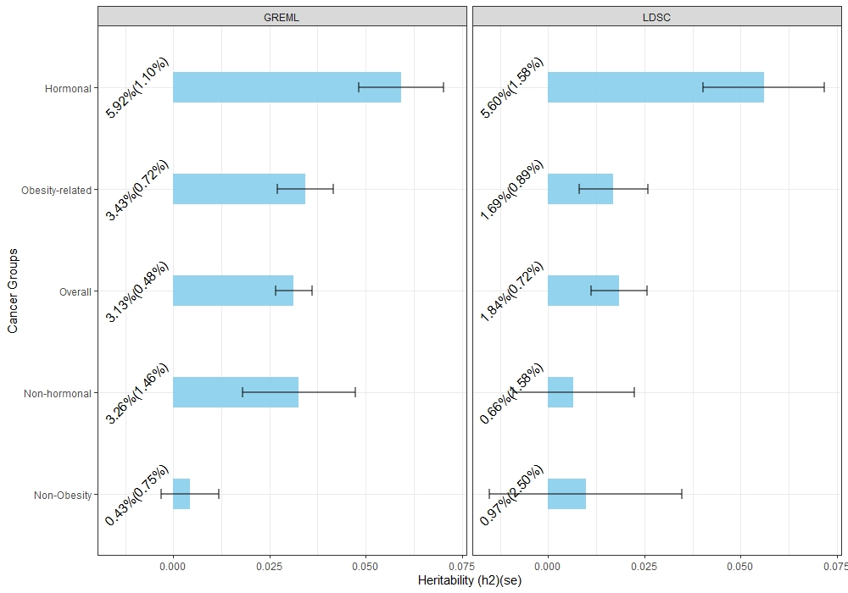 Supplementary Fig. 1: Heritability estimates for incident hormone-sensitive cancers in the UK Biobank
The panel in the left is the heritability estimate using GREML for subgroups of incident cancers indicating that the h² for newly diagnosed hormone-sensitive cancers is higher as compared to the rest of the cancer subgroupings. The panel in the right side is cancer subgrouping heritability estimates using summary statistics in LDSC method. The two panels consistently showed increased h² estimates for newly diagnosed [incident] hormone sensitive cancers. The heritability estimate with standard error are shown in the display. The error bars are the 95% CI of the estimates.

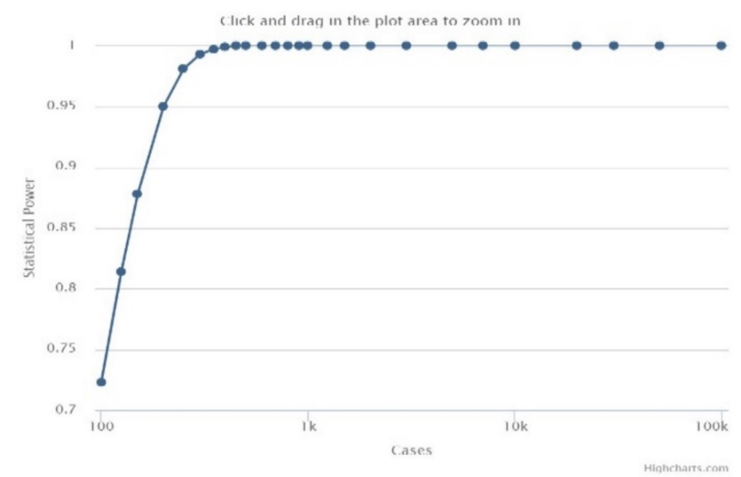

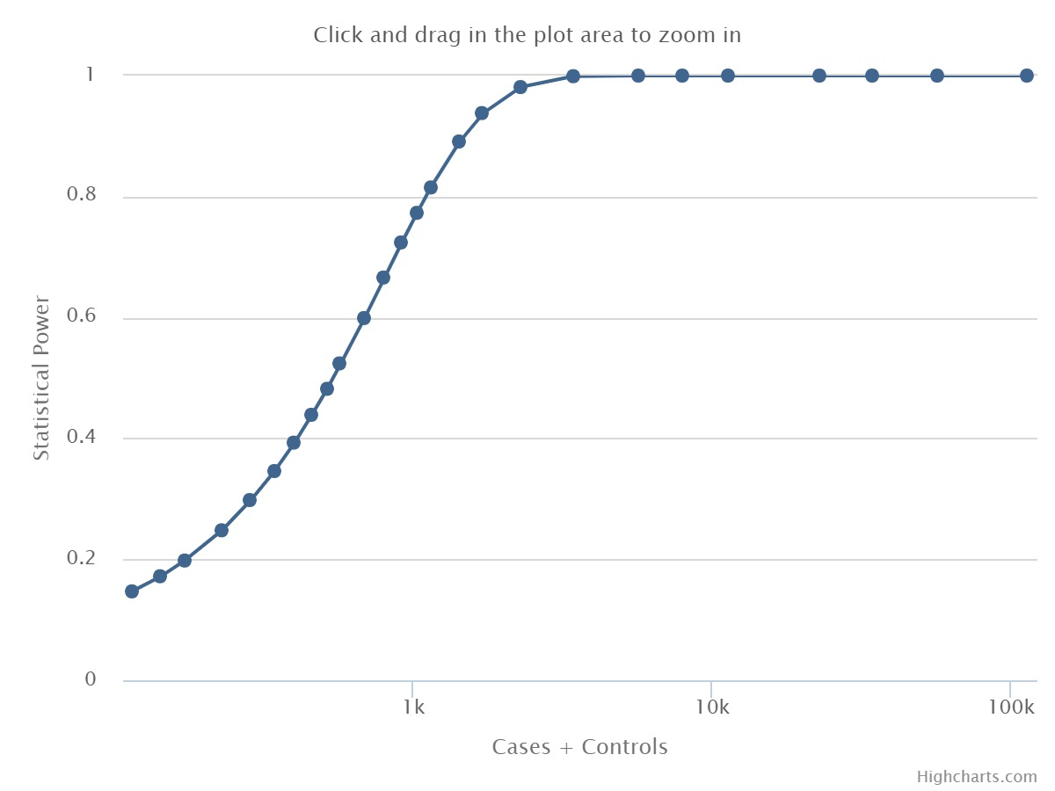

Supplementary Fig. 2: Power graph for GWAS analysis
Before the GWAS analysis, we estimate the power of the study using the genetic association study (GAS) power calculator. We applied the assumptions of number of cases and controls for hormone-sensitive cancer; the required significance level, prevalence of hormone-sensitive cancer in the sample and the disease model as additive.
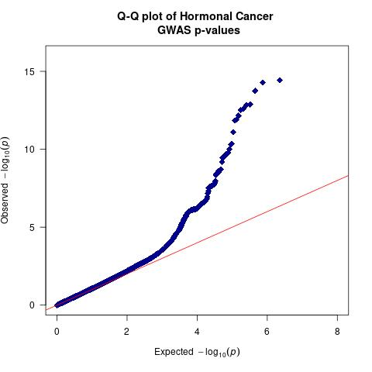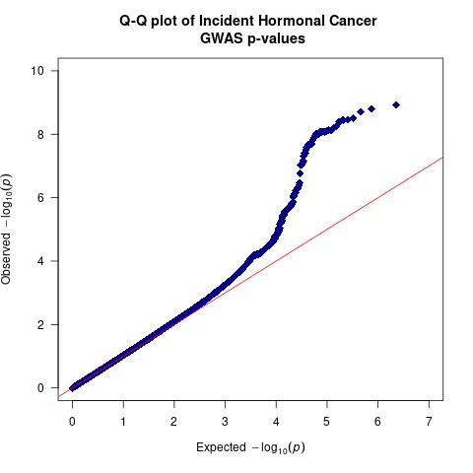
Supplementary Fig. 3: Quantile-Quantile plot of hormone-sensitive cancers association result in the UKB.
All the SNPs passed stringent quality control and all the study participants are of white British ancestry as verified by the genetic data. Panel A [the left panel] shows the overall distribution of p-values in all hormonal cancer cases. Panel B [panel in the right side] is for prospective hormonal cancer cases in the UKB. In both cases the bulk of distribution is in lower part of the graph showing the absence of inflation/deflation in the genomic inflation factor (λ).

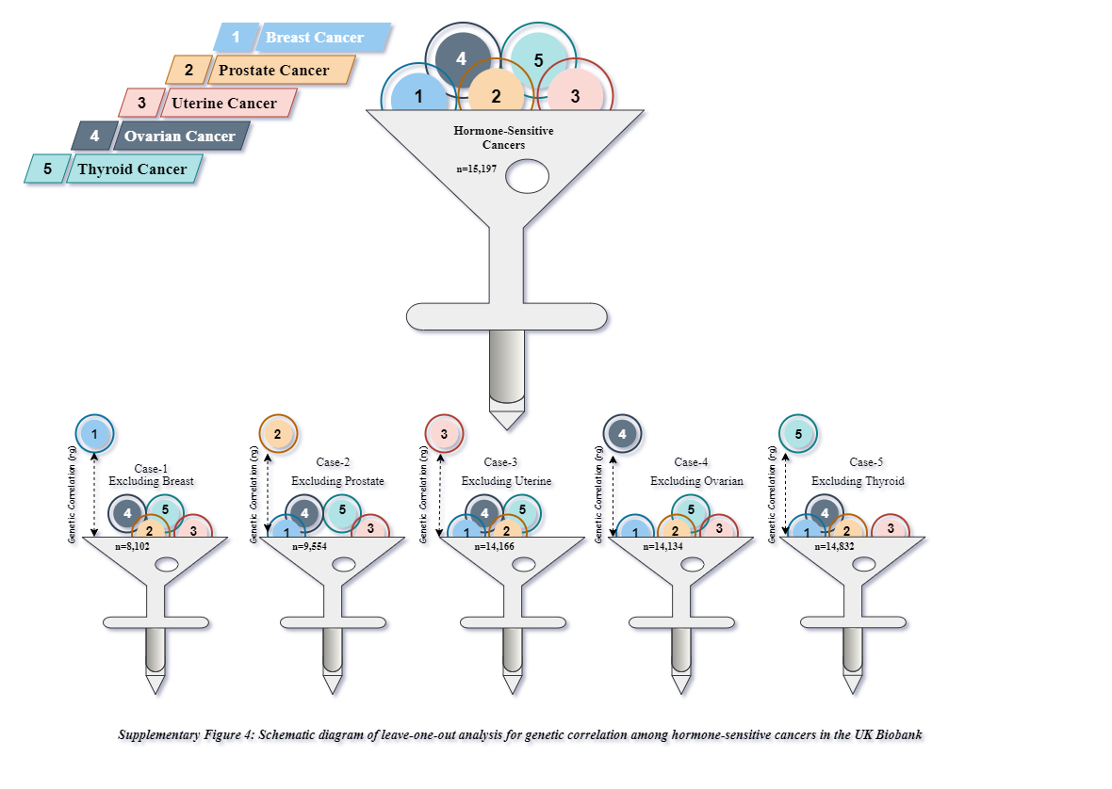

References

1. Lee SH, van der Werf JH. MTG2: an efficient algorithm for multivariate linear mixed model analysis based on genomic information. Bioinformatics. 2016;32(9):1420-2.
2. Bulik-Sullivan B, Finucane HK, Anttila V, Gusev A, Day FR, Loh PR, et al. An atlas of genetic correlations across human diseases and traits. Nat Genet. 2015;47(11):1236-41.
3. Yang JA, Lee SH, Goddard ME, Visscher PM. GCTA: A Tool for Genome-wide Complex Trait Analysis. American Journal of Human Genetics. 2011;88(1):76-82.

Supplementary Table Titles and Summaries
Supplementary Table 1: Meta-analysed SNP-based Heritability estimates using Univariate GREML for subgroups of cancer in UKB [n=288,837]
Supplementary Table 2: SNP-based Heritability estimates for subgroups of cancers in the UKB using LDSC [n=288,837]
Supplementary Table 3: Meta-analysed SNP-based Heritability estimates using univariate GREML for subgroup of incident cancers in UKB [n=288,837]
Supplementary Table 4: SNP-based Heritability estimates for subgroups of incident cancers in the UKB using LDSC [n=288,837]
Supplementary Table 5: Summary of SNP-based heritability estimates using GREML and LDSC for both all cases and Incident only cases in the UKB
Supplementary Table 6: Genome-wide significant SNP for hormone-sensitive cancers in the UKB
Supplementary Table 7: Genome-wide significant SNPs for incident hormone-sensitive cancers in the UKB
Supplementary Table 8: Phenotypic and Genetic correlation for Hormone-sensitive cancers and other non-cancer traits in the UKB using bivariate LDSC
Supplementary Table 9: GxEsum based GxE interaction estimates for incident hormone-sensitive cancers using the baseline measurement characteristics.
Supplementary table 10: Meta data for Ovarian Cancer
Supplementary table 11: Meta data for Thyroid Cancer
Supplementary Fig. 1: Heritability estimates for incident hormone-sensitive cancers in the UK Biobank
Supplementary Fig. 2: Power graph for GWAS analysis
Supplementary Fig. 3: Quantile-Quantile plot of hormone-sensitive cancers association result in the UKB
Supplementary Fig. 4: Schematic diagram of leave-one-out analysis for genetic correlation among hormone-sensitive cancers in the UK Biobank.

