Supplementary file 1
Custom made acrylic-based rhizotron units (Figure S1) were filled with a black coloured sand substrate (Flourite Black) which was sieved to have a uniform 16.67 % of its mass for each size fraction (mm): 4–2.8, 2.8–2.0, 2.0–1.4, 1.4–1, 1–0.5, 0.5–0. Leaky pipes were placed at the 2 opposite sides of the rhizotrons and irrigation cables were fitted to them to slowly saturate the rhizotrons over a series of irrigation events rather than forcing a large amount of water in turn connected to an irrigation pump (Boyu FP-1500 Adjustable Pump) in a black light-absorbing water container. The irrigation pump could then be controlled through a custom-made fitted timer to operate when required. Once the substrate had reached field capacity two pre-germinated spring barley (var. Optic) seedlings with a root length between 1–2 cm were randomly chosen and placed on top of the sand and were subsequently covered with moistened sand. The rhizotrons were then covered with a black light absorbing cloth until the termination of the experiment in three weeks. The second barley seedling was removed after 48 hours so that only one actively growing seedling remained after the initial establishment phase.

2 mm acrylic
8 mm acrylic spacer
8 mm acrylic spacer
A

0.8 mm leaky pipe
0.8 mm leaky pipe
4 mm plastic
5 mm acrylic

B

420 mm

297 mm

Figure S1: Schematic diagram of new minirhizotron design B A) Top view and B) Front view (circles indicate screws).

Supplementary file 2
The “Flourite Black Sand” came in two different size fractions both gravel (8–4 mm) and sand (4–0 mm). The gravel and the sand were first mixed in a 50:50 ratio (gravimetric) and the entire mixture was subsequently sieved at 4.0, 2.8, 2.0 and 1.4 mm to create mixtures of 4.0–2.8, 2.8–2.0, 2.0–1.4 and 1.4–0 mm respectively. Each mixture was then washed with tap water for three times and subsequently oven dried at 105 °C.
A series of cylindrically shaped (4.5 mm diameter x 5.0 mm height) repacked sand cores were packed at different dry bulk densities (1.4, 1.5 and 1.6 g cm⁻³) (n = 4). The gravimetric moisture content of each sand core was first adjusted to 20 % to give it consistency. Cores were saturated with degassed water, then subjected to a sequence of different matric suctions (5, 10, 20 and 50 kPa) via the use of sand and tension tables. A needle penetrometer (1 mm diameter, 30° cone angle, 4 mm min⁻¹ penetration rate, readings; averaged at 1–mm intervals from 5–15 mm depth range) fitted to a mechanical test frame (Instron model 5544; Instron, MA, USA), with a 50 N load cell accurate to 2 mN at maximum load, was used to measure penetration force at each matric suction and calculate penetrometer resistance (force divided by cone cross-sectional area) (69,70). The measurements of mass and penetrometer resistance enabled the estimation of the sand water release and strength curves respectively (Figure S2). This enabled an assessment of the differences between samples with contrasting physical properties and how that may affect their strength and water holding capacity.

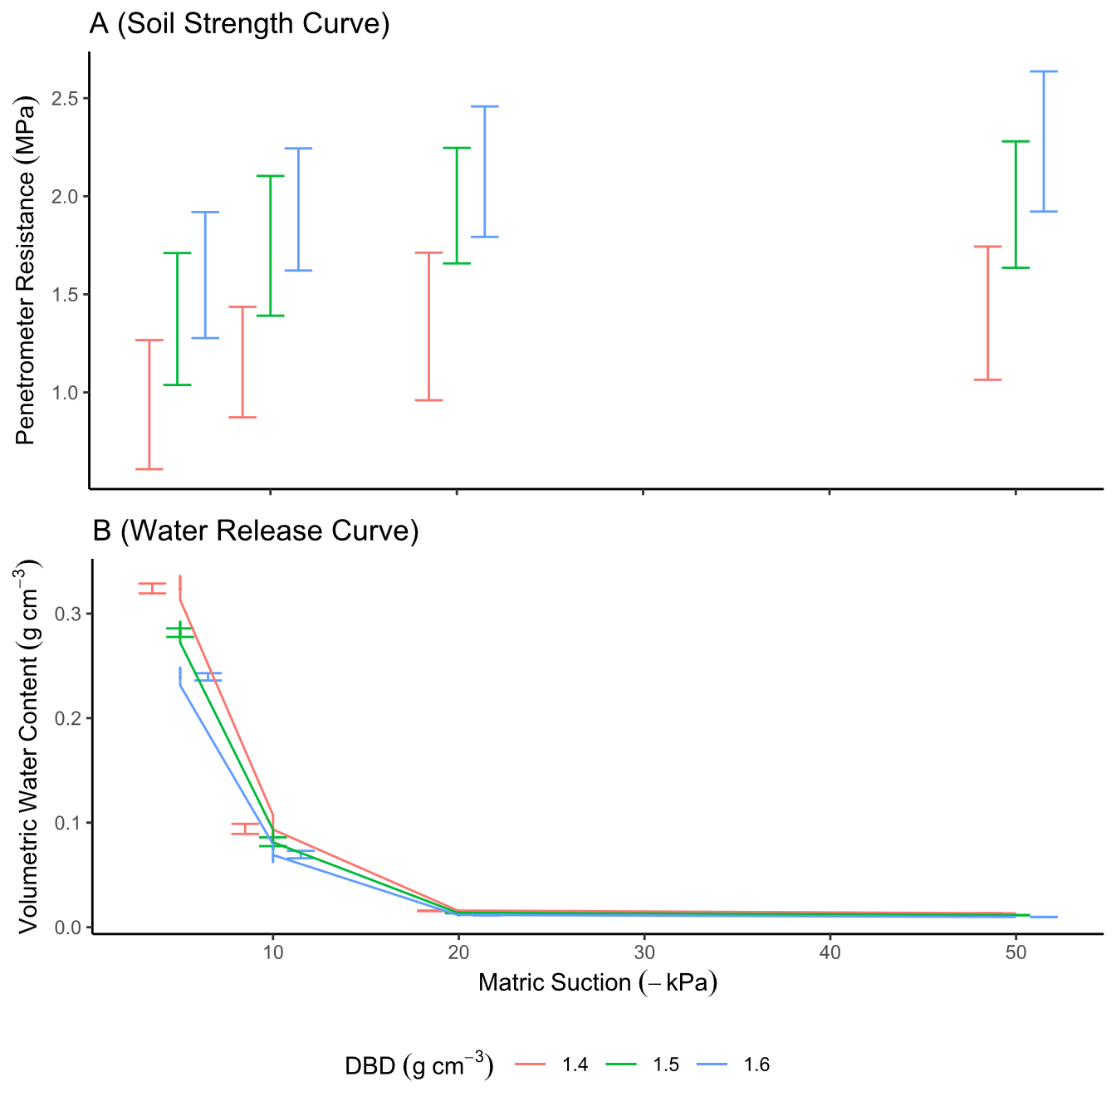
Figure S2: Sample mean ± standard deviation of rhizotron system substrate strength curves (A) and water release curves (B) for dry bulk density values of 1.4, 1.5 and 1.6 g cm⁻³ with connecting lines for the mean values.

