Extending ENSO Prediction beyond 18 Months through Stage-consistent Oceanic Internal Dynamics Based on Deep Learning

Supplementary Figures and Tables
Figure S1 Monthly time series of two strong El Niño events (2015, 2023) predicted at 1-, 6-, 9-, 12-, 15-, and 18-month lead times and monthly time series of the actual Niño3.4 index.

Figure S2 Monthly time series of two La Niña events (2017, 2021) predicted at 1-, 6-, 9-, 12-, 15-, and 18-month lead times and monthly time series of the actual Niño3.4 index.

Figure S3 Bootstrap-based significance test for differences in Hit Rate (HR) between two deep learning (DL) models and the MME (the seven models within the North American Multi-Model Ensemble [NMME]) in ENSO prediction. The bootstrapping method was employed to test the significance of HR differences (ΔHR) between two DL models (ConvTransformer and CNN) and the MME in forecasting El Niño and La Niña events: (a) error bars representing the 95% confidence intervals (CIs) of ΔHR for El Niño and La Niña events, comparing the ConvTransformer model with the MME;(b) error bars representing the 95% CIs of HRs for El Niño and La Niña events, comparing the CNN model with the MME. Open pentagrams indicate that the differences passed the 95% significance test, denoting statistically significant disparities.

Figure S4 Bootstrap-based significance test for differences in Hit Rate (HR) between ConvTransformer model and CNN model in ENSO prediction. The bootstrapping method was employed to test the significance of HR differences (ΔHR) between ConvTransformer model and CNN model in forecasting El Niño and La Niña events: error bars representing the 95% confidence intervals (CIs) of ΔHR for El Niño and La Niña events, comparing the ConvTransformer model with CNN model. Open pentagrams indicate that the differences passed the 95% significance test, denoting statistically significant disparities.

Figure S5 Bootstrap-based significance test for differences in Hit Rate (HR) between El Niño and La Niña events among ConvTransformer model and CNN model. The bootstrapping method was employed to test the significance of HR differences (ΔHR) between El Niño and La Niña events among ConvTransformer model and CNN model: error bars representing the 95% confidence intervals (CIs) of ΔHR between the two models (ConvTransformer and CNN) when comparing their forecasting performance for El Niño and La Niña events. Open pentagrams indicate that the differences passed the 95% significance test, denoting statistically significant disparities.

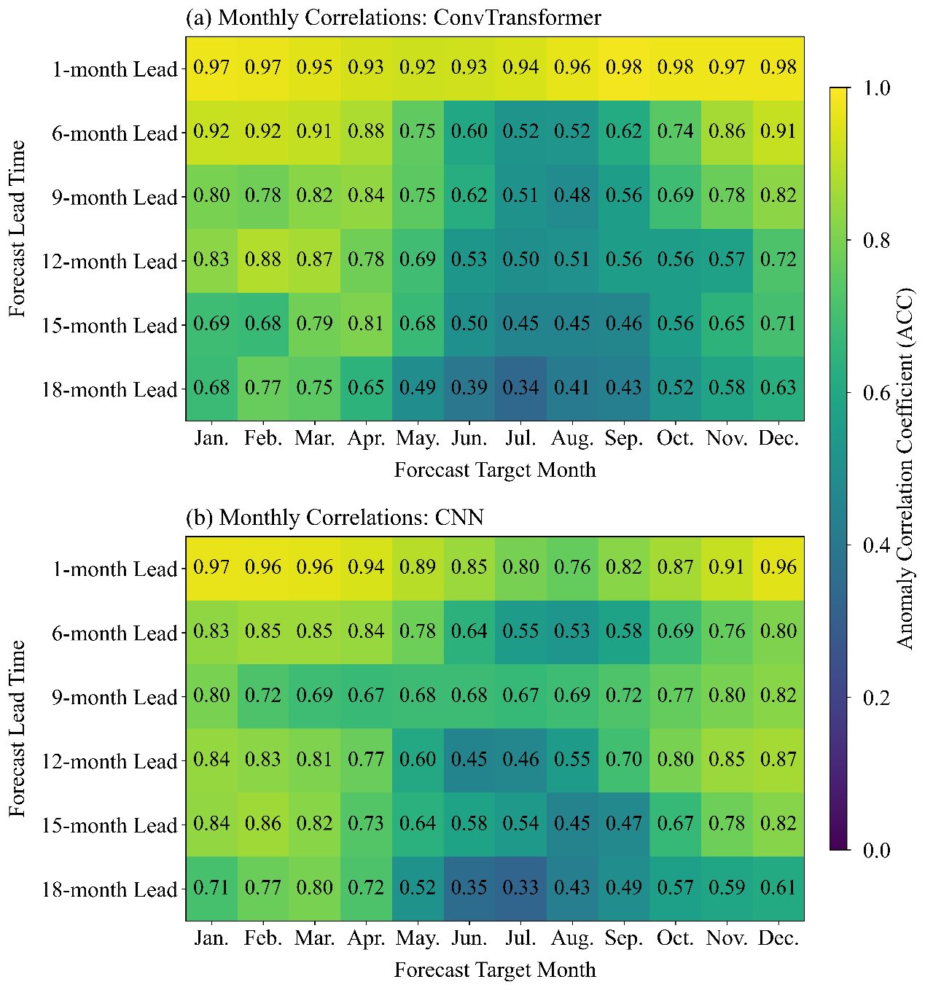
Figure S6 Monthly correlations between actual and predicted Niño3.4 index at 1-, 6-, 9-, 12-, 15-, and 18-month lead times. The bootstrapping method was employed to conduct statistical significance testing on the monthly correlations. All the correlations are statistically significant at a 95% confidence level.

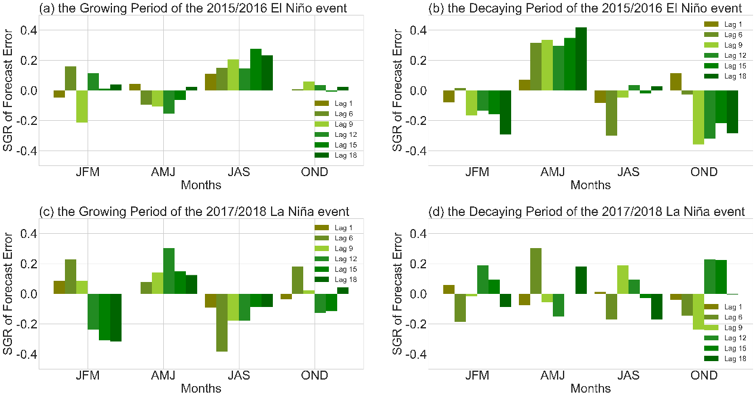
Figure S7 Seasonal growth rates of forecast errors for the 2015/2016 El Niño event and 2017/2018 La Niña event (during their respective growing and decaying periods), derived from predictions of the ConvTransformer model: (a) seasonal growth rate of forecast errors during the growing period of the 2015/2016 El Niño event;(b) seasonal growth rate of forecast errors during the decaying period of the 2015/2016 El Niño event;(c) seasonal growth rate of forecast errors during the growing period of the 2017/2018 La Niña event;(d) seasonal growth rate of forecast errors during the decaying period of the 2017/2018 La Niña event.

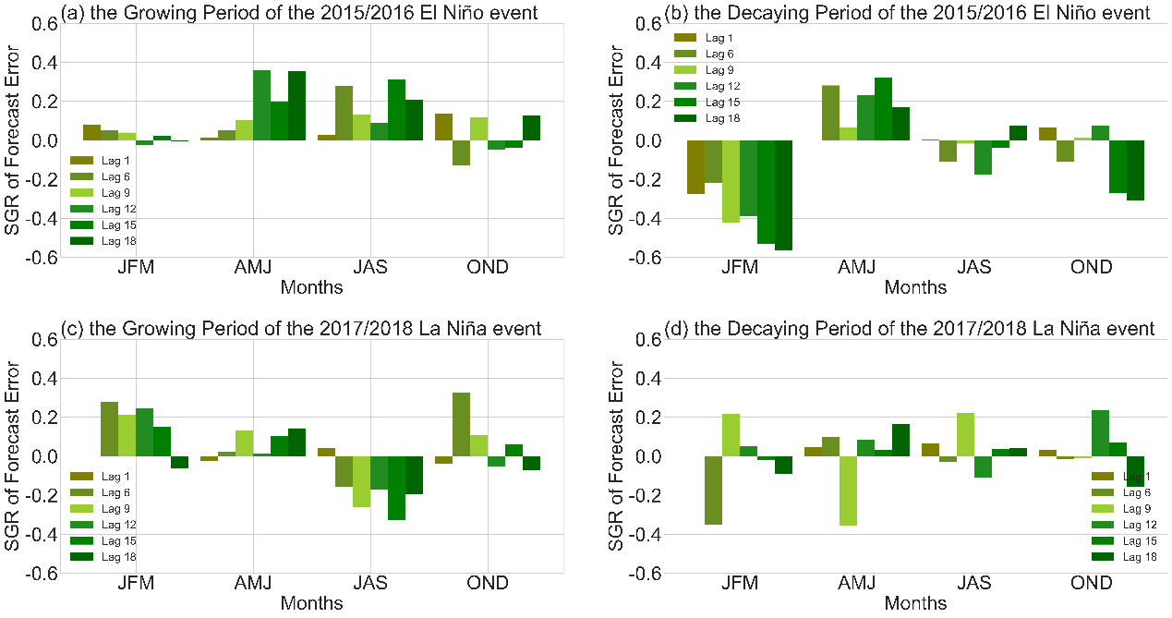
Figure S8 Seasonal growth rates of forecast errors for the 2015/2016 El Niño event and 2017/2018 La Niña event (during their respective growing and decaying periods), derived from predictions of the CNN model: (a) Seasonal growth rate of forecast errors during the growing period of the 2015/2016 El Niño event;(b) seasonal growth rate of forecast errors during the decaying period of the 2015/2016 El Niño event;(c) seasonal growth rate of forecast errors during the growing period of the 2017/2018 La Niña event;(d) seasonal growth rate of forecast errors during the decaying period of the 2017/2018 La Niña event.

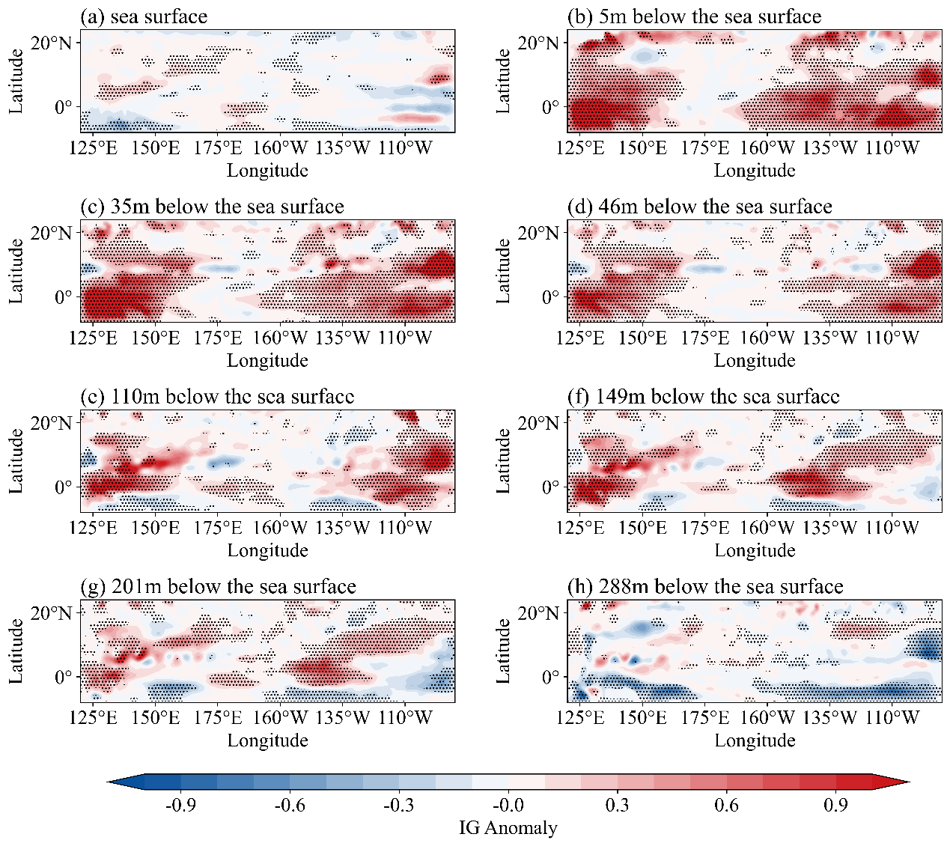
Figure S9 Composite integrated gradient (IG) maps for El Niño events (1871–1939), illustrating key characteristics of sea surface and multi-layer subsurface fields (at 5, 35, 46, 110, 149, 201, and 288 meters) during the peak stage of El Niño events that occurred between 1871 and 1939, as forecasted by ConvTransformer model at 1-month lead time. The maps were smoothed using a Gaussian filter (σ=1.0) to reduce outlier effects. Shaded regions indicate areas where attribution values exceed the 95% confidence level based on Student's t-test, highlighting statistically significant precursors for El Niño development.

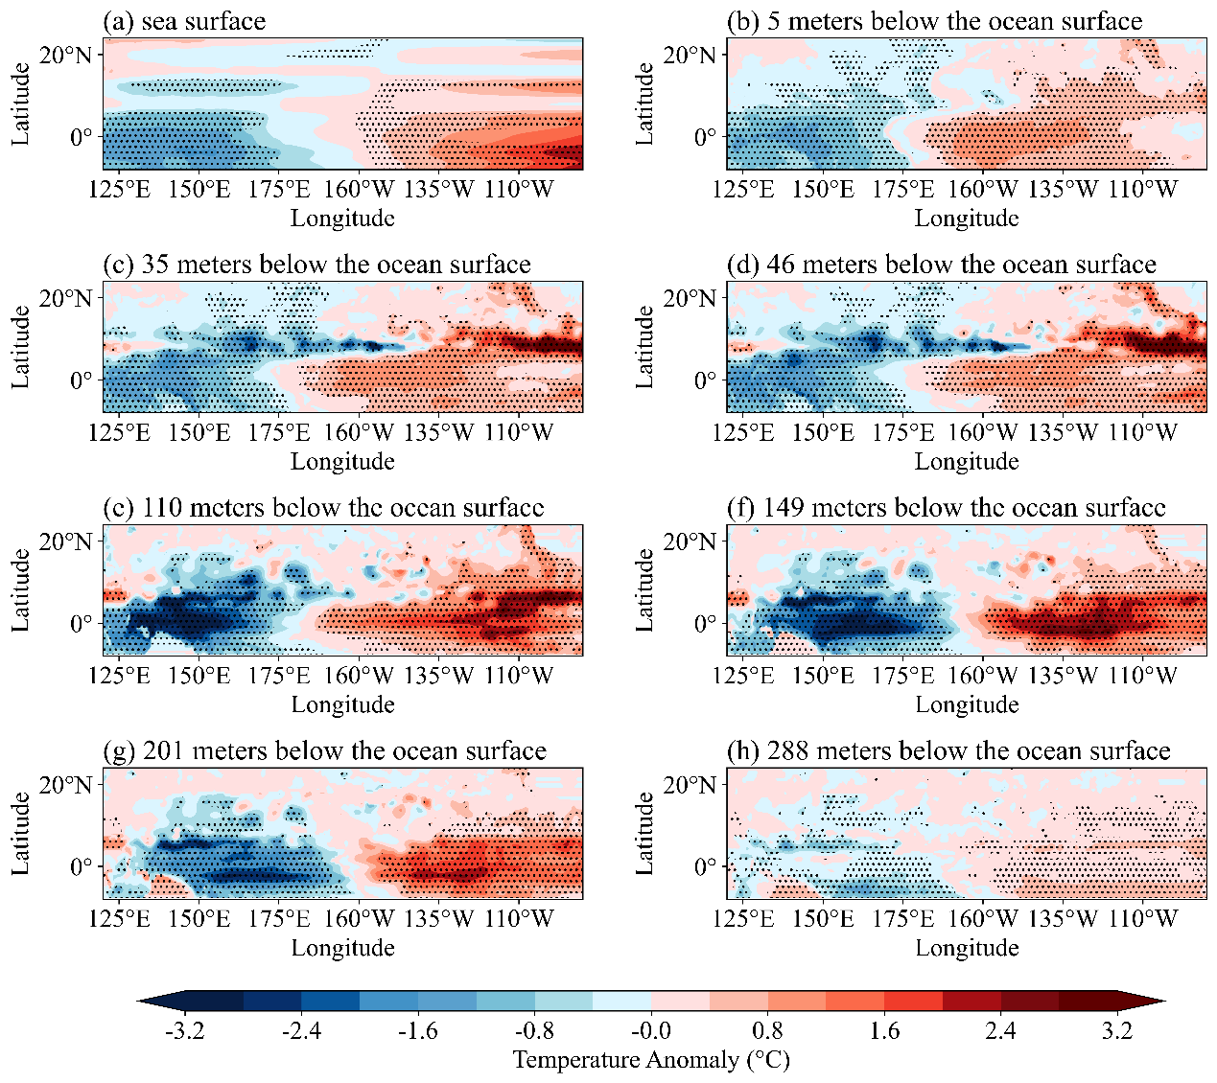
Figure S10 Composite analysis maps of sea surface and multi-layer subsurface fields (at 5, 35, 46, 110, 149, 201, and 288 meters) during the peak stage of El Niño Events (1871–1939), with the shaded areas representing regions where the values exceed the 95% confidence level.

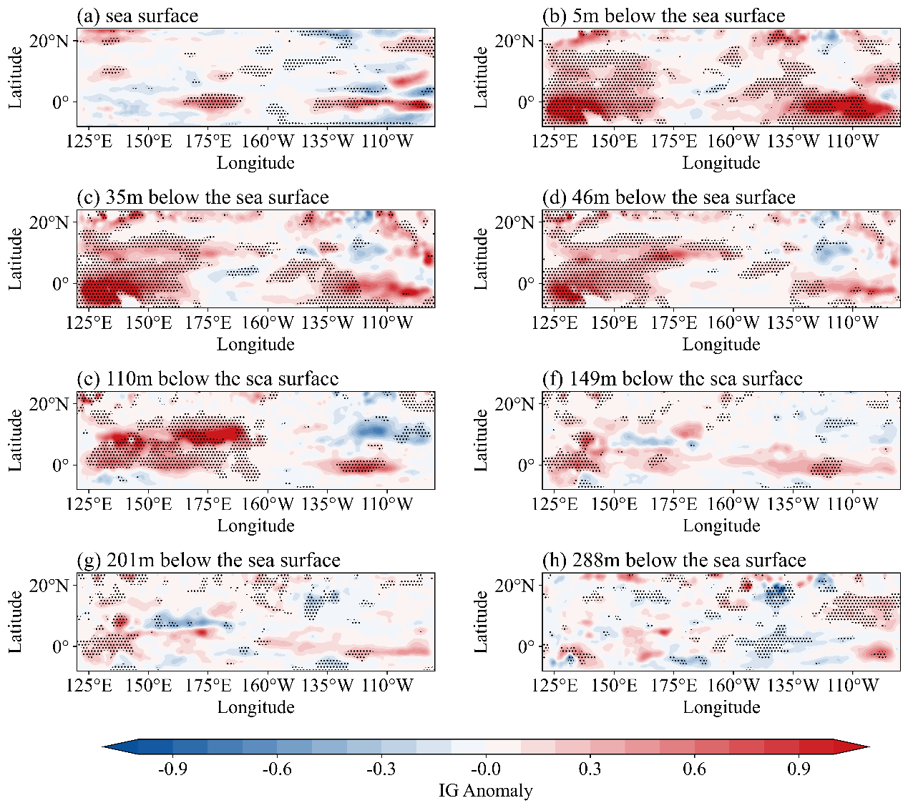
Figure S11 Composite integrated gradient (IG) maps for El Niño events (1940-1979), illustrating key characteristics of sea surface and multi-layer subsurface fields (at 5, 35, 46, 110, 149, 201, and 288 meters) during the peak stage of El Niño events that occurred between 1940 and 1979, as forecasted by ConvTransformer model at 1-month lead time. The maps were smoothed using a Gaussian filter (σ=1.0) to reduce outlier effects. Shaded regions indicate areas where attribution values exceed the 95% confidence level based on Student's t-test, highlighting statistically significant precursors for El Niño development.

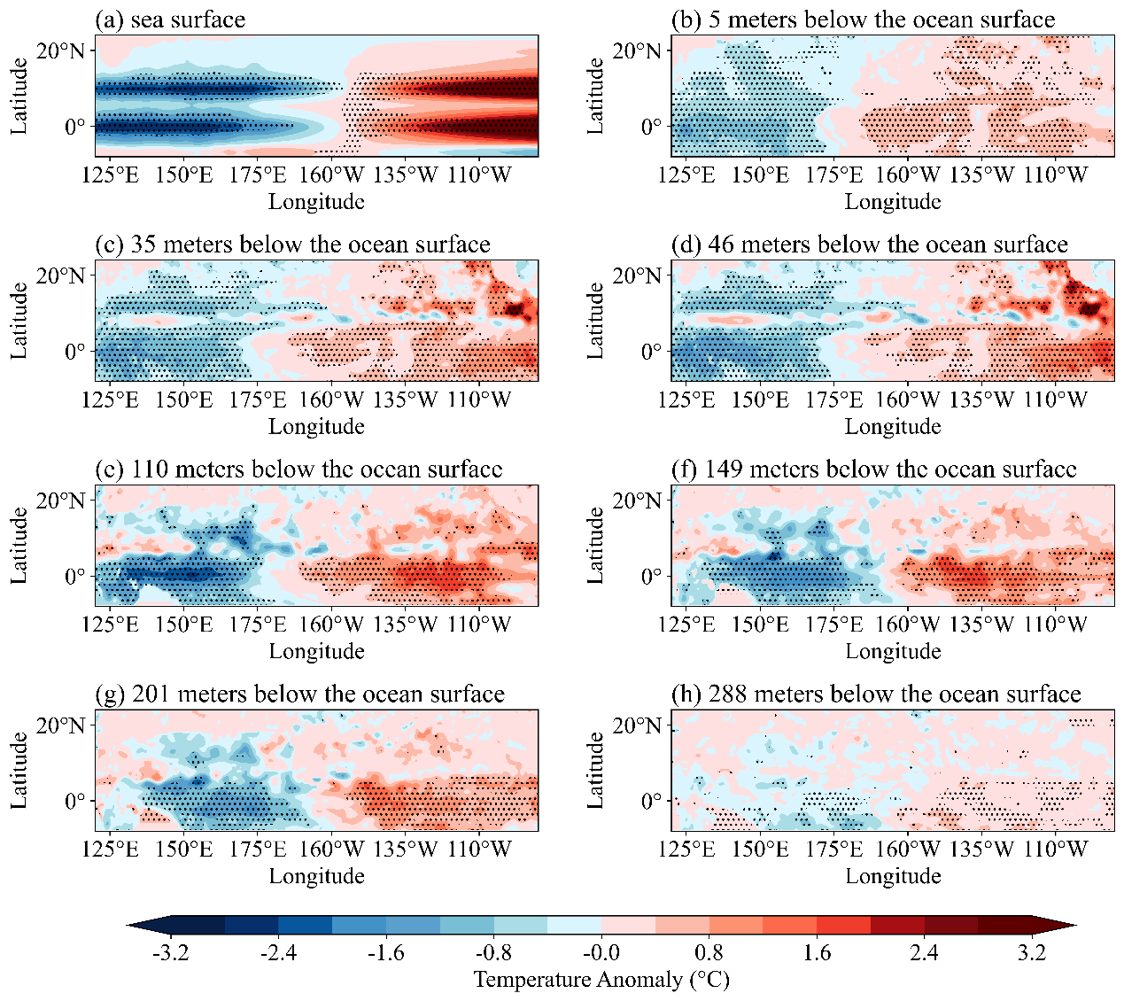
Figure S12 Composite analysis maps of sea surface and multi-layer subsurface fields (at 5, 35, 46, 110, 149, 201, and 288 meters) during the peak stage of El Niño Events (1940-1979), with the shaded areas representing regions where the values exceed the 95% confidence level.

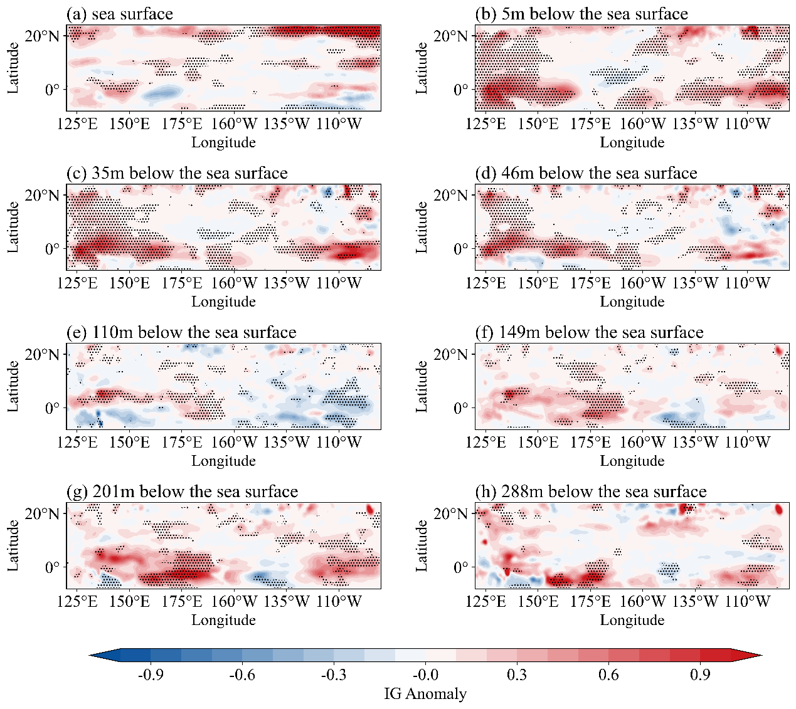
Figure S13 Composite integrated gradient (IG) maps for El Niño events (1980-2024), illustrating key characteristics of sea surface and multi-layer subsurface fields (at 5, 35, 46, 110, 149, 201, and 288 meters) during the pre-peak stage of El Niño events that occurred between 1980 and 2024, as forecasted by ConvTransformer model at 1-month lead time. The maps were smoothed using a Gaussian filter (σ=1.0) to reduce outlier effects. Shaded regions indicate areas where attribution values exceed the 95% confidence level based on Student's t-test, highlighting statistically significant precursors for El Niño development.

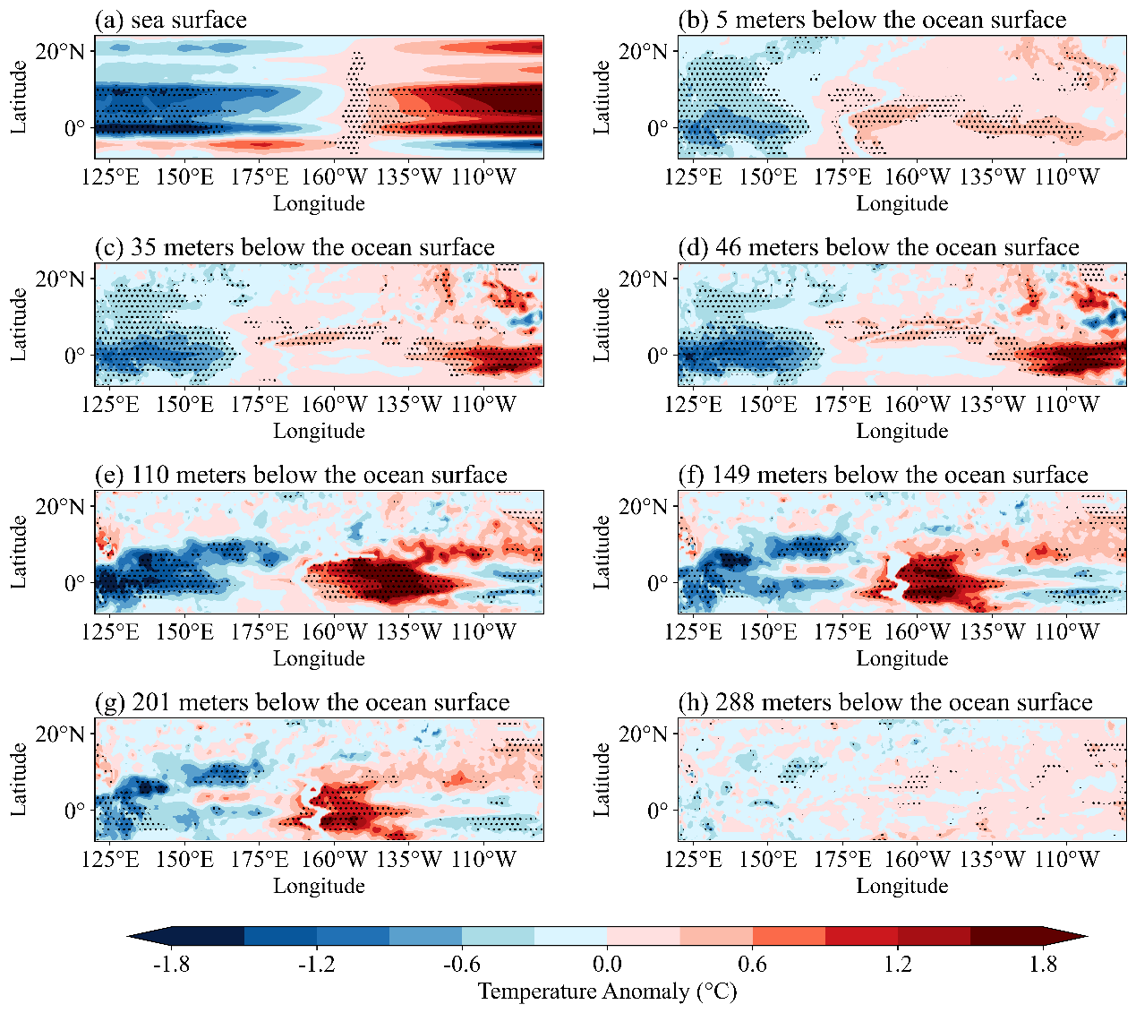
Figure S14 Composite analysis maps of sea surface and multi-layer subsurface fields (at 5, 35, 46, 110, 149, 201, and 288 meters) during the pre-peak stage of El Niño Events (1980-2024), with the shaded areas representing regions where the values exceed the 95% confidence level.
Figure S15 Sensitivity analysis of weighted RMSE under different weighting schemes for strong ENSO events. The figure shows the weighted RMSE of the ConvTransformer model, the CNN model, persistence, and the multi-model ensemble (MME) at different forecast lead times. Strong ENSO events are defined as cases with $∣Ni\tilde{n}o3.4∣>{1.0}^{∘}C$. The weight assigned to non-strong-event samples is fixed at $w_{non}=1$, whereas the weight assigned to strong-event samples is set to $w_{ext}=2$, 3, and 5. Different line styles denote different weighting schemes, and the shaded regions indicate the range of weighted RMSE variations for the same model across the different weight settings.

Model | Forecast Lead Time (months) | HR  (El Niño) | HR  (La Niña) | FAR  (El Niño) | FAR  (La Niña) | CSI  (El Niño) | CSI  (La Niña)
ConvTransformer | 1 | 0.70 | 1.00 | 0.12 | 0.51 | 0.64 | 0.49
ConvTransformer | 6 | 0.94 | 0.85 | 0.05 | 0.22 | 0.88 | 0.62
ConvTransformer | 9 | 0.88 | 0.76 | 0.09 | 0.22 | 0.78 | 0.59
ConvTransformer | 12 | 0.80 | 0.76 | 0.10 | 0.22 | 0.69 | 0.63
ConvTransformer | 15 | 0.67 | 0.68 | 0.22 | 0.07 | 0.51 | 0.64
ConvTransformer | 18 | 0.85 | 0.67 | 0.30 | 0.37 | 0.55 | 0.62
CNN | 1 | 0.73 | 0.79 | 0.20 | 0.25 | 0.61 | 0.63
CNN | 6 | 0.79 | 0.59 | 0.11 | 0.31 | 0.70 | 0.44
CNN | 9 | 0.76 | 0.65 | 0.18 | 0.40 | 0.66 | 0.43
CNN | 12 | 0.68 | 0.65 | 0.22 | 0.27 | 0.56 | 0.49
CNN | 15 | 0.69 | 0.70 | 0.16 | 0.08 | 0.59 | 0.67
CNN | 18 | 0.74 | 0.65 | 0.00 | 0.14 | 0.74 | 0.58
MME | 1 | 0.75 | 0.74 | 0.10 | 0.16 | 0.69 | 0.65
MME | 6 | 0.66 | 0.65 | 0.24 | 0.19 | 0.55 | 0.57
MME | 9 | 0.66 | 0.66 | 0.32 | 0.23 | 0.51 | 0.57
MME | 12 | 0.54 | 0.58 | 0.38 | 0.24 | 0.42 | 0.50
Table S1 Hit Rate (HR), False Alarm Rate (FAR), and Critical Success Index (CSI) for predicting ENSO events for deep learning models (ConvTransformer and CNN) and MME (the seven-model ensemble of the North American Multi-Model Ensemble [NMME]). An event can either be El Niño or La Niña. Hence the prediction is considered accurate only when it aligns with the sign and magnitude of the actual event. The thresholds for calculating the ENSO events were ±0.5. The bootstrapping method was employed to conduct statistical significance testing on the HR, FAR, and CSI values derived from the two deep learning models. All metric values passed the test at the 95% confidence level.

Model | Forecast Lead Time (months) | HR  (El Niño) | HR  (La Niña) | FAR  (El Niño) | FAR  (La Niña) | CSI  (El Niño) | CSI  (La Niña)
ConvTransformer | 1 | [0.53, 0.85] | [1.00, 1.00] | [0.00, 0.25] | [0.40, 0.63] | [0.48, 0.79] | [0.37, 0.60]
ConvTransformer | 6 | [0.84, 1.00] | [0.72, 0.97] | [0.00, 0.13] | [0.12, 0.33] | [0.76, 0.97] | [0.48, 0.75]
ConvTransformer | 9 | [0.76, 0.97] | [0.62, 0.90] | [0.02, 0.18] | [0.11, 0.35] | [0.64, 0.91] | [0.44, 0.73]
ConvTransformer | 12 | [0.65, 0.92] | [0.61, 0.90] | [0.02, 0.20] | [0.09, 0.38] | [0.54, 0.83] | [0.49, 0.78]
ConvTransformer | 15 | [0.51, 0.82] | [0.51, 0.83] | [0.11, 0.33] | [0.00, 0.19] | [0.37, 0.65] | [0.47, 0.79]
ConvTransformer | 18 | [0.72, 0.95] | [0.51, 0.83] | [0.20, 0.41] | [0.00, 0.75] | [0.42, 0.67] | [0.46, 0.77]
CNN | 1 | [0.57, 0.88] | [0.65, 0.92] | [0.07, 0.35] | [0.12, 0.40] | [0.46, 0.76] | [0.48, 0.77]
CNN | 6 | [0.64, 0.92] | [0.42, 0.75] | [0.02, 0.21] | [0.16, 0.41] | [0.55, 0.84] | [0.30, 0.59]
CNN | 9 | [0.60, 0.90] | [0.48, 0.81] | [0.04, 0.33] | [0.25, 0.55] | [0.50, 0.80] | [0.29, 0.57]
CNN | 12 | [0.52, 0.83] | [0.48, 0.81] | [0.08, 0.38] | [0.14, 0.42] | [0.41, 0.71] | [0.34, 0.64]
CNN | 15 | [0.54, 0.84] | [0.55, 0.85] | [0.05, 0.29] | [0.00, 0.21] | [0.44, 0.74] | [0.50, 0.82]
CNN | 18 | [0.60, 0.88] | [0.47, 0.80] | [0.00, 0.00] | [0.03, 0.29] | [0.60, 0.88] | [0.41, 0.73]
MME | 1 | [0.67, 0.82] | [0.66, 0.81 | [0.05, 0.17] | [0.10, 0.23] | [0.61, 0.77] | [0.57, 0.72]
MME | 6 | [0.58, 0.74 | [0.57, 0.73] | [0.16, 0.32] | [0.12, 0.26] | [0.47, 0.63] | [0.49, 0.64]
MME | 9 | [0.57, 0.74] | [0.58, 0.74] | [0.24, 0.41] | [0.15, 0.32] | [0.43, 0.59] | [0.49, 0.64]
MME | 12 | [0.45, 0.63] | [0.49, 0.65] | [0.29, 0.48] | [0.15, 0.33] | [0.35, 0.50] | [0.43, 0.58]
Table S2 During the test period, based on 10,000 bootstrap replications, the interquartile range confidence intervals of Hit Rate (HR), False Alarm Rate (FAR), and Critical Success Index (CSI) for El Niño and La Niña events, predicted by the ConvTransformer model, CNN model, and Multi-Model Ensemble (MME) at different forecast lead times, against the observed Niño3.4 index.

Period | Datasets | Time (month/year)
Training | HadISST1 | 1871.1-1996.12
Training | SODA2.2.4 | 1871.1-1996.12
Training | SODA3.15.2 | 1980.1-1996.12
Validation | HadISST1 | 1997.1-2010.12
Validation | SODA3.15.2 | 1997.1-2010.12
Testing | HadISST1 | 2011.1-2024.12
Testing | SODA3.15.2 | 2011.1-2024.12

Table S3 Datasets used to train, validate and test models.

Models | Forecast Lead (months) | Memberships | Resolution
CCSM4 | 12 | 10 | 1*1
CESM1 | 12 | 10 | 1*1
CanCM3 | 12 | 10 | 1*1
GEM-NEMO | 12 | 10 | 1*1
GFDL-FLOR-A06 | 12 | 12 | 1*1
GFDL-FLOR-B01 | 12 | 12 | 1*1
NCEP-CFSv2 | 10 | 24 | 1*1
Table S4 Basic information about the NMME model used in this study.

