Supplementary Tables

Table S1 Experimental characteristics of the overall group and the age subgroups.
 | Overall group  (N = 60) |  | < 1 year  (N = 37) |  | > 1 year  (N = 23) |  | Age group  comparison
 | Mean | SD | Mean | SD | Mean | SD | T₅₈ | P
Age (days) | 366 | 64 | 324 | 26 | 434 | 46 | -11.92 | <0.001
Wake time before encoding* (min) | 177.7 | 77.3 | 153.4 | 94.0 | 216.8 | 67.0 | -3.345 | 0.001
Sleep latency (from encoding, min) | 26.3 | 15.6 | 25.9 | 15.5 | 26.8 | 16.2 | -0.200 | 0.842
Retention period (min) | 98.5 | 33.2 | 94.3 | 29.5 | 105.2 | 38.2 | -1.244 | 0.218
Nap duration (parents’ report, min) | 55.1 | 26.4 | 52.9 | 26.0 | 58.6 | 27.2 | -0.818 | 0.416
* Time between the end of the last sleep and the begin of the encoding phase

Table S2 Nap characteristics of the groups included in the sleep analyses.
 | Overall group  (N = 48) |  | < 1 year  (N = 29) |  | > 1 year  (N = 19) |  | Age group  comparison
 | Mean | SD | Mean | SD | Mean | SD | T₄₆ | P
N1 (min) | 6.01 | 4.79 | 5.76 | 5.43 | 6.40 | 3.71 | -0.446 | 0.658
N2 (min) | 22.22 | 17.04 | 19.81 | 14.68 | 25.90 | 19.98 | -1.216 | 0.230
N3 (min) | 23.01 | 11.34 | 23.79 | 11.34 | 21.82 | 11.55 | 0.587 | 0.560
REM (min) | 6.14 | 7.74 | 6.03 | 7.41 | 6.29 | 8.42 | -0.110 | 0.913
Total sleep time (min) | 57.38 | 26.12 | 55.40 | 26.06 | 60.40 | 26.63 | -0.644 | 0.523
Nap duration (parents’ report, min) | 56.65 | 27.17 | 54.31 | 26.98 | 60.21 | 27.81 | -0.686 | 0.496

Table S3 Nap characteristics of the coupling subgroups.
 | Weak coupling |  | Strong coupling |  | Group comparison
 | Mean | SD | Mean | SD | T₄₆ | P
N1 (min) | 6.35 | 5.80 | 5.67 | 3.614 | 0.493 | 0.624
N2 (min) | 22.67 | 14.39 | 21.77 | 19.64 | 0.180 | 0.858
N3 (min) | 22.63 | 11.77 | 23.40 | 11.14 | -0.233 | 0.817
REM (min) | 7.98 | 7.55 | 4.29 | 7.63 | 1.682 | 0.099
Total sleep time (min) | 59.62 | 26.55 | 55.12 | 26.05 | 0.593 | 0.556
Nap duration (parents’ report, min) | 59.75 | 26.60 | 54.00 | 27.88 | 0.731 | 0.468

Table S4 Sleep spindle characteristics of the coupling subgroups (at Cz).
 | Weak coupling |  | Strong coupling |  | Group comparison
 | Mean | SD | Mean | SD | T₄₆ | P
Spindle number | 94.46 | 58.09 | 88.79 | 42.42 | 0.386 | 0.701
Spindle density (per 30 s) | 1.19 | 0.36 | 1.18 | 0.20 | 0.135 | 0.893
Spindle duration (s) | 1.15 | 0.18 | 1.09 | 0.10 | 1.545 | 0.129
Spindle peak-to-peak amplitude (µV) | 43.09 | 14.15 | 47.67 | 13.17 | -1.167 | 0.249
Proportion within 1.5 s  before SO downstate peak* (%) | 16.27 | 4.52 | 14.27 | 4.92 | 1.465 | 0.150
Proportion within 1.5 s  after SO downstate peak** (%) | 16.52 | 6.60 | 21.39 | 6.09 | -2.657 | 0.011
* Number of spindles occurring within 1.5 s before the SO downstate peak, relative to the total number of spindles.
** Number of spindles occurring within 1.5 s after the SO downstate peak, relative to the total number of spindles.

Supplementary Figures
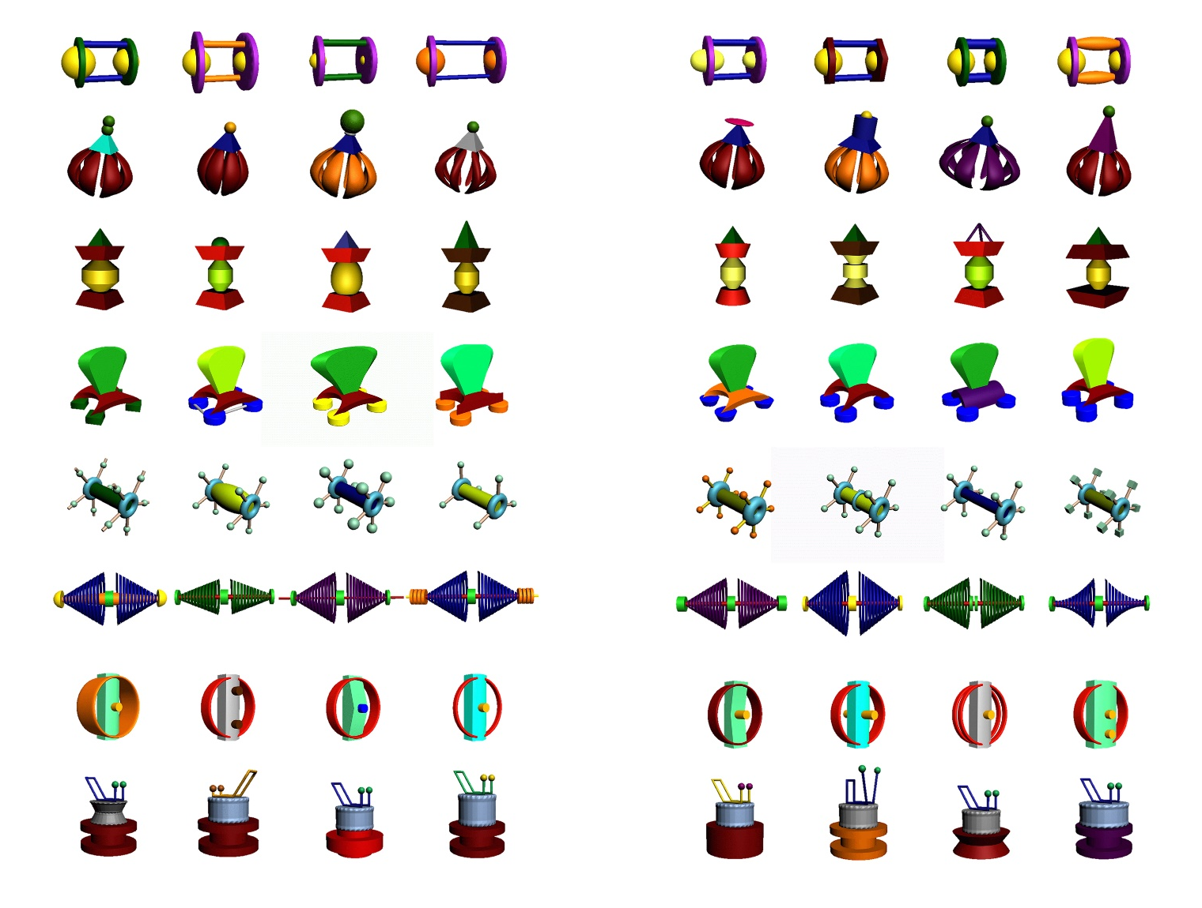
a b

Fig. S1 Visual stimulus material. The eight objects of a category (row) were assigned to two object sets (a and b) each with four objects (per category). In the encoding phase, only objects from one set were presented, with the sets being balanced between subjects. In the memory test, objects from both sets were presented, representing old and new objects, respectively.

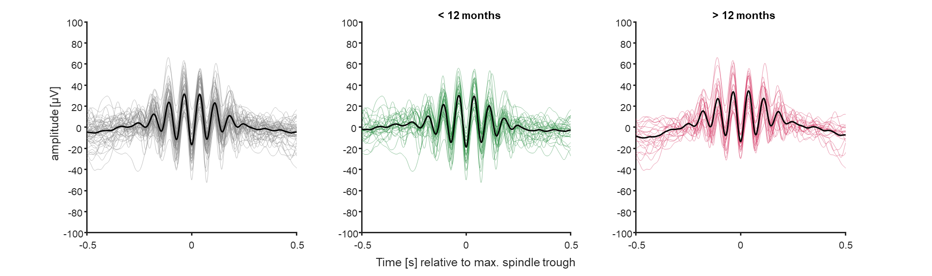
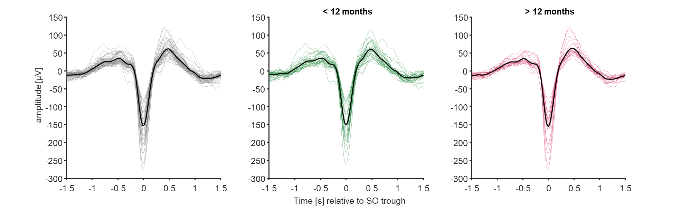
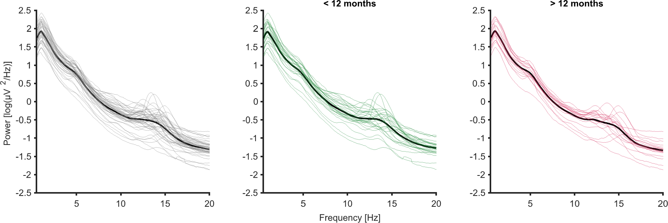
b
a
c
Time relative to SO trough (s)
Time relative to maximal trough (s)
Frequency (Hz)

Fig. S2 Characteristics of infants’ brain activity during NREM sleep in the nap (at Cz). a EEG power spectra. b Slow oscillations (with ‘0 s’ indicating the time of the SO negative half-wave peak). c Sleep spindles (‘0 s’ indicating maximum spindle trough). Individual values in grey, means in black.

