Table 1
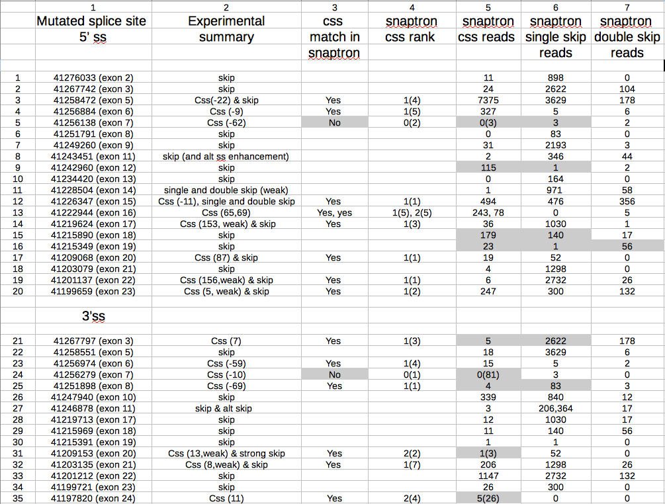

Table 2
Summary of DBASS aberrant splicing events
DBASS5 DBASS3
Css 459 182
Css (unusual) 15 41
De novo css (created) 34 123
De novo css (enhanced) 95 10
Pseudoexon activation 71 10
Pseudoexon activation (unusual ) 14 6

Table 3
5’css No. of css No that match Top match Poor match Source
analysed snaptron bss

DBASS5 237 201 (85%) 150 9 Table S3
DBASS5* 14 11 10 2 Table S6
BRCA1 10 9 8 1 Table 1
BRCA2 5 4 2 1 Table S4
DMD 13 4 1 5 Table S5

3’css
DBASS3 110 97 (88%) 62 2 Table S3
DBASS3* 41 40 33 0 Table S6
BRCA1 7 6 4 1 Table 1
BRCA2 13 10 6 2 Table S4
DMD 9 6 2 1 Table S5

Table 4
Snaptron data.
1 2 3 4 5
Experimental skip>css css>skip Total css Total skip
results reads reads reads reads
DBASS5 (Table S3)
39 css + skip 27 12 13578 251128
71 css only 11 60 122761 6621
DBASS3 (Table S3)
22 css + skip 12 10 15839 31596
18 css only 2 16 42516 2666
5’ skip database
(Table S7)
79 skip only 71 8 5978 198372
3 skip + css 1 2 9395 2852
3’ skip database
(Table S7)
64 skip only 54 10 17346 349439
4 skip + css 1 3 1939 3185

Table 5 Multi-exon skipping events.
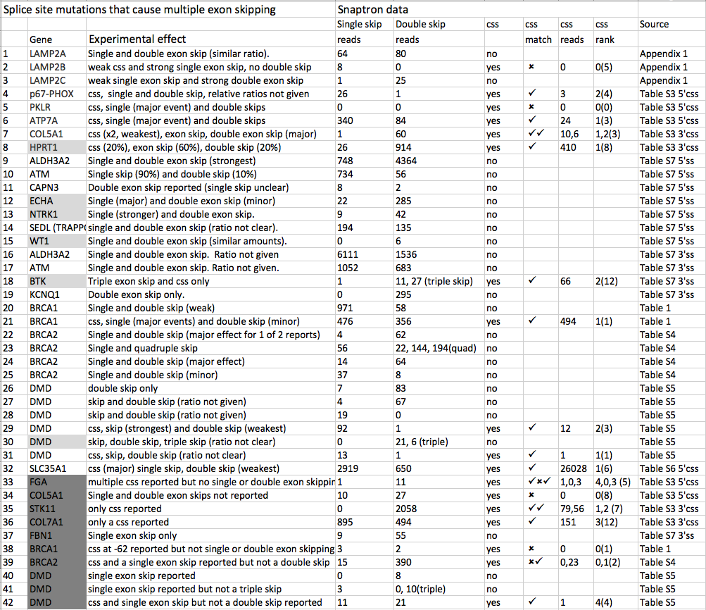

Table 6. Snaptron matches to de novo and pseudo splice sites

De novo De novo
Created Enhanced 3'pss 5'pss
1. 5'de novo ss 0(34) 29(40)
2. 3'de novo ss 0(123) 8(10)
3. 5’de novo 3’pss 0(35) 31(36) 59(71)
4. 3'de novo 5’pss 0(20) 1(2) 10(22)
5. Unusual pseudoexon 25(26) 25(26)

Table 7 Spliceosome mutations and cancer

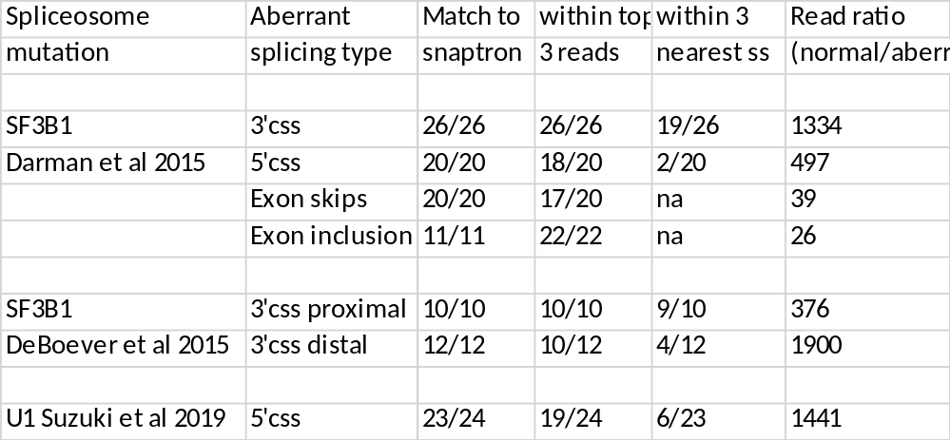

Table 8 recursive splice sites

Recursive splice sites | Snaptron match | Top rank
Kelly et al 2016 3'RS | 20/20 | 12/20
Gazzoli et al 2016 3'RS | 58/71 | 26/36
Gazzoli et al 2016 5'RS | 66/77 | 27/36

