Appendix 1.
The examples discussed here do not fit well into the format of Table S3 because the results are more complex. What most of these examples have in common (see below) is the activation of exon skipping that also involves the activation of css at a considerable distance from the ss mutation (which is unusal). Often the activated css are of the opposite splice to the mutated splice site ie a 3’css activated by a 5’ss mutation or a 5’css activated by a 3’ss mutation (this is also unusual). The css differ in strengh from weak to strong to exclusive use, as indicated. Overall our standard method of analysis (Fig 1D and text) was good at predicting the exon skips. However, we needed to introduce a secondary analysis to identify the exon skips caused by css activation.

AGL
3’ssExon 34 weak css
Exon 32 5’ss
Exon 33 5’ss

CDKN2A
3’ssExon 2 exclusive 3’css
β5’ss
Exon 1α 5’ss

COLQ
3’ssExon 17 weak css
Exon 16 5’ss
Exon 15 5’ss

EVC
3’ssExon 4 exclusive css
Exon 2 5’ss
Exon 3 5’ss

F8
3’ssExon 16 exclusive css
Exon 14 5’ss
Exon 15 5’ss

INVS
Exon 12 5’ss
Exon 13 5’ss
3’ssExon 14 strong css

TYMP
Exon 1 5’ss
3’ssExon 2
3’ssExon 3 exclusive css

XPA
Exon 2 5’ss
Exon 3 5’ss
3’ssExon 5 css strength not clear
3’ssExon 4
1
2
3

Exon 2 5’ss
Exon 3 5’ss
3’ssExon 5
3’ssExon 4
4

The secondary analysis suggested itself from the similar patterns seen for AGL, and INVS (and F8 to some extent). The primary analysis is as normal (Fig 1D), which led in all three cases to the identification of the 5’ss of the first exon as likely to be involved in aberrant exon skipping (see below). The secondary analysis looks for all of the partner ss of the 5’ss of the first exon in order to identify any other sites that might also be involved in the exon skipping result. For XPA and TYMP, which have mutations of the 3’ss, we did a similar secondary analysis of the 3’ss of the last exon. The COLQ css were identified by the primary analysis only but we also did a secondary analysis as a control. There was no real agreement between the CDKN2A experimental results and the snaptron data. LAMP2 is illustrated at the end of the appendix. It is an example of a splicing mutation that causes complicated exon skipping rather than css activation.

AGL
http://www.dbass.org.uk/DBASS3/viewsplicesite.aspx?id=258
Table S2 row 151

The authors report that mutation of the 5’ss of exon 33 caused it to be skipped by splicing between exons 32 and 34 plus they also reported a minor skipping event between exon 32 and a 3’css in exon 34.

3’ssExon 34
Exon 32 5’ss
Exon 33 5’ss

The mutated 5’ss (shown in red) CCTgt aa(g>a)a is 100382054 (hg 19) and its partner 3’ss of exon 34 is 100382153. We would normally look for the background 5’ss partners of 3’ss 100382153 in order to predict the likely effect of this mutation. These are shown below and as can be seen the single exon skip (in yellow) has the most reads of all of the background splice sites (290 reads, column O), so this part of the analysis agrees with the author’s results.

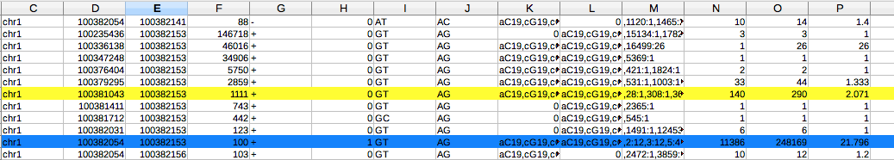

We sometimes find it useful to look at the partners of a mutated splice site in case there is a strong ass that would also need to be analysed. The partners of the 5’ss of exon 33 (100382054) are listed below.

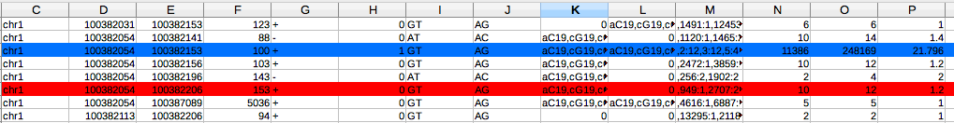

It can be seen that the 3’css identified by the authors (100382206, in red) is one of the bss for the 5’ss of exon 33 . This analysis indicates that the bss 100382206 would be a strong candidate for activation if the 3’ss of exon 34 was mutated but does not really explain why it is involved in the skipping of exon 33 as a result of mutation of the 5’ss of exon 33 (see diagram). The rows in column G marked – are from the opposite strand to AGL and can be ignored.

As a secondary analysis we looked at background reads involving the 5’ss of exon 32

This analysis again shows that there are 290 reads between exon 32 and the 3’ss of exon 34 and also shows 1 read between exon 32 and the 3’css discovered by the authors. Our working assumption is that this ratio of 290:1 will approximate to the ratio of skipping involving the 3’ss and 3’css of exon 34.

Consequently, snaptron shows that the css identified by the authors by careful experimentation is an active bss that splices to the 5’ss of exon 33 (12 reads) and the 5’ss of exon 32 (1 read). This is hardly a strong prediction for exon skipping by this 3’css but is consistent with the finding that it was only detected as a relatively faint RT-PCR band compared to skipping via the 3’ss of exon 34.

CDKN2A

http://www.dbass.org.uk/DBASS5/viewsplicesite.aspx?id=32
Table S2 row 138.

CDKN2A
3’ssExon 2 exclusive css
β5’ss
Exon 1α 5’ss

The authors report that mutation of the 5’ss of exon 1β (21994137) causes the activation of a 5’css 12 bases before the start of exon 1β (21994341) which then splices to a 3’css in exon 2 (21970939). For this gene exons 1β and 1α both splice to exon 2 in a mutually exclusive fashion (explained by the authors). We therefore first looked for the 5’ss partners of the 3’ss of exon 2 (21971208), rather than the partners of the 3’ss of exon 1α. As expected there were most reads between exon 2 and the alternative 5’ss of exons 1β and 1α. There were also 63 further 5’bss partners for exon 2, with a range of reads from 1 to over 11,000. None of these 5’bss matched the 5’css reported by the authors (21994341). An unrestricted search for this 5’css showed that it matched a bss with single reads to 3 different 3’bss (but not to the 3’ss of exon 2 nor to the 3’css the authors discovered). The 3’css reported by the authors (21970939) matched a 3’bss within the snaptron database with low reads to a small number of sites. Consequently, the snaptron data does not predict the activation of these css by the indicated mutation (as far as we can see) but it does show that the css discovered by the authors have some background activity.

COLQ-19
http://www.dbass.org.uk/DBASS5/viewsplicesite.aspx?id=9
http://www.dbass.org.uk/DBASS5/viewsplicesite.aspx?id=8
Table S2 DBASS5 row 147

3’ssExon 17
Exon 15 5’ss
Exon 16 5’ss

The authors report that a COLQ 5’ss mutation of exon 16 primarily causes a single exon 16 skip mediated by the upstream 5’ss of exon 15 but also mediated by two minor 5’css in exon 15 (5’CSS 15497424 and 15497435). This example although relatively unusual works OK with our normal approach (Fig 1D) which is to predict the likely effect of mutation of the 5’ss of exon 16 (hg19 15495335
TGGgt(a>g)g gg) by looking for 5’ bss partners of the 3’ss of exon 17 (15493221), as illustrated below. Please note that the 3’ss are in column D and the 5’ss in column E.

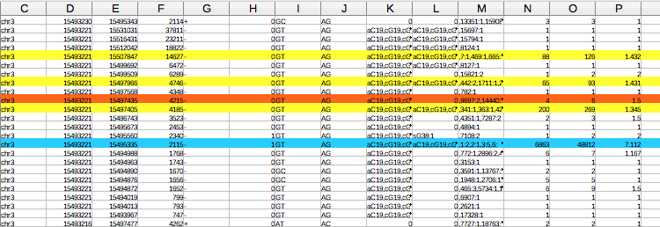

The snaptron data shows that the background ss with the most reads is for
a single skip (269 reads, column O), which agrees with the experimental result. There are also 6 reads for one of the css that was reported (in red) and the other css has reads in the larger database SRAv2 (data not shown). Again, snaptron shows that the css identified by the authors are active bss that were detected by careful experimentation but are not such an obvious prediction compared to the single exon skip, which is consistent with the experimental results.

As a slight aside, the two 5’ css identified by the authors have relatively high reads for splicing to the 3’ss of exon 16 (see below) and are therefore good candidates to be activated by mutations of the 5’ss of exon 15

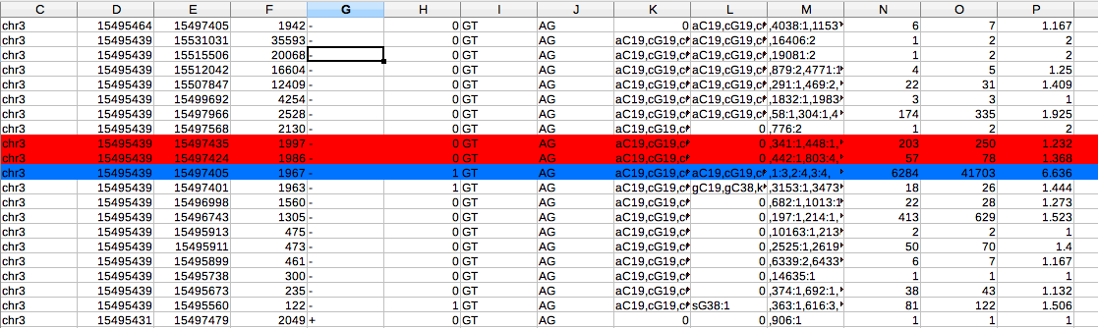Above shows the reads between exon 15 and exon 16 (blue) and red shows the reads between the two css of exon 15 identified by the authors with exon 16.

As a control we also did a secondary analysis where we looked for the partner ss of the 5’ss of exon 1.
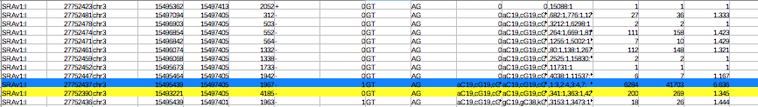
This showed 269 reads for skipping to the 3’ss of exon 17 but to no other site in this exon.
EVC
http://www.dbass.org.uk/DBASS3/viewsplicesite.aspx?id=599
Table S2 DBASS3 row 107

3’ssExon 4
Exon 2 5’ss
Exon 3 5’ss

The authors report that mutation of the 5’ss of exon 3 (hg19 5731118 CGGgtg a(g>c)a) inhibits splicing between exon 3 and the 3’ss of exon 4 (5733151), as expected. Remarkably the mutated 5’ss splices exclusively to a 3’css (5733220)in exon 4. Our normal approach, which would be to look for alternative partners of the 3’ss of exon4 (5733151), would indicate that the 5’ss mutation of exon 3 would cause it to be skipped as there are most reads (28) for this event in column O below.

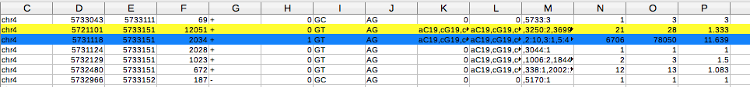

We also checked the 3’ss partners of the 5’ss of exon 3 (see below)
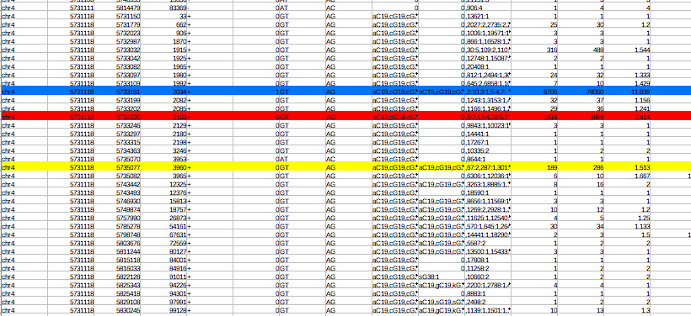

This reveals that the 3’css discovered by the authors is a very strong background partner to the 5’ss of exon 3 (shown in red, 3899 reads column O).

The authors’ results suggest that the +5 mutation inhibits splicing to the usual 3’ss partner of exon 4 but not to the alternative 3’ss within exon 4. The authors express some reservations about their results as they used a minigene construct because of the unavailability of patient RNA. Our method of analysis does not predict the authors results (it favours a single exon skip based on the assumption that the mutation would inhibit all splicing by the 5’ss of exon3) but the snaptron database does show that the css identified by the authors is a highly active background ss, but gives no further insight into the unusual effect of the 5’ss mutation.

F8
http://www.dbass.org.uk/DBASS3/viewsplicesite.aspx?id=92
Table S2 DBASS3 row 160.

3’ssExon 16
Exon 14 5’ss
Exon 15 5’ss

The authors report that mutation of the 5’ss of exon 15 (154134694, ATG(g>t)tgagt) activates an upstream 5’ss but it doesn’t splice at all to the 3’ss of exon 16 (which would normally be expected) but to a 3’css (154133252).

We would normally identify the background 5’ss partners of the 3’ss of exon 16 (154133299) in order to predict the effect of the 5’ss mutation of exon 15. In this case there are only reads (14882)for splicing with the partner 5’ss 154134694 ie there are no variants.

In the larger SRAv2 database there are 48K reads for normal splicing but again no reads for any variants. This is an unusual result because although there are quite a few examples of ss that have no variants in Table S3, these are nearly always associated with relatively low intron reads. So snaptron indicates that the 3’ss of exon 16 may have very high fidelity for splicing to the 5’ss of exon 15, which might help to explain the authors’ unusual results.

We also looked for the background partners of the exon 15 5’ss.

This identifies the css discovered by the authors as the next strongest partner for exon 15 5’ss with 40 reads after the normal 3’ss (with 14882 reads).

As a secondary analysis we looked for the partner ss of the 5’ss of exon 14. All of the sites were within the downstream intron, there were no background reads for downstream exon skipping (data not shown).

Overall, snaptron gives some insight as to why the 3’ss of exon 16 is not used for aberrant splicing when its partner 5’ss is mutated (it seems to have very high fidelity for only its normal 5’ss partner) and also indicates that the 3’css of exon 16 might be used instead of the 3’ss of exon 16 because it is the next most active alternative 3’ss in this region. However, there are no supporting background reads to indicate that this 3’css is likely to splice with the 5’ss of exon 14

INVS
http://www.dbass.org.uk/DBASS3/viewsplicesite.aspx?id=260
Table S2 3’css row 158.

Exon 12 5’ss
Exon 13 5’ss
3’ssExon 14

The authors report that mutation of the 5’ss of exon 13 activates splicing between the 5’ss of exon 12 and the 3’ss of exon 14 (this is a common effect of ss mutations). Unusually there is also splicing in roughly equal amounts (according to the RT-PCR band intensities) between the 5’ss of exon 12 and a 3’css within exon 14.

The mutated 5’ss (shown in red) ATGg(t >c)aggt is 103046886 (hg 19) and its partner 3’ss of exon 14 is 103054607. We would normally look for the background 5’ss partners of 3’ss 103054607 in order to predict the likely effect of this mutation.

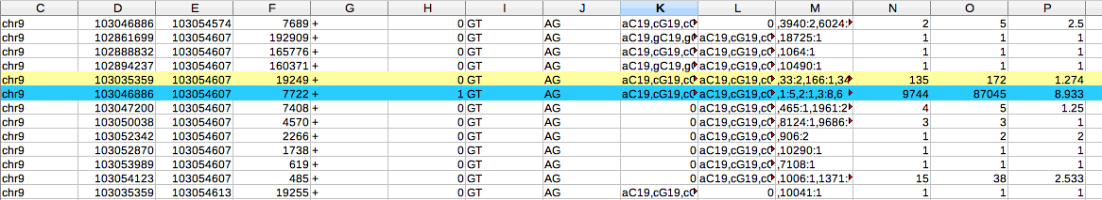

The snaptron data has most background reads (172, column O) for the exon skip, in agreement with the author’s results.

We also looked for the partners of the 5’ss of exon 13 in case there were any strong alternative ss.

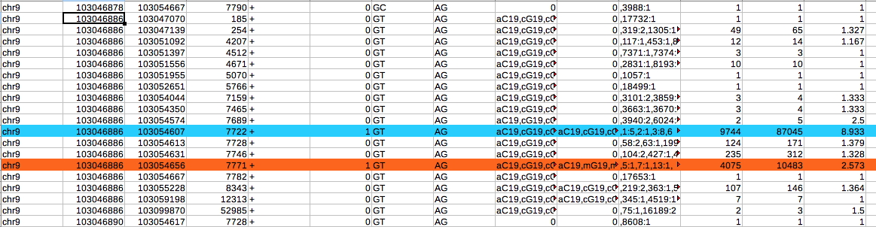

This screen shows that the 3’ss 103054656 (which is the 3’css identified by the authors) has 10483 reads with the 5’ss of exon 13 , which is over 10% of the intron reads of 87045. Consequently, the 5’ss mutation of exon 13 is also likely to cause this minor 3’ass to splice with alternative 5’ss. Analysis of this 3’css shows that its next most common partner is the upstream 5’ss of exon 1 (shown
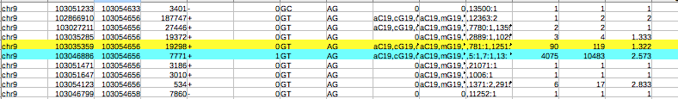

in yellow) with 119 reads.

As a secondary screen we also looked for the partners of the 5’ss of exon 12.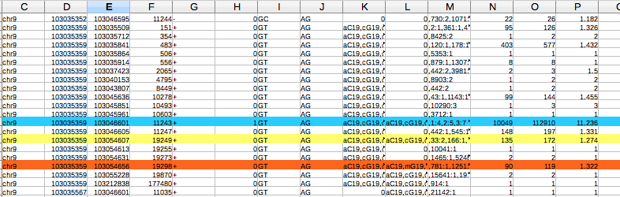

This gives a better overall picture that confirms there are 172 reads for the exon skip to the 3’ss of exon14 and 119 reads to the 3’css discovered by the authors. Our assumption is that these would be used roughly in the ratio of 172:119, which accords with the experimental results.

TYMP
http://www.dbass.org.uk/DBASS5/viewsplicesite.aspx?id=637
Table S2 dbass5 row 437

Exon 1 5’ss
3’ssExon 2
3’ssExon 3

The authors report that mutation of the 3’ss of exon 2 (50967768acc a(g>c)GGG) causes exon skipping by activating splicing between the 3’ss of exon 3 (50967040) with a 5’css within exon 1 (50967955).

We would normally look for the background partners of the 5’ss of exon 1 (50967924) in order to predict the likely effect of this mutation, which would be the activation of both single (336 reads) and double (1140 reads) downstream exon skipping (see below).

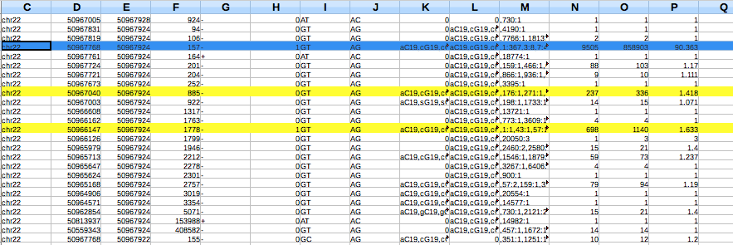

We would also check the 5’ ss partners of the 3’css of exon 2 in case of complications with alternative splicing (see below).

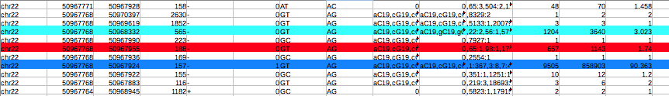

This analysis shows that the 5’css disovered by the authors (marked in red) is a strong bss for the 3’ss of exon 2, as is another site marked in light blue. Both of these sites would be good candidates for 5’css activated by mutations of the 5’ss of exon 1.

As a seondary analysis we looked for the partner ss of the 3’ss of exon 3. There are 130 reads between the 5’css of exon 1 with exon 3, which compares quite well to the 336 background reads between the 5’ss of exon 1 with exon 3.

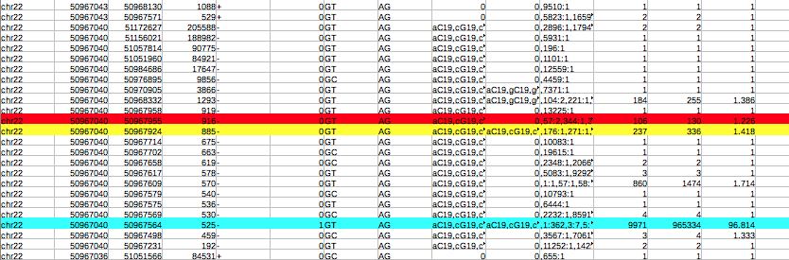
Our normal assumption would be skipping between the 5’css or the 5’ss of exon 1 to exon 3 to be roughly in the ratio of 130:336 ie we have no explanation for the experimental finding for the exclusive use of the 5’css

So the snaptron data shows that the css detected by the authors is a relatively active bss that splices to the 3’ss of both exons 2 and 3. It also shows that the 5’css of exon 1 has a surprisingly large amount of background reads for exon skipping to exon 3 compared to the 5’ss of exon 1. However, the snaptron data gives no further insight to the authors observation that the 5’css of exon 1 was exclusively preferred to the 5’ss of exon 1. Overall snaptron most strongly predicted a double exon skip, it is not clear if this was tested.

XPA
http://www.dbass.org.uk/DBASS5/viewsplicesite.aspx?id=319
Table S2 dbass5 row 640.

Exon 2 5’ss
Exon 3 5’ss
3’ssExon 5
3’ssExon 4
3
2
1

Exon 2 5’ss
Exon 3 5’ss
3’ssExon 5
3’ssExon 4
4

The authors identify four aberrant transcripts resulting from the mutation of the 3’ss of exon 4 (100449544, tttca(g >t)AGA). Transcripts 1, 2, and 3 were sequenced and show to have spliced between the normal 3’ss of exon 5 and a 5’css in exon 2, a 5’css in the intron just after exon 2 and the normal 5’ss of exon 3, as illustrated above. Transcript 4 shows splicing between the normal 5’ss of exon 2 and a 3’css in exon 4. This is shown separately for reasons of clarity. The hg19 reference numbers of the relevant ss of exons 2 to 5 are:

3’ss exon 5’ss
- 2 100455930
100451922 3 100451815
100449544 4 100449377
100447323 5 -

We would normally look for the background partners of the 5’ss of exon 3 to predict the effect of mutation of the 3’ss of exon 4. This analysis shows that the splicing events with the most reads after the 3’ss of exon 4 (shown in blue) are a 3’bss at position 100449542 with 61 reads, a single exon skip to exon 5 with 126 reads and a double exon skip (to exon 6) with 26 reads.

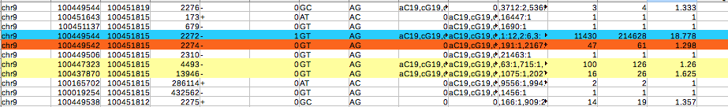

The exon skip with 126 reads is the same as transcript 3 discovered by the authors and the 3’bss 100449542 is the 3’css that the authors also discovered (transcript 4) but they found it spliced to exon 2 rather than exon 3.

We also analysed the partners of the 3’ss of exon 5 as a secondary analysis.

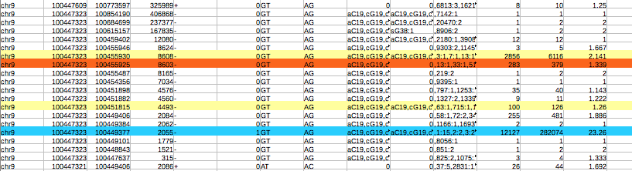

This screen shows that the 3’ss of exon 5 normally has 3668 reads to the 5’ss of exon 3 and 6116 reads for the double skip to exon 2. The line red shows that there are 379 reads for transcript 2, which is also likely to be increased in usage as a result of the mutation of the 3’ss of exon 4 blocking a competing splicing events. We didn’t find any background reads for transcript 1.

So overall snaptron would predict that the mutation the authors investigated would promote single and double exon skipping with some minor activation of two of the three css that the authors discovered. The authors did not discuss their unusual observation of exon skipping via css rather than intronic ss. The reads for the single and double exon skips are quite high and so might also be found in control samples. Perhaps for this reason they were not mentioned.

LAMP2
http://www.dbass.org.uk/DBASS5/viewsplicesite.aspx?id=606
Table S2 dbass5 row 177

Exon 9A
Exon 5
Exon 6
Exon 7
Exon 85’ss

Exon 9B
Exon 9C

The authors report the effect a mutation of a 5’ss of exon 8 of LAMP2 (119575584) that is normally involved in alternative splicing, as illustrated above. The use of alternative exons 9A, 9B or 9C generates three protein isoforms (LAMP2B, LAMP2A and LAMP2C). LAMP2 illustrates the importance of first checking whether the any mutated ss is involved in alternative splicing. This is done by looking for all of the splicing partners of the mutated site (119575584).

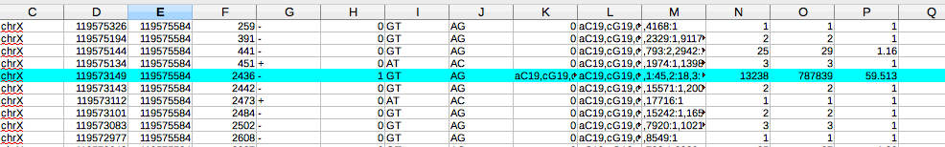

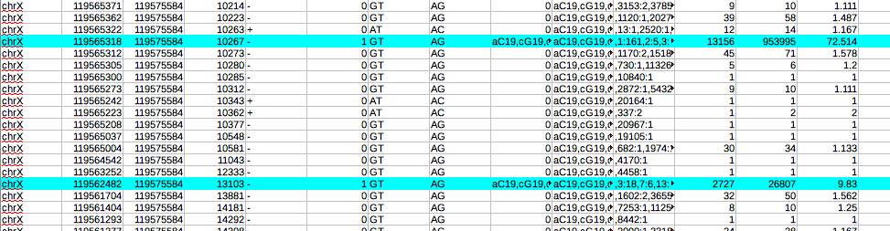

The 5’ss is listed in column E above because the gene is on the – strand. Column O shows that the 5’ss has large numbers of reads with the 3’ass 119573149 and 119565318 and a smaller number of reads with the more minor 3’ass 119562482 (in blue). Mutation of the common 5’ss partner will therefore affect the splicing of all three sites, each of which therefore require analysis.
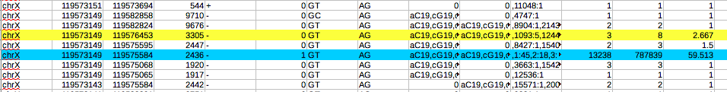
The above shows that the 3’ass 119573149 has most background reads (8) for a single exon skip.

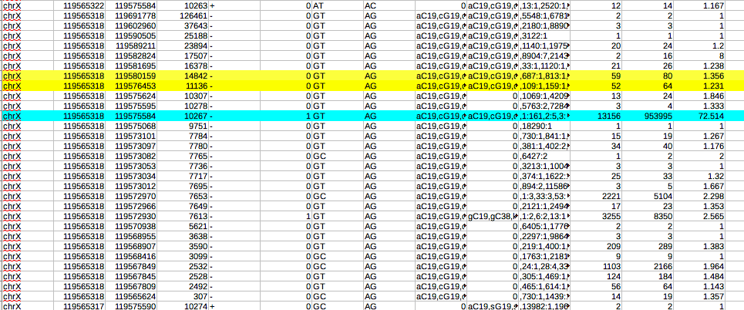The above shows that the 3’ass 119565318 has similar reads for a double exon skip (80) and a single exon skip (64). Note: the much larger background reads of 5104 and 8350 etc are greater than 1000 bases away and within the intron. Sites this far from the mutated 5’ss are rarely used as 5’css but might be recursive splice sites (see text).

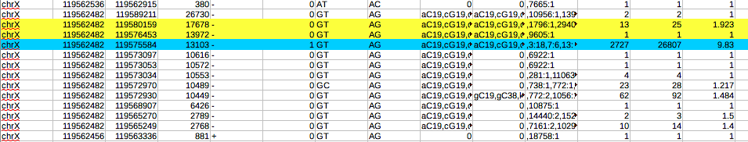The above shows that the minor 3’ass has most reads (25) for the double exon skip. Overall, the snaptron reads compare very well with the authors experimental reports about the effect of the 5’ss mutation upon exon skipping for the three LAMP2 isoforms (see Table 5).

