Lactylation Dynamics in Myxozoan Proteins

Amr A. G. Ibrahim, Juliana Naldoni, Antônio A. M. Maia, Juliano R. Sangalli, Caroline M. Meira, Rayline T. A. Figueredo, Beth Okamura, Paul F. Long, Edson A. Adriano

Supplementary File S3
Show that lactylation is preferentially predicted at H3K18 and H3K27 in M. macroplasmodialis, suggesting these residues act as key metabolic–epigenetic regulatory sites.

Distribution of predicted histone lactylation sites across key lysine residues in Myxobolus macroplasmodialis. The bar plot summarizes the frequency of predicted lysine lactylation sites across five major histone residues in M. macroplasmodialis, providing an overview of the relative susceptibility of distinct histone positions to lactylation. Among the analyzed residues, H3K18 and H3K27 displayed the highest densities of predicted lactylation sites, markedly exceeding those observed for other lysine positions. This enrichment identifies H3K18 and H3K27 as potential lactylation hotspots within myxozoan chromatin.
Both residues are well-established regulators of transcriptionally active chromatin states in eukaryotes, frequently associated with gene activation when modified by acetylation or other acyl marks. The preferential prediction of lactylation at these sites suggests that lactylation may act as an additional regulatory layer at key transcriptional control points, potentially modulating chromatin accessibility and transcriptional output in response to metabolic cues. Given the metabolic dependence of lactylation, enrichment at H3K18 and H3K27 supports a model in which parasite energy state and host-derived metabolic conditions directly influence epigenetic regulation. Collectively, these findings highlight histone H3 lysine residues as central nodes for metabolically driven chromatin regulation in myxozoan parasites and suggest that lactylation may contribute to fine-tuning gene expression programs essential for parasite adaptation and survival.

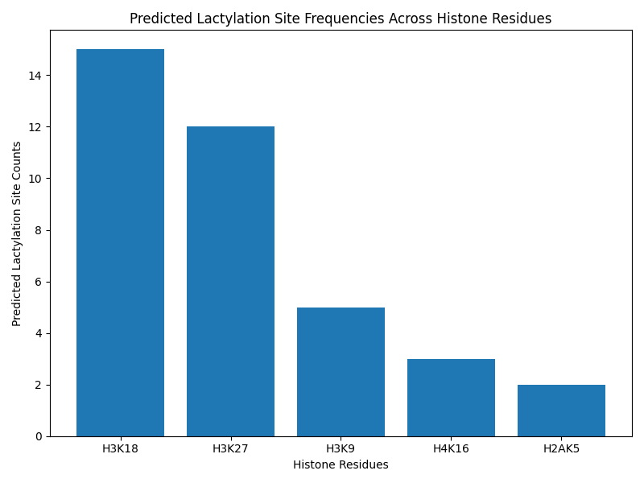
Fig. 1: Predicted lactylation site counts across histone residues in Myxobolus macroplasmodialis. Enrichment is observed at H3K18 and H3K27, consistent with their roles in transcriptionally active chromatin.

