Lactylation Dynamics in Myxozoan Proteins

Amr A. G. Ibrahim, Juliana Naldoni, Antônio A. M. Maia, Juliano R. Sangalli, Caroline M. Meira, Rayline T. A. Figueredo, Beth Okamura, Paul F. Long, Edson A. Adriano

Supplementary File S6
Predicted lactylation events in HSP70 and Histone H3 Protein Lactylation in Myxobolus macroplasmodialis.

This supplementary file presents a focused analysis of predicted lactylation events in HSP70 and predicted lactylation in Histone H3 proteins from Myxobolus macroplasmodialis.

Materials and Methods:
Protein sequences from M. macroplasmodialis were analyzed using AGAE-Layzer, a deep learning-based lactylation prediction framework (Ibrahim & Adriano, 2025). High-confidence lactylated lysine residues were selected based on prediction scores and sequence context. Protein structures were modeled using I-TASSER and AlphaFold. Structural quality was evaluated using C-score, TM-score, and normalized B-factor profiles. Predicted lactylation sites were mapped onto three-dimensional models.
Results
Multiple lysine residues were predicted to be lactylated in M. macroplasmodialis proteins. These sites were predominantly located in solvent-exposed and structurally flexible regions such as loops and terminal helices. Mapping onto three-dimensional structures showed that predicted lactylation sites overlapped with regions displaying increased normalized B-factor values. The figures below shows the predicted position using AGAE-Layzer and the 3D structure of the both proteins (Figs 1 - 4). The complete results of 3D structure prediction can be accessed using the links (HP70, Histone H3 https://doi.org/10.5281/zenodo.19460040).
1- Heat Shock Protein 70
>Heat_shock_protein_70,_ [Myxobolus_ macroplasmodialis]
TAAAIAYGLDKKAGSGTNVLIFDLGGGTFDVSILSIEDGVFEVKSTAGDVHLGGEDFDTRLVNHFIEEFKRKNKKDISENKRSVRRLRTACERAKRTLSSSATANIEIDSLFEGIDFYSTISRARFEELNADLFRSTLDPVEKALRDAKLSKPEIHDIVLVGGSTRIPKI
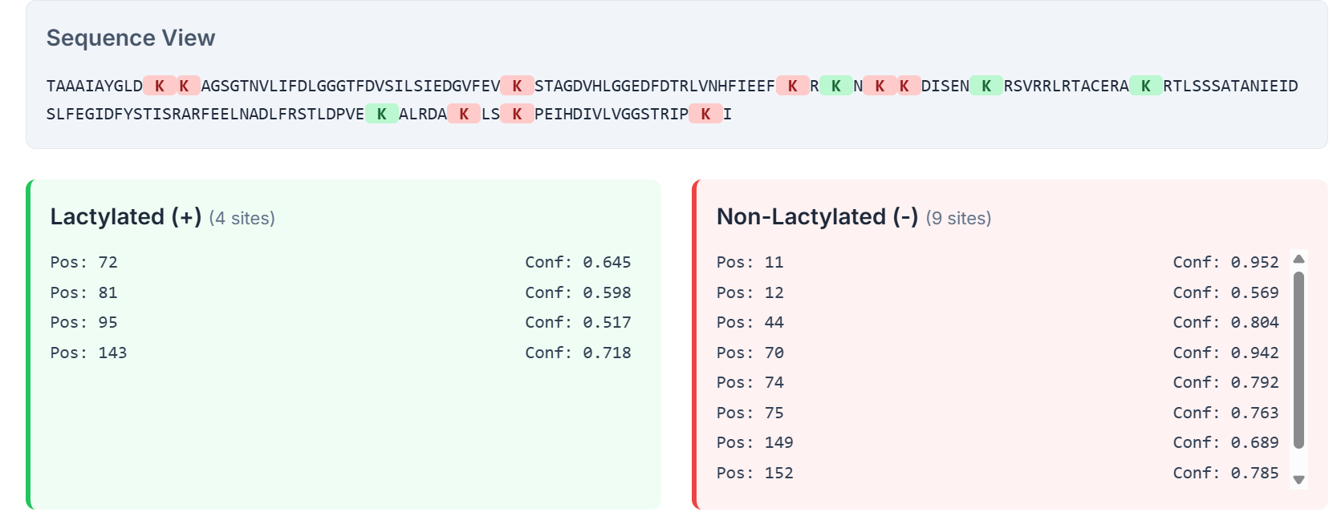
Fig. 1 Lactylation prediction in Heat Shock Protein 70 (HSP70) using AGAE-Layzer. Sequence-based prediction of lysine lactylation sites in HSP70 identified four positively lactylated residues (K72, K81, K95, and K143) with moderate to high confidence scores, while multiple lysines were predicted as non-lactylated. The highlighted lysine positions illustrate the site-specific nature of lactylation, supporting a potential regulatory role of this post-translational modification in HSP70 structure and stress-response function in Myxobolus macroplasmodialis.
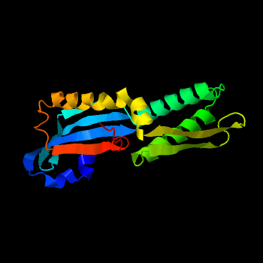
Fig. 2 Three-dimensional structure of Heat Shock Protein 70 (HSP70) highlighting predicted lactylation sites. The 3D ribbon representation depicts the conserved α/β architecture of HSP70, with flexible loop regions and functional domains clearly resolved. Predicted lysine lactylation sites are positioned on exposed surface regions, suggesting accessibility for post-translational modification. These modifications may influence HSP70 chaperone activity, protein–protein interactions, and stress-response regulation under metabolically altered conditions.

2- Histone H3 Protein
>Histone_H3_[Myxobolus_ macroplasmodialis]
MRKKSLPQKSQKPKTILVTSTPMVSQPPQKTKKDDTIFSDQDENYNPKLTEKSKGKKVETQKTKILTSKNPKVETRPSKPPIIITKKPIENKMTKELKNRVFKEIQFYQKSTQTLIPNAPFARLIKEIARDLGYLDKRFNLCALLALHEASEAFLVRLFEHTNLCAIHAKRVTIMKQDMKLVEKITKDT
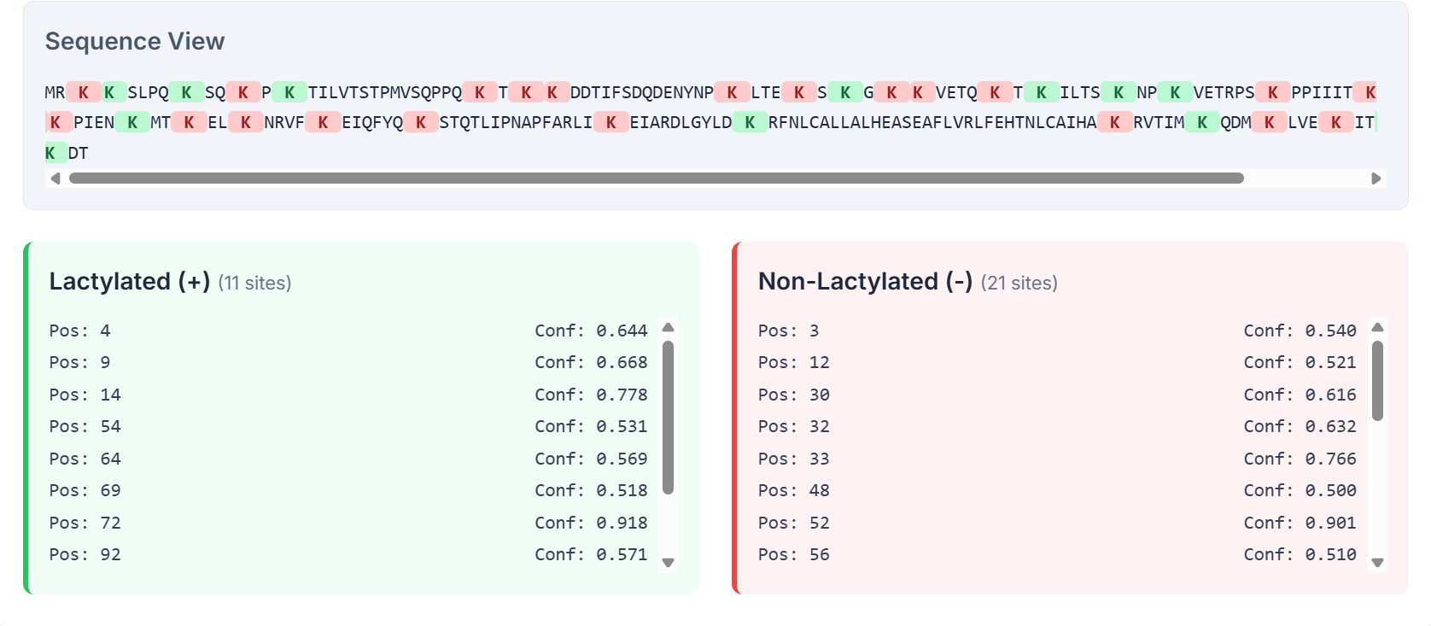
Fig. 3 Predicted lysine lactylation sites in Histone H3 identified using AGAE-Layzer. The sequence view highlights multiple lysine residues classified as lactylated with moderate to high confidence scores, indicating potential epigenetic regulation through histone lactylation. Non-lactylated lysines are shown for comparison, supporting site-specific modification patterns that may influence chromatin structure and transcriptional activity Myxobolus macroplasmodialis.
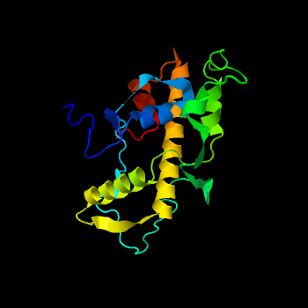
Fig. 4 Three-dimensional structure of Histone H3 showing predicted lactylation sites. The ribbon model illustrates the overall fold of Histone H3, with α-helices and connecting loops clearly resolved. Predicted lysine lactylation residues are located on solvent-exposed regions of the protein, consistent with their accessibility for post-translational modification. The spatial distribution of these sites supports a regulatory role for lactylation in modulating histone–DNA interactions and chromatin dynamics.
Discussion
The results suggest that lactylation in M. macroplasmodialis proteins is regulatory rather than structural. The localization of predicted sites in flexible and exposed regions supports a role in dynamic modulation of protein activity in response to metabolic conditions.

References
Ibrahim AGA, Adriano EA. AGAE-Layzer: An in-silico tool for predicting lysine lactylation sites. Version 1. Authorea [Preprint].[posted 2025 Nov 4]. Available from: https://doi.org/10.22541/au.176222447.78799278/v1

