Lactylation Dynamics in Myxozoan Proteins

Amr A. G. Ibrahim, Juliana Naldoni, Antônio A. M. Maia, Juliano R. Sangalli, Caroline M. Meira, Rayline T. A. Figueredo, Beth Okamura, Paul F. Long, Edson A. Adriano

Supplementary S4:
Integrative Analysis of Lactylation, Methylation, and Transcriptional Activity observed in a predicted lactylation site and it’s RNA-seq data

Analysis of the Histone H2A gene derived from the Ceratonova shasta genome reveals a clear relationship between predicted post-translational modifications and transcriptional output. RNA-seq exon coverage tracks indicate transcriptionally active regions that partially overlap with lysine residues predicted to undergo histone lactylation. Notably, these lactylation-associated regions exhibit reduced RNA-seq signal relative to neighboring regions enriched for methylation marks, suggesting a repressive or dampening effect of lactylation on transcription at this locus.
This pattern supports a model in which histone lactylation modulates chromatin accessibility and fine-tunes gene expression in response to metabolic or stress-related cues. In contrast, methylation marks correlate with increased RNA-seq coverage, consistent with a transcriptionally permissive or activating role. The opposing trends observed for lactylation and methylation highlight their distinct regulatory contributions within the same genomic context.
Comparable regulatory behavior has been reported in halophilic archaea, including Halobacterium salinarum and Haloferax volcanii, where environmental and metabolic conditions influence modification patterns at conserved genomic positions. High-resolution analyses (20 bp windows) demonstrated that these modifications can affect alternative transcription start sites (alTSS) and transcription processing sites (TPS), thereby reshaping transcriptional outputs under stress conditions (Ibrahim et al., 2021; Ibrahim, 2023).
Together, these observations indicate that histone lactylation and methylation act as complementary and potentially antagonistic epigenetic signals, contributing to transcriptional plasticity in myxozoan parasites under variable physiological conditions.
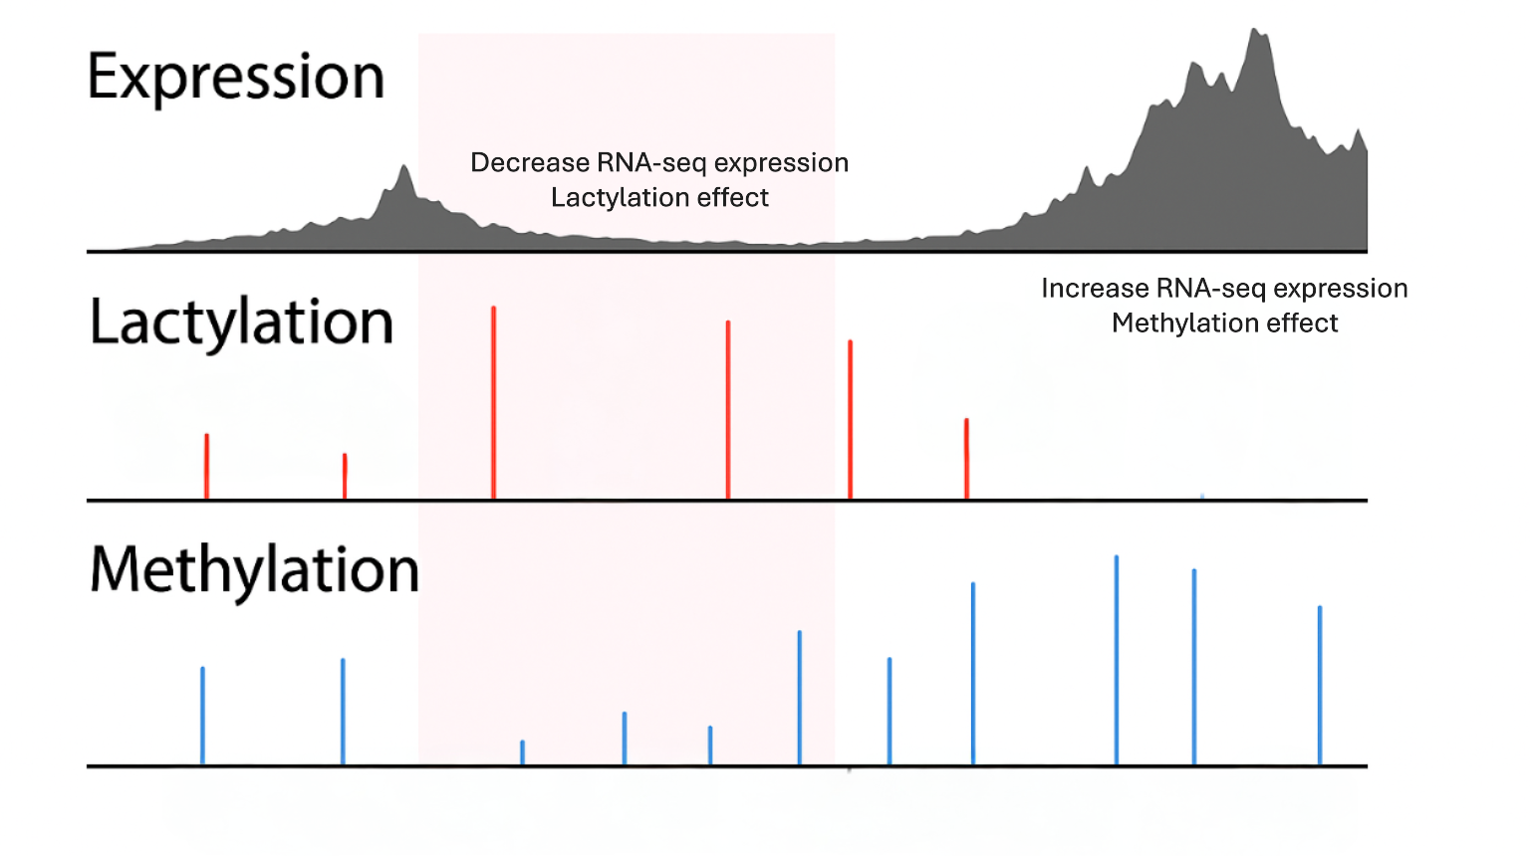
Fig. 1 Illustration of an integrative view of transcriptional activity and predicted epigenetic modifications in the Heat shock cognate 70 kDa protein (HSC70) locus. RNA-seq expression coverage is shown in the upper panel, predicted lactylation sites are indicated by red bars in the middle panel, and predicted methylation sites are shown as blue bars in the lower panel. Regions enriched for lactylation correspond to reduced RNA-seq signal, whereas methylation-rich regions coincide with increased expression, reinforcing the concept of functionally divergent regulatory roles.

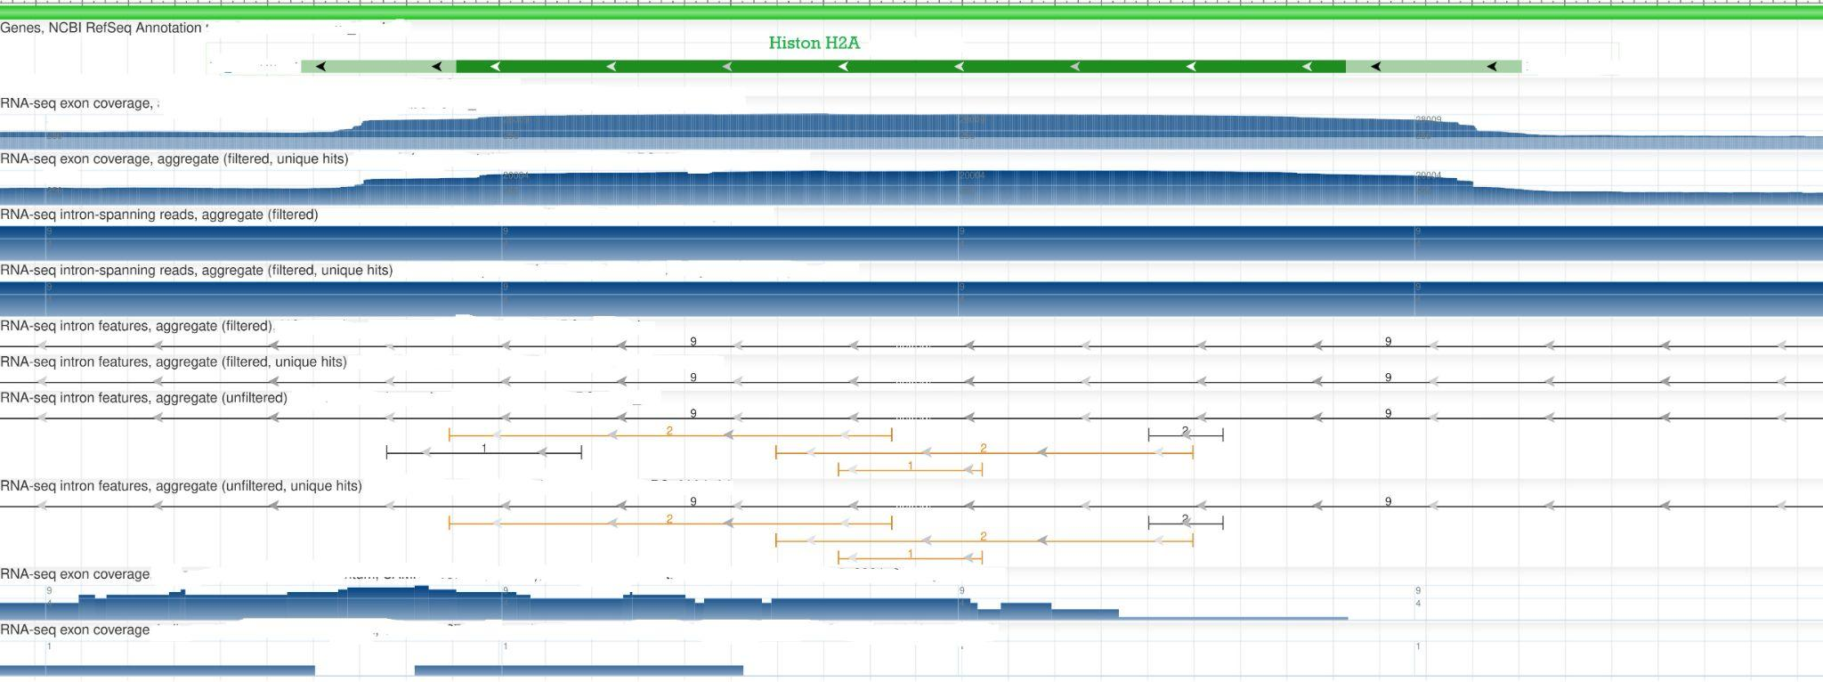
Fig. 2 Presents RNA-seq coverage aligned with the gene model of Histone H3K in the Ceratonova shasta genome. The exon–intron structure is shown in green, while blue coverage tracks depict read density across exon and intron-spanning regions. Areas of diminished RNA-seq coverage align with predicted lactylation sites, whereas regions of higher transcriptional activity overlap with methylation marks, further supporting a modification-dependent regulatory mechanism at the chromatin level.

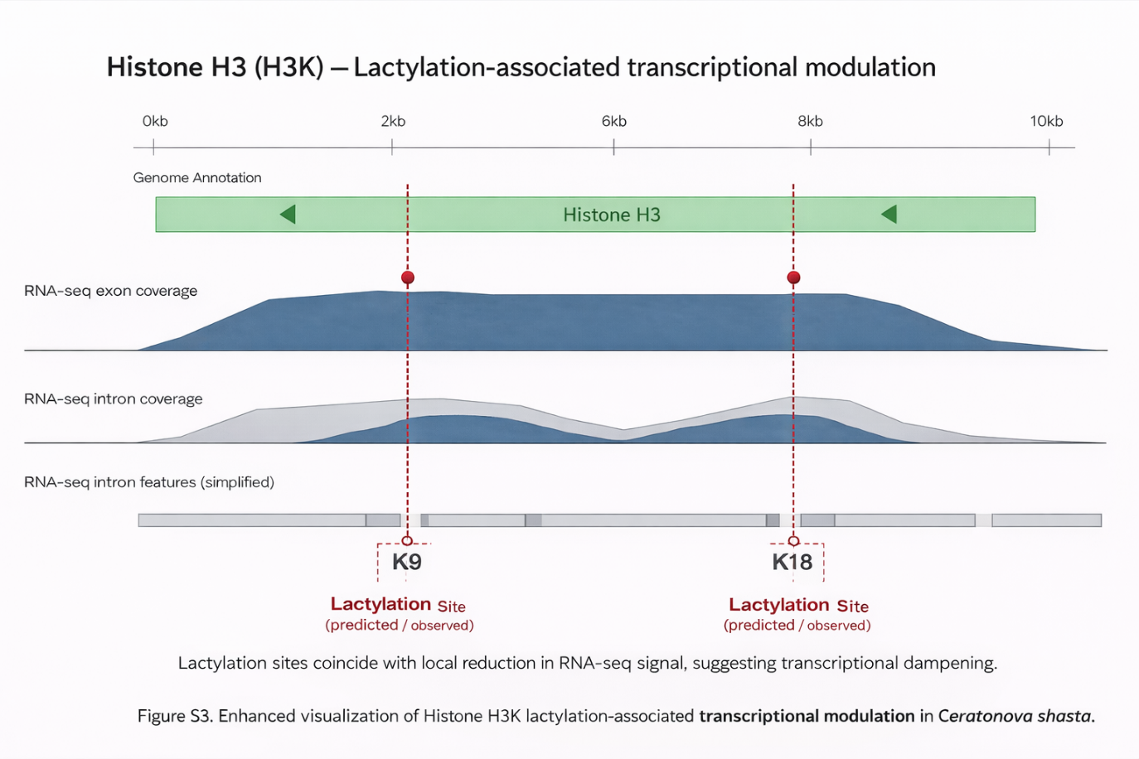
Fig. 3 Integrated genomic and transcriptomic view of Histone H3 (H3K) lactylation–associated transcriptional modulation in Ceratonova shasta. The top track shows the annotated Histone H3 gene model, followed by RNA-seq exon and intron coverage profiles. Vertical dashed lines indicate lysine residues K9 and K18 identified as predicted and/or experimentally supported lactylation sites. These positions coincide with localized reductions in RNA-seq signal relative to surrounding regions, suggesting that H3K lactylation is associated with attenuation of transcriptional output at this locus, consistent with a repressive or fine-tuning role of lactylation in chromatin-mediated gene regulation.

References

- Ibrahim AGAE-R, Vêncio RZN, Lorenzetti APR, Koide T. Halobacterium salinarum and Haloferax volcanii comparative transcriptomics reveals conserved transcriptional processing sites. Genes. 2021;12(7):1018. https://doi.org/10.3390/genes12071018
- Ibrahim AGAE-R. Discovery of transcription start, process, and termination sites in Halobacterium salinarum NRC-1 using dRNA-seq. Doctoral thesis. São Paulo: Universidade de São Paulo; 2023. https://doi.org/10.11606/T.95.2023.tde-17082023-215744

