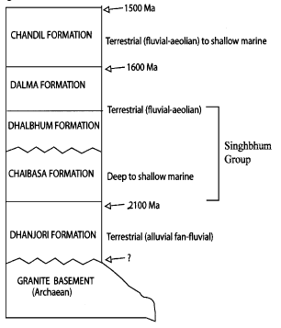
Table 1. Revised Proterozoic stratigraphic succession of the Singhbhum crustal province (Mazumdar, R., 2005).

Table 2. Major element and mineral chemistry of selected sulfides determined from X-ray fluorescence analysis (Major elements are in wt% and trace elements are in ppm.)

Sample | SiO₂ | TiO₂ | Al₂O₃ | Fe₂O₃ | MnO | MgO | CaO | Na₂O | K₂O | P₂O₅ | Cr | Co | Ni | Cu | Zn | Total
Mica Schist | 60.20 | 0.48 | 16.09 | 2.84 | 0.00 | 0.61 | 0.07 | 0.14 | 7.01 | 0.06 | - | - | - | - | - | 87.49
Quartzite | 86.4 | 0.00 | 6.54 | 1.41 | 0.01 | 0.10 | 0.01 | 2.15 | 0.00 | 0.01 | - | - | - | - | - | 96.24
Ultramafics | 45.05 | 0.01 | 8.60 | 15.58 | 19.02 | 0.18 | 8.81 | 0.28 | 0.05 | 0.13 | 128 | 82 | 63 | 28 | 109 | 98.81
Amphibolite | 65.09 | 0.52 | 17.92 | 5.27 | 4.31 | 0.05 | 0.17 | 2.55 | 3.52 | 0.06 | 84 | 20 | 55 | 6 | 90 | 99.48

Mica schist, quartzite, ultramafic and amphibolite; these four characteristic samples were selected for chemical analysis.
Table 3. Calibration of the heating stage
SL. No. | Chemical compounds | Melting points (°C) | Melting points Recorded (°C)
1. | Pure CO2 | -56.6 | -56.5
2. | Distilled water | 0.0 | 0.2
3. | Sodium Nitrate | 306.8 | 308.3

