Supplementary Material

A predictive systems vaccinology framework enables rational optimization of MVA-based vaccines

Vincent Deman^{1, 2}, Philippe Castera², Juan García-Arriaza^{3, 4}, Mariano Esteban³, Marine Ciantar², Laurent Naudin², Anne-Sophie Beignon^{1, 5, *}

¹ Université Paris-Saclay, Inserm, CEA, U1184, Immunological Diseases, Microbiology and Innovative Therapies (IDMIT), Fontenay-aux-Roses & Le Kremlin-Bicêtre, France
² Dassault Systèmes BIOVIA, Vélizy-Villacoublay, France
³ Department of Molecular and Cellular Biology, Centro Nacional de Biotecnología (CNB), Consejo Superior de Investigaciones Científicas (CSIC), Madrid, Spain
⁴ Centro de Investigación Biomédica en Red de Enfermedades Infecciosas (CIBERINFEC), Madrid, Spain
⁵ CNRS, Campus Gérard Mégie, Délégation Paris Michel-Ange, Paris, France

* Correspondence: anne-sophie.beignon@cea.fr

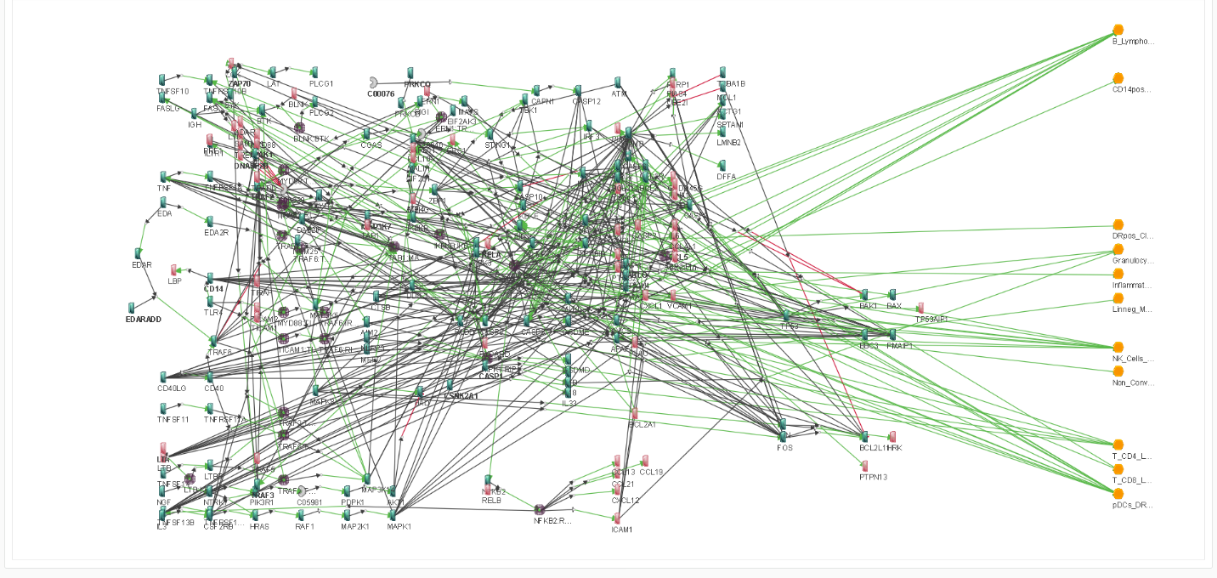Supplementary Figure S1: Calibrated Boolean network of the MVA-induced immune response. The network backbone is composed of the following three pathways from the KEGG database: cytosolic DNA-sensing, apoptosis, and NF-κB signaling. The naïve network was calibrated with experimental preclinical data from ⁴⁶, using ZhegAlCal ⁷⁴. The calibrated network is visualized using Dassault Systèmes Living Map software and is also available for simulation, perturbation, and analysis on the CellCollective platform (MVA 3 pathways).

Network update, 1; Experimental time point, 3 hours
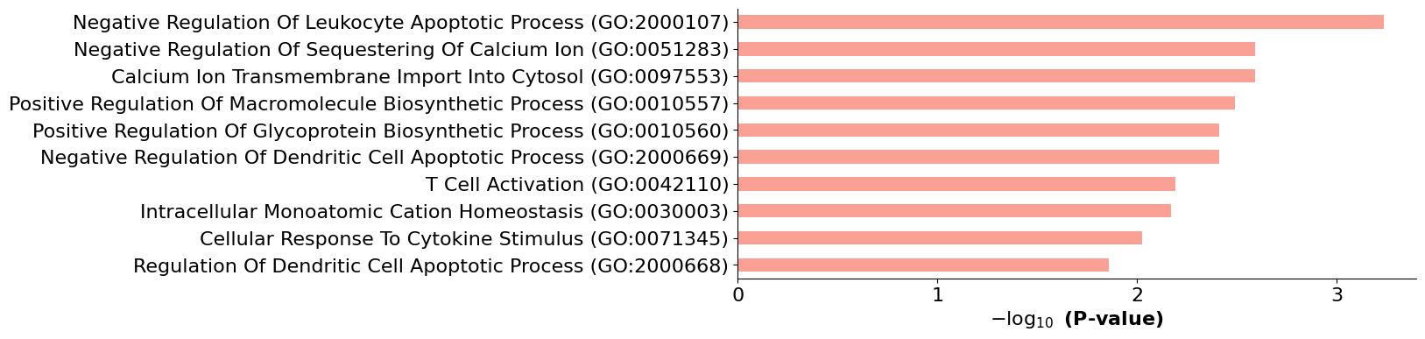
Network update, 2; Experimental time point, 6 hours
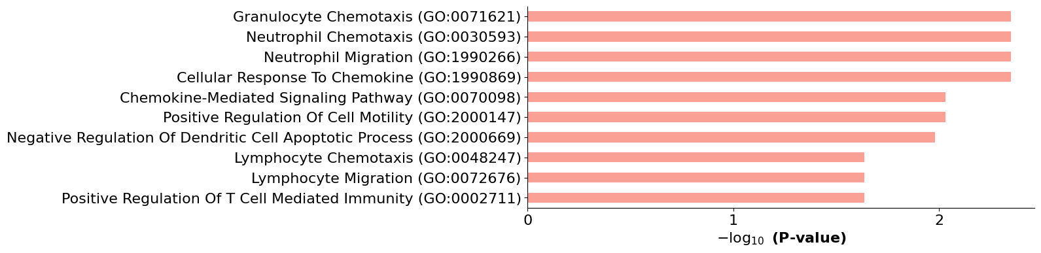
Network update, 3; Experimental time point, 24 hours
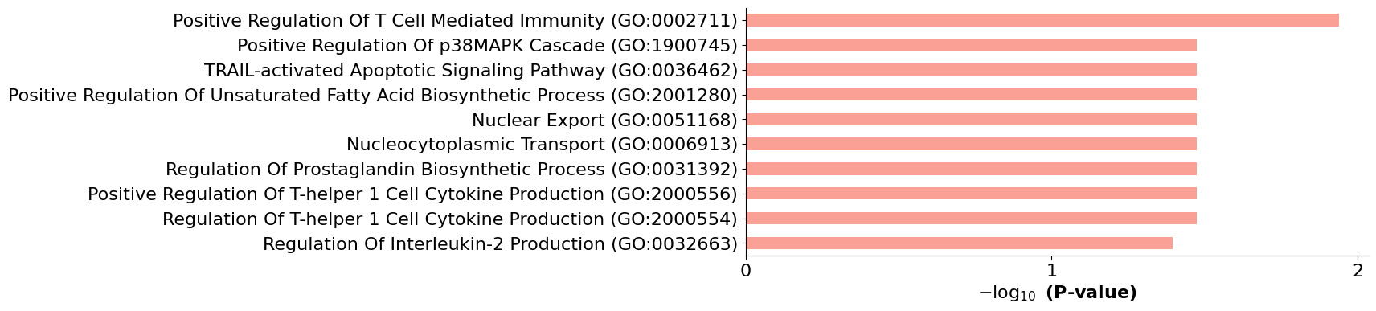
Network update, 4 (intermediary simulation step that match non experimental time point)
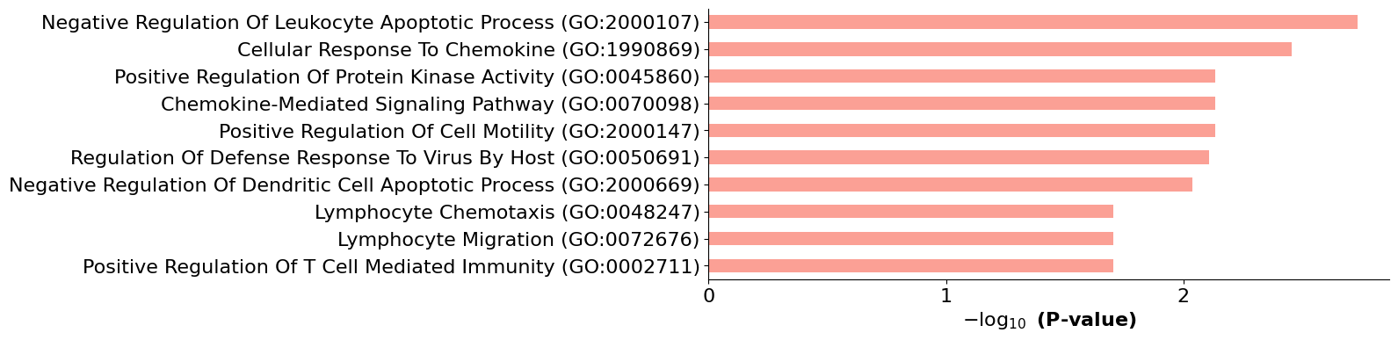
Network update, 5; Experimental time point, 48 hours
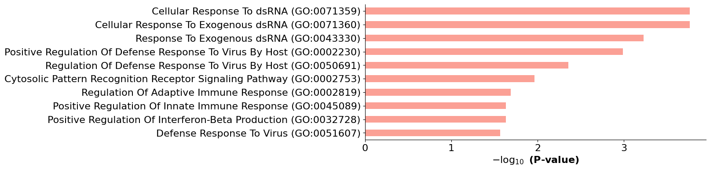
Network update, 6 (intermediary simulation step that match non experimental time point)
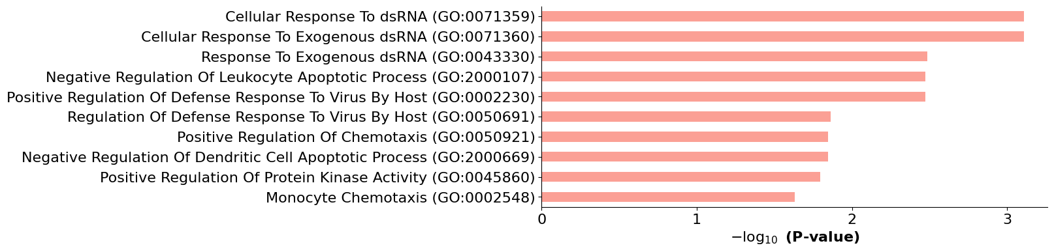
Network update, 7; Experimental time point, 72 hours
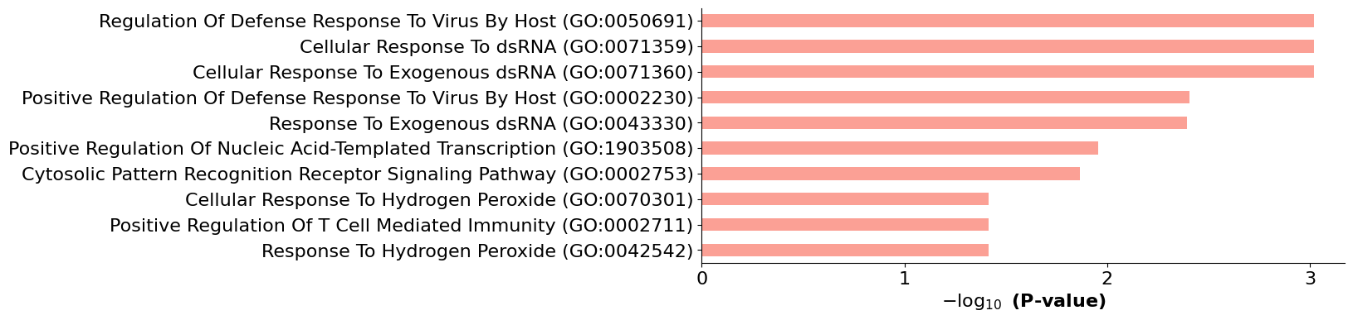
Network update, 8 (intermediary simulation step that match non experimental time point)
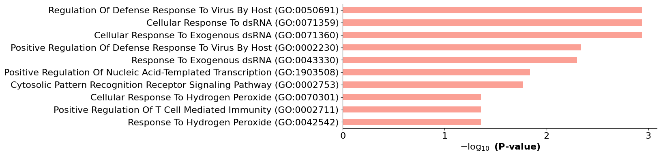
Network update, 9; Experimental time point, 168 hours
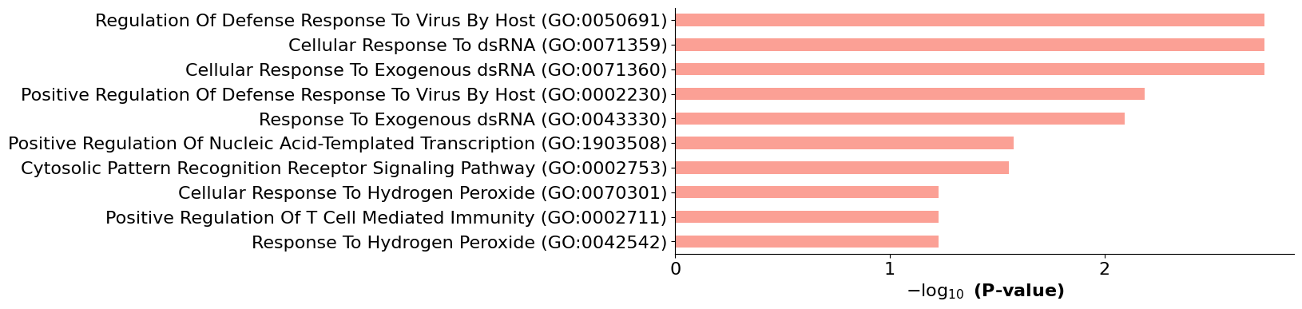

Supplementary Figure S2: Dynamic Gene Ontology (GO) enrichment analysis for the unperturbed MVA-induced innate immune response Boolean network trajectory. The y-axis indicates the top 10 enriched biological process GO terms, while the x-axis displays the negative logarithm of the associated p-values (all < 0.05).

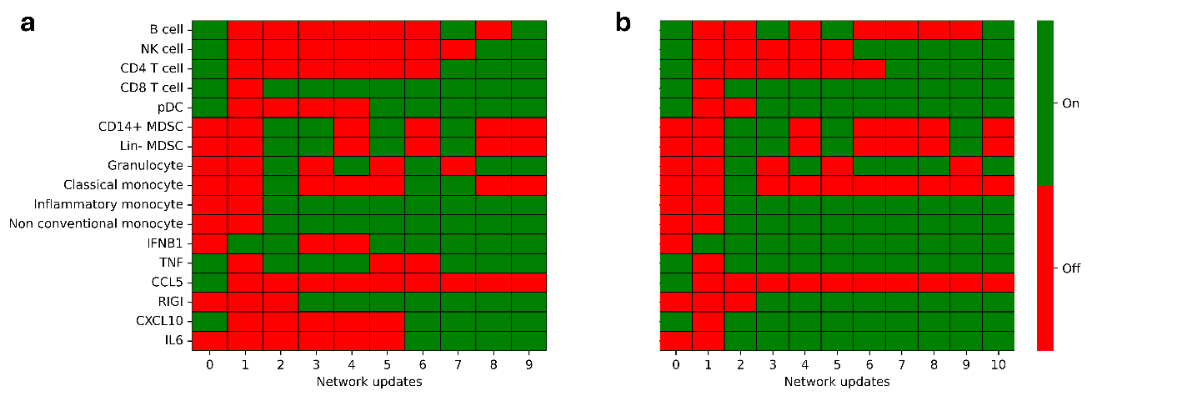Supplementary Figure S3: Binary cellular abundances and innate immune marker gene expressions in perturbed and unperturbed MVA-induced immune response Boolean network simulations. (a) Parental MVA simulation. (b) Triple mutant MVA ΔC6L/ΔK7R/ΔA46R simulation.

Network update, 1
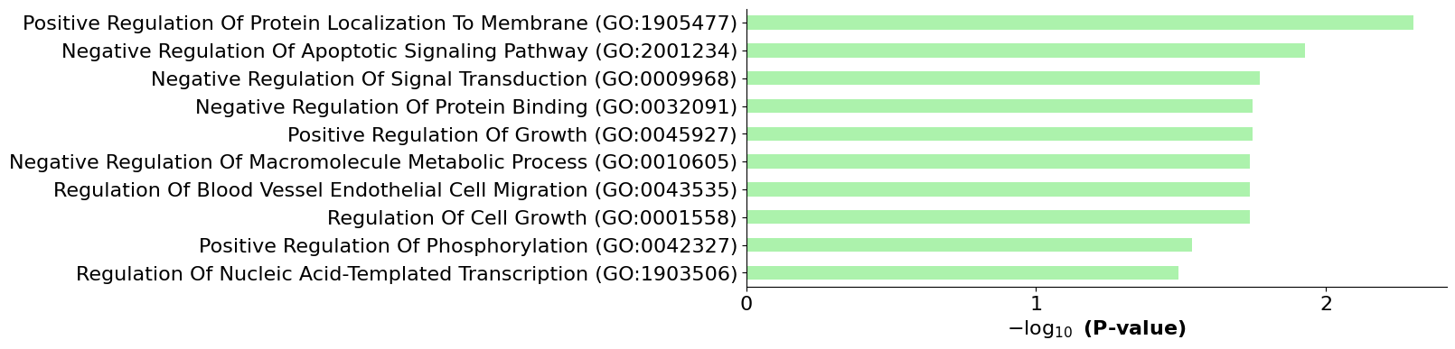
Network update, 2
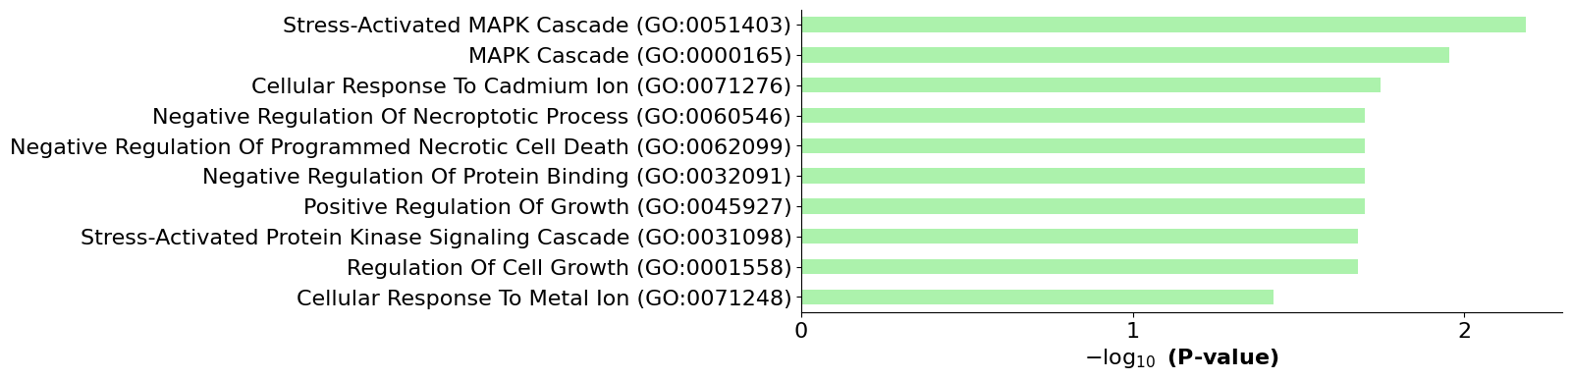
Network update, 3
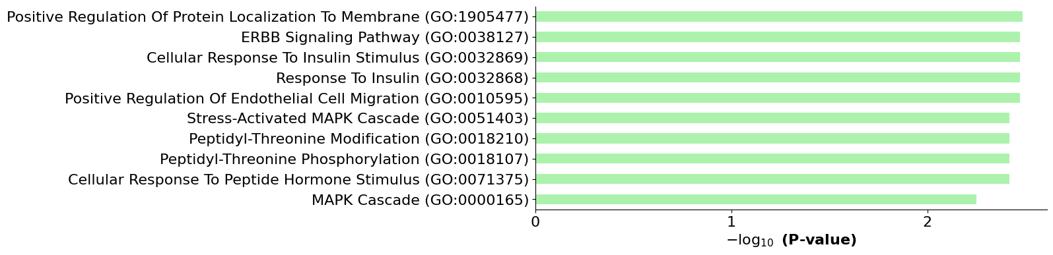
Network update, 4
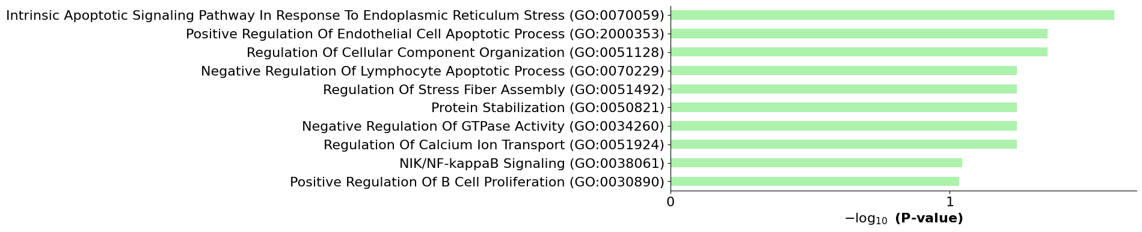
Network update, 5
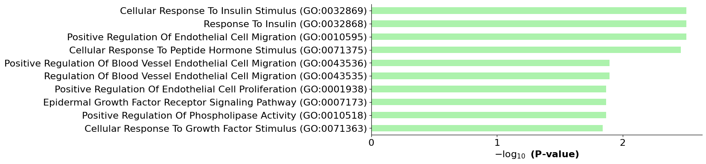
Network update, 6
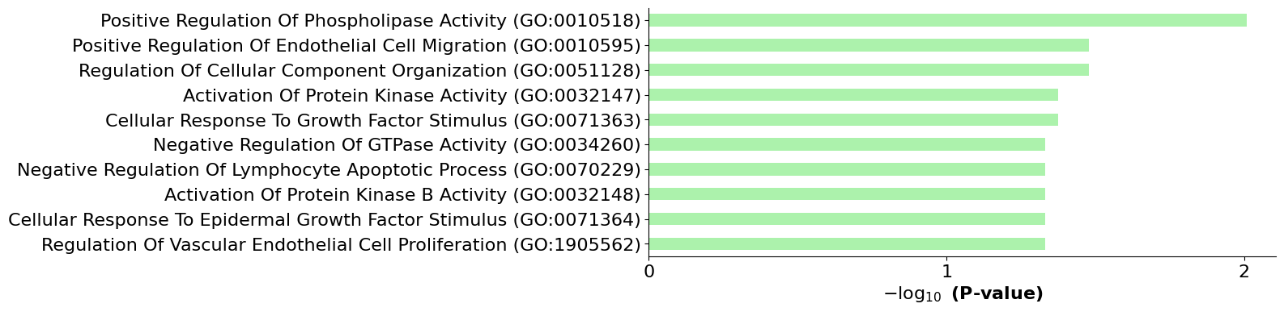
Network update, 7
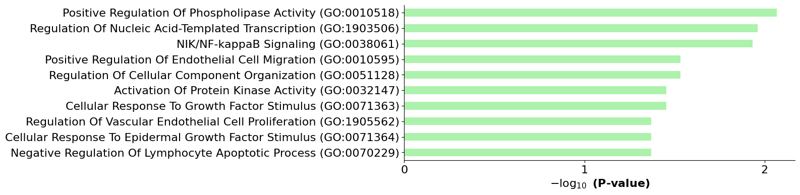
Network update, 8
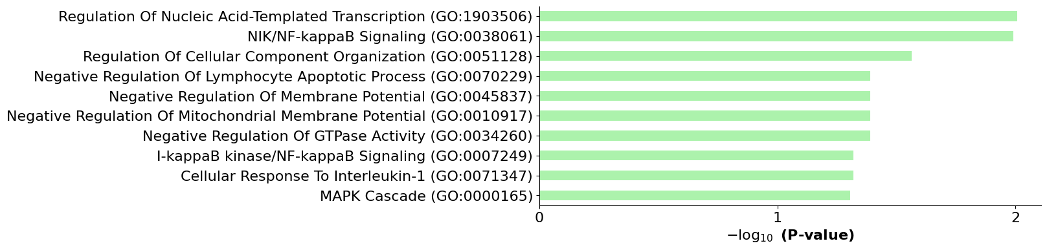
Network update, 9
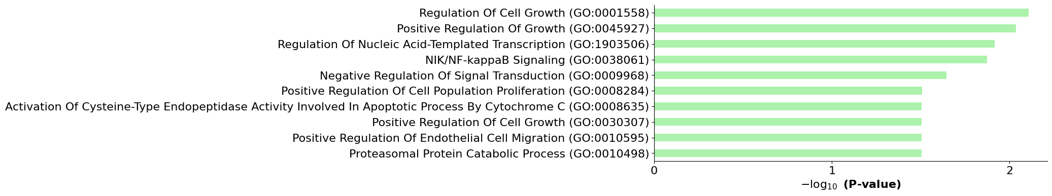
Network update, 10
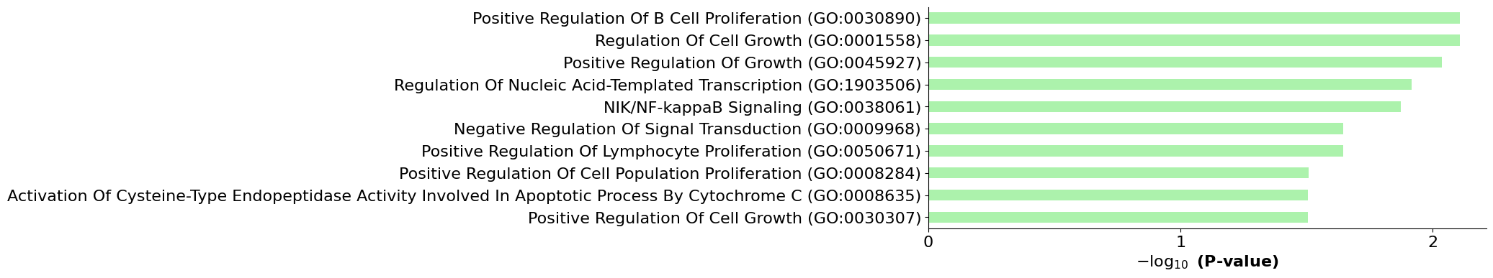

Supplementary Figure S4: Dynamic Gene Ontology enrichment analysis of the perturbed ΔC6L/ΔK7R/ΔA46R MVA-induced innate immune response Boolean network trajectory. The y-axis indicates the top 10 enriched biological process GO terms, and the x-axis displays the negative logarithm of the associated p-values (all < 0.05).

a
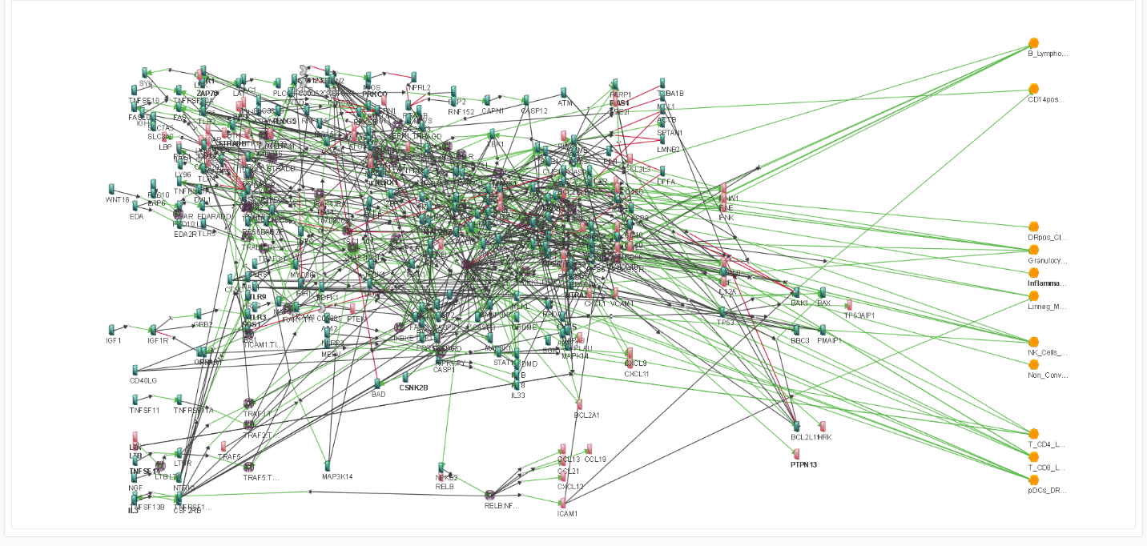
b
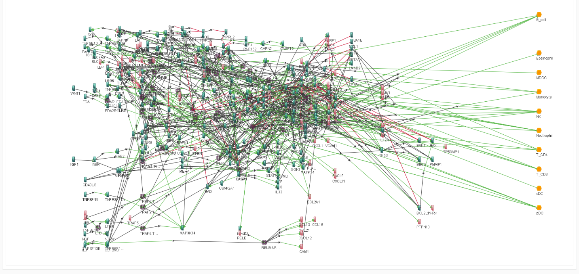Supplementary Figure S5: Calibrated Boolean networks of the MVA- and YF-17D-induced immune responses. The network backbone is composed of the following six pathways from the KEGG database: cytosolic DNA-sensing, apoptosis, Toll-like receptor signaling, RIG-I-like receptor signaling, NF-κB signaling and mTOR. The shared consensus naïve network was calibrated with experimental preclinical data from ⁴⁶ and ⁷¹, and using ZhegAlCal ⁷⁴. The calibrated networks are visualized using Dassault Systèmes Living Map software and are also available for simulation, perturbation, and analysis on the CellCollective platform. (a) MVA-induced response Boolean network (MVA 6 pathways). (b) YF-17D-induced response Boolean network (YF17D).

a
Network update, 1; Experimental time point, 24 hours
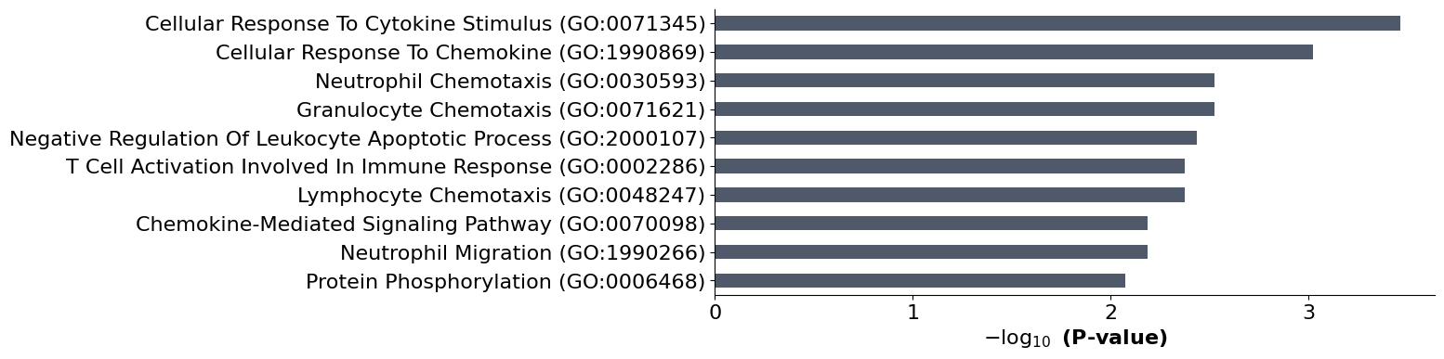
Network update, 2; Experimental time point, 72 hours
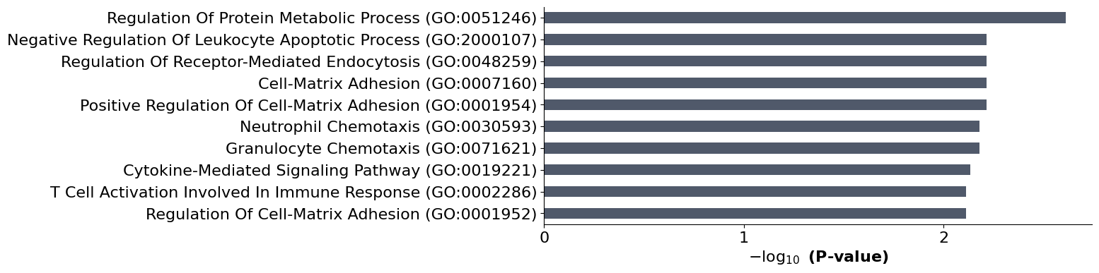
Network update, 3 (intermediary simulation step that match non experimental time point)
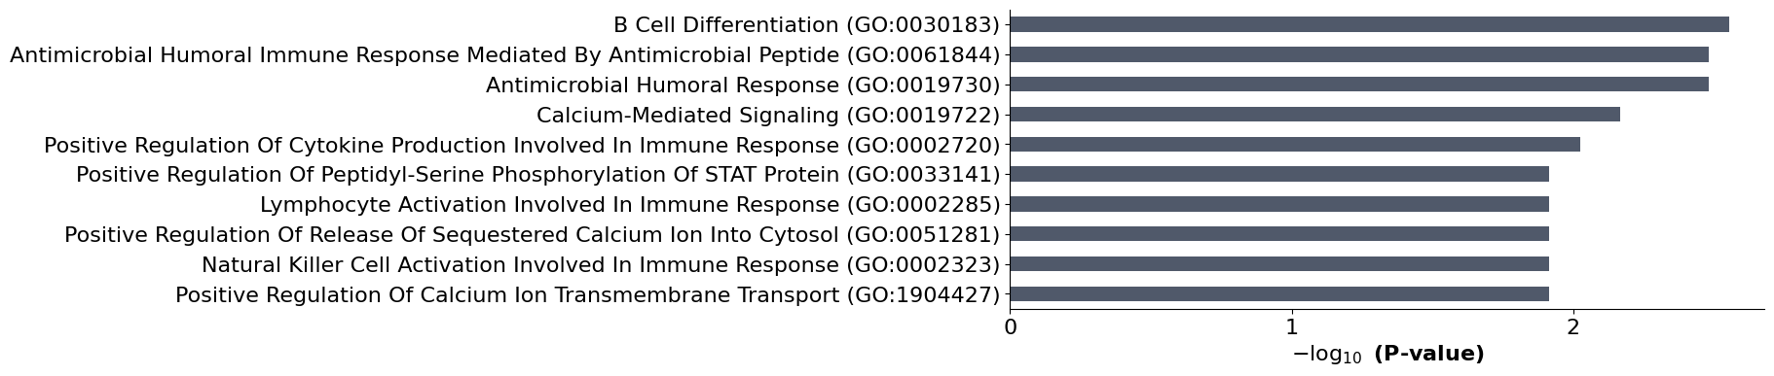
Network update, 4; Experimental time point, 168 hours
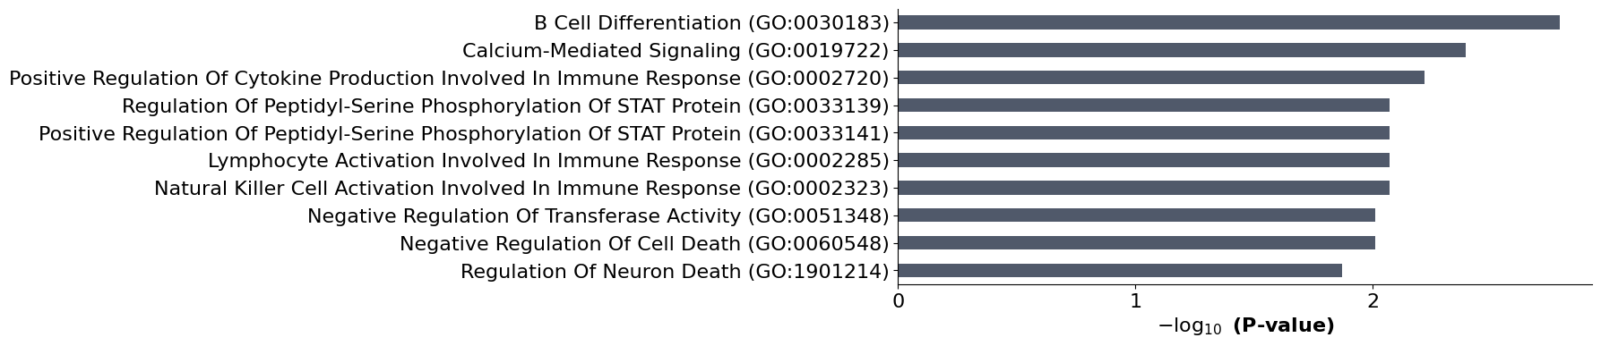

b
Network update, 1; Experimental time point, 24 hours
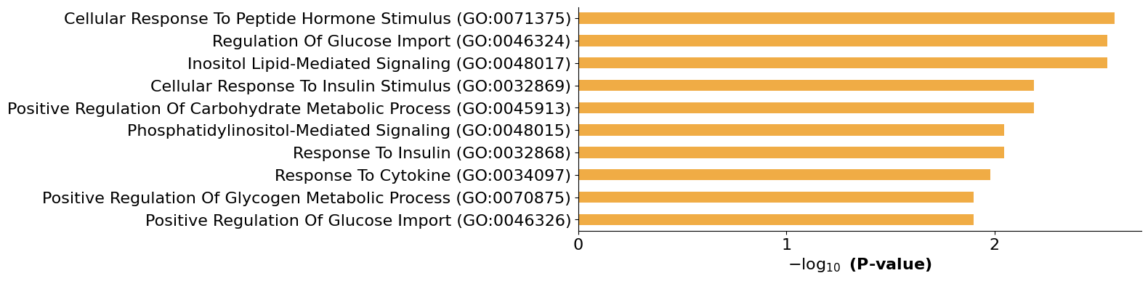
Network update, 2 (intermediary simulation step that match non experimental time point)
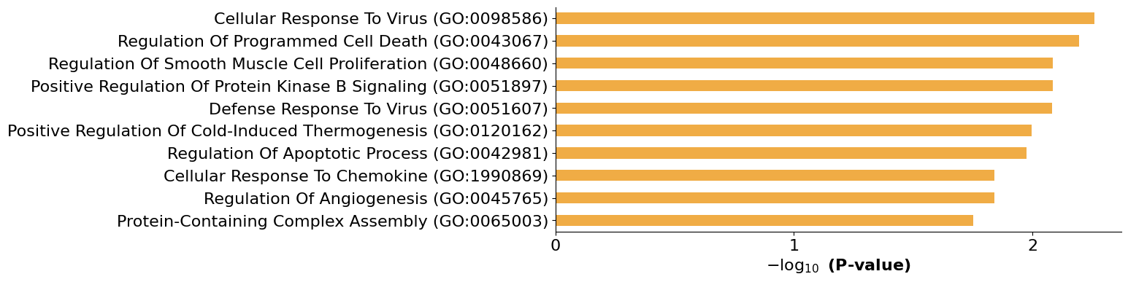
Network update, 3; Experimental time point, 72 hours
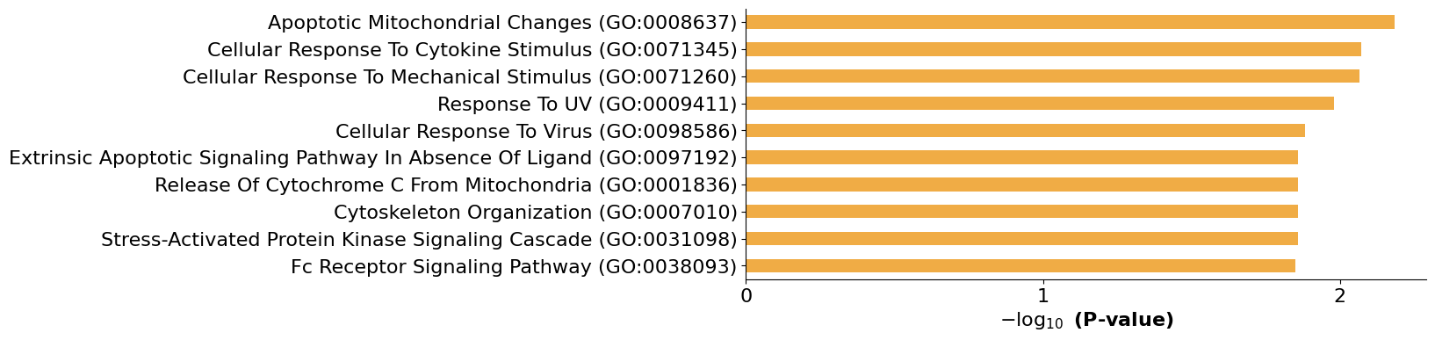
Network update, 4 (intermediary simulation step that match non experimental time point)
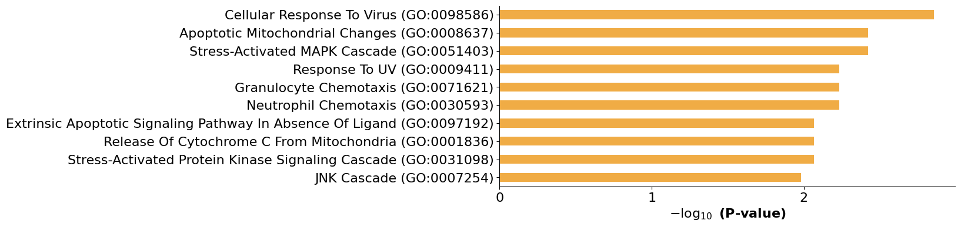
Network update, 5; Experimental time point, 168 hours
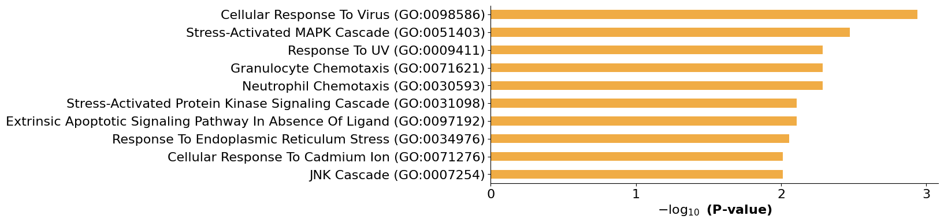

Supplementary Figure S6: Dynamic Gene Ontology enrichment analysis of the unperturbed MVA- and YF-17D-induced immune response Boolean network trajectories. (a) MVA-induced response Boolean network. (b) YF-17D-induced response Boolean network. The y-axis indicates the top 10 enriched biological process GO terms and the x-axis displays the negative logarithm of the associated p-values (all < 0.05).

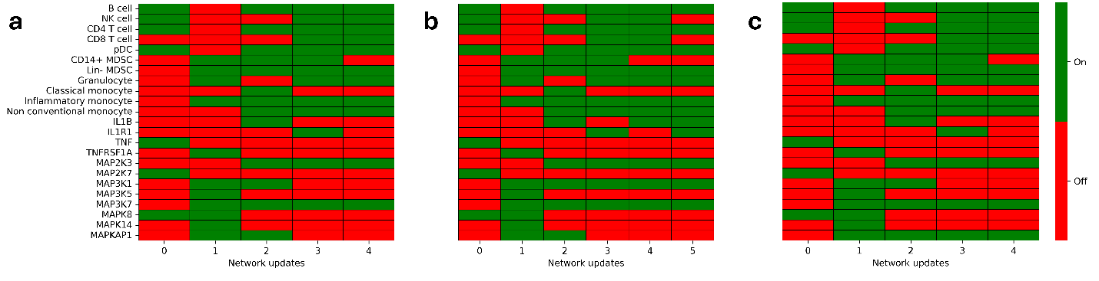Supplementary Figure S7: Binary cellular abundances and innate immune marker gene expression in perturbed and unperturbed MVA-induced immune response Boolean network simulations. (a) Parental MVA, (b) MVA ΔK7R MVA, and (c) MVA ΔF17R simulations.

