Figure S1. Western blot analysis of SIRT1 expression in PHN rats. GAPDH served as a loading control. Densitometric quantification is shown. *P < 0.05 vs. Control group; #P < 0.05 vs. PHN group.

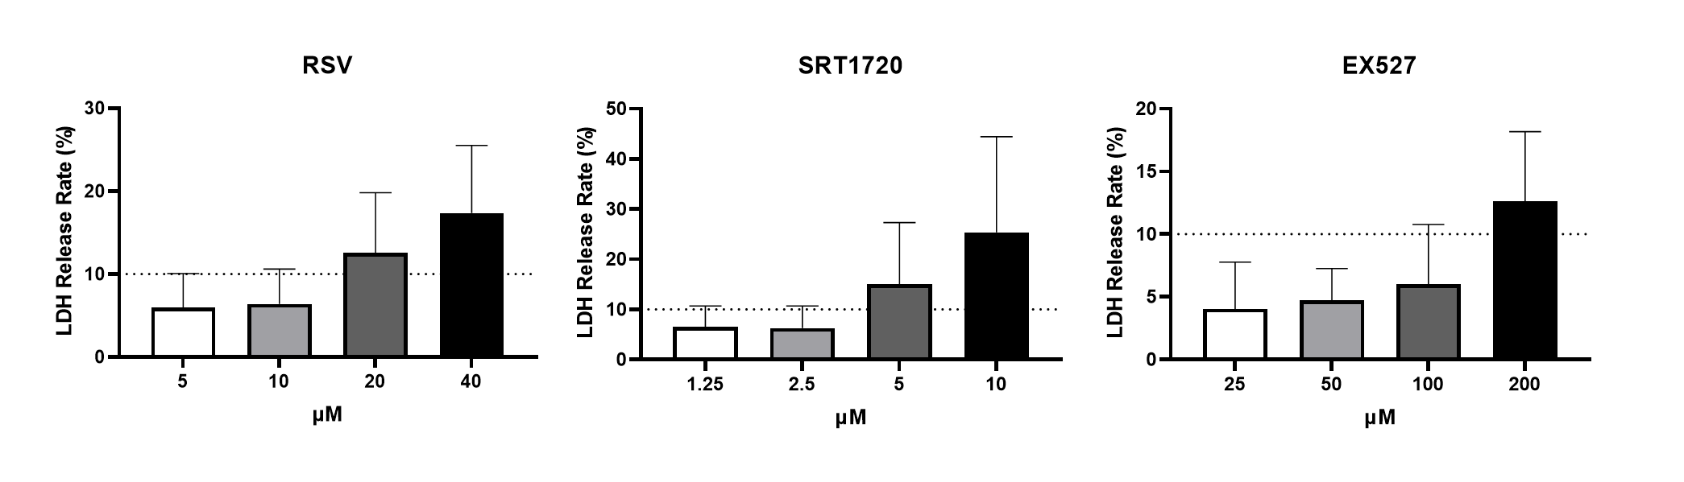
Figure S2. Cytotoxicity screening of SIRT1 agonists. LDH release in podocytes treated with RSV (0–100 μM) or SRT1720 (0–10 μM) for 24 h (n=5). Optimal non-toxic concentrations: RSV (10 μM), SRT1720 (2.5 μM).

