A multiscale framework for developing equations of state of supercritical aqueous systems from synchrotron experiments, atomistic simulations, and machine learning
Konstantinos Karalis^{1*}, Sergey V. Churakov^{1,2}, Nikolaos I. Prasianakis², Florentina Maxim³, Antonio Cervellino⁴, Laszlo Temleitner⁵, Laszlo Pusztai⁵, Ploutarchos Tzampoglou⁶, Matthias Krack⁷, Christian Ludwig^{8,9} and Bojan Niceno¹⁰
¹Institute of Geological Sciences, University of Bern, CH-3012 Bern, Switzerland
²Laboratory for Scientific Computing and Modelling (LSM/NES), Paul Scherrer Institute, 5232 Villigen PSI, Switzerland
³Laboratory for Chemical Thermodynamics, "Ilie Murgulescu" Institute of Physical Chemistry, Splaiul Independentei 202, 060021 Bucharest, Romania - permanent address
⁴Laboratory for Synchrotron Radiation (LSC), Paul Scherrer Institute, 5232 Villigen PSI, Switzerland
⁵Department of Complex Fluids, Institute for Solid State Physics and Optics, HUN-REN Wigner Research Centre for Physics, 1121 Budapest, Hungary
⁶Department of Civil & Environmental Engineering, University of Cyprus, Nicosia, Cyprus
⁷Laboratory for Materials Simulations (LMS), Paul Scherrer Institute, 5232 Villigen PSI, Switzerland
⁸École Polytechnique Fédérale de Lausanne (EPFL), ENAC IIE GR-LUD, 1015 Lausanne, Switzerland
⁹Laboratory for Sustainable Energy Carriers and Processes (LEP), PSI Center for Energy and Environmental Sciences, Paul Scherrer Institute
¹⁰Laboratory for Simulation and Modelling (LSM), Paul Scherrer Institute, 5232 Villigen PSI, Switzerland

Figure S1. Experimental x-ray diffraction spectrum.

Figure S2. Mean square displacement as obtained from the ab-initio molecular dynamics simulation in the NVT ensemble.
Fig.S3. Comparison between the experimental structure factor and the aqueous solution MD calculated using the three and four site water models (SPC/E and TIP4/2005 respectively).

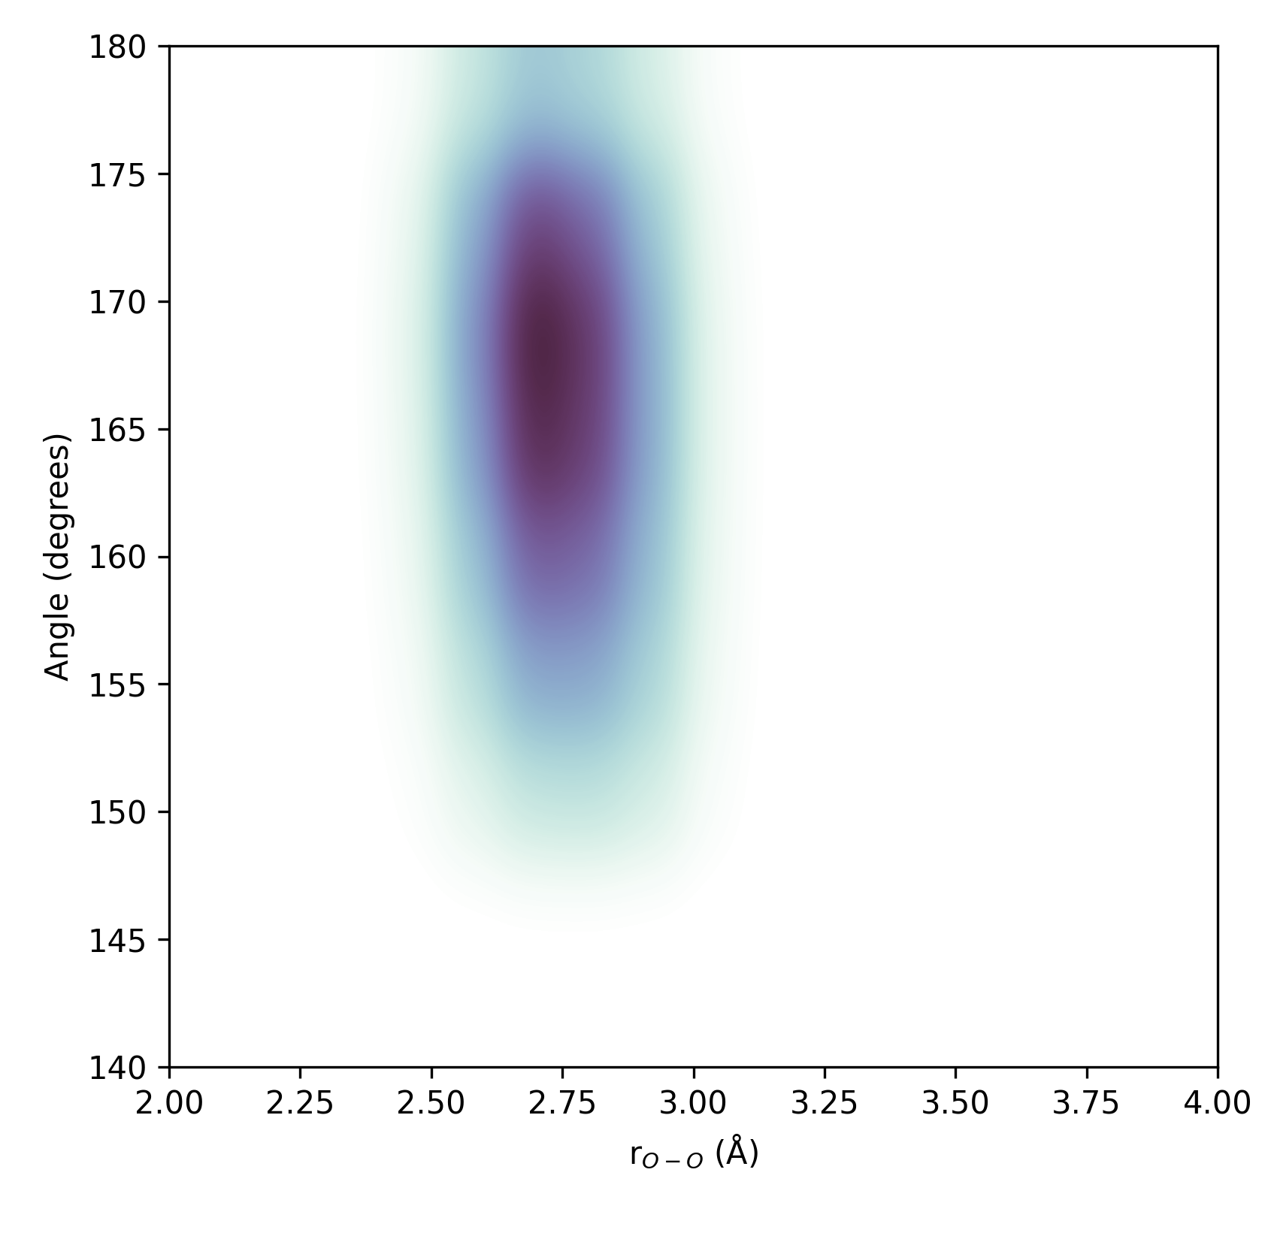
Figure S4. Contour map of hydrogen bonding

