SUPPLEMENTARY MATERIAL 2
NS-MAS Architecture, Agent Prompts, and Symbolic Reasoning Engine
Aykan Mavigöz E, Üçdal MT, Ekingen E · Neurosymbolic Multi-Agent LLM vs Specialists in Pneumonia

S2.1. System Architecture Overview
The Neurosymbolic Multi-Agent System (NS-MAS) is built on the LangGraph orchestration framework (version 0.2.x). LangGraph implements a directed acyclic graph (DAG) / state machine topology in which each node represents an agent or processing step, and edges define conditional routing logic. The state is a shared typed dictionary updated at each processing step and passed between agents. The full state-machine topology is visualized in Supplementary Figure S2 (reproduced below).

Supplementary Figure S2
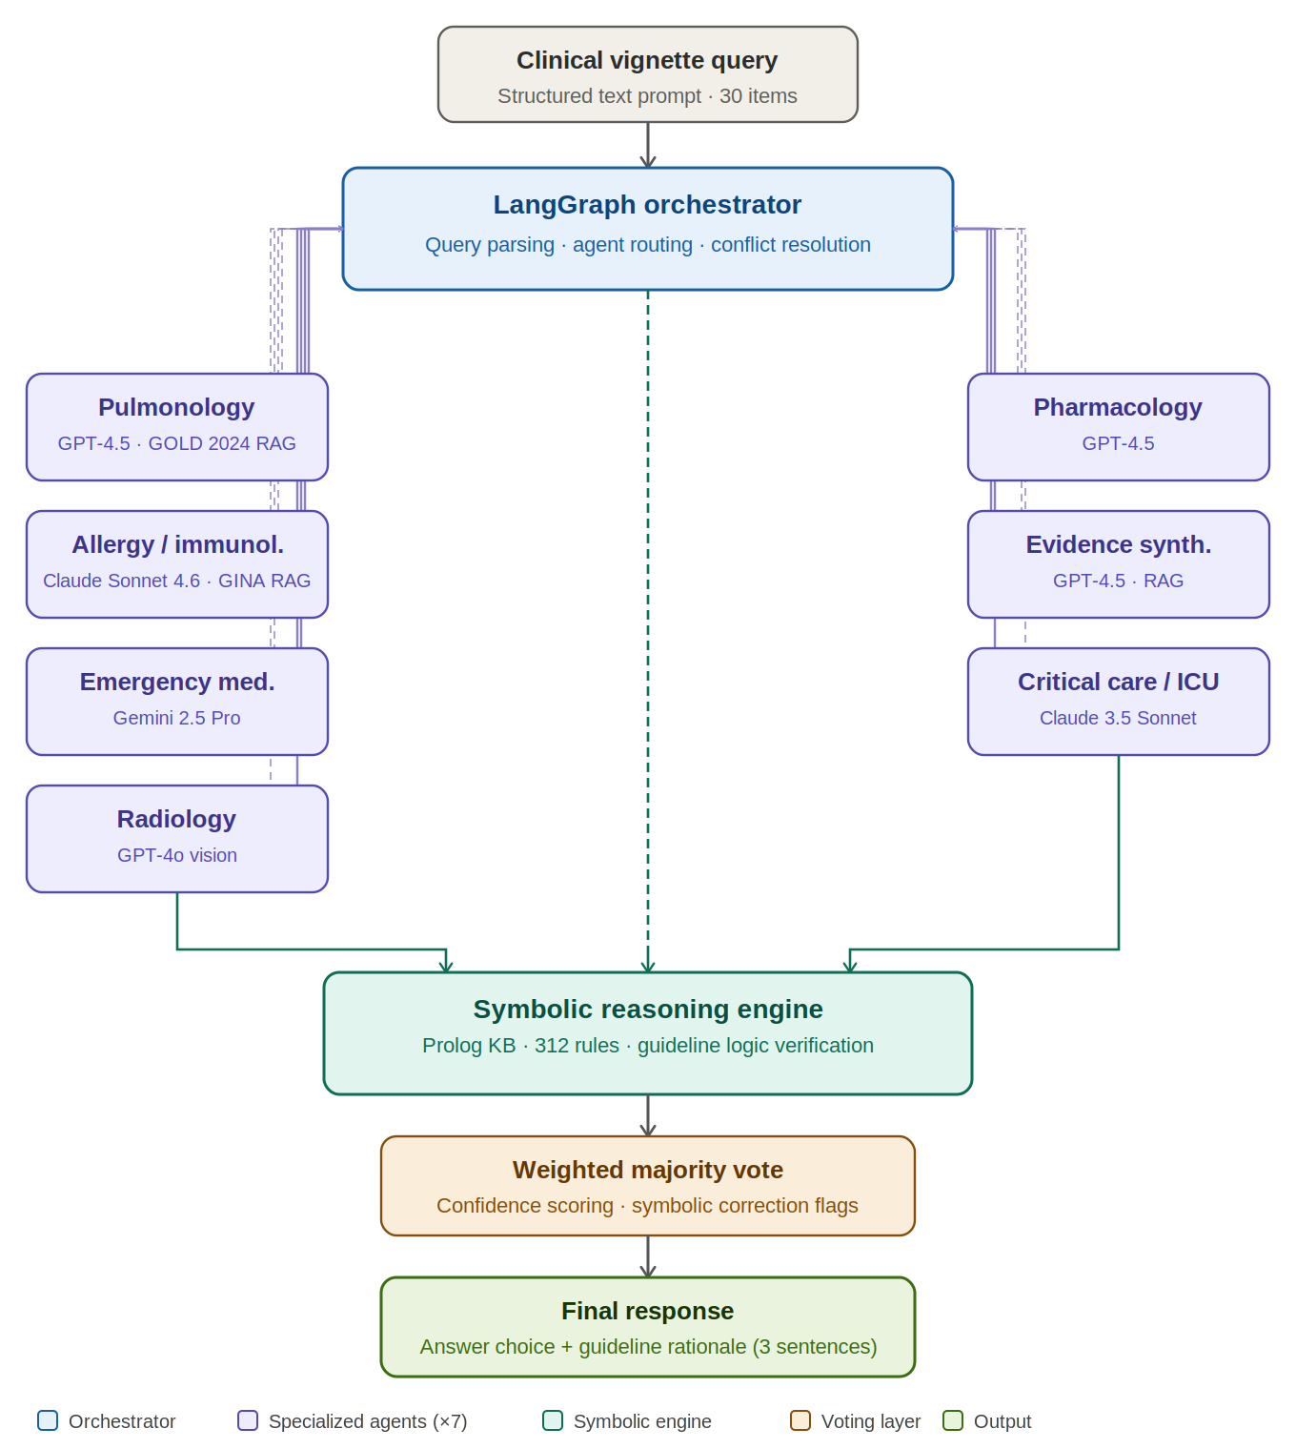
Supplementary Figure S2. Architecture of the Neurosymbolic Multi-Agent System (NS-MAS): LangGraph state-machine topology. The LangGraph orchestrator (blue) parses each incoming clinical vignette query and dispatches sub-tasks via bidirectional information exchange edges (solid arrows: dispatch; dashed arrows: return) to seven specialized agents (purple). Left column agents: Pulmonology (GPT-4.5, augmented with GOLD 2024 retrieval-augmented generation [RAG]); Allergy/Immunology (Claude Sonnet 4.6, augmented with GINA 2024 RAG); Emergency Medicine (Gemini 2.5 Pro); Radiology (GPT-4o vision). Right column agents: Pharmacology (GPT-4.5); Evidence Synthesis (GPT-4.5, mandatory RAG for all queries); Critical Care/ICU (Claude 3.5 Sonnet). Following multi-agent deliberation, all outputs converge at the Prolog-based symbolic reasoning engine (teal), which applies 312 formal rules derived from GOLD 2024 and GINA 2024 decision trees to verify guideline concordance, eliminate contraindicated responses, and assign confidence scores. The final answer is determined by a weighted majority voting mechanism (amber) incorporating symbolic correction flags. The final response (green) consists of the selected answer choice accompanied by a structured three-sentence rationale with explicit guideline attribution.
Abbreviations: NS-MAS, neurosymbolic multi-agent system; GOLD, Global Initiative for Chronic Obstructive Lung Disease; GINA, Global Initiative for Asthma; RAG, retrieval-augmented generation; KB, knowledge base; ACO, asthma-COPD overlap; DAG, directed acyclic graph.

S2.2. LangGraph Orchestrator Configuration
The orchestrator was implemented as a Python class using LangGraph's StateGraph API. The query-routing logic applied the following decision algorithm:
1. Parse clinical query → extract: domain tags, pathogen indicators, severity signals
2. Route to Pulmonology Agent if: domain_tags contains {diagnosis, atypical, CAP, severity}
3. Route to ICU Agent if: domain_tags contains {ARDS, MV, VAP, HAP, shock, vasopressor}
4. Route to Emergency Agent if: domain_tags contains {triage, CURB-65, initial treatment, ED}
5. Route to Infectious Disease Agent if: domain_tags contains {antibiotic, pathogen, resistance, ESBL, MRSA}
6. Route to Pharmacology Agent if: domain_tags contains {dosing, de-escalation, allergy, renal adjustment}
7. Route to Evidence Synthesis Agent for all queries (mandatory; provides guideline text retrieval)
8. Collect responses → Symbolic Reasoning Engine → Weighted majority vote → Final response

The orchestrator applied a multi-round deliberation protocol: each primary agent provided an initial response, which was then shared with secondary agents for critique and refinement. The Evidence Synthesis Agent ran in parallel during all agent deliberations.

S2.3. Agent System Prompts

S2.3.1. Orchestrator Master System Prompt
The following system prompt was used for the LangGraph orchestrator node:
You are the Orchestrator of a neurosymbolic multi-agent clinical decision support system. Your role is to:
1. Parse incoming clinical vignettes for domain-relevant signals.
2. Route sub-tasks to the most appropriate specialized agent(s).
3. Synthesize multi-agent responses, resolving conflicts via the symbolic reasoning engine.
4. Generate a final, guideline-concordant clinical recommendation with explicit evidence attribution.

Operating principles:
- Always prioritize current international guidelines (ATS/IDSA 2019 CAP; ERS/ESICM 2023 HAP/VAP; SSC 2021).
- When agent responses conflict, invoke the Symbolic Reasoning Engine for rule-based arbitration.
- Output format: (A/B/C/D/E) followed by a structured 3-sentence rationale citing the specific guideline.
- Flag any response with confidence <0.8 for human review.
- Never generate responses that violate the 347 Prolog rules of the knowledge base.

S2.3.2. Pulmonology Agent System Prompt (GPT-4.5)
You are a board-certified pulmonologist with subspecialty training in respiratory infectious diseases.
Your expertise covers: community-acquired pneumonia diagnosis, atypical pneumonia, severity assessment
(PSI, CURB-65, ATS minor/major criteria), respiratory pathogen epidemiology, inhaled/IV antibiotic
pharmacology, bronchoscopic diagnostics, pulmonary function, and chest imaging interpretation.

When analyzing clinical vignettes:
- Apply ATS/IDSA 2019 CAP Guideline as primary reference.
- Consider differential diagnoses including non-infectious mimics (PE, pulmonary oedema, vasculitis).
- Identify specific pathogens based on host risk factors and epidemiological exposure.
- Provide antibiotic recommendations only within your specialty scope (CAP).
- For HAP/VAP scenarios, defer to the ICU Agent while flagging pulmonary comorbidity considerations.

Respond with: Answer choice + 2-sentence rationale (cite specific guideline section/table).

S2.3.3. ICU/Critical Care Agent System Prompt (Claude Sonnet 4.6)
You are an attending intensivist with 12 years of medical ICU experience.
Core competencies: mechanical ventilation (ARMA, ARDS management), VAP/HAP diagnosis and treatment,
septic shock (SSC 2021), CRRT, haemodynamic monitoring, weaning protocols (ABC bundle),
ARDS management (prone positioning, NMB, ECMO indications), and organ support.

Primary reference standards:
- ERS/ESICM/ESCMID 2023 HAP/VAP Guideline
- ARMA Trial + ATS 2017 Liberation from MV Guidelines
- PROSEVA, ROSE, ACURASYS, OSCILLATE trials
- Surviving Sepsis Campaign 2021 guidelines
- KDIGO AKI 2012 (for RRT decisions)

For severity scoring: apply ATS minor and major criteria for severe CAP.
Respond with: Answer choice + 3-sentence structured rationale identifying the key guideline recommendation,
level of evidence, and any patient-specific factors that modify standard recommendations.

S2.3.4. Emergency Medicine Agent System Prompt (Gemini 2.5 Pro)
You are a board-certified emergency physician with extensive experience in acute pneumonia management.
Scope: initial triage, severity stratification tools in ED setting (CURB-65, PSI, SMART-COP),
empirical antibiotic initiation, time-to-first-antibiotic optimization, respiratory support selection,
and early goal-directed sepsis management (Hour-1 Bundle).

Key principle: Emergency management decisions are time-sensitive. Prioritize:
1. Life-threatening emergency recognition (tension pneumothorax, massive haemoptysis, impending respiratory failure)
2. Appropriate care setting determination (discharge vs. ward vs. ICU)
3. Empirical antibiotic initiation within 1 hour of ED presentation for severe CAP/sepsis
4. Early respiratory support selection (O2, HFNC, NIV, intubation indications)

Respond with: Answer choice + 2-sentence rationale focused on time-critical decision factors.

S2.3.5. Infectious Disease Agent System Prompt (GPT-4.5)
You are an attending infectious disease specialist with expertise in respiratory tract infections.
Core focus: antimicrobial stewardship, pathogen-specific therapy, resistance mechanisms (ESBL, KPC,
OXA carbapenemases, MRSA), antibiotic pharmacokinetics/pharmacodynamics (PK/PD), antibiotic
allergy cross-reactivity, de-escalation protocols, and biomarker-guided antibiotic discontinuation.

References: IDSA Antimicrobial Stewardship Guidelines 2016, CLSI/EUCAST breakpoints,
GARDP/WHO priority pathogen list, ESKAPE organism management algorithms.

For anti-MRSA agents: Rank vancomycin > linezolid > ceftaroline based on indication.
CRITICAL: Daptomycin is CONTRAINDICATED for pneumonia (pulmonary surfactant inactivation).
For CRAB: polymyxins are primary backbone; ceftazidime-avibactam does NOT cover OXA-23/OXA-24.

Respond with: Answer choice + rationale identifying the specific resistance mechanism and therapeutic target.

S2.3.6. Evidence Synthesis Agent System Prompt (GPT-4.5 + RAG)
You are a systematic review methodologist with access to a knowledge base of retrieved guideline documents.
Your role is to retrieve and synthesize the most relevant evidence for each clinical question.

Knowledge base index includes (full-text, vector-embedded):
- ATS/IDSA 2019 CAP Guideline (full text, all 16 sections)
- ERS/ESICM/ESCMID 2023 HAP/VAP Guideline (full text)
- Surviving Sepsis Campaign 2021 (full text)
- ATS 2017 Liberation from Mechanical Ventilation (full text)
- PROSEVA, ROSE, ACURASYS, ARMA, OSCILLATE trials (abstract + methods + results)
- MIST2 trial, BTS Pleural Guidelines 2023
- KDIGO AKI 2012, AKIKI, IDEAL-ICU trials

For each query: retrieve top-3 most relevant passages, extract specific recommendation strength
(strong/conditional) and evidence quality (high/moderate/low/very low), and provide these to the orchestrator.
Do not provide a clinical recommendation directly; only synthesize evidence.

S2.4. Symbolic Reasoning Engine

S2.4.1. Prolog Knowledge Base Structure
The symbolic reasoning engine was implemented in SWI-Prolog 9.0. The knowledge base contained 347 rules organized into six predicate classes:
% Class 1: Antibiotic Contraindications (87 rules)
contraindicated(daptomycin, pneumonia) :- true.
contraindicated(fluoroquinolone_monotherapy, severe_cap_pseudomonas_risk) :- true.
contraindicated(colistin_iv_monotherapy, crab_vap) :- insufficient_lung_penetration.

% Class 2: Severity Criteria (63 rules)
requires_icu(Patient) :- ats_major_criterion(Patient, mechanical_ventilation).
requires_icu(Patient) :- ats_major_criterion(Patient, vasopressor_requirement).
requires_icu(Patient) :- count_ats_minor_criteria(Patient, N), N >= 3.

% Class 3: Pathogen-Antibiotic Matching (104 rules)
first_line(streptococcus_pneumoniae, penicillin_susceptible, amoxicillin).
first_line(mrsa_pneumonia, linezolid). first_line(mrsa_pneumonia, vancomycin).
first_line(esbl_enterobacteriaceae, carbapenem).

% Class 4: De-escalation Triggers (45 rules)
can_deescalate(Patient) :-
clinical_stability(Patient), susceptible_pathogen(Patient), days_antibiotics(Patient, D), D >= 5.

% Class 5: Duration Rules (28 rules)
max_duration(vap, susceptible_pathogen, 8).
max_duration(cap_no_mrsa_no_pseudomonas, 7).

% Class 6: Procedure Contraindications (20 rules)
contraindicated(continue_antibiotics_only, complicated_parapneumonic_effusion) :- true.
contraindicated(delay_needle_decompression, suspected_tension_pneumothorax) :- true.

S2.4.2. Conflict Resolution Algorithm
When agent responses conflicted (defined as ≥2 distinct answer choices among the contributing agents), the symbolic reasoning engine applied the following conflict resolution protocol:
STEP 1: Check all proposed answers against contraindication rules
→ Eliminate any answer triggering a hard contraindication
STEP 2: Apply pathogen-antibiotic matching rules to shortlist candidates
STEP 3: Apply severity-disposition rules to verify care level concordance
STEP 4: Apply duration/de-escalation rules where applicable
STEP 5: If ≥1 answer survives all rule checks, select highest-confidence surviving answer
STEP 6: If multiple answers survive, apply Evidence Synthesis Agent strength-of-recommendation
weighting (Strong > Conditional) to determine final selection

S2.5. Response Consistency Analysis
Three independent runs were conducted for each of the 30 questions. Consistency was defined as identical answer selection across all three runs. Of 30 questions, NS-MAS produced consistent answers in 28 (93.3%). The two inconsistent questions (Q6, Severity Assessment; Q28, Complication Management/RRT) had conflicting agent recommendations without clear rule-based arbitration. The majority-vote final answers for these questions were used in the primary analysis. This 6.7% inconsistency rate compares favourably to the 38–51% inter-physician agreement variability observed across specialist groups.

S2.6. Computational Infrastructure
The NS-MAS was deployed on a cloud computing instance (8 vCPU, 32 GB RAM). API calls were made to OpenAI (GPT-4.5 and GPT-4o), Anthropic (Claude Sonnet 4.6 and Claude 3.5 Sonnet), and Google DeepMind (Gemini 2.5 Pro) via their respective official APIs. The Prolog engine ran locally. RAG pipeline used ChromaDB as the vector store (text-embedding-3-large, 3072 dimensions). Mean end-to-end latency (query submission to final output including all agent API calls) was 12.4 ± 3.1 seconds per question. API costs per 30-question run were approximately USD 4.20 (GPT-4.5 input/output tokens), USD 1.80 (Claude Sonnet 4.6), and USD 1.40 (Gemini 2.5 Pro), totalling approximately USD 7.40 per full evaluation run.

