Mixed-Solvent MD Suite: Modular Tools for Building and Analyzing Mixed-Solvent Molecular Dynamics Systems

Qiu Yue ^{a #*} Liu Qing ^{b} Xie Jian-Wu ª

ª Jinhua Key laboratory of Quality Evaluation and Standard Research of Traditional Chinese Medicine, Jinhua Institute For Food And Drug Control, Jinhua Advanced Research Institute of Technology, Jinhua 321019, China
^{b} Suzhou Institute for Advanced Research, University of Science and Technology of China, Suzhou 215004, China

#Authors
Qiu Yue, Jinhua Key laboratory of Quality Evaluation and Standard Research of Traditional Chinese Medicine, Jinhua Institute for Food and Drug Control; Jinhua Advanced Research Institute of Technology, Jinhua, China; E-mail: sean28299@gmail.com; Tel: +86-15631635591

*Corresponding authors
Qiu Yue, Jinhua Key laboratory of Quality Evaluation and Standard Research of Traditional Chinese Medicine, Jinhua Institute for Food and Drug Control; Jinhua Advanced Research Institute of Technology, Jinhua, China; E-mail: sean28299@gmail.com; Tel: +86-15631635591

Content
Mixed-Solvent MD Suite: Modular Tools for Building and Analyzing Hybrid Solvent MD Systems 1
Table S1. Properties and functional roles of 13 default probe molecules in MixMD. 3
Table S2. Probe Occupancy Sites Identified by GridMap Analysis Across Target Proteins. 3
Figure S1. Interfaces of PDB preprocessing tools. 4

Table S1. Properties and functional roles of 13 default probe molecules in MixMD.

Probe | SMILES | Aromaticity | Functional Role / Key Interactions
FMA | C=O.N | Non-aromatic | Polar amide; strong hydrogen bond donor; captures strong hydrogen bonding interactions [36].
DMS | CS(=O)C | Non-aromatic | Highly polar solvent; enhances membrane permeability; captures both polar and hydrophobic pockets [34].
MEH | CO | Non-aromatic | Polar protic solvent; hydrogen bond donor; captures polar protic interactions [32].
IPA | CC(O)C | Non-aromatic | Low-polarity solvent; captures small hydrophobic interactions [40, 43].
ACN | CC#N | Non-aromatic | Polar aprotic solvent; captures hydrophilic interactions; hydrogen bond donor [1,39].
GUA | C(N)=N | Non-aromatic | Mimics positively charged environments [33].
ACE | CC(=O)[O-] | Non-aromatic | Mimics negatively charged environments [44].
NMA | CC(=O)NC | Non-aromatic | Model for peptide backbone hydrogen bonding; mimics peptide substrate interactions [5,9].
BNZ | c1ccccc1 | Aromatic | Hydrophobic aromatic solvent; captures hydrophobic aromatic interactions [37, 45].
TOL | Cc1ccccc1 | Aromatic | Nonpolar aromatic solvent; captures nonpolar aromatic interactions [41, 45].
PHN | c1ccc(cc1)O | Aromatic | Moderately polar aromatic solvent; captures hydrophobic aromatic interactions [38].
IND | c1ccc2c(c1)cc[nH]2 | Aromatic | Aromatic moiety; mimics tryptophan side chains; captures hydrophobic interactions [35].
PYR | c1cncnc1 | Aromatic | Nitrogen-containing aromatic base; captures aromatic interactions; soluble aromatic probe [12, 35, 42].

Table S2. Probe Occupancy Sites Identified by GridMap Analysis Across Target Proteins.

PDB ID | 4HG7 | 6O0L | 1M47 | 1Q1M | 6WUU
1 | 81 | 138 | 91 | 58 | 36
2 | 79 | 133 | 22 | 54 | 32
3 | 37 | 50 | 10 | 35 | 29
4 | 36 | 17 | 7 | 33 | 24
5 | 2 | 4 | 3 | 18 | 22
Table S1. Probe Occupancy Sites Identified by GridMap Analysis Across Target Proteins. This table summarizes the top five probe occupancy positions identified in each target protein structure. The occupancy values reflect the frequency of probe presence at specific grid positions, as calculated by the GridMap-based spatial analysis following 100 ns MixMD simulations. Higher values indicate greater probe enrichment and potential interaction hotspots.

Figure S1. Interfaces of PDB preprocessing tools.
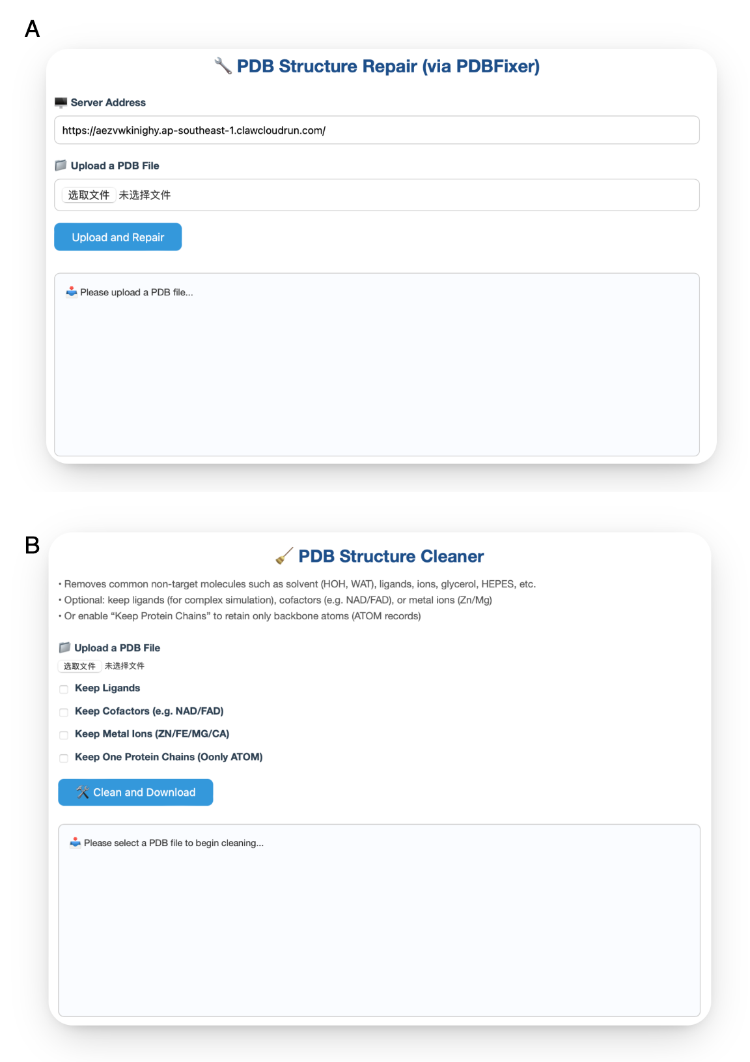
Figure S1. Interfaces of Online PDB preprocessing tools (https://sean28.github.io/pdb-pre-processing/). (A) PDB Structure Repair: Fixes missing atoms/residues via PDBFixer. (B) PDB Structure Cleaner: Removes solvents, ligands, and ions with optional retention settings.

