The file includes:
Figures S1 to 6
Figures S1: JQ1-induced cellular senescence is accompanied by p21 upregulation.
A) Representative flow-cytometry evaluation of cell death in SCC15 and SCC25 cells after treatment with increasing doses of JQ1 (n = 3). B) Western blotting of two cell lines after treatment with JQ1 for the indicated time periods. Jurkat cells were treated with 25 μM etoposide as positive control. S, short exposure; L, long exposure. C) Flow-cytometry of PI incorporation to determine 2N (G0/G1) and 4N (G2/M) DNA content in the two cell lines after treatment with the indicated concentrations of JQ1 (n = 3). Representative experimental results are shown. D) Western blotting analysis of the two cell lines after treatment with JQ1. E, F) Representative immunofluorescence images of p21 and p16 (left) and the levels (right) in the two cell lines after JQ1 treatment (n = 3, paired two-tailed t-test). Scale bar = 20 μm. Percentages of p21 positive cells were scored in > 100 cells from randomly selected fields, and the p16 relative mean intensity was calculated from 3 randomly selected fields, by Image J. G) Western blotting of p53 and phosphorylated p53 (p-p53) in SCC15 and SCC25 cells treated with 0.5 μM JQ1 for the indicated time periods (6 h, 48 h and 6 d). 293FT cells treated with 0.5 μM prexasertib dihydrochloride (PD) for 48 h were included as control. H) Western blotting of BRD2, BRD3 or BRD4 and p21 in SCC15 and SCC25 cells transfected with negative control siRNA (NC) or three independent siRNAs (#1–#3) targeting BRD2, BRD3 or BRD4.

Figure S2 BRD4 inhibition is correlated with senescence-associated transcriptome profiles without triggering an inflammatory response.
A) Scatter plot showing the correlation of gene-expression changes between SCC15 and SCC25 cells treated with 0.5 μM JQ1 for 48 h (RNA-seq). B) Heatmap of scaled FPKM values for selected inflammatory/SASP-related genes and regulators in SCC15 and SCC25 cells treated with DMSO or 0.5 μM JQ1. Green arrowheads indicate representative regulators (e.g., NF-κB/C/EBPβ- and senescence-related factors), and red arrowheads indicate key inflammatory SASP factors (e.g., TGFB1, CXCL1/2, IL1A/IL6/IL1B)C) Representative images of SA-β-gal staining assays (left) and quantification (right) of SA-β-gal–positive cells in MKN-45 cells treated with 5 μM JQ1 and MDA-MB-231 cells treated with 3 μM JQ1 compared with DMSO control. Scale bar = 100 μm. D) RT–qPCR analysis of IL-1α, IL-6 and CXCL8 mRNA levels in gastric cancer cell line (MKN-45; 5 μM JQ1) and breast cancer cell line (MDA-MB-231; 3 μM JQ1). (n = 3, mean ± s.d., two-tailed unpaired Student’s t-test.
Figure S3. A) Top 10 enriched KEGG pathway terms of the commonly upregulated DEGs (described in Fig. 3B) in JQ1-induced senescent SCC15 and SCC25 cells. B) Representative images (left) and quantification (right) of the mRFP-GFP-LC3 reporter assay in SCC25 cells treated with 0.5 μM JQ1 for the indicated time periods (6 h, 48 h, 6 d) (DMSO as control). Autophagosomes and autolysosomes were quantified as LC3 puncta per cell (n = 3; one-way ANOVA with LSD post hoc multiple comparison test). C) Western blotting of p62/SQSTM1 and LC3B (with p21 as indicated) in SCC15 and SCC25 cells treated with 0.5 μM JQ1; chloroquine (CQ, 10 μM) was used as a lysosomal inhibitor (4 h, as indicated). D) Western blotting analysis of BRD4, LAMP2, ASM (SMPD1) and LC3B in SCC15 and SCC25 cells transfected with siBRD4 or siNC control. E) Western blotting of ULK1, LC3B and p21 in SCC15 and SCC25 cells transfected with siULK1 (#1) (or control) and treated with 0.5 μM JQ1 as indicated. F) Representative images of SA-β-gal staining (left) and quantification of SA-β-gal–positive cells (%) (right) in SCC15 and SCC25 cells transfected with siULK1 (#1) (or siNC) after treatment with DMSO or 0.5 μM JQ1 (n = 3; statistical test as stated in the manuscript, consistent with multi-group comparisons) G) Representative images of EdU staining in the two cell lines transfected with siULK1 after treatment with JQ1 for 48 h (left) and the levels (right) of SCC15 and SCC25 (n = 3, unpaired two-tailed t test). Scale bar = 100 μm.The percentages of positive cells were scored in > 100 cells from randomly selected fields (F, G).
Figure S4. A)Western blotting of LC3B (I/II), ATG5 and p21 in SCC15 and SCC25 cells transfected with siATG5 (#3) or control siRNA and treated with 0.5 μM JQ1 (DMSO as control). B) Representative images (left) and quantification (right) of EdU incorporation in SCC15 and SCC25 cells transfected with siATG5 (#3) or control siRNA and treated with DMSO or 0.5 μM JQ1 (n = 3; one-way ANOVA with LSD post hoc multiple comparison test). Scale bar = 100 μm. C) Western blotting for G9a, BRD4 and MYC in SCC15 and SCC25 cells transduced with pLV-Empty or pLV-BRD4 (o.e., overexpression). D) Western blotting for G9a, BRD4 and MYC in SCC15 and SCC25 cells transfected with siBRD4 or negative control siRNA.
Figure S5. A) Smooth scatterplots comparing methylation levels (β-values) between senescent (Sen) and proliferating (Prolif) cells at promoter CpGIs, gene bodies and enhancer regions (SCC15, top; SCC25, bottom). B) Numbers and percentages of significant differential methylation probes (DMPs) located within CpGI regions or outside CpGIs (non-CpGIs). Hyper, Δβ = (Sen − Prolif) > 0, p < 0.05; Hypo, Δβ = (Sen − Prolif) < 0, p < 0.05. C) Genome-browser views of representative DMPs near or within the indicated genes in SCC15 or SCC25. Tracks show β-values of Prolif (blue) and Sen (pink) replicates, mean Δβ (Sen − Prolif; green), and p values (red). Senescence-associated promoter CpGI hypermethylated sites are boxed in red..

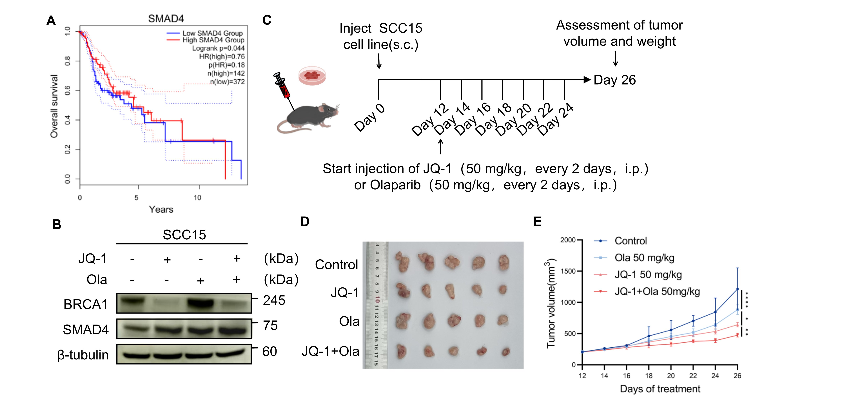
Figure S6. A) Kaplan–Meier overall survival analysis of the TCGA head and neck squamous cell carcinoma (TCGA-HNSC) cohort stratified by SMAD4 expression (High, n = 62; Low, n = 406); P = 0.047 (log-rank test). B) Immunoblot analysis of BRCA1 and SMAD4 in SCC15 cells treated with JQ-1 and/or olaparib as indicated; β-tubulin served as a loading control. C) Schematic of the SCC15 subcutaneous xenograft model and treatment schedule: SCC15 cells were implanted subcutaneously (s.c.), and mice received intraperitoneal (i.p.) injections of JQ-1 (50 mg/kg, every 2 days) and/or olaparib (50 mg/kg, every 2 days) followed by endpoint assessment of tumor volume and weight on day 26. D) Representative images of excised tumors from each treatment group at the study endpoint. E) Tumor growth curves showing tumor volume (mm³) over the indicated treatment period for control, olaparib, JQ-1, and the combination group; error bars indicate variability within each group, and asterisks denote statistical significance (*p < 0.05; **p < 0.01; ***p < 0.001).

