SUPPLEMENTARY MATERIAL – Cost-Effectiveness of ALK Inhibitors in NSCLC

This supplementary material provides additional details on model assumptions, sensitivity analyses, and data sources supporting the manuscript titled 'Cost-effectiveness of tyrosine kinase inhibitors for treatment of locally advanced or metastatic ALK+ non-small cell lung cancer in Brazil'. The content follows the Value in Health Regional Issues (ViHRI) guidance for appendices and online supplements.

Table S1 - Seven strategies simulated using first and second-line drug combinations
Alternatives | 1ª Linha | 2ª Linha
Alternative 1 | Crizotinib | Chemotherapy
Alternative 2 | Crizotinib | ALK inhibitors
Alternative 3 | Alectinib | Chemotherapy
Alternative 4 | Alectinib | Lorlatinib
Alternative 5 | Brigatinib | Chemotherapy
Alternative 6 | Brigatinib | Lorlatinib
Alternative 7 | Lorlatinib | Chemotherapy

Table S2 – Cost-effectiveness results of all strategies, dominated and non-dominated.
Dominance | Strategy | Cost | Incr Cost | Eff | Incr Eff | ICER
undominated | Crizotinib + Chemotherapy | 349.943,52 |  | 2,63
undominated | Brigatinib + Chemotherapy | 393.354,97 | 43.411,45 | 3,00 | 0,37 | 117.073,70
abs. dominated | Crizotinib + ALK Inhibitor | 480.796,14 | 87.441,17 | 2,96 | - 0,04 | - 2.072.571,09
ext. dominated | Brigatinib + Lorlatinib | 684.310,96 | 290.955,99 | 3,23 | 0,23 | 1.265.944,83
undominated | Alectinib + Chemotherapy | 687.231,54 | 293.876,57 | 3,76 | 0,75 | 391.118,87
abs. dominated | Lorlatinib + Chemotherapy | 801.429,67 | 114.198,13 | 3,42 | - 0,34 | - 336.232,30
undominated | Alectinib + Lorlatinib | 967.902,37 | 280.670,83 | 3,95 | 0,19 | 1.448.562,21

Figure S1 - Incremental Cost vs. Effectiveness Scatterplot. Alectinib + Chemotherapy vs. Brigatinib + Chemotherapy.
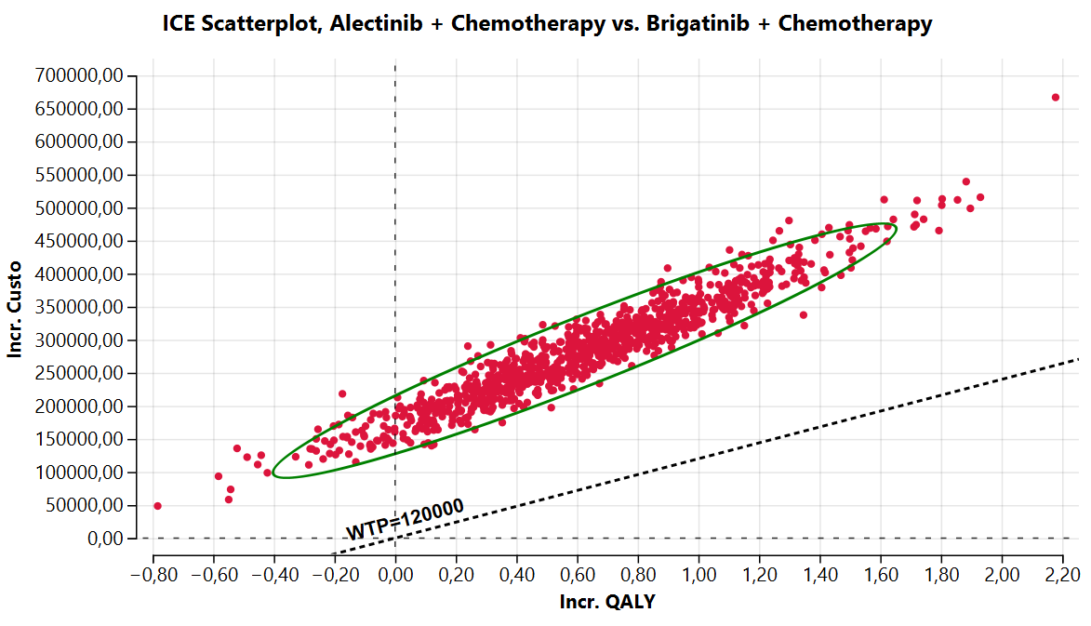

Figure S2: Incremental Cost vs. Effectiveness Scatterplot. Lorlatinib + Chemotherapy vs. Alectinib + Chemotherapy.
