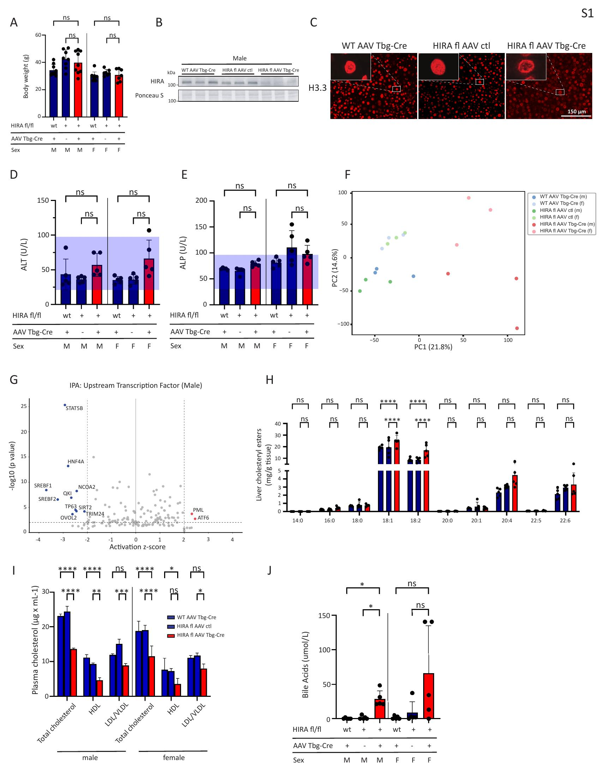

Supplementary Figure 1:
A. Body weight of control and HIRA KO mice at the time of tissue collection. Male mice: n = 9 (WT AAV Tbg-Cre, HIRA^{fl/fl} AAV Tbg-Cre); n = 8 (HIRA^{fl/fl} AAV ctl), Female mice: n = 9 (WT AAV Tbg-Cre); n = 7 (HIRA^{fl/fl} AAV ctl, HIRA^{fl/fl} AAV Tbg-Cre). B. Representative western blot demonstrating HIRA depletion in liver lysates from control and HIRA KO male mice. Ponceau S staining was used as loading control. n = 8 (HIRA^{fl/fl} AAV ctl); n = 9 (WT AAV Tbg-Cre, HIRA^{fl/fl} AAV Tbg-Cre). C. Immunofluorescence for H3.3 in control and HIRA KO livers, representative of n = 3 experiments. Scale bar, 150 μm. D. Effect in control and HIRA KO mice on serum ALT levels. n = 5 per group. E. Effect in control and HIRA KO mice on serum ALP levels. n = 5 per group. F. RNA-seq principal component analysis. n = 3 per group. G. Ingenuity Pathway Analysis (IPA) showing top predicted upstream transcription factors regulating DEGs in control versus HIRA KO mice. H. Hepatic cholesteryl ester composition showing individual species (14:0-22:6) as determined by LC-MS analysis. n = 5 per group. I. Plasma lipid profile showing total cholesterol and lipoprotein fractions (HDL, and LDL/ VLDL) in control and HIRA KO mice. n = 3 per group. J. Serum bile acid levels in control and HIRA KO mice measured using VetScan VS2 Mammalian Liver Profile rotors. n = 5 per group. Data are presented as means ± SEM. Statistical significance was determined by one-way analysis of variance (ANOVA) with Tukey’s multiple comparisons test. Asterisk (*) indicates p < 0.05, (**) p < 0.01, (***) p< 0.001, (****) p < 0.0001.

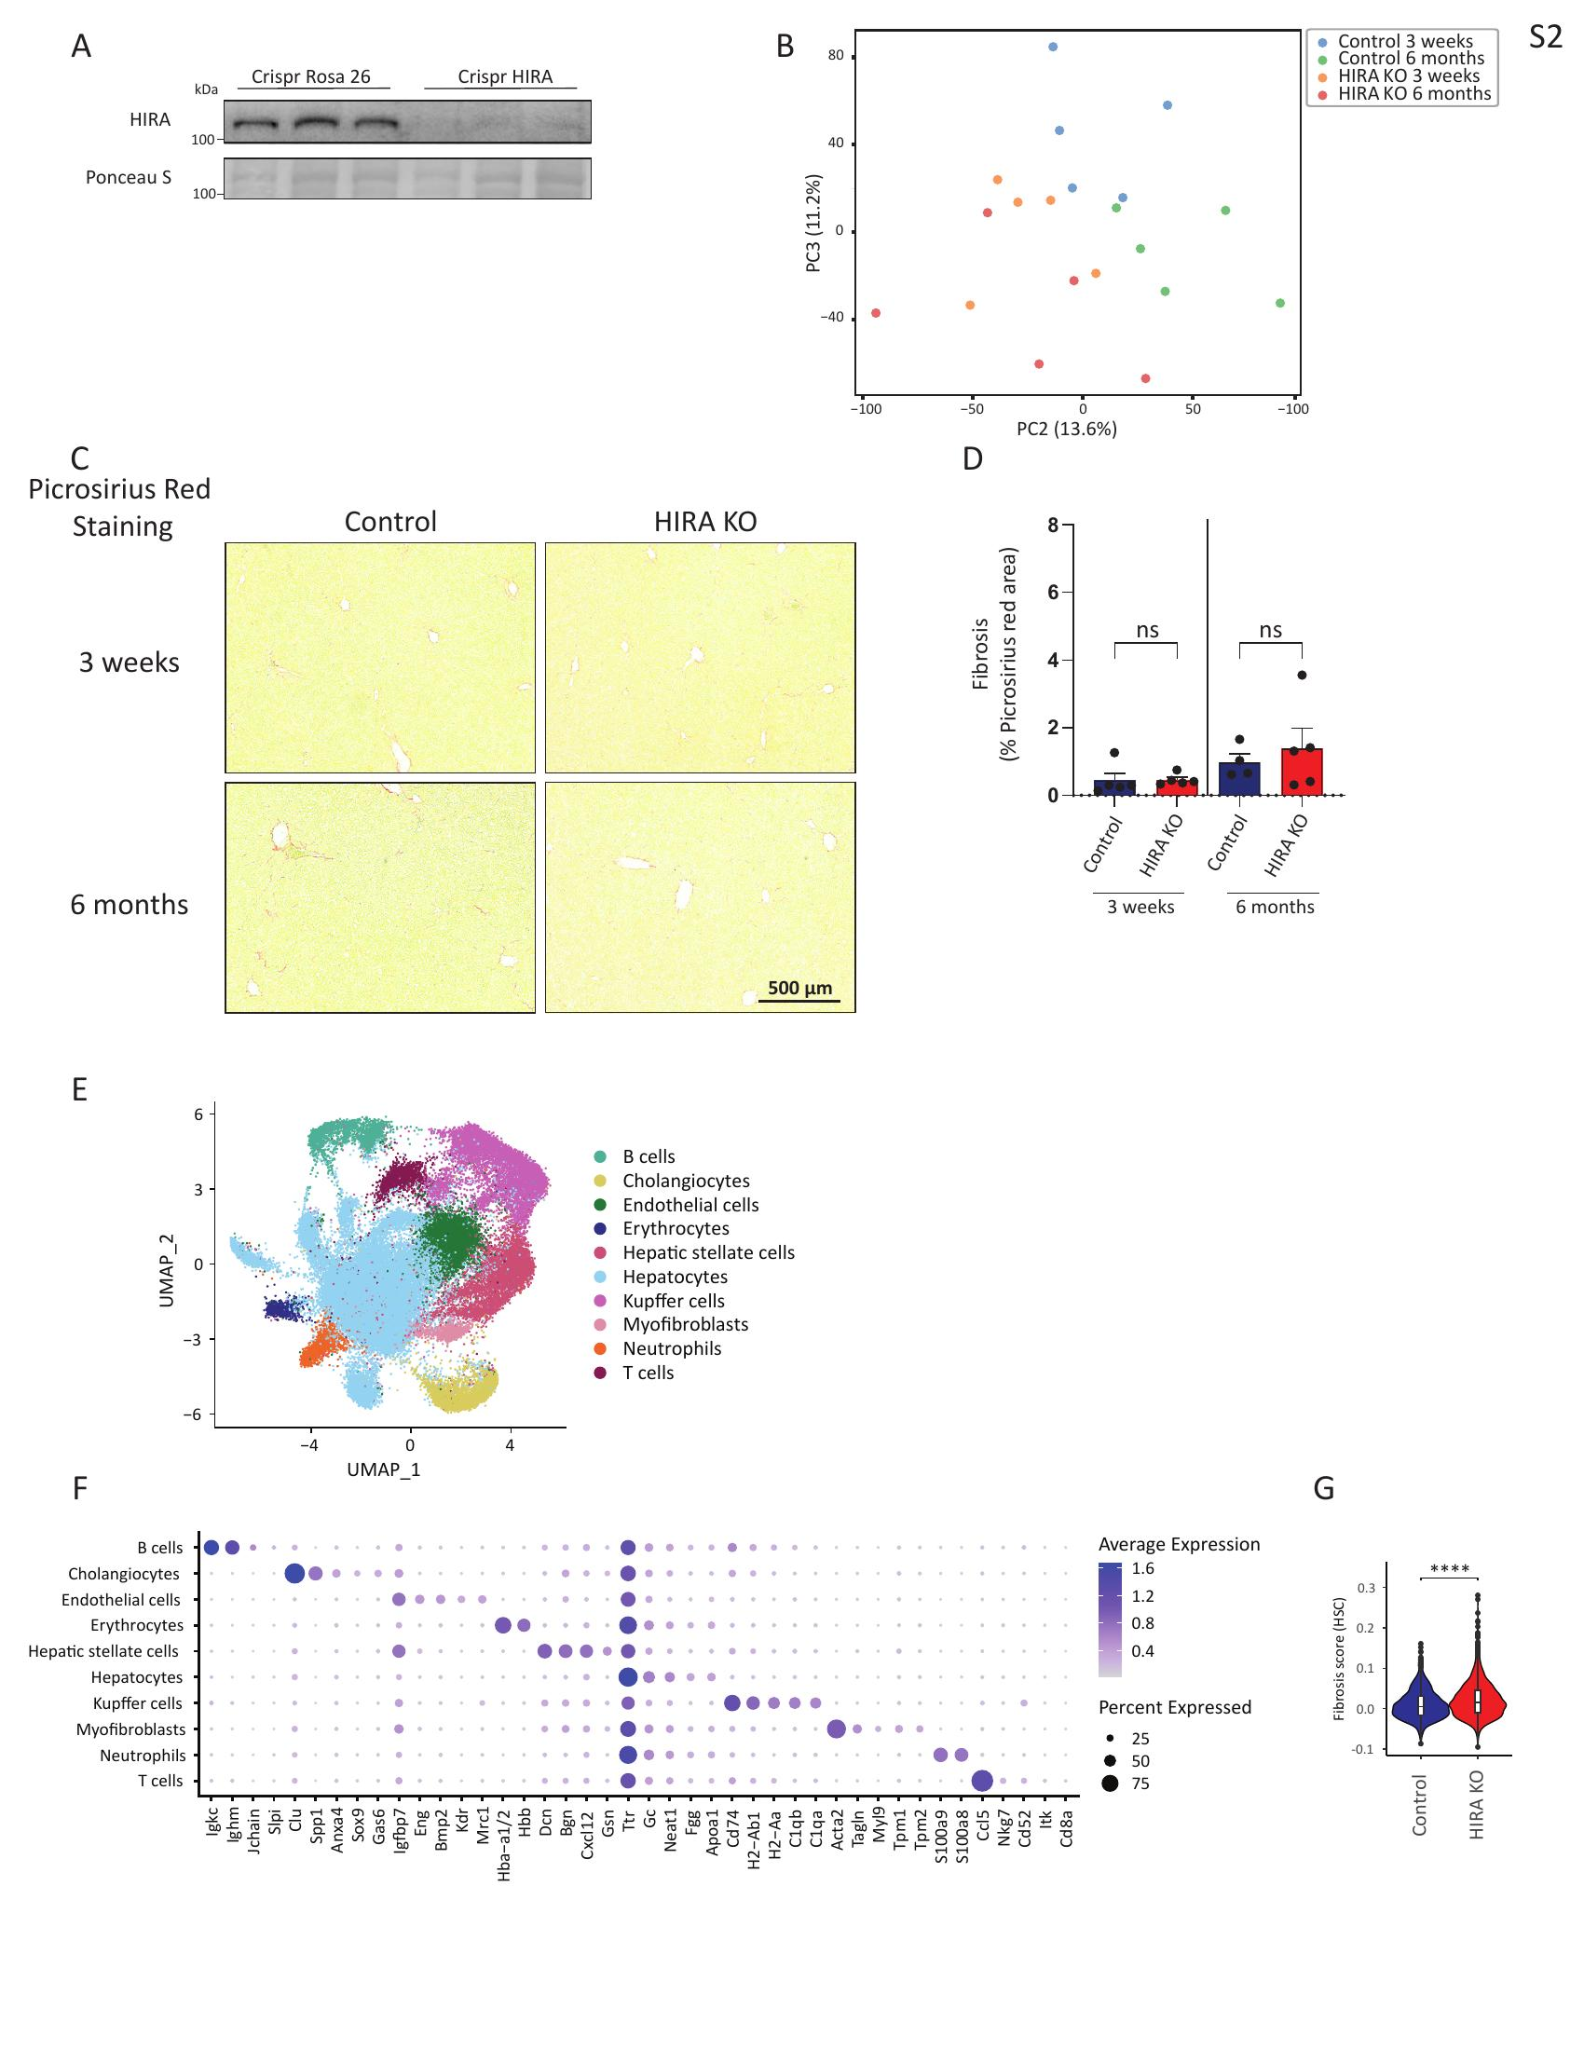

Supplementary Figure 2:
A. Representative western blot showing HIRA depletion in liver lysates from control and HIRA KO mice generated using CRISPR-Cas9. Ponceau S staining was used as loading control. n = 5. B. RNA-seq principal component analysis. n = 5 per group. C. Representative picrosirius red stainings of liver sections from control and HIRA KO mice at 3-week and 6-month timepoints. Scale bar, 500 μm. D. Quantification of picrosirius red positive area. n = 5. E. UMAP visualization of cell populations identified by CosMX spatial transcriptomics analysis in control and HIRA KO mouse liver tissue. n = 3. F. Dot plot displaying the top 5 marker genes for each cell type identified by CosMx spatial transcriptomics. Dot size represents the percentage of cells expressing each gene; color intensity indicates average expression level. G. Fibrosis score derived from a 43-gene signature (Suppl. Table 1) encompassing extracellular matrix components, matrix remodeling enzymes, and TGF-β signaling genes in control and HIRA KO liver sections. n = 3 per group. Data are presented as means ± SEM. Statistical significance for D was determined by one-way analysis of variance (ANOVA) with Tukey’s multiple comparisons test. For G, the Wilcoxon rank-sum test was used. Asterisk (*) indicates p < 0.05, (**) p < 0.01, (***) p< 0.001, (****) p < 0.0001.

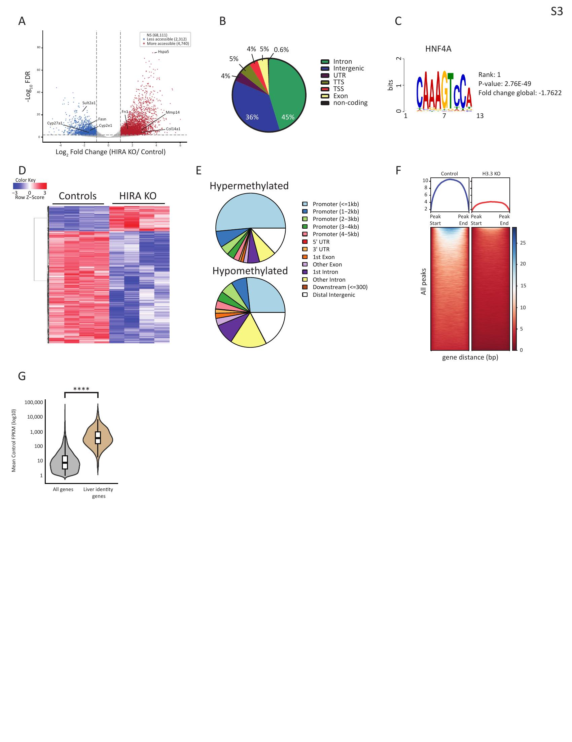

Supplementary Figure 3:
A. Volcano plot of differentially accessible chromatin regions identified by ATAC-seq in HIRA KO versus control livers. Regions classified as less accessible (n = 2,312), more accessible (n = 4,740), and not significant (NS; n = 68,111) are indicated. Selected genes are labeled. n = 2 per group. B. Pie chart showing the genomic distribution of differentially accessible ATAC-seq peaks by functional annotation (intron, intergenic, UTR, TTS, TSS, exon, non-coding). C. Top enriched transcription factor motif at regions with decreased chromatin accessibility in HIRA KO livers identified by ATAC-seq. HNF4α was ranked first. D. Heatmap of differentially methylated CpG sites (35,594 hypomethylated, 7,968 hypermethylated) in control and HIRA KO livers. n = 4 per group. E. Genomic distribution of hypermethylated and hypomethylated CpG sites annotated by functional category. F. Heatmap of H3.3 CUT&Tag signal intensity across all identified peaks in control and H3.3 KO livers, validating the H3.3 CUT&Tag approach. G. Expression distribution of all expressed genes compared to liver identity genes in female mice. Wilcoxon rank-sum test (Mann-Whitney U test) was used to calculate statistical significance. Asterisk (*) indicates p < 0.05, (**) p < 0.01, (***) p< 0.001, (****) p < 0.0001.

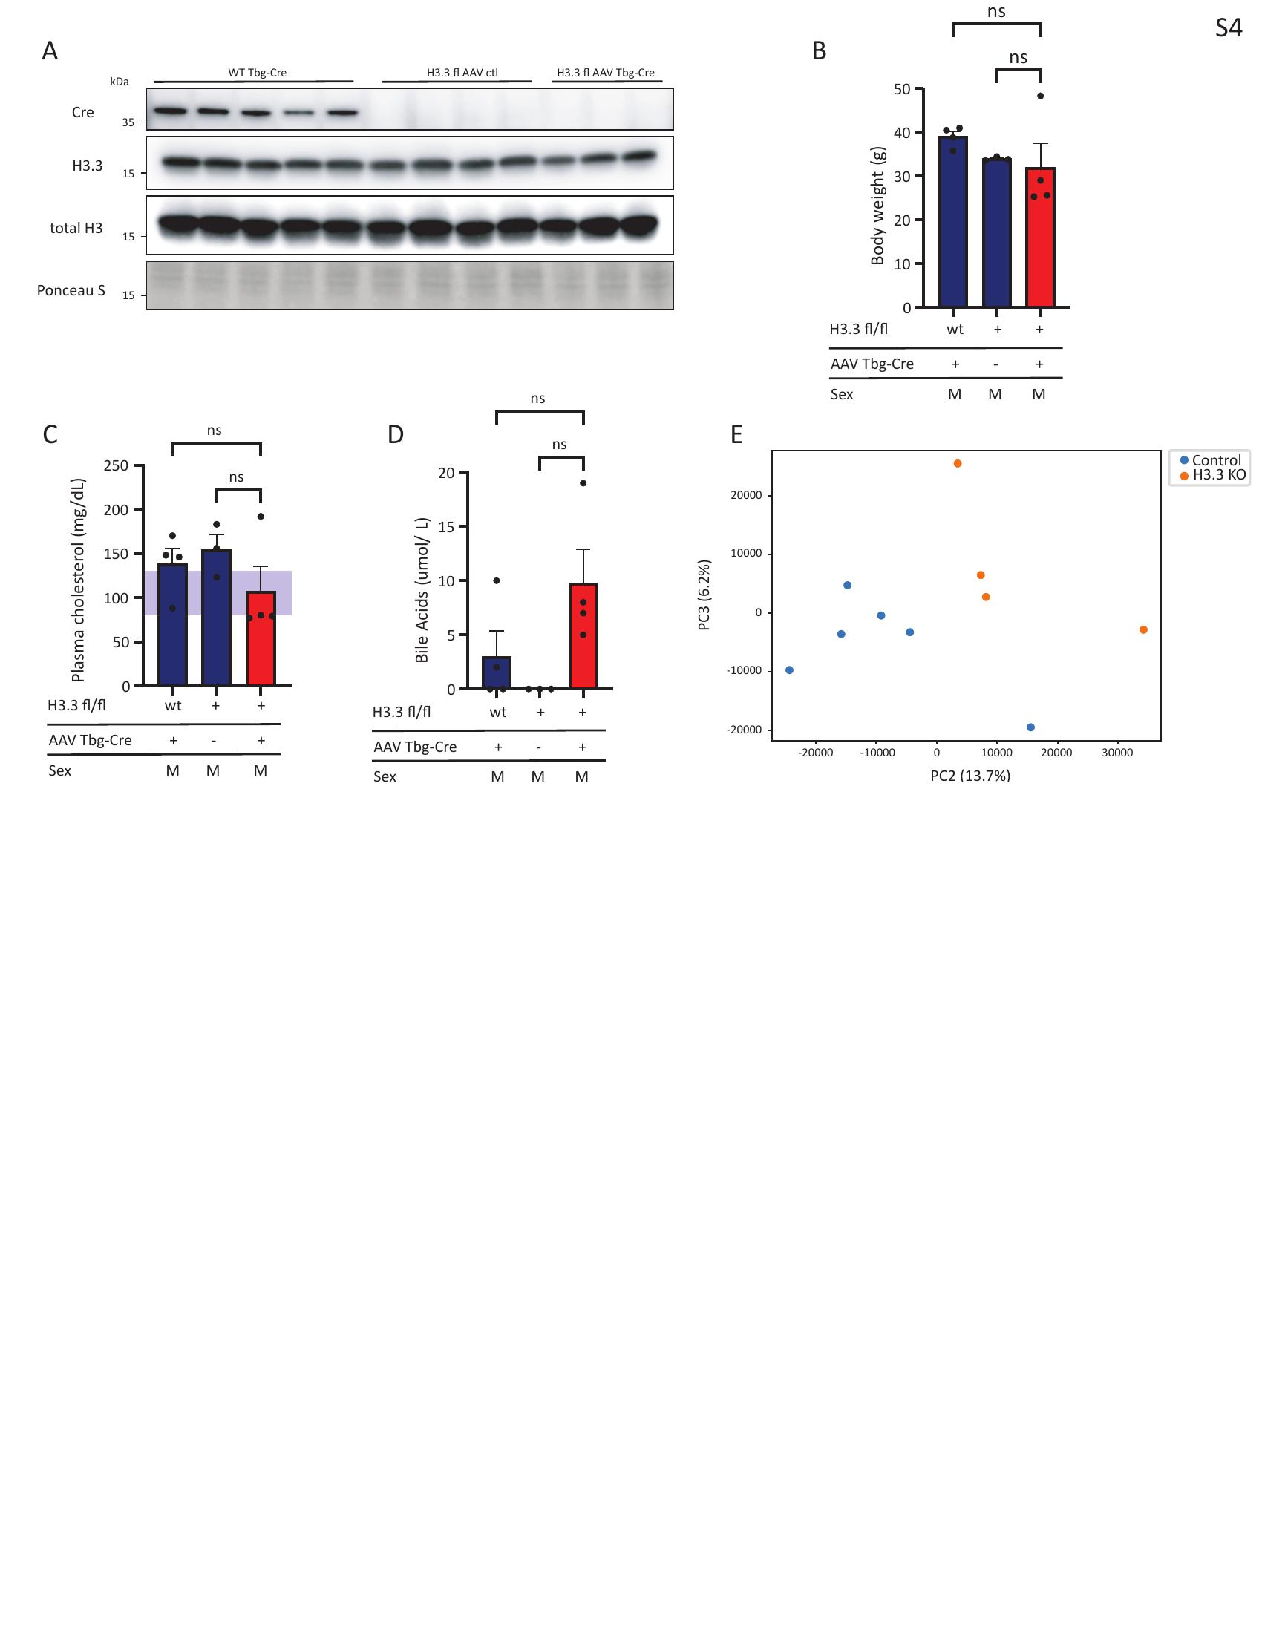

Supplementary Figure 4:
A. Representative western blot showing Cre, H3.3 and total H3 protein levels in liver lysates from control and H3.3 KO mice 1 year post-knockout. Ponceau S staining served as loading control. n = 5 (WT AAV Tbg-Cre); n = 4 (H3f3a^{fl/fl} H3f3b^{fl/fl} AAV ctl); n = 3 (H3f3a^{fl/fl} H3f3b^{fl/fl} AAV Tbg-Cre). B. Body weight of control and H3.3 KO mice 3 weeks post-knockout at the time of tissue collection. n = 4 (WT AAV Tbg-Cre, H3f3a^{fl/fl} H3f3b^{fl/fl} AAV Tbg-Cre); n = 3 (H3f3a^{fl/fl} H3f3b^{fl/fl} AAV ctl). C. Plasma cholesterol levels in control and H3.3 KO mice. D. Serum bile acid levels in control and H3.3 KO mice measured using VetScan VS2 Mammalian Liver Profile rotors. E. RNA-seq principal component analysis. n = 3 (WT AAV Tbg-Cre, H3f3a^{fl/fl} H3f3b^{fl/fl} AAV ctl); n = 4 (H3f3a^{fl/fl} H3f3b^{fl/fl} AAV Tbg-Cre). Data are presented as means ± SEM. Statistical significance was determined by one-way analysis of variance (ANOVA) with Tukey’s multiple comparisons test. Asterisk (*) indicates p < 0.05, (**) p < 0.01, (***) p< 0.001, (****) p < 0.0001.

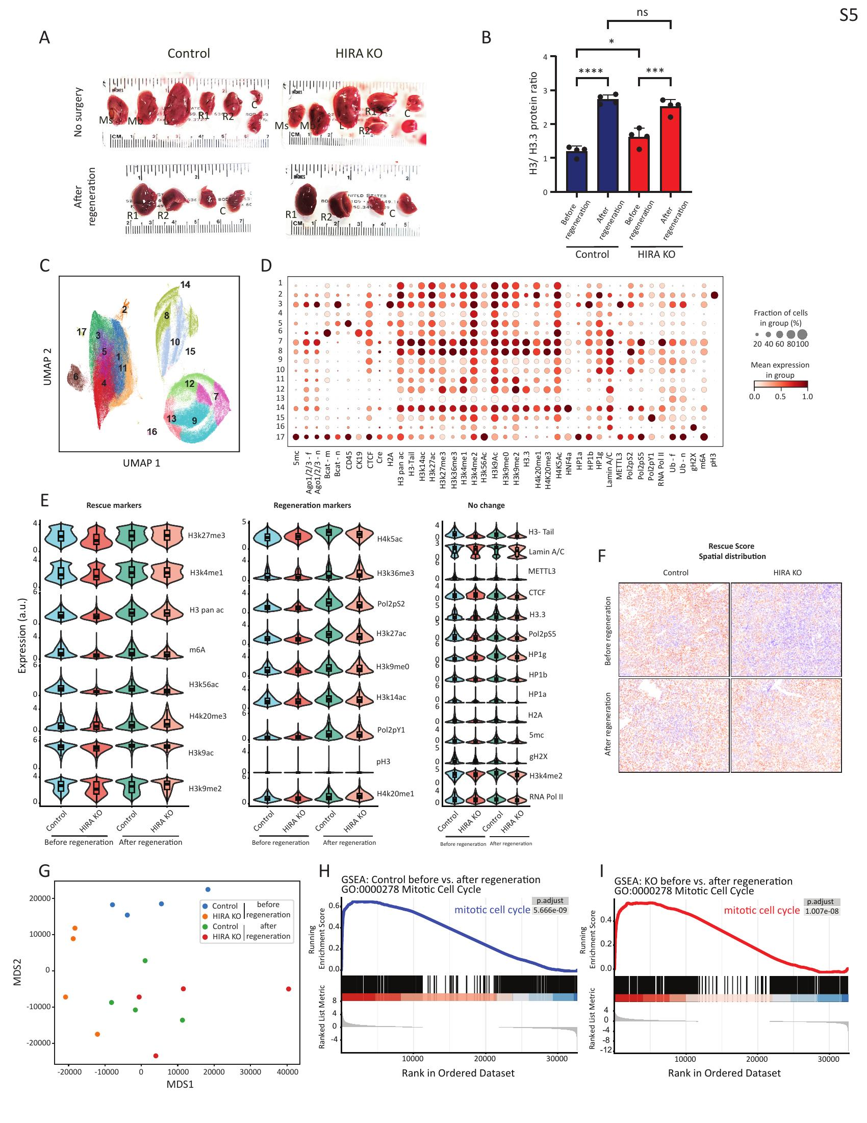

Supplementary Figure 5:
A. Representative images of liver lobes from control and HIRA KO mice without surgery and after regeneration. R1, R2: right lobe segments; C: caudate lobe; Ms: median lobe segments; L: left lobe. B. Western blot quantification, calculating the ratio of total H3/ H3.3 in control and HIRA KO livers before and after regeneration. n = 4. C. UMAP visualization identified by CODEX multiplex immunofluorescence analysis in control and HIRA KO liver tissue before and after regeneration. D. Dot plot displaying expression of epigenetic markers and cell type markers across identified clusters. Dot size represents the fraction of cells expressing each marker; color intensity indicates mean expression level. E. Violin plots showing expression of individual epigenetic markers in hepatocytes (HNF4α⁺, CK19⁻, CD45⁻; n = 194 165 cells) across conditions. Markers are grouped into rescue markers (altered by HIRA loss and restored after regeneration), regeneration markers (changed with regeneration in both genotypes), and no change markers (largely stable across conditions). F. Spatial distribution of rescue score mapped onto tissue sections from control and HIRA KO livers before and after regeneration. G. RNA-seq principal component analysis (MDS plot) of control and HIRA KO liver samples before and after regeneration. n = 4 per group. H, I. Gene Set Enrichment Analysis (GSEA) showing enrichment of mitotic cell cycle genes (GO:0000278) in control (H) and HIRA KO (I) livers comparing before versus after regeneration. Data are presented as means ± SEM. Statistical significance was determined by two-way ANOVA with Tukey’s multiple comparisons test. Asterisk (*) indicates p < 0.05, (**) p < 0.01, (***) p< 0.001, (****) p < 0.0001.

