Supplementary Table 1: Overview of TaqMan primers for q-PCR

Gene | catalog number
GJA1 | Hs00748445
JPH2 | Hs00375310_m1
ACTN2 | Hs00153809
BIN1 | Hs00184913_m1
CALM1 | Hs00300085_s1
CALM2 | Hs00830212_s1
CALM3 | Hs00968732_g1
RYR2 | Hs00181461_m1
CASQ2 | Hs00154286_m1
ATP2A2 | Hs00544877_m1
SLC8A1 | Hs01062258_m1
PLN | Hs00160179_m1
CACNA1C | Hs00167681
KCNJ2 | Hs00265315_m1
KCNQ1 | Hs00923522_m1
KCND3 | Hs00986860_m1
SCN5A | Hs00165693_m1
GAPDH | Hs02758991_g1

Supplementary Table 2: Beat-to-beat calcium transient parameters in CRISPRi and uncorrected CMTs.
 | Frequency (Hz) |  | Duration (ms) | Peak Amplitude (ΔF/F0) | Half-width (ms) | Time to % Peak (ms) |  | Time to % Decay (ms)
CRISPRi | 1 | N | 832.5 ± 51.2 | 0.31 ± 0.01 | 220.86 ± 41.1 | 10% | 3.76 ± 0.6 | 10% | 47±12.84
 |  |  |  |  |  | 50% | 38.74 ± 14.6 | 50% | 149.1±27
 |  |  |  |  |  | 90% | 70.51 ± 14.0 | 90% | 240.1±26
CRISPRi | 1 | N+1 | 845 ± 57 | 0.31 ± 0.01 | 225.7 ±28.1 | 10% | 3.77 ± 0.71 | 10% | 44.9±10.2
 |  |  |  |  |  | 50% | 48.6 ±14.39 | 50% | 134.8±19.7
 |  |  |  |  |  | 90% | 76.8 ± 12.32 | 90% | 237.8±16.1
CRISPRi | 0.5 | N | 1120 ± 84.85 | 0.37 ± 0.01 | 264.3 ± 35.8 | 10% | 5.02 ± 1.3 | 10% | 67.35±18.24
 |  |  |  |  |  | 50% | 46.83 ± 12.16 | 50% | 160.6±16.6
 |  |  |  |  |  | 90% | 111.34 ±1.18 | 90% | 295.4±2.85
CRISPRi | 0.5 | N+1 | 1015 ± 21.21 | 0.37 ± 0.002 | 233.2 ± 93.1 | 10% | 5.13 ± 0.47 | 10% | 60.78±3.08
 |  |  |  |  |  | 50% | 47.5 ± 13.3 | 50% | 176.5±2.44
 |  |  |  |  |  | 90% | 115.67 ± 5.9 | 90% | 328.9±1.5
Uncorrected  CTRL | 1 | N | 1031 ± 74.1 | 0.3 ± 0.016 | 286.9± 48.1 | 10% | 7.33 ± 1.45 | 10% | 68.59±16.6
 |  |  |  |  |  | 50% | 62.89± 13.2 | 50% | 174.1±29
 |  |  |  |  |  | 90% | 134.8 ± 17.7 | 90% | 272±23.5
Uncorrected  CTRL | 1 | N+1 | 988 ±94.7 | 0.21 ± 0.018** | 317.5 ± 58.4 | 10% | 6.43 ± 0.7 | 10% | 99.41±24.1
 |  |  |  |  |  | 50% | 46.55 ± 12.67 | 50% | 171.5±22.5
 |  |  |  |  |  | 90% | 147.9 ± 13.9 | 90% | 276.9±54.9
Uncorrected  CTRL | 0.5 | N | 1875 ± 35.35 | 0.3 ± 0.017 | 418.5 ± 11.7 | 10% | 8.4 ± 1.25 | 10% | 139.93±19.56
 |  |  |  |  |  | 50% | 63.5 ± 28.28 | 50% | 239.1±20.94
 |  |  |  |  |  | 90% | 162.9 ± 17.4 | 90% | 430.9±21.7
Uncorrected  CTRL | 0.5 | N+1 | 1690 ± 14.14* | 0.25 ± 0.011* | 365.8 ± 20.8 | 10% | 6.76 ± 1.03 | 10% | 120.93±15.33*
 |  |  |  |  |  | 50% | 52.3 ±10.1 | 50% | 194.7±10.33*
 |  |  |  |  |  | 90% | 188.4± 25.1 | 90% | 367.5±32.6

Supplementary Figure 1: A-D: flow cytometry data show Troponin T expression of CMs from 4 different differentiations. E-F: Fluorescence expression of KRAB transcriptional repressor in hiPSC-CMs, used to quantify transduction efficiency (31–34%). (gray: Without virus treatment, blue: uncorrected control (CTRL) red: CRISPRi)
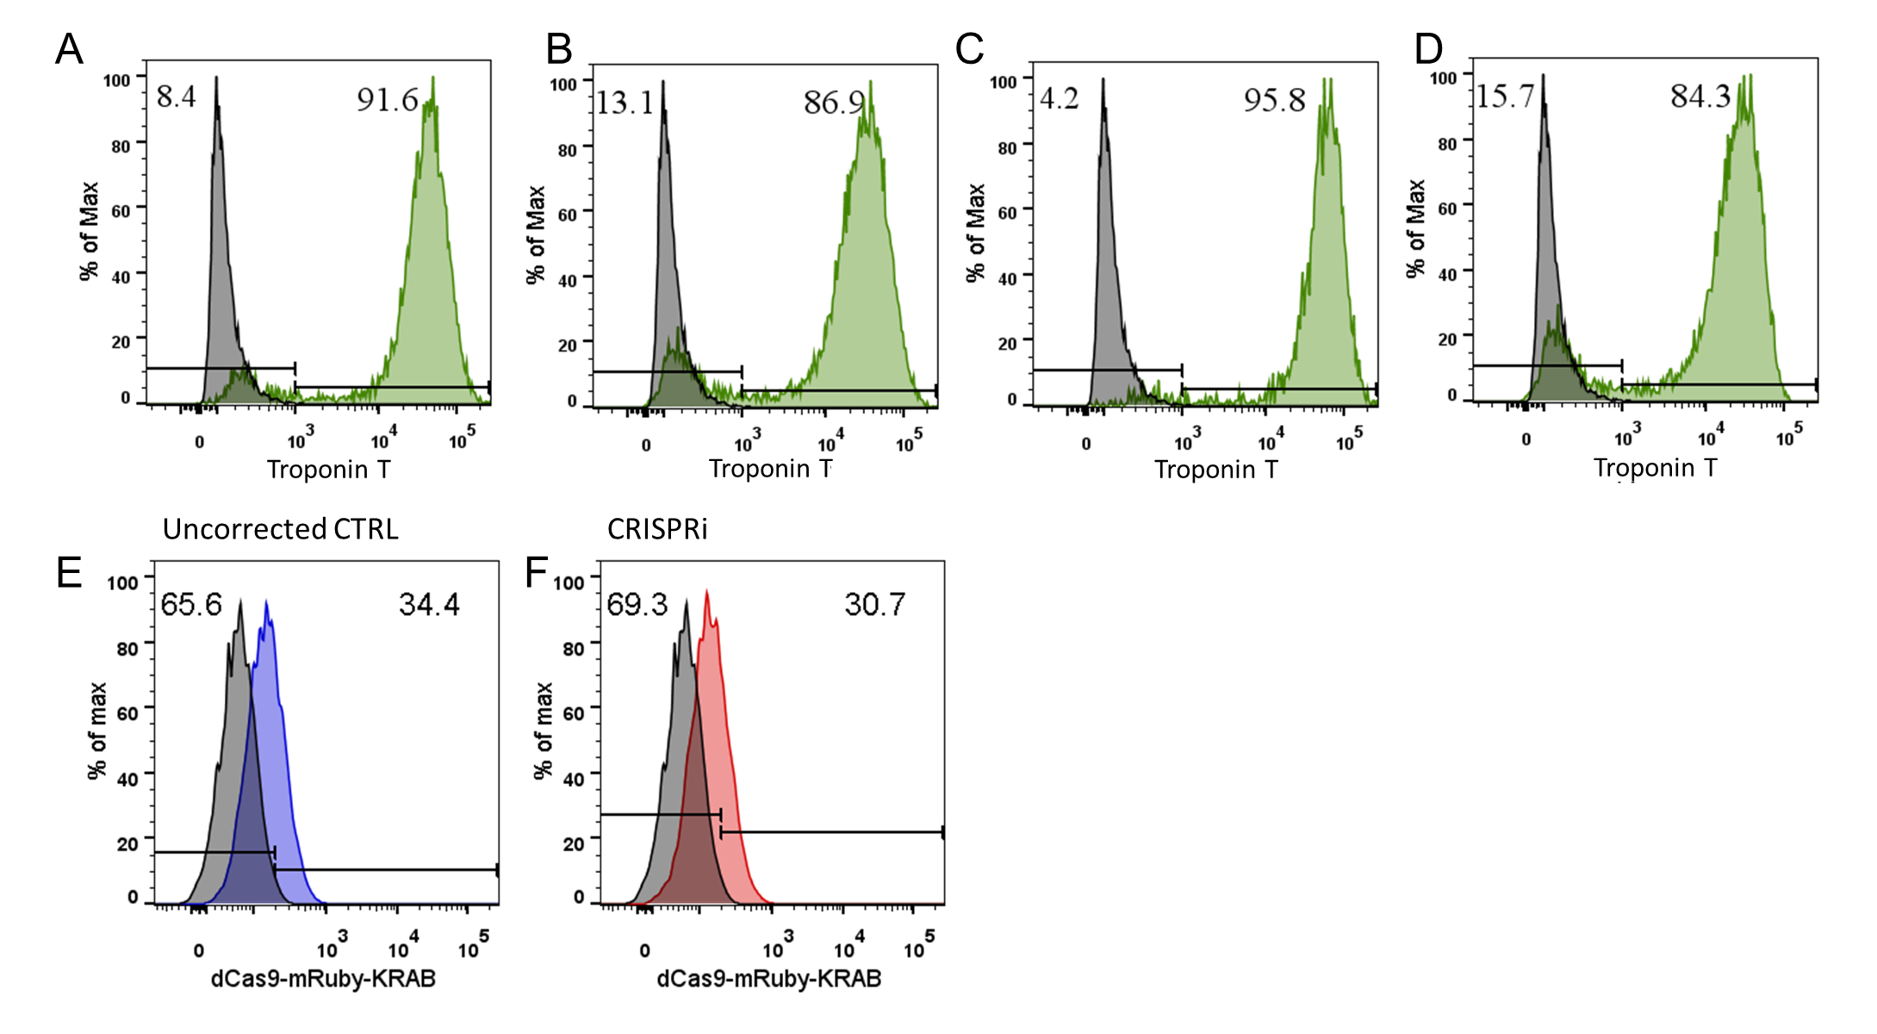

Supplementary Figure 2: Morphology of untreated, CRISPRi and uncorrected control CMTs. Scale bar: 200 µm.

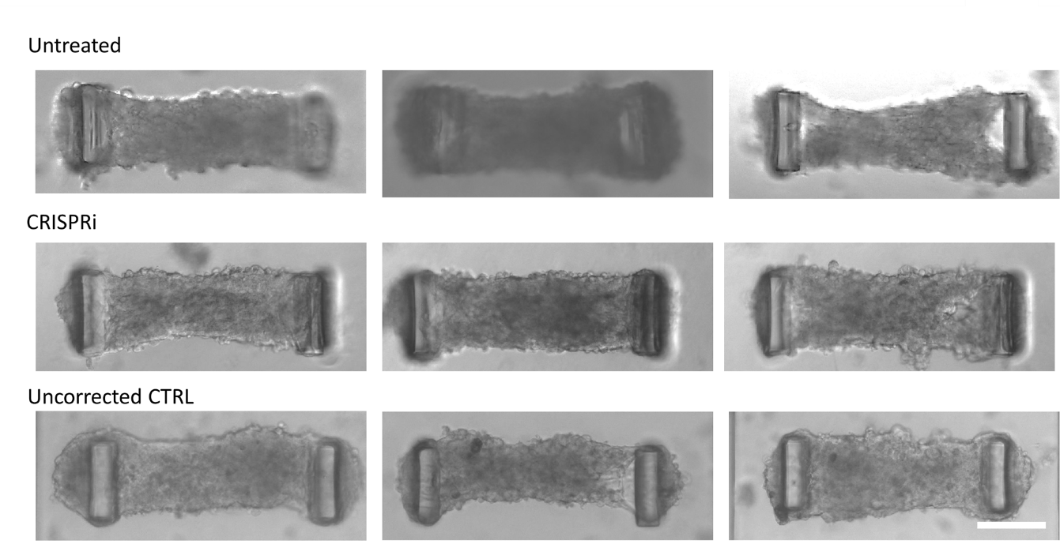

Supplementary Figure 3: Action potential traces of CRISPRi vs uncorrected CTRL CMTs at different pacing cycle length.
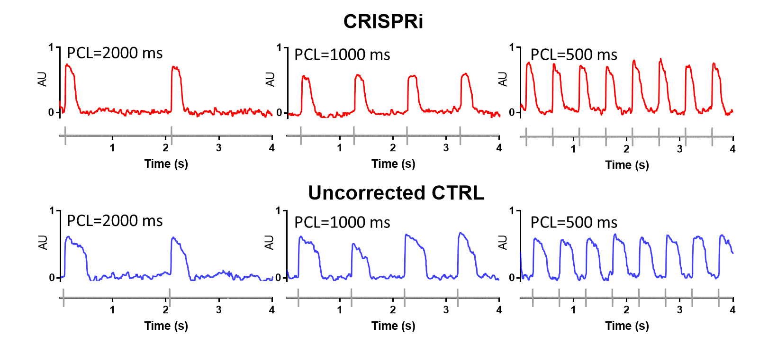

Supplementary Figure 4: Representative force traces of CRISPRi and uncorrected CTRL CMTs.
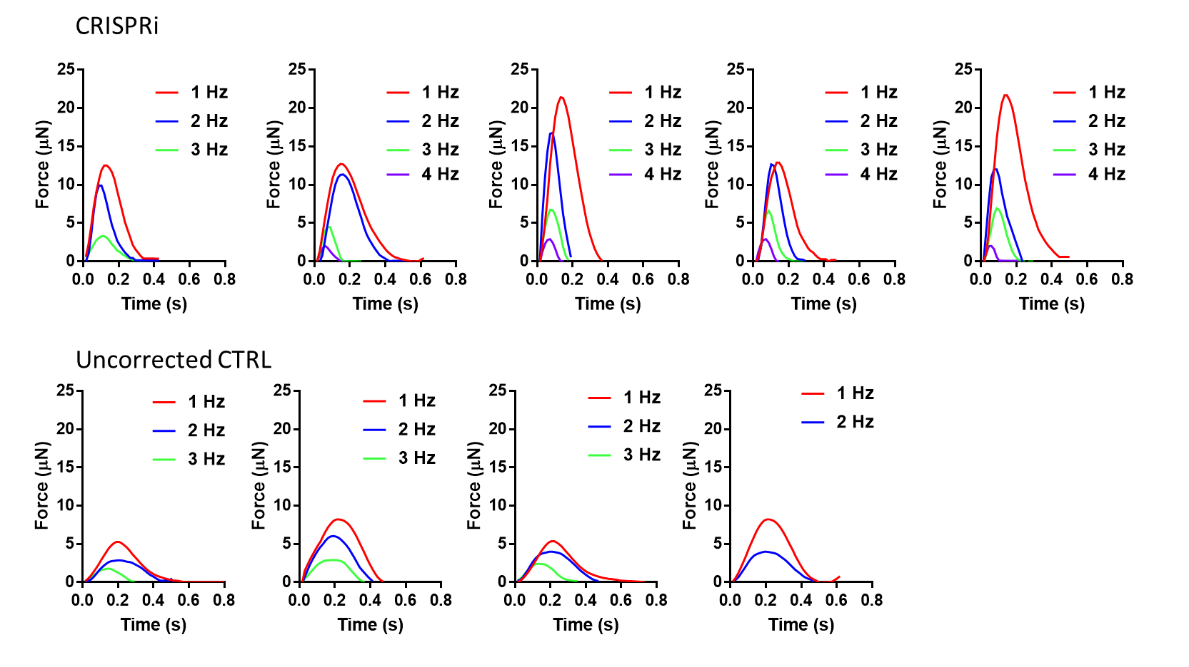

Supplementary Figure 5: TEM of CRISPRi and uncorrected CTRL CMTs.
