Table 2
Main compounds of Mentha piperita and their corresponding absorption bands
Compound | Structural formula
  Absorption peaks
Menthol <iso-> | 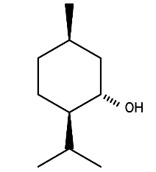 | 3600-3200 cm¹: O–H stretching vibration  3000-2820 cm¹: Alkyl (methylene and methyl) stretching vibrations  1470-1430 cm¹: Asymmetric bending vibrations of methylene and methyl groups  1370 cm¹: Symmetric bending vibration of methyl group  1050 cm¹: C–O stretching vibration
Compound | Structural formula
  Absorption peaks
Menthone<iso-> | 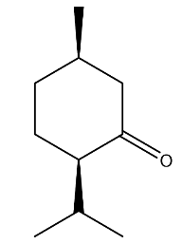 | 3000-2820 cm¹: Alkyl (methylene and methyl) stretching vibrations  1750-1700 cm¹: C=O stretching vibration  1470-1430 cm¹: Asymmetric bending vibrations of methylene and methyl groups  1370 cm¹: Symmetric bending vibration of methyl group
Compound | Structural formula
  Absorption peaks
Cineole <1,8-> | 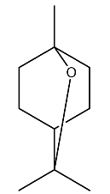 | 3000-2820 cm¹: Alkyl (methylene and methyl) stretching vibrations  1470-1430 cm¹: Asymmetric bending vibrations of methylene and methyl groups  1370 cm¹: Symmetric bending vibration of methyl group  1280-1230 cm¹: Asymmetric C–O–C stretching vibration

