Supplementary Information for Confocal-inspired computational fluorescence microscopy via transfer point spread function

Table of contents

Supplementary Notes
Supplementary Note 1: Electric-dipole emission and statistical intensity propagation in scattering media.
Supplementary Note 2: Convolutional redistribution under the slowly varying isotropic approximation.
Supplementary Note 3: Pre-processing PSF mismatch and the effective redistribution estimate.
Supplementary Note 4: Associativity and validity limits of the cascaded convolution model.
Supplementary Note 5: Pinhole filtering of the scattering kernel and the confocal constraint.
Supplementary Note 6: Maximum-likelihood estimation of the TPSF.
Supplementary Note 7: Preprocessing, resampling and rigid registration.

Supplementary Figures
Supplementary Fig. 1: TPSF calibration and deployment workflow for CCFM.
Supplementary Fig. 2: Cross-sample consistency of TPSFs decoupled from biological specimens.
Supplementary Fig. 3: Comparison of widefield, AQ, and TPSF-based reconstructions of zucchini pollen.
Supplementary Fig. 4: Influence of widefield pre-processing on subsequent TPSF decoupling.
Supplementary Fig. 5: Monte Carlo validation of scattering-kernel estimation and convolutional redistribution.
Supplementary Fig. 6: Morphology dependence of decoupled scattering kernels in simulation.
Supplementary Fig. 7: Effect of filament thickness on decoupled scattering kernels in simulation.

Supplementary Tables
Supplementary Table 1: Imaging parameters for all datasets.

Supplementary Note 1: Electric-dipole emission and statistical intensity propagation in scattering media.

Electric-dipole source formulation for a single fluorophore
At the microscopic scale, the spontaneous emission of a single fluorophore is modeled as radiation from an oscillating electric dipole $p$ [1],[2]. In an inhomogeneous nonmagnetic medium with zero free charge density, the emitted field is therefore governed by Maxwell’s equations in vector form,
$$\begin{aligned}\begin{aligned}∇×E\left(r,ω\right)=iωμ_{0}H\left(r,ω\right)\# \\ ∇×H\left(r,ω\right)=-iωD\left(r,ω\right)+J_{ext}\left(r,ω\right)\end{aligned}\#（1）\end{aligned}$$
Here, $J_{ext}$ denotes the equivalent current density describing dipole radiation [2]. Taking the curl of the first equation and substituting the second, together with the constitutive relation $D=ϵ_{0}ϵ\left(r\right)E$, yields the vector wave equation in an inhomogeneous medium,
$$\begin{aligned}∇×∇×E\left(r,ω\right)-k^{2}ϵ\left(r\right)E\left(r,ω\right)=iωμ_{0}J_{ext}\left(r,ω\right)\#\left(2\right)\end{aligned}$$
where $k = ω/c$ is the free space wavenumber.
For an ideal point dipole located at $r_{0}$, the time varying polarization density is written as $P\left(r,t\right)=pδ\left(r-r_{0}\right)e^{-iωt}$. Using the relation between current density and polarization, $J_{ext}=∂P/∂t$, this becomes in the frequency domain,
$$\begin{aligned}J_{ext}\left(r,ω\right)=-iωpδ\left(r-r_{0}\right)\#\left(3\right)\end{aligned}$$
Substituting this expression into the right hand side of the vector wave equation yields the physical form of the source term,
$$\begin{aligned}S\left(r,ω\right)=iωμ_{0}\left(-iωp\right)δ\left(r-r_{0}\right)=μ_{0}ω^{2}pδ\left(r-r_{0}\right)\#\left(4\right)\end{aligned}$$
At this stage, the emitted quantity remains a vector field driven by the dipole source term.

Green’s function and Born-series representation of field propagation
Owing to the linearity of the vector wave equation in Eq. (2), the field generated by a point source can be represented through the Green’s function $G$ , which characterizes the response of the medium to an impulsive excitation. Correspondingly, $G\left(r,r_{0}\right)$ satisfies
$$\begin{aligned}\left(∇^{2}+k^{2}ϵ\left(r\right)\right)G\left(r,r_{0}\right)=-δ\left(r-r_{0}\right)\#\left(5\right)\end{aligned}$$
Under this definition, the emitted field at the detection point can be written as the superposition of the responses from all source points,
$$\begin{aligned}E\left(r\right)=\int{G\left(r,r^{'}\right)S\left(r^{'},ω\right)dr^{'}}\#\left(6\right)\end{aligned}$$
For the point-dipole source introduced in Part 1, this expression reduces to $E\left(r\right)=G\left(r,r_{0}\right)⋅S\left(r_{0},ω\right)$, showing that $G$ completely determines the transfer of field amplitude from the source point to the observation point [3].
To elucidate the physical nature of $G$ in complex media, the inhomogeneous refractive index distribution is decomposed into a homogeneous background and a random fluctuation term, $ϵ\left(r\right)=ϵ_{b}+Δϵ\left(r\right)$. Using the Dyson equation [4], the Green’s function can be expressed as an infinite Born series [5],
$$\begin{aligned}G=G_{0}+G_{0}VG_{0}+G_{0}VG_{0}VG_{0}+⋯\#\left(7\right)\end{aligned}$$
where $G_{0}$ is the free space Green’s function of the homogeneous background medium and $V=k^{2}Δϵ\left(r\right)$ denotes the scattering potential.The first term $G_{0}$ represents ballistic photon propagation directly from $r_{0}$ to $r$ without scattering [6]. Subsequent terms correspond to photons that undergo one, two and multiple scattering events before reaching the observation point [7]. The Green’s function $G\left(r,r_{0}\right)$ therefore does not describe a single trajectory but the coherent summation of all possible scattering paths between the source and the detector [8].

From coherent field superposition to ensemble-averaged intensity
At a given instant and for a specific realization of the microscopic medium, the instantaneous electric field at the detection point $r$ is the coherent superposition of all scattering paths. The observed instantaneous intensity $I_{inst}\left(r\right)$ can therefore be written as
$$\begin{aligned}I_{inst}\left(r\right)={\left|E\left(r\right)\right|}^{2}={\left|G\left(r,r_{0}\right)⋅p\right|}^{2}={\left|p\right|}^{2}⋅{\left|\sum_{j}{A_{j}e^{iϕ_{j}}}\right|}^{2}\#\left(8\right)\end{aligned}$$
where $A_{j}$ and $ϕ_{j}$ denote the amplitude and phase associated with the $j$-th scattering path, respectively. Expanding the squared modulus yields
$$\begin{aligned}I_{inst}\left(r\right)={\left|p\right|}^{2}\left(\sum_{j}{A_{j}^{2}}+\sum_{j≠l}{A_{j}A_{l}e^{i\left(ϕ_{j}-ϕ_{l}\right)}}\right)\#\left(9\right)\end{aligned}$$
The first term represents the incoherent sum of energies carried by individual paths, whereas the second term contains the interference contributions responsible for speckle formation [7],[8].
In practice, the detector records a time-averaged intensity rather than an instantaneous field realization. Because fluorescence emission is temporally incoherent over the detector integration time, and because microscopic thermal motion continuously perturbs the phase differences $\left(ϕ_{j}-ϕ_{l}\right)$ between distinct paths, the interference terms vanish under ensemble averaging[9],[10],[11],
$$\begin{aligned}\left\langle \sum_{j≠l}{A_{j}A_{l}e^{i\left(ϕ_{j}-ϕ_{l}\right)}}\right\rangle =0\#\left(10\right)\end{aligned}$$
Consequently, the ensemble averaged intensity reduces to
$$\begin{aligned}I\left(r\right)=\left\langle I_{inst}\left(r\right)\right\rangle ={\left|p\right|}^{2}\sum_{j}{\left\langle A_{j}^{2}\right\rangle }={\left|p\right|}^{2}⋅\left\langle {\left|G\left(r,r_{0}\right)\right|}^{2}\right\rangle \#\left(11\right)\end{aligned}$$
This result shows that the experimentally observable quantity is a statistically stable intensity propagator rather than the phase-sensitive instantaneous field intensity.

Point-source intensity propagation and definition of the scattering kernel
Equation (11) shows that, after ensemble averaging, the originally phase-sensitive wave propagation is reduced to a statistically stable intensity transfer from the source point $r_{0}$ to the observation point $r$. We therefore define the point-source intensity propagator, equivalently the scattering kernel in the main text, as $K_{scat}\left(r,r_{0}\right)≡\left\langle {\left|G\left(r,r_{0}\right)\right|}^{2}\right\rangle$. Equation (11) becomes $I\left(r\right)={\left|p\right|}^{2}K_{scat}\left(r,r_{0}\right)$. Physically, $K_{scat}$ characterizes how the energy emitted by a single fluorescent point source is statistically redistributed by the surrounding medium before entering the imaging system. It suppresses realization-dependent speckle fluctuations while preserving the dominant energy-redistribution envelope governed by the scattering properties of the medium [9],[12].
Since the time-averaged radiated power of an oscillating dipole is proportional to ${\left|p\right|}^{2}$ [6] the quantity ${\left|p\right|}^{2}$ can be used to represent the intrinsic intensity of an individual fluorescent point source. For an incoherent ensemble of fluorophores, the macroscopic object distribution $O\left(r\right)$ therefore corresponds to the spatial density of radiated power from these microscopic dipoles.

Supplementary Note 2: Convolutional redistribution under the slowly varying isotropic approximation.
In random media theory, the microscopic structure of a medium is described by the refractive index fluctuation term $Δϵ\left(r\right)$. A medium is termed statistically stationary, or spatially statistically homogeneous, if all its statistical moments remain invariant under spatial translations. For the imaging model, the most critical requirement is that the second order correlation function of the medium depends only on the relative displacement [9],[13],
$$\begin{aligned}\left\langle Δϵ\left(r_{1}\right)Δϵ\left(r_{2}\right)\right\rangle =C_{ϵ}\left(r_{1}-r_{2}\right)\#\left(12\right)\end{aligned}$$
In biological tissues, although the microscopic structure is highly complex and disordered, the average scattering properties, such as the scattering coefficient $μ_{s}$ and the anisotropy factor $g$ , often approximately uniform within a limited field of view [10],[14]. Building on Supplementary Note 1, the scattering kernel is defined as the ensemble-averaged point-source intensity propagator, $K_{scat}\left(r-r_{0}\right)=\left\langle {\left|G\left(r,r_{0}\right)\right|}^{2}\right\rangle$.
Under the slowly varying isotropic approximation, if both the source position $r_{0}$ and the observation point $r$ are translated by the same vector $a$，the statistical response of the system remains unchanged,
$$\begin{aligned}\left\langle {\left|G\left(r+a,r_{0}+a\right)\right|}^{2}\right\rangle ≈\left\langle {\left|G\left(r,r_{0}\right)\right|}^{2}\right\rangle \#\left(13\right)\end{aligned}$$
Choosing $a=-r_{0}$ yields:
$$\begin{aligned}K_{scat}\left(r,r_{0}\right)≈K_{scat}\left(r-r_{0}\right)\#\left(14\right)\end{aligned}$$
For a continuously distributed fluorescent object $O\left(r_{0}\right)$, the scattered field $E\left(r\right)$ is therefore written as,
$$\begin{aligned}E\left(r\right)=\int{O\left(r_{0}\right)K_{scat}\left(r-r_{0}\right)dr_{0}}=O\left(r\right)⊗K_{scat}\left(r\right)\#\left(15\right)\end{aligned}$$
This convolutional form is a local approximation rather than a strict global property, and remains valid only when the medium statistics vary slowly over the region occupied by the object.
To support this model, we implemented a GPU-accelerated three-dimensional Monte Carlo simulation framework for fluorescence self-emission in turbid media, based on an extended mcxyz.c pipeline [15],[16]. Emissive structures were embedded voxel-wise in a weakly heterogeneous background tissue, individual emission events were modeled as equivalent isotropic point sources, and only photons satisfying the objective numerical-aperture constraint at the tissue surface were recorded. By accumulating many independent photon realizations, the simulated signal provides a stochastic approximation to the ensemble-averaged point-source intensity propagator defined above. Across simulated samples with distinct morphologies and different local thicknesses (Supplementary Figs. 5–7), the recovered scattering kernels remained highly consistent in their dominant three-dimensional structure, and kernel-based deconvolution restored the ground-truth objects with high agreement. These results support both the statistical definition of $K_{scat}$ and the validity of the convolutional redistribution model within the applicable approximation range.

Supplementary Note 3: Pre-processing PSF mismatch and the effective redistribution estimate.
In the cascaded imaging model used in this work, widefield image formation consists of two successive stages. The intrinsic fluorescence distribution $O$ is first redistributed by the scattering kernel $K_{scat}$ under the slowly varying isotropic approximation, forming the scattering field $E=O⊗K_{scat}$. The scattering field is then further blurred by the system response under the true sample imaging conditions, denoted by $h_{sys}$, and recorded as the widefield image,
$$\begin{aligned}G\left(r\right)=E\left(r\right)⊗h_{sys}\left(r\right)+N\left(r\right)\#\left(16\right)\end{aligned}$$
Here, $E$ denotes only the intermediate field after scattering-mediated redistribution and does not include the subsequent system blur.
To remove the second-stage blur as much as possible, the preprocessing step requires a system PSF for non-blind deconvolution. We denote this preprocessing PSF by $h_{pre}$. In practice, $h_{pre}$ is typically obtained in one of two ways: either from theoretical calculation based on microscope parameters, or from experimental measurement using fluorescent beads [17],[18]. Both can serve as approximations to the system response and can therefore be used in the first deconvolution step, but neither should be regarded as identical to the true system response $h_{sys}$ under the actual sample imaging conditions.
The limitation of a theoretical PSF is that it is usually determined by a small set of parameters, such as numerical aperture, wavelength, refractive index, and sampling conditions[18]-[20]. Such a model can describe system blur under idealized or simplified conditions, but the actual imaging conditions of biological specimens are generally more complex and cannot be fully captured by a few parameters alone. This limitation becomes more evident in thick-specimen imaging, where the actual imaging conditions can differ substantially from the simplified assumptions used in theoretical calculation. As a result, a theoretical PSF usually captures only part of the stable system response and cannot fully represent the complete response under the real sample imaging conditions.
A bead-measured PSF also has intrinsic limitations. Its estimation depends on the specific bead sample preparation and post-processing procedures, so the measured result is itself conditioned on how the bead data are acquired and processed [17],[21],[22]. More precisely, under a given bead preparation and post-processing strategy, a bead-measured PSF can reflect part of the actual system deviation, including some aberration-related effects, but it still does not become equivalent to $h_{sys}$ under real sample imaging conditions [19],[20]. In addition, fluorescent beads are typically distributed within a very thin layer close to the coverslip, whereas fluorescence in thick biological samples originates from a volumetric environment that differs substantially from such calibration conditions. Therefore, even a bead-measured PSF generally cannot fully represent the true system response encountered in thick-sample imaging.
For these reasons, applying the first non-blind deconvolution to the widefield image $G$ using $h_{pre}$ does not, in general, recover the ideal scattering field $E$. Instead, the recovered quantity is more appropriately described as an effective redistribution estimate, denoted by $\hat{E}$.
In an equivalent convolution form, this intermediate quantity can be written as
$$\begin{aligned}\hat{E}≈E⊗h_{r}\#\left(17\right)\end{aligned}$$
where $h_{r}$ denotes the residual system response that remains after preprocessing. Here, $h_{r}$ is not an independently measured physical PSF. Rather, it is an effective term used to represent the portion of the system response that is not accurately captured by $h_{pre}$. In other words, the first deconvolution removes the part of $h_{sys}$ that can be approximated by $h_{pre}$, while the unmatched part remains in $\hat{E}$ as the residual system response $h_{r}$.
This mismatch can arise both from the simplifications inherent in the theoretical model and from the inconsistency between bead calibration conditions and actual sample imaging conditions. For a theoretical PSF, aberration-related effects are typically not fully incorporated. For a bead-measured PSF, although part of the actual system deviation, including some aberration-related effects, may be captured to a certain extent, the aberration state under real sample imaging conditions is still not fully inherited by $h_{pre}$, because the bead calibration geometry and the thick-sample imaging geometry are substantially different. Accordingly, among the system effects retained in $h_{r}$, aberration-related deviation should be regarded as an important component that deserves particular consideration, although it is not treated here as the only possible source.
This interpretation is also consistent with the observations in Supplementary Figs. 2–4. Supplementary Fig. 4 shows that, for the same specimen, changing only the preprocessing PSF $h_{pre}$ leads to decoupled TPSFs that remain similar in their overall structure but differ in detail. This indicates that the choice of the preprocessing PSF indeed affects the residual system-related component retained in the subsequently recovered composite kernel. Supplementary Fig. 2 further shows that TPSFs decoupled from different specimens remain highly consistent in their dominant three-dimensional structure, whereas Supplementary Fig. 3 indicates that structurally more similar specimens can still provide slightly better reconstruction matching. Taken together, these observations suggest that the experimentally decoupled TPSF is not a pure scattering kernel, but a composite result containing both a shared system-related residual component and a sample-dependent scattering component.
Accordingly, $\hat{E}$ should be understood neither as the pure scattering field nor as the intrinsic object distribution itself, but as an effective intermediate quantity recovered after preprocessing. It retains both the redistribution imposed by the first-stage scattering kernel $K_{scat}$ and the residual system response $h_{r}$ left by the mismatch between $h_{pre}$ and $h_{sys}$. Under the calibration setting, if the registered confocal volume $C_{reg}$ is taken as an approximate reference to $O$, then
$$\begin{aligned}\hat{E}=C_{reg}⊗\left({K_{scat}⊗h}_{r}\right)\#\left(18\right)\end{aligned}$$
The bracketed composite kernel corresponds to the experimentally decoupled TPSF. Therefore, the TPSF should not be interpreted simply as the pure scattering kernel itself. Rather, it should be understood as an effective composite transfer operator from the registered confocal reference $C_{reg}$ to the effective redistribution estimate $\hat{E}$, jointly absorbing the scattering contribution and the residual system response left after preprocessing. This also explains why the experimentally decoupled TPSF differs in morphology from the pure scattering kernel obtained in simulation, particularly through additional structures in out-of-focus regions.

Supplementary Note 4: Associativity and validity limits of the cascaded convolution model.
Under the slowly varying isotropic approximation, widefield image formation is described by a cascaded model in which the intrinsic object distribution $O$ is first redistributed by the scattering kernel $K_{scat}$ and then blurred by the system response $h_{sys}$, $G\left(r\right)=\left[O\left(r\right)⊗K_{scat}\left(r\right)\right]⊗h_{sys}\left(r\right)$. Because both stages are treated as linear and shift-invariant operators within the valid field of view, the Fourier-domain form is， $\tilde{G}\left(f\right)=\tilde{O}\left(f\right)⋅\tilde{K_{scat}}\left(f\right)⋅\tilde{h_{sys}}\left(f\right)$. Accordingly, associativity of scalar multiplication gives $\tilde{G}\left(f\right)=\left[\tilde{O}\left(f\right)⋅\tilde{h_{sys}}\left(f\right)\right]⋅\tilde{K_{scat}}\left(f\right)$, which corresponds in real space to $G=\left(O⊗h_{sys}\right)⊗K_{scat}=O⊗\left(h_{sys}⊗K_{scat}\right)$. This regrouping does not alter the physical order of widefield image formation, which remains scattering-mediated redistribution before system blur. Rather, it shows that, under the shift-invariant approximation, the two degradation stages can be represented as a single composite operator for analysis and inversion.
The physical validity of this representation rests on two conditions. First, the medium must satisfy the slowly varying isotropic approximation discussed in Supplementary Notes 2, such that $K_{scat}$ is approximately translation invariant over the imaging region and is therefore well defined as a convolution operator. Second, the microscope must remain approximately isoplanatic over the same region, such that the shape of $h_{sys}$ does not vary appreciably across the field of view. When either condition fails, for example in strongly heterogeneous samples, extremely thick specimens, or regions with pronounced spatially varying aberration, the cascaded convolution model becomes only an approximation and a single spatially invariant kernel can no longer fully describe the degradation.
Under these conditions, associativity provides the mathematical basis for representing scattering-mediated redistribution and system blur within a unified convolutional framework.

Supplementary Note 5: Pinhole filtering of the scattering kernel and the confocal constraint.
In confocal imaging theory, the overall system point spread function is commonly described as the product of the illumination PSF $h_{ill}$ and the detection PSF $h_{det}$ [23] . To fully elucidate its robustness in randomly scattering media, however, this process must be physically decomposed into two pinhole constrained stages: spatial shaping of the excitation source and coherent detection of the returning signal. The essence of this decomposition lies in recognizing that the detection pinhole is, in effect, the conjugate image of the illumination pinhole at the sample plane, and that together they cooperatively suppress scattering paths to their physical limit [24].
In widefield mode, fluorophores throughout the entire field of view are excited simultaneously by incoherent illumination, so the scattering kernel $K_{scat}$ reflects unrestricted multiple scattering within the tissue. In contrast, the confocal architecture first constrains the excitation light to a diffraction limited focal volume via the illumination pinhole. This physical constraint localizes the effective emission region at its origin [23].
In the sense of statistical optics, only the illuminated point can act as a radiation source. Accordingly, the effective scattering kernel in a confocal system, $K_{scat}^{CF}$, is given by the product of the intrinsic tissue scattering kernel and the illumination intensity distribution $I_{ill}$,
$$\begin{aligned}K_{scat}^{CF}\left(r-r_{0}\right)=K_{scat}\left(r-r_{0}\right)⋅I_{ill}\left(r\right)\#\left(19\right)\end{aligned}$$
Because the illumination pinhole restricts emission to a single focal point, even in strongly scattering media, multiply scattered paths lack sufficient source support to extend spatially. As the illumination beam approaches an ideal point source, the effective scattering kernel is shaped toward its ballistic limit, $K_{scat}^{CF}≈δ$. This step achieves scattering decoupling at the level of the emission field.
The emission field generated from this localized point source then propagates back through the tissue toward the detection system. Because a physical pinhole conjugate to the illumination pinhole is present at the detection plane, the imaging process is no longer a collection of widefield energy but a second spatial frequency filtering of the returning field [25].
For this “half-path” imaging system, the form of the effective point spread function $h_{sys}^{CF}$ is directly governed by the physical boundary of the conjugate pinhole. Acting as a spatial filter at the detector, the pinhole blocks all off-axis diffuse photons and permits only the ballistic components carrying high spatial frequency information to pass. Mathematically, the effective detection response can be approximated as the detection PSF truncated by the pinhole function $P\left(r\right)$ [23],[25],
$$\begin{aligned}h_{sys}^{CF}\left(r\right)≈h_{det}\left(r\right)⋅P\left(r\right)\#\left(20\right)\end{aligned}$$
When the pinhole size matches the Airy disk, this highly sharpened system response collapses mathematically to an ideal spatial sampling operator, such that $h_{sys}^{CF}≈δ$.
Taken together, the confocal imaging process $C=\left(O⊗K_{scat}^{CF}\right)⊗h_{sys}^{CF}$ is subject to dual delta-function constraints at both the illumination and detection ends, enabling high-fidelity recovery of the intrinsic object distribution $O$ [23],[24],
$$\begin{aligned}C≈\left(O⊗δ\right)⊗δ=O\#\left(21\right)\end{aligned}$$
This physical picture reveals the fundamental mechanism underlying background suppression in confocal microscopy. First, the illumination pinhole enforces point excitation, reshaping the scattering kernel $K_{scat}$ into an impulse and eliminating spatial migration of scattered energy at its origin. Second, the conjugate detection pinhole polarizes the imaging PSF $h_{sys}$ toward an impulse, ensuring diffraction-limited resolution of the observed signal.

Supplementary Note 6: Maximum-likelihood estimation of the TPSF.
Estimating $h_{t}$ constitutes an inverse problem with a known input $C_{reg}$ and output ${\hat{E}}_{calib}$. We formulate this as a maximum likelihood estimation (MLE) problem under Poisson statistics [26]-[28] The objective is to maximize the likelihood $P\left({\hat{E}}_{calib} | h_{t}\right)$, which is equivalent to minimizing the generalized Kullback–Leibler (KL) divergence between the measured field ${\hat{E}}_{calib}$ and the model prediction $C_{reg}⊗h_{t}$ [29],
$$\begin{aligned}J\left(h_{t}\right)=\sum_{r}{\left[\left(C_{reg}⊗h_{t}\right)\left(r\right)-{\hat{E}}_{calib}\left(r\right)⋅\ln\left(\left(C_{reg}⊗h_{t}\right)\left(r\right)\right)\right]}\#\left(22\right)\end{aligned}$$
To identify the optimal kernel, we compute the Fréchet derivative of the cost function with respect to $h_{t}$,
$$\begin{aligned}\frac{∂J}{∂h_{t}}\left(r\right)=1-\left(\frac{{\hat{E}}_{calib}}{C_{reg}⊗h_{t}}\right)⊗C_{reg}^{†}\#\left(23\right)\end{aligned}$$
Here, $C_{reg}^{†}\left(r\right)=C_{reg}\left(-r\right)$ denotes the adjoint operator of the registered confocal volume, corresponding to spatial reversal [30]. This term arises from the chain rule in the convolution domain and physically represents the cross-correlation required to back-project the residual error from image space into kernel space.
Applying a multiplicative gradient descent scheme consistent with the Karush–Kuhn–Tucker conditions to the derived gradient yields the iterative update rule for the kernel, which we refer to as the dual Richardson–Lucy algorithm [31],[32],
$$\begin{aligned}h_{t}^{\left(k+1\right)}=h_{t}^{\left(k\right)}⋅\left[\left(\frac{{\hat{E}}_{calib}}{C_{reg}⊗h_{t}^{\left(k\right)}}\right)⊗C_{reg}^{†}\right]\#\left(24\right)\end{aligned}$$
This derivation confirms that our approach is mathematically rigorous under the assumption of Poisson noise. To ensure physical validity, two constraints are strictly enforced during optimization. First, non-negativity is imposed, $h_{t}\left(r\right)≥0$, because photon probabilities cannot be negative. Second, energy conservation is enforced, $\int{h_{t}\left(r\right)dr}=1$, preventing artificial amplification or attenuation of total photon flux.
In practice, optimization is typically terminated after 50 to 100 iterations, which is sufficient to capture the dominant low-frequency scattering envelope while avoiding overfitting to high-frequency noise.

Supplementary Note 7: Preprocessing, resampling and rigid registration.

Sampling strategy and voxelization.
Standard confocal imaging protocols typically adopt an axial sampling density below the Nyquist limit to optimize acquisition speed. During calibration, however, we employ a dense sampling strategy for widefield acquisition to prevent aliasing artifacts that could compromise subsequent registration [33]. Let the original axial sampling intervals of the widefield and confocal volumes be $Δz_{WF}$ and $Δz_{CF}$, respectively, with $Δz_{WF}<Δz_{CF}$ in general.
To establish voxel-level correspondence, we designate the confocal volume $C$ as the geometric reference while preserving its rigid spatial structure. The effective redistribution estimat ${\hat{E}}_{calib}$ is then resampled by cubic spline interpolation to match the confocal grid [34],
$$\begin{aligned}{{\hat{E}}_{calib}}^{'}\left(r\right)=I_{cubic}\left({\hat{E}}_{calib},Δz_{CF}\right)\#（25）\end{aligned}$$
Consequently, the derived TPSF is inherently coupled to the specific sampling density $Δz_{CF}$). Because the transfer point spread function primarily encodes object induced scattering statistics rather than purely system dependent diffraction parameters such as numerical aperture, the kernel is, in principle, transferable across different imaging systems once the sampling rate has been mathematically normalized. Nevertheless, given that the kernel inevitably retains residual system specific aberrations, we recommend performing calibration at the specific magnification used for imaging to ensure maximal reconstruction fidelity. Under constrained conditions, a generic kernel may still be employed, albeit with an acceptable compromise in performance.

Coarse-to-fine registration framework.
To align the scattering-dominated widefield volume with the sectioned confocal volume, we formulate registration as a six-degree-of-freedom (6-DOF) rigid transformation problem and adopt a coarse-to-fine strategy [35] to avoid local minima.
Step 1: coarse registration via dimensionality reduction. We decouple the 3D problem into orthogonal 2D projections. Let $P_{xy}\left(⋅\right)$ and $P_{xz}\left(⋅\right)$ denote maximum intensity projection operators. We first estimate the lateral translation $t_{xy}$ and in-plane rotation $θ_{z}$ by maximizing the normalized cross-correlation (NCC) between the xy-MIPs,
$$\begin{aligned}\{\hat{t_{xy}},\hat{θ_{z}}\}={\text{argmax}}_{t,θ} \text{NCC}\left(P_{xy}\left(C\right),R_{θ}\left(P_{xy}\left(G^{'}\right)\right)+t\right)\#（26）\end{aligned}$$
After applying these lateral corrections, we estimate the axial displacement $t_{z}$ using the xz-MIP.
Step 2: 3D volume refinement. Parameters initialized from the coarse stage are further optimized by full 3D rigid registration. We define a transformation mapping $T_{p}$ parameterized by a 6-DOF vector $p$. Optimal alignment is achieved by minimizing the mean squared error,
$$\begin{aligned}\hat{p}={\text{argmin}}_{p}\frac{1}{\left|Ω\right|}\sum_{r∈Ω}{\left.|T_{p}\left(C\left(r\right)\right)-{\hat{E}}_{calib}\left(r\right)\right.|^{2}}\#（27）\end{aligned}$$
Registration validity is enforced by monitoring the smoothness of the transformation field across adjacent optical slices, thereby suppressing outliers arising from sample instability.

Physical boundary constraints and artifact suppression.
A critical prerequisite for accurate scattering inversion is that the acquired widefield volume $G\left(r\right)$ captures the complete scattering history of the object. If the acquisition ROI is too tightly cropped, truncating the scattering halo of the emission field generated by peripheral structures, the missing information will induce boundary ringing artifacts during deconvolution [36].
Mathematically, let $Ω_{obj}$ denote the spatial support of the fluorescent object and $Ω_{st}$ represent the effective support radius of the TPSF. The minimum valid acquisition volume $Ω_{acq}$ must satisfy the Minkowski sum condition [37],
$$\begin{aligned}Ω_{acq}⊇Ω_{obj}⊕Ω_{st}\#（28）\end{aligned}$$
In practice, this implies that the field of view should extend beyond the biological ROI by at least one scattering radius, typically 20–50 µm depending on tissue turbidity.
At the algorithmic level, to mitigate circular convolution artifacts inherent to FFT-based computation, namely wrap-around interference from volume boundaries, we apply boundary padding to the input volume. Prior to Fourier transformation, an edge-tapering function smoothly blends the image boundaries to the mean background level. The volume is then zero-padded to a size of $N + M - 1$, where $N$ and $M$ denote the dimensions of the image and the kernel, respectively, thereby preserving the linearity of convolution.

Supplementary References
- Mertz, J. Introduction to Optical Microscopy. 2nd edn, (Cambridge University Press, 2019).
- Jackson, J. D. Classical Electrodynamics. 3rd edn, (Wiley, 1998).
- Arfken, G. B. & Weber, H. J. Mathematical Methods for Physicists. 6th edn, (Academic Press, 2005).
- Dyson, F. J. The radiation theories of Tomonaga, Schwinger, and Feynman. Phys. Rev. 75, 486–502 (1949).
- Born, M. & Wolf, E. Principles of Optics. 7th edn, (Cambridge University Press, 1999).
- Novotny, L. & Hecht, B. Principles of Nano-Optics. 2nd edn, (Cambridge University Press, 2012).
- Ishimaru, A. Wave Propagation and Scattering in Random Media. (Academic Press, 1978).
- Goodman, J. W. Speckle Phenomena in Optics: Theory and Applications. 2nd edn, (Roberts and Company Publishers, 2020).
- Goodman, J. W. Statistical Optics. 2nd edn, (Wiley, 2015).
- Boas, D. A. & Dunn, A. K. Laser speckle contrast imaging in biomedical optics. J. Biomed. Opt. 15, 011109 (2010).
- Mandel, L. & Wolf, E. Optical Coherence and Quantum Optics. (Cambridge University Press, 1995).
- Wang, L. V. & Wu, H.-i. Biomedical Optics: Principles and Imaging. (Wiley-Interscience, 2007).
- Rytov, S. M., Kravtsov, Y. A. & Tatarskii, V. I. Principles of Statistical Radiophysics. Vol. 4 (Springer-Verlag, 1989).
- Cheong, W. F., Prahl, S. A. & Welch, A. J. A review of the optical properties of biological tissues. IEEE J. Quantum Electron. 26, 2166–2185 (1990).
- Wang, L., Jacques, S. L. & Zheng, L. MCML—Monte Carlo modeling of light transport in multi-layered tissues. Comput. Methods Programs Biomed. 47, 131–146 (1995).
- Jacques, S. L. Coupling 3D Monte Carlo light transport in optically heterogeneous tissues to photoacoustic signal generation. Photoacoustics 2, 137–142 (2014).
- Shaw, P. J. & Rawlins, D. J. The point-spread function of a confocal microscope: its measurement and use in deconvolution of 3-D data. J. Microsc. 163, 151–165 (1991).
- Hanser, B. M. et al. Phase-retrieved pupil functions in wide-field fluorescence microscopy. J. Microsc. 216, 32–48 (2004).
- Gibson, S. F. & Lanni, F. Experimental test of an analytical model of aberration in an oil-immersion objective lens used in three-dimensional light microscopy. J. Opt. Soc. Am. A 8, 1601–1613 (1991).
- Shaevitz, J. W. & Fletcher, D. A. Enhanced three-dimensional deconvolution microscopy using a measured depth-varying point-spread function. J. Opt. Soc. Am. A 24, 2622–2627 (2007).
- Yoo, H. et al. Measurement and restoration of the point spread function of fluorescence confocal microscopy. J. Microsc. 221, 172–176 (2006).
- Cole, R. W. et al. Measuring and interpreting point spread functions to determine confocal microscope resolution and ensure quality control. Nat. Protoc. 6, 1929–1941 (2011).
- Pawley, J. B. Handbook of Biological Confocal Microscopy. 3rd edn, (Springer, 2006).
- Conchello, J.-A. & Lichtman, J. W. Optical sectioning microscopy. Nat. Methods 2, 920–931 (2005).
- Goodman, J. W. Introduction to Fourier Optics. 4th edn, (W. H. Freeman, 2017).
- Shepp, L. A. & Vardi, Y. Maximum likelihood reconstruction for emission tomography. IEEE Trans. Med. Imaging 1, 113–122 (1982).
- Snyder, D. L., Schulz, T. J. & O'Sullivan, J. A. Deblurring subject to nonnegativity constraints. IEEE Trans. Signal Process. 40, 1143–1150 (1992).
- Bertero, M. & Boccacci, P. Introduction to Inverse Problems in Imaging. (Institute of Physics Publishing, 1998).
- Cover, T. M. & Thomas, J. A. Elements of Information Theory. 2nd edn, (Wiley-Interscience, 2006).
- Vogel, C. R. Computational Methods for Inverse Problems. (Society for Industrial and Applied Mathematics, 2002).
- Richardson, W. H. Bayesian-based iterative method of image restoration. J. Opt. Soc. Am. 62, 55–59 (1972).
- Fish, D. A., Brinicombe, A. M., Pike, E. R. & Walker, J. G. Blind deconvolution by means of the Richardson–Lucy algorithm. J. Opt. Soc. Am. A 12, 58–65 (1995).
- Shannon, C. E. Communication in the presence of noise. Proc. IRE 37, 10–21 (1949).
- Gonzalez, R. C. & Woods, R. E. Digital Image Processing. 4th edn, (Pearson, 2018).
- Zitová, B. & Flusser, J. Image registration methods: a survey. Image Vis. Comput. 21, 977–1000 (2003).
- Biggs, D. S. & Andrews, M. Acceleration of iterative image restoration algorithms. Appl. Opt. 36, 1766–1775 (1997).
- Schneider, R. Convex Bodies: The Brunn-Minkowski Theory. (Cambridge University Press, 1993).

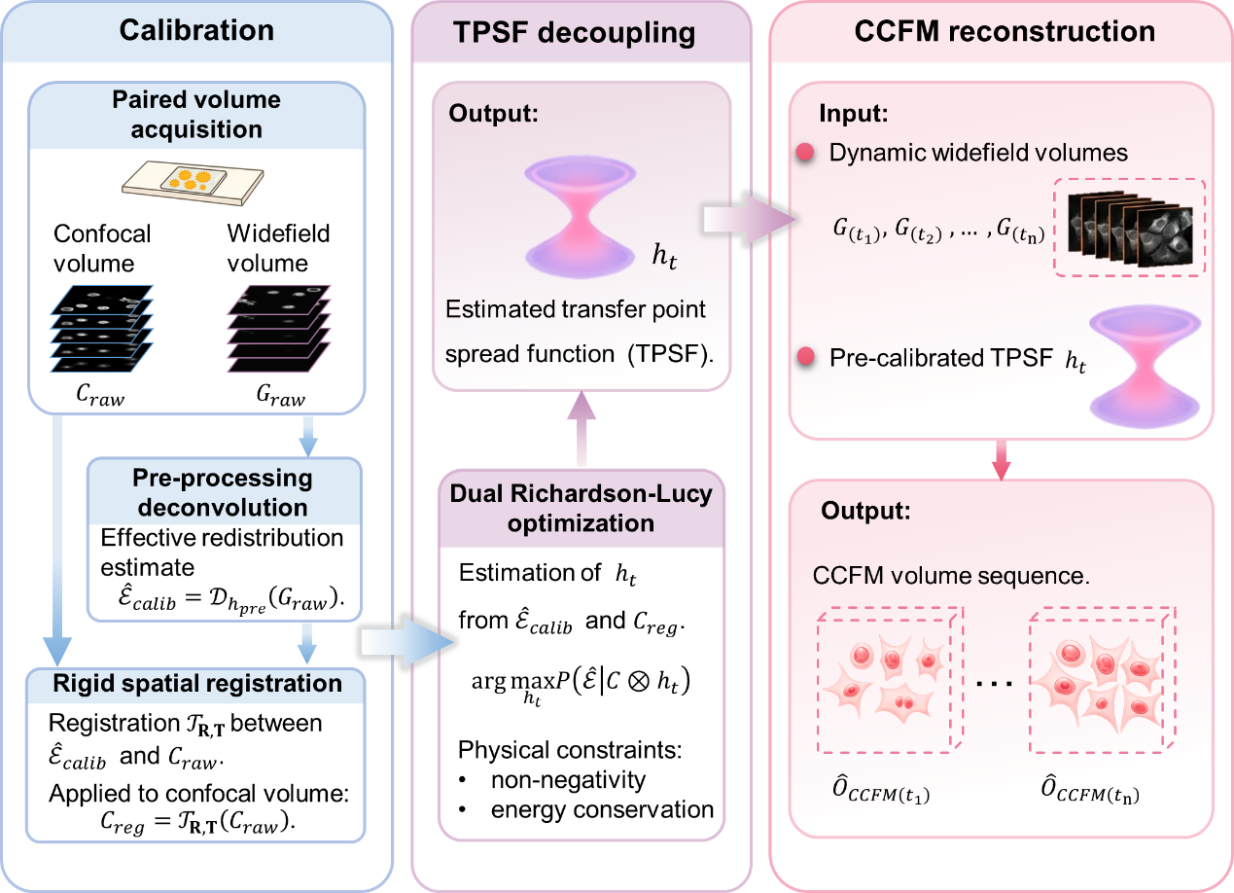

Supplementary Fig. 1 | TPSF calibration and deployment workflow for CCFM. A static reference sample is imaged to acquire paired confocal and widefield volumes ($C_{raw}$ and $G_{raw}$). The widefield volume is first pre-processed by non-blind deconvolution using the pre-processing PSF to obtain the effective redistribution estimate ${\hat{E}}_{calib}$. A rigid spatial transformation $T_{R,T}$ is then estimated between the effective redistribution estimate and the confocal volume and applied to the confocal data to yield the registered confocal volume $C_{reg}$. The transfer point spread function (TPSF) $h_{t}$, which captures the composite transfer from the registered confocal reference to the effective redistribution estimate, is estimated by a dual Richardson–Lucy optimization using ${\hat{E}}_{calib}$ and $C_{reg}$, subject to physical constraints of non-negativity and energy conservation. For dynamic experiments, time-resolved widefield volumes {$G_{\left(t_{1}\right)},{ G}_{\left(t_{2}\right)}, …,G_{\left(t_{n}\right)}$} TPSF $h_{t}$ are used to reconstruct a sequence of virtual confocal volumes {${\hat{O}}_{CCFM\left(t_{1}\right)} ,…, {\hat{O}}_{CCFM\left(t_{n}\right)}$}, enabling confocal-like optical sectioning without point scanning.
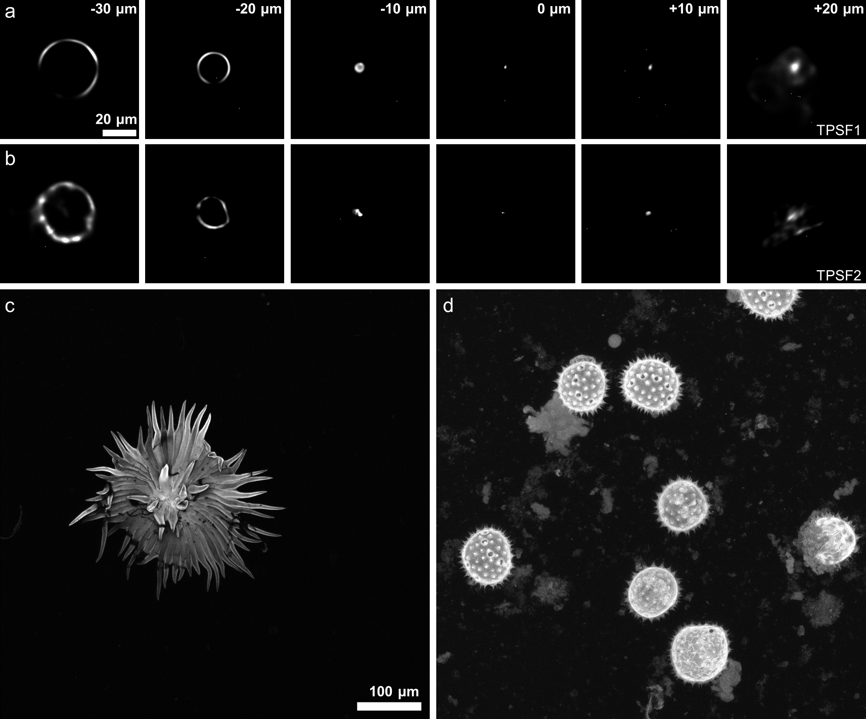

Supplementary Fig. 2 | Cross-sample consistency of TPSFs decoupled from biological specimens. a,b, Axial slices of the two decoupled TPSFs, denoted TPSF1 and TPSF2, obtained from the samples shown in c and d, respectively, from −30 to +20 μm. Despite substantial morphological differences between the two specimens, the decoupled TPSFs remain highly consistent in their overall three-dimensional organization, with a 3D SSIM of 0.9988. In both cases, the TPSF exhibits a compact central lobe near the focal plane together with broadened and asymmetric peripheral sidelobes away from focus, indicating a shared composite structure shaped by both residual system response and scattering-mediated redistribution. At the same time, subtle differences are visible in the outer regions: the TPSF decoupled from the sample in c appears smoother and more continuous, whereas that decoupled from the sample in d shows slightly more heterogeneous peripheral features. These results indicate that the dominant TPSF structure is largely preserved across different samples, while retaining limited sample-dependent local variation. c,d, Representative MIPs of the two biological specimens used for TPSF decoupling, corresponding to a berry trichome c and cotton pollen d, respectively.
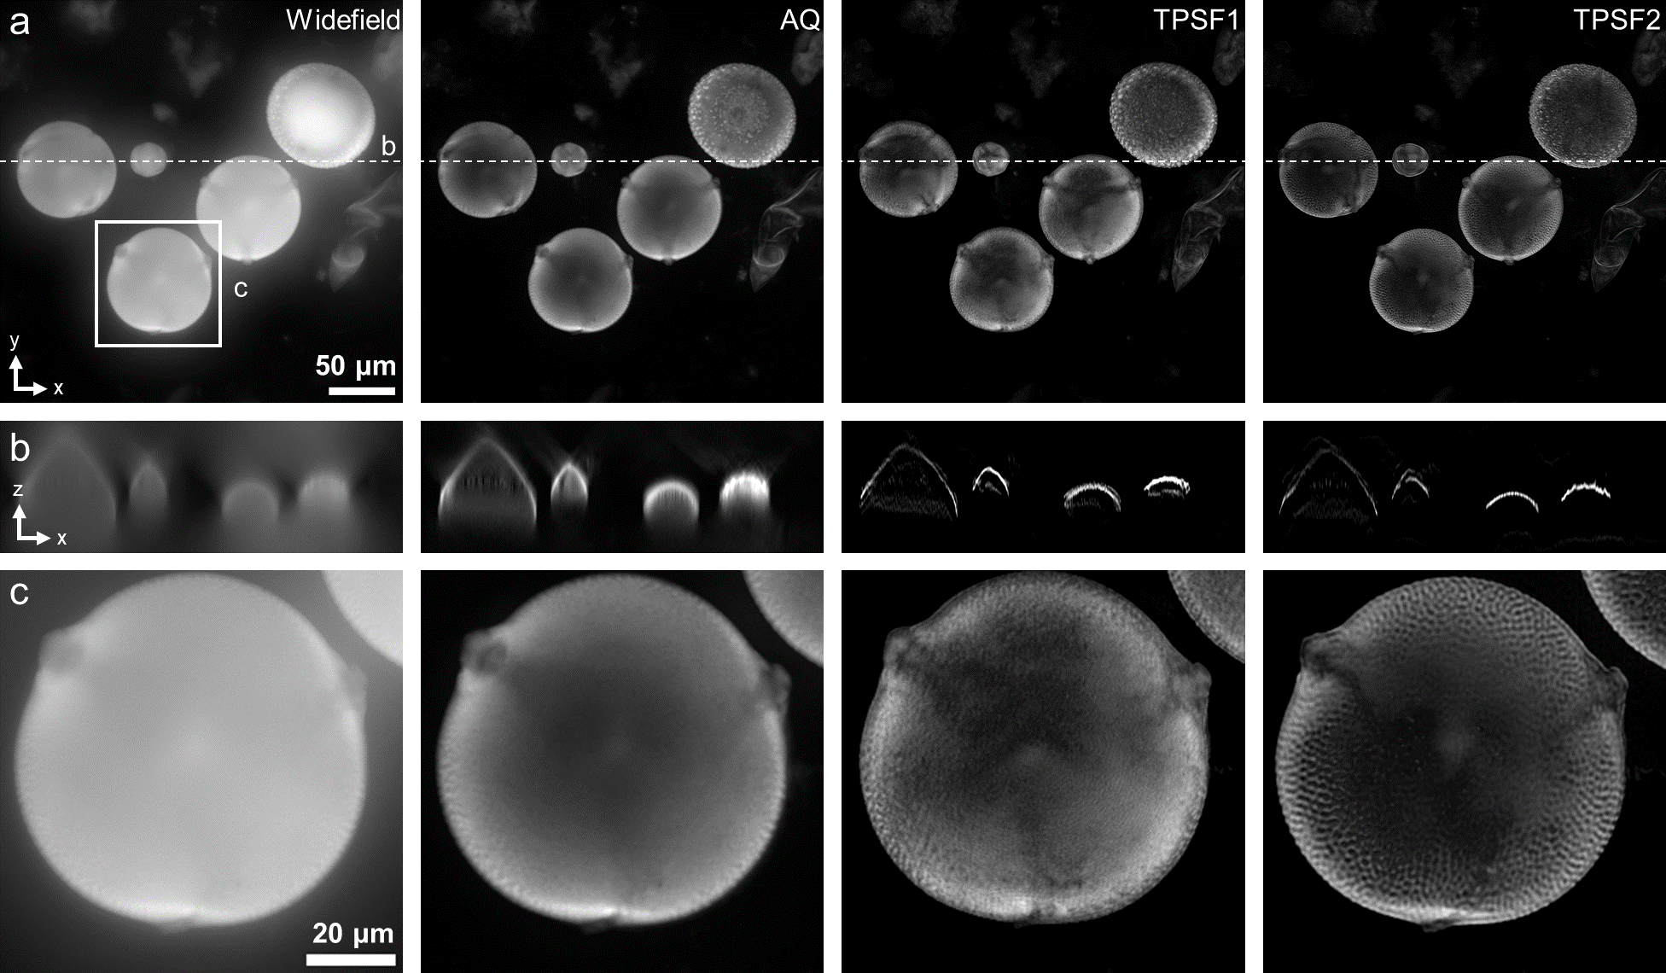

Supplementary Fig. 3 | Comparison of widefield, AQ, and TPSF-based reconstructions of zucchini pollen. a, Maximum intensity projection (MIP) images of zucchini pollen reconstructed from the widefield image, AQ, TPSF1, and TPSF2. b, Axial cross-sections taken along the dashed line in a. c, Magnified views of the boxed region in a. Compared with the widefield image, both TPSF-based reconstructions effectively suppress out-of-focus blur and recover resolvable surface features of the pollen grain. While AQ improves optical sectioning to some extent, the TPSF-based results provide clearer surface detail and stronger background rejection. TPSF2, which was decoupled from cotton pollen, yields slightly better recovery of the surface texture for zucchini pollen, suggesting that although a shared residual system response supports cross-sample transferability, a TPSF derived from a structurally related specimen can provide a better match through a more compatible sample-dependent scattering contribution.
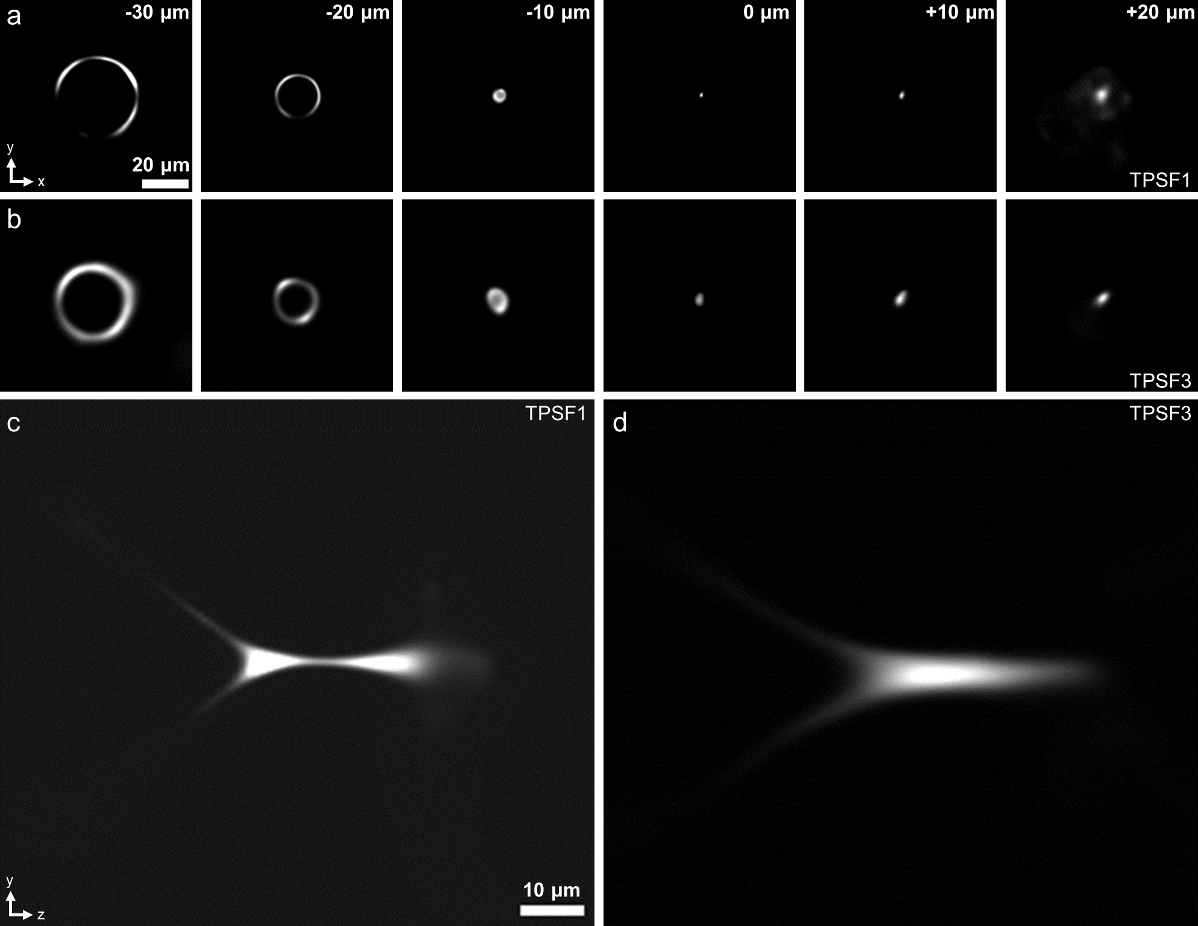

Supplementary Fig. 4 | Influence of widefield pre-processing on subsequent TPSF decoupling. a,b, Axial slices of two TPSFs decoupled from the same biological specimen, differing only in the PSF used in the preceding widefield deblurring step for system-blur removal. a, TPSF1, obtained by further decoupling the effective redistribution estimate pre-processed with a theoretical PSF. b, TPSF3, obtained by further decoupling the effective redistribution estimate pre-processed with a PSF measured from fluorescent microspheres. c,d, Orthogonal yz views of TPSF1 and TPSF3, respectively. The two TPSFs remain highly similar in their overall structure, with an SSIM of 0.9670, while still showing visible differences in fine details. These results indicate that the PSF used in the pre-processing step can affect the subsequently decoupled TPSF mainly through changes in the residual system response, even when the dominant structure is preserved. Therefore, the pre-processing strategy used for TPSF calculation should remain consistent with that used in subsequent processing, so that the residual system response absorbed into the TPSF remains matched.
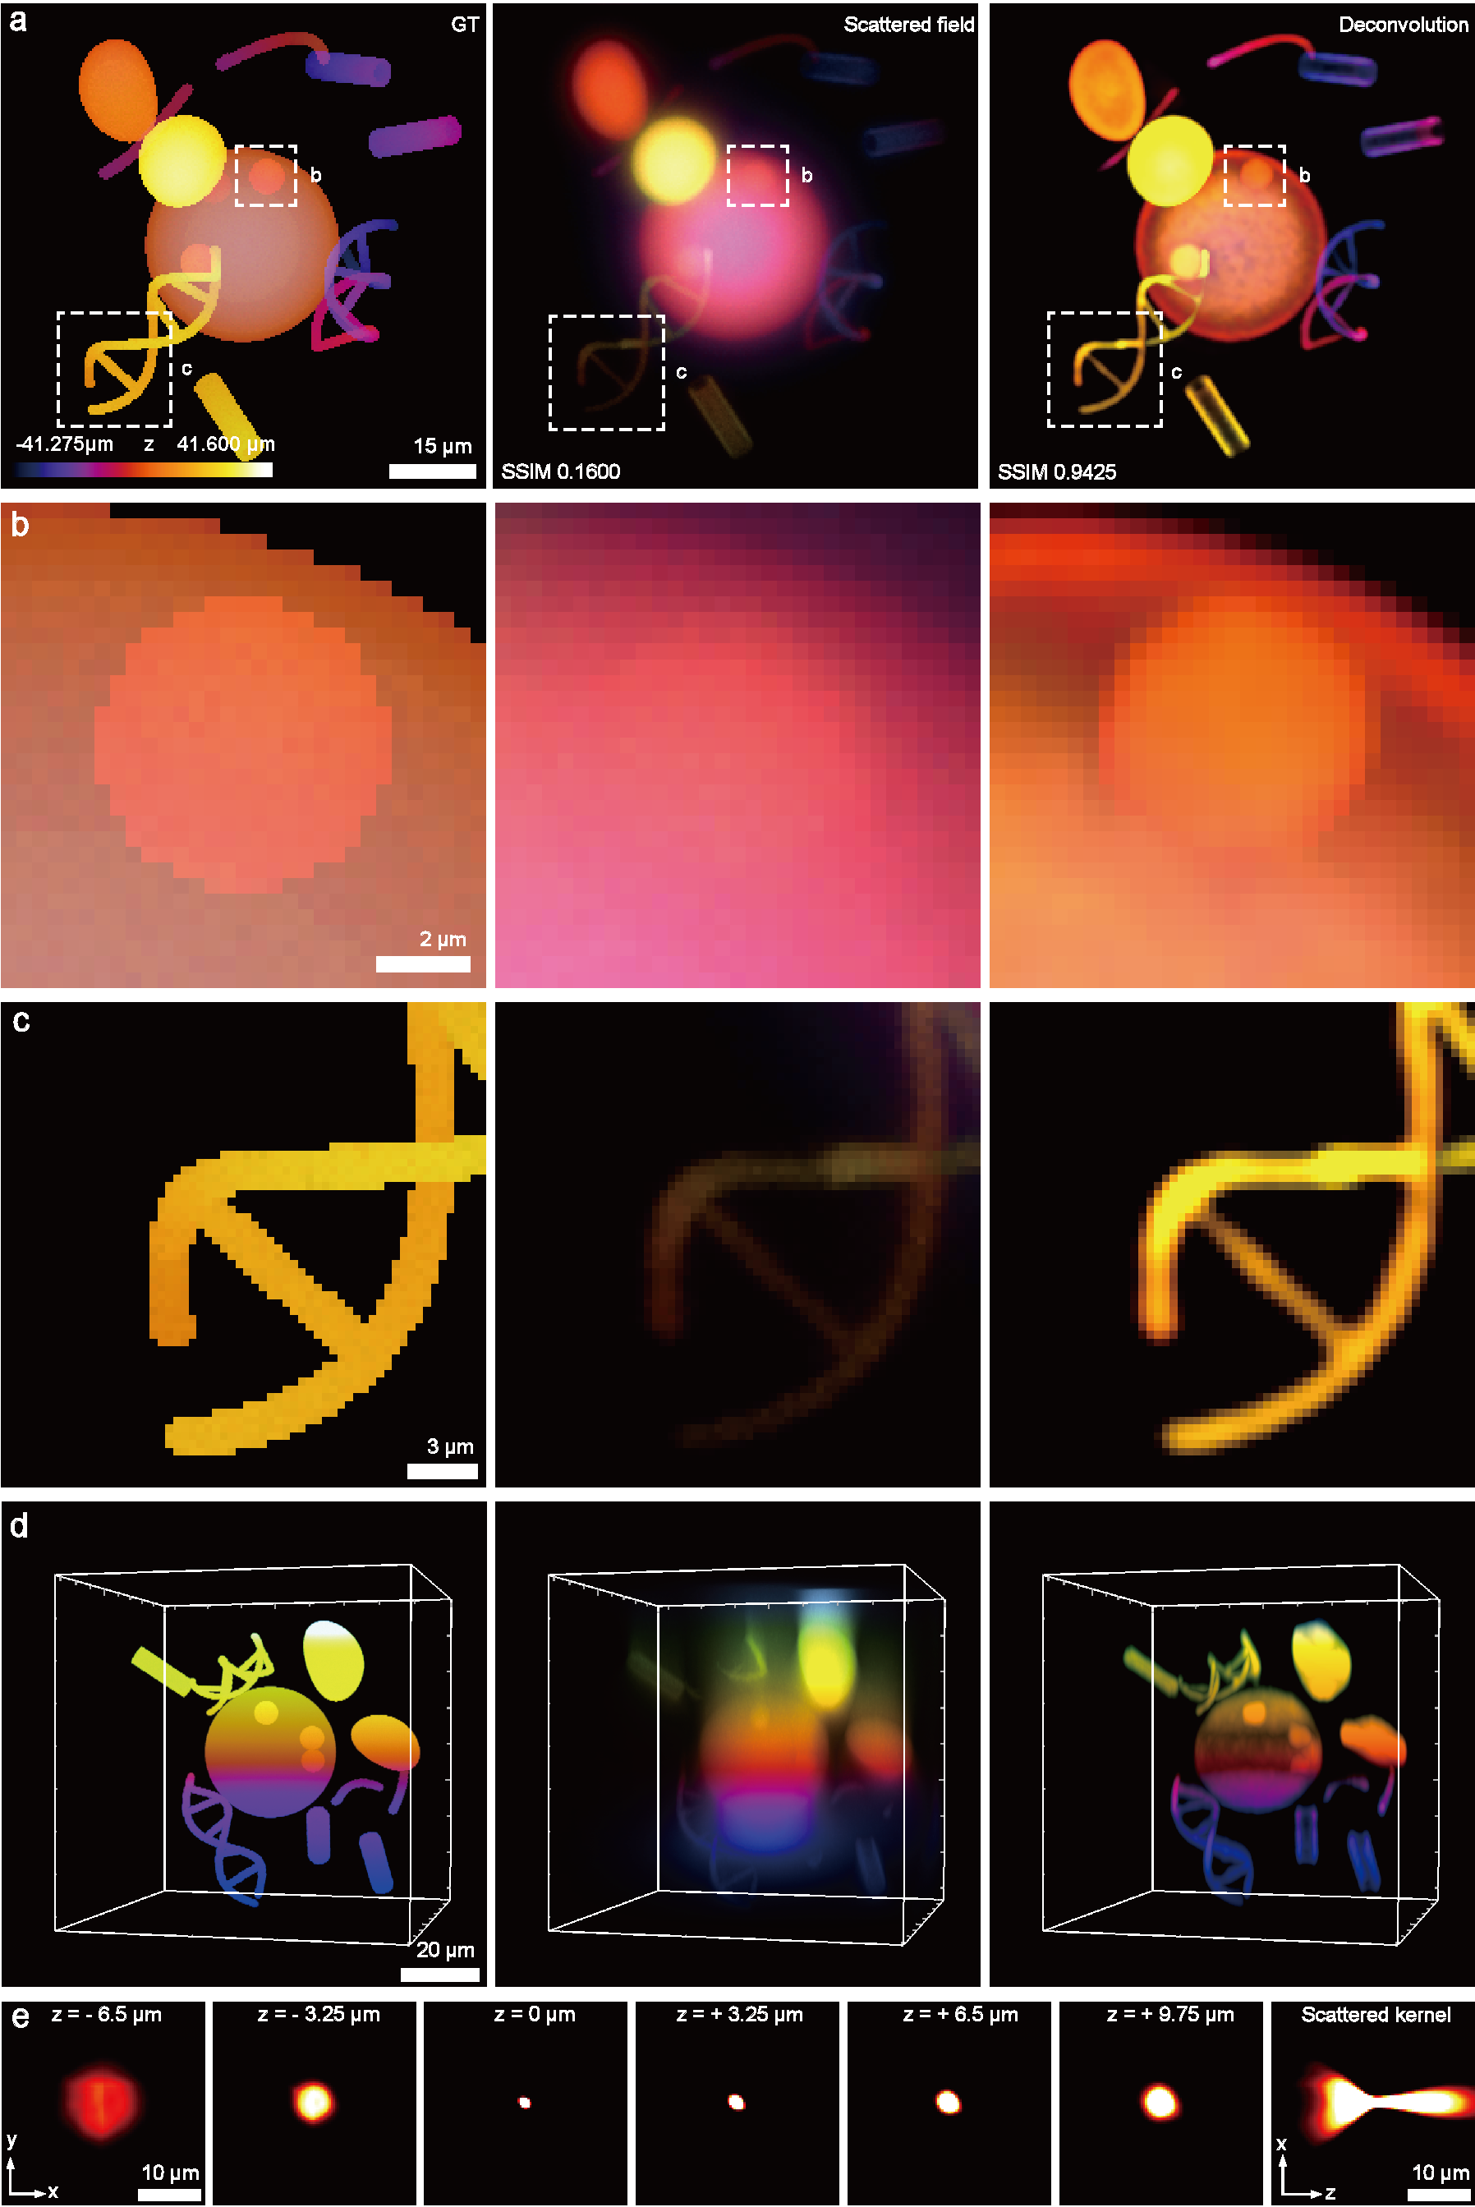

Supplementary Fig. 5 | Monte Carlo validation of scattering-kernel estimation and convolutional redistribution. a, Color-coded depth projection of the three-dimensional fluorescent GT, the Monte Carlo–simulated scattering-mediated redistribution field, and the deconvolution result obtained using the estimated scattering kernel $K_{scat}$. The structural similarity index (SSIM) is computed with respect to the GT, showing substantial discrepancy between the scattering-mediated redistribution field and the GT, whereas the deconvolved result exhibits close agreement with the GT, indicating effective compensation of scattering-induced degradation by kernel-based deconvolution. b, Magnified views of the region marked in a, showing a spherical structure with concentric, hierarchical geometry, used to model multiscale inclusion relationships commonly found in biological tissues; the results demonstrate that kernel-based deconvolution recovers internal hierarchical boundaries obscured by scattering. c, Local magnification of a filamentary structure, illustrating severe loss of geometric continuity in the scattering-mediated redistribution field and its effective restoration after deconvolution. d, Three-dimensional volume renderings of the GT object, the scattering-mediated redistribution field, and the deconvolution result, highlighting volumetric blurring induced by tissue scattering and its global correction in three dimensions. e, axial cross-sections of the scattering kernel $K_{scat}$ estimated from independent pairs of ground-truth objects and corresponding scattering-mediated redistribution fields; the estimated kernel is applied to the current sample to validate its estimability, convolutional consistency, and cross-sample transferability.
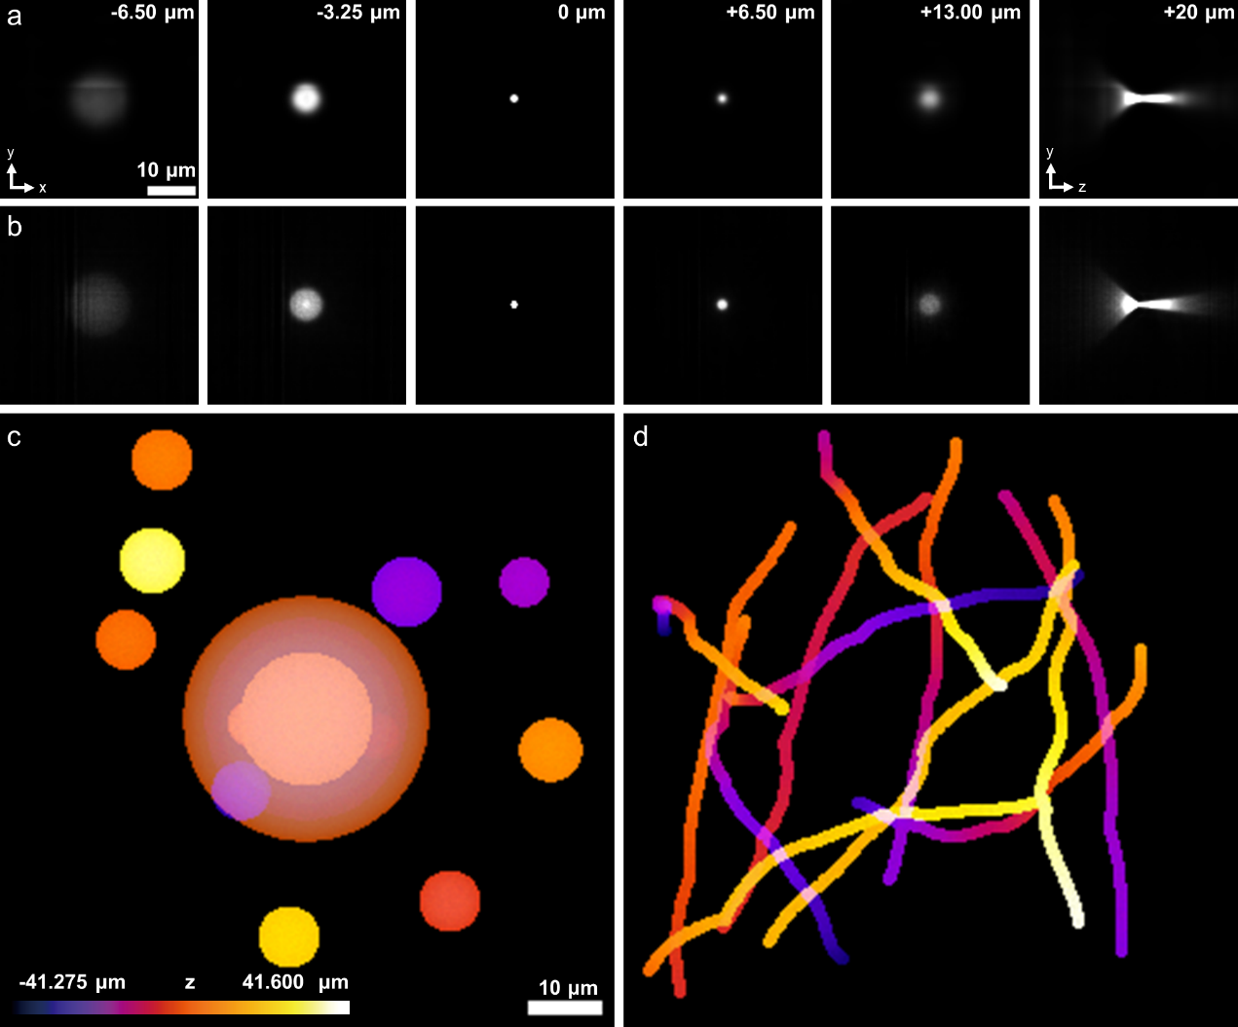

Supplementary Fig. 6 | Morphology dependence of decoupled scattering kernels in simulation. a,b, Selected axial slices and orthogonal views of the scattering kernels $K_{scat}$. decoupled from the simulated samples shown in c and d, respectively, used to assess the influence of sample specificity on the decoupled kernel. Despite the pronounced geometric differences between the two simulated samples, the resulting kernels remain highly consistent in their overall three-dimensional structure, with a 3D SSIM of 0.9998. The kernel from c exhibits a relatively smooth and nearly symmetric spread away from focus, whereas the kernel from d shows slight local heterogeneity in the peripheral regions, indicating that sample morphology introduces only limited variation into the outer kernel structure. c, Simulated sample composed entirely of spherical structures, in which a small sphere is embedded inside the central large sphere to mimic the inclusion architecture commonly found in biological specimens. d, Simulated sample composed of randomly distributed line-like structures. The two samples were assigned similar but not identical scattering and absorption coefficients, chosen from representative optical-property ranges of common biological specimens.
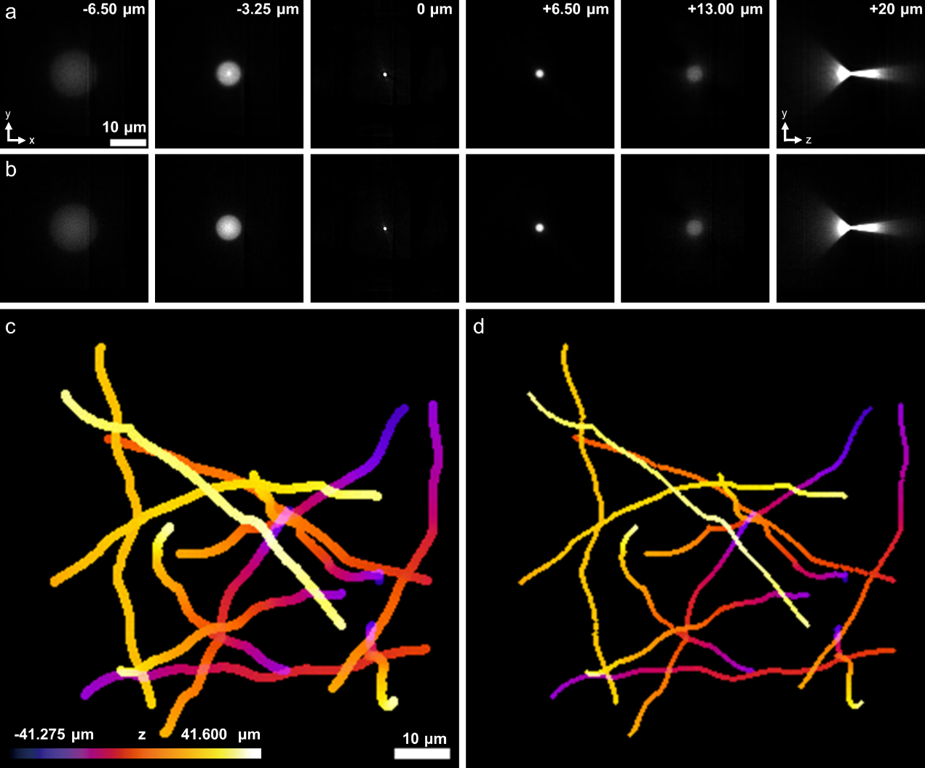

Supplementary Fig. 7 | Effect of filament thickness on decoupled scattering kernels in simulation. a,b, Selected axial slices and orthogonal yz views of the scattering kernels decoupled from the simulated samples shown in c and d, respectively. The two samples share the same random filamentous spatial distribution, while the scattering coefficient, absorption coefficient, and all other simulation parameters are kept identical; only the filament thickness differs, with c and d representing the thick and thin versions, respectively. Despite this change in local geometric scale, the two decoupled kernels remain highly consistent in their overall three-dimensional structure, exhibiting a compact core near focus and progressive broadening away from focus in both cases. This result indicates that, when all other conditions are fixed, local filament thickness has only a limited effect on the dominant kernel morphology, and that the decoupled kernel is governed primarily by stable bulk scattering transport rather than fine-scale filament caliber. c,d, Random filamentous simulated samples with identical spatial distribution but different line thicknesses; color indicates axial position z.

Supplementary Table 1: Imaging parameters for all datasets.
Figure(s) | Sample Description | Objective | NA | Immersion | Approx. Thickness | Z-Step | XY Size | Channels / Labels | Exposure (ms) | Remarks
Fig. 1b,  ExFig. 1 | Ranunculus root cross-section | 20× | 0.75 | Air | ~20 μm | 1 μm | 1300 nm | Ex 530–550 nm / Em 575 nm | 60 | Validation sample
Fig. 1c-e | Live HeLa cells | 20× | 0.75 | Air | ~8 μm | 1 μm | 325 nm | Ex 530–550 nm / Em 575 nm | 1500 | Time-lapse imaging
Fig. 2a-e | Mouse lung tissue section | 20× | 0.75 | Air | ~20 μm | 1 μm | 325 nm | Ex 530–550 nm / Em 575 nm | 22 | Thin sample validation
Fig. 2f-j | Rotifer | 20× | 0.75 | Air | ~100 μm | 1 μm | 325 nm | Ex 530–550 nm / Em 575 nm | 50 | Thick/Transparent sample
Fig. 2k-l | Fluorescent beads (500 nm) | 20× | 0.75 | Air | - | 1 μm | 325 nm | Ex 530–550 nm / Em 575 nm | 1000 | Resolution quantification
Fig. 3a-e | Banana stem section | 40× | 0.9 | Air | ~20 μm | 0.5 μm | 162.5 nm | Ex 530–550 nm / Em 575 nm | 50 | Mid-high NA validation
Fig. 3f-g | Bovine Pulmonary Artery Endothelial (BPAE) cells | 40× | 0.9 | Air | ~5 μm | 0.5 μm | 162.5 nm | Ch1: Ex 460–498 nm / Em 510–550 nm  Microtubules  Ch2: Ex 530–550 nm / Em 575 nm  F-actin (Phalloidin) | Ch1: 4000  Ch2: 5000 | Dual-color / Fine structure
Fig. 3h-k | Banana stem section | 100× | 1.4 | Oil | ~20 μm | 0.25 μm | 65 nm | Ex 530–550 nm / Em 575 nm | 250 | High NA / Oil immersion
Fig. 4a-d | Chlorella | 100× | 1.4 | Oil | - | - | 65 nm | Auto-fluorescence | 100 | Brownian motion , time-lapse
Fig. 4e-g | Zebrafish | 20× | 0.75 | Air | ~100 μm | 1 μm | 325 nm | Ex 530–550 nm / Em 575 nm | 200 | 5-min interval volumetric time-lapse
Fig. 4h-j | Paramecium | 20× | 0.75 | Air | - | - | 325 nm | Ex 530–550 nm / Em 575 nm | 10 | Ciliary beating, time-lapse
Fig. 4k | Paramecium | 20× | 0.75 | Air | - | - | 325 nm | Ex 530–550 nm / Em 575 nm | 40 | Cell lysis , time-lapse
ExFig. 2 | Berry trichome | 20× | 0.75 | Air | ~80 μm | 1 μm | 325 nm | Ex 530–550 nm / Em 575 nm | 17 | Calibration Reference
ExFig. 3 | Butterfly leg | 20× | 0.75 | Air | ~75 μm | 1 μm | 325 nm | Ex 530–550 nm / Em 575 nm | 50 | Highly scattering / Chitinous
ExFig.4a-d | Cucurbita (Zucchini) pollen | 20× | 0.75 | Air | ~90 μm | 2.5 μm | 1300 nm | Ex 530–550 nm / Em 575 nm | 20 | Densely packed / Scattering
ExFig. 4e-g | Lilium pollen | 20× | 0.75 | Air | ~100 μm | 2.5 μm | 1300 nm | Ex 530–550 nm / Em 575 nm | 15 | No Confocal GT available
ExFig. 5 | Flower bud section | 40× | 0.9 | Air | ~15 μm | 0.5 μm | 162.5 nm | Ex 530–550 nm / Em 575 nm | 120 | Low SNR / Saturation test
ExFig. 6 | Fluorescent beads (100 nm) | 40× | 0.9 | Air | - | 0.5 μm | 162.5 nm | Ex 530–550 nm / Em 575 nm | 5000 | High NA Resolution quantification
ExFig. 7 | C. elegans embryo | 100× | 1.4 | Oil | ~22 μm | 0.2 μm | 64.5 nm | Ch1: DAPI (Nuclei)Ch2: FITC (Microtubules)Ch3: CY3 (Spots) | - | Open Dataset (DeconvolutionLab2)

