Supplementary:
Supplementary Figure S1. 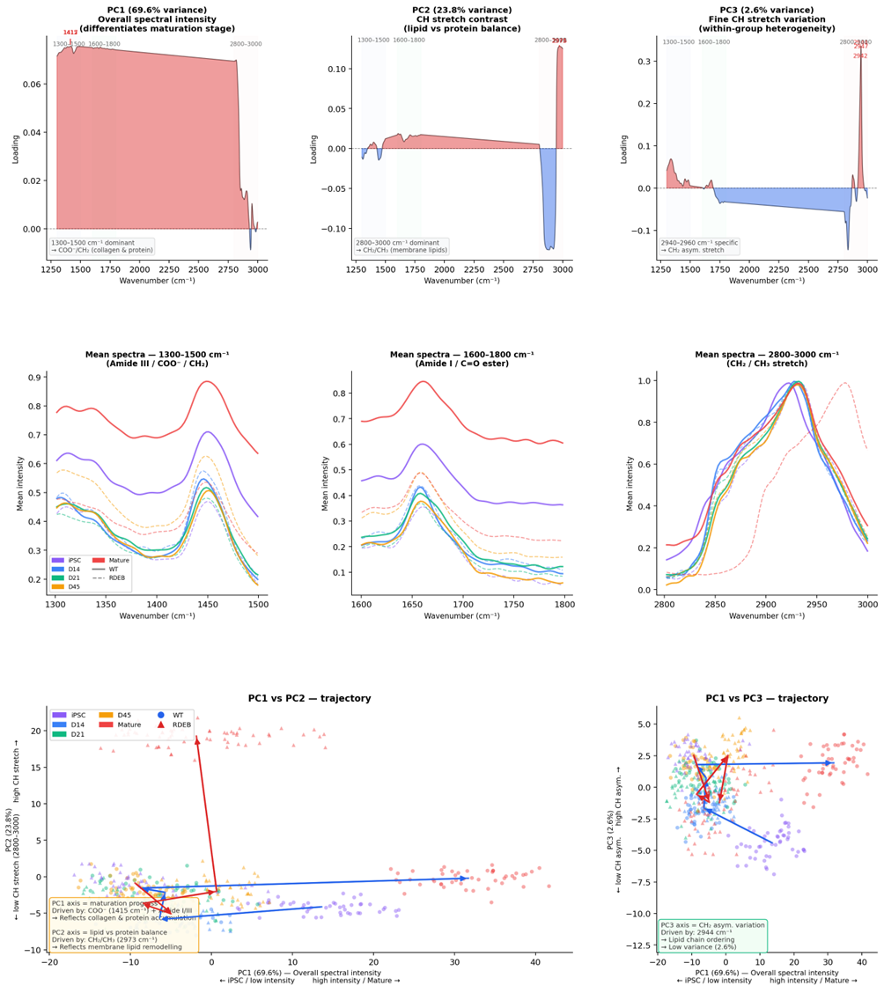
Figure S1. Principal-component loadings, window-specific mean spectra, and annotated genotype trajectories underlying Raman differentiation analysis.
(A–C) Loading profiles for PC1–PC3 across the concatenated 1300–1500, 1600–1800, and 2800–3000 cm⁻¹ windows. PC1 captures broad stage-associated spectral intensity, PC2 emphasizes contrast between the CH-stretch region and lower-wavenumber protein-associated bands, and PC3 highlights finer variation within the high-wavenumber CH-stretch region. (D–F) Mean spectra for iPSC, D14, D21, D45, and Mature states in the 1300–1500, 1600–1800, and 2800–3000 cm⁻¹ windows. Solid and dashed traces distinguish WT and RDEB as labeled in the figure. (G,H) Annotated trajectory plots in PC1–PC2 and PC1–PC3 space showing stage-colored spectra and genotype-specific centroid paths, with text boxes summarizing the dominant biochemical interpretation of each component axis.

Supplementary Figure S2. 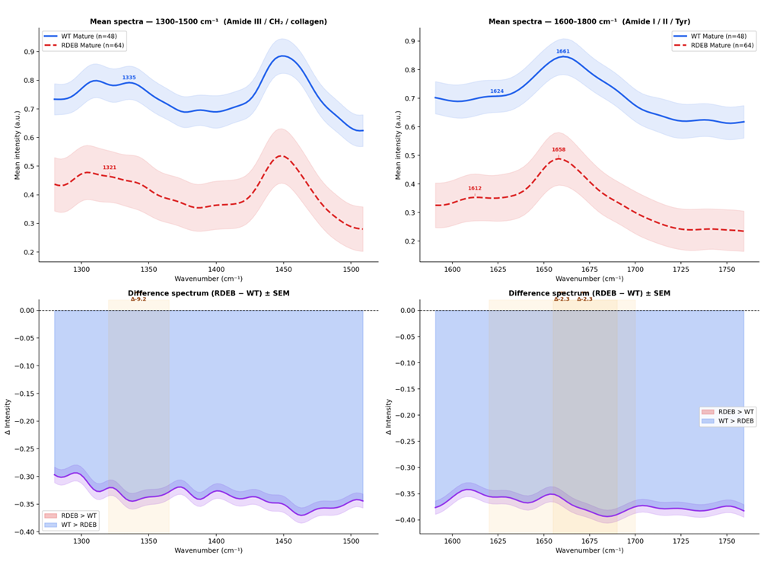 Supplementary Figure S2. Mature-stage WT and RDEB spectra and difference spectra in protein-associated Raman windows.
(A,B) Mean mature spectra for WT and RDEB in the 1300–1500 and 1600–1800 cm⁻¹ regions, with labeled peak positions and shaded variability bands. WT mature spectra (n=48) and RDEB mature spectra (n=64) are shown as indicated. (C,D) Difference spectra (RDEB – WT) ± SEM across the same windows, highlighting the broad reduction of mature RDEB signal relative to WT and the subregions surrounding the major shifted protein-associated bands.
Supplementary Figure S3.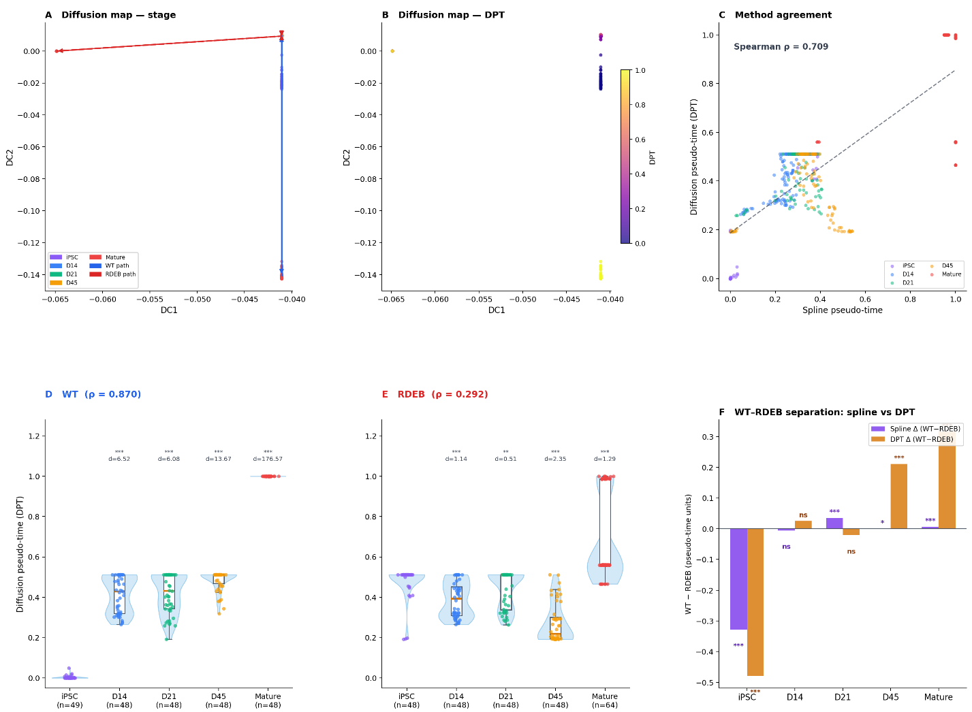
Supplementary Figure S3. Diffusion map and diffusion pseudo-time analysis. Diffusion map and diffusion pseudo-time (DPT) analysis of 497 filtered Raman spectra (WT n=241, RDEB n=256) as a complementary validation of the spline-based trajectory. (A) Diffusion map embedding in DC1–DC2 space, colored by differentiation stage; lines connect stage centroids for WT (solid) and RDEB (dashed). (B) Diffusion map embedding colored by DPT value. (C) Spearman correlation between spline pseudo-time and DPT (ρ=0.709), colored by stage. (D–E) DPT distributions per differentiation stage for WT (D, ρ=0.870) and RDEB (E, ρ=0.292), with significance vs iPSC baseline (Mann–Whitney U; Cohen's d below brackets). ((F) Mean WT−RDEB pseudo-time separation per stage for spline (purple) and DPT (amber); bars show mean WT minus mean RDEB, significance from Mann−Whitney U test. The substantially lower DPT stage association in RDEB (ρ=0.292) compared with WT (ρ=0.870) reveals method-dependent behaviour that is not apparent from the overall agreement (ρ=0.709). In WT, spline and diffusion estimates converge (ρ=0.926 vs 0.870), indicating a robust monotonic trajectory. In RDEB, the larger divergence (ρ=0.595 vs 0.292) indicates that the spline estimate is partly anchored by the imposed stage order rather than an intrinsically ordered spectral progression, consistent with a biochemically aberrant differentiation path in RDEB.
Supplementary table
Supplementary Table S1. Stage-specific WT versus RDEB Raman band comparisons.
Stage-specific comparisons for Raman-derived metrics across the differentiation series, including the 1300–1500, 1600–1800, and 2800–3000 cm⁻¹ mean intensity windows and the 2800–3000/1600–1800 lipid/protein ratio. Suggested columns: Stage; Metric; WT (mean ± SD); RDEB (mean ± SD); p-value; Cohen’s d.
Stage | Metric | WT (mean ± SD) | RDEB (mean ± SD) | n_WT | n_RDEB | p-value | Cohen's d
iPSC | 1300–1500 cm⁻¹ (CH₂/CH₃ bending) | 0.565 ± 0.069 | 0.348 ± 0.060 | 49 | 48 | 4.91e-16 | 3.36
 | 1600–1800 cm⁻¹ (Amide I / protein) | 0.442 ± 0.060 | 0.167 ± 0.049 | 49 | 48 | 2.84e-17 | 5.02
 | 2800–3000 cm⁻¹ (CH stretching / lipid) | 0.561 ± 0.012 | 0.517 ± 0.019 | 49 | 48 | 1.06e-15 | 2.74
 | 2800–3000/1600–1800 (lipid/protein ratio) | 1.290 ± 0.170 | 3.292 ± 0.714 | 49 | 48 | 2.84e-17 | -3.88
D14 | 1300–1500 cm⁻¹ (CH₂/CH₃ bending) | 0.367 ± 0.047 | 0.374 ± 0.040 | 48 | 41 | 3.42e-01 | -0.18
 | 1600–1800 cm⁻¹ (Amide I / protein) | 0.202 ± 0.040 | 0.215 ± 0.027 | 48 | 41 | 5.26e-02 | -0.37
 | 2800–3000 cm⁻¹ (CH stretching / lipid) | 0.553 ± 0.014 | 0.539 ± 0.015 | 48 | 41 | 1.83e-04 | 0.94
 | 2800–3000/1600–1800 (lipid/protein ratio) | 2.835 ± 0.523 | 2.542 ± 0.314 | 48 | 41 | 6.85e-03 | 0.67
D21 | 1300–1500 cm⁻¹ (CH₂/CH₃ bending) | 0.375 ± 0.056 | 0.342 ± 0.067 | 48 | 48 | 1.85e-02 | 0.54
 | 1600–1800 cm⁻¹ (Amide I / protein) | 0.220 ± 0.054 | 0.183 ± 0.053 | 48 | 48 | 1.96e-03 | 0.70
 | 2800–3000 cm⁻¹ (CH stretching / lipid) | 0.529 ± 0.022 | 0.538 ± 0.024 | 48 | 48 | 1.34e-02 | -0.42
 | 2800–3000/1600–1800 (lipid/protein ratio) | 2.542 ± 0.600 | 3.204 ± 0.910 | 48 | 48 | 2.59e-04 | -0.86
D45 | 1300–1500 cm⁻¹ (CH₂/CH₃ bending) | 0.361 ± 0.042 | 0.453 ± 0.056 | 48 | 38 | 9.00e-11 | -1.91
 | 1600–1800 cm⁻¹ (Amide I / protein) | 0.178 ± 0.041 | 0.266 ± 0.042 | 48 | 38 | 2.49e-11 | -2.11
 | 2800–3000 cm⁻¹ (CH stretching / lipid) | 0.508 ± 0.023 | 0.534 ± 0.013 | 48 | 38 | 3.72e-07 | -1.33
 | 2800–3000/1600–1800 (lipid/protein ratio) | 3.010 ± 0.713 | 2.066 ± 0.359 | 48 | 38 | 1.13e-10 | 1.62
Mature | 1300–1500 cm⁻¹ (CH₂/CH₃ bending) | 0.753 ± 0.055 | 0.424 ± 0.083 | 48 | 59 | 7.56e-19 | 4.59
 | 1600–1800 cm⁻¹ (Amide I / protein) | 0.687 ± 0.058 | 0.323 ± 0.070 | 48 | 59 | 7.56e-19 | 5.60
 | 2800–3000 cm⁻¹ (CH stretching / lipid) | 0.591 ± 0.026 | 0.450 ± 0.021 | 48 | 59 | 7.56e-19 | 6.02
 | 2800–3000/1600–1800 (lipid/protein ratio) | 0.866 ± 0.061 | 1.449 ± 0.258 | 48 | 59 | 1.40e-18 | -2.97

Supplementary Table S2. Raman peak positions in the protein spectral regions of mature wild-type (WT, SC8) and RDEB fibroblasts.
Summary of mature-stage peak positions for protein-associated Raman bands used in the peak-shift analysis. Suggested columns: Raman Band; Biochemical Assignment; WT (cm⁻¹); RDEB (cm⁻¹); Shift (cm⁻¹); p-value.
Raman band | Biochemical assignment | WT (cm⁻¹) | RDEB (cm⁻¹) | Shift (cm⁻¹) | p-value | Sig.
1300–1500 cm⁻¹ region (protein backbone)
Phenylalanine (~1004 cm⁻¹) | Phe ring breathing (protein marker) | 1005.2 ± 0.7 | 1005.7 ± 1.0 | +0.5 | = 0.005 | **
Amide III (~1240 cm⁻¹) | C–N stretch + N–H bend (β-sheet / collagen) | 1259.4 ± 6.2 | 1258.8 ± 12.5 | -0.6 | = 0.180 | ns
CH₂ wagging (~1340 cm⁻¹) | Collagen-specific CH₂ wagging | 1331.1 ± 6.9 | 1322.0 ± 2.8 | -9.2 | < 0.001 | ***
1600–1800 cm⁻¹ region (protein secondary structure)
Amide II (~1550 cm⁻¹) | N–H bend + C–N stretch (protein 2° structure) | 1577.2 ± 3.6 | 1578.1 ± 2.8 | +1.0 | = 0.099 | ns
Tyr/Phe (~1615 cm⁻¹) | Tyr / Phe ring C=C stretch | 1620.4 ± 4.9 | 1618.1 ± 6.5 | -2.3 | = 0.148 | ns
Amide I (~1650 cm⁻¹) | C=O stretch (α-helix / β-sheet) | 1661.0 ± 1.9 | 1658.7 ± 2.1 | -2.3 | < 0.001 | ***
2800–3000 cm⁻¹ region (aliphatic CH stretch)
CH₂ sym. (~2850 cm⁻¹) | CH₂ symmetric stretch (lipid) | 2869.7 ± 0.0 | 2869.0 ± 2.8 | -0.7 | = 0.069 | ns
CH₂/CH₃ (~2930 cm⁻¹) | CH₂/CH₃ mixed stretch (protein/lipid) | 2932.0 ± 1.4 | 2954.0 ± 0.0 | +22.1 | < 0.001 | ***
CH₃ asym. (~2960 cm⁻¹) | CH₃ asymmetric stretch (lipid) | 2951.6 ± 0.0 | 2977.6 ± 1.3 | +26.0 | < 0.001 | ***
n_WT = 48; n_RDEB = 59 for all Mature comparisons. Shift = RDEB − WT (cm⁻¹). Significance: *p < 0.05, **p < 0.01, ***p < 0.001; ns, not significant (Mann–Whitney U, two-sided).

