SUPPLEMENTARY MATERIALS
Table 1 Different Model Architectures
Model Name | Architecture Description
CNN | The CNN is designed to capture local motifs and spatial patterns within the protein sequence embeddings. The architecture first projects the input features into a 256-dimensional space, followed by a series of one-dimensional convolutional layers with escalating and then refining channel capacities (64→128→256→128). By integrating Batch Normalization and Adaptive Max Pooling, this branch effectively extracts the most salient local structural information, providing a robust basis for discriminating functional sites through a final linear classifier.
Transformer | The Transformer leverages the multi-head self-attention mechanism to model long-range global dependencies within the protein sequences. After an initial linear embedding layer (d_{model}=256), the features are processed through four stacked Transformer Encoder layers. With eight parallel attention heads, this branch excels at capturing synergistic interactions between distant amino acid residues. This global contextual awareness allows the model to generate high-level semantic representations that are crucial for understanding complex protein-protein or protein-ligand interactions.
Mamba | The Mamba utilizes a modern Selective State Space Model (SSM) architecture to achieve efficient sequence modeling with linear computational complexity. Comprising five sequential Mamba blocks, the model employs a state dimension (d_{state}) of 16 and a local convolution width (d_{conv}) of 4. This branch is specifically optimized to maintain a deep memory of long sequences while avoiding the quadratic memory overhead of traditional transformers. The inclusion of residual connections and Layer Normalization ensures stable gradient flow and enhances the representative power of the extracted features.
Table 2 Key Hyperparameter Search and Selection for the Model
Parameter Name | Search Range | Current Value
lr | 1e-5 ~ 1e-3（log） | 0.00015659813436174998
weight_decay | 1e-5 ~ 1e-3（log） | 5.201826253047156e-05
kl_weight | 0.1 ~ 1.0, step=0.1 | 0.4
cnn_dropout | 0.1 ~ 0.5, step=0.1 | 0.2
trans_dropout | 0.1 ~ 0.5, step=0.1 | 0.2
mamba_dropout | 0.1 ~ 0.5, step=0.1 | 0.4
gate_dropout1 | 0.1 ~ 0.5, step=0.1 | 0.4
gate_dropout2 | 0.1 ~ 0.5, step=0.1 | 0.3
refine_dropout | 0.05 ~ 0.3, step=0.05 | 0.15
attn_dropout | 0.1 ~ 0.4, step=0.1 | 0.2
embed_dim | {64, 128, 256} | 128
transformer_layers | 2 ~ 6, step=2 | 4
mamba_blocks | 3 ~ 7, step=2 | 5
batch_size | {8, 16, 32, 64} | 16
Table 3 Classification Performance of DynML-Net Across Viral Categories (PEVs)
Category | Acc | AUC
PEDV | 0.6038 ± 0.1378 | 0.9559 ± 0.0108
TGEV | 0.7304 ± 0.0759 | 0.9494 ± 0.0151
PoRV | 0.9584 ± 0.0185 | 0.9846 ± 0.0040
PDCoV | 0.6843 ± 0.1207 | 0.9701 ± 0.0094
PAstV | 0.9200 ± 0.0980 | 0.9945 ± 0.0107
Class 6 | 0.9500 ± 0.0269 | 0.9867 ± 0.0074
PoNoV | 0.9500 ± 0.0612 | 0.9985 ± 0.0020
SADS-Cov | 0.5667 ± 0.2261 | 0.9182 ± 0.0514
Table 4 Classification Performance of DynML-Net Across Viral Categories (Non_PEVs)
Category | Acc | AUC
FIV | 0.6538 ± 0.1403 | 0.9697 ± 0.0109
HIV | 0.8500 ± 0.0382 | 0.9325 ± 0.0235
HCV | 0.7946 ± 0.0283 | 0.9582 ± 0.0083
HPIV3 | 0.9889 ± 0.0222 | 0.9999 ± 0.0001
HSV1 | 0.6904 ± 0.0640 | 0.9510 ± 0.0115
INFVA | 0.7656 ± 0.1626 | 0.9553 ± 0.0296
RSV | 0.8746 ± 0.1018 | 0.9802 ± 0.0141
SARS-CoV | 0.8103 ± 0.0425 | 0.9619 ± 0.0122
Table 5 Integration learning construction method
Method | Specific Implementation/Mechanism
simple_avg | Calculates the arithmetic mean of prediction probabilities from all base models.
majority_vote | Counts predicted classes for each sample from base models and performs hard voting, selecting the majority class.
product | Multiplies prediction probabilities from all base models and then normalizes the result.
dempster_shafer | Based on Evidence Theory, calculates basic probability mass for base models and combines using Dempster's rule.
confidence_intervals | Calculates the mean and standard deviation of prediction probabilities, constructs a confidence interval, and uses the midpoint as the final probability.
max_vote | Makes a final prediction based on the highest probability among base models and a preset threshold, possibly falling back to weighted average.
rank_avg | Converts prediction probabilities to ranks, performs a weighted average on ranks, and converts the result back to a probability.
confidence_weighted | Calculates prediction confidence of base models, normalizes it into weights, and performs a weighted average of probabilities using combined weights.
super_ensemble | Defines a list of basic ensemble methods and performs a secondary combination (voting or averaging) on the prediction results of these basic ensemble methods.
stacking | Uses Logistic Regression as a meta-classifier, trained on the prediction probabilities of base models.
xgboost_stacking | Uses XGBoost as a meta-classifier, trained on the prediction probabilities of base models.
catboost_stacking | Uses CatBoost as a meta-classifier, trained on the prediction probabilities of base models.
gradient_boosted_ensemble | Trains a Gradient Boosting Classifier (GBC) meta-learner, and its prediction is combined with the weighted average of base model predictions.
mlp_stacking | Uses a Multi-layer Perceptron (MLP) as a meta-classifier, trained on the prediction probabilities of base models.
svm_stacking | Uses a Support Vector Machine (SVM) as a meta-classifier, trained on the prediction probabilities of base models.
weighted_avg | Learns linear combination weights using an optimization algorithm (e.g., SLSQP), applied to the weighted sum of base model prediction probabilities.
bayesian_stacking | Uses a Bayesian Classifier as a meta-classifier, trained on the prediction results of base models.
dynamic_selection | Fits a Nearest Neighbors model in the space of base model predictions (meta-features), dynamically selecting or weighting base model predictions based on neighbor information.
cross_validation_ensemble | Determines optimal linear combination weights via optimization, applied to the weighted sum of base model prediction probabilities (optimization target often evaluated via cross-validation).
adaboost_ensemble | Calculates the performance of each base model on the dataset and computes model weights based on performance, then applies weights to combine base model predictions.
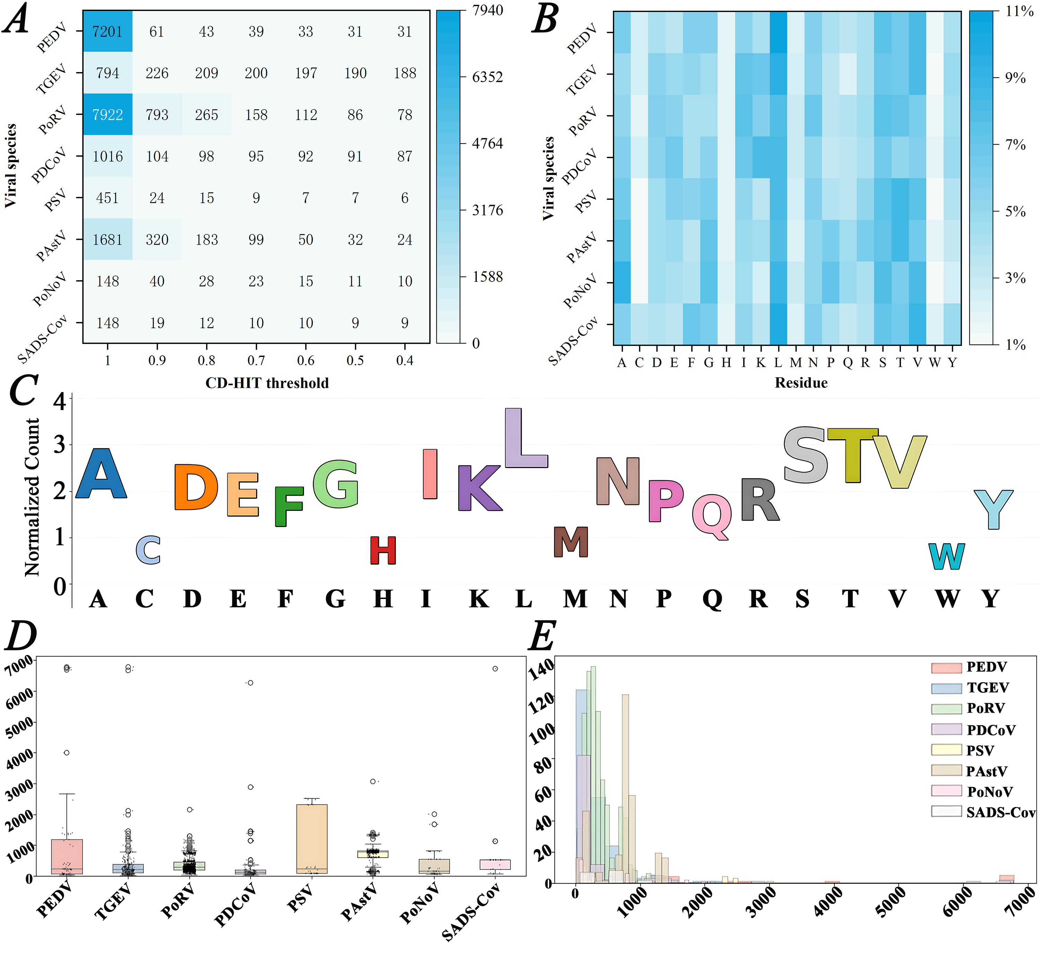
Figure 1 Porcine Enterovirus Dataset Structure Diagram
A: Heatmap of the sequence counts for various Porcine Enterovirus categories across different redundancy thresholds;
B: Heatmap of the average content difference of various viral sequences across 20 standard amino acids (CD-HIT=90%);
C: Amino acid frequency distribution in the dataset (CD-HIT=90%);
D: Box plot of viral sequence length distribution by category in the dataset (CD-HIT=90%);
E: Histogram of viral sequence length distribution by category in the dataset (CD-HIT=90%).

System deployment (File download link: https://github.com/cqw0715/DynML-Net.git)
Before deploying the system, please download all files in the "3-System deployment" folder. Installation Requirements for the Operating Environment Corresponding to the System：
pip install -r requirements.txt
After installation, you can run the following command:
streamlit run main.py
If you are redirected to the following page, the deployment is successful.
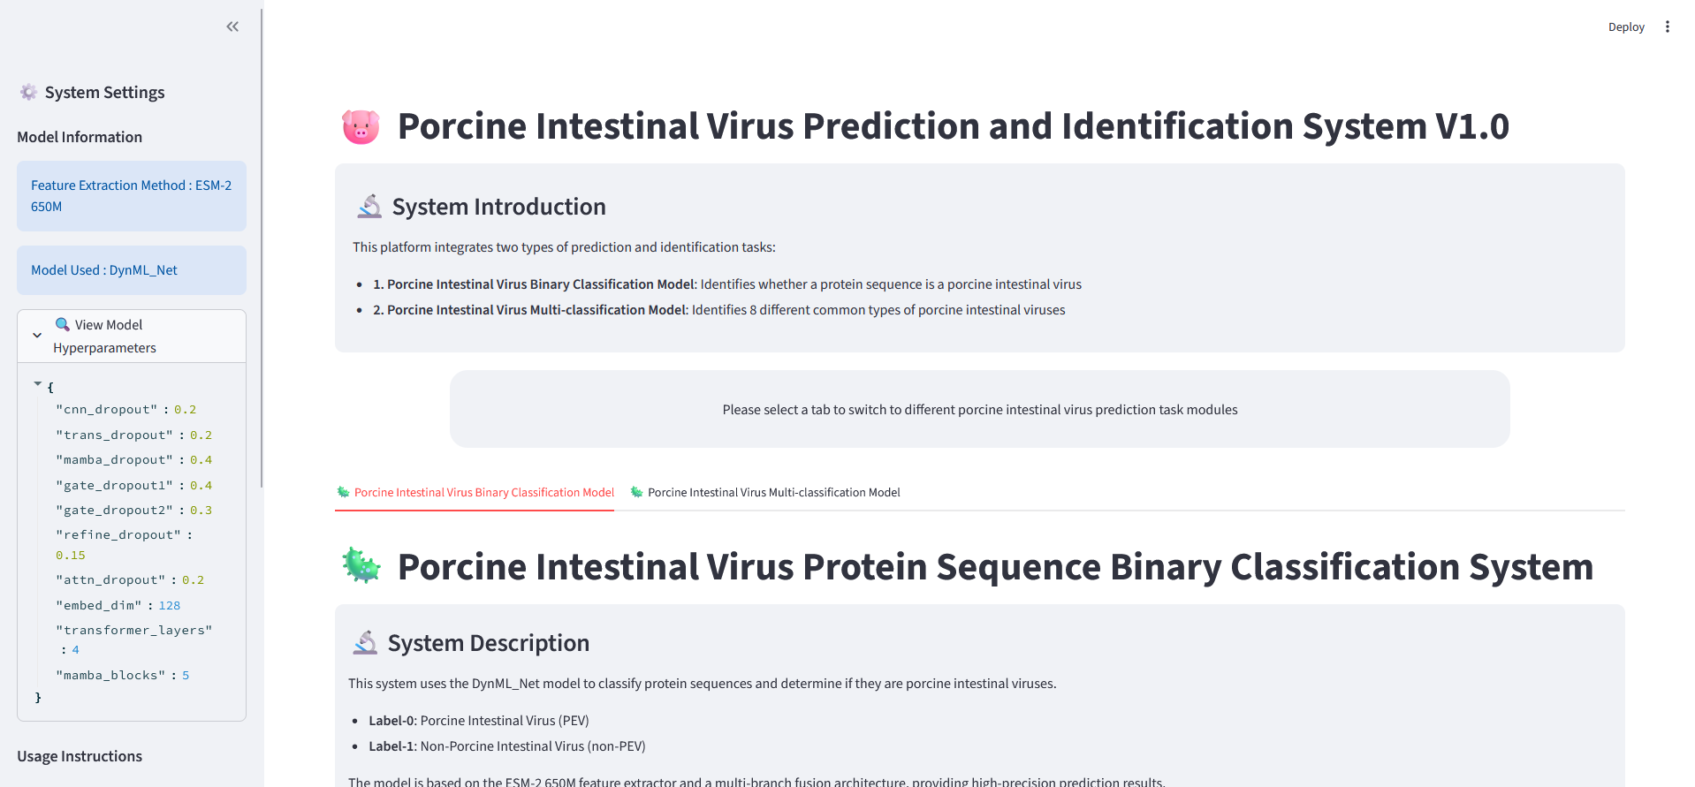
Figure 2 System Main Page
Subsequently, you can perform binary classification prediction or multiclass recognition tasks; the system supports prediction and recognition for a single sequence or multiple sequences (uploaded as a CSV file).
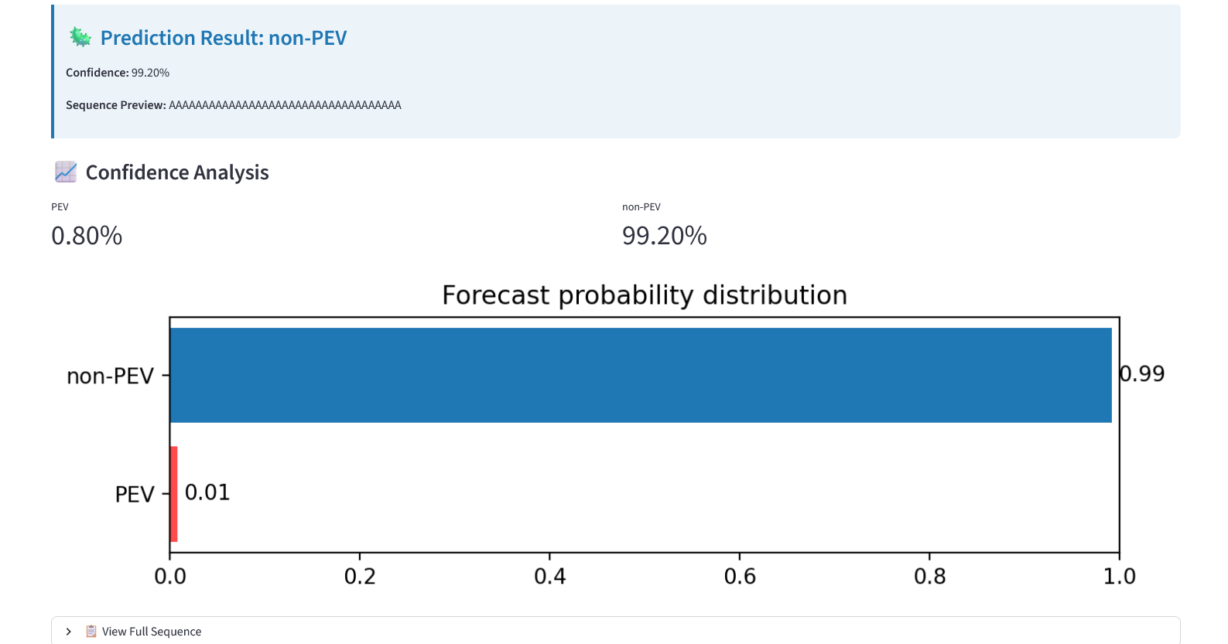
Figure 3 Single-sequence Recognition Results (Binary Classification)
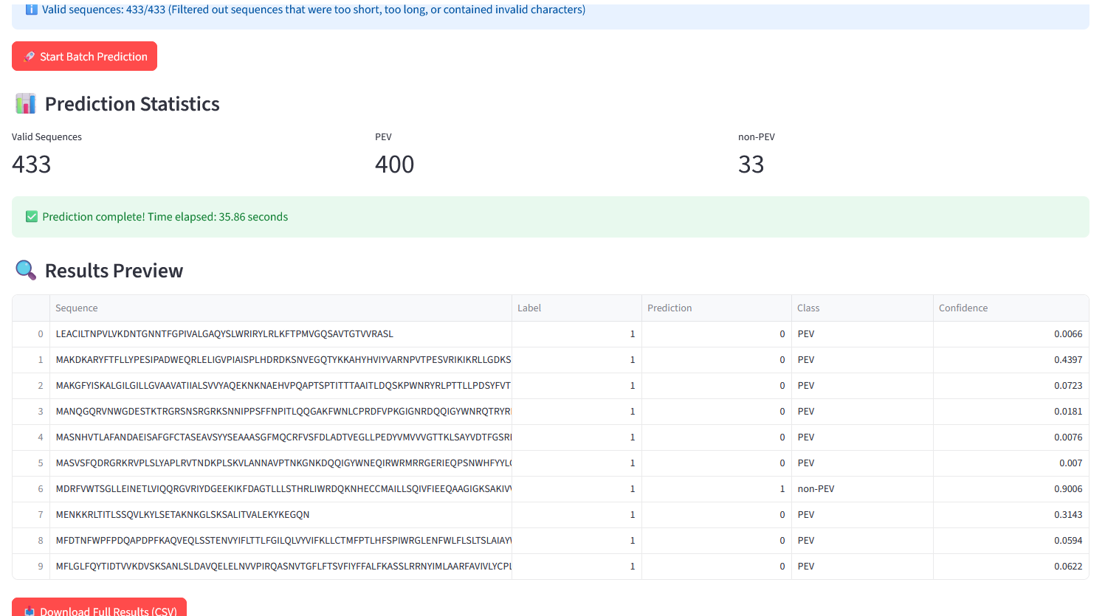
Figure 4 Multi-sequence Recognition Results (Binary Classification)
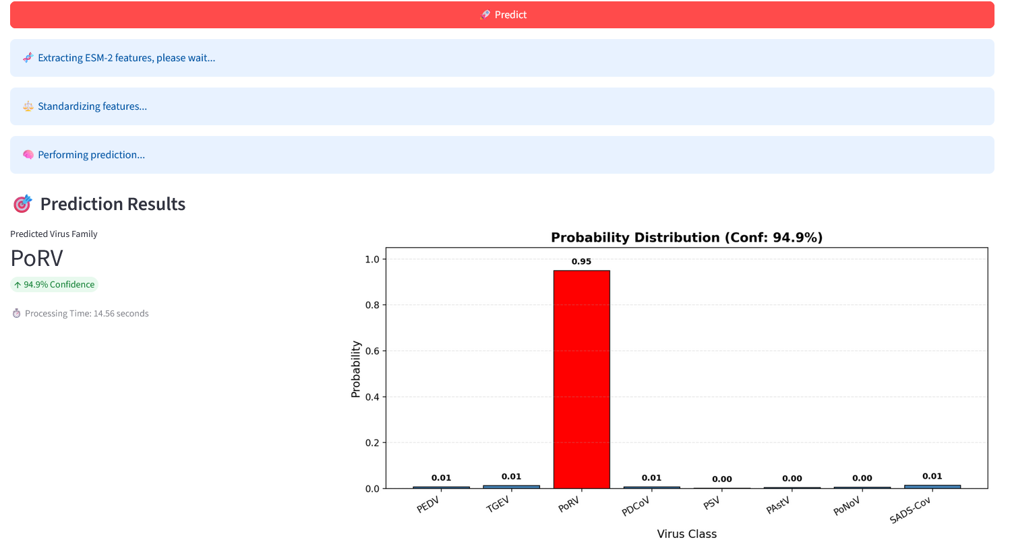
Figure 5 Single-sequence Recognition Results (Multi-class Classification)
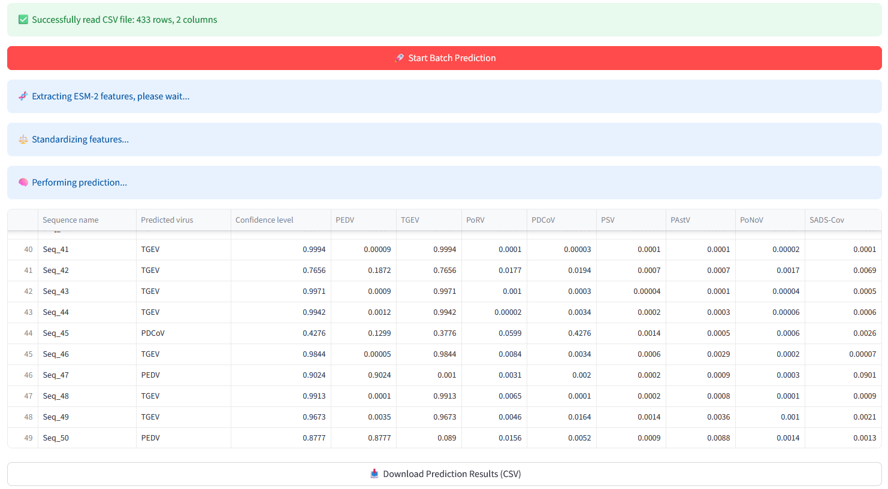
Figure 6 Multi-sequence Recognition Results (Multi-class Classification)

