Appendix:

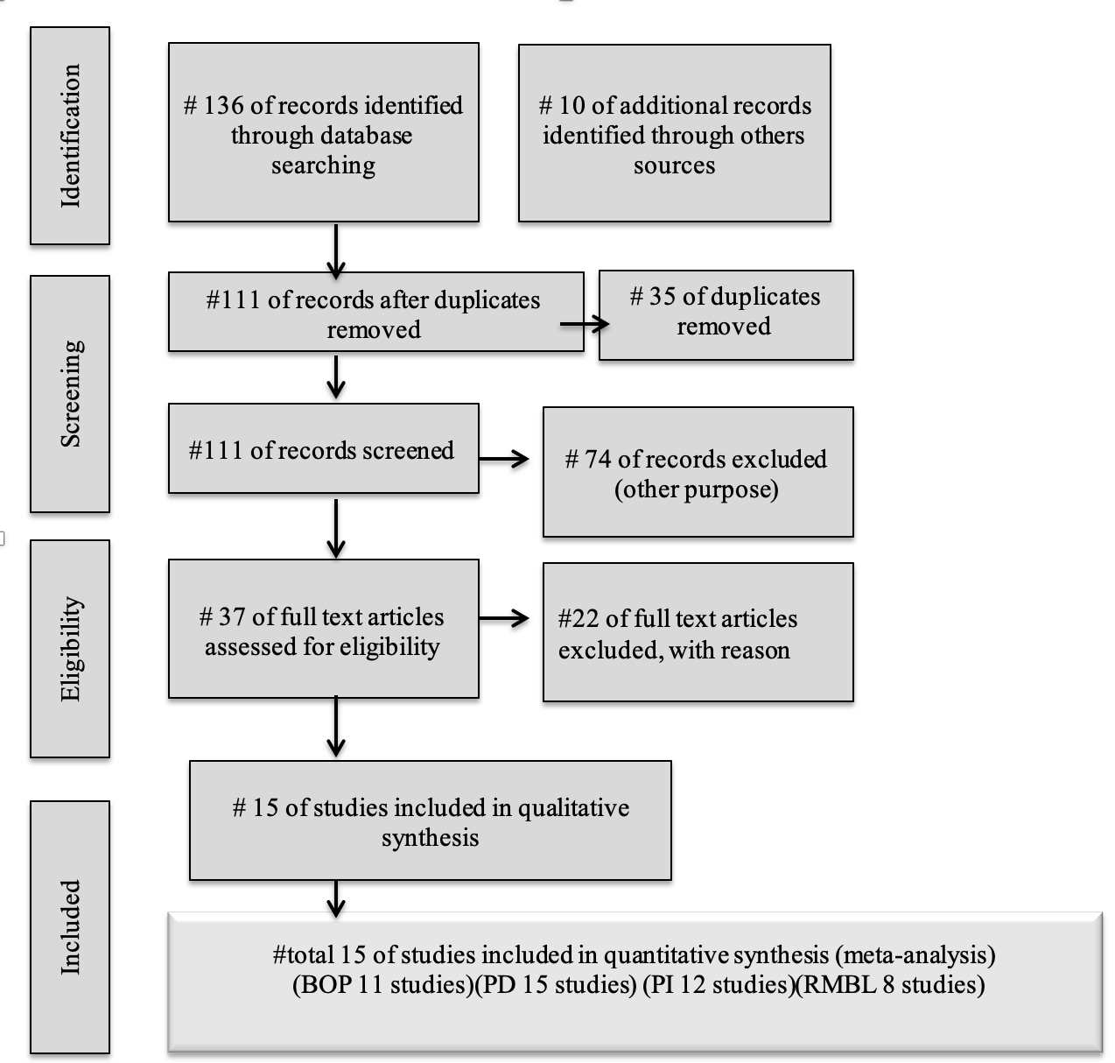

Appendix Figure 1
PRISMA Flow Chart. (shows the systematic search and selection process, including the number of articles identified, screened, excluded, and finally included in the meta-analysis)

Study | Design | Follow up (months) | Peri implantitis | Study groups | Sessions number | Test group specifications | No of patients (No of implants) | Outcomes | Debridement method
schwarz et al (2005)(11) | controlled parallel design pilot study | 6 | PD≥4mm | Er:YAG laser | Single | 100 mJ/pulse (12.7 J/cm2), 10 pps, | 20(32)  Equally distributed | Clinical outcomes | plastic curettes and 0.2%  chlorhexidine digluconate
Bassetti et al (2014)(18) | prospective RCT | 3, 6, 9, and 12 | PD:4-6mm | PDT | Double  (1 week apart) | 660 nm diode laser (power  density of 100 mW, 10 s) + phenothiazine  chloride (HELBO system) | 40(40)  Equally distributed | Clinical and microbiological outcomes | Titanium curette and powder airpolishing  Control group: minocycline microsphere into the pocket
Arisan et al (2015)(19) | split-mouth RCT | 6 | PD:4-6mm  MBL<3mm | Diode laser (810nm) | Single | 1.0W,  pulsed mode, energy density: 3 J/cm2; 1min; power density: 400 mW/cm2, energy: 1.5 J | 10 (48)  Equally distributed | Clinical and radiographic (marginal bone loss), and microbiological outcomes | Plastic implant scaler
Birang et al (2017)(20) | double-blind  RCT | 3 | Not specified | PDT | Double (2weeks apart) | 810 nm diode laser(0.3W,30s) + EmunDo photosensitizer | 20 (40) | Clinical and microbiological outcomes | Carbone fiber curette
Wang et al (2019)(8) | open-label,  RCT | 1,3,6 | PD ≥ 6mm | PDT | Single | 635 diode LED (0.75W,10s/site, 60 mW/cm²) + toluidine blue | C:66 (66), T:65 (65) | Clinical outcomes | Subgingival sand-blast with glycine powder
Almohareb et al (2020)(21) | parallel-arm,  RCT | 6 and 12 | PD ≥ 6mm  MBL ≥ 3mm  Suppuration | PDT | Single | 670nm Diode laser (10s/site) +MB | C:20 (36), T:20 (43) | Clinical, microbiological outcomes and pain level | US scaler  C: thrice daily oral antibiotic for 7 days
Ahmed et al (2020)(22) | RCT | 3 and 6 | PD ≥ 6mm  MBL ≥ 3mm  Diabetic II patient | PDT | Single | 660 nm diode laser (power density of 150 mW, 10 s) + phenothiazine  chloride (HELBO system) | 40 (40)  Equally distributed | Clinical, radiographic and immunological (biomarkers) outcomes | Debridement with ultrasonic  GII: Antibiotic gel therapy
Strauss et al (2021)(23) | RCT | 12 | PD ˃ 4mm | Nd:YAG | Single | 3.6 W, 20 mHz, rate:4J/mm, pulsed(100 µs) | 20 (36)  Equally distributed | Clinical, radiographic outcomes | No mechanical debridement in the test group
Alpaslan et al (2022)(24) | double- blinded, RCCT | 6 | PD:4-6mm  MBL:2-3mm | 940nm diode laser  2780nm Er,Cr:YSGG | Single | Diode laser: 0.8W,30s, 3J/cm²  Er,Cr:YSGG: 1.5W, 30s, 30Hz, Pulsed (140 µs) | C:17(17)  Diode:16(16)  Er,Cr:YSGG: 17(17) | Clinical outcomes and biomarkers | Titanium curette
Labban et al (2021)(16) | RCCT | 3 and 6 | PD ≥ 6mm  MBL ˃ 3mm  Diabetic II patients | PDT | Four  (day 0,7,17,27) | 810 diode laser (200mW, 4J, 30s&10s/site) + ICG | C: 24 (29)  T: 24 (35) | Clinical, radiographic, microbiological and biomarkers (IL-1&6) outcomes | Ultrasonic with carbon tip
Chen et al (2022)(25) | RCCT | 3 and 6 | PD< 7mm | Er:YAG | Single | 100mJ/pulse, 10Hz, pulsed (100 µs), | C: 12 (12)  T: 11 (11) | Clinical and microbiological outcomes | Ultrasonic scaler  No mechanical debridement in the test group
Roccuzzo et al (2022)(26) | double-blinded, RCCT | 3 and 6 | PD ≥ 5mm  MBL ≥ 2mm | Diode laser  (810nm) | Three sessions (one week apart) | 2.5 W, pulsed 50 Hz/10 ms, 90s, | T: 12 (12)  C: 13 (13) | Clinical, radiographic, microbiological and biomarkers | Titanium curette for implant/Stainless steel curette for pocket wall
Alpaslan et al (2024)(27) | RCT | 6 | PD:4-6mm | Er,Cr:YSGG  (2780nm) | Single | 1.5W, 30Hz, 140 µs/pulse, 30s | T: 23 (23)  C: 26 (26) | Clinical and radiographic outcomes, biomarkers (RANKL,OPG) | Titanium curette
Kang et al (2023)(10) | double-blinded, RCT | 9 | PD ˃ 5mm | Er,Cr:YSGG | Single | 1.5W, 50mJ. 60 µs, 50 Hz  “Waterlase iplus2 protocol” | 32 (88)  Equally distributed | Clinical and radiographic outcomes | US and hand instruments
Erduran et al (2024)(28) | prospective, double-masked, RCCT | 3 and 6 | Non specified | Diode laser  (940nm) | Single | 0.8W, 0.8J/s, continuous mode | T: 19 (19)  C: 18 (18) | Clinical and immunohisto-chemistry analysis (TWEAK,IL-1,IL-17,IL-10, RANKL,OPG) | Titanium curette for implant /Stainless steel curette for pocket wall
Appendix Table 1: Characteristics of Included Studies (Summary table).
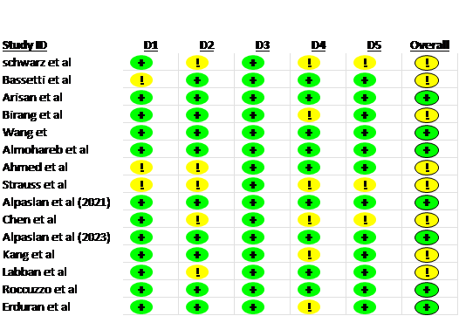

Low risk
Some concerns
High risk
D1 Randomization process
D2 Deviations from the intended interventions
D3 Missing outcome data
D4 Measurement of the outcome
D5 Selection of the reported result

Appendix Figure 2: Risk of Bias Summary (RoB 2.0).

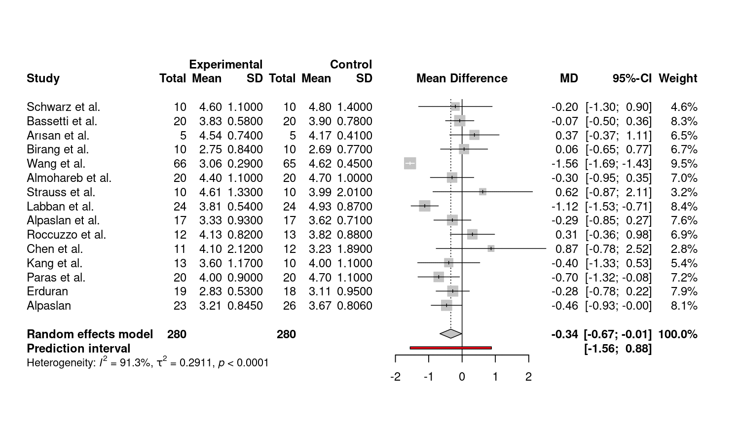

Appendix Figure 3: Forest Plot - Probing Depth (PD).

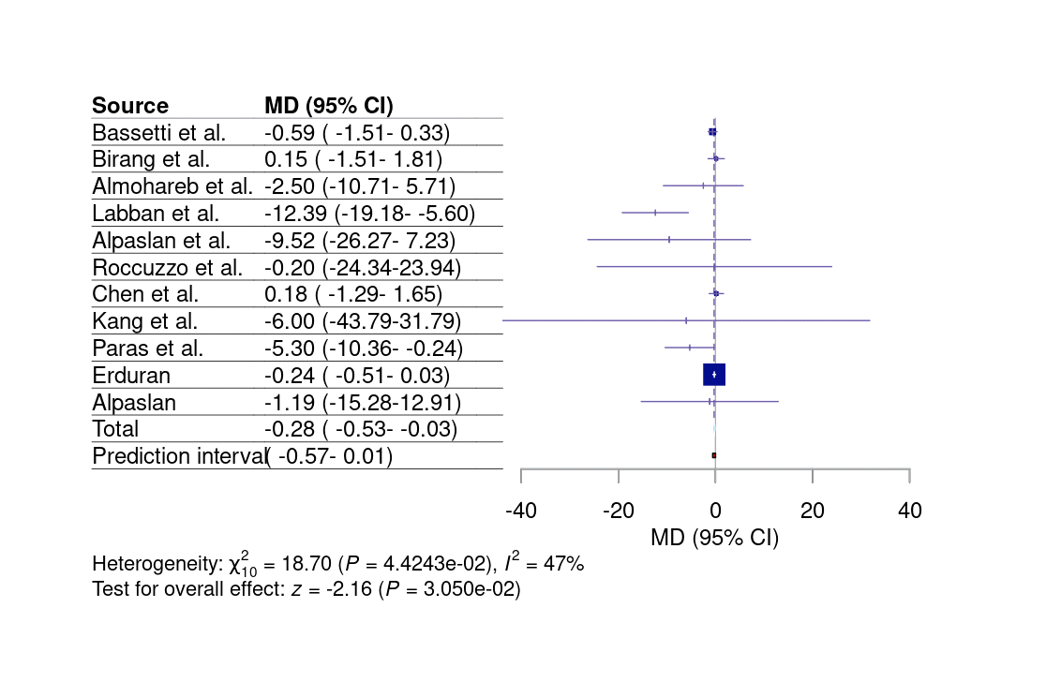

Appendix Figure 4: Forest Plot - Bleeding on Probing (BOP).

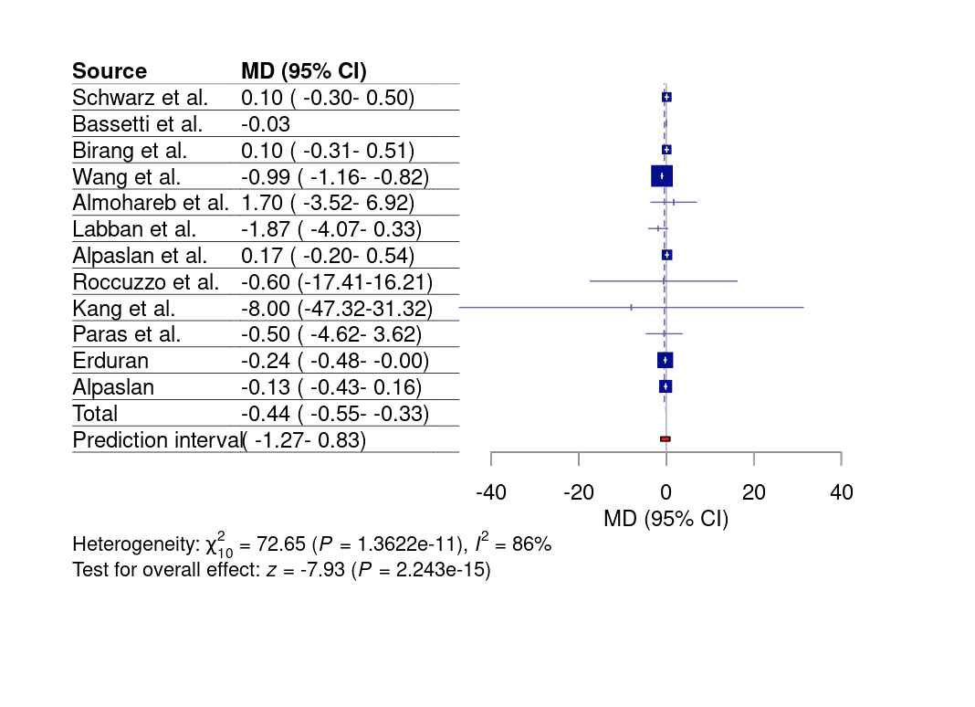
Appendix Figure 5: Forest Plot - Plaque Index (PI).

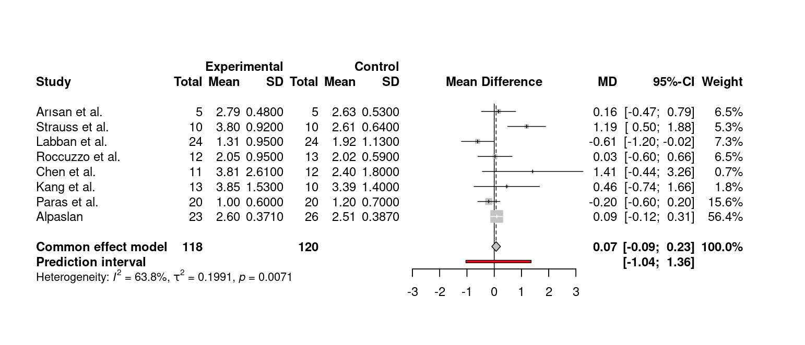
Appendix Figure 6: Forest Plot - Radiographic Marginal Bone Loss (RMBL).

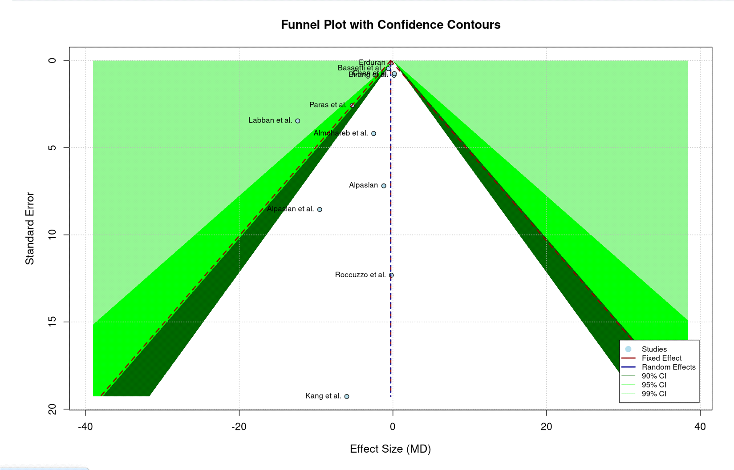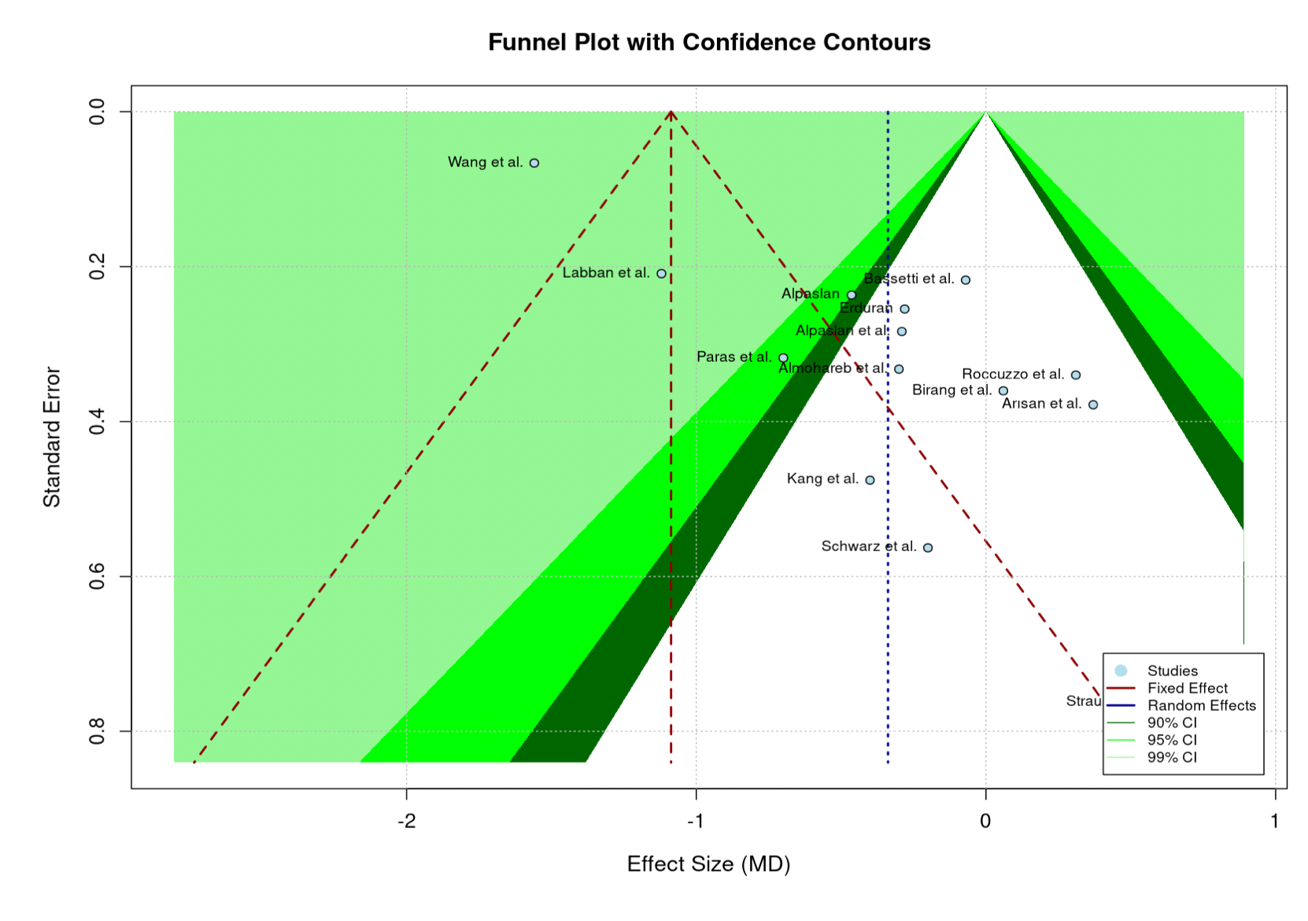

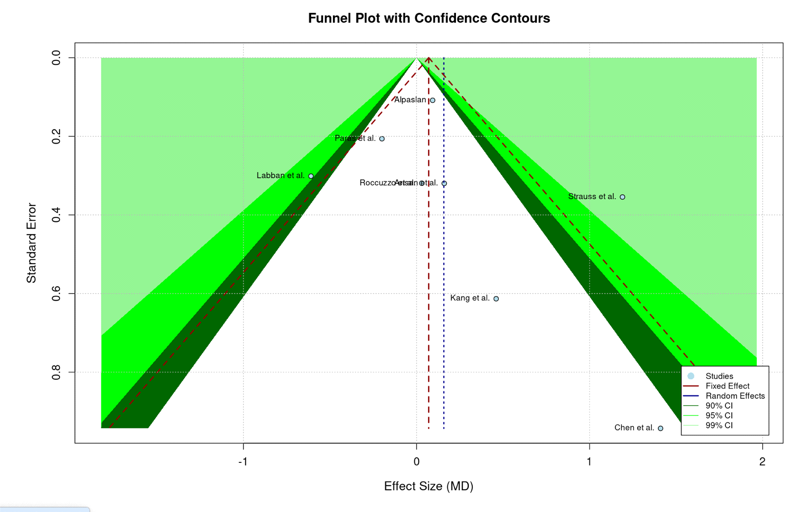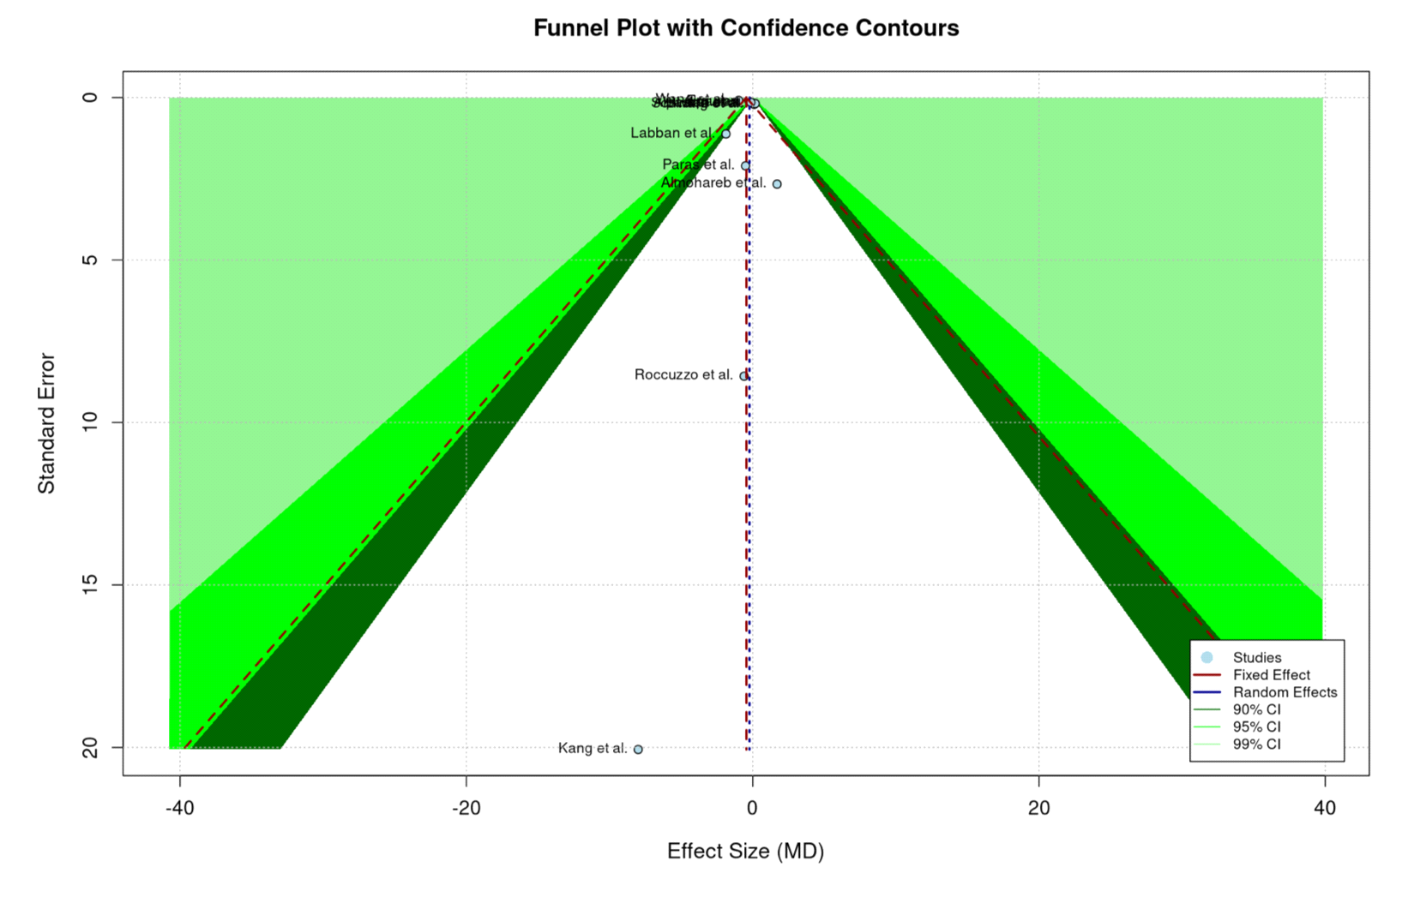

Appendix figure 7: Funnel plot for publication bias for the included outcomes. A: Bleeding on probing B: Probing pocket depth, C: Radiographic marginal bone loss D: Plaque index

Study | PI | BOP | PD | CAL | MBL | Conclusion
schwarz et al (2005)(11) | 1.1±0.4/ 1±0.5 | 31/58* | 4.6±1.1/  4.8±1.4 | 5.1±0.9/ 5.6±1.4 |  | Er:YAG irradiation resulted in statistically significant reduction of BOP
Bassetti et al (2014)(18) | 0±0 /  0.03±0.15 | 1.5±1.4/  2.1±1.6 | 3.83±0.6/  3.9±0.8 | 2.5±0.8/  2.5±0.6 |  | Mechanical debridment with adjunctive PDT is equally effective as adjunctive minocycline microspheres
Arisan et al (2015)(19) |  |  | 4.5±0.7/  4.17±0.4 |  | 2.8±0.5/  2.6±0.5* | Adjunctive diode laser did not yield additional positive effect
Wang et al (2019)(8) |  |  | 3.1±0.3/  4.6±0.3* | 1.3±0.4/  1.5±0.7 |  | Adjunctive PDT with MD significantly improved PD, PI, and SBI and better CAL than MD alone
Almohareb et al (2020)(21) | 21.8±9.1/  20.1±7.7 | 27.2±13.3/  29.7±13.2 | 4.4±1.1/  4.7±1 |  |  | PDT was equally effective to antimicrobial therapy in reducing periimplantitis
Ahmed et al (2020)(22) | 13.7±6.8/  14.2±6.5 | 14.5±6.7  /19.8±9.4* | 4.0±0.9/  4.7±1.1* |  | 1.0±0.6/  1.2±0.7 | PDT application improved the clinical, radiographic and immunological parameters in treatment of periimplantitis
Alpaslan et al (2022)(24) | Diode:1.1±0.6/ Er,Cr:YSGG: 1.1±0.4/  Control:1±0.7 | Diode:61.9±29.4/ Er,Cr:YSGG: 61.9±29.4/  Control:60.7±29.1 | Diode:3.3±1/ Er,Cr:YSGG: 3.3±0.9/  Control:3.6±0.7 |  |  | Diode laser did not add any additional benefit, Er,Cr:YSGG was more effective at clinical and molecular levels.
Labban et al (2021)(16) | 15.2±3.8/  17.1±4.01 | 19.2±5.98/  31.59±15.89 | 3.81±0.54/  4.93±0.87* |  | 1.3±0.9/  1.9±1.1* | Multiple application of PDT improved clinical and microbial parameters among diabetic II patients
Chen et al (2022)(25) |  | 2.8±1.9/  2.7±1.6 | 4.1±2.1/  3.2±1.9 |  | 3.8±2.6/  2.4±1.8 | Both laser and mechanical debridement led to significant improvement in PD
Roccuzzo et al (2022)(26) | 9.7±13.2/  10.3±27.7 | 47.2±33.3/  47.4±27.9 | 4.13±0.8/  3.8±0.9 |  | 2.1±0.9/  2.0±0.6 | Repeated adjunctive diode laser application failed to provide significant benefits compared to MD alone
Alpaslan et al (2024)(27) | 0.84±0.5/  0.78±0.6 | 39.1±30.3/  27.9±23.1* | 1.01±0.6/  0.6±0.5* |  | 2.6±0.4/  2.5±0.4 | The laser group yielded more favorable results by reducing the clinical inflammation and biomarkers
Erduran et al (2024)(28) | 0.1±0.16/  0.3±0.5 | 0.12±0.3/ 0.36±0.5 | 2.8±0.5/  3.1±0.95 |  |  | Diode laser seems to be a reliable tool for supporting MD in treatment of periimplantitis
Appendix Table 2: Results of clinical /radiographic outcomes from the included studies at approximately “6 months”; Test group/Control group, and drawn conclusions

Outcome | No. of Studies (Patients/Implants) | Effect Size (MD, 95% CI) | Risk of Bias | Inconsistency () | Imprecision | Overall Certainty
Probing Depth (PD) | 15 (644/742) | -0.34 mm [-0.67, -0.01] | Low/Some Concerns | Very Serious () | Not Serious | low
Bleeding on Probing (BOP) | 11 (480/550) | -0.28 [-0.53, -0.03] | Low/Some Concerns | Serious () | Not Serious | MODERATE
Plaque Index (PI) | 12 (520/600) | -0.44 [-0.55, -0.33] | Low/Some Concerns | Very Serious () | Not Serious | low
Marginal Bone Loss (RMBL) | 8 (320/380) | 0.16 mm [-0.24, 0.55] | Low/Some Concerns | Serious () | Serious (Wide CI) | LOW

Appendix Table 3: Quality Assessment of the evidence. GRADE Summary of Findings for Adjunctive Laser Therapy in Non-Surgical Peri-implantitis Treatment.

