Supplementary Materials
Appendix A: Search strategies
Table A.1: Search strategies
Database | Keywords | Search level | Final hits
PubMed | (((((((((((("Energy Intake"[Mesh]) OR ("Caloric Intake"[Title/Abstract] OR "Caloric Restriction"[Title/Abstract] OR "Diet,Food,and,Nutrition"[Title/Abstract] OR "food choices"[Title/Abstract])) OR (("Vegetables"[Mesh]) OR ("vegetable serving"[Title/Abstract] OR " vegetable consumption"[Title/Abstract] OR "Diet,Food,and,Nutrition"[Title/Abstract]))) OR (("Dietary Fiber"[Mesh]) OR ("Fibers, Dietary"[Title/Abstract] OR "Carbohydrates"[Title/Abstract] OR "Dietary Carbohydrates"[Title/Abstract]))) OR (("Nutritional Requirements"[Mesh]) OR ("Nutritional Requirement"[Title/Abstract] OR "Requirements, Dietary"[Title/Abstract] OR "Nutritional Sciences"[Title/Abstract]))) OR ((("Feeding Behavior"[Mesh])) OR ("Feeding-Related Behavior"[Title/Abstract] OR "Eating Behaviors"[Title/Abstract] OR "Feeding Patterns"[Title/Abstract]))) OR (("Portion Size"[Mesh]) OR (Diet, Food,[Title/Abstract] AND Nutrition[Title/Abstract] OR self-selected portion[Title/Abstract]))) OR (("Diet"[Mesh]) OR ("Carbohydrate-Restricted"[Title/Abstract] OR "Dietary Patterns"[Title/Abstract]))) OR (("Serving Size"[Mesh]) OR ("portion control"[Title/Abstract] OR "food portion"[Title/Abstract]))) OR (("Health Education"[Mesh]) OR ("Health Promotion"[Title/Abstract] OR "Weight Reduction ProgramS"[Title/Abstract] OR "Health Knowledge"[Title/Abstract] OR "Attitude to Health"[Title/Abstract]))) OR (("Health Behavior"[Mesh]) OR ("Health-Related Behavior"[Title/Abstract] OR "Health-Promoting Behaviors"[Title/Abstract]))) OR (((((("Dyslipidemias"[Mesh]) OR (Hyperlipidemias[Title/Abstract])) OR (("Waist Circumference"[Mesh]) OR ("Waist-Hip Ratio"[Title/Abstract] OR "Circumferences, Waist"[Title/Abstract]))) OR (("Blood Glucose"[Mesh]) OR ("Glycemic Index"[Title/Abstract] OR "Blood Sugar"[Title/Abstract] OR "Hyperglycemia"[Title/Abstract]))) OR (("Blood Pressure"[Mesh]) OR ("Ankle Brachial Index"[Title/Abstract] OR "Blood Pressure"[Title/Abstract] OR "Monitoring, Ambulatory"[Title/Abstract]))) OR (("Body Mass Index"[Mesh]) OR ("Quetelet's Index"[Title/Abstract] OR "Body Weights and Measures"[Title/Abstract] OR "Body Weight"[Title/Abstract] OR "Index, Body Mass"[Title/Abstract])))) AND ((("Adult"[Mesh]) OR ("Middle Aged"[Title/Abstract] OR "Young Adult"[Title/Abstract] OR "Aged"[Title/Abstract] OR "Patients"[Title/Abstract] OR "Frail Elderly"[Title/Abstract])) AND ("Tableware"[Title/Abstract] OR "portion control plate"[Title/Abstract] OR "portion size"[Title/Abstract] OR "self-selected portion"[Title/Abstract] OR "serving size"[Title/Abstract] OR "healthy eating plate"[Title/Abstract] OR "myplate"[Title/Abstract] OR "portion control"[Title/Abstract])) | Title/Abstract/MeSH Terms | 1028
Embase | (((((((((((("Energy Intake"[Mesh]) OR ("Caloric Intake"[Title/Abstract] OR "Caloric Restriction"[Title/Abstract] OR "Diet,Food,and,Nutrition"[Title/Abstract] OR "food choices"[Title/Abstract])) OR (("Vegetables"[Mesh]) OR ("vegetable serving"[Title/Abstract] OR " vegetable consumption"[Title/Abstract] OR "Diet,Food,and,Nutrition"[Title/Abstract]))) OR (("Dietary Fiber"[Mesh]) OR ("Fibers, Dietary"[Title/Abstract] OR "Carbohydrates"[Title/Abstract] OR "Dietary Carbohydrates"[Title/Abstract]))) OR (("Nutritional Requirements"[Mesh]) OR ("Nutritional Requirement"[Title/Abstract] OR "Requirements, Dietary"[Title/Abstract] OR "Nutritional Sciences"[Title/Abstract]))) OR ((("Feeding Behavior"[Mesh])) OR ("Feeding-Related Behavior"[Title/Abstract] OR "Eating Behaviors"[Title/Abstract] OR "Feeding Patterns"[Title/Abstract]))) OR (("Portion Size"[Mesh]) OR (Diet, Food,[Title/Abstract] AND Nutrition[Title/Abstract] OR self-selected portion[Title/Abstract]))) OR (("Diet"[Mesh]) OR ("Carbohydrate-Restricted"[Title/Abstract] OR "Dietary Patterns"[Title/Abstract]))) OR (("Serving Size"[Mesh]) OR ("portion control"[Title/Abstract] OR "food portion"[Title/Abstract]))) OR (("Health Education"[Mesh]) OR ("Health Promotion"[Title/Abstract] OR "Weight Reduction ProgramS"[Title/Abstract] OR "Health Knowledge"[Title/Abstract] OR "Attitude to Health"[Title/Abstract]))) OR (("Health Behavior"[Mesh]) OR ("Health-Related Behavior"[Title/Abstract] OR "Health-Promoting Behaviors"[Title/Abstract]))) OR (((((("Dyslipidemias"[Mesh]) OR (Hyperlipidemias[Title/Abstract])) OR (("Waist Circumference"[Mesh]) OR ("Waist-Hip Ratio"[Title/Abstract] OR "Circumferences, Waist"[Title/Abstract]))) OR (("Blood Glucose"[Mesh]) OR ("Glycemic Index"[Title/Abstract] OR "Blood Sugar"[Title/Abstract] OR "Hyperglycemia"[Title/Abstract]))) OR (("Blood Pressure"[Mesh]) OR ("Ankle Brachial Index"[Title/Abstract] OR "Blood Pressure"[Title/Abstract] OR "Monitoring, Ambulatory"[Title/Abstract]))) OR (("Body Mass Index"[Mesh]) OR ("Quetelet's Index"[Title/Abstract] OR "Body Weights and Measures"[Title/Abstract] OR "Body Weight"[Title/Abstract] OR "Index, Body Mass"[Title/Abstract])))) AND ((("Adult"[Mesh]) OR ("Middle Aged"[Title/Abstract] OR "Young Adult"[Title/Abstract] OR "Aged"[Title/Abstract] OR "Patients"[Title/Abstract] OR "Frail Elderly"[Title/Abstract])) AND ("Tableware"[Title/Abstract] OR "portion control plate"[Title/Abstract] OR "portion size"[Title/Abstract] OR "self-selected portion"[Title/Abstract] OR "serving size"[Title/Abstract] OR "healthy eating plate"[Title/Abstract] OR "myplate"[Title/Abstract] OR "portion control"[Title/Abstract])) | Title/Abstract/Keywords | 1459
Web of Science | (((((((((((("Energy Intake"[Mesh]) OR ("Caloric Intake"[Title/Abstract] OR "Caloric Restriction"[Title/Abstract] OR "Diet,Food,and,Nutrition"[Title/Abstract] OR "food choices"[Title/Abstract])) OR (("Vegetables"[Mesh]) OR ("vegetable serving"[Title/Abstract] OR " vegetable consumption"[Title/Abstract] OR "Diet,Food,and,Nutrition"[Title/Abstract]))) OR (("Dietary Fiber"[Mesh]) OR ("Fibers, Dietary"[Title/Abstract] OR "Carbohydrates"[Title/Abstract] OR "Dietary Carbohydrates"[Title/Abstract]))) OR (("Nutritional Requirements"[Mesh]) OR ("Nutritional Requirement"[Title/Abstract] OR "Requirements, Dietary"[Title/Abstract] OR "Nutritional Sciences"[Title/Abstract]))) OR ((("Feeding Behavior"[Mesh])) OR ("Feeding-Related Behavior"[Title/Abstract] OR "Eating Behaviors"[Title/Abstract] OR "Feeding Patterns"[Title/Abstract]))) OR (("Portion Size"[Mesh]) OR (Diet, Food,[Title/Abstract] AND Nutrition[Title/Abstract] OR self-selected portion[Title/Abstract]))) OR (("Diet"[Mesh]) OR ("Carbohydrate-Restricted"[Title/Abstract] OR "Dietary Patterns"[Title/Abstract]))) OR (("Serving Size"[Mesh]) OR ("portion control"[Title/Abstract] OR "food portion"[Title/Abstract]))) OR (("Health Education"[Mesh]) OR ("Health Promotion"[Title/Abstract] OR "Weight Reduction ProgramS"[Title/Abstract] OR "Health Knowledge"[Title/Abstract] OR "Attitude to Health"[Title/Abstract]))) OR (("Health Behavior"[Mesh]) OR ("Health-Related Behavior"[Title/Abstract] OR "Health-Promoting Behaviors"[Title/Abstract]))) OR (((((("Dyslipidemias"[Mesh]) OR (Hyperlipidemias[Title/Abstract])) OR (("Waist Circumference"[Mesh]) OR ("Waist-Hip Ratio"[Title/Abstract] OR "Circumferences, Waist"[Title/Abstract]))) OR (("Blood Glucose"[Mesh]) OR ("Glycemic Index"[Title/Abstract] OR "Blood Sugar"[Title/Abstract] OR "Hyperglycemia"[Title/Abstract]))) OR (("Blood Pressure"[Mesh]) OR ("Ankle Brachial Index"[Title/Abstract] OR "Blood Pressure"[Title/Abstract] OR "Monitoring, Ambulatory"[Title/Abstract]))) OR (("Body Mass Index"[Mesh]) OR ("Quetelet's Index"[Title/Abstract] OR "Body Weights and Measures"[Title/Abstract] OR "Body Weight"[Title/Abstract] OR "Index, Body Mass"[Title/Abstract])))) AND ((("Adult"[Mesh]) OR ("Middle Aged"[Title/Abstract] OR "Young Adult"[Title/Abstract] OR "Aged"[Title/Abstract] OR "Patients"[Title/Abstract] OR "Frail Elderly"[Title/Abstract])) AND ("Tableware"[Title/Abstract] OR "portion control plate"[Title/Abstract] OR "portion size"[Title/Abstract] OR "self-selected portion"[Title/Abstract] OR "serving size"[Title/Abstract] OR "healthy eating plate"[Title/Abstract] OR "myplate"[Title/Abstract] OR "portion control"[Title/Abstract])) | Topic Search (Title, Abstract, Author Keywords, Keywords Plus) | 539
SciVerse Scopus | (((((((((((("Energy Intake"[Mesh]) OR ("Caloric Intake"[Title/Abstract] OR "Caloric Restriction"[Title/Abstract] OR "Diet,Food,and,Nutrition"[Title/Abstract] OR "food choices"[Title/Abstract])) OR (("Vegetables"[Mesh]) OR ("vegetable serving"[Title/Abstract] OR " vegetable consumption"[Title/Abstract] OR "Diet,Food,and,Nutrition"[Title/Abstract]))) OR (("Dietary Fiber"[Mesh]) OR ("Fibers, Dietary"[Title/Abstract] OR "Carbohydrates"[Title/Abstract] OR "Dietary Carbohydrates"[Title/Abstract]))) OR (("Nutritional Requirements"[Mesh]) OR ("Nutritional Requirement"[Title/Abstract] OR "Requirements, Dietary"[Title/Abstract] OR "Nutritional Sciences"[Title/Abstract]))) OR ((("Feeding Behavior"[Mesh])) OR ("Feeding-Related Behavior"[Title/Abstract] OR "Eating Behaviors"[Title/Abstract] OR "Feeding Patterns"[Title/Abstract]))) OR (("Portion Size"[Mesh]) OR (Diet, Food,[Title/Abstract] AND Nutrition[Title/Abstract] OR self-selected portion[Title/Abstract]))) OR (("Diet"[Mesh]) OR ("Carbohydrate-Restricted"[Title/Abstract] OR "Dietary Patterns"[Title/Abstract]))) OR (("Serving Size"[Mesh]) OR ("portion control"[Title/Abstract] OR "food portion"[Title/Abstract]))) OR (("Health Education"[Mesh]) OR ("Health Promotion"[Title/Abstract] OR "Weight Reduction ProgramS"[Title/Abstract] OR "Health Knowledge"[Title/Abstract] OR "Attitude to Health"[Title/Abstract]))) OR (("Health Behavior"[Mesh]) OR ("Health-Related Behavior"[Title/Abstract] OR "Health-Promoting Behaviors"[Title/Abstract]))) OR (((((("Dyslipidemias"[Mesh]) OR (Hyperlipidemias[Title/Abstract])) OR (("Waist Circumference"[Mesh]) OR ("Waist-Hip Ratio"[Title/Abstract] OR "Circumferences, Waist"[Title/Abstract]))) OR (("Blood Glucose"[Mesh]) OR ("Glycemic Index"[Title/Abstract] OR "Blood Sugar"[Title/Abstract] OR "Hyperglycemia"[Title/Abstract]))) OR (("Blood Pressure"[Mesh]) OR ("Ankle Brachial Index"[Title/Abstract] OR "Blood Pressure"[Title/Abstract] OR "Monitoring, Ambulatory"[Title/Abstract]))) OR (("Body Mass Index"[Mesh]) OR ("Quetelet's Index"[Title/Abstract] OR "Body Weights and Measures"[Title/Abstract] OR "Body Weight"[Title/Abstract] OR "Index, Body Mass"[Title/Abstract])))) AND ((("Adult"[Mesh]) OR ("Middle Aged"[Title/Abstract] OR "Young Adult"[Title/Abstract] OR "Aged"[Title/Abstract] OR "Patients"[Title/Abstract] OR "Frail Elderly"[Title/Abstract])) AND ("Tableware"[Title/Abstract] OR "portion control plate"[Title/Abstract] OR "portion size"[Title/Abstract] OR "self-selected portion"[Title/Abstract] OR "serving size"[Title/Abstract] OR "healthy eating plate"[Title/Abstract] OR "myplate"[Title/Abstract] OR "portion control"[Title/Abstract])) | Article title, Abstract, Keywords | 1036
Cochrane library | (((((((((((("Energy Intake"[Mesh]) OR ("Caloric Intake"[Title/Abstract] OR "Caloric Restriction"[Title/Abstract] OR "Diet,Food,and,Nutrition"[Title/Abstract] OR "food choices"[Title/Abstract])) OR (("Vegetables"[Mesh]) OR ("vegetable serving"[Title/Abstract] OR " vegetable consumption"[Title/Abstract] OR "Diet,Food,and,Nutrition"[Title/Abstract]))) OR (("Dietary Fiber"[Mesh]) OR ("Fibers, Dietary"[Title/Abstract] OR "Carbohydrates"[Title/Abstract] OR "Dietary Carbohydrates"[Title/Abstract]))) OR (("Nutritional Requirements"[Mesh]) OR ("Nutritional Requirement"[Title/Abstract] OR "Requirements, Dietary"[Title/Abstract] OR "Nutritional Sciences"[Title/Abstract]))) OR ((("Feeding Behavior"[Mesh])) OR ("Feeding-Related Behavior"[Title/Abstract] OR "Eating Behaviors"[Title/Abstract] OR "Feeding Patterns"[Title/Abstract]))) OR (("Portion Size"[Mesh]) OR (Diet, Food,[Title/Abstract] AND Nutrition[Title/Abstract] OR self-selected portion[Title/Abstract]))) OR (("Diet"[Mesh]) OR ("Carbohydrate-Restricted"[Title/Abstract] OR "Dietary Patterns"[Title/Abstract]))) OR (("Serving Size"[Mesh]) OR ("portion control"[Title/Abstract] OR "food portion"[Title/Abstract]))) OR (("Health Education"[Mesh]) OR ("Health Promotion"[Title/Abstract] OR "Weight Reduction ProgramS"[Title/Abstract] OR "Health Knowledge"[Title/Abstract] OR "Attitude to Health"[Title/Abstract]))) OR (("Health Behavior"[Mesh]) OR ("Health-Related Behavior"[Title/Abstract] OR "Health-Promoting Behaviors"[Title/Abstract]))) OR (((((("Dyslipidemias"[Mesh]) OR (Hyperlipidemias[Title/Abstract])) OR (("Waist Circumference"[Mesh]) OR ("Waist-Hip Ratio"[Title/Abstract] OR "Circumferences, Waist"[Title/Abstract]))) OR (("Blood Glucose"[Mesh]) OR ("Glycemic Index"[Title/Abstract] OR "Blood Sugar"[Title/Abstract] OR "Hyperglycemia"[Title/Abstract]))) OR (("Blood Pressure"[Mesh]) OR ("Ankle Brachial Index"[Title/Abstract] OR "Blood Pressure"[Title/Abstract] OR "Monitoring, Ambulatory"[Title/Abstract]))) OR (("Body Mass Index"[Mesh]) OR ("Quetelet's Index"[Title/Abstract] OR "Body Weights and Measures"[Title/Abstract] OR "Body Weight"[Title/Abstract] OR "Index, Body Mass"[Title/Abstract])))) AND ((("Adult"[Mesh]) OR ("Middle Aged"[Title/Abstract] OR "Young Adult"[Title/Abstract] OR "Aged"[Title/Abstract] OR "Patients"[Title/Abstract] OR "Frail Elderly"[Title/Abstract])) AND ("Tableware"[Title/Abstract] OR "portion control plate"[Title/Abstract] OR "portion size"[Title/Abstract] OR "self-selected portion"[Title/Abstract] OR "serving size"[Title/Abstract] OR "healthy eating plate"[Title/Abstract] OR "myplate"[Title/Abstract] OR "portion control"[Title/Abstract])) | Article title, Abstract, Keywords | 897
CKNI | 餐盘 + 餐具 + 健康餐盘 and 成人 + 患者 + 青少年 + 产妇 + 老年 and 饮食 + 行为 + 代谢指标 + 食物选择 + 摄入量 + 体重 + 营养 + 健康 + 血糖 | Article title, Abstract, Keywords | 508
VIP | 餐盘 or 餐具 or 健康餐盘 and 成人 or 患者 or 青少年 or 产妇 or 老年 and 饮食 or 行为 or 代谢指标 or 食物选择 or 摄入量 or 体重 or 营养 or 健康 or 血糖 | Article title, Abstract, Keywords | 1636
Wanfang | 餐盘 or 餐具 or 健康餐盘 and 成人 or 患者 or 青少年 or 产妇 or 老年 and 饮食 or 行为 or 代谢指标 or 食物选择 or 摄入量 or 体重 or 营养 or 健康 or 血糖 | Article title, Abstract, Keywords | 187
Search limits: species (“humans”), language (“English、Chinese”), publication type (“journal articles”), and type (“randomized controlled trial”).

Appendix B: Study characteristics
Table B.1: Overview of the 14 publications included in this review
Author/Year/Country | Population | Age (year) | Sample Size |  |  | Intervention Group Intervention | Control Group Intervention | Intervention Period | Intervention Tool Description | Theoretical Basis
Author/Year/Country | Population | Age (year) | Total  (n) | Intervention  (n) | Control  (n)
Yamauchi, 2014,Japan | Patients with type 2 diabetes who are overweight or obese | 20–70 | 19 | 10 | 9 | A monthly 3.5-hour nutrition course (three sessions in total), including lunch served on a portion-control plate to encourage all-day use. | Accepts only diabetes awareness lectures and dietary advice | 3-month intervention, 3-month follow-up | Four-colour printed portion control grid (1/2 vegetables, 1/6 rice/pasta, 2/6 fish/meat/nuts), each section ≈ 80 kcal exchange portion | Social cognitive theory
Hube, 2015,United States | Primary care outpatients with obesity (BMI 30–39.9 kg/m²) | 18–55 | 90 | 45 | 45 | Remote telephone support (seven 20-minute sessions fortnightly), including delivery of portion-control plates and an instruction manual. | Accepts only the ‘Healthy Eating and Exercise’ booklet issued by the organisation | 3-month intervention, 6-month follow-up | 21cm diameter plate with accompanying instructions guiding ‘half fruit and vegetables, one quarter protein, one quarter carbohydrates’. | Social cognitive theory
Kesman, 2011,United States | Primary care outpatients with obesity (BMI 30–<40 kg/m²) | 18–75 | 65 | 33 | 32 | 60-min initial dietitian consult; phone/email follow-up at 1, 3, 5 months; largest meal must use plate, all-day use encouraged. | Accepts only leaflets on healthy weight and lifestyle changes | 6-month intervention, 6-month follow-up | Plate printed with three zones (½ vegetables, ¼ fish/lean meat/chicken/nuts, ¼ potatoes/pasta/rice/  beans/whole grains), bowl marked with ⅓−½−1 cup measurements. | Cognitive-behavioural theory
Pedersen, 2007,Canada | Patients with obesity and type 2 diabetes | 31−77 | 130 | 65 | 65 | 15-minute meal plate usage guidance, with four daily telephone reminders; the largest meal must use the plate, with no additional compensation for eating permitted. | Nutritionist-guided food exchange portions + calorie estimation | 6-month intervention | 9-inch gender-specific meal plate (male portion ≈ 800 kcal, female portion ≈ 650 kcal), featuring compartmentalised sections (carbohydrates, protein, cheese/sauce, remaining vegetables). | Diabetes Self-Management Theory
Long, 2025,China | Patients with obesity and type 2 diabetes | 18−59 | 148 | 73 | 75 | 4×45-minute group guidance sessions, requiring at least one daily use of the portion control plate with meal photos uploaded. | Guidance on using food scales, measuring cups, label calorie checks, and exchange portion calculations | 1-month intervention, 6-month follow-up | ½ green-based vegetable compartment + ¼ orange-based protein compartment + ¼ lightning-oil-drop carbohydrate compartment, featuring raised partitions and oil drainage channels | Nudge Theory  Dual-Process Model
Jayawardena,2019,Sri Lanka | Patients in the recovery phase following myocardial infarction | 20−70 | 120 | 60 | 60 | Use the plate alongside the food poster; apply to at least two daily rice-based meals. | Standard cardiac rehabilitation guidance only (nutrition education + exercise + psychological support) | 3-month intervention | ¼ portion of rice, ¼portion of egg whites, ½portion of non-starchy vegetables (subdivided into three sections: green leafy salad + two types of vegetables) | Cardiac Rehabilitation Theory
Leung, 2025,Taiwan, China | Patients with type 2 diabetes | ≥20 | 94 | 47 | 47 | Dietitians provide dietary education and instruct on meal plate usage, requiring its use at every meal where possible and recording frequency of use. | Dietitian-led dietary education (food exchange portions + carbohydrate counting + individualised calorie calculation) | 12-month intervention | Four-compartment portion plate (large compartment: 230mL unlimited vegetables, 3×50mL small compartments for protein) + 300mL calibrated bowl (carbohydrates/fruit) + 370mL calibrated cup (dairy) + 15mL measuring spoon (oil/nuts); paired with food exchange method | Diabetes ABC Target Theory Food Exchange Theory
Zhang, 2022,China | Patients with type 2 diabetes | 18–65 | 419 | 210 | 209 | Daily use of the meal plate alongside monthly dietary education and medical follow-ups by dietitians, with distribution of colour-coded low-literacy manuals. | Traditional carbohydrate counting method: paper manual + monthly dietitian guidance + medical follow-ups. | 12-month intervention | ½ Low-carbohydrate vegetables, ¼ Starchy foods, ¼ Fish/poultry/meat/eggs | Medical Nutrition Therapy Theory
Bowen, 2016,United States | Patients with type 2 diabetes | 18−85 | 100 | 50 | 50 | Three 30–60 minute face-to-face dietary education sessions, utilising portion control plates and personalised carbohydrate measuring bowls/cups for meals | 3 sessions of general health education | 3-month intervention, 6-month follow-up | 9-inch plate, ½ plate non-starchy vegetables, ¼ plate protein, ¼ plate carbohydrates | Diabetes self-management education and support theory Food exchange theory
Li Peng, 2020,China | Patients with type 2 diabetes | 50−70 | 117 | 59 | 58 | Use portion control plates and reference tables to manage total food servings | Standard diabetes dietary education | 12-month intervention | Plate divided into four sections with engraved markings | Not specified
Yang Wanqi, 2016,China | Patients with type 2 diabetes | 45−78 | 134 | 67 | 67 | Employ portion control plates combined with the palm method alongside six 60-minute dietary education sessions monthly | Standard diabetes dietary education | 6-month intervention | Plate divided into: ¼ for grains/starchy foods, 1/4 for meat/eggs/dairy, ½ for vegetables/fruit (vegetables predominant, minimal fruit) | Not specified
Shi Zhaowei, 2021, China | Patients with type 2 diabetes | 30−65 | 76 | 37 | 39 | Use portion control plate combined with standard dietary education; ≥80% usage required for lunch/dinner | Standard diabetes dietary education | 6-month intervention | Plate features 7 portion-control indentations (vegetables, mixed meat/veg, meat, tofu/beans, rice, spoon, chopsticks). Vegetable section base includes drainage holes for oil/salt separation. Rice compartment inner wall marked with portion graduations | Food exchange theory
Yu Zhiying,  2021,China | Patients with type 2 diabetes | 31−70 | 105 | 52 | 53 | Healthcare staff provide daily guidance on using the grooved plate for portion control + reference chart method to manage total exchange servings; plates are gifted upon discharge. | Standard diabetes dietary education | 1-weekend intervention, 3-month follow-up | The plate is divided into four equal wedge-shaped sections, with the edge engraved with corresponding food category names and food exchange portions. For example: ¼ section labelled ‘2 portions of grains and starchy vegetables’ ¼ section labelled ‘1 portion of lean meat, fish, eggs and beans’ ½ section labelled ‘0.5 portion of leafy, stem and fruit vegetables’ + ‘a small portion of fruit’” | Food exchange theory
Montevirge,  2021,Philip  pines | Patients with type 2 diabetes | 22−68 | 148 | 75 | 73 | Nutrition education using the Filipino Plate Method (a visual proportion-guide plate) | Standard nutrition education based on ADA guidelines | 1-day intervention, 12-month follow-up | The Filipino Plate Method is a proportion-guide plate—a visual tool dividing a standard 9-inch plate into sections for different food groups (vegetables, carbohydrates, protein, fruits) to guide portion choices without precise quantification. | Not specified

Table B.2:Exclusion List
No. | First Author (Year) PMID/DOI | Article Title | Reason for Exclusion (PICOS) | Notes
1 | Yiyun Zhang, 2024  DOI: 10.1016/j.physbeh.2023.114412 | The specially designed nudging tableware promotes healthy food choices:  Evidence from a randomized crossover trial in normal-weight young adults | P | Not suitable for individuals with chronic conditions
2 | Lillian Gelberg, 2019  DOI:10.1186/s12889-019-7294-z | Comparative effectiveness trial comparing MyPlate to calorie counting for mostly low-income Latino primary care patients of a federally qualified community health center: study design, baseline characteristics | C | The control group did not receive a conventional dietary education programme.
3 | Maxine A Sharps, 2019 DOI: 10.1016/j.appet.2019.104457 | Using pictorial nudges of fruit and vegetables on tableware to increase children's fruit and vegetable consumption | P | Not suitable for individuals with chronic conditions
4 | Alessandra L Marcone, 2023 DOI: 10.1186/s40795-023-00764-3 | Effects of an educational planetary plate graphic on meat consumption in a Stanford University dining hall: a randomized controlled trial | P O | Not suitable for individuals with chronic conditions  Does not meet the outcome indicators
5 | M Ángeles Vargas-Alvarez, 2023 DOI: 10.1016/j.appet.2023.106542 | Portion control tableware differentially impacts eating behaviour in women with and without overweight | P | Not suitable for individuals with chronic conditions
6 | Joel W Hughes,2017  DOI:10.1186/s40608-017-0167-z | Controlled testing of novel portion control plate produces smaller self-selected portion sizes compared to regular dinner plate | O S | Non-compliance with resolution indicators and research design
7 | Roel C J Hermans, 2017 DOI: 10.1016/j.appet.2017.02.014 | The effect of real-time vibrotactile feedback delivered through an augmented fork on eating rate, satiation, and food intake | p | Not suitable for individuals with chronic conditions
8 | Gibson B Kagaruki,2023 DOI: 10.1371/journal.pone.0289289 | The effectiveness of interventions to reduce cardio-metabolic risk factors among regular street food consumers in Dar es Salaam, Tanzania: The pre-post findings from a cluster randomized trial (Registered by Pan African clinical trial registry with trial # PACTR202208642850935) | I | Intervention tools are not compliant
9 | Dirk F de Korne, 2017 DOI: 10.1017/jns.2017.60 | Effects of a portion design plate on food group guideline adherence among hospital staff | P S | Not suitable for individuals with chronic conditions  Not in line with the research design
10 | Bohnert A.M, 2011 DOI: 10.1016/j.jneb.2010.07.007 | The development and evaluation of a portion plate for youth: A pilot study | P O | Not suitable for individuals with chronic conditions  Does not meet the outcome indicators
11 | Aylin Ayaz, 2016  DOI:10.4162/nrp.2016.10.5.524 | Effect of plate size on meal energy intake in normal weight women | P | Whether the individual has a chronic medical condition has not been reported.
12 | M Shah, 2011 DOI: 10.1111/j.1365-277X.2011.01210.x | A pilot study to investigate the effect of plate size on meal energy intake in normal weight and overweight/obese women | P | The research subjects were not exclusively individuals with chronic illnesses.
13 | Barbara J Rolls, 2002 DOI: 10.1093/ajcn/76.6.1207 | Portion size of food affects energy intake in normal-weight and overweight men and women | p | The research subjects were not exclusively individuals with chronic illnesses.
14 | Rebecca M Puhl, 2022  DOI: 10.2337/cd20-0071 | Weight stigma and diabetes stigma: implications for weight-related health behaviors in adults with type 2 diabetes | I | Intervention tools are not compliant
15 | Ho J, 2016 DOI: 10.1177/2333794X16669014 | . Family Intervention for Obese/Overweight Children Using Portion Control Strategy (FOCUS) for Weight Control: A Randomized Controlled Trial. | P | Not suitable for individuals with chronic conditions
16 | Almiron-Roig E, 2016. DOI: 10.1017/S0007114516004104 | Acceptability and potential effectiveness of commercial portion control tools amongst people with obesity | O | Does not meet the outcome indicators
17 | Hughes J.W, 2017 DOI: 10.1186/s40608-017-0167-z | Controlled testing of novel portion control plate produces smaller self-selected portion sizes compared to regular dinner plate. | P | Not suitable for individuals with chronic conditions
18 | Fang Yuewei, 2019 | Design and Application of a Convenient Quantitative Diabetes Dietary Management Tool: The Healthy Plate Food Measurement and Proportion System. | S | Not in line with the research design
19 | Mu Lining, 2016 | Application of the Plate Method in Diabetes Dietary Health Education | S | Not in line with the research design
20 | Zhang Yajuan, 2009 | Evaluation of the Effect of Individualized and Quantitative Dietary Intervention on Blood Glucose Control in Community Patients with Type 2 Diabetes. | I | Intervention tools are not compliant
21 | Li Wei, 2023 | Effects of Alternate Fasting on Blood Glucose, Body Mass Index, and Blood Lipids in Overweight or Obese Patients with Type 2 Diabetes | I | Does not conform to the intervention method
22 | Pan Xiangdong, 2021 | Evaluation of the Application Effect of "Internet + Intelligent Plate" in the Diet Management of Patients with Type 2 Diabetes. | I | The article does not specify the type of plate, making it impossible to determine whether it is designed for portion control.
23 | Hu Yaying, 2016 | Application of a Food Model-Based Health Education Sheet in Diabetic Patients. | I | The intervention group did not actually use the meal trays.
24 | Wang Weijie, 2016 | Effect Analysis of Customized Plates on Improving the Nutritional Status of Elderly Living Alone | P | Not suitable for individuals with chronic conditions
25 | Wu Zhiheng,, 2018 | Effects of Different Dietary Intervention Models Combined with Traditional Chinese Medicine Nursing on Metabolic Indicators in Patients with Type 2 Diabetes. | I | Intervention tools are not compliant
26 | Chen,2018 | Effects of Different Dietary Approaches on Type 2 Diabetes Patients | C | The control group intervention measures were not compliant.
27 | Luo Baoyu 2019 | A Study on the Application of the Fixed-Portion Diet Method in the Dietary Management of Diabetes | S | Not a Randomised Controlled Trial
28 | R.Åsgård,E | High intake of fruit and vegetables is related to low oxidative stress and inflammation in a group of patients with type 2 diabetes |  | Unable to retrieve
29 | R. Taylor, K.M | 218-LB: remission of type 2 diabetes after weight loss in “normal” weight people—the ReTUNE study |  | Unable to retrieve
30 | Yang Guifang, 2019 | Application of the Plate Method in Dietary Health Education for Patients with Diabetes Mellitus |  | Unable to retrieve
31 | Tao Meihua, 2016 | Academic English Translation: Evaluation of the Efficacy of Nutritional Diet Plates in Dietary Therapy for Patients with Type 2 Diabetes Mellitus |  | Unable to retrieve
32 | He Ye 2020 | Academic English Translation: Observation on the Application Effect of the Fixed Plate Method in Dietary Therapy for Patients with Diabetes Mellitus |  | Unable to retrieve
Notes: Some Chinese publications do not have a DOI

Table B.3:Raw Data Extraction Table
Author/Year/Country | Continuous variable | Follow-up time (months) | Intervention group mean | Intervention group SD | Intervention group n | Control group mean | Control group SD | Control group n
Yamauchi,2014 | Weight  BMI  Waist circumference  SBP  DBP  HbA1c  TC  LDL  HDL  TG | 3  3  3  3  3  3  3  3  3  3 | 67.6  26.2  89.3  119.8  72.1  6.7  4.55  2.77  1.37  0.88 | 15.6  3.6  11.4  11.5  10.8  0.8  0.80  0.62  0.36  0.29 | 10  10  10  10  10  10  10  10  10  10 | 72.8  28.3  93.5  129.1  74.3  7.3  4.81  2.65¹  1.50  1.37 | 9.7  2.2  7.9  11.3  6.5  1.0  0.57  0.65  0.36  0.75 | 8  8  8  8  8  8  8  8  8  8
Huber,2015 | Weight  Weight  BMI  BMI  Waist circumference  Waist circumference | 3  6  3  6  3  6 | 97.4  97.0  35.2  35.1  105.4  104.5 | 12.7  12.3  3.5  3.5  8.1  8.4 | 38  37  38  37  38  36 | 102.6  102.5  36.2  36.1  110.5  109.6 | 18.0  18.0  3.9  4.0  12.2  12.5 | 40  39  40  39  39  39
Kesman,2011 | Weight  Weight | 3  6 | 96.1  96.6 | 11.6  11.6 | 33  33 | 98.4  98.3 | 11.7  11.1 | 32  32
Pedersen,2007 | weight  BMI  SBP  DBP  HbA1c  TC  TG  HDL  LDL | 6  6  6  6  6  6  6  6  6 | 103.1  38.3  133.7  78.6  7.75  4.54²  2.31²  1.28²  2.22² | 18.4  5.8  26.6  13.7  1.80  1.03²  1.03²  0.36²  0.63² | 65  65  59  59  65  65  65  65  65 | 106.0  38.8  127.8  75.3  7.48  4.75²  2.14²  1.21²  2.49² | 16.8  6.4  14.6  9.5  1.06  1.28²  1.45²  0.42²  0.83² | 65  65  60  60  65  65  65  65  65
Long,2025 | HbA1c  FPG  TC  TG  LDL  HDL  BMI  Total calorie  Carbohydrate  Protein  Lipid  Vegetable intake | 6  6  6  6  6  6  6  6  6  6  6  6 | 6.95  7.63  4.62  1.99  3.03  1.27  27.46  1284.35  157.17  53.89  37.37  350.09 | 1.74  3.08  1.13  2.88  0.98  0.85  4.56  434.72  48.88  20.49  19.55  80.86 | 73  73  73  73  73  73  73  73  73  73  73  73 | 7.74  8.42  4.87  2.29  3.15  1.43  27.72  1757.70  233.95  65.70  54.47  216.88 | 1.73  2.47  1.13  1.31  0.95  0.42  3.92  324.14  52.42  13.46  16.44  68.01 | 75  75  75  75  75  75  75  75  75  75  75  75
Jayawardena,2019 | Weight  BMI  WC  HC  WHR  WHT  SBP  DBP  FPG  TC  TG  HDL  LDL  ALT | 4  4  4  4  4  4  4  4  4  4  4  4  4  4 | 65.70  24.30  86.54  90.16  0.96  0.52  113.70  74.38  5.99³  3.50³  1.21³  0.99³  1.77³  37.50 | 9.40  2.80  6.40  5.40  0.04  0.05  17.10  13.10  1.99³  0.77³  0.45³  0.36³  0.71³  36.20 | 40  40  40  40  40  40  40  40  40  40  40  40  40  40 | 65.98  24.28  85.59  90.81  0.94  0.51  112.79  74.95  5.53³  3.26³  1.24³  0.94³  1.72³  32.00 | 10.09  3.43  8.03  7.39  0.05  0.05  13.91  11.21  1.18³  0.62³  0.47³  0.20³  0.51³  14.51 | 39  39  39  39  39  39  39  39  39  39  39  39  39  39
Leung,2025 | HbA1c  HbA1c  FPG  FPG  LDL  SBP  DBP  2-h-PPG | 6  12  6  12  12  12  12  12 | 7.7  7.6  8.76  7.69  2.56  128.24  74.14  12.17 | 1.4  1.1  2.66  2.01  0.63  13.4  7.95  4.38 | 34  34  34  34  34  34  34  54 | 8.4  8.4  9.23  8.99  2.74  131.42  75.22  12.51 | 1.3  1.3  3.89  2.48  0.67  12.87  8.95  3.77 | 43  43  43  43  43  43  43  59
Zhang,2022 | HbA1c  Weight  BMI  FPG  2hPG  TC  LDL  HDL  TG  SBP  DBP | 12  12  12  12  12  12  12  12  12  12  12 | 8.02  87.20  25.80  7.44  8.35  4.59⁴  3.02  1.68  1.64  123.83  79.33 | 1.10  17.50  3.46  0.88  1.99  1.34⁴  0.35  0.56  0.74  10.47  16.18 | 210  210  210  210  210  210  210  210  210  210  210 | 9.31  88.90  25.00  8.94  10.59  5.15⁴  3.13  1.65  1.47  136.17  83.08 | 1.44  23.84  2.91  1.74  2.42  1.23⁴  0.22  0.33  0.83  16.40  13.15 | 209  209  209  209  209  209  209  209  209  209  209
Bowen,2016 | HbA1c  Weight | 6  6 | 7.17  216.0 | 1.98  10.1 | 45  45 | 7.95  215.9 | 1.57  10.3 | 46  46
Li Peng, 2020 | BMI  SBP  WC  FPG  TC  TG  LDL  HDL | 12  12  12  12  12  12  12  12 | 24.0  129  86.1  8.06  5.02  1.93  2.82  1.28 | 2.1  8  9.3  1.85  1.00  1.33  0.69  0.28 | 59  59  59  59  59  59  59  59 | 24.2  130  83.9  7.95  5.13  1.74  2.92  1.32 | 2.0  9  7.0  1.90  0.96  1.24  0.72  0.37 | 58  58  58  58  58  58  58  58
Yang Wanqi, 2016 | BMI  HbA1c | 6  6 | 21.04  6.31 | 1.74  1.03 | 66  66 | 24.06  7.85 | 1.89  1.56 | 65  65
Shi Zhaowei, 2021, | FPG  2hPG  HbA1c  TC  TG  SBP  DBP  BMI | 6  6  6  6  6  6  6  6 | 7.36  8.83  7.38  3.86  1.68  130  88  23.02 | 1.14  2.86  1.03  1.16  0.34  10  6  3.85 | 37  37  37  37  37  37  37  37 | 7.92  10.23  7.96  4.43  1.94  136  92  23.57 | 1.21  3.15  1.22  1.32  0.39  9  7  3.99 | 39  39  39  39  39  39  39  39
Yu Zhiying,  2021 | HbA1c  FPG  TG  TC | 3  3  3  3 | 7.21  7.03  1.59  4.67 | 1.08  0.99  1.18  0.98 | 52  52  52  52 | 8.51  7.77  1.51  4.91 | 1.34  1.38  0.63  0.95 | 53  53  53  53
Montevirgen, 2021 | 2-h-PPG | 12 | 10.34 | 2.87 | 34 | 12.62 | 3.72 | 43
Notes:
1 Unit Standardization: All lipid (TC, TG, HDL, LDL) and blood glucose (FPG, 2h-PPG) values have been standardized to mmol/L for consistency. Values originally reported in mg/dL were converted using the following standard factors: Glucose (mg/dL) ÷ 18 = mmol/L; Cholesterol (TC, HDL, LDL) (mg/dL) ÷ 38.67 = mmol/L; Triglycerides (TG) (mg/dL) ÷ 88.57 = mmol/L.
- Pedersen 2007: Data were originally reported in mg/dL and have been converted to mmol/L. Original TC values: Intervention 175.7 mg/dL (≈4.54 mmol/L), Control 183.8 mg/dL (≈4.75 mmol/L).
- Jayawardena 2019: Data were originally reported in mg/dL and have been converted to mmol/L.
4. Zhang 2022: TC values were originally reported in mg/dL and have been converted to mmol/L. Original TC values: Intervention 191.25 mg/dL (≈4.95 mmol/L), Control 199.08 mg/dL (≈5.15 mmol/L). SDs were converted proportionally.

Appendix C: Risk of Bias
Table C.1: Risk of bias assessment
Author/Year | Randomization process | Deviations from intended interventions | Missing outcome data | Measurement of the outcome | Selection of the reported result | Overall bias
Pedersen, 2007 | Low | Low | Low | Low | Low | Low
Kesman, 2011 | Low | Low | Some concerns | Low | Low | Some concerns
Yamauchi, 2014 | Low | Low | Low | Low | Some concerns | Some concerns
Huber, 2015 | Low | Low | Low | Low | Low | Low
Bowen, 2016 | Low | Low | Low | Low | Some concerns | Some concerns
Yang wanqi, 2016 | Some concerns | Low | Low | Low | Some concerns | Some concerns
Jayawardena, 2019 | Low | Low | Some concerns | Some concerns | Low | Low
Lipeng, 2020 | Low | Some concerns | Some concerns | Low | Some concerns | Some concerns
Yuzhiying, 2021 | Some concerns | Some concerns | Hight | Low | Some concerns | Hight
Shizhaowei, 2021 | Low | Some concerns | Some concerns | Low | Some concerns | Some concerns
Zhang, 2022 | Low | Low | Low | Low | Low | Low
Long, 2025 | Low | Low | Some concern | Low | Low | Some concerns
Leung, 2025 | Low | Low | Some concerns | Low | Some concerns | Some concerns
Montevirge, 2021 | Low | Some concerns | Low | Some concerns | Some concerns | Some concerns
Evaluation criteria: Where any single dimension is classified as “high risk”, the overall assessment is deemed high risk; where no dimension is classified as high risk, but one dimension is classified as moderate risk, the overall assessment is deemed moderate risk.

Figure C.1: Risk of bias assessment

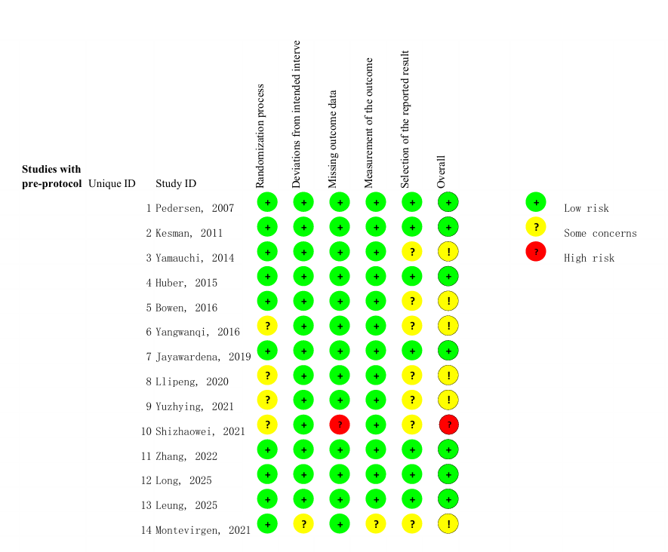
Appendix D: Meta-analysis
Table D.1: Sensitivity analysis for body weight
Weight | MD | P | I2
Exclude Bowen,2016 | -3.34 | 0.01 | 0
Exclude Huber,2015 | -1.97 | 0.10 | 0
Exclude Kesman,2011 | -2.48 | 0.05 | 0
Exclude Pedesen,2007 | -2.26 | 0.07 | 0

Table D.2: Sensitivity analysis for body BMI
BMI | MD | P | I2
Exclude long,2025 | -1.19 | 0.18 | 85
Exclude Huber,2015 | -1.43 | 0.07 | 78
Exclude shizhaowei,2021 | -1.31 | 0.12 | 84
Exclude Pedesen,2007 | -1.30 | 0.12 | 85
Exclude yangwanqi,2016 | -0.54 | 0.20 | 0

Table D.3: Sensitivity analysis for body waist circumference
waist circumference | MD | P | I2
Exclude Huber,2015 | 0.08 | 0.97 | 9
Exclude Jayawardena,2019 | -4.91 | 0.02 | 0
Exclude yamauchi,2014 | -1.89 | 0.53 | 76

Table D.4: Sensitivity analysis for body HbA1c
HbA1c | MD | P | I2
Exclude yamauchi,2014 | -0.88 | ＜0.00001 | 81
Exclude yuzhiying, 2021 | -0.80 | ＜0.00001 | 80
Exclude Bowen,2016 | -0.92 | ＜0.00001 | 79
Exclude leung,2025 6month | -0.88 | ＜0.00001 | 81
Exclude long,2025 | -0.87 | ＜0.00001 | 81
Exclude Pedesen,2007 | -1.04 | ＜0.00001 | 54
Exclude shizhaowei,2021 | -0.88 | ＜0.00001 | 81
Exclude yangwanqi,2016 | -0.79 | ＜0.00001 | 79
Exclude zhang,2022 6month | -0.80 | ＜0.00001 | 79
Exclude leung,2025 12month | -0.87 | ＜0.00001 | 81
Exclude zhang,2022 12month | -0.80 | ＜0.00001 | 79

Table D.5: Sensitivity analysis for body 2-h-PPG
2-h-PPG | MD | P | I2
Exclude Montevirgen2021 | -1.43 | 0.13 | 82
Exclude zhang2022 | -1.32 | 0.17 | 69
Exclude leung2025 12 month | -2.24 | ＜0.00001 | 0

Table D.6: Sensitivity analysis for body FPG
FPG | MD | P | I2
Exclude leung2025 6 month | -0.81 | ＜0.00001 | 64
Exclude lipeng2020 | -1.01 | ＜0.00001 | 67
Exclude shizhaowei2021 | -1.33 | ＜0.00001 | 9
Exclude long2025 | -1.07 | 0.00001 | 64
Exclude leung2025 12 month | -0.99 | 0.00002 | 67
Exclude zhang2022 | -0.81 | ＜0.00001 | 0

Table D.7: Sensitivity analysis for body TC
TC | MD | P | I2
Exclude Pedesen2007 | -0.21 | 0.04 | 0
Exclude shizhaowei2021 | -0.19 | 0.0004 | 0
Exclude long2025 | -0.19 | 0.002 | 0
Exclude lipeng2020 | -0.21 | 0.0007 | 0
Exclude zhang2022 | -0.20 | 0.002 | 0

Table D.8: Sensitivity analysis for body TG
TG | MD | P | I2
Exclude Pedesen2007 | -0.03 | 0.86 | 81
Exclude shizhaowei2021 | 0.16 | 0.02 | 0
Exclude long2025 | 0.04 | 0.78 | 81
Exclude lipeng2020 | -0.03 | 0.85 | 81
Exclude zhang2022 | -0.07 | 0.62 | 50

Table D.9: Sensitivity analysis for body HDL
HDL | MD | P | I2
Exclude Pedesen2007 | -0.01 | 0.76 | 30
Exclude lipeng2020 | 0.02 | 0.52 | 39
Exclude long2025 | 0.02 | 0.52 | 0
Exclude zhang2022 | -0.01 | 0.75 | 44

Table D.10: Sensitivity analysis for body LDL
LDL | MD | P | I2
Exclude Pedesen2007 | -0.11 | ＜0.00001 | 0
Exclude lipeng2020 | -0.12 | ＜0.00001 | 0
Exclude long2025 | -0.12 | ＜0.00001 | 0
Exclude zhang2022 | -0.17 | 0.01 | 0
Exclude leung2025 | -0.12 | ＜0.00001 | 0

Table D.11: Sensitivity analysis for body DBP
DBP | MD | P | I2
Exclude Pedesen2007 | -3.25 | 0.0004 | 0
Exclude shizhaowei2021 | -0.75 | 0.71 | 73
Exclude leung2022 | -1.78 | 0.38 | 78
Exclude zhang2025 | -0.82 | 0.70 | 74

Table D.12: Sensitivity analysis for body SBP
SBP | MD | P | I2
Exclude Pedesen2007 | -7.6 | 0.009 | 82
Exclude shizhaowei2021 | -3.69 | 0.49 | 92
Exclude leung2025 | -4.87 | 0.27 | 91
Exclude zhang2022 | -1.76 | 0.59 | 71

Figure D1:Effect of portion-control plate–based interventions on weight

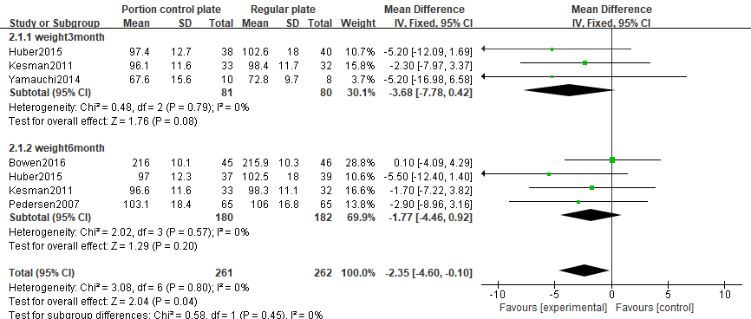

Figure D2:Effect of portion-control plate–based interventions on BMI
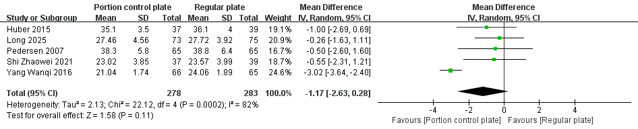

Figure D3:Effect of portion-control plate–based interventions on waist circumference
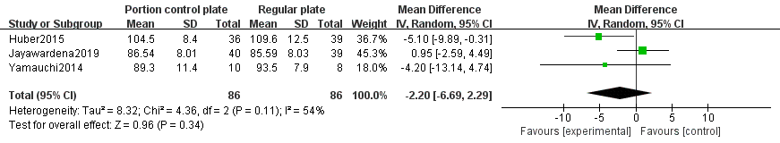

Figure D4:Effect of portion-control plate–based interventions on HbA1c

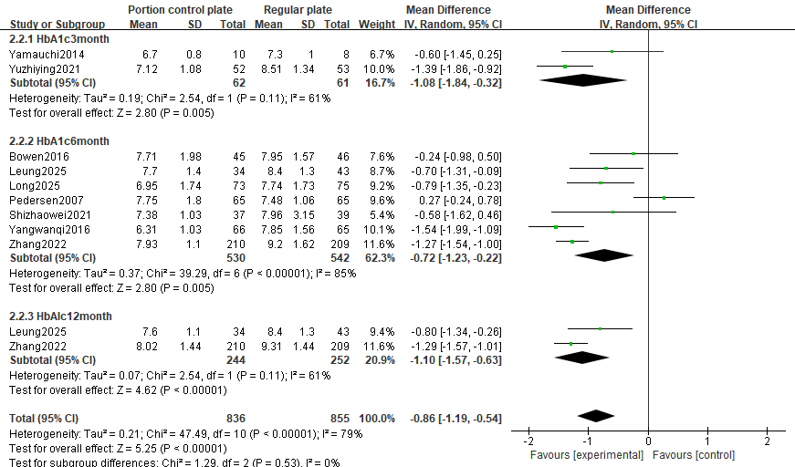

Figure D5:Effect of portion-control plate–based interventions on 2-h-PPG

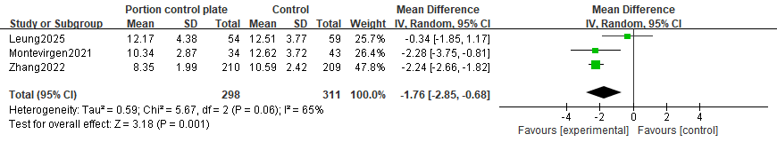

Figure D6:Effect of portion-control plate–based interventions on FPG
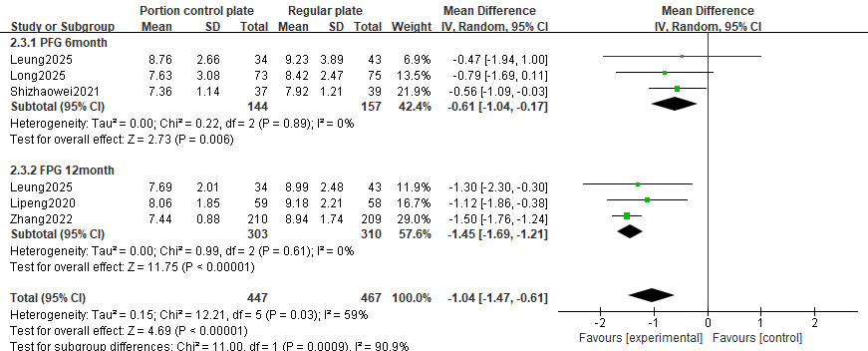

Figure D7:Effect of portion-control plate–based interventions on TC

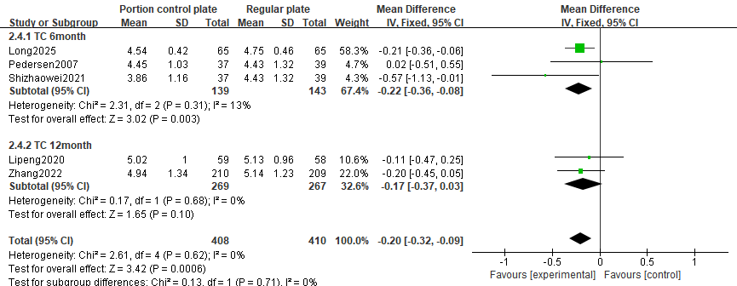

Figure D8:Effect of portion-control plate–based interventions on TG
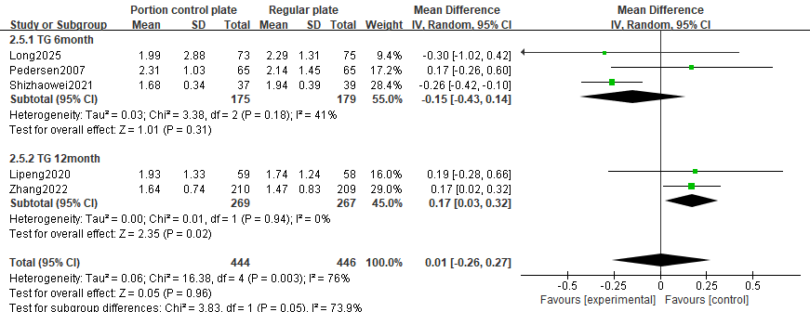

Figure D9:Effect of portion-control plate–based interventions on HDL

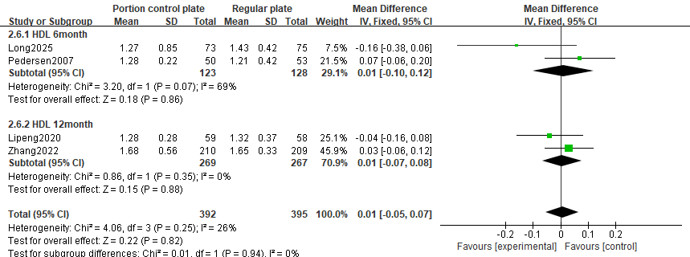

Figure D10:Effect of portion-control plate–based interventions on LDL

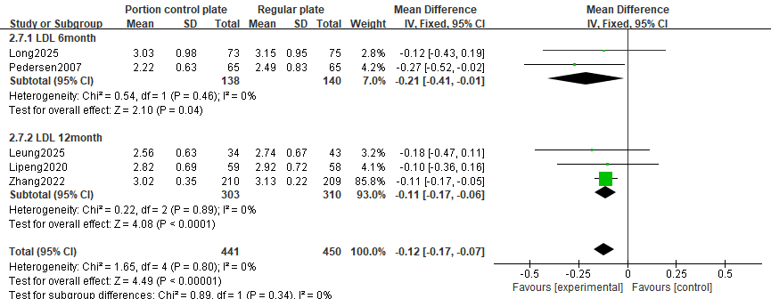

Figure D11:Effect of portion-control plate–based interventions on DBP

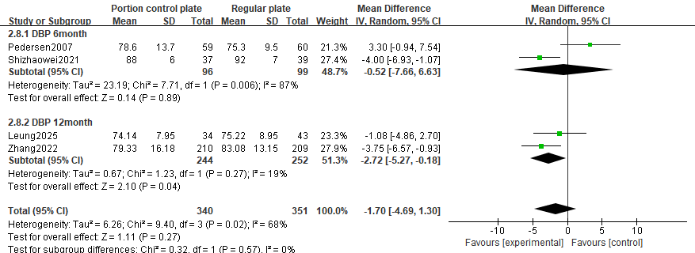

Figure D12:Effect of portion-control plate–based interventions on SBP

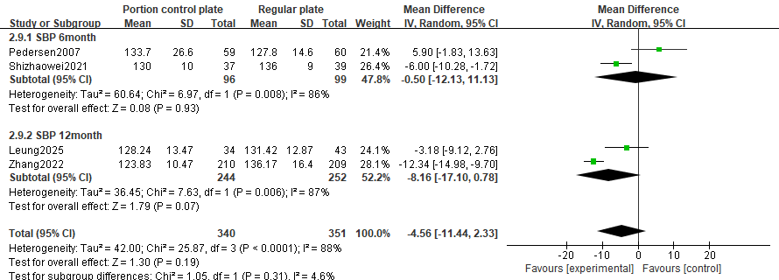

Appendix E: Publication bias assessment
Figure E1: Funnel plot and Egger's test for weight
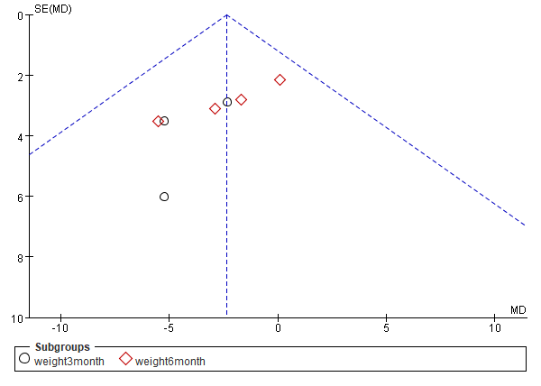

Egger's test
Std_Eff | Coefficient | Std. err. | t | P>|t| | [95% conf. interval]
slope | 3.853544 | 2.034715 | 1.89 | 0.117 | -1.376858 | 9.083946
bias | -2.11172 | .6698101 | -3.15 | 0.025 | -3.833522 | -.389918

Figure E2:Funnel plot and Egger's test for waist circumference
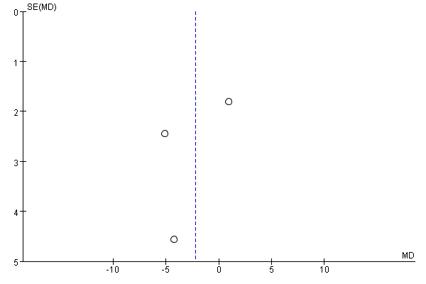

Egger's test
Std_Eff | Coefficient | Std. err. | t | P>|t| | [95% conf. interval]
slope | 3.788849 | 6.817607 | 0.56 | 0.677 | -82.83707 | 90.41477
bias | -2.321259 | 2.845716 | -0.82 | 0.564 | -38.47951 | 33.83699

Figure E3:Funnel plot and Egger's test for BMI
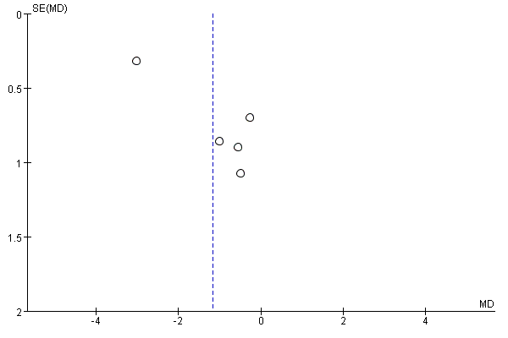

Egger's test
Std_Eff | Coefficient | Std. err. | t | P>|t| | [95% conf. interval]
slope | -4.271017 | .5543054 | -7.71 | 0.005 | -6.035064 | -2.50697
bias | 4.225591 | .9733204 | 4.34 | 0.023 | 1.128051 | 7.323131

Figure E4:Funnel plot and Egger's test for TC
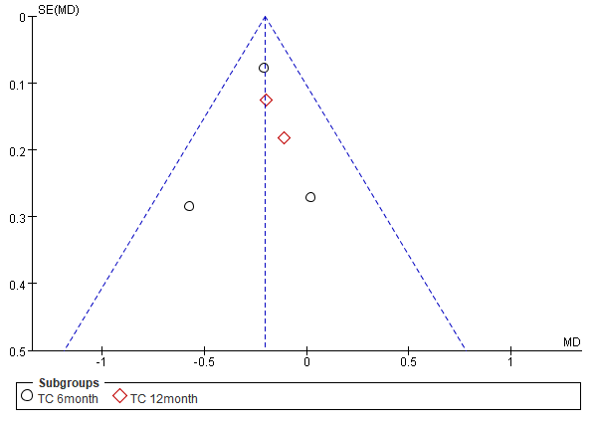

Egger's test
Std_Eff | Coefficient | Std. err. | t | P>|t| | [95% conf. interval]
slope | -.0934672 | .2527652 | -0.37 | 0.736 | -.8978788 | .7109444
bias | -.7951768 | 1.609372 | -0.49 | 0.655 | -5.916915 | 4.326562

Figure E5:Funnel plot and Egger's test for HDL
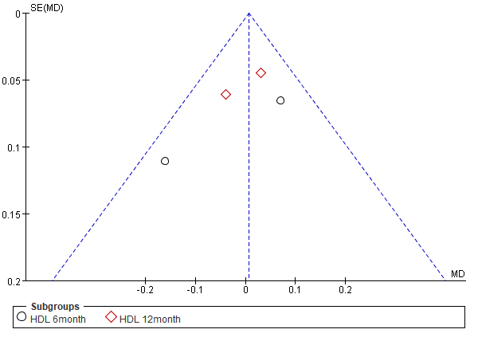

Egger's test
Std_Eff | Coefficient | Std. err. | t | P>|t| | [95% conf. interval]
slope | .1401027 | .3277661 | 0.43 | 0.711 | -1.270161 | 1.550367
bias | -1.036326 | 2.295536 | -0.45 | 0.696 | -10.91322 | 8.840568

Figure E6:Funnel plot and Egger's test for LDL
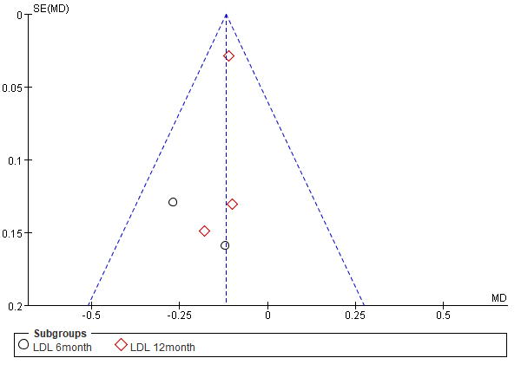

Egger's test
Std_Eff | Coefficient | Std. err. | t | P>|t| | [95% conf. interval]
slope | -.4987735 | .167482 | -2.98 | 0.059 | -1.031776 | .034229
bias | 1.432492 | 1.110385 | 1.29 | 0.287 | -2.101248 | 4.966231

Figure E7:Funnel plot and Egger's test for TG
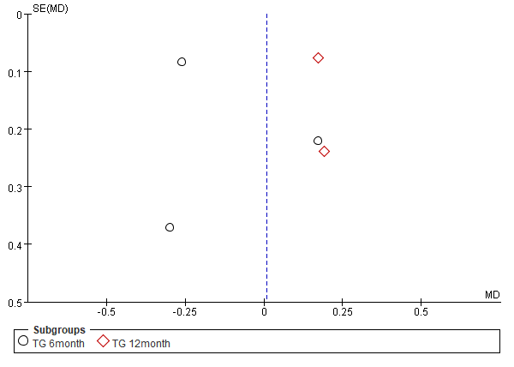

Egger's test
Std_Eff | Coefficient | Std. err. | t | P>|t| | [95% conf. interval]
slope | .6658233 | .3235567 | 2.06 | 0.132 | -.3638785 | 1.695525
bias | -4.215749 | 2.14854 | -1.96 | 0.145 | -11.05336 | 2.621866

Figure E8:Funnel plot and Egger's test for DBP
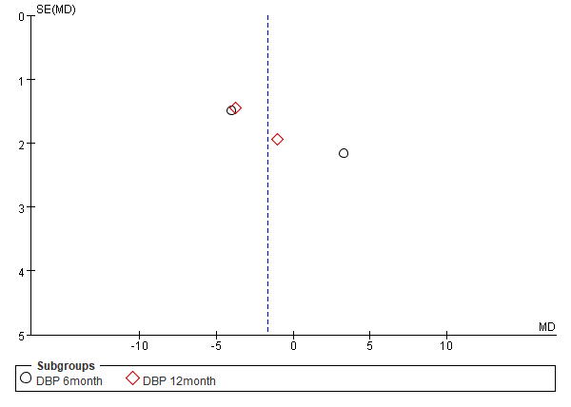

Egger's test
Std_Eff | Coefficient | Std. err. | t | P>|t| | [95% conf. interval]
slope | -.2556057 | .4624141 | -0.55 | 0.636 | -2.245213 | 1.734002
bias | .4912541 | 3.01832 | 0.16 | 0.886 | -12.49553 | 13.47804

Figure E9:Funnel plot and Egger's test for SBP
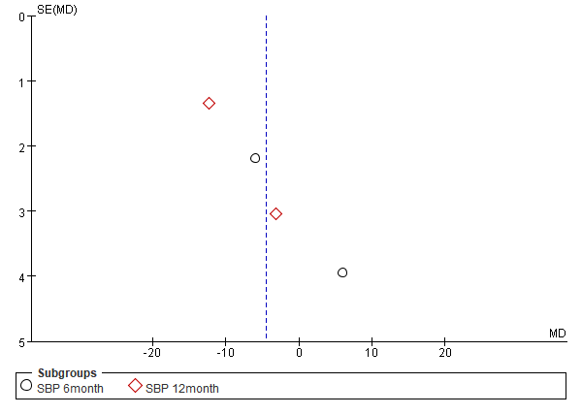

Egger's test
Std_Eff | Coefficient | Std. err. | t | P>|t| | [95% conf. interval]
slope | -1.379645 | .6758789 | -2.04 | 0.178 | -4.287717 | 1.528427
bias | 5.45161 | 4.294639 | 1.27 | 0.332 | -13.02673 | 23.92995

Figure E10:Funnel plot and Egger's test for HbA1c
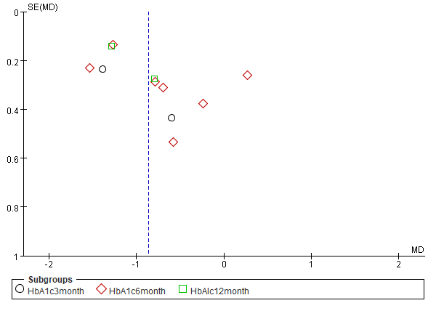

Egger's test
Std_Eff | Coefficient | Std. err. | t | P>|t| | [95% conf. interval]
slope | -1.05413 | .3208942 | -3.28 | 0.009 | -1.780044 | -.3282172
bias | 2.285472 | 1.91271 | 1.19 | 0.263 | -2.041378 | 6.612321

Figure E11:Funnel plot and Egger's test for 2-h-PPG
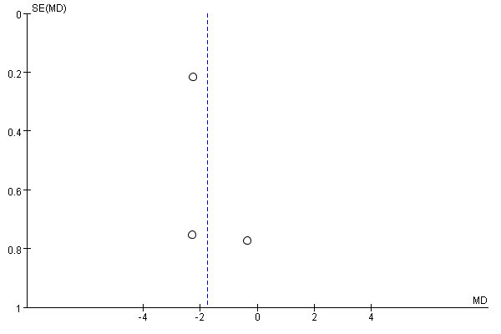

Egger's test
Std_Eff | Coefficient | Std. err. | t | P>|t| | [95% conf. interval]
slope | -1.525969 | .7222542 | -2.11 | 0.281 | -10.70308 | 7.65114
bias | 5.405086 | 4.915288 | 1.10 | 0.470 | -57.04957 | 67.85974

Figure E12:Funnel plot and Egger's test for FPG
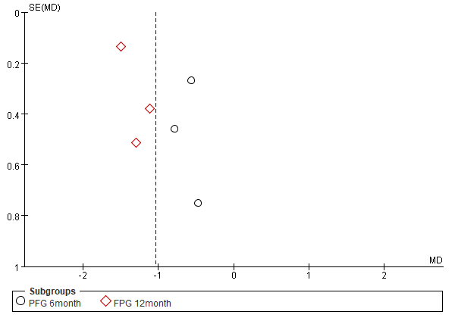

Egger's test
Std_Eff | Coefficient | Std. err. | t | P>|t| | [95% conf. interval]
slope | -1.606092 | .3225958 | -4.98 | 0.008 | -2.501762 | -.7104229
bias | 5.70372 | 1.915727 | 2.98 | 0.041 | .38481 | 11.02263

Appendix F: GRADE Evidence Profile
Table F1:Subgroup analysis
Quality assessment |  |  |  |  |  |  | No of patients |  | Effect
No of studies | Outcome | Risk of bias | Inconsistency | Indirectness | Imprecision | Other considerations | Subgroup analysis | Control | Relative  (95% CI) | Absolute | Quality | Importance
5 | weight | no serious risk of bias1 | no serious inconsistency2 | no serious indirectness3 | very serious4 | none5 | 261 | 262 | - | MD 2.35 lower (4.6 to 0.1 lower) | ÅÅOO  LOW | IMPORTANT
3 | Weight 3 month | no serious risk of bias1 | no serious inconsistency2 | no serious indirectness3 | very serious4 | none5 | 81 | 80 | - | MD 3.68 lower (7.78 lower to 0.42 higher) | ÅÅOO  LOW | IMPORTANT
3 | Weight 6 month | no serious risk of bias1 | no serious inconsistency2 | no serious indirectness3 | very serious4 | none5 | 180 | 182 | - | MD 1.77 lower (4.46 lower to 0.92 higher) | ÅÅOO  LOW | IMPORTANT
11 | HbA1c | serious6 | very serious7 | no serious indirectness3 | no serious imprecision11 | None15 | 836 | 855 | - | MD 0.86 lower (1.19 to 0.54 lower) | ÅOOO  VERY LOW | IMPORTANT
2 | HbA1c 3 month | no serious risk of bias1 | serious10 | no serious indirectness3 | serious12 | None55 | 62 | 61 | - | MD 1.08 lower (1.84 to 0.32 lower) | ÅÅOO  LOW | IMPORTANT
7 | HbA1c 6 month | serious6 | very serious7 | no serious indirectness3 | serious16 | none5 | 530 | 542 | - | MD 0.72 lower (1.23 to 0.22 lower) | ÅOOO  VERY LOW | IMPORTANT
2 | HbA1c 12 month | no serious risk of bias1 | serious10 | no serious indirectness3 | no serious imprecision11 | none5 | 244 | 252 | - | MD 1.1 lower (1.57 to 0.63 lower) | ÅÅÅO  MODERATE | IMPORTANT
5 | FPG | serious6 | serious10 | no serious indirectness3 | serious12 | none5 | 447 | 467 | - | MD 1.04 lower (1.47 to 0.61 lower) | ÅOOO  VERY LOW | IMPORTANT
3 | FPG 6month | serious6 | no serious inconsistency2 | no serious indirectness3 | serious12 | none5 | 144 | 157 | - | MD 0.61 lower (1.04 to 0.17 lower) | ÅÅOO  LOW | IMPORTANT
3 | FPG 12month | no serious risk of bias1 | no serious inconsistency2 | no serious indirectness3 | very serious13 | none5 | 303 | 310 | - | MD 1.45 lower (1.69 to 1.21 lower) | ÅÅOO  LOW | IMPORTANT
5 | TC | serious6 | no serious inconsistency2 | no serious indirectness3 | serious12 | none5 | 408 | 410 | - | MD 0.2 lower (0.32 to 0.09 lower) | ÅÅOO  LOW | IMPORTANT
3 | TC 6month | serious6 | no serious inconsistency2 | no serious indirectness3 | serious9 | none | 139 | 143 | - | MD 0.22 lower (0.36 to 0.08 lower) | ÅÅOO  LOW | IMPORTANT
2 | TC 12month | no serious risk of bias1 | no serious inconsistency2 | no serious indirectness3 | very serious4 | none | 269 | 267 | - | MD 0.17 lower (0.37 lower to 0.03 higher) | ÅÅOO  LOW | IMPORTANT
5 | TG | serious6 | very serious7 | no serious indirectness3 | very serious4 | none5 | 444 | 446 | - | MD 0.01 higher (0.26 lower to 0.27 higher) | ÅOOO  VERY LOW | IMPORTANT
3 | TG 6month | serious6 | serious10 | no serious indirectness3 | serious9 | none5 | 175 | 179 | - | MD 0.15 lower (0.43 lower to 0.14 higher) | ÅOOO  VERY LOW | IMPORTANT
2 | TG 12month | no serious risk of bias1 | no serious inconsistency2 | no serious indirectness3 | no serious imprecision14 | none5 | 269 | 267 | - | MD 0.17 higher (0.03 to 0.32 higher) | ÅÅÅÅ  HIGH | IMPORTANT
4 | HDL | no serious risk of bias1 | serious10 | no serious indirectness3 | serious12 | none | 392 | 395 | - | MD 0.01 higher (0.05 lower to 0.07 higher) | ÅÅOO  LOW | IMPORTANT
2 | HDL 6month | no serious risk of bias1 | serious10 | no serious indirectness3 | serious9 | none | 123 | 128 | - | MD 0.01 higher (0.1 lower to 0.12 higher) | ÅÅOO  LOW | IMPORTANT
2 | HDL 12month | no serious risk of bias1 | no serious inconsistency2 | no serious indirectness3 | serious12 | none5 | 269 | 267 | - | MD 0.01 higher (0.07 lower to 0.08 higher) | ÅÅÅO  MODERATE | IMPORTANT
5 | LDL | no serious risk of bias1 | no serious inconsistency2 | no serious indirectness3 | no serious imprecision14 | none5 | 441 | 450 | - | MD 0.12 lower (0.17 to 0.07 lower) | ÅÅÅÅ  HIGH | IMPORTANT
2 | LDL 6month | no serious risk of bias1 | no serious inconsistency2 | no serious indirectness3 | serious9 | none5 | 138 | 140 | - | MD 0.21 lower (0.41 to 0.01 lower) | ÅÅÅO  MODERATE | IMPORTANT
3 | LDL 12month | no serious risk of bias1 | no serious inconsistency2 | no serious indirectness3 | no serious imprecision14 | none5 | 303 | 310 | - | MD 0.11 lower (0.17 to 0.06 lower) | ÅÅÅÅ  HIGH | IMPORTANT
4 | DBP | serious6 | serious10 | no serious indirectness3 | very serious4 | none5 | 346 | 356 | - | MD 2.84 lower (4.68 to 1.01 lower) | ÅOOO  VERY LOW | IMPORTANT
2 | DBP 6month | serious6 | very serious7 | no serious indirectness3 | very serious4 | none5 | 102 | 104 | - | MD 2.59 lower (5.22 lower to 0.04 higher) | ÅOOO  VERY LOW | IMPORTANT
2 | DBP 12month | no serious risk of bias1 | no serious inconsistency2 | no serious indirectness3 | serious9 | none5 | 244 | 252 | - | MD 3.08 lower (5.64 to 0.52 lower) | ÅÅÅO  MODERATE | IMPORTANT
5 | SBP | serious6 | very serious7 | no serious indirectness3 | serious12 | none5 | 405 | 414 | - | MD 4.7 lower (10.55 lower to 1.16 higher) | ÅOOO  VERY LOW | IMPORTANT
2 | SBP 6month | serious6 | very serious7 | no serious indirectness3 | serious9 | none5 | 102 | 104 | - | MD 0.44 lower (12.08 lower to 11.19 higher) | ÅOOO  VERY LOW | IMPORTANT
3 | SBP 12month | no serious risk of bias1 | very serious7 | no serious indirectness3 | serious9 | none5 | 303 | 310 | - | MD 7.11 lower (14.88 lower to 0.65 higher) | ÅOOO  VERY LOW | IMPORTANT
1 No studies at high risk of bias were included
2 0%<I²<25%
3 Fully compliant with the PICOT criteria.
4 Very serious imprecision: 95% CI crosses both the null effect and the predefined minimal clinically important difference (±2 kg), with total sample size below the optimal information size.
5 Number of studies < 10
6 a study with high risk
7 I²≥75%
8 Large sample size with statistically significant and clinically meaningful narrow confidence interval supports adequate precision.
9 Wide confidence interval approaching clinical non-significance and substantial heterogeneity warrant downgrading for imprecision.
10 25%<I²<75%
11 Large precise effect with a tight confidence interval excluding null and exceeding clinical thresholds indicates no serious imprecision.
12 The small number of studies and limited total sample size fail to achieve the optimal information size (OIS), resulting in wide confidence intervals
13 An extremely small number of studies and a very limited sample size lead to confidence intervals that are exceptionally wide.
14 The confidence interval is narrow and does not cross the null line.
15 No evidence of publication bias was found
16Wide confidence interval approaching clinical non-significance, and the total sample size failed to achieve the optimal information size, warranting downgrading for imprecision.

Table F2:Other indicators
Quality assessment |  |  |  |  |  |  | No of patients |  | Effect
No of studies | Outcome | Risk of bias | Inconsistency | Indirectness | Imprecision | Other considerations | Subgroup analysis | Control | Relative  (95% CI) | Absolute | Quality | Importance
5 | BMI | serious1 | very serious2 | no serious indirectness3 | very serious4 | none5 | 278 | 283 | - | MD 1.17 lower (2.63 lower to 0.28 higher) | ÅOOO  VERY LOW | IMPORTANT
3 | waist circumference | no serious risk of bias6 | serious7 | no serious indirectness3 | very serious8 | none5 | 88 | 86 | - | MD 2.24 lower (6.75 lower to 2.27 higher) | ÅOOO  VERY LOW | IMPORTANT
3 | 2-h-PPG | no serious risk of bias6 | serious7 | no serious indirectness3 | serious4 | none | 298 | 311 | - | MD 1.76 lower (2.85 to 0.68 lower) | ÅÅOO  LOW | IMPORTANT
1 a study with high risk
2 I²≥75%
3 Fully compliant with the PICOS criteria.
4 Serious imprecision: CI crosses the null effect and one clinically important boundary; total sample below optimal information size.
5 Number of studies < 10
6 No studies at high risk of bias were included
7 25%<I²<75%
8 Very serious imprecision: total sample below optimal information size; 95% CI crosses both the null effect and the predefined clinically important boundaries (±2 kg); very wide confidence interval.
Appendix G: List of Abbreviations
Table G1:List of Abbreviations
Abbreviations | Full Forms
BMI | Body mass index
CI | Confidence interval
DBP | Diastolic blood pressure
FPG | Fasting plasma glucose
GRADE | Grading of Recommendations Assessment, Development and Evaluation
HbA1c | Glycated hemoglobin
HDL | High-density lipoprotein
LDL | Low-density lipoprotein
MD | Mean difference
MeSH | Medical Subject Headings
PCP | Portion-control plate
PICOS | Population, Intervention, Comparison, Outcomes, and Study design
PRISMA | Preferred Reporting Items for Systematic Reviews and Meta-Analyses
PROSPERO | International Prospective Register of Systematic Reviews
RCT | Randomized controlled trial
RevMan | Review Manager
RoB 2 | Cochrane Risk of Bias tool version 2
SBP | Systolic blood pressure
SMD | Standardized mean difference
TC | total cholesterol
TG | triglycerides
WC | waist circumference
2h-PPG | 2-hour postprandial glucose

