Supporting Information
Corresponding Author
Yachao Zhu, ICGM, CNRS, Université de Montpellier, Montpellier, France. Institute of Future Technology, Southwest Jiaotong University, Chengdu 610031, China. yachao.zhu@umontpellier.fr
Jie Deng, School of Architecture and Civil Engineering, Chengdu University, Chengdu, China. College of Food and Biological Engineering and College of Chemistry and Chemical Engineering, Chengdu University, Chengdu, 610106, China. Institute for Advanced Study, Chengdu University, Chengdu,610106, China. dengjie@cdu.edu.cn
Si Chen, Sichuan Institute of Product Quality Supervision and Inspection, Chengdu, China. chensi2005020203@163.com
Authors
Ruxin Lei, College of Food and Biological Engineering and College of Chemistry and Chemical Engineering, Chengdu University，Chengdu, China.
Yufeng Zhang, School of Architecture and Civil Engineering, Chengdu University, Chengdu, China.
Li Chen, College of Food and Biological Engineering and College of Chemistry and Chemical Engineering, Chengdu University，China.
Yuying Wu, College of Food and Biological Engineering and College of Chemistry and Chemical Engineering, Chengdu University，China.
Haitao Chen, College of Food and Biological Engineering and College of Chemistry and Chemical Engineering, Chengdu University，China.

Ce and S Co-Induced Oxygen Vacancies for Enhanced Alkaline Water Electrolysis
Ruxin Lei, Yufeng Zhang, Li Chen, Yuying Wu, Haitao Chen Si Chen#, Yachao Zhu#, Jie Deng#
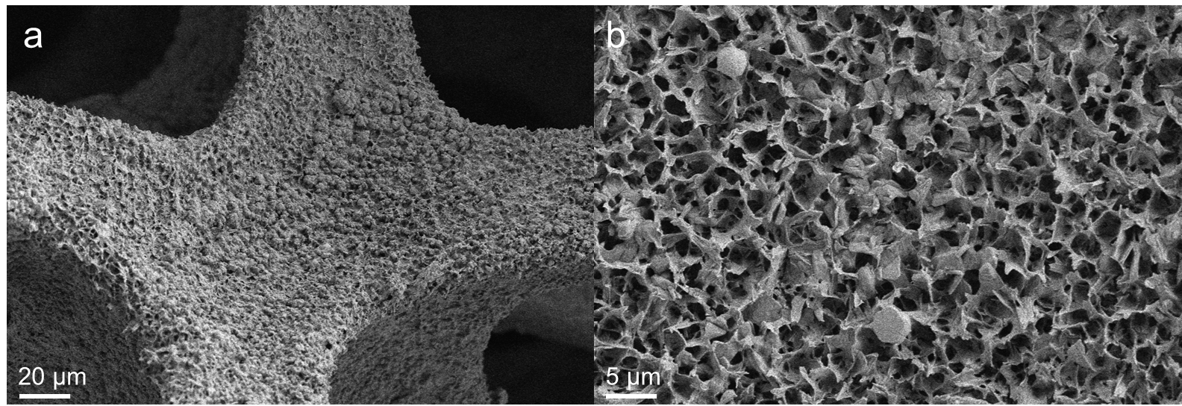
Figure S1 SEM images of NiCe/NF.
Figure S2 EDS energy spectrum of NiCeS/NF.
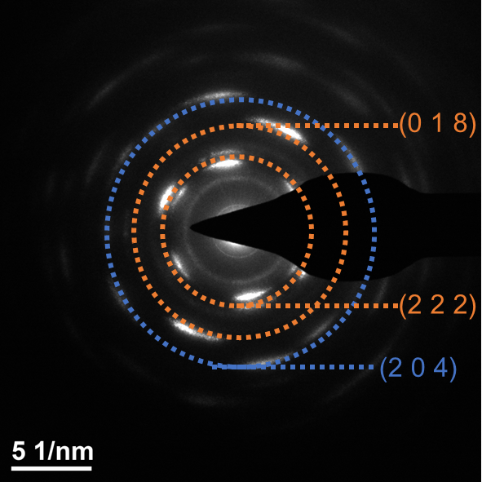
Figure S3 The electron diffraction ring of NiCeS/NF.
Figure S4 The initial potential of each sample.

Table S1 The proportion of each element in NiCeS/NF.
Element | Wt% | At%
O | 38.19 | 70.77
S | 1.47 | 1.36
Ni | 51.46 | 25.99
Ce | 8.88 | 1.88

Table S2 Comparison of the stability of NiCeS/NF with the reported catalysts.
Samples | Current density (mA cm⁻²) | Time (h)
A-RSCOH[1] | 100 | 60
NiFeCe-LDH@CP[2] | 20 | 70
MIM@Fe-CoNiCH/NF[3] | 50 | 192
FeCe-Ni₃S₂@NF[4] | 20 | 50
NF-S_{0.15}[5] | 100 | 80
Cr_{0.6}Ru_{0.4}O₂[6] | 300 | 350
CoPSe[7]  NiCeS/NF (This work) | 100  1000 | 100  1466
[1] C. Wang, C. Deng, P. Zhai, X. Shi, W. Liu, D. Jin, B. Shang, J. Gao, L. Sun, J. Hou, Tracking the correlation between spintronic structure and oxygen evolution reaction mechanism of cobalt-ruthenium-based electrocatalyst, Nat Commun 16 (2025) 215. https://doi.org/10.1038/s41467-024-55688-8.
[2] Y. Liao, R. He, W. Pan, Y. Li, Y. Wang, J. Li, Y. Li, Lattice distortion induced Ce-doped NiFe-LDH for efficient oxygen evolution, Chemical Engineering Journal 464 (2023) 142669. https://doi.org/10.1016/j.cej.2023.142669.
[3] Y. Chen, Q. Li, Y. Lin, J. Liu, J. Pan, J. Hu, X. Xu, Boosting oxygen evolution reaction by FeNi hydroxide-organic framework electrocatalyst toward alkaline water electrolyzer, Nat Commun 15 (2024) 7278. https://doi.org/10.1038/s41467-024-51521-4.
[4] Y. He, K. Shi, X. Wang, X. Zheng, L. Luo, L. Lin, Z. Sun, G. Sun, Synergistic Fe,Ce doping of Ni₃ S₂ for enhancing oxygen evolution reaction performance, Inorg. Chem. Front. 11 (2024) 7623–7632. https://doi.org/10.1039/D4QI02187H.
[5] H. Liao, T. Luo, P. Tan, K. Chen, L. Lu, Y. Liu, M. Liu, J. Pan, Unveiling Role of Sulfate Ion in Nickel‐Iron (oxy)Hydroxide with Enhanced Oxygen‐Evolving Performance, Adv Funct Materials 31 (2021) 2102772. https://doi.org/10.1002/adfm.202102772.
[6] X. Cao, H. Qin, J. Zhang, X. Chen, L. Jiao, Regulation of Oxide Pathway Mechanism for Sustainable Acidic Water Oxidation, J. Am. Chem. Soc. 146 (2024) 32049–32058. https://doi.org/10.1021/jacs.4c12942.
[7] Y. Shi, S. Zhou, J. Liu, X. Zhang, J. Yin, T. Zhan, Y. Yang, G. Li, J. Lai, L. Wang, An integrated amorphous cobalt phosphoselenide electrocatalyst with high mass activity boosts alkaline overall water splitting, Applied Catalysis B: Environmental 341 (2024) 123326. https://doi.org/10.1016/j.apcatb.2023.123326.

