Supporting Information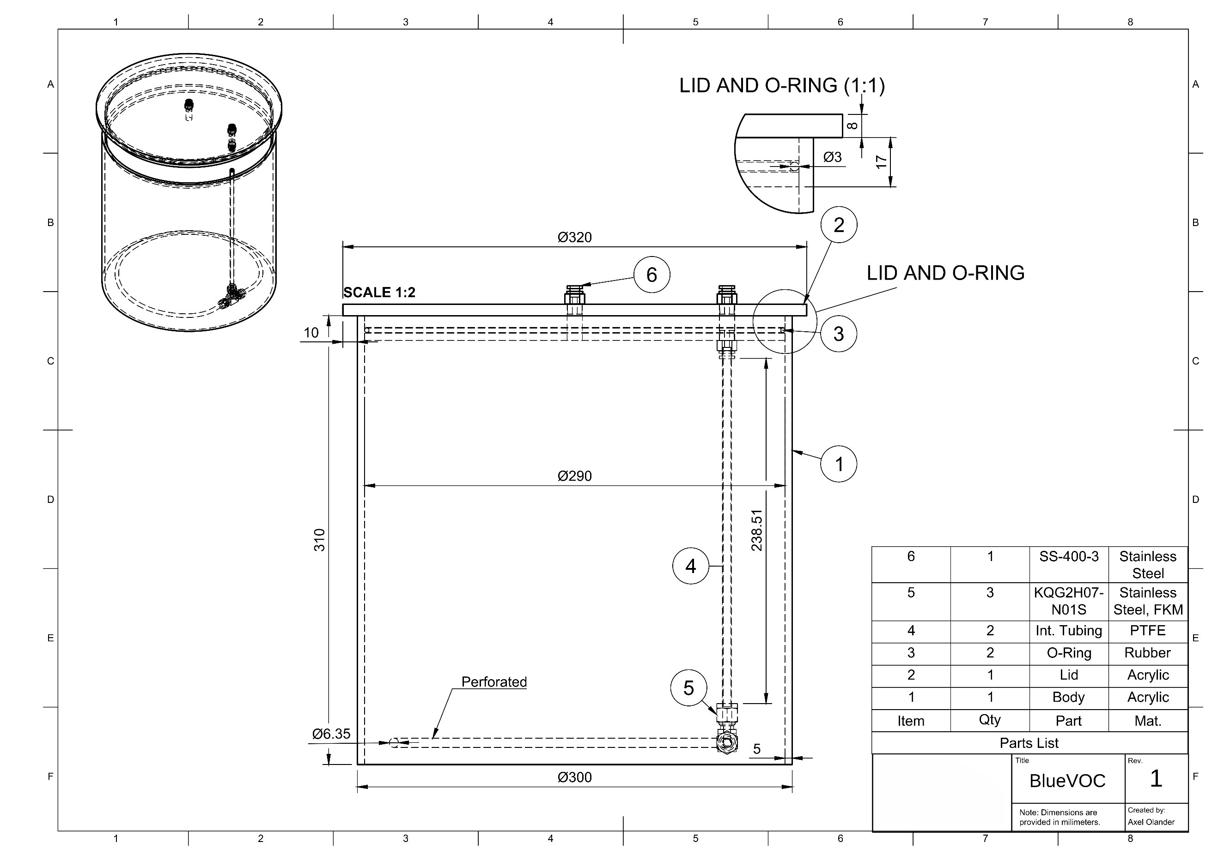
Fig. S1: Technical drawing of the BlueVOC 1.0.
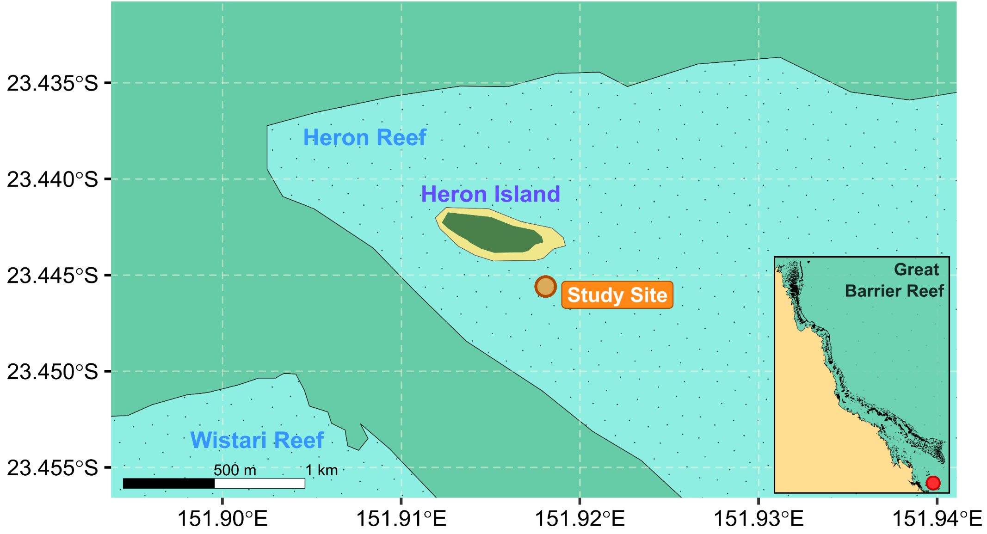
Fig. S2: Map of Heron Island, GBR, Australia. The study site where the BlueVOC 1.0 methodology was employed is indicated.
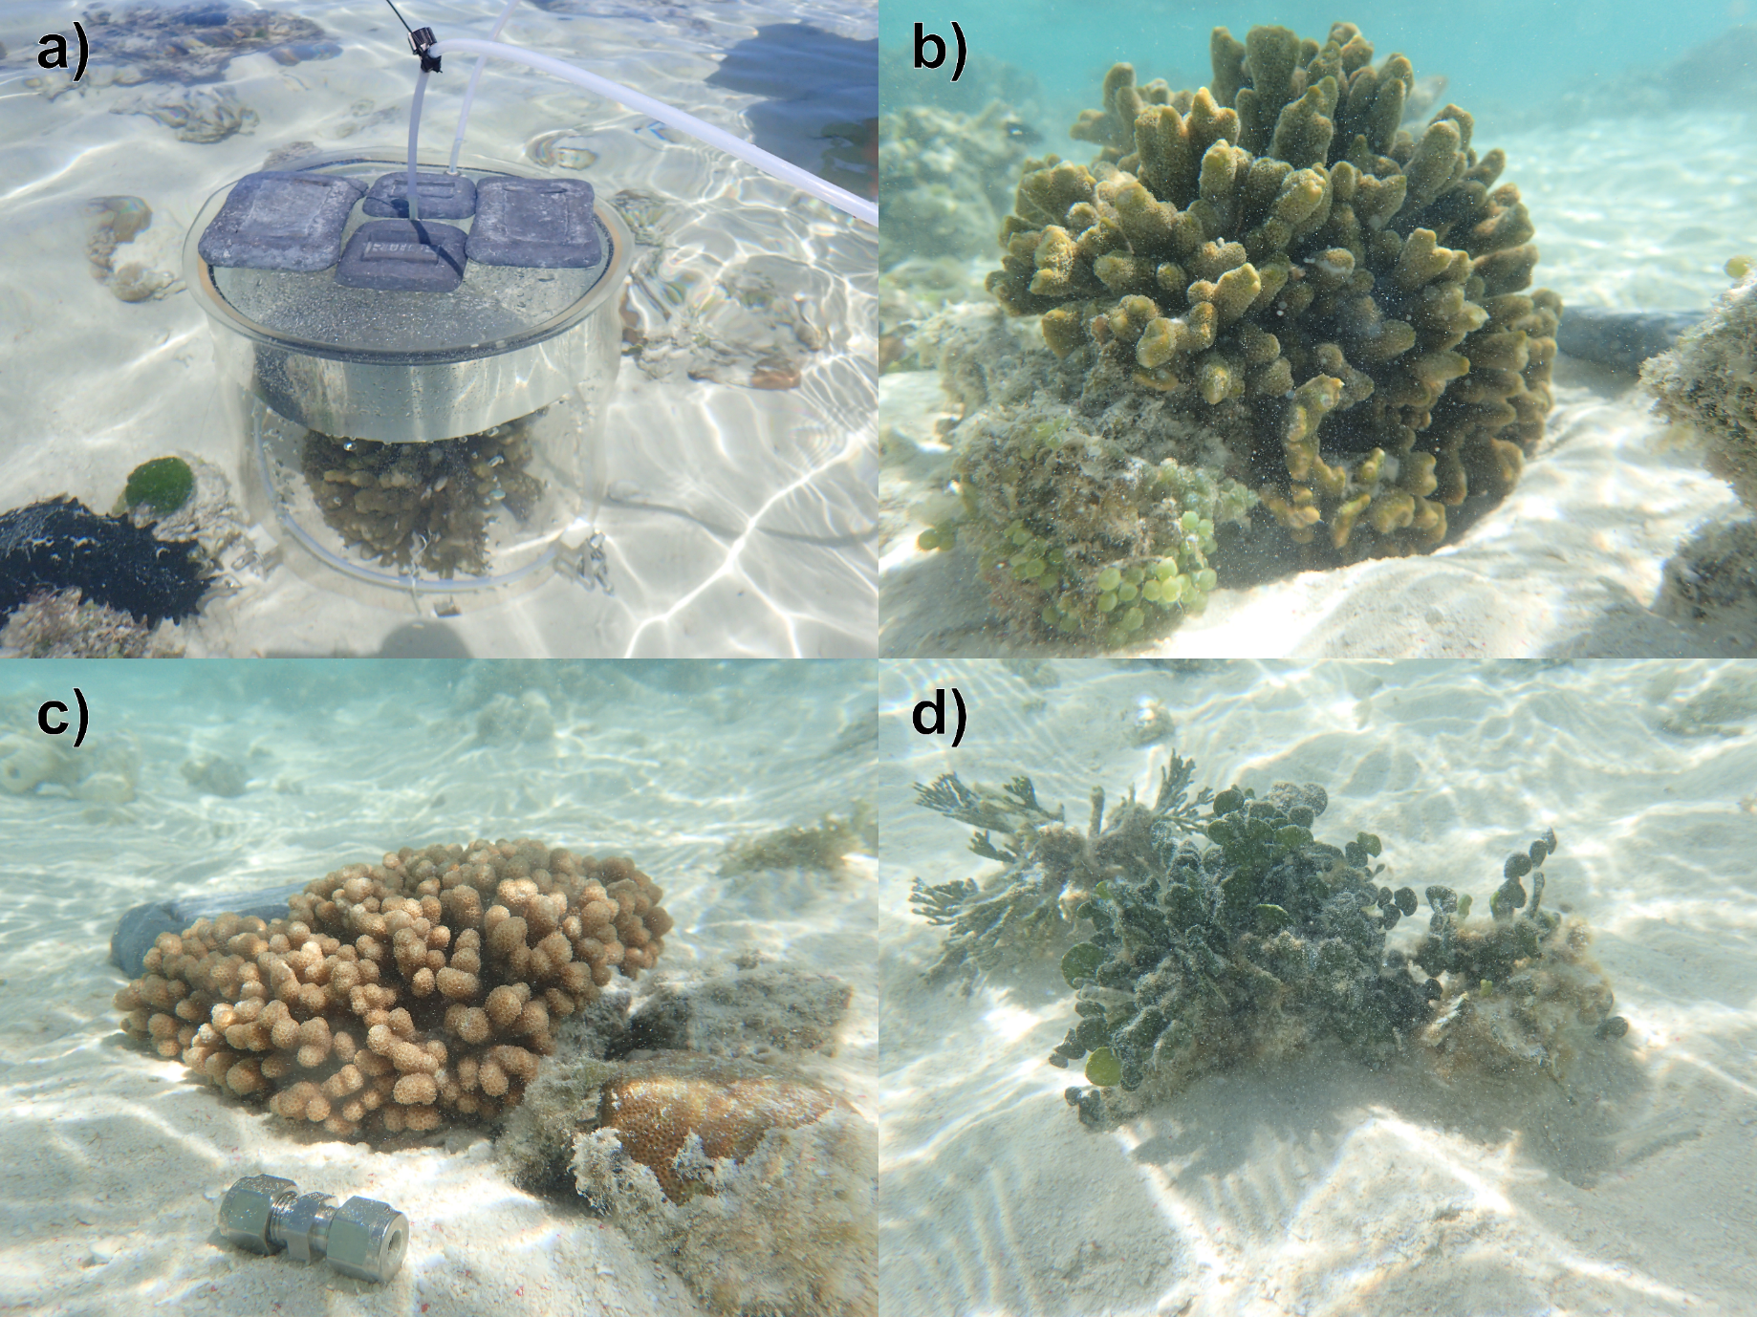
Fig. S3: a) Image of the BlueVOC 1.0 deployed on the reef flat of Heron Island, Great Barrier Reef, Australia (23°26'42’S, 151°54'57’E), in April of 2021. Approximately 8 kg of dive weights were placed upon the lid of the chamber to act against the buoyant force of the gaseous headspace forming inside, anchoring it to the sediment. Images of b) Montipora cf. digitata, Cladiella sp. and d) Halimeda sp. targeted for volatilomic sampling using the BlueVOC 1.0.

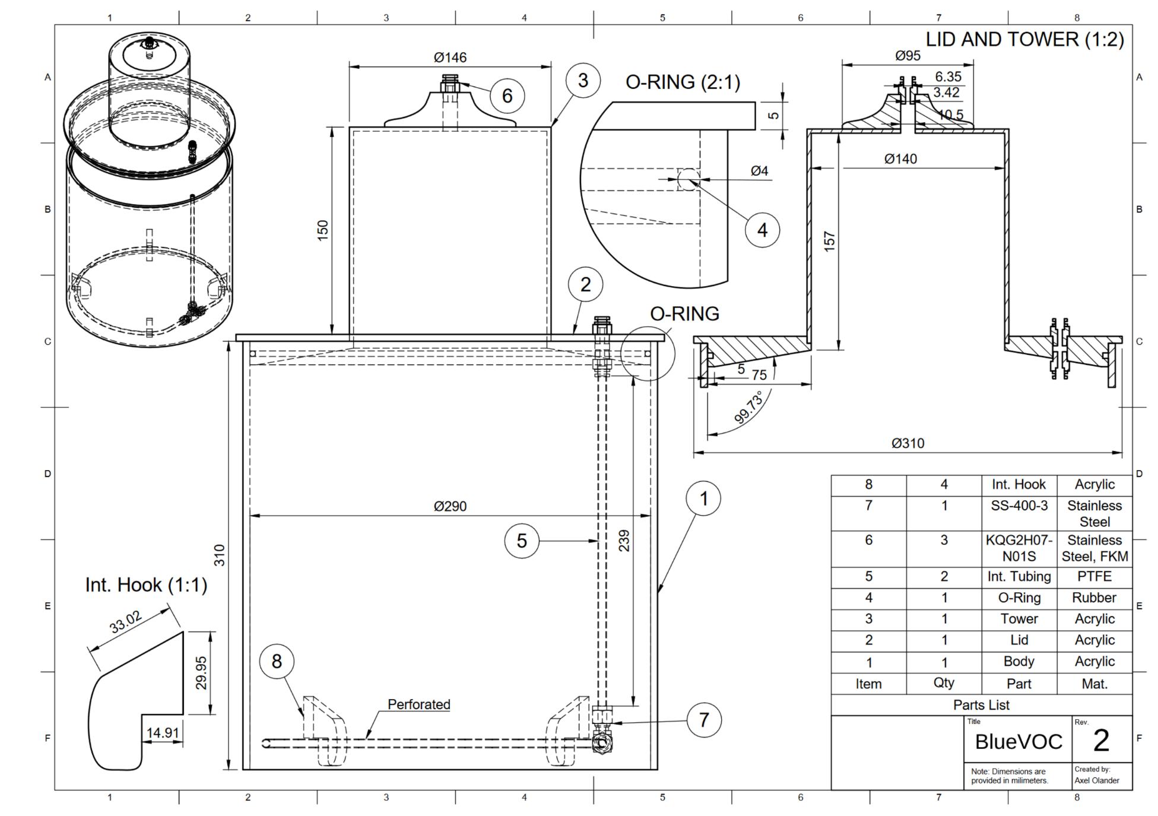
Fig. S4: Technical drawing of BlueVOC 2.0.
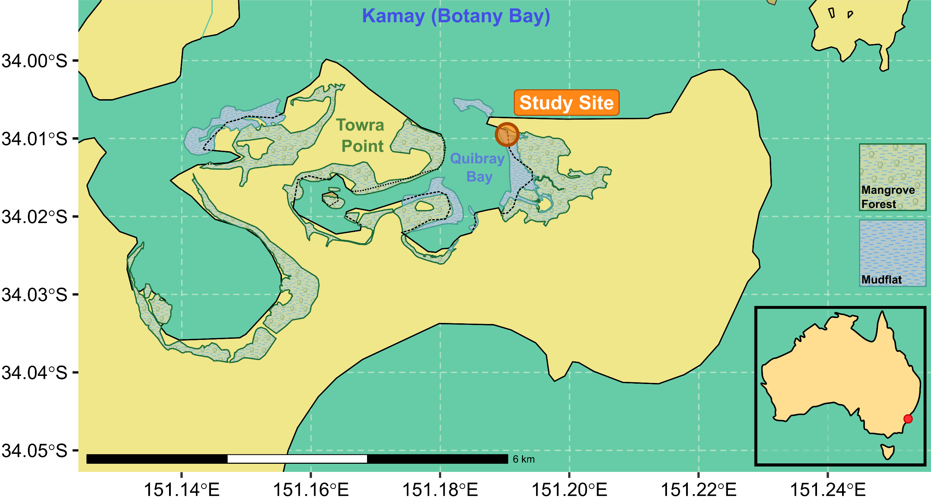
Fig. S5: Map of Kurnell, located on the southern side of Kamay (Botany Bay), Sydney, Australia. The BlueVOC 2.0 methodology was applied at the study site illustrated, at the border of a mangrove forest and mudflat.
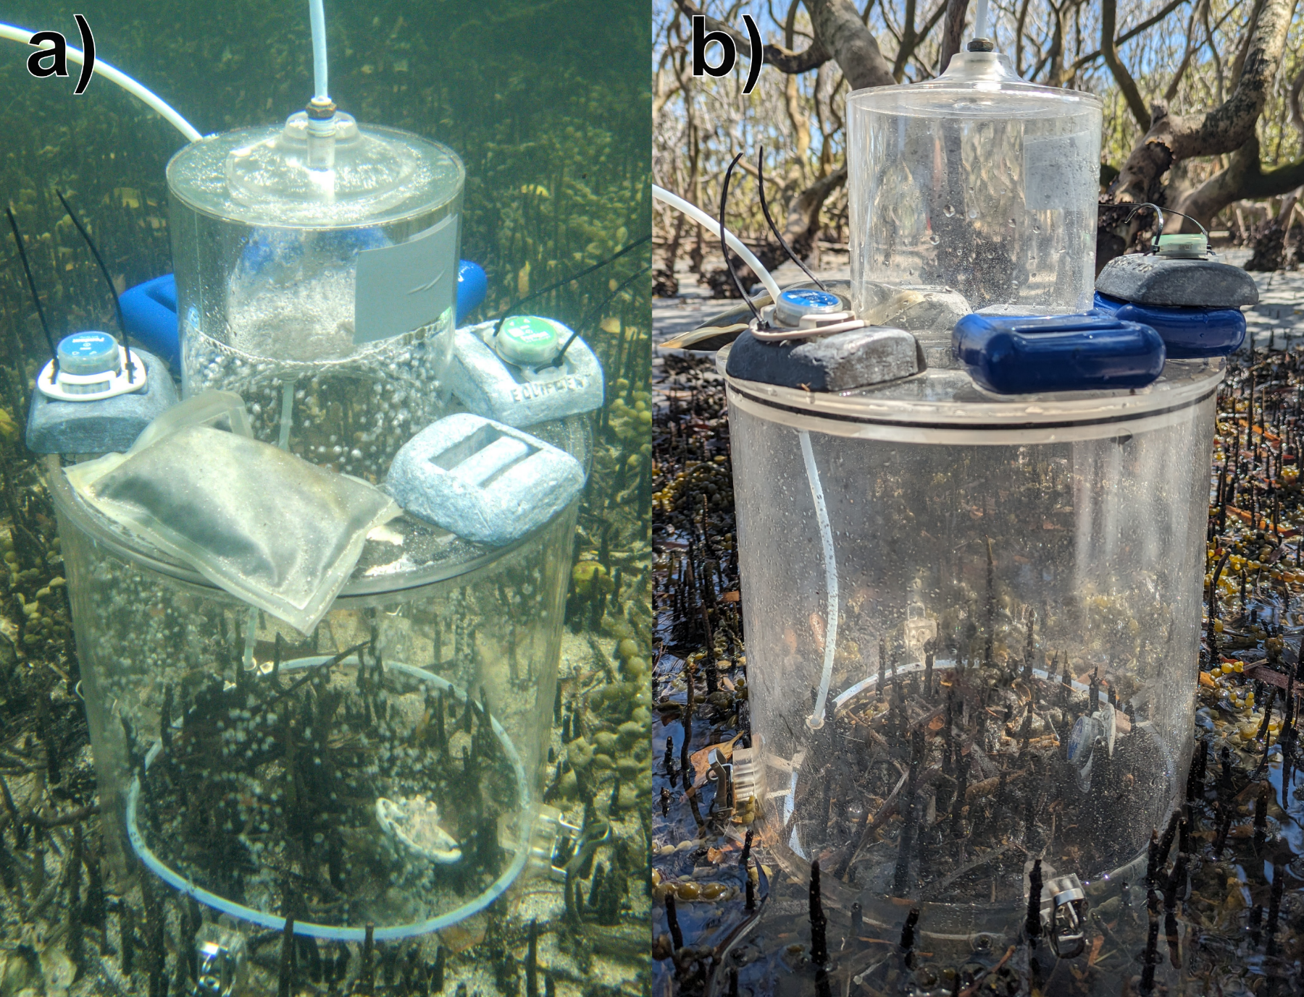
Fig. S6: Images of BlueVOC 2.0 during a) submerged and b) exposed sampling of volatiles from Avicennia marina pneumatophores at Towra Point Aquatic Reserve, Sydney.
Table S1: Auxiliary data from deployment of the revised BlueVOC system.
Date | Time | Treatment | Tidal State | Tidal Height (m) | BlueVOC internal temperature (°C) | BlueVOC external temperature (°C) | Fv/Fm (± SE) | pH | DO2(%) | Salinity (mS/cm)
26/09/2023 | 12:15 | Mangrove 1 | Exposed | 0.6 | 22.01 | - | 0.717 ± 0.031 | 7.97 | 101.6 | 53.2
26/09/2023 | 13:20 | Sediment 1 | Exposed | 0.9 |  |  |  | 7.97 | 101.6 | 53.2
26/09/2023 | 15:19 | Mangrove 2 | Submerged | 1.5 | 21.05 | - | 0.761 ± 0.024 | 7.97 | 101.6 | 53.2
26/09/2023 | 16:30 | Sediment 2 | Submerged | 1.7 |  |  |  | 7.97 | 101.6 | 53.2
12/10/2023 | 11:36 | Mangrove 3 | Exposed | 0.8 | 24.03 | 25.23 | 0.688 ± 0.023 | 7.92 | 116.5 | 53.8
12/10/2023 | 13:08 | Sediment 3/4 | Exposed | 0.6 |  |  |  | 7.92 | 116.5 | 53.8
12/10/2023 | 14:11 | Mangrove 4 | Exposed | 0.6 | 28.56 | 35.74 | 0.677 ± 0.032 | 7.92 | 116.5 | 53.8
3/11/2023 | 11:05 | Mangrove 5 | Submerged | 1.5 | 18.55 | 18.51 | 0.541 ± 0.052 | 8.2 | 105 | 54
3/11/2023 | 12:35 | Sediment 5/6 | Submerged | 1.6 |  |  |  | 8.2 | 105 | 54
3/11/2023 | 14:04 | Mangrove 6 | Submerged | 1.5 | 19.94 | 20.10 | 0.537 ± 0.049 | 8.2 | 105 | 54
10/11/2023 | 11:06 | Mangrove 7 | Exposed | 0.8 | 24.04 | 27.22 | 0.600 ± 0.050 | 7.96 | 135.5 | 52.6
10/11/2023 | 12:32 | Sediment 7/8 | Exposed | 0.6 |  |  |  | 7.96 | 135.5 | 52.6
10/11/2023 | 14:06 | Mangrove 8 | Exposed | 0.6 | 29.13 | 28.49 | 0.705 ± 0.020 | 7.96 | 135.5 | 52.6
18/11/2023 | 11:21 | Mangrove 9 | Submerged | 1.7 | 21.74 | 21.97 | 0.628 ± 0.038 | 8.23 | 107 | 53.2
18/11/2023 | 13:28 | Mangrove 10 | Submerged | 1.7 | 21.98 | 22.59 | 0.609 ± 0.037 | 8.23 | 107 | 53.2
18/11/2023 | 15:21 | Sediment 9/10 | Submerged | 1.3 |  |  |  | 8.23 | 107 | 53.2

Note S1: Full BlueVOC 2.0 volatile analysis methodology
As described for sampling using BlueVOC 1.0, collected TDTs were injected with 0.2 μL of 10 ppm d5-chlorobenzene to act as an internal standard, before being desorbed for analysis using a Unity–Ultra-xr automated thermal desorption unit (Markes International). Samples were first subject to a pre-purge period of four minutes, ran with a split of 30 mL/min, before undergoing thermal desorption at 300°C for another four minutes. Desorbed gases were carried using He (high purity grade 5.0, BOC) at a flow rate of 30 ml/min with a split of 35 ml/min to a General Purpose Carbon C4/5-C30/32 cold trap (Markes international) held at -15°C. The trap was then flash heated to 300°C and desorbed for three minutes at 30 ml/min. Desorbed samples were then carried by a 1.4 m fused silica transfer line (Markes international) to a Pegasus BT 4D GC×GC–TOFMS (LECO) for analysis.
The GC×GC was installed with the same columns used previously, a RXI-624Sil MS (30 m × 0.25 mm inner diameter, 1.4 μm film thickness, Restek corp.) as the primary, and a Stabilwax (1.59 m × 0.25 mm inner diameter, 0.5 μm film thickness, Restek corp.) as the secondary, again connected by a SilTite μ-Union connector (SGE Analytical Science). He was used as the carrier gas maintained at a constant flowrate of 1 mL/min. The primary oven was held at an initial temperature of 35°C for five minutes, before being heated to 240°C at a rate of 5°C/min, where temperature was held for a further five minutes. The secondary oven and modulator were offset by +15°C and +20°C respectively, relative to the primary oven, with a modulation period of five seconds, with a hot pulse time of 1 sec, and a 1.5 sec cool time between stages. The transfer line was maintained at 250°C, with mass acquisition performed between 29 and 450 amu at a rate of 200 spectra/s.

