S1. Keywords and Boolean search strategies used for the systematic literature search on SCA27

 | Key words
Pubmed | (("Spinocerebellar ataxia 27B"[Title/Abstract] OR "SCA27B"[Title/Abstract] OR "SCA-27B"[Title/Abstract])  OR  ("FGF14"[Title] AND ("ataxia"[Title/Abstract] OR "GAA"[Title/Abstract])))  AND (humans[Filter])
Scopus | "spinocerebellar ataxia 27B" OR SCA27B OR "GAA-FGF14" OR "FGF14 (GAA)" OR "FGF14 repeat expansion" OR "GAA/FGF14" 95
Ovid medline | (spinocerebellar ataxia 27B or SCA27B or SCA 27B or SCA-27B).ti,kf.
Embase | ('spinocerebellar ataxia 27b':ti OR 'sca27b':ti OR ('fgf14':ti AND 'gaa':ti)) AND [article]/lim

S2. Summary table of demographic, clinical features and number of repeats in SCA27B cases (n= 1228)
Author, year of publication | Number of patients | Age of onset (in years) | Age at presentation (in years) | Sex | Family history | Symptoms at onset | Vertigo and dizziness | Dysarthria | Nystagmus  -specify type | Oculomotor disorders | Pyramidal signs | Cerebellar Ataxia | Tremors | Amyotrophy | Extrapyramidal symptoms | Dysautonomia | H/o fever at onset or other triggers | Episodic symptoms | Genetics (No of repeats) | Treatment
Pellerin D et al 2023¹ | 68 | 54 ± 14 | 59 ± 12 | 36 F  (53%), 32 M(47%) | 58(85%) | NA | 21/64 (33%) | 39/68 (57%) | 37/65 (57%)/ DB 43/65 (66%) | 39/66 (59%) | NA | NA | 6/60 (10%) | NA | NA | NA | NA | NA | ≥250 | NA
Pellerin D et al 2023¹ | 48 | 62± 7 | 60± 11 | 24 F (50%), 24 M(50%) | 22/44 (50%) | NA | 10/44 (23%) | 21/44 (48%) | 25/48 (52%)/ DB 5/48 (10%) | 16/48 (33%) | NA | NA | 11/48 (23%) | NA | NA | NA | NA | NA | ≥250 | NA
Pellerin D et al 2023¹ | 3 | 48 | 57± 11 | 0 F, 3 M(100%) | 1/3 (33%) | NA | 0/3 (0%) | 2/3 (67%) | 2/3 (67%)/ DB 0/3 (0%) | 0/3 (0%) | NA | NA | 0/3 (0%) | NA | NA | NA | NA | NA | ≥250 | NA
Pellerin D et al 2023¹ | 3 | 67 | 62± 9 | 0 F,3 M  (100%) | 1/3 (33%) | NA | 2/3 (67%) | 1/3 (33%) | 1/3 (33%)/DB 2/3 (67%) | 2/3 (67%) | NA | NA | 1/3 (33%) | NA | NA | NA | NA | NA | ≥250 | NA
Wirth et al 2023⁴ | 15 | 67.5 ±7 | 72.4± 6.3 | 4 F (27%)  11 M (73%) | NA | NA | 10 (66.7%) | 6 (42.9%) | 10 (66.7%)/NA | 12 (80%) | 3 (21.4%) | 10  (64.3%) | 2  (14.3%) | 1 (7.7%) | 2 (14.3%) | 3  (20%) | NA | NA | Median GAA repeats 346 (281, 525) repeats | NA
Wirth T et al 2024⁵ | 19 | 67.9 ± 6.52 | 72.6 ± 5.84 | NA | NA | NA | 11 (73.7%) | 7 (38.9%) | 12 (63.2%)/NA | 15 (78.9%) | 4 (22.2%) | 8  (42.1%) | 2(11.1%) | 1 (5.8%) | 4 (22.2%) | 1(5.8%) | NA | 8  (42.1%) | ≥250 | NA
Kartanou C et al 2024¹⁹ | 19 | 60.5 ± 12.3 | 67.9 ± 11.6 | 10 F (5%)  9 M  (4%) | 6 (31.6%) | NA | 5(26.3%) | 15 (78.9%) | 10 (52.6%) /DB 6 (31.6%) | NA | 3 (15.8%) | 19 (100%) | 0 | NA | 0 | 0 | NA | 7 (36.8%) | ≥250 | NA
Iruzubieta P et al 2023²⁰ | 18 | 55 (30-82) | 67 (44-87) | 47 F (44%)  60M (5 %) | 7/17 (41.2%) | NA | 6/14 (42.8%) | 12/18 (66.67%) | 6/16 (37.5%)/ DB 6/16 (37.5%) | NA | 7 (38.8%) | 18 (100%) | NA | NA | 2  (11.1%) | 5/15 (33.3%) | NA | 7 (38.8%) | ≥250 | NA
Wilke C et al 2023¹⁵ | 50 | 60 (53.5-68.5) | 73.4 (66.5-78) | 25 F (50%)  25 M  (50%) | NA | Impaired gait (79%)-  40 | 9/43 (21%) | 25/42 (59.5%) | NA/NA | 38/43 (88.37%) | 1/40 (2.5%) | 41/43 (95.3%) | 14/27 (51.8%) | 1/33 (3%) | 4/33 (12.12%) | 14/36 (38.8%) | NA | 6/47 (12.76%) | Repeat count of longer allele 349 (316-402)  Repeat count of shorter allele 16 (8-52) | 7/50 (14%)  4- Amino  Pyridine  6 (86%) Improved
Indelicato E et al 2025²¹ | 6 | 55.83 ± 11.07 | NA | 3 F (50%)  3 M  (50%) | 6/6 (100%) | NA | NA | NA | NA/DB 3/6 (50%) | NA | NA | NA | NA | NA | NA | NA | NA | 6/6 (100%) | ≥250 | NA
Satolli S et al 2024²² | 64 | 62 median | NA | NA | 27/53 (50.94%) | NA | 14/47 (30%) | 32/64 (50%) | NA/ DB 7/23 (30%) | 52/63 (82.5%) | 5/64 (8%) | 63/64 (98%) | 25/63 (40%) | NA | 11/63 (17%) | 21/63 (33%) | NA | 20/64 (31%) | 23 - GAA 250-299, 39- GAA ≥ 300 | NA
Hirschfeld et al AS 2025²³ | 1 | 60 | 64 | M | Yes | Impaired gait | No | Yes | No | No | No | Yes | No | No | No | No | No/Physical activity | Yes Dysarthria, dysphagia, diplopia | Repeat count of longer allele 420/Repeat count of lower allele 94 | NA
Pinheiro-Barbosa R et al 2024²⁴ | 20 | 58.35±11.56 | 64.55±11.79 | 6 F (30%),14 M  (70%) | NA | NA | 7 (35%) | 11 (55%) | NA / DB 4 (20.00%) | 17 (85.00%) | 12 (60%) | 15 (75%) | 3 (15%) | NA | 0 | 2 (10%) | NA | 12 (60%) | Median 351.25±60.68 | NA
Abou Chaar W et al 2024¹³ | 102 | 57 ± 12.5 | NA | 44 F (43%) 58 M (57%) | NA | NA | Dizziness 39 /90 (43%)  Vertigo 28/ 86 (33%) | 68/96 (71%) | 80/93 (86%)/  DB 48/69 (70%) | 87/98 (89%) | NA | 99/101 (98%) | 23/93 (25%) | NA | NA | 23/70 (33%) | NA | 51/100 (51%) | Median repeat size 1- 18 (9.5-51),  Median size repeats 2- 337 (297- 392) | 28 patients-  4 aminopyridine  or dalfampridine  ER,  21 patients (75%)  Improved
Miyatake S et al 2024²⁵ | 8 patients with GAA repeats ≥250 | 55 | NA | NA | Yes | Impaired gait | No | NA | Yes/DB Yes | NA | No | Yes | NA | NA | NA | NA | NA | No | GAA≥250, 17/402 | NA
Miyatake S et al 2024²⁵ |  | 64 | NA | NA | No | Impaired gait, Dysarthria | NA | NA | NA | NA | NA | Yes | NA | NA | NA | NA | NA | NA | GAA≥250,  14/363 | NA
Miyatake S et al 2024²⁵ |  | 73 | NA | NA | Yes | Impaired gait, Dysarthria | Yes | NA | No/ DB No | NA | No | Yes | NA | NA | NA | NA | NA | Yes | GAA≥250, 8/300 | NA
Miyatake S et al 2024²⁵ |  | 74 | NA | NA | Yes | Dysesthesias of LL | Yes | NA | Yes/DB Yes | NA | No | Yes | NA | NA | NA | NA | NA | No | GAA≥250, 10/293 | NA
Miyatake S et al 2024²⁵ |  | 78 | NA | NA | No | Impaired gait | Yes | NA | Yes/ DB No | NA | Yes | Yes | NA | NA | NA | NA | NA | No | GAA≥250, 9/282 | NA
Miyatake S et al 2024²⁵ |  | 56 | NA | NA | Yes | Impaired gait | No | NA | No/DB No | NA | No | Yes | NA | NA | NA | NA | NA | No | GAA≥250, 17/269 | NA
Miyatake S et al 2024²⁵ |  | 66 | NA | NA | No | Dizziness | Yes | NA | Yes/ DB Yes | NA | No | Yes | NA | NA | NA | NA | NA | No | GAA≥250, 9/259 | NA
Miyatake S et al 2024²⁵ |  | 68 | NA | NA | No | NA | NA | NA | Yes/DB Yes | NA | NA | Yes | NA | NA | NA | NA | NA | NA | GAA≥250, 26/254 | NA
Miyatake S et al 2024²⁵ | 6 patients with GAA repeats 200-250 | 71 | NA | NA | No | Oscillopsia | No | NA | Yes/DB Yes | NA | Yes | Yes | NA | NA | NA | NA | NA | No | GAA 200-250, 9/242 | NA
Miyatake S et al 2024²⁵ |  | 73 | NA | NA | Yes | Dizziness, Vomiting | Yes | NA | Yes/DB No | NA | No | Yes | NA | NA | NA | NA | NA | Yes | GAA 200-250, 10/240 | NA
Miyatake S et al 2024²⁵ |  | 72 | NA | NA | Yes | Impaired gait, Dysarthria | No | NA | Yes/ DB No | NA | No | Yes | NA | NA | NA | NA | NA | Yes | GAA 200-250, 9/230 | NA
Miyatake S et al 2024²⁵ |  | 77 | NA | NA | No | Dysarthria, Dysphagia, Impaired gait | Yes | NA | No/No | NA | Yes | Yes | NA | NA | NA | NA | NA | Yes | GAA 200-250, 9/229 | NA
Miyatake S et al 2024²⁵ |  | 75 | NA | NA | No | Impaired gait | Yes | NA | Yes/ DB No | NA | No | Yes | NA | NA | NA | NA | NA | No | GAA 200-250, 152/227 | NA
Miyatake S et al 2024²⁵ |  | 65 | NA | NA | Yes | Impaired gait | NA | NA | No/DB No | NA | No | Yes | NA | NA | NA | NA | NA | No | GAA 200-250, 10/213 | NA
Mendes Ferreira V et al 2025²⁶ | 1 | 58 | 62 | M | Yes | Impaired gait | No | Yes | No/DB No | Yes, Impaired pursuit | No | Yes | No | No | No | No | Yes/ Exercise, physical activity | Yes | > 360 repeats | Riluzole,  worsening  reported
Rettenmaier A L et al 2025²⁷ | 10 | 48 (24.5–52.8) | 54 | 6 F (60%), 4 M (40%) | 4 (40%) | NA | NA | 2 (20%) | 10 (100%)/ DB 10 (100%) | 10 (100%) | NA | 5 (50%) | 2 (20%) | NA | NA | NA | No/ Alcohol 2 (20%) Fatigue 4 (40%), Emotional stress 2 (20%) | 5 (50%) | GAA repeats<200 | NA
Rettenmaier A L et al 2025²⁷ | 2 | 69, 72 | 74, 78 | 1 F (50%), 1 M (50%) | 0 | NA | NA | 1 (50%) | 2 (100%)/  DB 2 (100%) | 2 (100%) | NA | 2 (100%) | 1 (50%) | NA | NA | NA | No/ Alcohol 1 (50%), Fatigue 2 (100%) | 2 (100%) | GAA repeats 200-249 | NA
Rettenmaier A L et al 2025²⁷ | 27 | 63 (54.3–66.0) | 68 | 12 F (44%), 15 M (56%) | 17 (63%) | NA | NA | 7 (26%) | 26 (96%)/ DB 21 (78%) | 26 (96%) | NA | 17 (63%) | 5 (19%) | NA | NA | NA | No/lcohol 11 (41%), Fatigue 21 (78%), Emotional stress 9 (33%) | 22 (82%) | GAA repeats ≥250 | NA
Kytovuori L et al 2025²⁸ | 6 | 64 | 75 | M | No | Impaired gait | NA | No | No | NA | NA | NA | NA | NA | NA | NA | NA | No | GAA repeats  326/9 | NA
Kytovuori L et al 2025²⁸ |  | 71 | 88 | M | Yes | Impaired gait, Dysarthria | NA | Yes | Yes/ DB NA | NA | NA | Yes | NA | NA | NA | NA | No/Exercise, Heat | Yes | GAA repeats 372/8 | NA
Kytovuori L et al 2025²⁸ |  | 63 | 72 | F | No | Nystagmus | NA | Yes | Yes/ DB NA | NA | NA | Yes | NA | NA | NA | NA | No/  Exercise | Yes | GAA repeats 300/300 | NA
Kytovuori L et al 2025²⁸ |  | 70 | 86 | M | No | Decreased strength in LLs, Impaired gait | NA | Yes | Yes/ DB NA | NA | NA | NA | NA | NA | NA | NA | No/ Fatigue, Exercise | Yes | GAA repeats 278/15 | NA
Kytovuori L et al 2025²⁸ |  | 24 | 48 | M | Yes | Dysarthria | NA | Yes | No | NA | NA | NA | NA | NA | NA | NA | No/ No triggers | No | GAA repeats 330/15 | NA
Kytovuori L et al 2025²⁸ |  | 18 | 27 | M | Yes | Dysarthria, Impaired gait | NA | Yes | No | NA | NA | Yes | NA | NA | NA | NA | No/Alcohol | Yes | GAA repeats 248/15 | NA
Shirai S et al 2023²⁹ | 2 | 74 | 76 | F | Yes | Impaired gait | No | No | Yes/DB Yes | Yes | No | Yes | No | No | No | No | No | No | GAA repeats 293 | NA
S Shirai S et al 2023²⁹ |  | 65 | 77 | M | No | Nystagmus, Impaired gait | No | No | Yes/DB Yes | No | No | Yes | No | No | No | No | No | No | GAA repeats 259 | NA
Prasad G et al 2025²⁹ | 17 | 33 | 44 | M | Yes | NA | NA | Yes | Yes/ DB No | No | NA | Yes | NA | NA | NA | NA | NA | NA | 21/621 | NA
Prasad G et al 2025³⁰ |  | 23 | 29 | F | Yes | NA | NA | Yes | Yes/ DB Yes | No | NA | Yes | NA | NA | NA | NA | NA | NA | 367/616 | NA
Prasad G et al 2025³⁰ |  | 42 | 42 | M | Yes | NA | NA | Yes | Yes/ DB No | No | NA | Yes | NA | NA | NA | NA | NA | NA | 9/454 | NA
Prasad G et al 2025³⁰ |  | 35 | 55 | M | Yes | NA | NA | Yes | Yes/DB Yes | Yes | NA | Yes | NA | NA | NA | NA | NA | NA | 8/409 | NA
Prasad G et al 2025³⁰ |  | 50 | 55 | M | No | NA | NA | Yes | Yes/ DB Yes | No | NA | Yes | NA | NA | NA | NA | NA | NA | 35/377 | NA
Prasad G et al 2025³⁰ |  | 55 | 58 | M | No | NA | NA | No | No | No | NA | Yes | NA | NA | NA | NA | NA | NA | 9/317 | NA
Prasad G et al 2025³⁰ |  | 20 | 23 | F | NA | NA | NA | NA | NA | NA | NA | NA | NA | NA | NA | NA | NA | NA | 16/313 | NA
Prasad G et al 2025³⁰ |  | 36 | 63 | M | Yes | NA | NA | Yes | No | No | NA | Yes | NA | NA | NA | NA | NA | NA | 17/298 | NA
Prasad G et al 2025³⁰ |  | 40 | 45 | M | No | NA | NA | No | No | Yes | NA | Yes | NA | NA | NA | NA | NA | NA | 16/297 | NA
Prasad G et al 2025³⁰ |  | 65 | 66 | M | No | NA | NA | No | No | Yes | NA | Yes | NA | NA | NA | NA | NA | NA | 9/297 | NA
Prasad G et al 2025³⁰ |  | 28 | 29 | M | NA | NA | NA | NA | NA | NA | NA | NA | NA | NA | NA | NA | NA | NA | 63/283 | NA
Prasad G et al 2025³⁰ |  | 1 | 17 | F | No | NA | NA | Yes | Yes/ DB No | Yes | NA | Yes | NA | NA | NA | NA | NA | NA | 235/268 | NA
Prasad G et al 2025³⁰ |  | NA | 57 | F | No | NA | NA | NA | NA | NA | NA | NA | NA | NA | NA | NA | NA | NA | 8/263 | NA
Prasad G et al 2025³⁰ |  | 51 | 52 | M | No | NA | NA | NA | NA | NA | NA | NA | NA | NA | NA | NA | NA | NA | 8/251 | NA
Prasad G et al 2025³⁰ |  | 27 | 37 | M | No | NA | NA | Yes | No | Yes | NA | Yes | NA | NA | NA | NA | NA | NA | 17/247 | NA
Prasad G et al 2025³⁰ |  | 52 | 54 | M | No | NA | NA | Yes | No | No | NA | Yes | NA | NA | NA | NA | NA | NA | 169/247 | NA
Prasad G et al 2025³⁰ |  | 11 | 17 | F | Yes | NA | NA | No | No | No | NA | No | NA | NA | NA | NA | NA | NA | 8/229 | NA
Iruzubieta et al 2025³¹ | 17 | 52 (IQR 46–58) | 66 (IQR 56-72) | 9 F (53%), 8 M  (47%) | 11/15 (73%) | NA | 8/10 (80%) | 4/11 (36%) | NA/ DB 6/17 (35%) | 11/17 (65%) | 4/16 (25%) | 13/17 (76%) | 6/13 (46%) | NA | NA | NA | NA | Yes, 8/13 (62%) | GAA repeat size200–249 | NA
IIruzubieta et al 2025³¹ | 17 | 56 (IQR 51.5–60.5) | 76 (IQR 71-81) | 5 F (29%), 12M (71%) | 13/16 (81%) | NA | 6/15 (40%) | 6/9 (67%) | NA/ DB 8/16 (50%) | 11/16 (69%) | 1/17 (6%) | 16/17 (94%) | 0/15 (0%) | NA | NA | NA | NA | Yes  7/9 (78%) | GAA repeats 250–299 | NA
Iruzubieta et al 2025³¹ | 91 | 51 (IQR 40–62) | 68.5 (IQR 61.8- 75) | 48 F (53%), 43 M (47%) | 74/85 (87%) | NA | 30/69 (43%) | 31/49 (63%) | NA/ DB 46/86 (53%) | 65/86 (76%) | 10/86 (12%) | 78/87 (90%) | 13/72 (18%) | NA | NA | NA | NA | Yes  54/63 (86%) | GAA repeats ≥300 | NA
Mitrotti P et al 2024³² | 1 | 11 | 53 | F | No | Impaired gait | Yes | Yes | Yes/ DB Yes | Yes | Yes | Yes | Yes | No | No | No | No | Yes | GAA repeats 302 | 4- Aminopyridine  10mg BD  Improvement
Bonnet C et al 2023 ³ French Canadian | 22 | 54±9 | NA | 9 F (41%),13 M  (59%) | 17 (77%) | NA | 8/20 (40%) | NA | 20 (91%)/ DB NA | 15/21 (71%) | NA | 21 (95%) | NA | NA | NA | NA | NA | 16 (73%) | GAA repeats 333 (287–392) | NA
Bonnet C et al 2023 ³ French | 11 | 64±9 | NA | 7 F(64%), 4 M(36%) | 7 (64%) | NA | 5/10 (50%) | NA | 8 (73%)/DB NA | 5/9 (56%) | NA | 11 (100%) | NA | NA | NA | NA | NA | 8 (73%) | GAA repeats 370 (313–492) | NA
Novis et al 2023³³ | 9 | 45 | 84 | F | Yes | NA | No | No | Yes/DB No | No | NA | Yes | Yes | NA | NA | NA | NA | No | 253 | NA
Novis et al 2023³³ |  | 40 | 65 | M | Yes | NA | No | No | Yes/ DB No | Yes | NA | Yes | No | NA | NA | NA | NA | No | 268 | NA
Novis et al 2023³³ |  | 67 | 73 | F | NA | NA | No | No | No | No | NA | Yes | No | NA | NA | NA | NA | No | 376 | NA
Novis et al 2023³³ |  | 28 | 51 | F | NA | NA | Yes | No | No | Yes | NA | Yes | No | NA | NA | NA | NA | Yes | 449 | NA
Novis et al 2023³³ |  | 60 | 63 | M | NA | NA | Yes | No | Yes/DB No | Yes | NA | Yes | No | NA | NA | NA | NA | No | 363/448 | NA
Novis et al 2023³³ |  | 59 | 68 | M | NA | NA | Yes | No | Yes/ DB No | Yes | NA | Yes | No | NA | NA | NA | NA | No | 424 | NA
Novis et al 2023³³ |  | 63 | 75 | M | NA | NA | No | No | Yes/ DB No | No | NA | Yes | No | NA | NA | NA | NA | No | 303 | NA
Novis et al 2023³³ |  | 57 | 64 | M | NA | NA | Yes | No | Yes/ DB No | Yes | NA | Yes | No | NA | NA | NA | NA | No | 259 | NA
Novis et al 2023³³ |  | 60 | 78 | F | NA | NA | No | No | Yes/ DB No | No | NA | Yes | No | NA | NA | NA | NA | No | 257 | NA
Chen S et al 2024³⁴ | 35 | 52 (25–75) | 9 (1–34) | 15 F (42.85%), 20 M (57.14%) | NA | NA | NA | NA | 20 (57.1%)/ DB 20 (57.1%) | NA | NA | 29 (93.5%) | NA | NA | NA | NA | NA | 2 (6.2%) | NA | NA
Pellerin D et al 2024³⁵ | 82 | 67 (61.75–71.5) | NA | 38 F (46%), 44 M (54%) | NA | NA | 23/82 (28%) | 13/81(61%) | 57/82 (70%)/  DB No | 80/81 (99%) | 1/77 (1%) | 12/79 (15%) | 67/79 (85%) | NA | NA | NA | NA | 11/81(14%) | ≥250 | NA
Pellerin D et al 2024³⁵ | 20 | 72 (64–77.5) | NA | 9 F (45%), 11 M (55%) | NA | NA | 10/20(50%) | 4/19 (21%) | 11/20 (55%)/ DB No | 20/20 (100%) | 0/18 (0) | 2/18 (11%) | 13/19 (68%) | NA | NA | NA | NA | 0/19 (0%) | 200-249 | NA
Pellerin D et al 2024³⁵ | 68 | 66 (54.75-75) | NA | 28 F (41%), 40 M (59%) | NA | NA | 26/68 (38%) | 13/66 (20%) | 42/67 (63%)/ DB No | 59/67 (88%) | 2/66 (3%) | 6/66 (9%) | 44/64 (69%) | NA | NA | NA | NA | 18/66 (27.2%) | <200 | NA
Ignjatijevic et al 2025³⁶ | 19 | NA | NA | NA | NA | NA | 8/19 (42%) | 10/19 (53%) | 12/19 (63%)/ DB 6/19(32% ) | NA | NA | NA | 18/19 (95%) | NA | NA | NA | NA | 7/19 (37%) | ≥250 | NA
Chukwuocha I 2025³⁷ | 50 | NA | NA | 19 F (38%), 31 M (62% ) | NA | NA | NA | 18 (36%) | 39 (78%)/ DB 25 (50%) | NA | 50 (100%) | 11 (22%) | NA | NA | NA | NA | NA | 14(28%) | NA | 23 patients-  3,4  Diaminopyridine
Tiyasha De et al 2024³⁸ | 23 | 50.2±17.22 | 51.2±16.6 | 4 F (17.3%) , 19 M  (82.6%) | Yes (13%) | NA | NA | NA | NA | NA | NA | NA | NA | NA | NA | 2 (8.7%) | NA | NA | Mean GAA repeats 338±81 | NA
Koutsis G et al 2024³⁹ | 20 | 60.9 ± 12.1 | 68.1 ± 11.3 | 10 F  (50%) 10 M(50%) | Yes  7 (35%) | NA | 5 (25%) | 16 (80%) | 10 (50%)/ DB 6 (30%) | NA | NA | 20 (100%) | NA | NA | 0 | 0 | NA | 7 (35%) | NA | NA
Pellerin D et al 2024⁴⁰ | 1 | NA | 74 | F | Yes | No | No | No | No | No | Yes | No | No | No | No | No | No | No | 484/9 | No
Borsche M et al 2024⁴¹ | 9 | 62.3 ± 10.7 | 70.7 ± 11.7 | 7 F (78%), 2 (22%) | NA | NA | NA | NA | NA / DB 9 (100%) | NA | 9 (100%) | NA | NA | NA | NA | NA | NA | NA | NA | NA
Halstuk O et al 2024⁴² | 5 | 56 | 74 | M | Yes | Transient diplopia | Yes | NA | Yes/ DB Yes | NA | NA | NA | NA | NA | NA | NA | NA | NA | 293/39 | NA
Halstuk O et al 2024⁴² |  | 40 | 64 | F | Yes | Impaired gait | No | NA | Yes/ DB No | NA | Yes | NA | NA | NA | NA | NA | NA | NA | 301/12 | NA
Halstuk O et al 2024⁴² |  | 67 | 81 | M | Yes | Impaired gait | Yes | NA | Yes/No DB | NA | Yes | NA | NA | NA | NA | NA | NA | NA | 349/10 | NA
Halstuk O et al 2024⁴² |  | 59 | 70 | M | No | Impaired gait, dysarthria | Yes | NA | Yes/ DB Yes | NA | Yes | NA | NA | NA | NA | NA | NA | NA | 259/70 | NA
Halstuk O et al 2024⁴² |  | 60 | 84 | F | Yes | Impaired gait | Yes | NA | Yes/ DB No | NA | Yes | NA | NA | NA | NA | NA | NA | NA | 278/15 | NA
Milovanovic et al 2024⁴³ | 9 | 53 | 69 | F | No | Episodic Vertigo,  nausea | NA | Yes | Yes/ DB Yes | Yes | No | Yes | Yes | NA | NA | NA | NA | NA | 480 | NA
Milovanovic et al 2024⁴³ |  | 56 | 57 | M | No | Impaired gait | NA | Yes | Yes/ DB No | No | No | Yes | Yes | NA | NA | NA | NA | NA | 330 | NA
Milovanovic et al 2024⁴³ |  | 54 | 59 | F | Yes | Impaired gait | NA | Yes | Yes/DB Yes | No | No | Yes | Yes | NA | NA | NA | NA | NA | 280 | NA
Milovanovic et al 2024⁴³ |  | 35 | 43 | F | Yes | Incoordination with hands ,episodic vertigo | No | No | No | No | No | Yes | No | NA | NA | NA | NA | NA | 300 | NA
Milovanovic et al 2024⁴³ |  | 36 | 46 | F | Yes | Impaired gait | No | Yes | Yes/ DB No | Yes | No | Yes | Yes | NA | NA | NA | NA | NA | 400 | NA
Milovanovic et al 2024⁴³ |  | 54 | 66 | M | No | Impaired gait | NA | No | Yes/ DB Yes | No | No | Yes | NA | NA | NA | NA | NA | NA | 350 | NA
Milovanovic et al 2024⁴³ |  | 66 | 74 | M | No | Impaired gait | NA | Yes | Yes/DB No | Yes | No | Yes | NA | NA | NA | NA | NA | NA | 270 | NA
Milovanovic et al 2024⁴³ |  | 27 | 33 | F | Yes | Impaired gait | NA | Yes | Yes/ DB No | Yes | No | Yes | NA | NA | NA | NA | NA | NA | 450 | NA
Milovanovic et al 2024⁴³ |  | 18 | 35 | M | No | Episodic vertigo, nausea | NA | Yes | No | No | No | Yes | NA | NA | NA | NA | NA | NA | 280 | NA
Ariello L E et al 2025⁴⁴ | 20 | 63 (50.3–75.7) | 74.5 (66.1–82.8) | 10 F, 10 M | 11/20 (55%) | NA | 17/20, (85%) | 11/20, (55%) | 20/20 (100%)/DB NA | 13/20, (65%) | NA | 20/20, (100%) | NA | NA | NA | NA | NA | NA | Median 357.53 (275.11–439.95) | NA
Coulette S et al 2025⁴⁵ | 12 | 57 (52-62) | 68 (64-71) | 6 F (50%), 6 M (50%) M | NA | NA | 2 (33%) | NA | 12(100%)/ DB 11 (92%) | NA | NA | NA | NA | NA | NA | NA | NA | NA | 312 (265;  380)/ 12 (9;  22) | NA
Coulette S et al 2025⁴⁵ | 22 | 68 (55-72) | 74 (64-78) | 11 F (50%) , 11 M (50%) | NA | NA | 2 (33%) | NA | 13 (59%)/DB 8 (36%) | NA | NA | NA | NA | NA | NA | NA | NA | NA | 17 (12;48)/ 9 (9;15) | NA
Wong T H et al 2025⁴⁶ | 1 | 67 | 71 | F | Yes | Diplopia, dysarthria, vertigo, Impaired gait | Yes | Yes | Yes/ DB Yes | Yes | No | Yes | No | No | No | No | No | No | >300 | NA
Kakumoto T et al 2024⁴⁷ | 6 | 65.5 (57–71) | 74.0 (64–78) | 2 F (33.3%), 4 M (66.7%) | 1 (16.7%) | NA | NA | 4/6 (66.7%) | 3/5 (60%)/ DB 1/4 (25%) | NA | 0/4 (0%) | 6/6 (100%) | 2/6 (33.3%) | NA | NA | 0/2 (0%) | NA | 2/5 (40%) | ≥250 | NA
Kakumoto T et al 2024⁴⁷ | 2 | 51.5 (25–78) | 54.0 (30–78) | 1 F (50%), 1 M (50%) | 1 (50%) | NA | NA | 2/2 (100%) | 1/2 (50%)/ DB 0/2 (0%) | NA | 0/1 (0%) | 2/2 (100%) | 0/2 (0%) | NA | NA | 0/2 (0%) | NA | 0/1 (100%) | 200-249 | NA
Livanos I et al 2025⁴⁸ | 12 | 60.0 ± 13.5 | 66.3 ± 14.4 | NA | NA | NA | 3/12 (25%) | 7/12 (58%) | 7/12 (58%)/ DB 5/12 (42%) | 3/12 (25%) | NA | 12/12 (100%) | NA | NA | NA | NA | NA | 2/12 (16.7%) | NA | NA
Gold R D et al 2025⁴⁹ | 18 | 44 | 46 | NA | NA | Episodic oscillopsia | NA | NA | NA | NA | NA | NA | NA | NA | NA | NA | NA | Yes | >300 | 4-Aminopyridine-  Improved
Gold R D et al 2025⁴⁹ |  | 60 | 65 | NA | NA | Episodic diplopia | NA | NA | Yes/DB | Yes | NA | Yes | NA | NA | NA | NA | NA | Yes | >309 | 4-Aminopyridine-  Improved
Gold R D et al 2025⁴⁹ |  | 71 | 79 | NA | NA | Constant diplopia | NA | NA | NA | Yes | NA | NA | NA | NA | NA | NA | NA | No | >409 | 4-Aminopyridine  No benefit
Gold R D et al 2025⁴⁹ |  | 62 | 82 | NA | NA | Episodic gait disturbances | NA | NA | NA | NA | NA | Yes | NA | NA | NA | NA | NA | Yes | >370 | 4-Aminopyridine-  Improved
Gold R D et al 2025⁴⁹ |  | 73 | 88 | NA | NA | Impaired gait, episodic  diplopia | NA | NA | NA | Yes | NA | Yes | NA | NA | NA | NA | NA | NA | >265 | 4-Aminopyridine-  Improved
Gold R D et al 2025⁴⁹ |  | 67 | 77 | NA | NA | Impaired gait, episodic  oscillopsia and  diplopia | NA | NA | NA | Yes | NA | Yes | NA | NA | NA | NA | NA | NA | >306 | 4-Aminopyridine-  Improved
Gold R D et al 2025⁴⁹ |  | 62 | 71 | NA | NA | Constant gait impairment, episodic  Oscillopsia, diplopia,  parkinsonism | NA | NA | NA | Yes | NA | Yes | NA | NA | Yes | NA | NA | Yes | >257 | 4-Aminopyridine  No benefit
Gold R D et al 2025⁴⁹ |  | 66 | 72 | NA | NA | Impaired gait | NA | NA | NA | No | NA | Yes | NA | NA | NA | NA | NA | No | 432 | 4-Aminopyridine-  Improved
Gold R D et al 2025⁴⁹ |  | 66 | 69 | NA | NA | Episodic impaired gait | NA | NA | NA | NA | NA | Yes | NA | NA | NA | NA | NA | Yes | >422 | 4-Aminopyridine-  Improved
Gold R D et al 2025⁴⁹ |  | 69 | 77 | NA | NA | Constant impaired gait, episodic  diplopia | NA | NA | NA | Yes | NA | Yes | NA | NA | NA | NA | NA | Yes | 269 | 4-Aminopyridine-  Improved
Gold R D et al 2025⁴⁹ |  | 64 | 65 | NA | NA | Constant  Dizziness  at 1  yea, constant oscillopsia 3 years | Yes | NA | NA | Yes | NA | No | NA | NA | NA | NA | NA | No | >390 | 4- Aminopyridine-  Improved
Gold R D et al 2025⁴⁹ |  | 70 | 80 | NA | NA | Episodic  Ataxia  after exercise | NA | NA | NA | No | NA | Yes | NA | NA | NA | NA | NA | Yes | >341 | 4- Aminopyridine-  Improved
Gold R D et al 2025⁴⁹ |  | 64 | 65 | NA | NA | Constant ataxia, constant oscillopsia, parkinsonism | NA | NA | NA | Yes | NA | Yes | NA | NA | NA | NA | NA | Yes | 456 | 4- Aminopyridine-  Improved
Gold R D et al 2025⁴⁹ |  | 67 | 71 | NA | NA | Constant  ataxia, dizziness | Yes | NA | NA | No | NA | Yes | NA | NA | NA | NA | NA | No | 295 | 4- Aminopyridine-  Improved
Gold R D et al 2025⁴⁹ |  | 55 | 64 | NA | NA | Constant ataxia | NA | NA | NA | No | NA | Yes | NA | NA | NA | NA | NA | No | 437 | 4- Aminopyridine-  Improved
Gold R D et al 2025⁴⁹ |  | 52 | 64 | NA | NA | Episodic dizziness | Yes | NA | NA | No | NA | No | NA | NA | NA | NA | NA | Yes | 400 | 4- Aminopyridine-  Modest benefit
Gold R D et al 2025⁴⁹ |  | 64 | 79 | NA | NA | Episodic diplopia | NA | NA | NA | Yes | NA | No | NA | NA | NA | NA | NA | Yes | 251 | None
Gold R D et al 2025⁴⁹ |  | 54 | 69 | NA | NA | Episodic ataxia, diplopia | NA | NA | NA | Yes | NA | Yes | NA | NA | NA | NA | NA | Yes | 286 | None
Mohren L et al 2024⁵⁰ | 42 | 51.9 (21–76) | 66.3 (27–85) | 22 F (52%), 20 M (47.6%) | NA | NA | NA | 16/41 (39%) | NA/ DB 21/42 (50%) | 40/42 (95%) | NA | 42/42 (100%) | NA | NA | NA | 11/37 (30%) | NA | 25/27 (93%) | ≥250 | NA
Mori Y et al 2024⁵¹ | 1 | 73 | 80 | M | No | Impaired gait | No | Yes | No | Yes | No | Yes | No | No | No | No | No | No | 229/9 | NA
Ouyang R et al 2024⁵² | 9 | 47 (40-60) | 57 | 6 F (67%), 3 M (33%) | NA | NA | NA | 4/9 (44%) | 7/7 (100%)/ DB 4/7 (57%) | NA | NA | 9/9 (100%) | NA | NA | NA | NA | NA | 6/9 (67%) | 286 (222–383) | NA
Ando M et al 2023⁵³ | 12 | 59 | 64 | F | No | NA | NA | Yes | Yes/ DB NA | NA | No | Yes | NA | No | No | No | NA | No | 110/361 | NA
Ando M et al 2023⁵³ |  | 69 | 76 | F | No | NA | NA | Yes | Yes/DB NA | NA | No | Yes | NA | No | No | No | NA | NA | 24/354 | NA
Ando M et al 2023⁵³ |  | 59 | 67 | M | No | NA | NA | No | Yes/DB NA | NA | No | Yes | NA | No | Yes | Yes | NA | No | 8/341 | NA
Ando M et al 2023⁵² |  | 58 | 61 | M | No | NA | NA | Yes | Yes/DB NA | NA | No | Yes | NA | No | No | No | NA | Yes | 24/347 | NA
Ando M et al 2023⁵³ |  | 67 | 73 | F | No | NA | NA | Yes | Yes/DB NA | NA | No | Yes | NA | NA | NA | NA | NA | Yes | 8/340 | NA
Ando M et al 2023⁵³ |  | 77 | 77 | M | No | NA | NA | Yes | Yes/ DB NA | NA | Yes | Yes | NA | NA | No | No | NA | NA | 23/315 | NA
Ando M et al 2023⁵³ |  | 50 | 70 | F | Yes | NA | NA | Yes | Yes/ DB NA | NA | No | Yes | NA | No | No | No | NA | Yes | 25/272 | NA
Ando M et al 2023⁵³ |  | 66 | 67 | F | Yes | NA | NA |  | Yes/DB NA | NA | No | Yes | NA | No | No | No | NA | No | 25/288 | NA
Ando M et al 2023⁵³ |  | NA | NA | F | Yes | NA | NA | Yes | NA/ DB NA | NA | NA | NA | NA | NA | NA | NA | NA | NA | 8/273 | NA
Ando M et al 2023⁵³ |  | 79 | 83 | F | No | NA | NA | NA | Yes/ DB NA | NA | No | Yes | NA | No | Yes | Yes | NA | Yes | 16/273 | NA
Ando M et al 2023⁵³ |  | 78 | 86 | F | No | NA | NA | Yes | Yes/DB NA | NA | No | Yes | NA | No | Yes | No | NA | Yes | 16/273 | NA
Ando M et al 2023⁵³ |  | 74 | 75 | F | No | NA | NA | Yes | Yes/ DB NA | NA | No | Yes | NA | No | No | No | NA | No | 204/270 | NA
Jimenez A J et al⁵⁴ | 1 | 64 | 72 | F | No | Impaired gait | Yes | Yes | No/ DB Yes | No | Yes | Yes | No | No | No | No | No | Yes | 270 | NA
Foucard C et al 2023¹⁶ | 4 | 45 | 51 | F | Yes | Paroxysmal dysarthria, ataxia | Yes | Yes | Yes/DB Yes | Yes | No | No | Yes | NA | NA | No | No | Yes | 485 | Acetazolamide-Improved,  4-Aminopyridine- NA
Foucard C et al 2023¹⁶ |  | 45 | NA | F | Yes | Episodes- Impaired gait | NA | Yes | N/ DB NA | NA | NA | NA | NA | NA | NA | NA | No | Yes | NA | Acetazolamide- NA,  4-Aminopyridine- NA
Foucard C et al 2023¹⁶ |  | 50 | NA | F | Yes | Episodes- Impaired gait | Yes | Yes | Yes/DB Yes | Yes | NA | No | No | NA | NA | NA | No | Yes | 450 | Acetazolamide- NA,  4-Aminopyridine- NA
Foucard C et al 2023¹⁶ |  | 45 | NA | F | Yes | Episodes- Impaired gait | Yes | Yes | NA/DB NA | NA | No | No | Yes | NA | NA | NA | No | Yes | 500 | Acetazolamide- NA,  4-Aminopyridine- NA
Seemann J et al 2023⁵⁵ | 1 | 58 | 63 | M | No | Imbalance, horizontal diplopia | No | Yes | NA | Yes | NA | Yes | NA | NA | NA | NA | Exercise, Exhaustion | Yes | 330 | 4-aminopyridine
Ashton C et al 2023⁵⁶ | 23 | 52 (30–75) | NA | 9 F  (39%), 14 (60.8%) | NA | NA | 10 (43%) | 13 (57%) | 15 (65%)/ DB 17 (74%) | 16 (70%) | 3 (4%) | 22 (96%) | NA | NA | NA | NA | NA, Yes Alcohol 5/5100%) Exercise 6/6(100%) | Yes | NA | Overall Acetazolamide  34%
Ashton C et al 2023⁵⁶ | 7 | 56 (50–70) | NA | 3 F (43%), 4 M (57%) | NA | NA | 2 (29%) | 6 (86%) | 3 (43%)/ DB 2 (29%) | 4 (57%) | 3 (43%) | 7 (100%) | NA | NA | NA | NA | NA  Yes Alcohol 11/21 (52%) | Yes | NA | Overall Acetazolamide  34%
Ashton C et al 2023⁵⁶ | 1 | 48 | NA | 0 F, 1 M (100%) | NA | NA | No | Yes | No | No | Yes | Yes | NA | NA | NA | NA | NA/ Yes Alcohol / Exercise | Yes | NA | Overall Acetazolamide  34%
Ashton C et al 2023⁵⁶ | 3 | 62 (60–71) | NA | 2 F (66%), 1 M (34%) | NA | NA | 3 (100%) | No | 2 (66%)/ DB 1 (33%) | 3 (100%) | No | 3 (100%) | NA | NA | NA | NA/ Yes | NA/  Alcohol 2/2 (100%),  Exercise 1 (33%) | Yes | NA | Overall Acetazolamide  34%
Bustamante ML et al 2025⁵⁷ | 8 | NA | NA | 5 F (62.5%), 3 M (37.5%) | 6 (75%) | Episodic symptoms | No | Yes | NA | NA | NA | NA | NA | NA | NA | NA | Yes (62.5%)/sensory overload 1, Hot weather, smoking, alcohol 1, stress 1, anaesthesia, vaccines, heat 1 | NA | 255-483 | NA
Van Prooije TH et al 2026⁵⁸ | 109 | NA | 71 (40-86) | 51 F (50.8%), 76 M (59.8%) | NA | NA | 39 (30.7%) | 43 (54%) | NA/ DB 49 (37.9 %) | NA | NA | 109(100%) | 18  (13.7%) | NA | NA | 26 (19.8%) | 95 (75%) | No | NA | NA
Our study | 7 | 27 | 37 | F | No | Episodic Vertigo | Yes | Yes | Yes/ DB No | No | No | Yes | No | No | No | No | No | Yes | 17/295 | Amantadine 100mg twice daily  worsening
Our study |  | 14 | 24 | M | No | Falls,  Impaired gait | Yes | Yes | Yes/ DB No | Yes | No | Yes | Yes | No | No | No | Yes | No | 78/262 | Propranolol 20mg once daily  Trihexyphenydyl 2mg  three times daily  Improved
Our study |  | 7 | 19 | M | No | Fever,seizures | No | Yes | Yes/ DB No | No | No | Yes | No | No | No | No | Yes | No | 112/302 | ASMs, amantadine 100mg twice daily, same
Our study |  | 46 | 56 | M | Yes | Impaired gait | No | Yes | Yes/ DB No | Yes | Yes | Yes | No | No | No | No | No | No | 278/378 | Amantadine 100mg twice daily  Improved
Our study |  | 61 | 61 | M | No | Dizziness, Impaired gait | Yes | No | No/  DB No | No | No | Yes | No | No | No | No | No | Yes | 10/278 | Acetazolamide 250mg twice daily, Improved
Our study |  | 48 | 50 | F | Yes | Fever, Impaired gait, slurring of speech | No | Yes | Yes/ DB No | Yes | Yes | Yes | No | Yes | No | No | Yes | Yes | 278/612 | Acetazolamide 250mg twice daily, Amantadine 100mg twice daily, 4 aminopyridine, worsening
Our study |  | 42 | 47 | M | Yes | Impaired gait | No | Yes | No/DB No | No | No | Yes | No | No | No | No | No | No | 278/528 | Amantadine 100mg twice daily
IQR: Interquartile range, NA: Not available, M: Male, F: Female, LL: Lower limbs, DB: Downbeat, CA: Cerebellar ataxia, ASM: Antiseizure medication

S3. Investigations including nerve conduction studies, radiological findings of SCA27B (n=1364)

Author, year of publication | Sensory motor axonal neuropathy | Sensory motor demyelinating neuropathy | Abnormal MRI Brain | Cerebellar atrophy | Pons atrophy | Midbrain atrophy | Cervical medullary atrophy | MCP hypersignals | MCP atrophy | Hemispheric WM hypersignals | Pons hypersignals | Basal ganglia calcification | HCB sign
Pellerin D et al 2023¹ | NA | NA | Yes | 28/44 (64%) | NA | NA | NA | NA | NA | NA | NA | NA | NA
Pellerin D et al 2023¹ | NA | NA | Yes | 34/41 (83%) | NA | NA | NA | NA | NA | NA | NA | NA | NA
Pellerin D et al 2023¹ | NA | NA | Yes | 2/3 (67%) | NA | NA | NA | NA | NA | NA | NA | NA | NA
Pellerin D et al 2023¹ | NA | NA | Yes | 3/3 (100%) | NA | NA | NA | NA | NA | NA | NA | NA | NA
Wirth et al 2023⁴ | 7(46.7%) | 1(6.7%) | 15 (100%) | 10(64.3%) | 2(14.3%) | 1 (7.1%) | 0% | 1 (7.1%) | 4(28.7%) | 10(64.3%) | 1(7.1%) | 0% | 0%
Wirth T et al 2024⁵ | 7 (36.8%) | 1 (5.5%) | 19 (100%) | 13(66.7%) | 2(11.1%) | 1 (5.5%) | NA | 1 (5.6%) | 4(22.2%) | 13 (66.7%) | 2(11.1%) | 0 (1.7%) | 0%
Kartanou C et al 2024¹⁹ | NA | NA | 12/16  (75%) | 12/16 (75%) | NA | NA | NA | NA | NA | NA | NA | NA | NA
Iruzubieta P et al 2023²⁰ | 1/8 (12.55) | NA | 7/15 (47%) | 7/15 (47%) | NA | NA | NA | NA | NA | NA | NA | NA | NA
Wilke C et al 2023¹⁵ | NA | NA | NA | 20/28 (71.4%) | NA | NA | NA | NA | NA | NA | NA | NA | NA
Indelicato E et al 2025²¹ | NA | NA | 6/6 (100%) | 6/6 (100%) | NA | NA | NA | NA | NA | NA | NA | NA | NA
Satolli S et al 2024²² | NA | NA | 46/59 (78%) | 46/59 (78%) | NA | NA | NA | NA | NA | NA | NA | NA | NA
Hirschfeld et al AS 2025²³ | Yes, motor neuropathy | No | Yes | Yes | No | No | No | No | No | No | No | No | No
Pinheiro-Barbosa R et al 2024²⁴ | NA | NA | NA | 14 (70.00%) | NA | NA | NA | NA | NA | NA | NA | NA | 0 (0%)
Abou Chaar W et al 2024¹³ | NA | NA | NA | 80/86 (93%) | NA | 11/37 (30%) | NA | NA | NA | NA | NA | NA | NA
Miyatake S et al 2024²⁴ | NA | NA | Yes | Yes | NA | NA | NA | NA | NA | NA | NA | NA | NA
Miyatake S et al 2024²⁵ | NA | NA | Yes | Yes | NA | NA | NA | NA | NA | NA | NA | NA | NA
Miyatake S et al 2024²⁵ | NA | NA | Yes | Yes | NA | NA | NA | NA | NA | NA | NA | NA | NA
Miyatake S et al 2024²⁵ | NA | NA | NA | No | NA | NA | NA | NA | NA | NA | NA | NA | NA
Miyatake S et al 2024²⁵ | NA | NA | Yes | Yes | NA | NA | NA | NA | NA | NA | NA | NA | NA
Miyatake S et al 2024²⁵ | NA | NA | Yes | Yes | NA | NA | NA | NA | NA | NA | NA | NA | NA
Miyatake S et al 2024²⁵ | NA | NA | NA | No | NA | NA | NA | NA | NA | NA | NA | NA | NA
Miyatake S et al 2024²⁵ | NA | NA | NA | NA | NA | NA | NA | NA | NA | NA | NA | NA | NA
Miyatake S et al 2024²⁵ | NA | NA | NA | No | NA | NA | NA | NA | NA | NA | NA | NA | NA
Miyatake S et al 2024²⁵ | NA | NA | NA | Yes | NA | NA | NA | NA | NA | NA | NA | NA | NA
Miyatake S et al 2024²⁵ | NA | NA | NA | No | NA | NA | NA | NA | NA | NA | NA | NA | NA
Miyatake S et al 2024²⁵ | NA | NA | NA | Yes | NA | NA | NA | NA | NA | NA | NA | NA | NA
Miyatake S et al 2024²⁵ | NA | NA | NA | Yes | NA | NA | NA | NA | NA | NA | NA | NA | NA
Miyatake S et al 2024²⁵ | NA | NA | NA | Yes | NA | NA | NA | NA | NA | NA | NA | NA | NA
Mendes Ferreira V et al 2025²⁶ | NA | No | Yes | Yes | No | No | No | No | No | No | No | No | No
Rettenmaier A L et al 2025²⁷ | NA | NA | Yes | Yes, 8/10 (80%) | NA | NA | NA | NA | NA | NA | NA | NA | NA
Rettenmaier A L et al 2025²⁷ | NA | NA | Yes | Yes, 2/2 (100%) | NA | NA | NA | NA | NA | NA | NA | NA | NA
Rettenmaier A L et al 2025²⁷ | NA | NA | Yes | Yes, 23/24 (95.8%) | NA | NA | NA | NA | NA | NA | NA | NA | NA
Kytovuori L et al 2025²⁸ | NA | NA | Yes, WM atrophy | Yes | No | No | No | No | No | No | No | No | No
Kytovuori L et al 2025²⁸ | NA | NA | No | No | No | No | No | No | No | No | No | No | No
Kytovuori L et al 2025²⁸ | NA | NA | Yes, cortical atrophy | No | No | No | No | No | No | No | No | No | No
Kytovuori L et al 2025²⁸ | NA | NA | Yes, cortical atrophy | Yes | No | No | No | No | No | No | No | No | No
Kytovuori L et al 2025²⁸ | NA | NA | Yes, Mild cortical atrophy | Yes | No | No | No | No | No | No | No | No | No
Kytovuori L et al 2025²⁸ | NA | NA | Yes, mild cerebral ventricular enlargement | No | No | No | No | No | No | No | No | No | No
Shirai S et al 2023²⁹ | No | No | Yes | Yes | No | No | No | No | No | No | No | No | No
Shirai S et al 2023²⁹ | No | No | Yes | Yes | No | No | No | No | No | No | No | No | No
Prasad G et al 2025³⁰ | NA | NA | Yes | Yes | NA | NA | NA | NA | NA | NA | NA | NA | NA
Prasad G et al 2025³⁰ | NA | NA | Yes | Yes | NA | NA | NA | NA | NA | NA | NA | NA | NA
Prasad G et al 2025³⁰ | NA | NA | NA | NA | NA | NA | NA | NA | NA | NA | NA | NA | NA
Prasad G et al 2025³⁰ | NA | NA | Yes | Yes | NA | NA | NA | NA | NA | NA | NA | NA | NA
Prasad G et al 2025³⁰ | NA | NA | Yes | Yes | NA | NA | NA | NA | NA | NA | NA | NA | NA
Prasad G et al 2025³⁰ | NA | NA | No | No | NA | NA | NA | NA | NA | NA | NA | NA | NA
Prasad G et al 2025³⁰ | NA | NA | NA | NA | NA | NA | NA | NA | NA | NA | NA | NA | NA
Prasad G et al 2025²⁹ | NA | NA | No | No | NA | NA | NA | NA | NA | NA | NA | NA | NA
Prasad G et al 2025³⁰ | NA | NA | Yes | Yes | NA | NA | NA | NA | NA | NA | NA | NA | NA
Prasad G et al 2025³⁰ | NA | NA | No | No | NA | NA | NA | NA | NA | NA | NA | NA | NA
Prasad G et al 2025³⁰ | NA | NA | NA | NA | NA | NA | NA | NA | NA | NA | NA | NA | NA
Prasad G et al 2025³⁰ | NA | NA | Yes | Yes | NA | NA | NA | NA | NA | NA | NA | NA | NA
Prasad G et al 2025³⁰ | NA | NA | NA | NA | NA | NA | NA | NA | NA | NA | NA | NA | NA
Prasad G et al 2025³⁰ | NA | NA | NA | NA | NA | NA | NA | NA | NA | NA | NA | NA | NA
P Prasad G et al 2025³⁰ | NA | NA | Yes | Yes | NA | NA | NA | NA | NA | NA | NA | NA | NA
Prasad G et al 2025³⁰ | NA | NA | No | No | NA | NA | NA | NA | NA | NA | NA | NA | NA
Prasad G et al 2025³⁰ | NA | NA | Yes | Yes | NA | NA | NA | NA | NA | NA | NA | NA | NA
Iruzubieta et al 2025³¹ | NA | NA | NA | Yes,  1/2 (50%) | NA | NA | NA | NA | NA | NA | NA | NA | NA
Iruzubieta et al 2025³¹ | NA | NA | NA | Yes,  4/8 (50%) | NA | NA | NA | NA | NA | NA | NA | NA | NA
Iruzubieta et al 2025³¹ | NA | NA | NA | Yes,  25/36 (69%) | NA | NA | NA | NA | NA | NA | NA | NA | NA
Mitrotti P et al 2024³² | No | No | Yes, FLAIR HI in hilum of dentate, peri-dentate, SCP | Yes | No | No | No | No | No | No | No | No | No
Bonnet C et al 2023³ | NA | NA | Yes | Yes  12/20 (60%) | NA | NA | NA | NA | NA | NA | NA | NA | NA
Bonnet C et al 2023³ | NA | NA | Yes | 4/9 (44%) | NA | NA | NA | NA | NA | NA | NA | NA | NA
Novis et al 2023³³ | No | No | NA | NA | NA | NA | NA | NA | NA | NA | NA | NA | NA
Novis et al 2023³³ | No | No | Yes | Yes | NA | NA | NA | NA | NA | NA | NA | NA | NA
Novis et al 2023³³ | No | No | Yes | Yes | NA | NA | NA | NA | NA | NA | NA | NA | NA
Novis et al 2023³³ | No | No | Yes | Yes | NA | NA | NA | NA | NA | NA | NA | NA | NA
Novis et al 2023³³ | No | No | No | No | NA | NA | NA | NA | NA | NA | NA | NA | NA
Novis et al 2023³³ | Yes | No | Yes | Yes | NA | NA | NA | NA | NA | NA | NA | NA | NA
Novis et al 2023³³ | No | No | Yes | Yes | NA | NA | NA | NA | NA | NA | NA | NA | NA
Novis et al 2023³³ | No | No | Yes | Yes | NA | NA | NA | NA | NA | NA | NA | NA | NA
Novis et al 2023³³ | No | No | Yes | Yes | NA | NA | NA | NA | NA | NA | NA | NA | NA
Chen S et al 2024³⁴ | NA | NA | NA | 33 (94.3) | NA | NA | NA | NA | NA | 28 (80) PV  22 (62.8) multifocal | NA | NA | NA
Pellerin D et al 2024³⁵ | 7/15 (47%) | NA | NA | 5/60 (8%) | NA | NA | NA | NA | NA | NA | NA | NA | NA
Pellerin D et al 2024³⁵ | 3/5 (60%) | NA | NA | 0/11 (0%) | NA | NA | NA | NA | NA | NA | NA | NA | NA
Pellerin D et al 2024³⁵ | 10/11 (91%) | NA | NA | 8/47 (17%) | NA | NA | NA | NA | NA | NA | NA | NA | NA
Ignjatijevic et al 2025³⁶ | NA | NA | NA | 16/17 (94%) | NA | NA | NA | NA | NA | NA | NA | NA | NA
Chukwuocha I et al 2025³⁷ | NA | NA | NA | 31 (75.5%) | NA | NA | NA | NA | NA | NA | NA | NA | NA
Tiyasha De et al 2024³⁸ | NA | NA | Yes, 23 (100%) | 23 /23  (100%) | NA | NA | NA | NA | NA | NA | NA | NA | NA
Koutsis G et al 2024³⁹ | NA | NA | NA | 13/17  (76.5%) | NA | NA | NA | NA | NA | NA | NA | NA | NA
Pellerin D et al 2024⁴⁰ | NA | NA | NA | NA | NA | NA | NA | NA | NA | NA | NA | NA | NA
Borsche M et al 2024⁴¹ | NA | NA | NA | NA | NA | NA | NA | NA | NA | NA | NA | NA | NA
Halstuk O et al 2024⁴² | NA | NA | Yes | No | No | No | No | No | No | No | No | No | No
Halstuk O et al 2024⁴² | NA | NA | Yes | Yes | No | No | No | No | No | NA | No | No | No
Halstuk O et al 2024⁴² | NA | NA | Yes | Yes | No | No | No | No | No | Yes | No | No | No
Halstuk O et al 2024⁴² | NA | NA | Yes | Yes | No | No | No | No | No | No | No | No | No
Halstuk O et al 2024⁴² | NA | NA | Yes | No | No | No | No | No | No | No | No | No | No
Milovanovic et al 2024⁴³ | No | No | Yes | No | No | No | No | No | No | No | No | No | No
Milovanovic et al 2024⁴³ | NA | NA | Yes | No | No | No | No | No | No | No | No | No | No
Milovanovic et al 2024⁴³ | No | No | Yes | No | No | No | No | No | No | No | No | No | No
Milovanovic et al 2024⁴³ | No | No | Yes | No | No | No | No | No | No | No | No | No | No
Milovanovic et al 2024⁴³ | No | No | No | No | No | No | No | No | No | No | No | No | No
Milovanovic et al 2024⁴³ | NA | NA | Yes | Yes | No | No | No | No | No | No | No | No | No
Milovanovic et al 2024⁴³ | No | No | Yes | No | No | No | No | No | No | No | No | No | No
Milovanovic et al 2024⁴³ | NA | NA | Yes | No | No | No | No | No | No | No | No | No | No
Milovanovic et al 2024⁴³ | No | No | No | No | No | No | No | No | No | No | No | No | No
Ariello L E et al 2025⁴⁴ | NA | NA | Yes  6/20 (30%) | NA | NA | NA | NA | NA | NA | NA | NA | NA | NA
Coulette S et al 2025⁴⁵ | NA | NA | NA | 6 (50%) | 0 (0%) | NA | 2 (17%) | NA | NA | NA | NA | NA | NA
Coulette S et al 2025⁴⁵ | NA | NA | NA | 12 (55%) | 1 (5%) | NA | 1 (5%) | NA | NA | NA | NA | NA | NA
Wong T H et al 2025⁴⁶ | NA | NA | Yes | Yes | No | No | No | No | No | Yes | No | No | No
Kakumoto T et al 2024⁴⁷ | NA | NA | 3/5 (60%) | 3/5 (60%) | 0/5 (0%) | NA | NA | NA | NA | NA | NA | NA | NA
Kakumoto T et al 2024⁴⁷ | NA | NA | 2/2 (100%) | 2/2 (100%) | 0/2 (0%) | NA | NA | NA | NA | NA | NA | NA | NA
Livanos I et al 2025⁴⁸ | 1 (20%) | NA | 5/12 (41.7%) | 3/12 (25%) | NA | NA | NA | NA | NA | 4/12, (33.3%) | NA | NA | NA
Gold R D et al 2025⁴⁹ | NA | NA | Yes | Yes | No | No | No | No | No | No | No | No | No
Gold R D et al 2025⁴⁹ | NA | NA | No | No | No | No | No | No | No | No | No | No | No
Gold R D et al 2025⁴⁹ | NA | NA | Yes | Yes | No | No | No | No | No | No | No | No | No
Gold R D et al 2025⁴⁹ | NA | NA | Yes | Yes | No | No | No | No | No | No | No | No | No
Gold R D et al 2025⁴⁹ | NA | NA | Yes | Yes | No | No | No | No | No | No | No | No | No
Gold R D et al 2025⁴⁹ | NA | NA | Yes | Yes | No | No | No | No | No | No | No | No | No
Gold R D et al 2025⁴⁹ | NA | NA | Yes | Yes | No | No | No | No | No | No | No | No | No
Gold R D et al 2025⁴⁹ | NA | NA | Yes | Yes | No | No | No | No | No | No | No | No | No
Gold R D et al 2025⁴⁹ | NA | NA | Yes | Yes | No | No | No | No | No | No | No | No | No
Gold R D et al 2025⁴⁹ | NA | NA | Yes | Yes | No | No | No | No | No | No | No | No | No
Gold R D et al 2025⁴⁹ | NA | NA | Yes | Yes | No | No | No | No | No | No | No | No | No
Gold R D et al 2025⁴⁹ | NA | NA | Yes | Yes | No | No | No | No | No | No | No | No | No
Gold R D et al 2025⁴⁹ | NA | NA | Yes | No | No | No | No | No | No | No | No | No | No
Gold R D et al 2025⁴⁹ | NA | NA | No | No | No | No | No | No | No | No | No | No | No
Gold R D et al 2025⁴⁹ | NA | NA | Yes | Yes | No | No | No | No | No | No | No | No | No
Gold R D et al 2025⁴⁹ | NA | NA | No | No | No | No | No | No | No | No | No | No | No
Gold R D et al 2025⁴⁹ | NA | NA | Yes | Yes | No | No | No | No | No | No | No | No | No
Gold R D et al 2025⁴⁹ | NA | NA | No | No | No | No | No | No | No | No | No | No | No
Mohren L et al 2024⁵⁰ | NA | NA | NA | NA | NA | NA | NA | NA | NA | NA | NA | NA | NA
Mori Y et al 2024⁵⁵ | Yes | No | Yes | Yes | No | No | No | No | No | No | No | No | No
Ouyang R et al 2024⁵² | NA | NA | Yes, 6/6 (100%) | Yes, 6/6 (100%) | No | No | No | No | No | No | No | No | No
Ando M et al 2023⁵³ | NA | NA | Yes | Yes | No | No | No | NA | NA | NA | NA | NA | NA
Ando M et al 2023⁵³ | NA | NA | Yes | Yes | No | No | No | NA | NA | NA | NA | NA | NA
Ando M et al 2023⁵³ | NA | NA | Yes | No | No | No | No | NA | NA | NA | NA | NA | NA
Ando M et al 2023⁵³ | NA | NA | Yes | Yes | No | No | No | NA | NA | NA | NA | NA | NA
Ando M et al 2023⁵³ | NA | NA | Yes | Yes | NA | No | No | NA | NA | NA | NA | NA | NA
Ando M et al 2023⁵³ | NA | NA | Yes | Yes | No | No | No | NA | NA | NA | NA | NA | NA
Ando M et al 2023⁵³ | NA | NA | Yes | Yes | No | No | No | NA | NA | NA | NA | NA | NA
Ando M et al 2023⁵³ | NA | NA | Yes | Yes | No | No | No | NA | NA | NA | NA | NA | NA
Ando M et al 2023⁵³ | NA | NA | NA | NA | No | No | No | NA | NA | NA | NA | NA | NA
Ando M et al 2023⁵³ | NA | NA | Yes | Yes | No | No | No | NA | NA | NA | NA | NA | NA
Ando M et al 2023⁵³ | NA | NA | Yes | Yes | No | No | No | NA | NA | NA | NA | NA | NA
Ando M et al 2023⁵³ | NA | NA | Yes | Yes | No | No | No | NA | NA | NA | NA | NA | NA
Jiménez-Huete A et al 2024⁵⁴ | NA | NA | Yes | Yes | No | No | No | No | No | No | No | No | No
Foucard C et al 2023¹⁶ | NA | NA | Yes | Yes | No | No | No | No | No | No | No | No | No
Foucard C et al 2023¹⁶ | NA | NA | NA | NA | NA | NA | NA | NA | NA | NA | NA | NA | NA
Foucard C et al 2023¹⁶ | NA | NA | NA | NA | NA | NA | NA | NA | NA | NA | NA | NA | NA
Foucard C et al 2023¹⁶ | NA | NA | NA | NA | NA | NA | NA | NA | NA | NA | NA | NA | NA
Seemann J et al 2023⁵⁵ | NA | NA | NA | NA | NA | NA | NA | NA | NA | NA | NA | NA | NA
Ashton C et al 2023⁵⁶ | 2/8 (25%) | NA | NA | Yes,  13/22 (59%) | NA | NA | NA | NA | NA | NA | NA | NA | NA
Ashton C et al 2023⁵⁶ | 0/5 | NA | NA | Yes, 5 (71%) | NA | NA | NA | NA | NA | NA | NA | NA | NA
Ashton C et al 2023⁵⁶ | NA | NA | NA | Yes | NA | NA | NA | NA | NA | NA | NA | NA | NA
Ashton C et al 2023⁵⁶ | NA | NA | NA | Yes, 20/33 (61%) | NA | NA | NA | NA | NA | NA | NA | NA | NA
Bustamante ML et al 2025⁵⁷ | No | No | Yes 5/8, (62.5%)  SCP sign | NA | NA | NA | NA | NA | NA | NA | NA | NA | NA
Van Prooije TH et al 2026⁵⁸ | No | No | Yes 34/64 (53.2%) | NA | Yes  Mild vermis atrophy  34/64 (53.2%), moderate vermis atrophy 4/64 (6.2%) | NA | NA | NA | NA | Yes 60 /64 (94%) | NA | NA | NA
Our series (Asian Indian) Patient 1 | Yes | No | NA | NA | NA | NA | NA | NA | NA | NA | NA | NA | NA
Our series (Asian Indian)  Patient 2 | No | No | Yes | Yes | No | No | No | No | No | No | No | No | No
Our series (Asian Indian)  Patient 3 | No | No | Yes | Yes | No | No | No | No | No | No | No | No | No
Our series (Asian Indian)  Patient 4 | No | No | No | No | No | No | No | No | No | No | No | No | No
Our series (Asian Indian)  Patient 5 | No | No | Yes | Yes | No | No | No | No | No | No | No | No | No
Our series (Asian Indian)  Patient 6 | No | No | No | No | No | No | No | No | No | No | No | No | No
Our series (Asian Indian)  Patient 7 | No | No | No | No | No | No | No | No | No | No | No | No | No

HCB= hot cross bun; NA= not available, SCP= Superior cerebellar peduncle

S4. Genotype-Phenotype Correlations of clinical Features Stratified by GAA Repeat Expansion Size (High ≥250 vs Low ≤249)
Phenotype | Total Patients (N) | High Repeats (≥250)(n/N, %) | Low Repeat (≤249)(n/N, %) | Odds Ratio (OR) | 95% CI | P-value | Significance
Oculomotor Signs | 899 | 508/839 (60.5%) | 34/116 (29.3%) | 3.696 | 2.387 – 5.828 | < 0.001 | S
Pyramidal Signs | 634 | 96/536 (17.9%) | 54/116 (46.6%) | 0.25 | 0.16 – 0.394 | < 0.001 | S
Nystagmus | 793 | 438/625 (70.1%) | 100/119 (84.0%) | 0.445 | 0.25 – 0.759 | 0.00165 | S
Downbeat Nystagmus | 976 | 348/789 (44.1%) | 81/138 (58.7%) | 0.556 | 0.377 – 0.814 | 0.00164 | S
Episodic Symptoms | 909 | 283/744 (38.0%) | 33/116 (28.4%) | 1.543 | 0.99 – 2.452 | 0.0493 | S
Cerebellar Ataxia | 925 | 545/760 (71.7%) | 87/116 (75.0%) | 0.845 | 0.519 – 1.343 | 0.5058 | NS
Dysarthria | 992 | 361/862 (41.9%) | 49/116 (42.2%) | 0.985 | 0.654 – 1.492 | 1.000 | NS
Dysautonomia | 453 | 63/422 (14.9%) | 0/11 (0.0%) | Inf | 0.43 – Inf | 0.3792 | NS
Tremor | 807 | 164/759 (21.6%) | 19/116 (16.4%) | 1.407 | 0.824 – 2.511 | 0.221 | NS
Vertigo | 990 | 245/838 (29.2%) | 46/138 (33.3%) | 0.826 | 0.555 – 1.243 | 0.3661 | NS
Amyotrophy | 145 | 3/136 (2.2%) | 0/9 (0.0%) | Inf | 0.03 – Inf | 1.000 | NS
Extrapyramidal Symptoms | 61 | 4/52 (7.7%) | 0/9 (0.0%) | Inf | 0.107 – Inf | 1.000 | NS
Trigger: Fatigue | 111 | 21/102 (20.6%) | 0/9 (0.0%) | Inf | 0.466 – Inf | 0.2035 | NS
Trigger: Alcohol | 111 | 16/102 (15.7%) | 0/9 (0.0%) | Inf | 0.328 – Inf | 0.3527 | NS
Trigger: Emotion | 111 | 9/102 (8.8%) | 0/9 (0.0%) | Inf | 0.159 – Inf | 1.000 | NS
Trigger: Physical Activity | 111 | 6/102 (5.9%) | 0/9 (0.0%) | Inf | 0.094 – Inf | 1.000 | NS
Trigger: Fever | 88 | 0/79 (0.0%) | 0/9 (0.0%) | 0.00 | 0.00 – Inf | 1.000 | NS

Inf: Infinity, S: Significant, NS: Non-significant
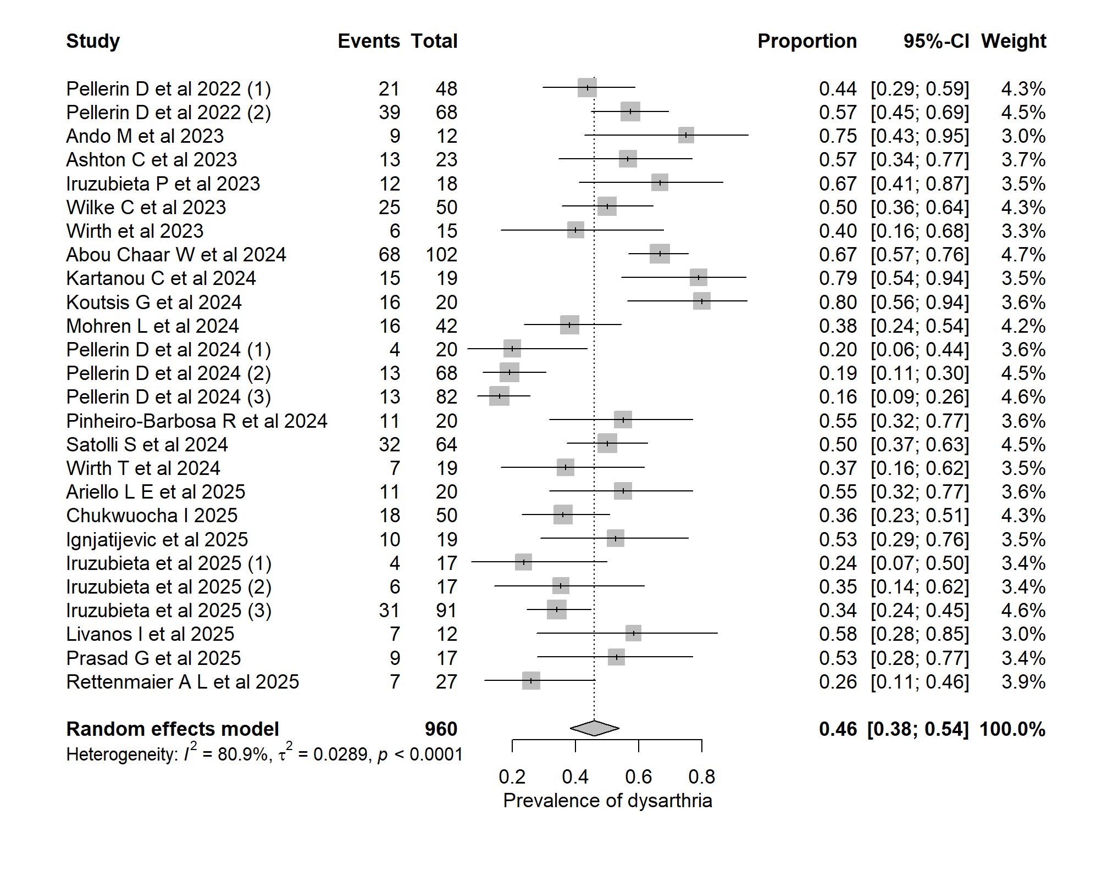
S5: Forest plot showing individual study estimates and the pooled random-effects proportion of dysarthria in SCA27B (0.46; 95% CI: 0.38–0.54). Squares represent study-level prevalence estimates with 95% confidence intervals, while the diamond represents the pooled summary estimate. Substantial heterogeneity was observed across studies (I² = 80.9%, Tau² = 0.0289, p <0.001).

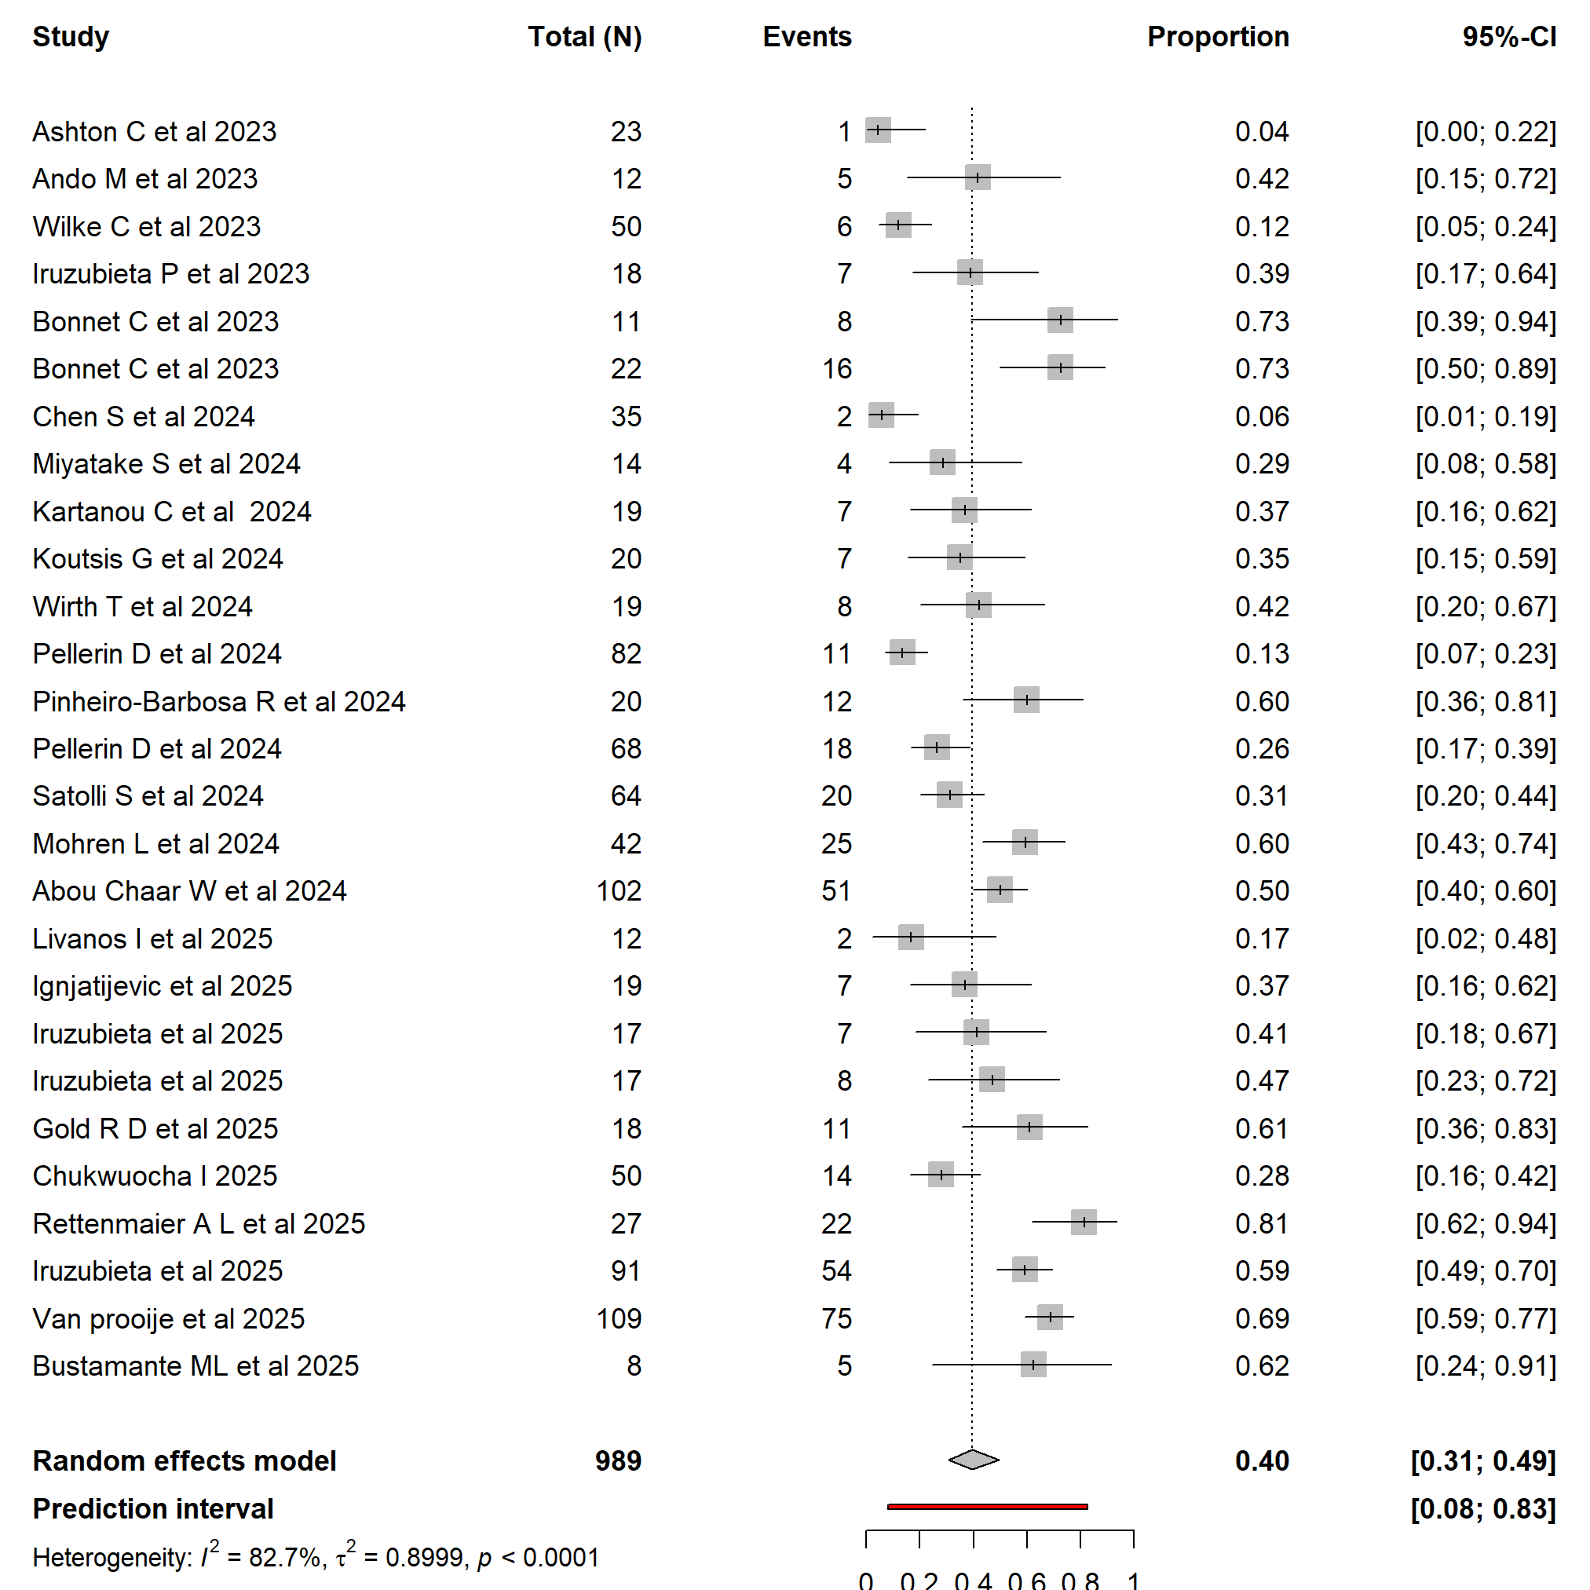

S6: Forest plot showing individual study estimates and the pooled random-effects proportion of episodic symptoms in SCA27B (0.38; 95% CI: 0.29–0.48). Squares represent study-level prevalence estimates with 95% confidence intervals, while the diamond represents the pooled summary estimate. Substantial heterogeneity was observed across studies (I² = 85.9%, Tau² = 0.0441, p <0.0001).
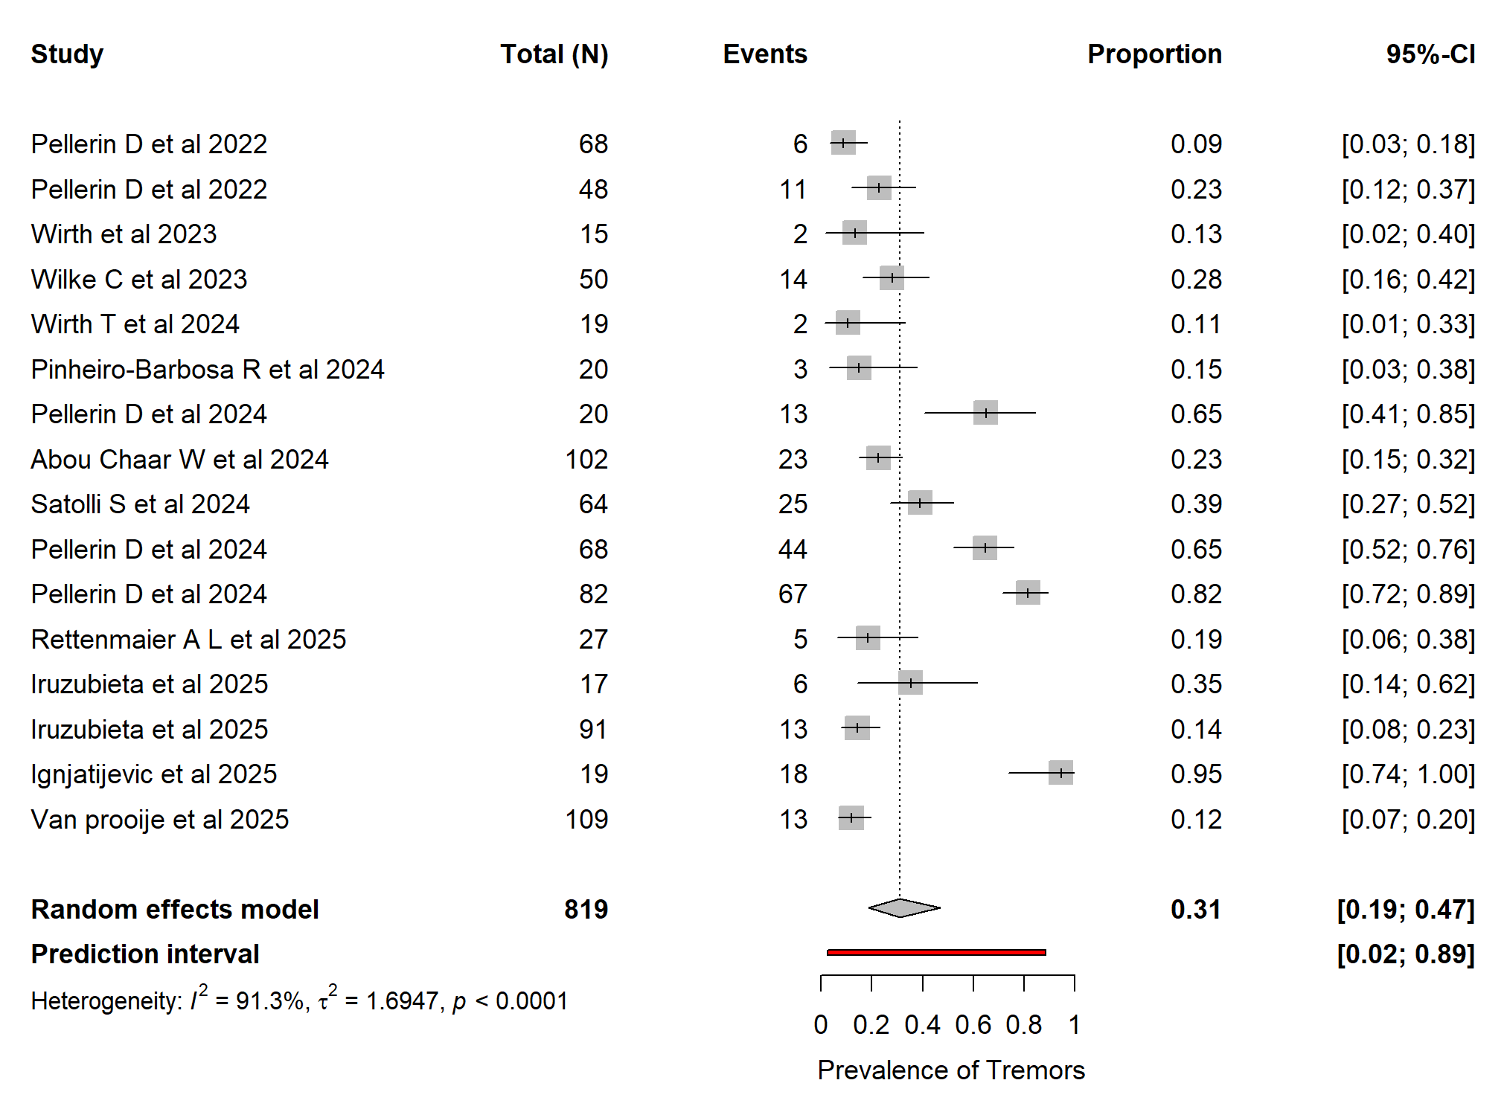
S7: Forest plot showing individual study estimates and the pooled random-effects proportion of tremors in SCA27B (0.31; 95% CI: 0.19–0.47). Squares represent study-level proportions with 95% confidence intervals and the diamond indicates the overall pooled estimate. Substantial heterogeneity was observed across studies (I² = 91.3%, Tau² = 1.6947, p < 0.0001).

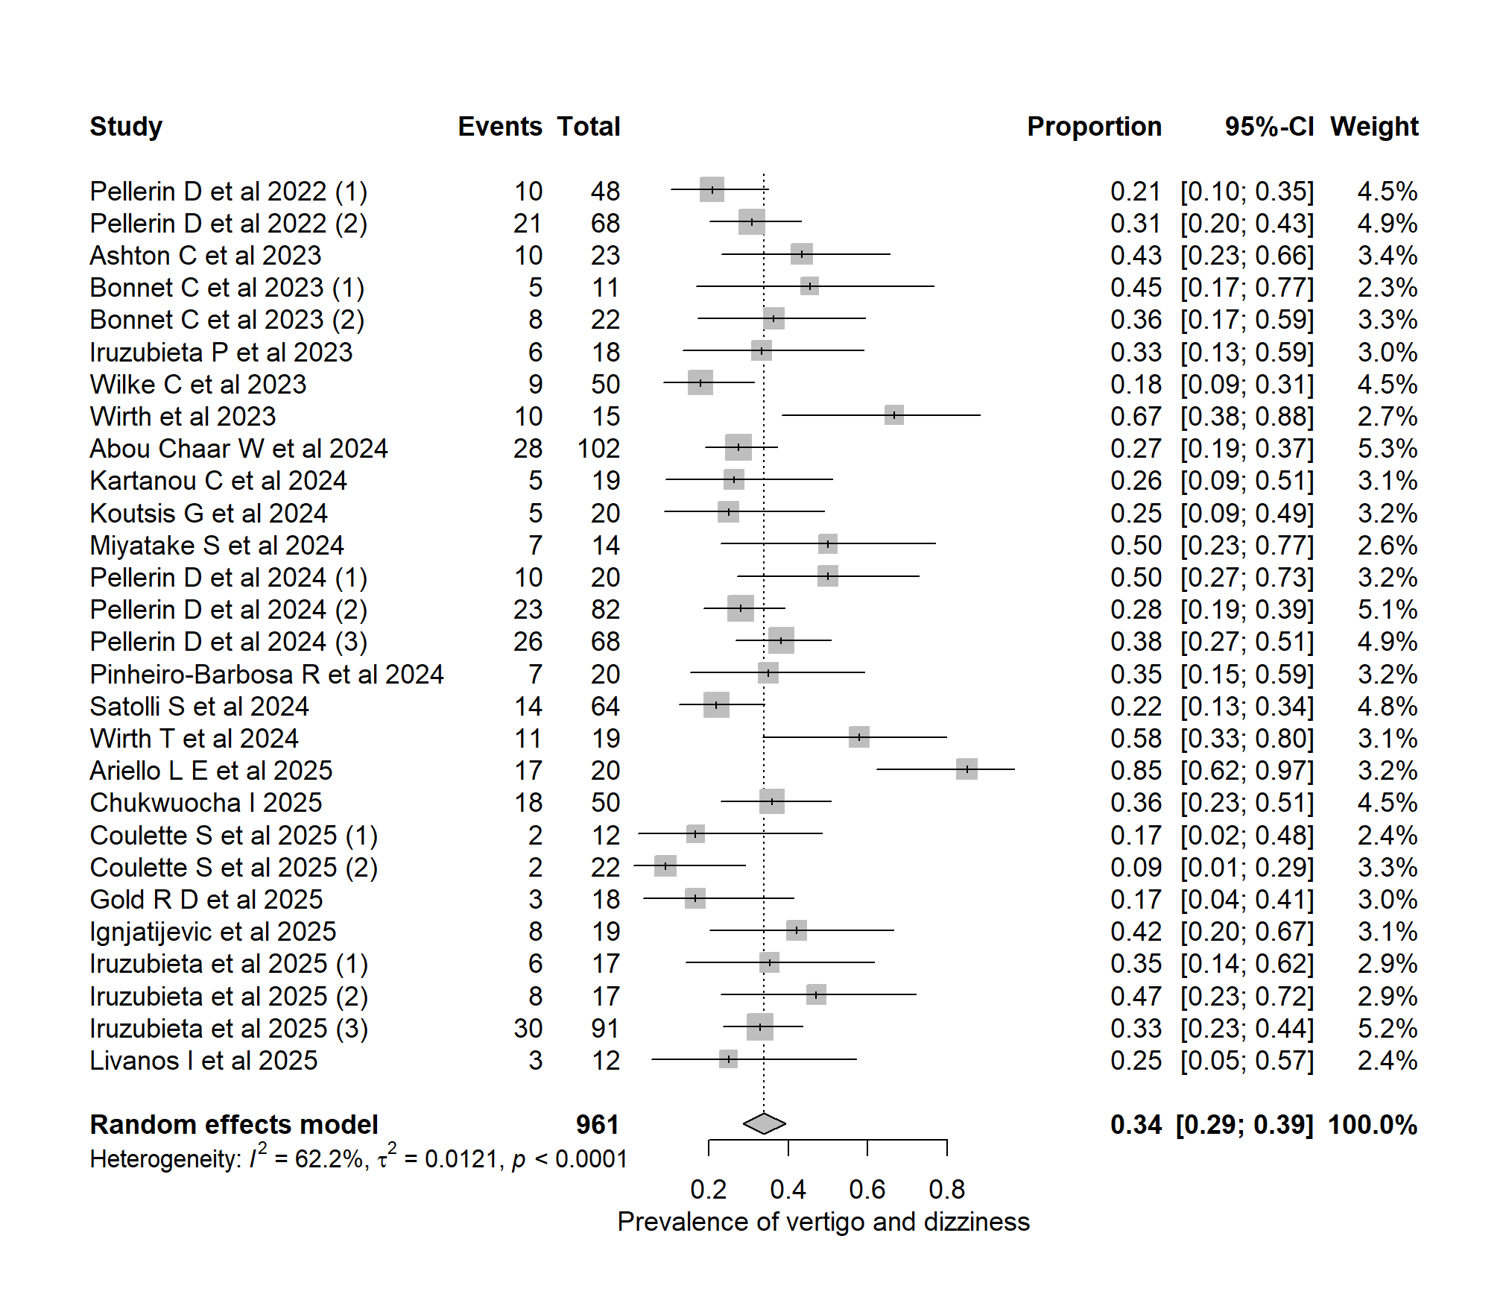
S8: Forest plot showing individual study estimates and the pooled random effects proportion of vertigo and dizziness in SCA27B (0.34; 95% CI: 0.29–0.39). Square markers indicate study level proportions with 95% confidence intervals and the diamond represents the pooled estimate. Substantial heterogeneity was noted the across studies (I² = 62.2%, Tau² = 0.0121, p <0.0001).

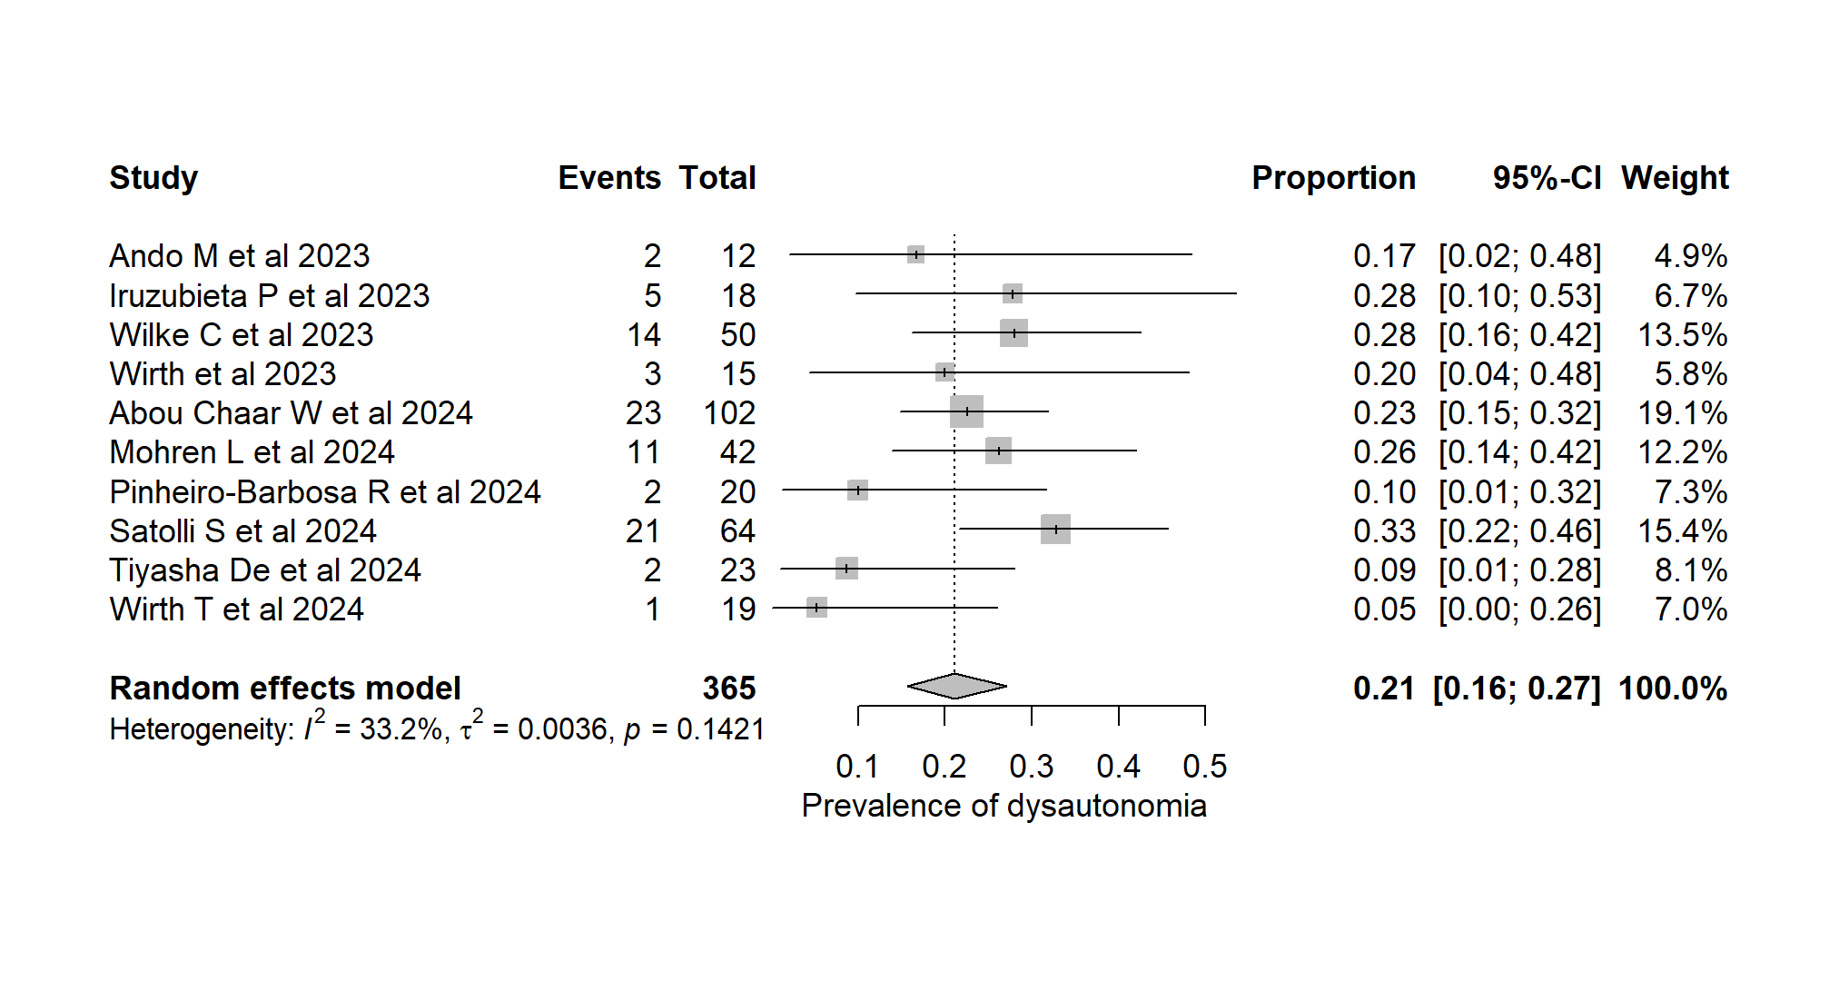
S9: Forest plot showing individual study estimates and the pooled random-effects proportion of dysautonomia in SCA27B (0.21; 95% CI: 0.16–0.27). Squares represent study-level prevalence estimates with 95% confidence intervals, while the diamond represents the pooled summary estimate. Mild to moderate heterogeneity was observed across studies (I² = 33.2%, τ² = 0.0036, p = 0.1421).

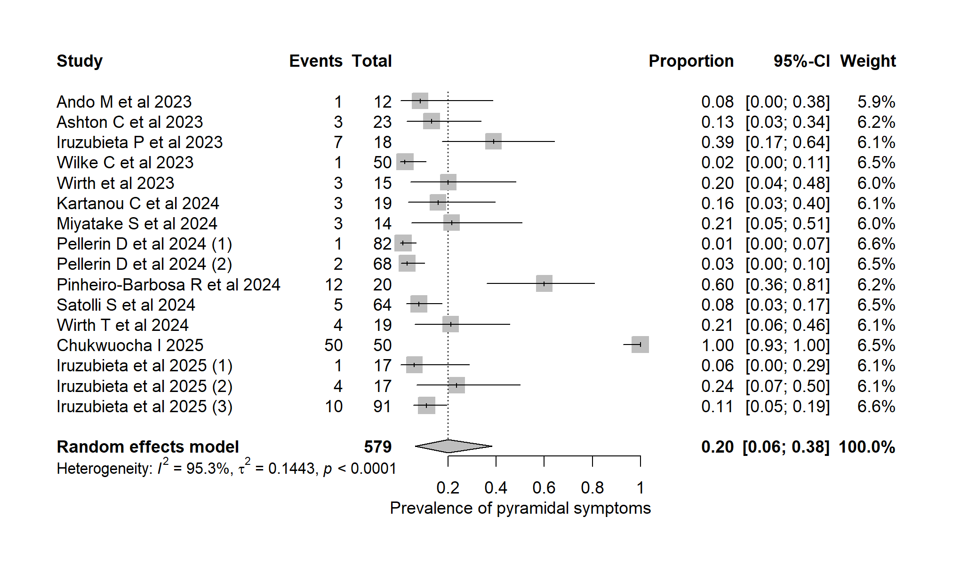
S10: Forest plot showing individual study estimates and the pooled random-effects proportion of pyramidal symptoms in SCA27B (0.20; 95% CI: 0.06-0.38). Squares represent study-level proportions with 95% confidence intervals and the diamond represents the pooled estimate. Substantial heterogeneity was observed across studies (I² = 95.3%, Tau² = 0.1443, p <0.0001).

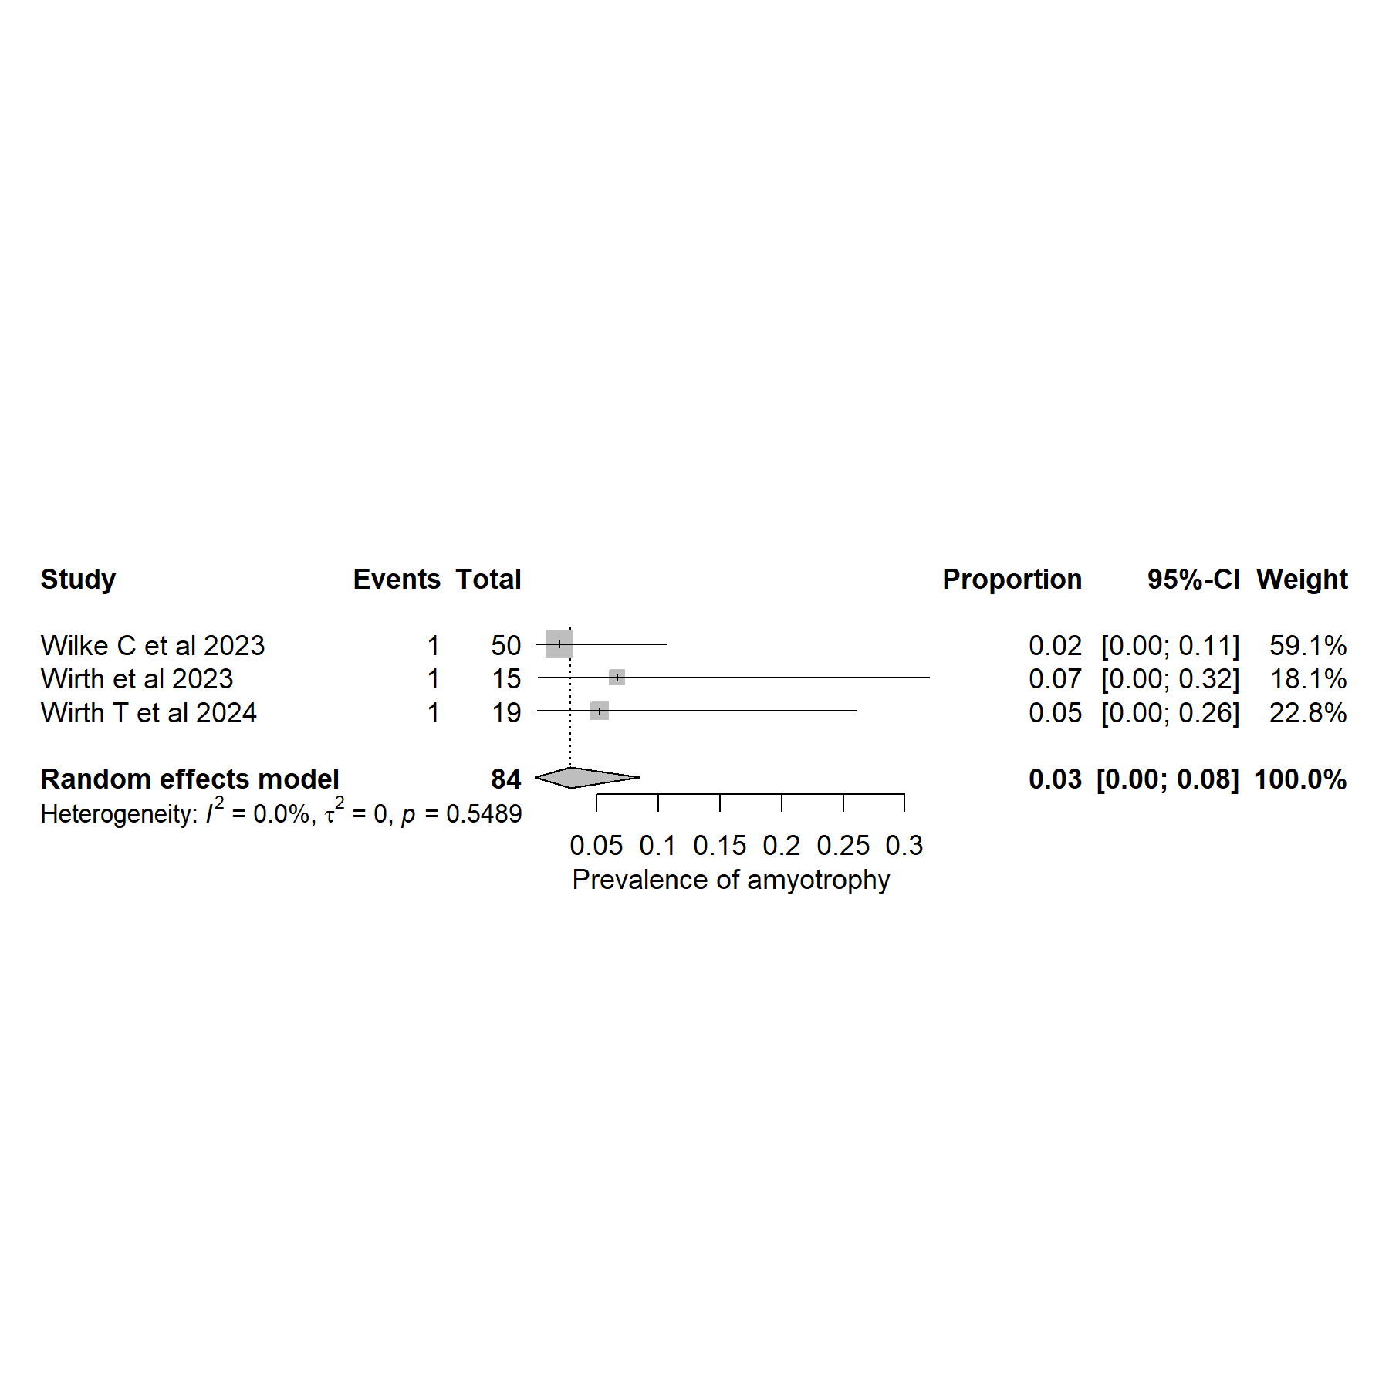
S11: Forest plot showing individual study estimates and the pooled random-effects proportion of amyotrophy in SCA27B (0.03; 95% CI: 0.00–0.08). Squares represent study-level prevalence estimates with 95% confidence intervals, while the diamond represents the pooled summary estimate. Minimal heterogeneity was observed across studies (I² = 0.0%, τ² = 0, p = 0.5489), indicating no statistically significant between-study heterogeneity.

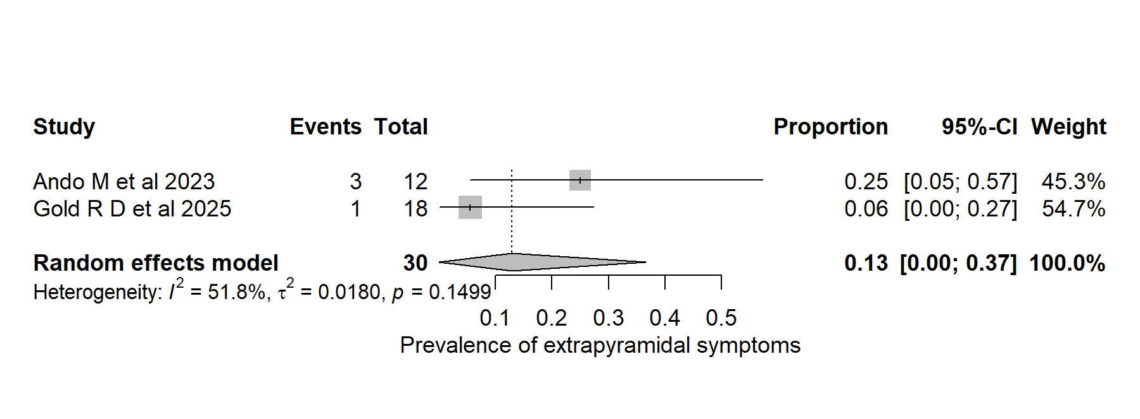
S12: Forest plot showing individual study estimates and the pooled random-effects proportion of Extrapyramidal symptoms in SCA27B (0.13; 95% CI: 0.00–0.37). Squares represent study-level prevalence estimates with 95% confidence intervals, while the diamond represents the pooled summary estimate. Moderate heterogeneity was observed across studies (I² = 51.8%, τ² = 0.0180, p = 0.1499) despite a non-significant Q-test.

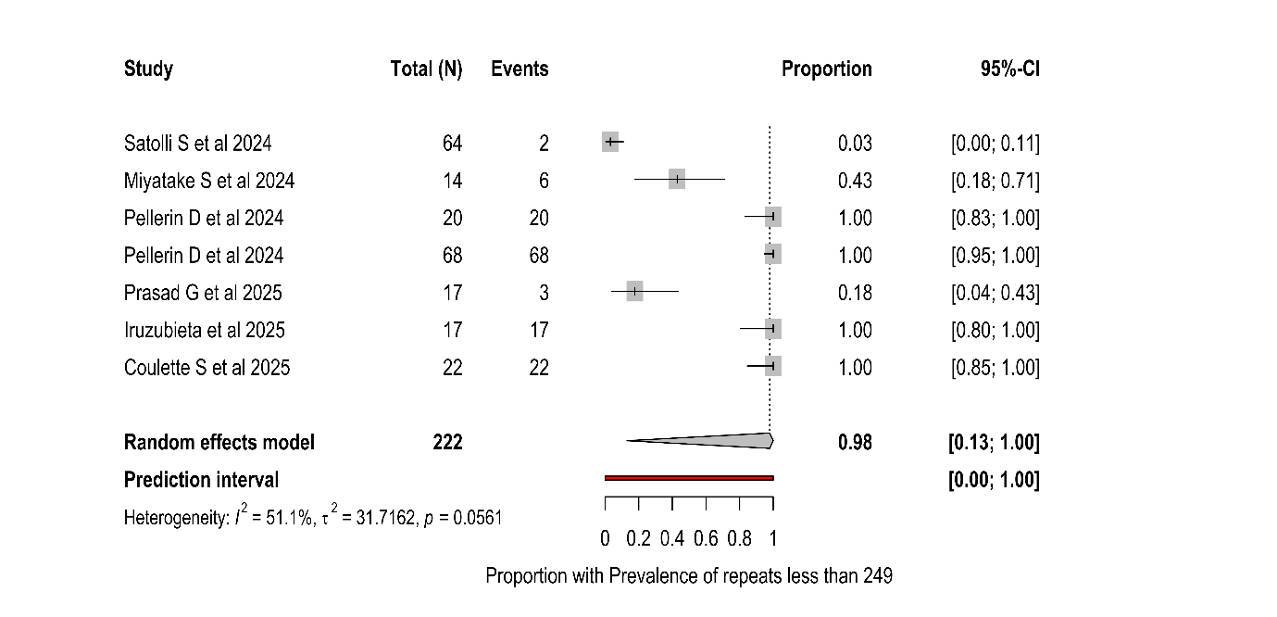

S13: Forest plot showing individual study estimates and the pooled random-effects proportion of repeats less than 250 in SCA27B (Pooled Proportion 0.98; 95% CI: 0.12-1.00). Squares represent study-level prevalence estimates with 95% confidence intervals, while the diamond represents the pooled summary estimate. Moderate heterogeneity was observed across studies (I² = 51.1%, τ² = 31.7162, p = 0.0561) despite a non-significant Q-test.

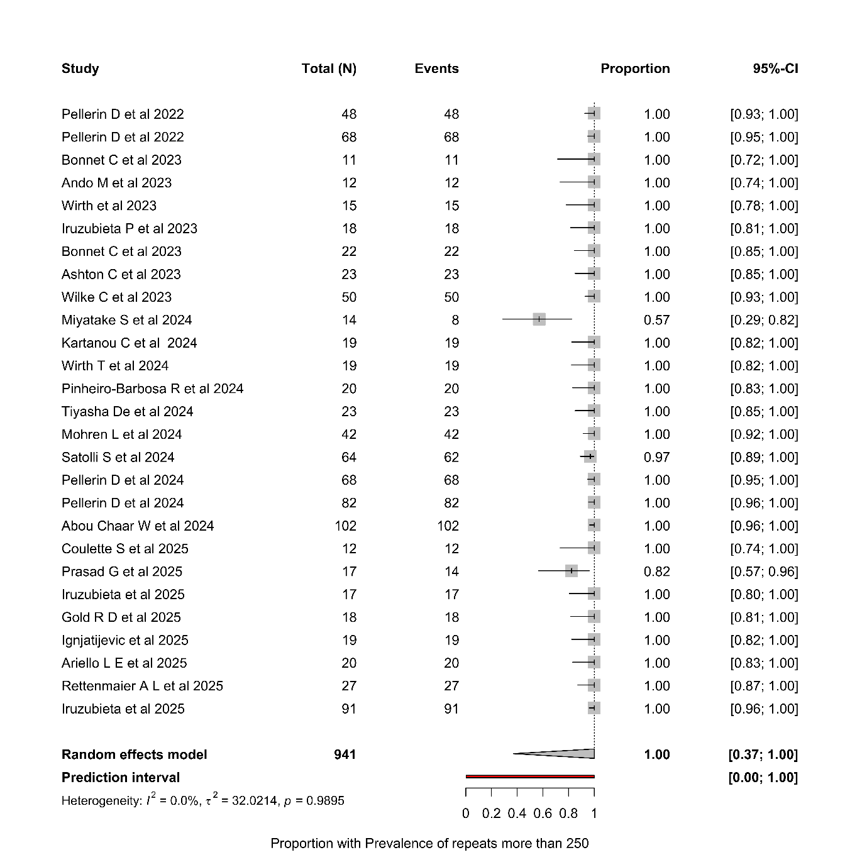
S14: Forest plot showing individual study estimates and the pooled random-effects proportion of repeats > 250 in SCA27B (Pooled Proportion 1.00; 95% CI: 0.37-1.00). Squares represent study-level prevalence estimates with 95% confidence intervals, while the diamond represents the pooled summary estimate. No heterogeneity was observed across studies (I² = 0.0%, τ² = 32.0214, p = 0.9895)

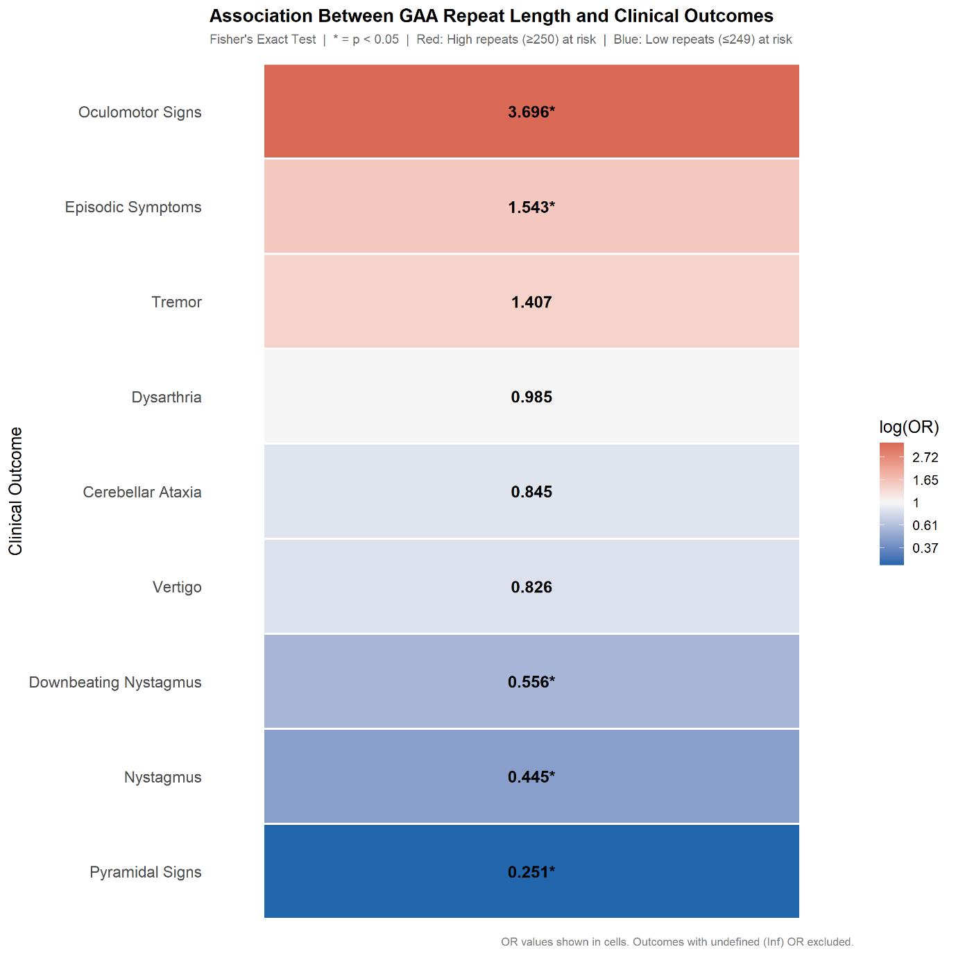

S15: Heatmap showing the association between FGF14 GAA repeat length and clinical outcomes in SCA27B. This Heatmap shows the odd’s ratios (ORs) derived from 2 × 2 contingency analysis comparing patients with ≥250 repeats versus ≤249 repeats. Colour intensity represents the magnitude and direction of association on a log(OR) scale. Red shades indicate higher odds of the clinical feature in the high-repeat group (≥250 repeats) and blue shades indicate higher odds in the low-repeat group (≤249 repeats). White/neutral tones indicate minimal or no association (OR ≈ 1). Asterisks (*) denote statistically significant associations (two-sided Fisher’s exact test, p < 0.05). OR values are displayed within each cell. Outcomes with undefined or infinite ORs were excluded from visualization.

S16: Publication-bias statistics and funnel plot for vertigo

Fail-Safe N Analysis (File Drawer Analysis)
Fail-safe N |  |  |  | p
4966.000 |  |  |  | < .001
Note. Fail-safe N Calculation Using the Rosenthal Approach

Rank Correlation Test for Funnel Plot Asymmetry (Begg’s test)
Kendall's Tau |  | p
0.374 |  | 0.005
Regression Test for Funnel Plot Asymmetry (Egger’s test)
Z |  | p
2.234 |  | 0.025

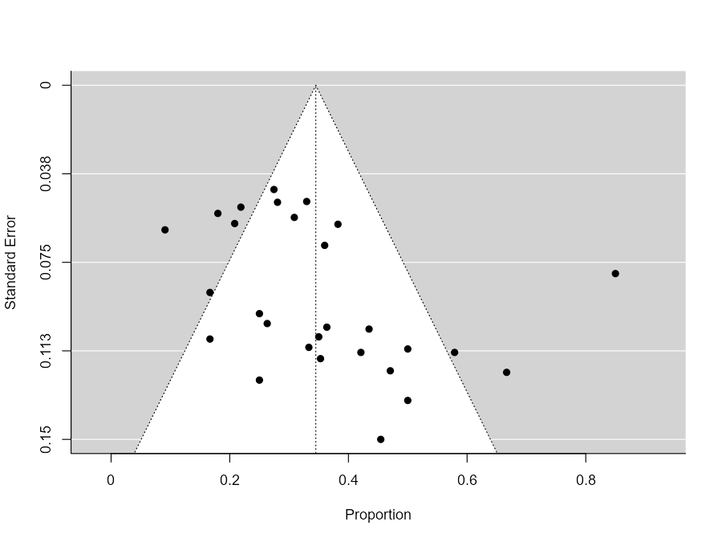

S17: Publication-bias statistics and funnel plot for tremors

Fail-Safe N Analysis (File Drawer Analysis)
Fail-safe N |  |  |  |  |  |  |  | p
6448.000 |  |  |  |  |  |  |  | < .001
Note. Fail-safe N Calculation Using the Rosenthal Approach
Rank Correlation Test for Funnel Plot Asymmetry (Begg’s test)
Kendall's Tau |  |  |  |  | p
15 |  |  |  |  | 0.498
Regression Test for Funnel Plot Asymmetry (Egger’s test)
Z |  | p
0.50 |  | 0.620

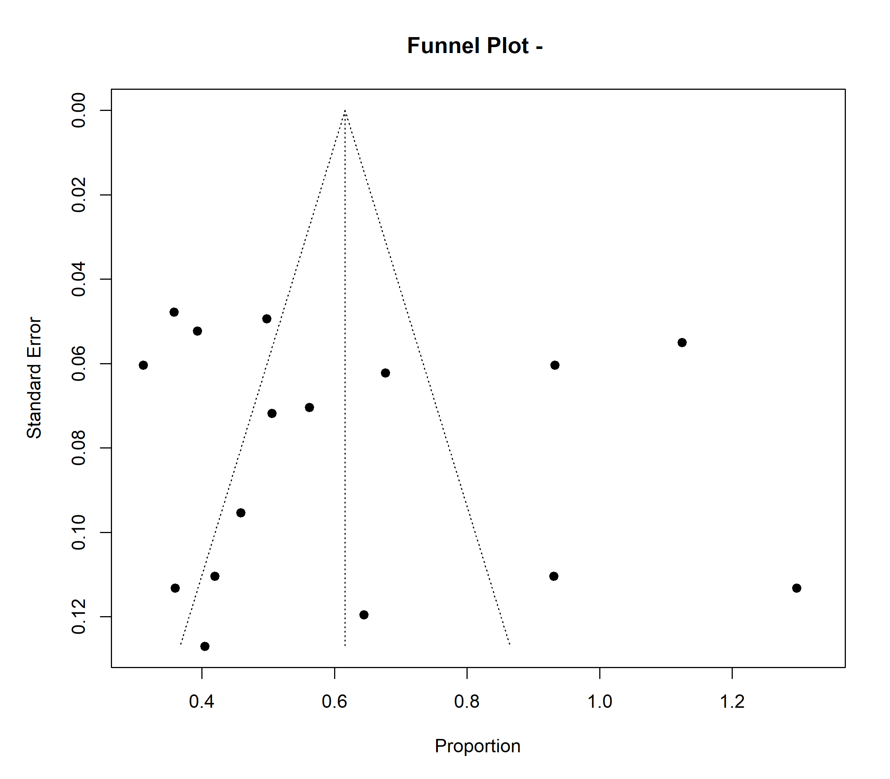

S18: Publication-bias statistics and funnel plot for pyramidal symptoms

Fail-Safe N Analysis (File Drawer Analysis)
Fail-safe N |  |  |  |  |  |  |  | p
2988.000 |  |  |  |  |  |  |  | < .001
Note. Fail-safe N Calculation Using the Rosenthal Approach
Rank Correlation Test for Funnel Plot Asymmetry (Begg’s test)
Kendall's Tau |  |  |  |  | p
24.2143 |  |  |  |  | 0.0758
Regression Test for Funnel Plot Asymmetry (Egger’s test)
Z |  | p
3.0805 |  | 0.3354

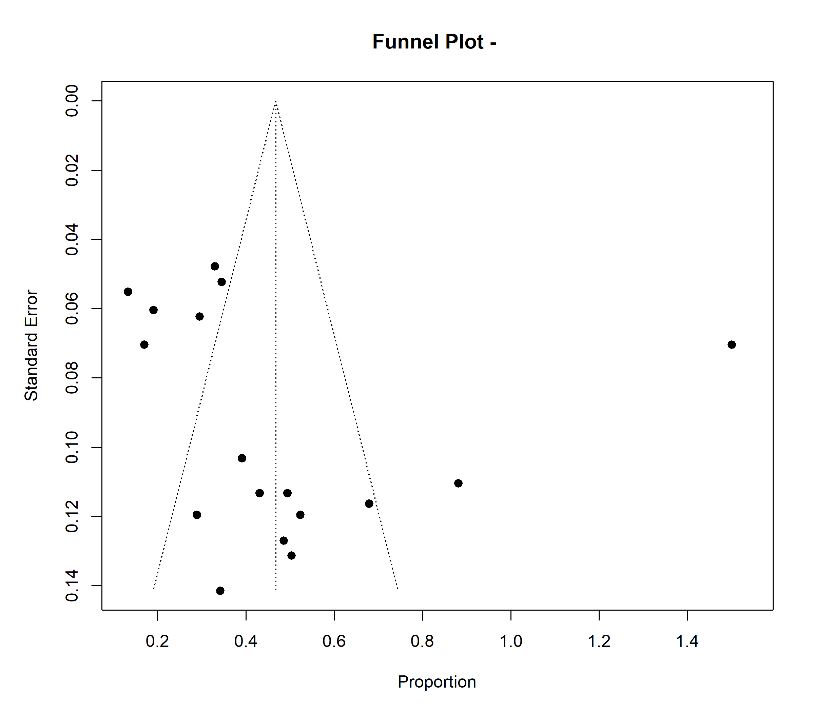
S19: Publication-bias statistics and funnel plot for oculomotor abnormalities

Fail-Safe N Analysis (File Drawer Analysis)
Fail-safe N |  |  |  |  |  |  | p
37108.000 |  |  |  |  |  |  | < .001
Note. Fail-safe N Calculation Using the Rosenthal Approach
Rank Correlation Test for Funnel Plot Asymmetry
Kendall's Tau |  |  |  |  | p
-0.532 |  |  |  |  | < .001
Regression Test for Funnel Plot Asymmetry
Z |  | p
-4.607 |  | < .001
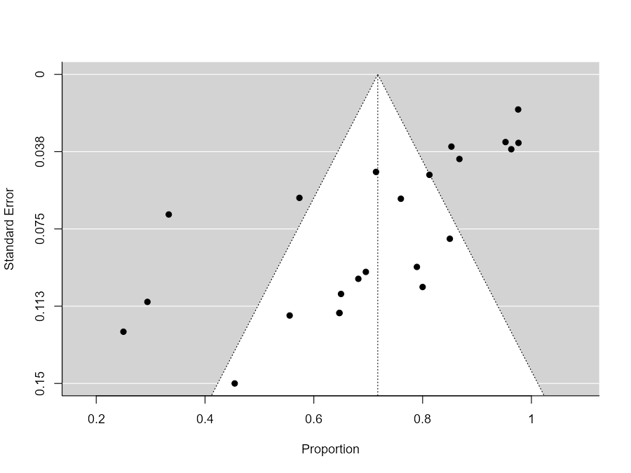

S20: Publication-bias statistics and funnel plot for nystagmus

Fail-Safe N Analysis (File Drawer Analysis)
Fail-safe N |  |  |  |  |  |  | p
28700.000 |  |  |  |  |  |  | < .001
Note. Fail-safe N Calculation Using the Rosenthal Approach
Rank Correlation Test for Funnel Plot Asymmetry
Kendall's Tau |  |  |  |  | p
-9 |  |  |  |  | 0.8507
Regression Test for Funnel Plot Asymmetry
Z |  | p
-0.4514 |  | 0.72579
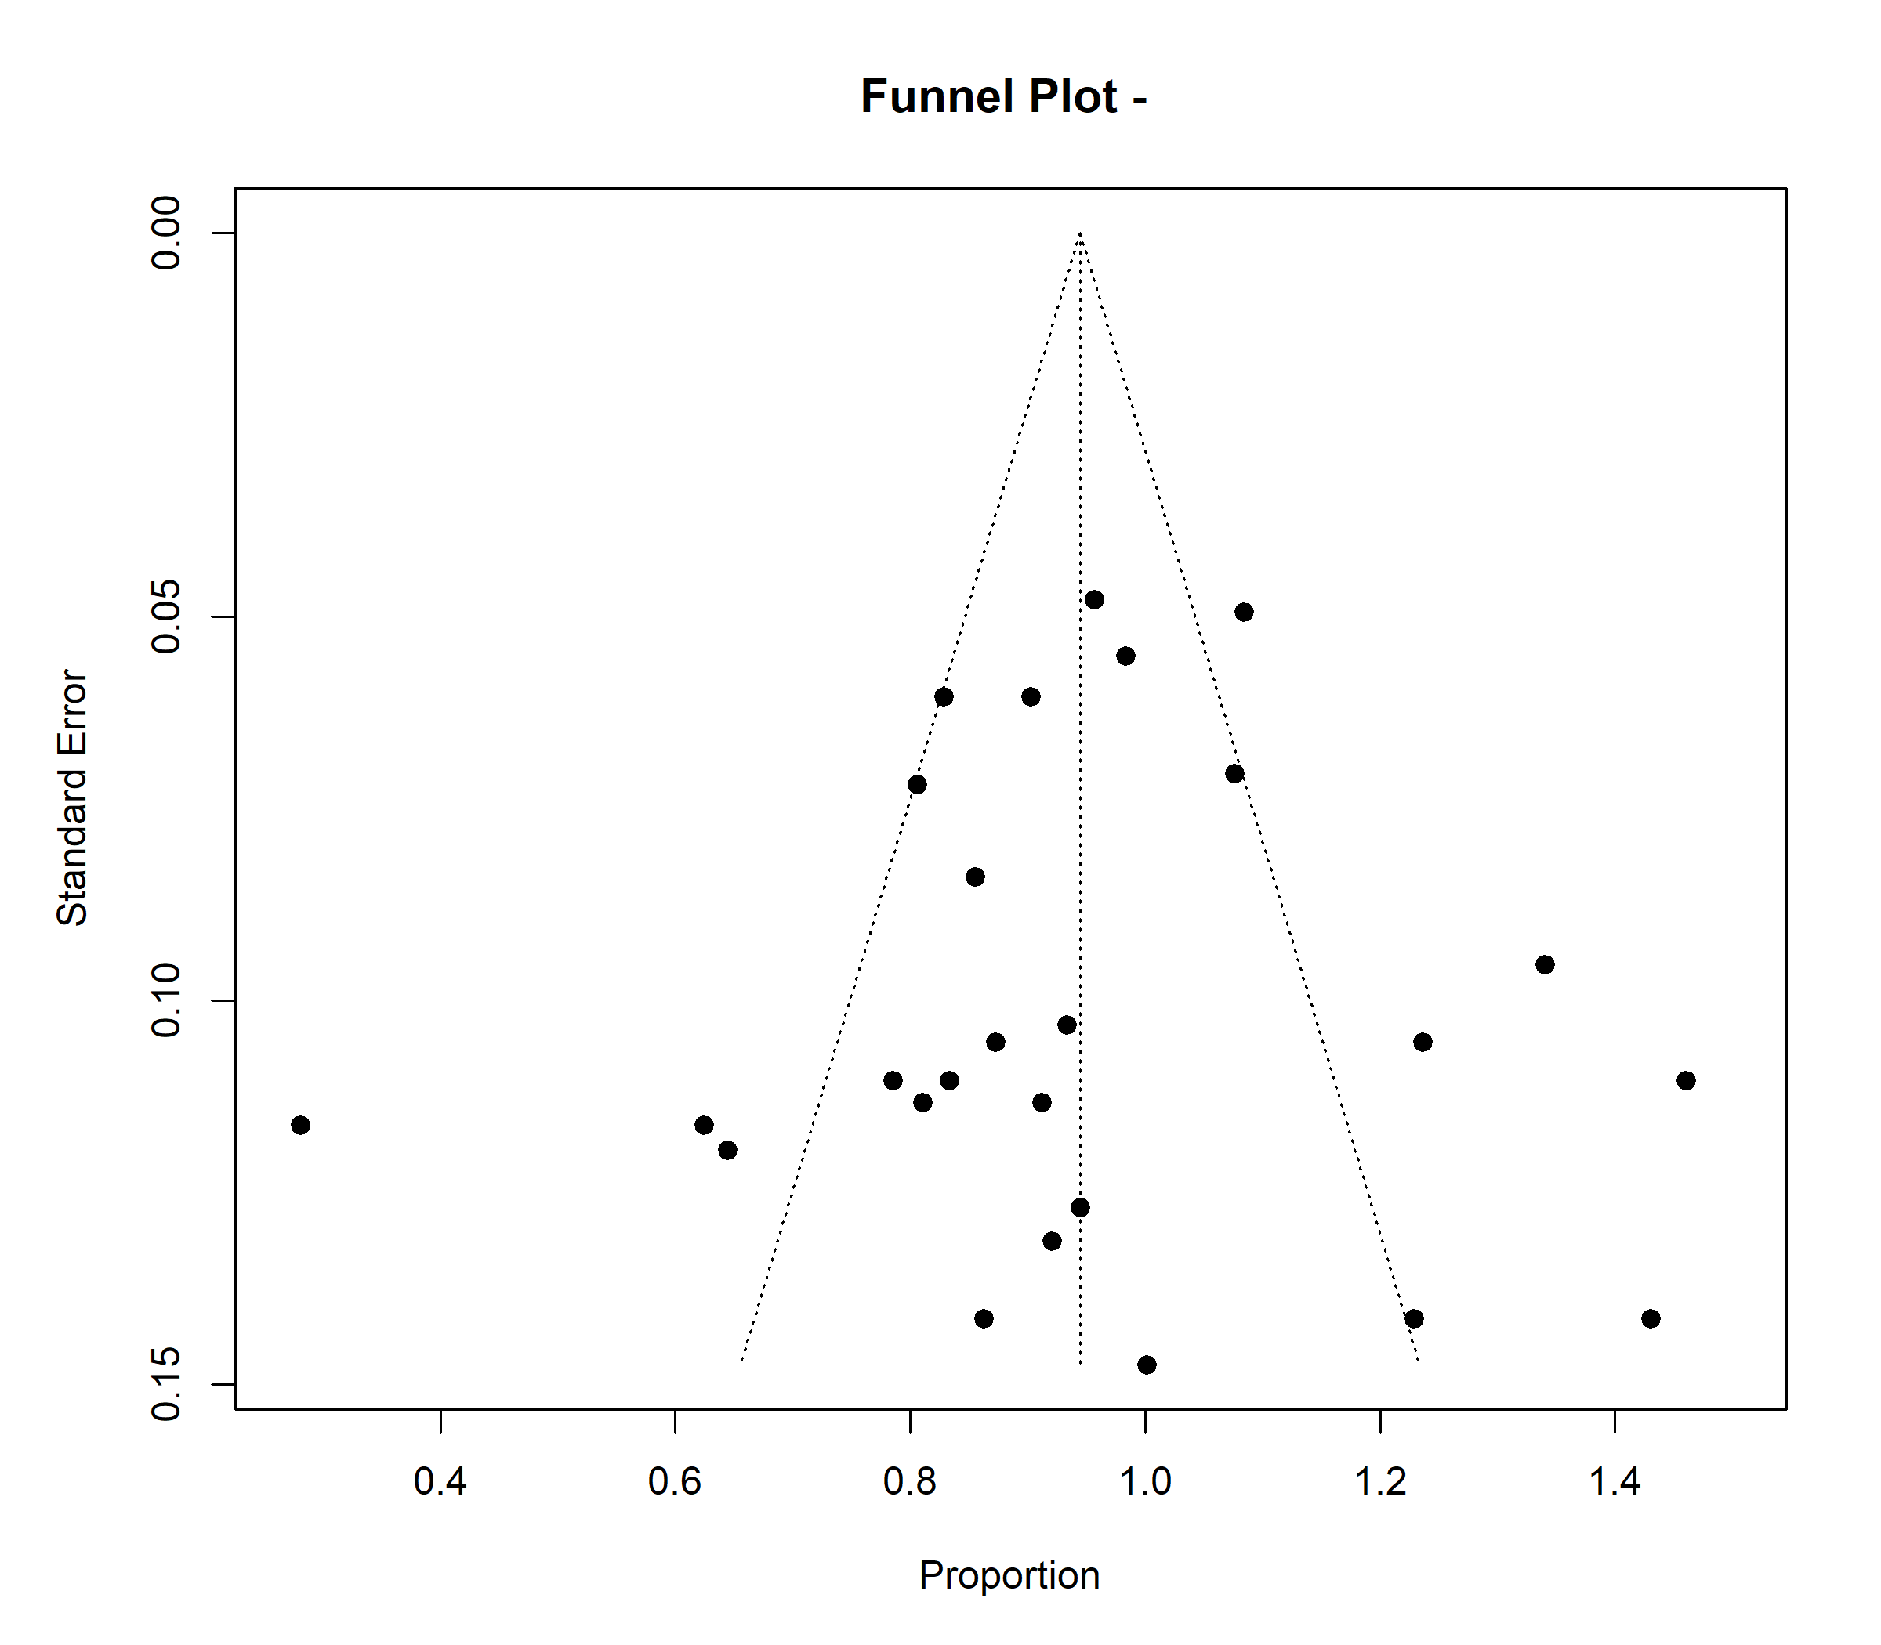

S21: Publication-bias statistics and funnel plot for Dysarthria

Fail-Safe N Analysis (File Drawer Analysis)
Fail-safe N |  |  |  |  |  |  |  | p
7762.000 |  |  |  |  |  |  |  | < .001
Note. Fail-safe N Calculation Using the Rosenthal Approach
Rank Correlation Test for Funnel Plot Asymmetry
Kendall's Tau |  |  |  |  | p
0.111 |  |  |  |  | 0.427
Regression Test for Funnel Plot Asymmetry
Z |  | p
1.697 |  | 0.090
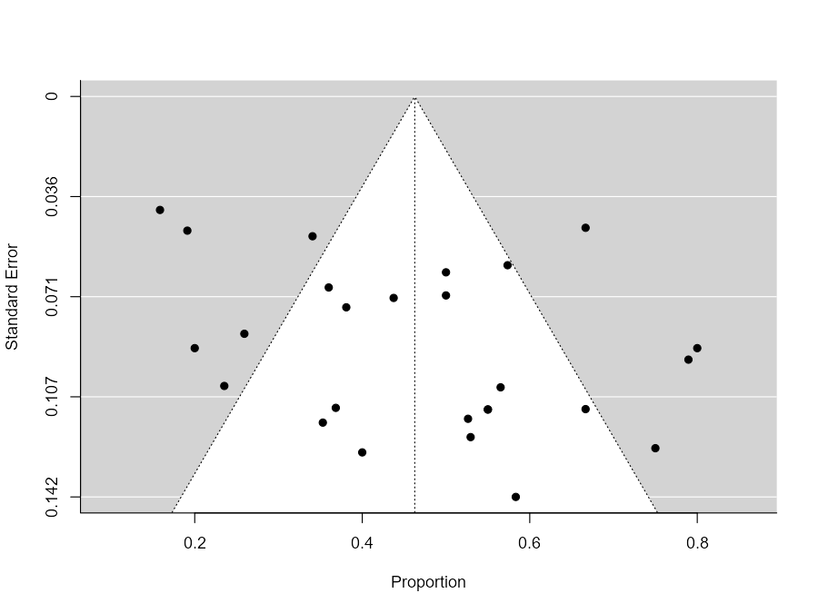

S2: Publication-bias statistics and funnel plot for Downbeat nystagmus

Fail-Safe N Analysis (File Drawer Analysis)
Fail-safe N |  | p
17895.000 |  | < .001
Note. Fail-safe N Calculation Using the Rosenthal Approach

Rank Correlation Test for Funnel Plot Asymmetry (Begg’s test)
Kendall's Tau |  | p
1 |  | 0.9813
Regression Test for Funnel Plot Asymmetry (Egger’s test)
Z |  | p
-1.3302 |  | 0.5161

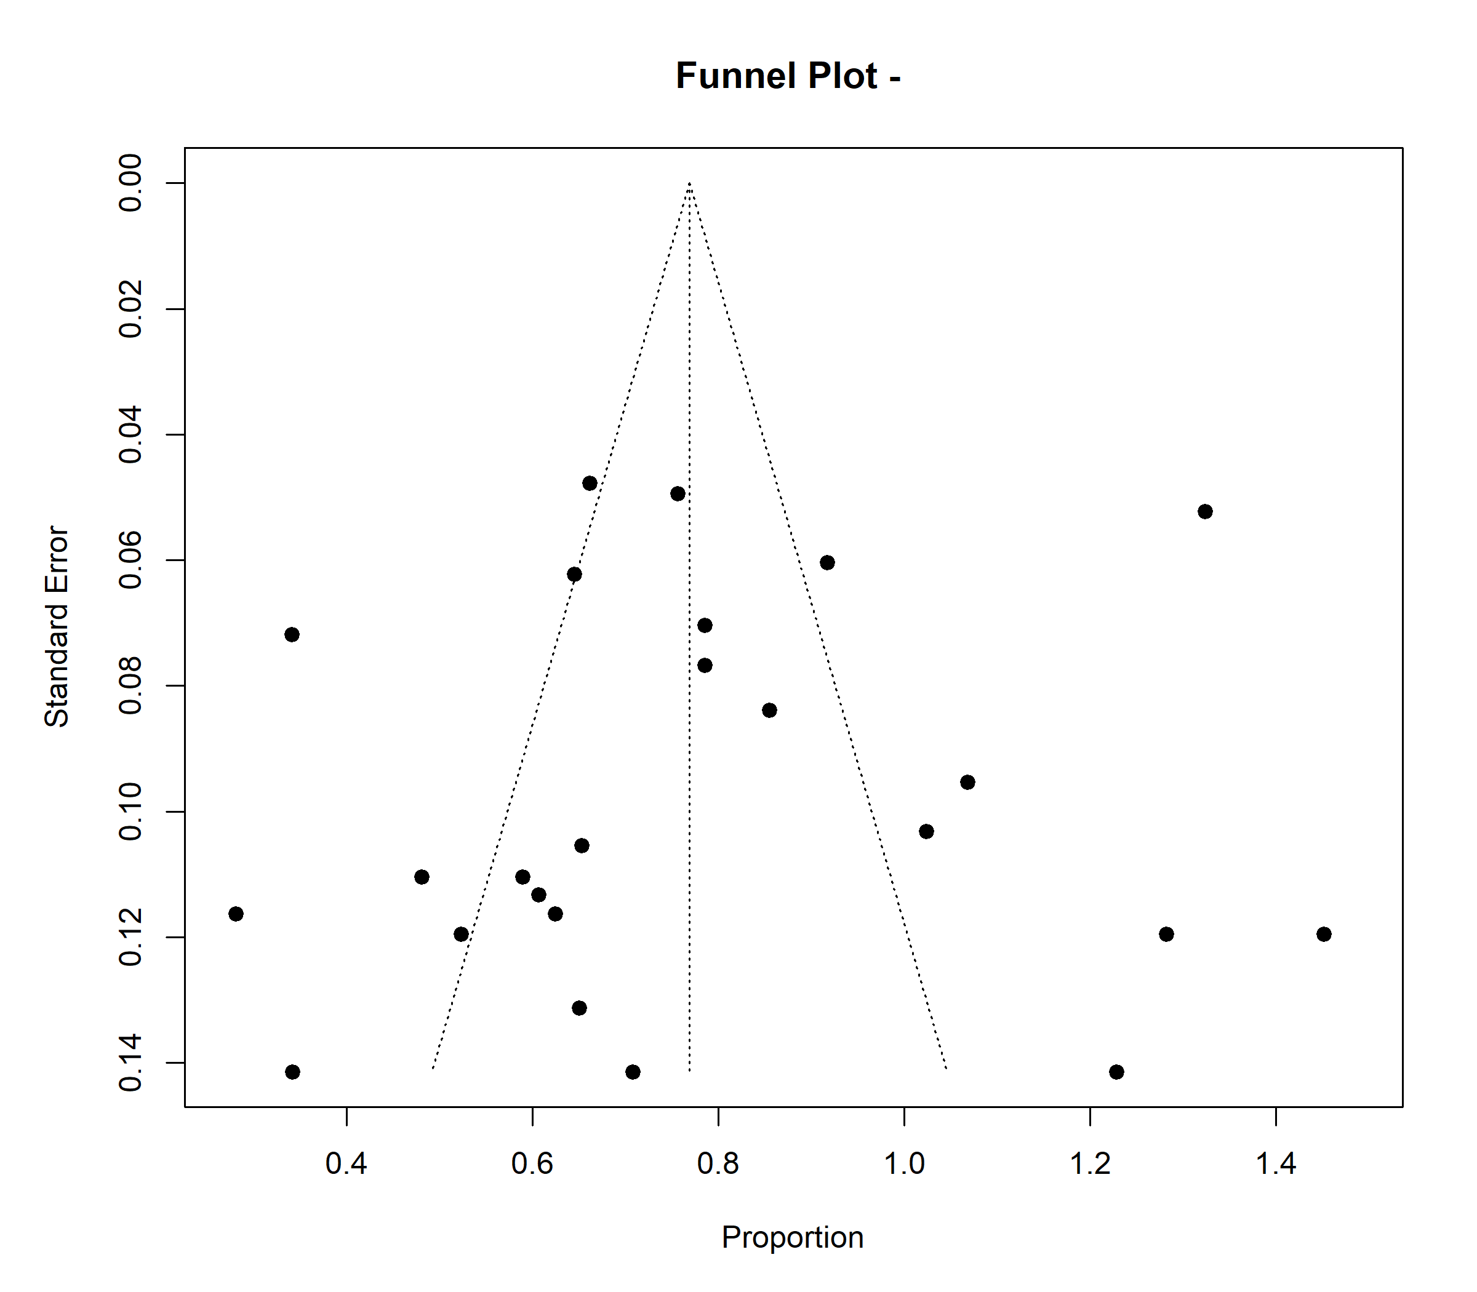

S 23: Publication-bias statistics and funnel plot for cerebellar ataxia

Fail-Safe N Analysis (File Drawer Analysis)
Fail-safe N |  | p
48513.000 |  | < .001
Note. Fail-safe N Calculation Using the Rosenthal Approach
Rank Correlation Test for Funnel Plot Asymmetry (Begg’s test)
Kendall's Tau |  |  |  | p
-21 |  |  |  | 0.693
Regression Test for Funnel Plot Asymmetry (Egger’s test)
Z |  | p
0.32 |  | 0.745

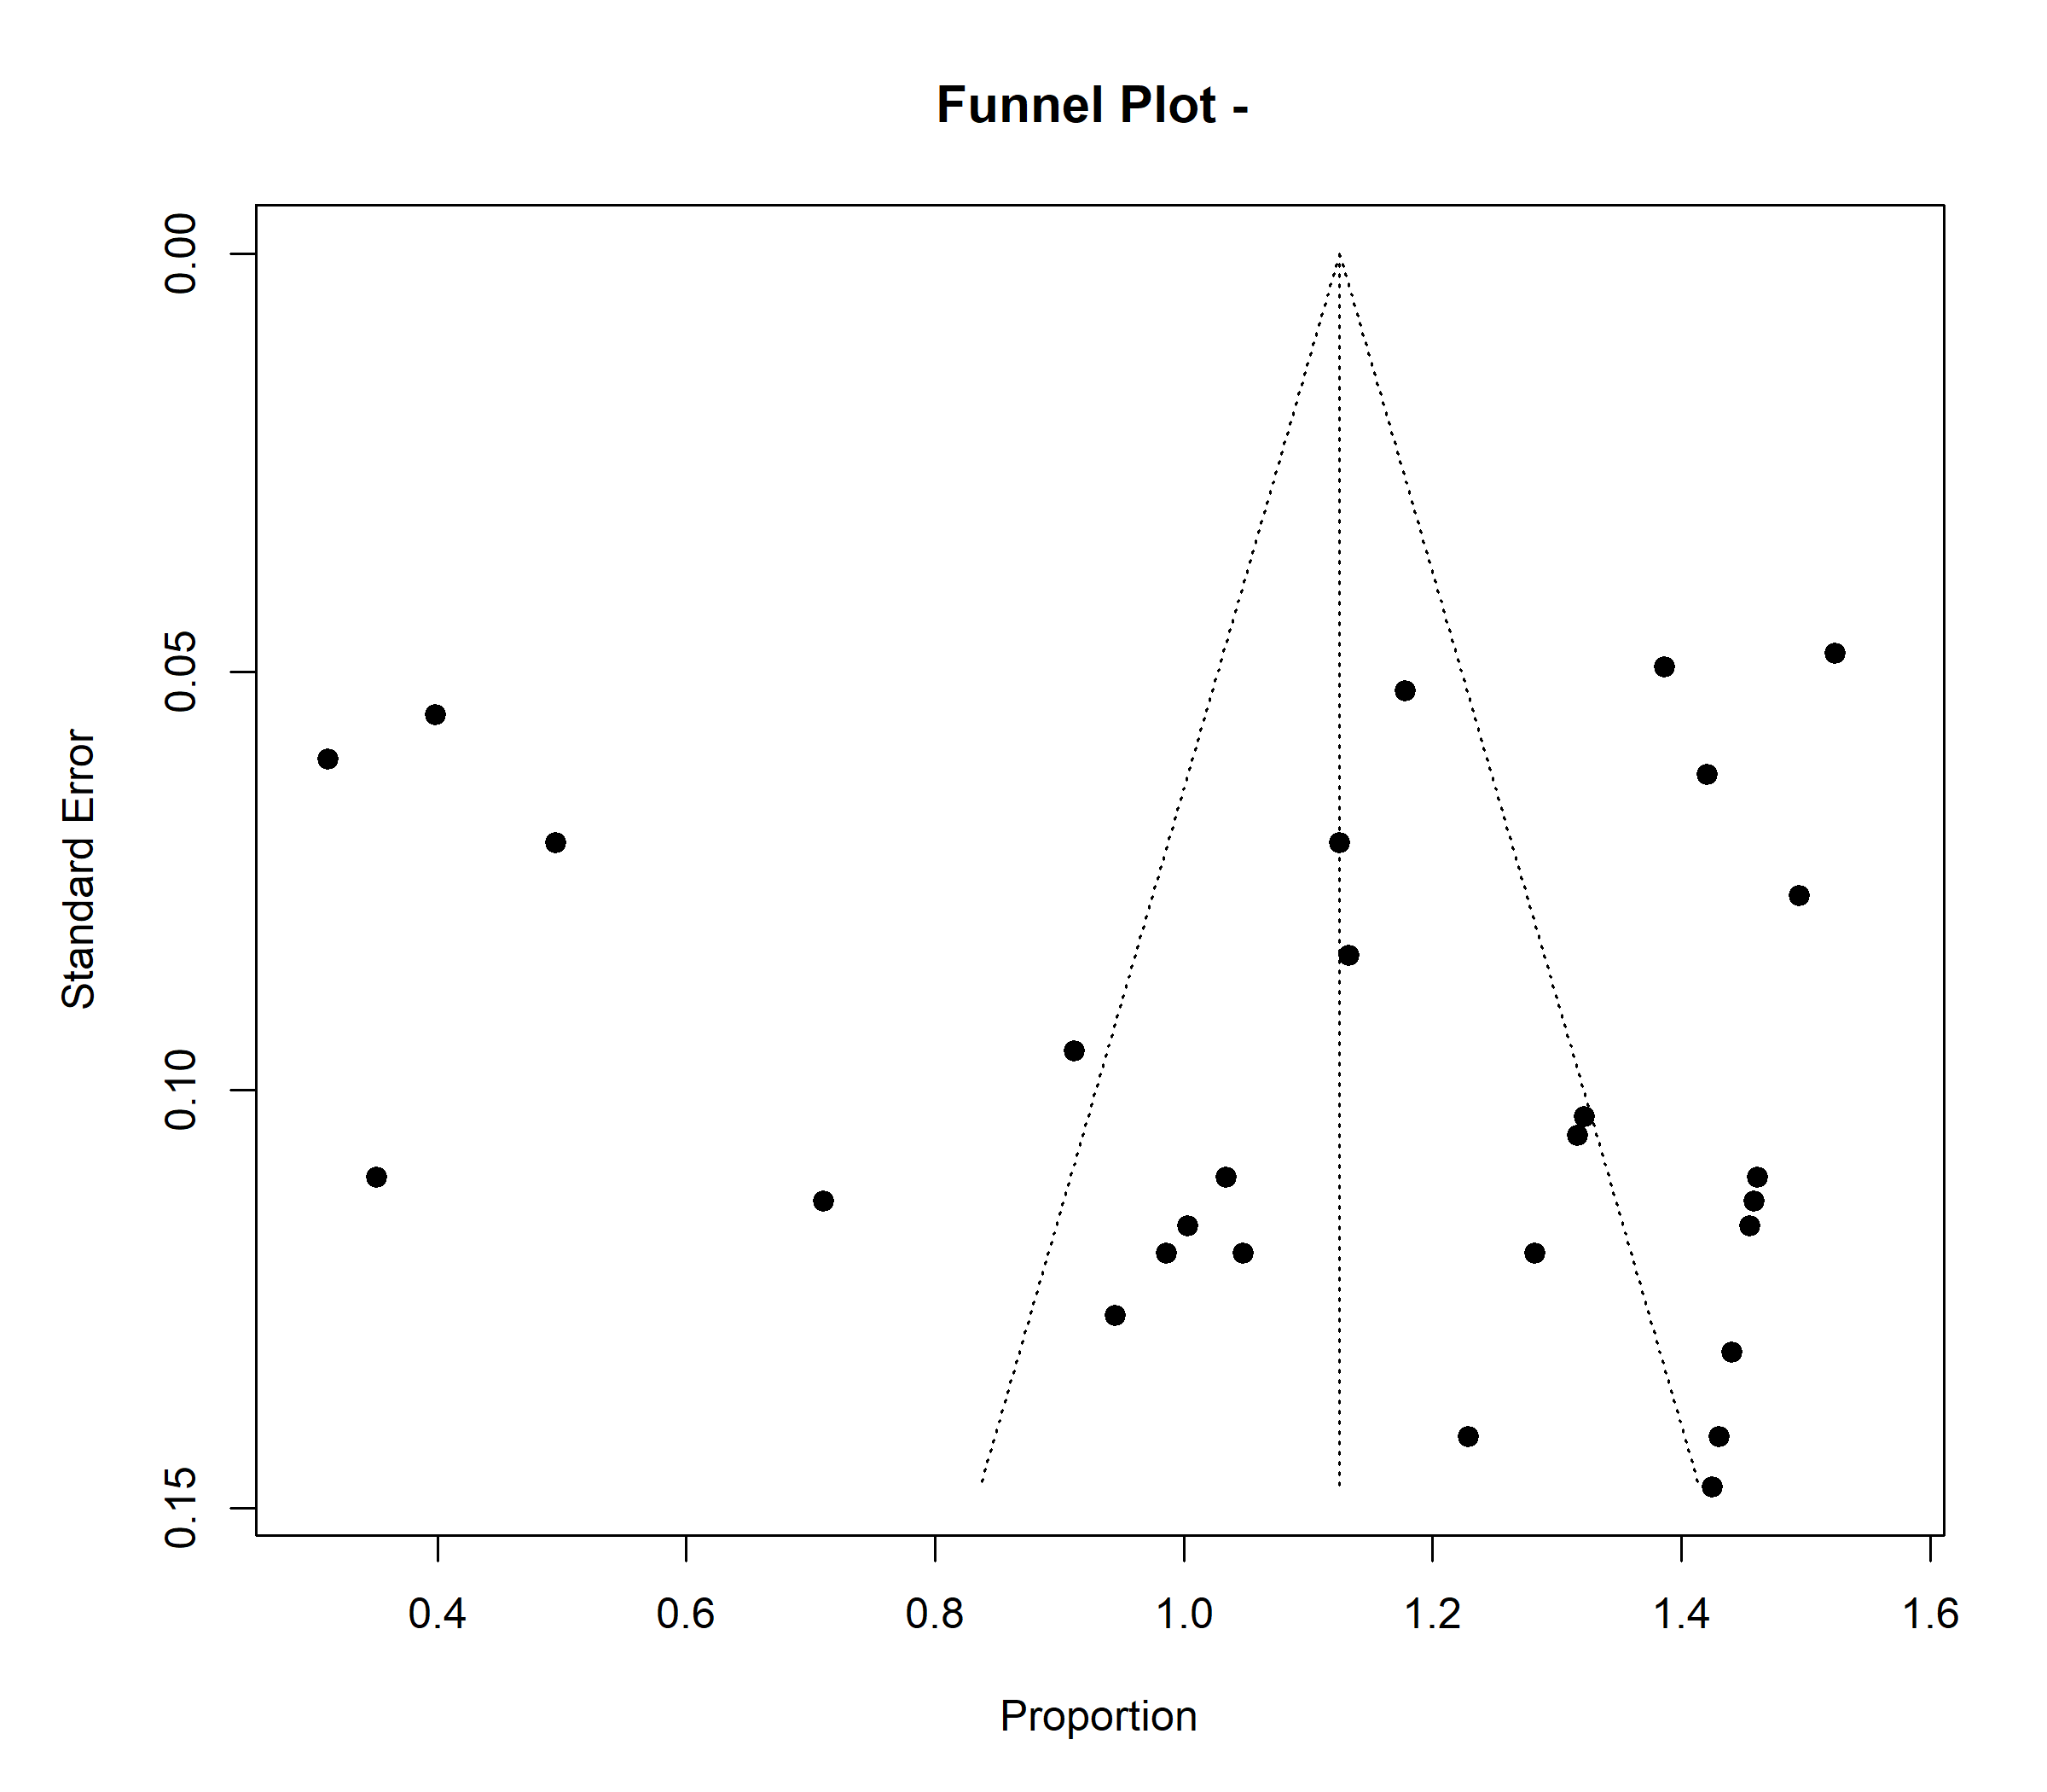

S24: Publication-bias statistics and funnel plot for episodic symptoms

Fail-Safe N Analysis (File Drawer Analysis)
Fail-safe N |  | p
16609.000 |  | < .001
Note. Fail-safe N Calculation Using the Rosenthal Approach
Rank Correlation Test for Funnel Plot Asymmetry (Begg’s test)
Kendall's Tau |  |  |  | p
19 |  |  |  | 0.6914
Regression Test for Funnel Plot Asymmetry (Egger’s test)
Z |  | p
0.2127 |  | 0.8925

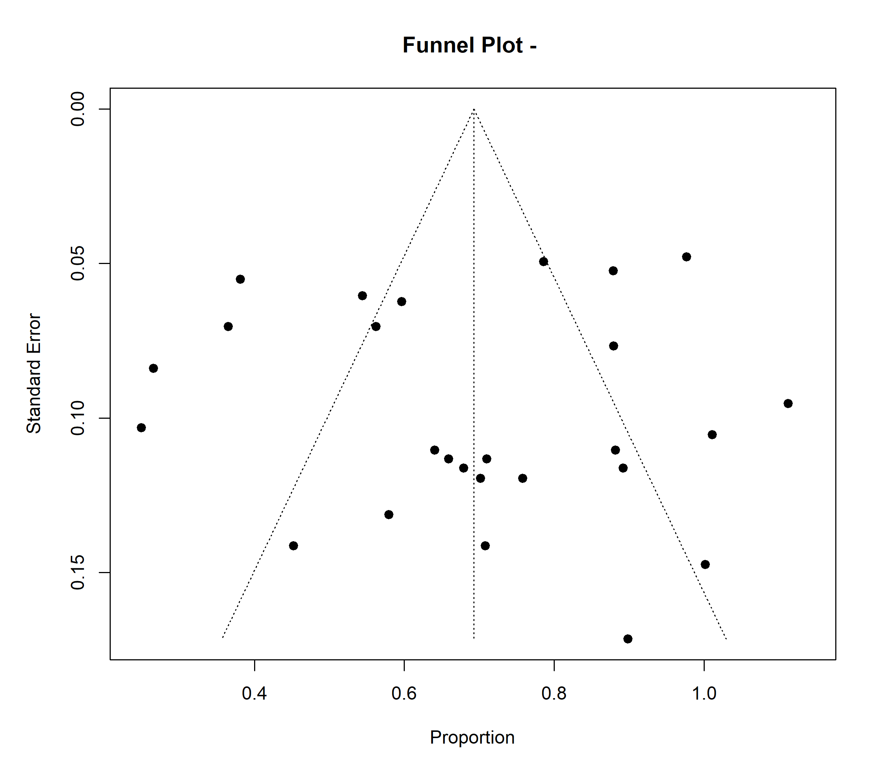
S25: Publication-bias statistics and funnel plot for dysautonomia

Fail-Safe N Analysis (File Drawer Analysis)
Fail-safe N |  | p
1527.000 |  | < .001
Note. Fail-safe N Calculation Using the Rosenthal Approach
Rank Correlation Test for Funnel Plot Asymmetry (Begg’s test)
Kendall's Tau |  |  |  | p
-11 |  |  |  | 0.3918
Regression Test for Funnel Plot Asymmetry (Egger’s test)
Z |  | p
-0.8265 |  | 0.4619

