Supplementary data
Supplement 1. Kaplan–Meier estimates the progression-free survival rate for all patients according to radiotherapy status.
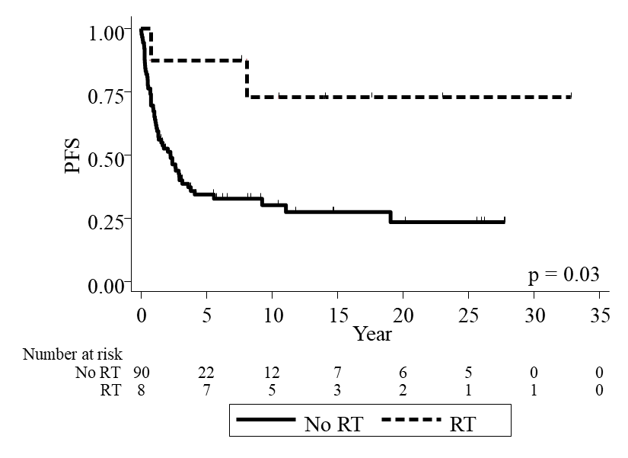

Supplement 2. Kaplan–Meier estimates the progression-free survival rate for all patients according to intra-cystic chemotherapy status.
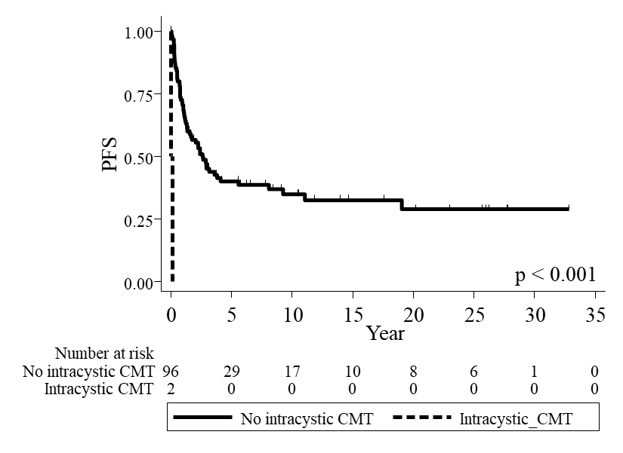

Supplement 3. Treatment modalities for primary salvage treatment after first progression.
Primary salvage treatment | N | %
No. of patients with progressive disease | 62 | 100
Surgery alone  - GTR  - SRT  - No record | 41  6  32  3 | 66.1  14.6  78  7.3
Radiotherapy (RT) | 14 | 22.6
Surgery combined with RT  - GTR + RT  - STR + RT | 3  0  3 | 4.8  0  100
Intra-cystic CMT | 3 | 4.8
No treatment | 1 | 1.6

Supplement 4. Kaplan–Meier estimates the second progression-free survival (PFS2) rate for all patients underwent salvage treatment.
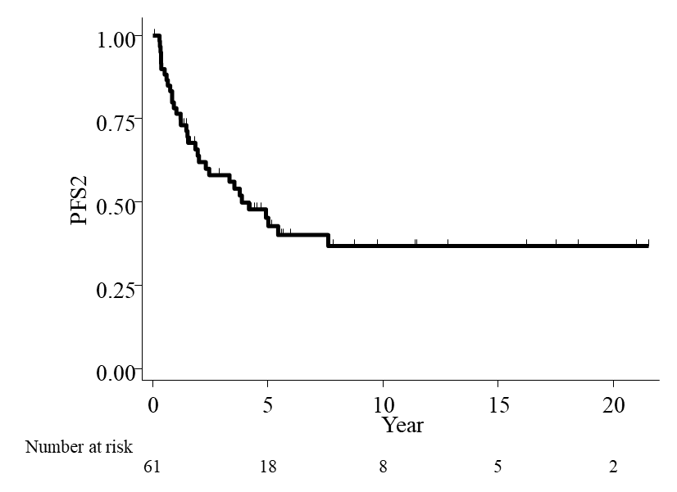

Supplement 5. Kaplan–Meier estimates the second progression-free survival (PFS2) rate for all patients underwent salvage treatment according to radiotherapy status.
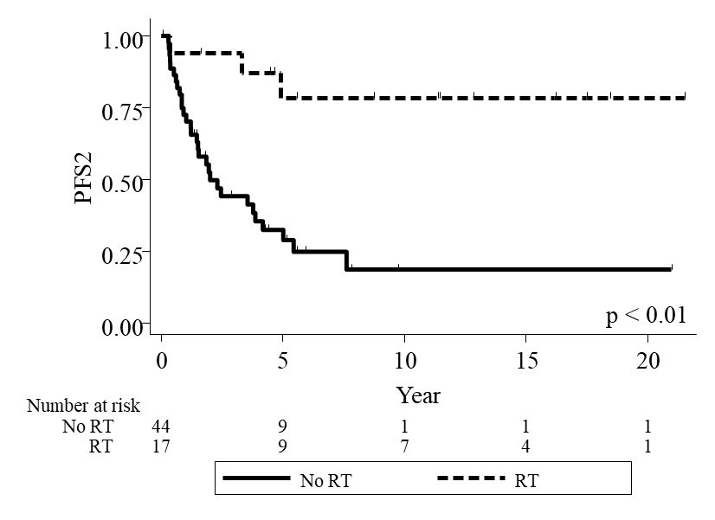

Supplement 6. Table showed endocrine status.
Endocrine | No. for pre-treatment (%) |  |  | No. for post-treatment (%)
Endocrine | Available data | Normal function | Abnormal function | Available data | Normal function | Abnormal function
Growth hormone | 34 (34.6) | 13 (38.2) | 21 (61.8) | 29 (29.6) | 24 (82.8) | 5 (17.2)
Hypothyroidism | 59 (60.2) | 9 (15.3) | 50 (84.7) | 51 (52) | 2 (4) | 49 (96)
Delay puberty | 57 (58.2) | 8 (14) | 49 (86) | 54 (55.1) | 12 (22.2) | 42 (77.8)

Supplement 7. Table showed visual field status for pre- and post-treatment.
Visual field status | Pre-Tx N=54 | Post-Tx N=72
Full | 44.4 % (n=24) | 43.1 % (n=31)
Unilateral hemianopia | 7.4 % (n=4) | 2.8 % (n=2)
Bilateral hemianopia | 24.1 % (n=13) | 22.2 % (n=16)
Unilateral blindness | 7.4 % (n=4) | 9.7 % (n=7)
Bilateral blindness | 0 % (n=0) | 6.9 % (n=5)
Quadratic anopia | 1.9 % (n=1) | 2.8 % (n=2)
Hemianopia (1 site) with Blindness (1 site) | 13 % (n=7) | 8.3 % (n=6)
Hemianopia (1 site) with Quadratic anopia (1 site) | 0 % (n=0) | 0 % (n=0)
Blindness (1 site) with Quadratic anopia (1 site) | 1.9 % (n=1) | 4.2 % (n=3)

Supplement 8. Table showed long-term intracerebral vascular adverse events, secondary tumor and psychological problem after treatment.
Type of events | No. of patients with adverse events (%) | Comments
Intracerebral vascular disease | 6 (6.1) | -Sx alone = 3  -Sx + RT = 2  -Sx + Intra-cystic CMT = 1
Secondary tumor | 2 (2) | - 1 Calcified meningioma at right  frontal convexity  - 1 Nasopharyngeal carcinoma
Psychological problem | 6 (6.1) | - 2 Moody, problem with emotional control  - 1 ADHD  - 1 Delirium  - 1 MDD, Panic, Anxiety  - 1 Delirium, insomnia

