Suppl. Fig.1 Ferroptosis induces the selective secretion of methylmalonic acid in HK-2 cells. (A) MMA levels in the cell culture supernatants of HK-2 cells stimulated for 24 h with erastin, RSL3, TSZ (TNF-α + SM-164 + Z-VAD-FMK), or TS (TNF-α + SM-164). The data are presented as the mean ± SD. ****p < 0.0001, ***p < 0.001, **p < 0.01, *p < 0.05.
Suppl. Fig.2 Ferroptosis-derived metabolites promote M1 macrophage polarization. (A) Schematic diagram of the experimental groups. HK-2 cells were treated with 2 μM RSL3 or 5 μM erastin for 24 h, after which the culture supernatants were collected. To remove high-molecular-weight proteins, the supernatants were filtered through Amicon® Ultra centrifugal filter units (10 kDa MWCO; Millipore, USA). The retained ferroptosis-associated metabolites were subsequently used to stimulate RAW264.7 macrophages. (B) Flow cytometry analysis of M1 marker expression (F4/80 and TNF-α) in macrophages (n = 3). The data are presented as the mean ± SD. ****p < 0.0001, ***p < 0.001, **p < 0.01, *p < 0.05.
Suppl. Fig.3 Renal macrophage depletion by clodronate liposomes. (A) Schematic diagram of the experimental groups. (B) Flow cytometry analysis of renal F4/80⁺CD11b⁺ macrophages to assess depletion efficiency.
Suppl. Fig.4 BMDMs are recruited to the kidney following RIRI. (A) Flow cytometry analysis of the macrophage surface markers F4/80 and CD11b on BMDMs, showing successful induction in vitro. (B) Immunofluorescence staining showing successful labeling of BMDMs with PKH-26 in vitro. (C) Representative immunofluorescence images showing the recruitment of PKH-26–labeled BMDMs into kidneys from different groups following IRI. Nuclei were counterstained with DAPI (blue). Scale bars: 50 μm. The quantification of PKH-26⁺-positive BMDMs is shown on the right.
Suppl. Fig.1
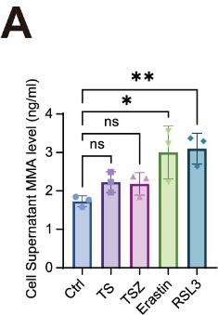
Suppl. Fig.2
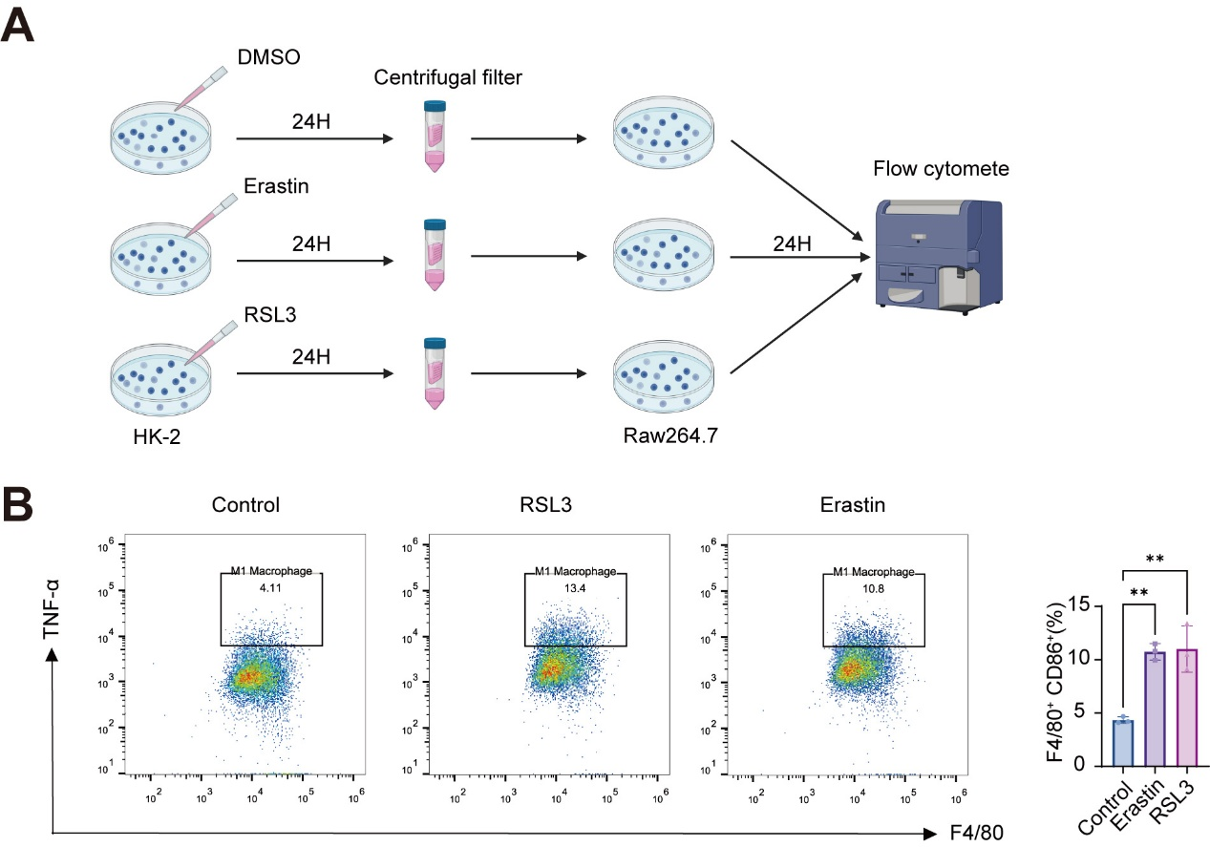

Suppl. Fig.3
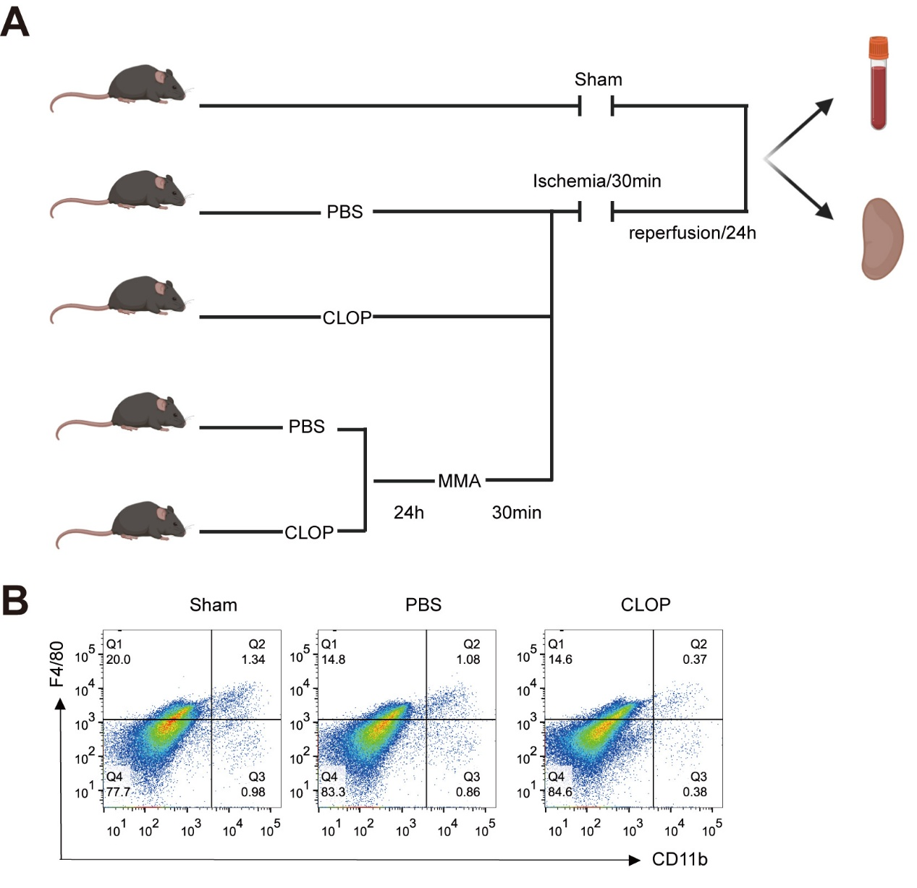

Suppl. Fig.4
