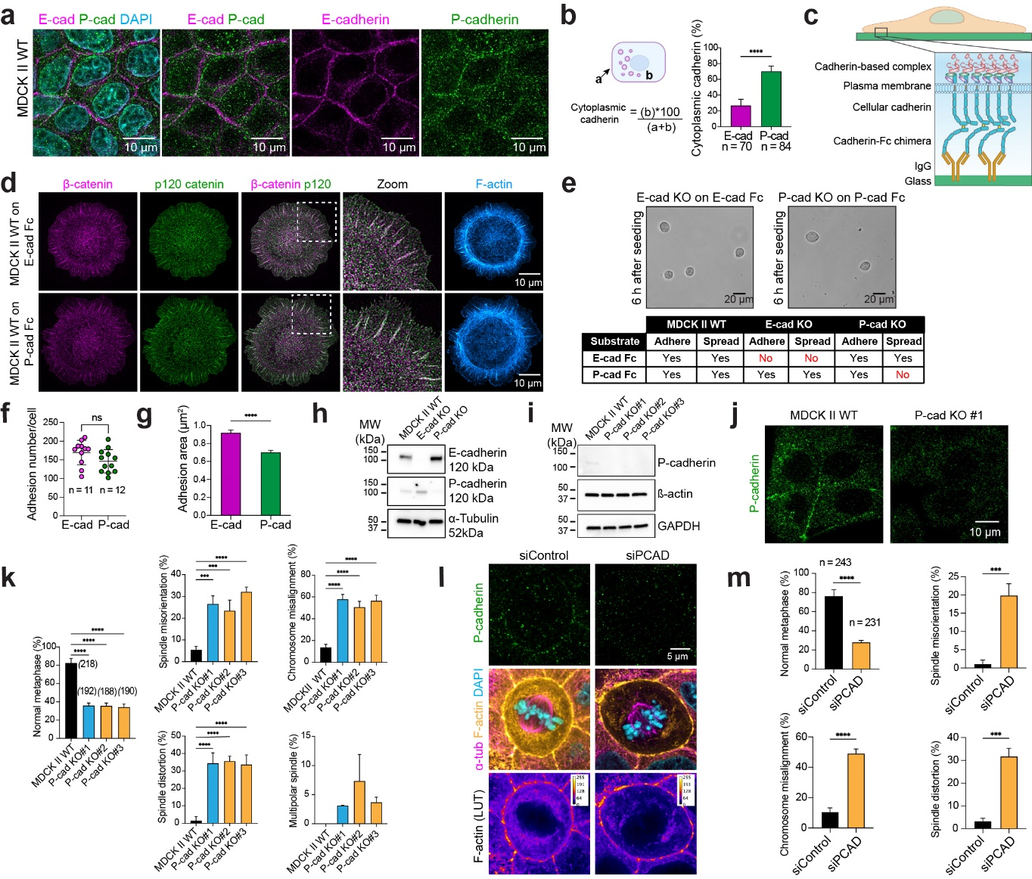
Extended Data Fig. 1. Characterization of P-cadherin functions in adhesion and mitotic fidelity.
(a-b) Localization of endogenous E-cadherin and P-cadherin in MDCK II WT cells. Confocal immunofluorescence microscopy of MDCK II (a), with quantification of cytoplasmic fraction relative to total intensity of each cadherin shown in (b). (c) Schematic diagram of planar biomimetic cadherin–F_{c} chimera substrate platform for assaying cadherin engagement. (d, f, g) MDCK engages to planarized E-cadherin or P-cadherin. Immunofluorescence microscopy against endogenous proteins in MDCK II WT cells plated on E-cad-F_{c} (top) or P-cad-F_{c} (bottom). Quantification of numbers and total area of cadherin-based adhesions formed by WT on planarized substrates in (f) and (g). (e) Adhesion and spreading responses of MDCK II WT, E-cadherin KO, or P-cadherin KO cells to a panel of cadherin-F_{c} substrates, after 6 h of seeding. (Top). Representative phase contrast images of E-cad KO on E-cad-F_{c} and P-cad KO on P-cad-F_{c}, showing inability to spread as expected. (Bottom) Scoring of adhesion and spreading characteristics. (h-i) Immunoblots of MDCK II WT, E-cadherin KO, and various clones of P-cadherin KO cells confirming biallelic depletion of target cadherins. α-Tubulin (h) or β-actin and GAPDH (i) served as loading controls. (j) Representative immunofluorescence microscopy against endogenous P-cadherin, comparing WT and P-cadherin KO. (k) Quantifications of mitotic fidelity, and categorization of observed mitotic defects of different KO clones. (l) SiRNA-mediated depletion of P-cadherin disrupts mitotic fidelity and interior actin network. (Left) Comparison of confocal images comparing MDCK II WT cells treated with control siRNA (left) versus P-cadherin KD (right). (Top) Immunostaining against endogenous P-cadherin. (Middle) 3-color super-resolution confocal composite (F-actin, yellow; α-tubulin, magenta; DNA, cyan), showing a significant depletion of interior actin networks in KD. (Bottom) Comparison of F-actin channel from super-resolution confocal at mid-spindle slice using identical color scale. (Right) Quantifications of key categories of mitotic defects. (m) Quantification of mitotic defects arising from SiRNA-depletion of P-cadherin. Scale bars: 10 µm (a, d, j); 5 µm (l); 20 µm (e). ns: not significant; ***: P < 0.001; ****: P < 0.0001.

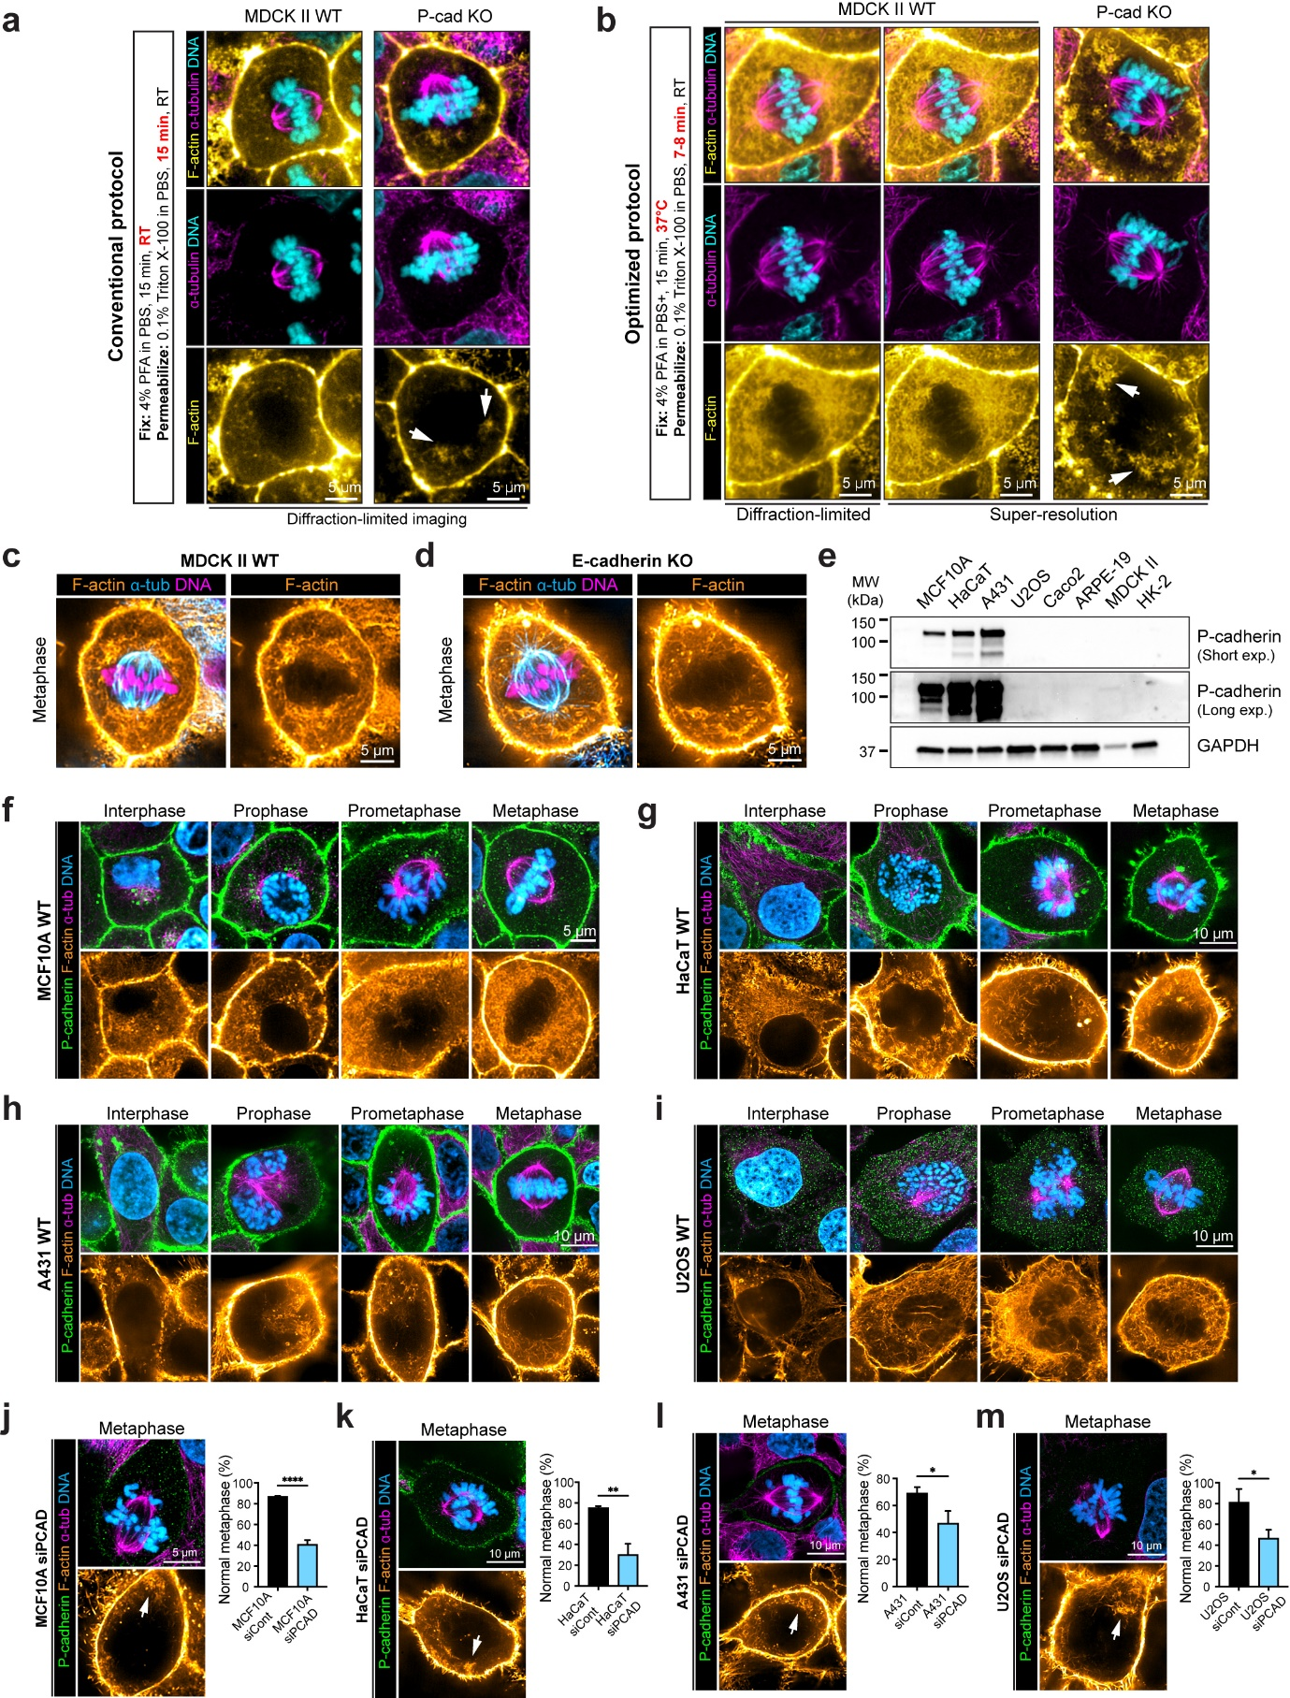
Extended Data Fig. 2. Visualization of P-cadherin-dependent mitotic interior actin networks.
(a–b) Optimization of fixation protocols for preserving interior actin networks in MDCK II cells. (a) Representative confocal images of WT and P-cadherin KO MDCK II cells stained for F-actin (yellow), α-tubulin (magenta), and DNA (cyan), fixed by conventional protocol at room-temperature (RT) and imaged using diffraction-limited optics, resulting in interior actin appearing largely indistinct. (b) Representative images of cells prepared using optimized 37°C fixation and subjected to imaging soon afterward. Super-resolution imaging mode (middle and right) provides additional enhancement of filamentous features compared to diffraction-limited (left). (c-d) E-cadherin is dispensable for interior actin network. Representative 3-color composite super-resolution confocal mid-spindle slice of metaphase MDCK II cells (WT: left, c or E-cadherin KO: right, d), showing robust interior actin networks (F-actin, orange; α-tubulin, blue; DNA, magenta). (e) Immunoblots showing P-cadherin expression across multiple epithelial and carcinoma cell lines (MCF10A, HaCaT, A431, U2OS, Caco2, ARPE-19, MDCK II, HK-2). Long and short exposure blots confirm variable P-cadherin expression among different cell lines. GAPDH serves as loading control. (f-i) Representative 4-color super-resolution confocal mid-spindle slice of MCF10A (f: non-tumorigenic human mammary epithelial), HaCaT (g: non-tumorigenic spontaneously immortalized human keratinocytes), A431 (h: tumorigenic human epidermoid carcinoma), or U2OS (i: tumorigenic human osteosarcoma), prepared with optimized fixation protocols (P-cadherin, green; F-actin, orange; α-tubulin, blue; DNA, magenta), with representative images at interphase and various mitotic stages. (j-m) SiRNA-mediated KD of P-cadherin gives rise to mitotic defects and depletion of interior actin networks, with white arrows indicating peri-mitochondria actin shell (Left). (Right) Quantification of mitotic fidelity upon siRNA-mediated KD compared to control. Scale bars: 5 µm (a-d, f, j), 10 µm (g-l, k-m). *: P < 0.05; **: P < 0.01; ****: P < 0.0001.

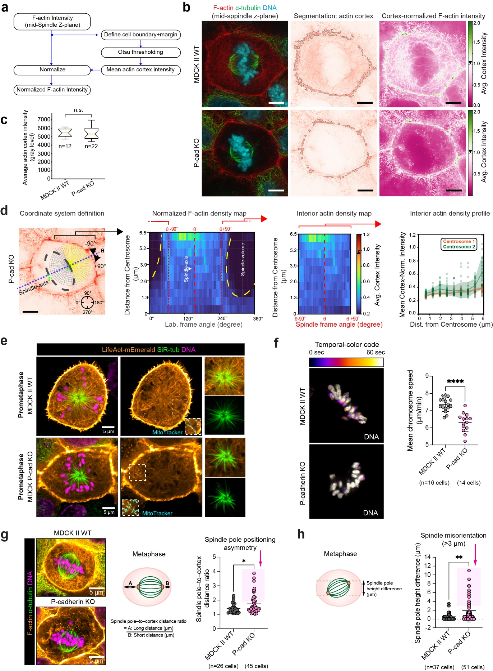
Extended Data Fig. 3. Interior actin network contributes to mitotic spindle functions.
(a) Framework for quantifying interior actin network density, against the cortex reference. (b) Definition of actin cortex for normalization. (Left) Composite 3-channel confocal mid-spindle
Z-slice (F-actin, red; α-tubulin, green; DNA, cyan), defined by the average z-plane of the two spindles. (Middle) Otsu segmentation of the F-actin channel for a region within 10 pixels (~6.5 µm) from the cell boundary (grey overlay) was performed, and the average intensity in segmented region used as the reference cortex intensity. (Right) F-actin intensity normalized by the reference cortex intensity. (c) Comparison of average cortical intensity between WT and P-cadherin KO. (d) Quantification of interior actin density relative to spindle frame-of-reference for P-cadherin KO (see Fig. 2c for WT). (Left) Definition of coordinate system. Polar coordinate is defined with origin at each metaphase centrosome. Azimuthal angle is defined relative to the spindle axis (centrosome-centrosome vector), with positive and negative angle corresponding to clockwise (+) and counter-clockwise (-) direction, respectively. Representative images for P-cadherin KO shown overlaid with one polar grid for clarity. Dashed regions corresponding to chromosome-spindle region. (Inner left) 2D heatmap of actin density is calculated as the average cortex-normalized intensity corresponding to the grid in leftmost panel. (Inner right) Interior actin density corresponding to azimuthal angle: -90° to +90° relative to spindle axis. (Rightmost) Plots of normalized actin density as a function of distance from the nearest spindle poles. (e) Decreased actin cables near spindle poles (insets) and increased mitochondria-actin association during prometaphase in P-cadherin KO. (Left panels) Four-color live-cell super-resolution imaging datasets are decomposed into separate views for clarity: three-color composite (LifeAct-mEmerald, orange; SiR-tubulin, green; DNA, magenta), and boxed regions with 2-color composite (MitoTracker, cyan; LifeAct-mEmerald, orange) shown in insets. (Right panels) Zoomed view of the spindle poles, showing lower actin cables in P-cadherin KO. (f) Temporal color-coded images depicting metaphase chromosome dynamics, comparing WT and P-cadherin KO, and quantification of tracked chromosome speed (right). (g) Asymmetric positioning of mitotic spindle in P-cadherin KO. (Left) 3-color super-resolution mid-spindle z-slice comparing WT (top) and P-cadherin KO (LifeAct-mEmerald, orange; SiR-tubulin, green; DNA, magenta). (Right) Quantification of spindle positioning asymmetric as the ratio of distance between the spindle poles to the nearest cortex. (h) Misorientation of mitotic spindles in P-cadherin KO. Quantification of z-position difference between the two spindle poles at metaphase. Mitotic cells with spindle misorientation (g) and spindle pole positioning asymmetry (h) are in pink box indicating by pink arrows. Scale bars: 5 µm (b, d, e, g). N.s.: not significant; *: P < 0.05; **: P < 0.01; ****: P < 0.0001.

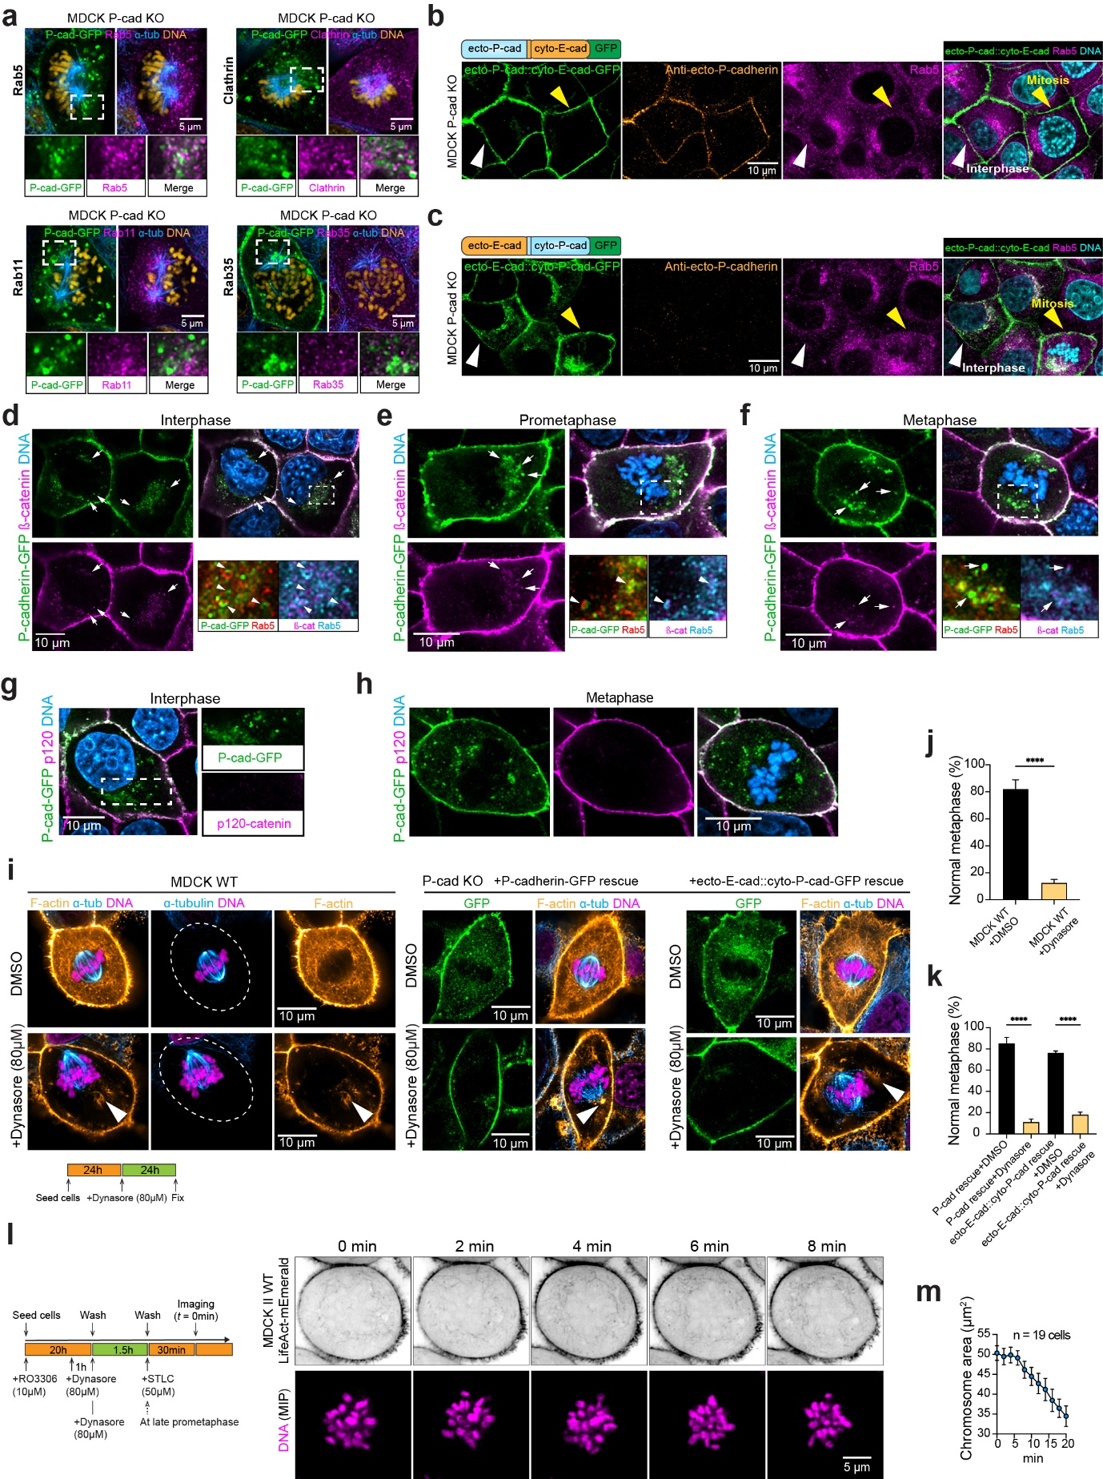
Extended Data Fig. 4. Endosomal trafficking of P-cadherin in Rab5 endosomes is determined by its cytoplasmic domain and generates interior actin network upon endocytosis to promote chromosome congression.
(a) Co-localization of P-cadherin with endosome markers. 4-color confocal datasets of P-cadherin KO cells rescued with P-cadherin-GFP and immunostained for specified endosomal markers (magenta), and α-tubulin (blue) and DNA (yellow). To aid visualization, top panels are displayed as two 3-color composites, with enlarged view of boxed region shown in bottom row as individual channels or 2-color composite of P-cadherin and endosome markers (Rab5, Clathrin, Rab11, and Rab35, respectively). (b-c) Cytoplasmic domain of P-cadherin determines Rab5 endosome localization. Cytodomain-swapped constructs (b, ecto-P-cadherin::cyto-E-cadherin) or (c, ecto-E-cadherin::cyto-P-cadherin) are expressed in MDCK P-cadherin KO cells. 4-color confocal images datasets are decomposed for clarity. Individual channels: (left, green) GFP tag on cadherin construct, (center left, orange) antibody against P-cadherin ectodomain, (center right, magenta) Rab5, and 3-color composite (GFP, green; Rab5, magenta; DNA, cyan), identifying P-cadherin cytoplasmic domain as the determinant of Rab5 endosome localization. (d-h) Endosomal P-cadherin co-localizes with β-catenin but not p120-catenin, while junctional P-cadherin also colocalizes with p120-catenin. (d-f) 4-color confocal datasets of Interphase (d), prometaphase (e), or metaphase (f) P-cadherin-GFP rescue KO cells are decomposed as single-channels for P-cadherin-GFP (green) or β-catenin-immunostained (magenta) or 3-channel composite (P-cadherin, green; β-catenin, magenta; DNA, blue), with enlarged views (bottom right) corresponding to boxed regions shown as 2-color composites (P-cadherin, green; Rab5, red) or (β-catenin, magenta; Rab5, blue). White arrows denote Rab5 endosomes containing both P-cadherin and β-catenin. (g-h) P-cadherin-GFP rescue KO cells during interphase (g) or metaphase (h) are immunostained for p120-catenin, with 3-color datasets and individual channels (P-cadherin, green; p120-catenin, magenta; DNA, blue) shown. Enlarged view in (g, right) shows that p120-catenin staining is largely limited to cell-cell junctions. (i-k) Inhibition of endocytosis by Dynasore disrupts interior actin networks and mitotic fidelity. Super-resolution confocal slices of metaphase cells comparing control (DMSO, top) with Dynasore inhibition (bottom) for WT cells, P-cadherin KO rescued with P-cadherin-GFP, or P-cadherin KO rescued with ecto-E-cadherin::cyto-P-cadherin-GFP (green, GFP; blue, α-tubulin; orange, F-actin; magenta, DNA). Arrows indicate abnormal F-actin clumps upon Dynasore treatment. Schematic of treatment on bottom left. (j, k) Quantification of mitotic fidelity due to Dynasore treatment. (l-m) Observation of interior actin network formation in conjunction with chromosome congression by dynasore washout and 2-step cell cycle synchronization. (Left) Schematic diagram depicting initial synchronization of cells at G2/M by RO-3306 treatment, followed by Dynasore addition 1 h before G2/M release. Cells were allowed to enter prometaphase in the presence of Dynasore. After washout, cells were stalled at prometaphase using STLC and endocytosis was allowed to resume for 30 min before image acquisition. (Right) Time-lapse montage of F-actin (inverted grayscale for LifeAct-mEmerald, top) and clustered chromosome (magenta, bottom) showing increased cytoplasmic actin cables and congressing chromosomes after Dynasore washout (see also Movie 6). (m) Quantification of clustered chromosome area during prometaphase after Dynasore washout. Mean ± SD. Scale bars: 10 µm (a, b, d, f, g), 5 µm (j). ****: P < 0.0001.

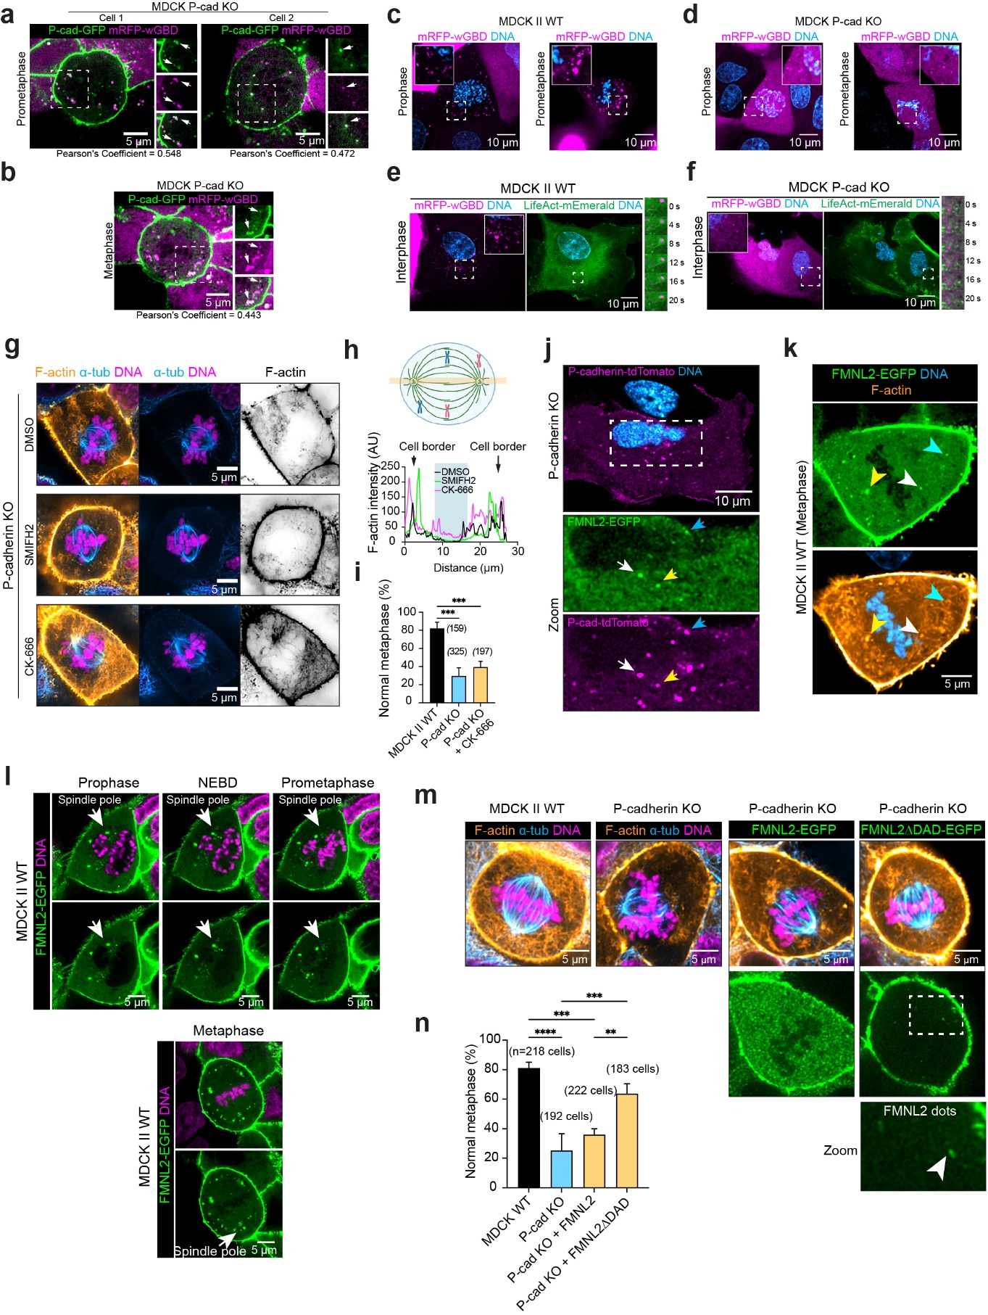
Extended Data Fig. 5. P-cadherin is co-trafficked with active Cdc42 and FMNL2 formin in association with actin cables and regulates endosomal localization of FMNL2.
(a-b) P-cadherin co-localizes with active Cdc42 primarily in endosomes. Live-cell confocal images of MDCK P-cadherin KO re-expressing P-cadherin-GFP and the active Cdc42 biosensor, mRFP-wGBD, during prometaphase (a) or metaphase (b, see also Fig. 5a-b). Pearson’s coefficient provided for indicated cells. (c-d) P-cadherin is required for active Cdc42 localization at endosomes. MCDK II WT (c) or P-cadherin KO (d) at prophase or prometaphase expressing mRFP-wGBD, which localizes in endosomes in WT but is largely cytosolic in P-cadherin KO. See also Fig. 5a-b and Quantification in Fig. 5d. (e-f) 3-color live-cell datasets of interphase MDCK II WT (e) or P-cadherin KO (f) expressing mRFP-wGBD and LifeAct-mEmerald shown as 2-color composites, (left: active Cdc42 biosensor, magenta; DNA, blue) or (right: LifeAct-mEmerald, green; DNA, blue). (Right) 2-color time-lapse montage (LifeAct-mEmerald, green; mRFP-wGBD, magenta), highlighting dynamic endosomal actin polymerization in WT (e), and its absence from KO (f). (g-i) Effects of actin polymerase inhibition on interior actin network in P-cadherin KO. Super-resolution confocal images (g) of P-cadherin KO cells treated with the formin inhibitor, SMIFH2, or Arp2/3 inhibitor, CK666. Left panels show composite 3-channel image (F-actin, orange; α-tubulin, blue; DNA, magenta). Center and right panels: 2-color composite of spindle and inverted contrast F-actin channel, respectively. (h) Intensity profile along the spindle axis (highlighted band in diagram), comparing control with CK666 or SMIFH2 treatment and (i) quantification of mitotic fidelity. (j) P-cadherin colocalizes at endosomes with FMNL2. 3-color confocal datasets of P-cadherin KO re-expressing P-cadherin-tdTomato, shown as 2-color composite (top, P-cadherin-tdTomato, magenta; DNA, blue) with enlarged individual channel view for FMNL2-EGFP (center) and P-cadherin-tdTomato (bottom). Arrows indicate co-localized vesicles. (k) FMNL2 endosomes are associated with actin cables. 3-color confocal datasets of metaphase MDCK II WT, with (top) individual FMNL2-EGFP channel and (bottom) 2-color composite (F-actin, orange; DNA, blue). (l) FMNL2 localizes to endosomes near mitotic spindle vicinity. (Top) Live-cell confocal 2-color composite (upper row, FMNL2: green, DNA, magenta) and individual FMNL2 channel (lower row) montages of WT cells progressing through prophase, NEBD, and prometaphase, expressing FMNL2-EGFP (green) and stained by Hoechst dye for DNA (magenta). (Bottom) Metaphase cell, with arrows indicating FMNL2 puncta accumulated at spindle poles. (m-n) Endosomal localization of FMNL2 depends on P-cadherin, or relief of FMNL2 autoinhibition. 3 or 4-color super-resolution confocal images (green, GFP if present; F-actin, orange; a-tubulin, magenta; DNA, blue) of metaphase MDCK II WT, P-cadherin KO, P-cadherin KO expressing FMNL2-EGFP, or P-cadherin KO expressing constitutively active FMNL2-ΔDAD-EGFP. Individual panels for FMNL2 show cytosolic distribution in P-cadherin KO with FMNL2-EGFP, in contrast with cell-cell junction and endosome localization in P-cadherin KO expressing FMNL2-ΔDAD-EGFP (m). (n) Quantification of mitotic fidelity corresponding to (m). Scale bars: 5 µm (a, b, g, k-m), 10 µm (c-f, j). **: P < 0.01; ***: P < 0.001, ****: P < 0.0001.

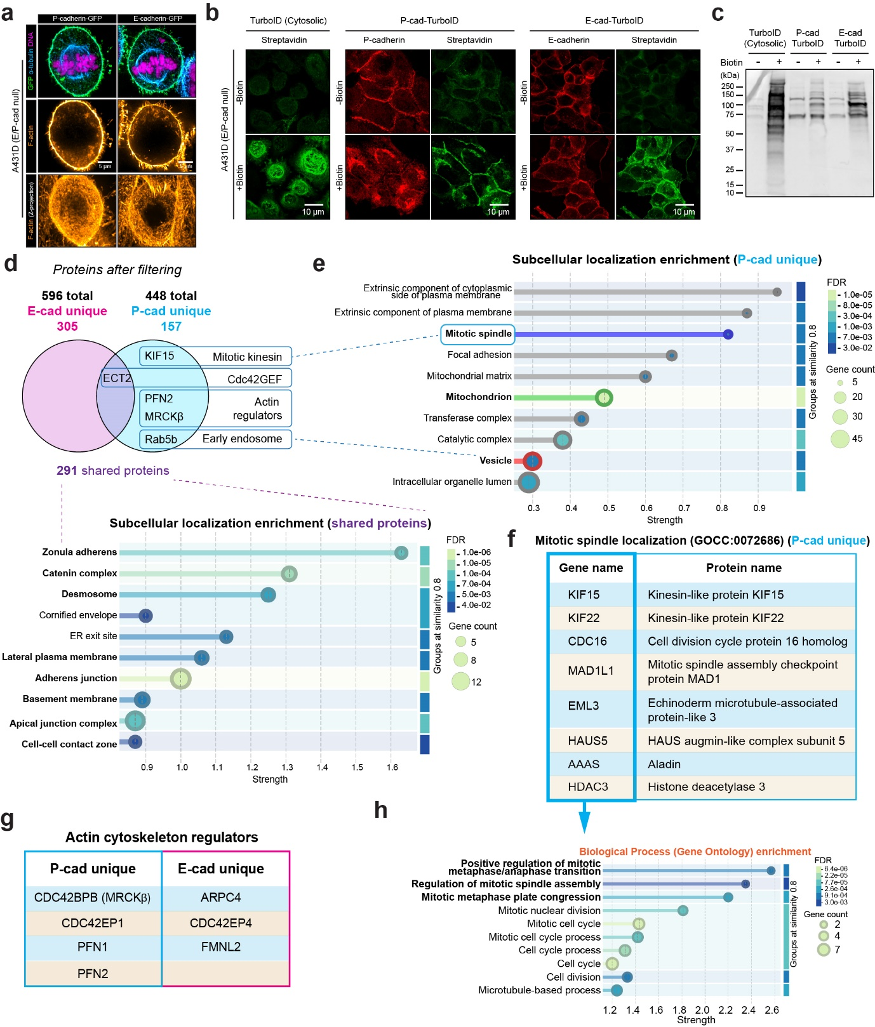
Extended Data Fig. 6. Proximity biotinylation proteomics of P-cadherin and E-cadherin identifies the roles of MRCKβ in P-cadherin-dependent mitotic functions.
(a) Effect of re-expression of E-cadherin or P-cadherin in cadherin-null A431D. (Top) 4-color super-resolution confocal image of fixed cells (green, E- or P-cadherin-GFP; blue, α-tubulin; orange, F-actin; magenta, DNA), showing mitotic defect (lagging chromosome) in E-cadherin-GFP re-expression. (Center) Mid-spindle plane slice of F-actin channel, and (bottom) maximum intensity projection, showing increased cytoplasmic F-actin upon P-cadherin expression. (b) Confocal images of A431D cells expressing TurboID alone (left, no cell-cell junctions), P-cadherin–TurboID (middle), or E-cadherin–TurboID (right), with (bottom) or without (top) biotin incubation. Cells were labelled with streptavidin (green) and antibodies against P-cadherin or E-cadherin (red). (c) Streptavidin–HRP immunoblot detecting biotinylated proteins from A431D cells expressing TurboID, P-cadherin–TurboID, or E-cadherin–TurboID. (d-h) Mass spectrometry identified 596 E-cadherin–proximal and 448 P-cadherin–proximal proteins (see Supplementary Table 1). Candidate proteins selected for functional validation are highlighted. The 291 proteins shared between E-cadherin–TurboID and P-cadherin–TurboID were categorized by subcellular localization using STRING. (e) The 157 proteins uniquely associated with P-cadherin–TurboID were annotated and plotted according to subcellular localization enrichment. (f) List of proteins localized to the mitotic spindle in (d) were further classified based on their associated biological processes (h). (g) Lists of actin cytoskeleton regulators uniquely associated with P-cadherin or E-cadherin are shown. Scale bars: 5 μm (a), 10 μm (b).

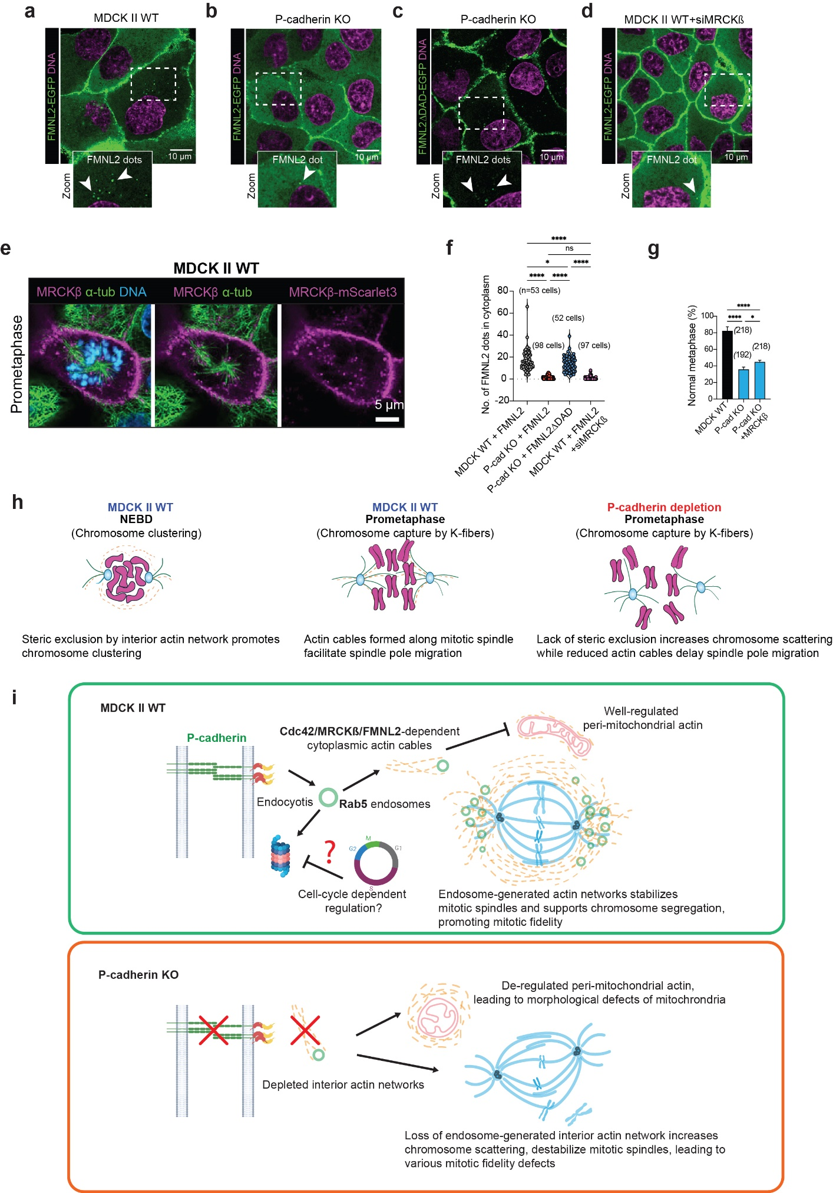
Extended Data Fig. 7. Cdc42/MRCKβ/FMNL2 pathway mediates P-cadherin-dependent interior actin network to promote mitotic fidelity and organelle homeostasis.
(a-d) Endosomal localization of FMNL2 depends on P-cadherin, MRCKβ, or relief of autoinhibition. Live-cell confocal images (green, GFP; magenta, DNA) of interphase MDCK II WT expressing FMNL2-EGFP (a), P-cadherin KO expressing FMNL2-EGFP (b), P-cadherin KO expressing constitutively active FMNL2-ΔDAD-EGFP (c), and MDCK II WT expressing FMNL2-EGFP with siRNA against MRCKβ (d). (Insets) Enlarged views corresponding to boxed region in top panels, with arrows indicating FMNL2 puncta. (e) 3-color confocal datasets of MDCK II WT (upper) expressing MRCKβ-mScarlet3 (magenta) and stained for α-tubulin (green) and DNA (blue) during prometaphase (see Fig. 7a,d for interphase or metaphase). (f) Quantification of puncta containing FMNL2 or mutants corresponding to (a-d). (g) Quantification of mitotic fidelity comparing WT with P-cadherin KO with or without over-expression of MRCKβ. (h-i) Working Model for P-cadherin-dependent regulation of mitotic fidelity. (h) During mitosis in MDCK II WT, the interior actin network helps sterically cluster chromosomes near spindle center, limiting chromosome scattering. During prometaphase, the enhanced chromosome congression facilitates chromosome capture, timely spindle pole migration, and proper mitotic progression. In P-cadherin KO, depletion of interior actin network enable scattering of chromosomes, impairing chromosome capture, spindle pole migration, and affect mitotic fidelity. (I) Working model for P-cadherin-based mechanisms: upon clathrin-mediated endocytosis, P-cadherin is trafficked in Rab5-positive endosomes which are associated with active Cdc42, MRCKβ, and FMNL2 to dynamically generate actin cables within the cytoplasm. P-cadherin trafficking is proposed to be regulated in a cell-cycle dependent fashion, likely via regulation of its degradation pathways. During mitosis, P-cadherin endosomes accumulate near the spindle poles, and the actin cables thus generated organize into interior actin networks that exclude the mitotic spindle volume, helping to physically constrain the chromosomes to facilitate efficient and timely capture. Additionally, actin polymerization associated with the P-cadherin endosomes competitively regulate peri-mitochondrial actin, helping to maintain normal mitochondrial morphology and functions. Upon P-cadherin loss (bottom), the absence of actin-polymerizing endosomes leads to depleted interior actin networks. Less physical constraints may result in increased scattering of chromosomes that impair timely capture and affect mitotic spindle organization. Reduced endosomal actin polymerization may also lead to excessive mitochondrial actin polymerization that results in defect in morphology and distribution of mitochondria. Some elements of the graphics were generated using BioRender®. Scale bars: 10 µm (a-d), 5 µm (e). *: P < 0.05; ****: P < 0.0001.

Supplementary Table 1.
Protein identification results of P-cadherin and E-cadherin proximal proteins from A431D (E-cadherin/P-cadherin-null) cells expressing P-cad-TurboID or E-cad-TurboID.

Movie 1 Dynamics of interior actin network during mitosis
4-color live-cell super-resolution spinning disc confocal imaging of WT MDCK during NEBD mitosis corresponding to Fig. 3 with LifeAct-mEmerald (orange), SiR-tubulin (green), MitoTracker Orange (cyan), and Hoechst 33342 (magenta) imaged. Concomitant spindle pole inward migration, along with dynamics of actin cables, mitochondria, and chromosomes, are shown. Four-color datasets are decomposed into separate views for clarity with leftmost panel showing actin, microtubules, and chromosomes; center-left showing microtubules and chromosomes; center-right showing actin and mitochondria; and rightmost showing actin.

Movie 2 Loss of P-cadherin impairs mitotic interior actin dynamics
4-color live-cell super-resolution spinning disc confocal imaging of P-cadherin KO MDCK during NEBD corresponding to Fig. 3, with LifeAct-mEmerald (orange), SiR-tubulin (green), MitoTracker Orange (cyan), and Hoechst 33342 (magenta) imaged. Decrease in spindle pole inward migration, decreased actin cable formation at spindle poles, increased actin-mitochondria association, and altered chromosome dynamics compared to WT (Movie 2), are shown. Four-color datasets are decomposed into separate views for clarity with leftmost panel showing actin, microtubules, and chromosomes; center-left showing microtubules and chromosomes; center-right showing actin and mitochondria; and rightmost showing actin.

Movie 3 P-cadherin antagonizes peri-mitochondrial actin
Live-cell super-resolution spinning disc confocal movies corresponding to Fig. 2f-g, comparing WT (left) with P-cadherin KO (right) MDCK II cells, showing increased Mitochondrial actin and clumped mitochondrial organization in P-cadherin KO. Mitochondrial actin is visualized by chromobody-based AC-mito (green), DNA (blue) by Hoechst 33342, and mitochondria by MitoTracker Orange (magenta).

Movie 4 P-cadherin is trafficked in endosomes in association with dynamic actin cables during interphase
3-color live-cell super-resolution spinning disc confocal imaging of P-cadherin KO MDCK rescued with P-cadherin-tdTomato (green) and expressing LifeAct-mEmerald (green), corresponding to Fig. 5d, showing the dynamics of actin cables as well as actin comets that are associated with P-cadherin endosomes during interphase. 3-color datasets are decomposed into separate views for clarity with leftmost panel showing P-cadherin, actin, and DNA; inner left panel showing P-cadherin and actin; inner right panel showing P-cadherin; and rightmost showing actin.

Movie 5 P-cadherin is trafficked in endosomes in association with dynamic actin cables during mitosis
3-color live-cell super-resolution spinning disc confocal imaging of P-cadherin KO MDCK rescued with P-cadherin-GFP corresponding to Fig. 5e, showing the dynamics of P-cadherin vesicles and actin cables in a mitotic cell. 3-color datasets are decomposed into separate views for clarity, with P-cadherin-GFP in magenta, LifeAct-mScarlet-I in green, and DNA (Hoechst 33342) in blue. Leftmost: P-cadherin, actin, and chromosomes; inner left: P-cadherin and actin; inner right: actin; right: P-cadherin.

Movie 6 Relief of endocytosis initiates interior actin network formation and chromosome congression in synchronized cells
Combined cell-cycle synchronization and dynasore wash-out as described in Extended Data Fig. 4l-m. 2-color live-cell imaging of WT MDCK with stable expression of LifeAct-mEmerald (left, inverted grayscale) and Hoechst 3342 (magenta) following the combined cell cycle-synchronization and Dynasore wash-out. Progressive increase in actin cables in conjunction with chromosome congression are shown. Time stamp indicates elapsed time since the wash-out of dynasore to permit clathrin-mediated endocytosis, in the presence of prometaphase block.

