Supplemental information

Oral cancer-derived extracellular vesicles biodistribute to lymph nodes, educating the metastatic niche.

Yanyin Lu, Kunihiro Yoshida, Kisho Ono, Lizi Xing, Hiroki Shinchi, Htoo Shwe Eain, May Wathone Oo, Hotaka Kawai, Kuniaki Okamoto, Koji Ueda, and Takanori Eguchi

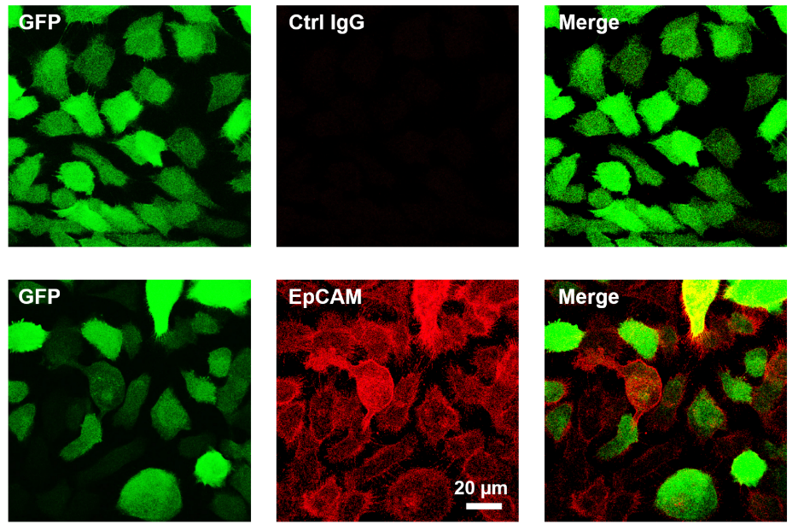

Figure S1. Confocal images of EpCAM ICC and GFP in M3/mbGLuc cells.

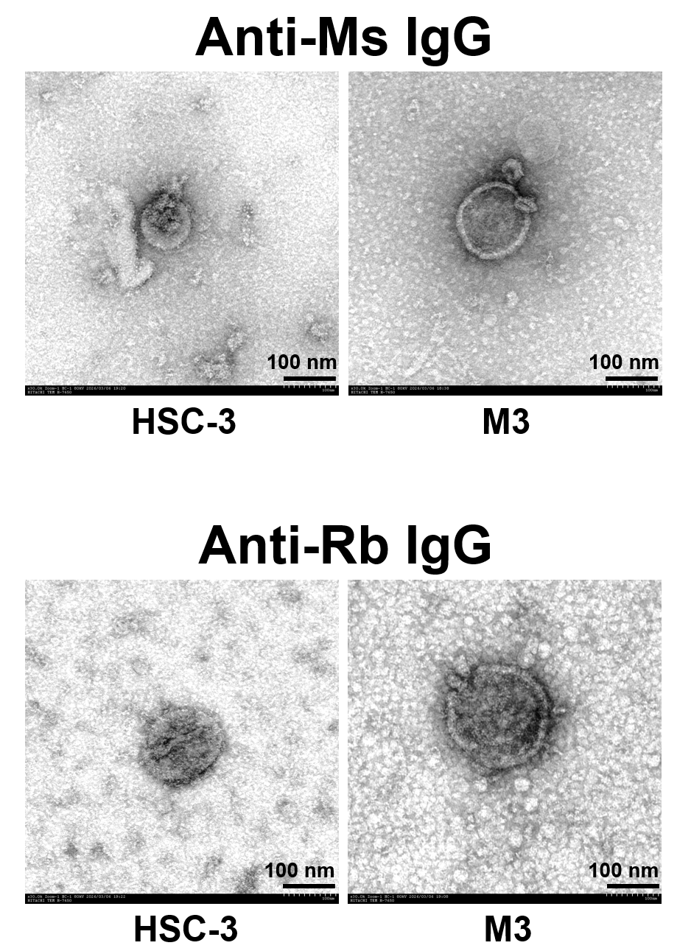

Figure S2. Negative control immunoEM images of SEVs. Anti-mouse or rabbit IgG was used.

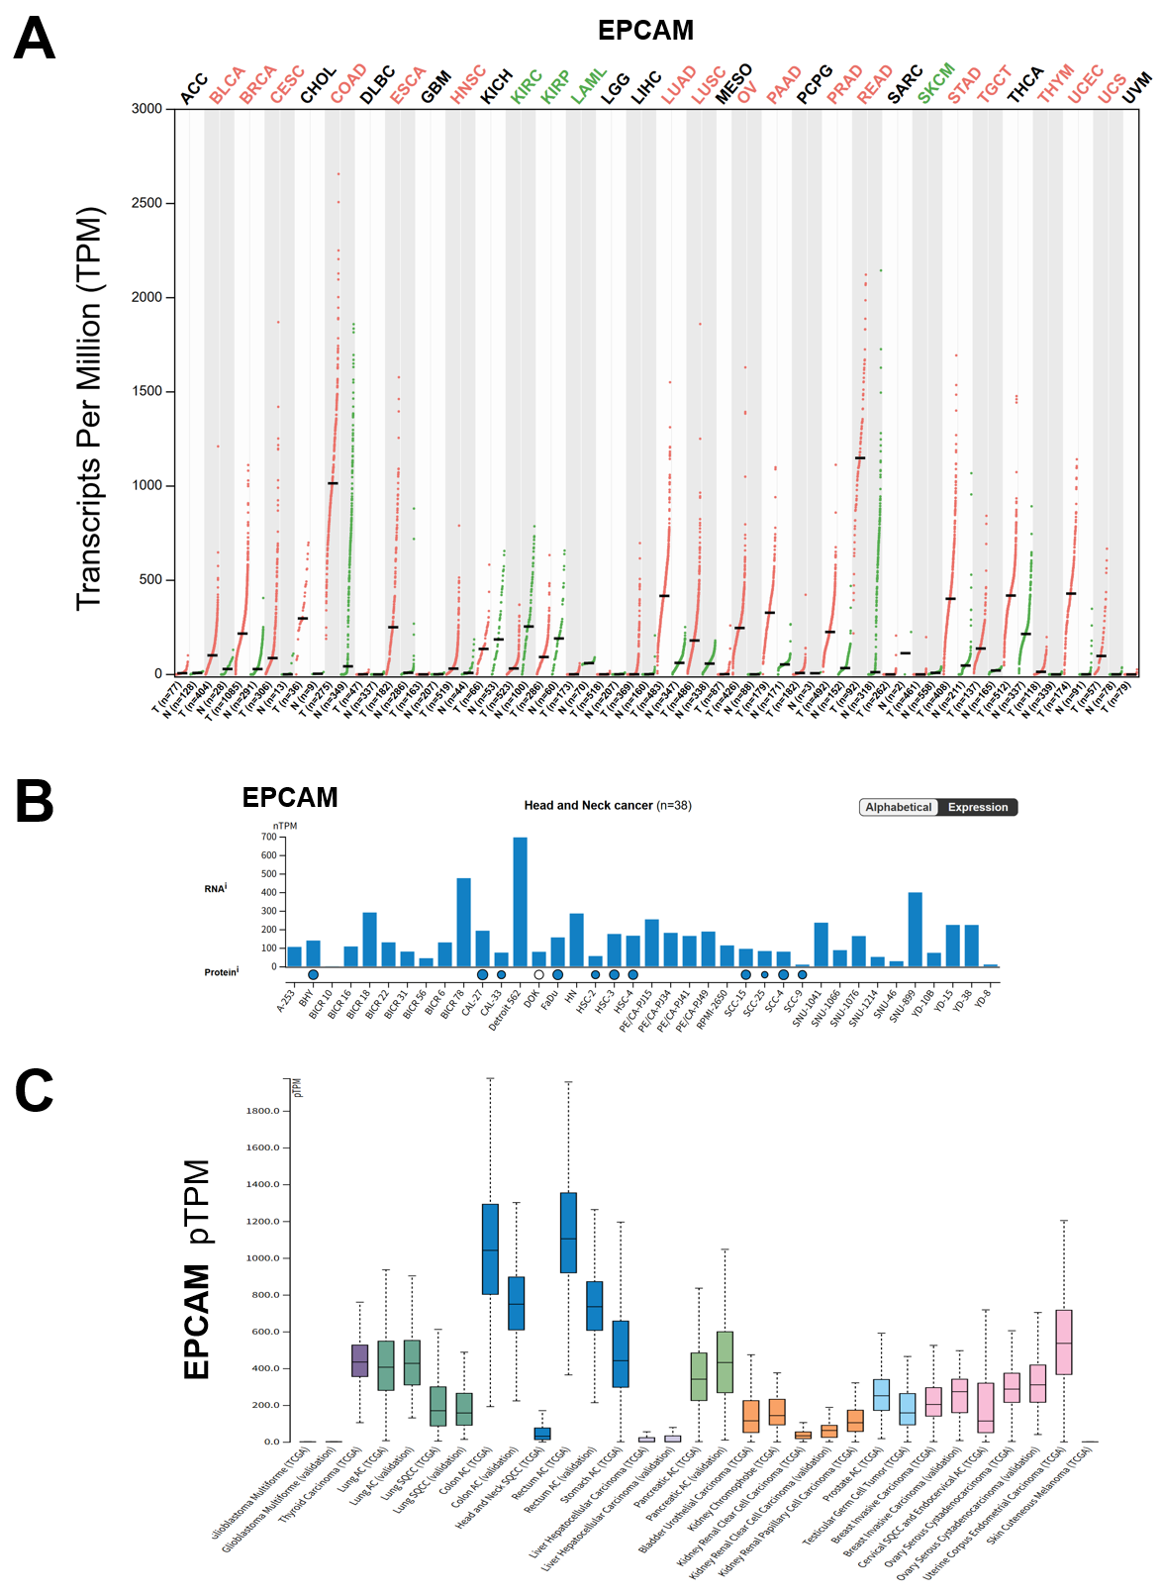
Figure S3. Gene expression of EPCAM in various types of tumors, normal tissues, and HNSC cell lines. (A) Tumors vs. normal tissues. Data are from GEPIA2. (B) HNSC cell lines. (C) Various cancer types. (B, C) Data are from Human Protein Atlas.

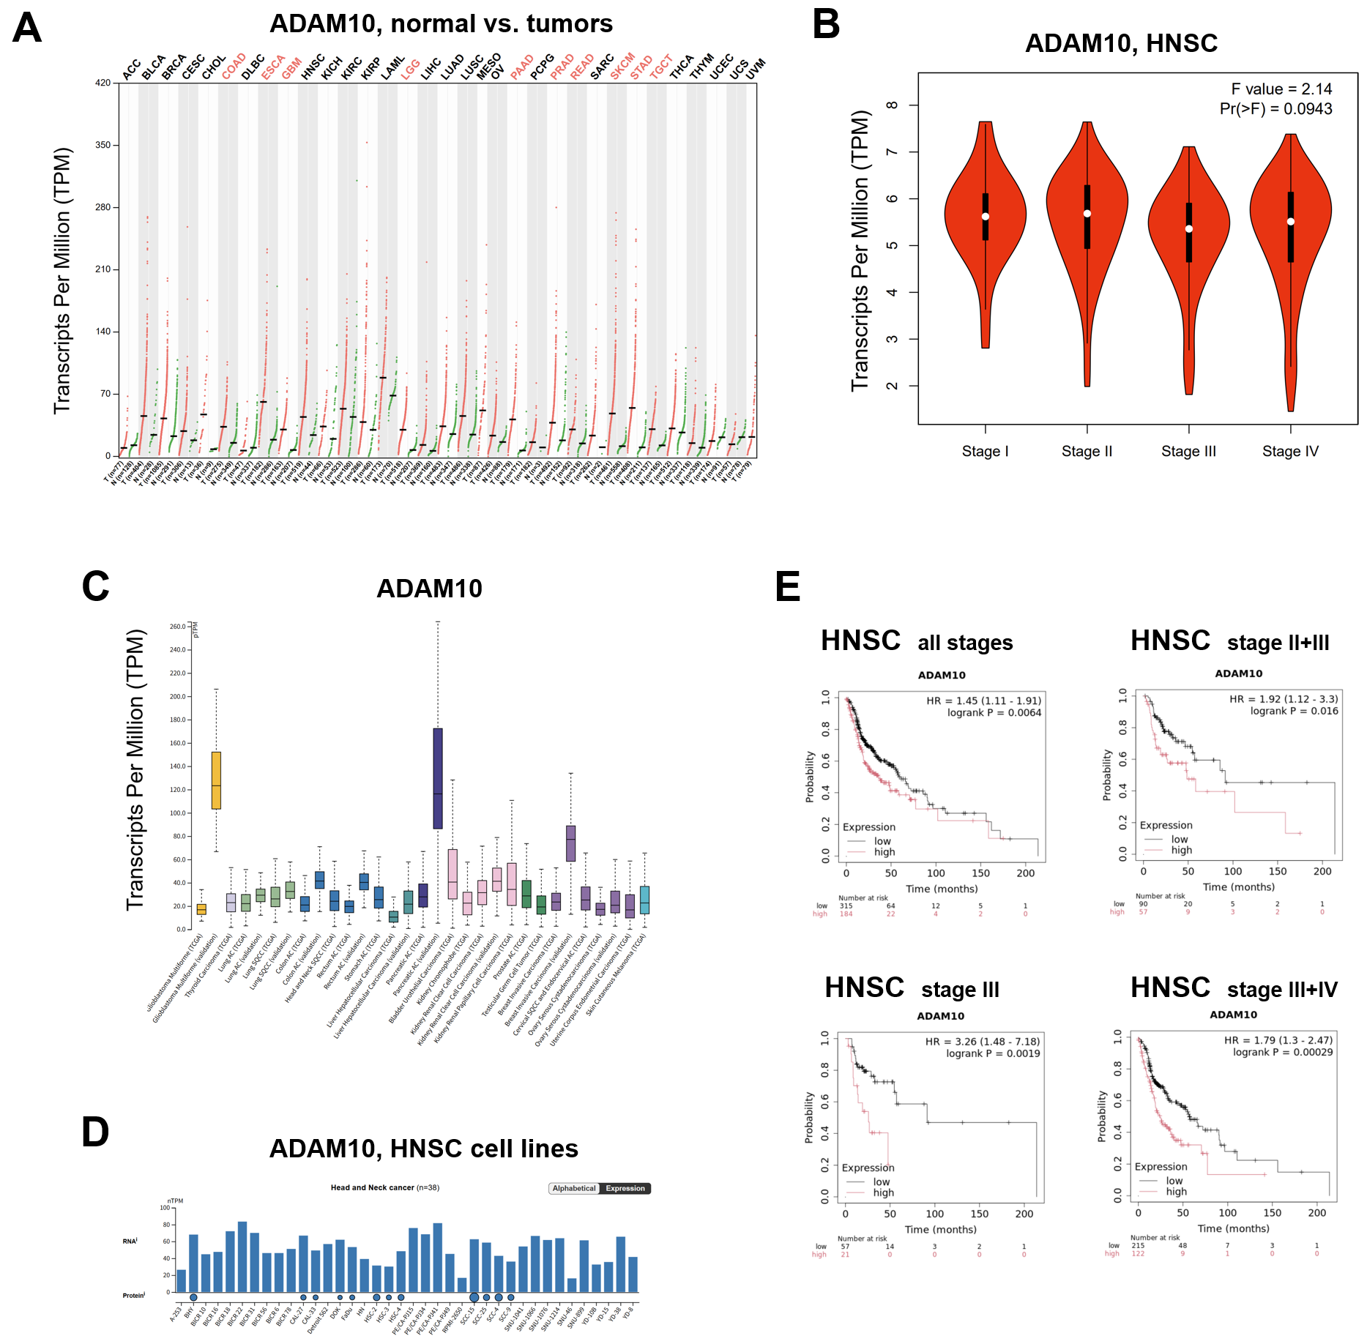

Figure S4. Gene and protein expression of ADAM10 in various types of tumors, including HNSC, and normal tissues. (A) ADAM10 mRNA expression levels in normal tissues vs tumors. (B) Stage dependency in HNSC. (C) Pan-cancer analysis. (D) mRNA and protein expression in HNSC cell lines. (E) Kaplan-Meier plotting in various stages of HNSC patients.
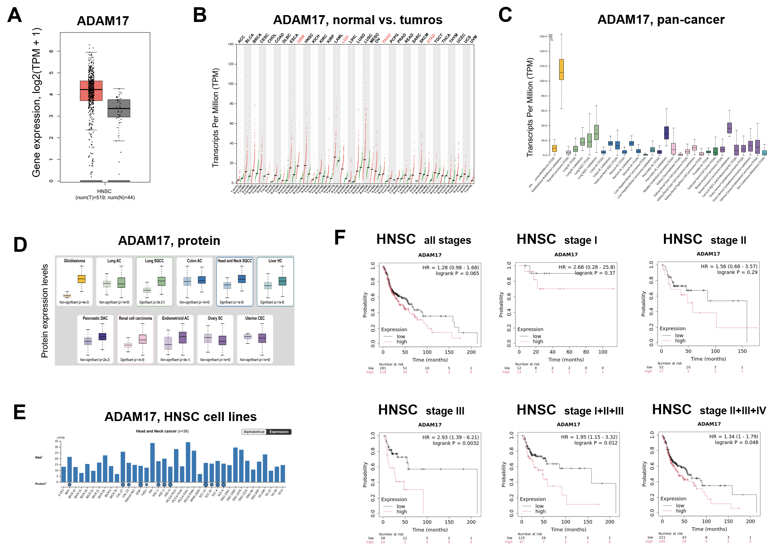

Figure S5. Gene and protein expression of ADAM17 in various types of tumors, including HNSC, and normal tissues. (A) mRNA expression in HNSC vs. normal tissues. (B) ADAM17 mRNA expression in various tumors vs. normal tissues. (A, B) Data are from GEPIA2. (C) ADAM17 mRNA expression in various cancer types. (D) ADAM17 protein expression in various cancer types vs. normal tissues. (E) ADAM17 mRNA and protein expression in HNSC cell lines. (C-E) Data are from Human Protein Atlas. (F) Kaplan-Meier plotting in various stages of HNSC patients. Data were from the KM plotter.

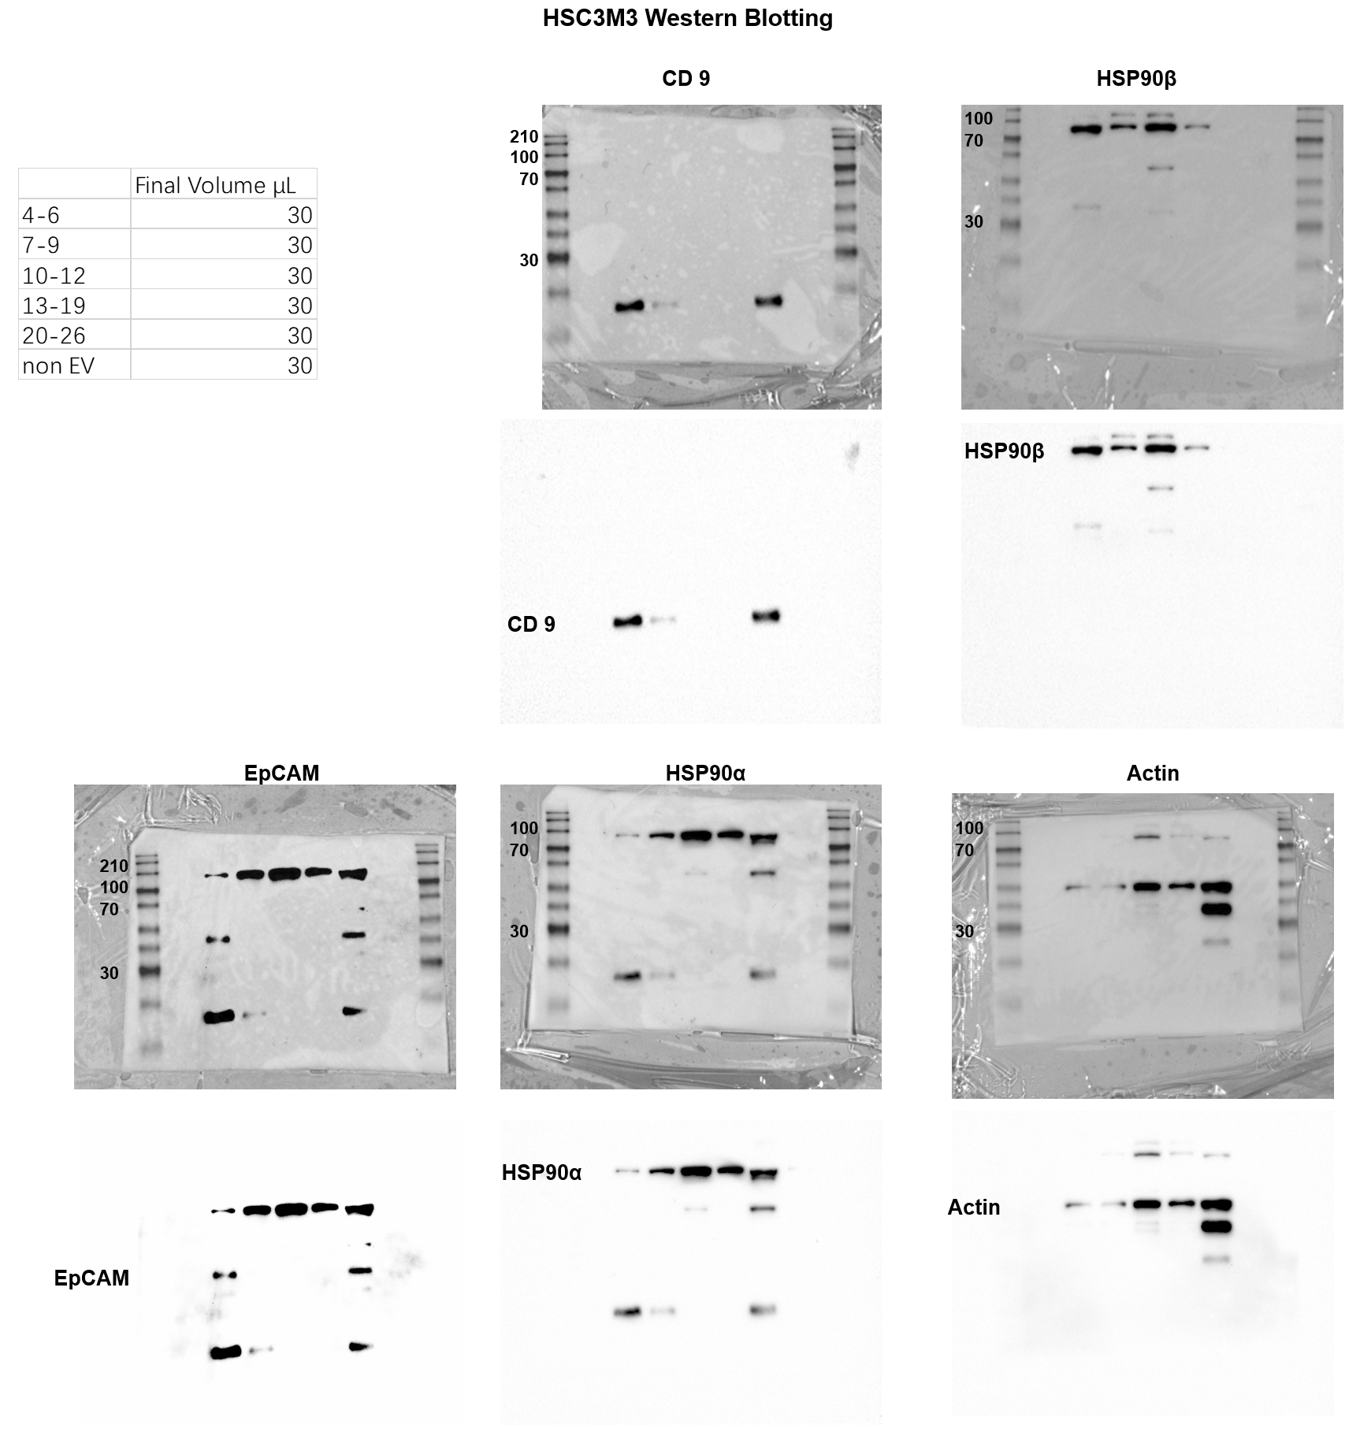
Figure S6. Uncropped full images of western blotting of M3 cells.

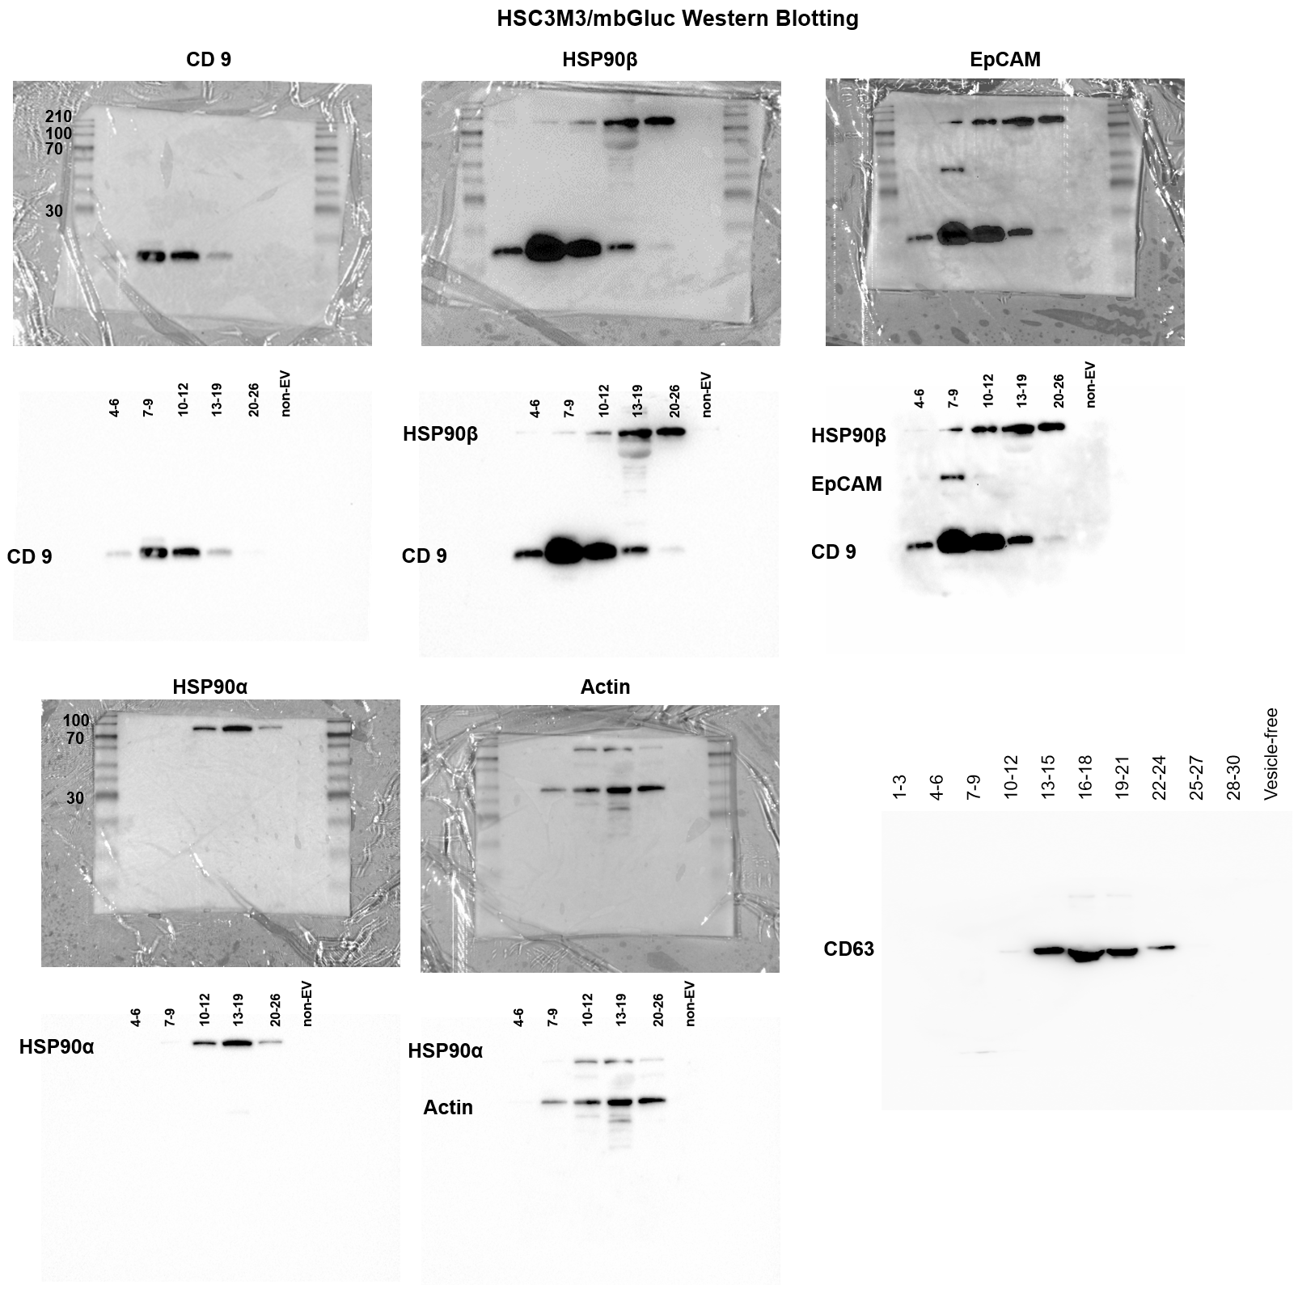

Figure S7. Uncropped full images of western blotting of M3/mbGLuc cells.

