Supplementary Information
The Natural Coding of Language: SPECTRA is All You Need
Yi Feng¹,† Shijie Tao¹,† Xiaolong Zhang¹,† Meng Huang¹, Donglai Zhou¹, Linjiang Chen¹, Daobin Liu¹, Guokun Yang¹, Hengyu Xiao², Yang Wang¹, Cheng Chen¹, Pieter E S Smith², Yan Huang¹, Shuo Feng¹, Song Wang¹, Jun Jiang¹*
¹State Key Laboratory of Precision and Intelligent Chemistry, University of Science and Technology of China, Hefei, Anhui 230026, China
²Hefei JiShu Quantum Technology Co. Ltd, Hefei 230026, China.
*Corresponding author: Shuo Feng, sfeng18@ustc.edu.cn; Yan Huang, hyan@ustc.edu.cn; Song Wang, wsong09@ustc.edu.cn; Jun Jiang, jiangj1@ustc.edu.cn
†These authors contributed equally to this work.

Automated High-Throughput Infrared Spectroscopy Workflow
1. System Architecture & Integration
The automated IR platform is built around a central cloud-based computational server that orchestrates a suite of interconnected modules. Core components include:
1) A mobile robotic arm for transporting sample trays and consumables between stations.
2) A high-precision stationary robotic arm dedicated to instrument operation and delicate sample handling.
3) Integrated workstations: Automated Liquid Handler, Weighing Station, Hydraulic Press, Drying Oven, and the FT-IR Spectrometer with interchangeable accessories (ATR, Transmission).
4) A centralized Data Management System for sample tracking, spectral collection, and preliminary analysis.

2. Automated Sample Preparation & Handling
1) Liquid Samples & ATR Analysis
- Tray Reception: The mobile robot delivers a sealed tray containing pre-loaded liquid sample vials from a storage module to the ATR preparation station.
- Automated Decapping: A dedicated tool on the stationary arm unscrews or removes vial caps.
- Surface Preparation & Background Measurement: The arm retrieves a clean swab, executes a solvent-cleaning and drying cycle on the ATR crystal, and commands the spectrometer to collect a background scan.
- Precision Dispensing & Measurement: Using a calibrated electronic pipette (e.g., 10 µL), the arm aspirates sample from the vial, dispenses it onto the ATR crystal, and immediately initiates spectral acquisition.
- Post-Measurement Cleaning: Post-scan, the arm performs another automated solvent-and-dry clean cycle on the crystal.
- Recapping & Storage: The vial is recapped, and the tray is transferred to a "completed samples" storage zone.
2) Solid Samples & KBr Pellet Analysis
- Weighing & Mixing: The system receives a tray with solid samples and pure KBr. An automated micro-balance dispenses pre-programmed masses (e.g., 1-2 mg sample, 100-200 mg KBr) into individual pellet die cavities on a multi-die holder.
- Automated Grinding & Homogenization: The entire die holder is transferred to a vibration milling station for a timed cycle, ensuring homogeneous mixing.
- Pelletization: The die holder is moved under a hydraulic press. The robotic arm aligns each die for automatic pressing at a predefined tonnage and duration.
- Background & Sample Measurement:
- A pure KBr pellet is first loaded into the spectrometer's transmission holder by the robot, and a background spectrum is collected.
- The robot swaps the KBr pellet for a sample-containing pellet and initiates the sample scan. This process repeats for all pellets in a batch, utilizing a single background measurement per batch for consistency.
3) Solution Samples & Transmission Cell Analysis
- Automated Solution Preparation: In a fume hood module, the liquid handler prepares solutions in sealed vials. It weighs solid samples, adds precise volumes of solvent (e.g., dichloromethane), and performs ultrasonic agitation for dissolution.
- Film Casting: The robot pipettes a defined volume (e.g., 100 µL) of the solution onto a designated IR window plate (e.g., KBr, NaCl).
- Solvent Evaporation: The plate is transferred to a temperature-controlled drying station to evaporate the solvent, forming a uniform thin film.
- Measurement: The plate is robotically loaded into a multi-position transmission holder in the spectrometer for sequential analysis.

3. High-Throughput Spectral Acquisition & Data Pipeline
The spectrometer operation (purge, background collection, sample scan parameters, data saving) is fully controlled via the central server using instrument-specific APIs. All spectral files are automatically named and uploaded to a structured database. The system can run 24/7, processing batches of samples (e.g., 40 per batch as indicated in the high-throughput synthesis image) with minimal human intervention.

4. Post-Analysis & Cleanup
- Waste Disposal: Used tips, swabs, and liquid waste are deposited into designated sealed waste containers.
- Equipment Cleaning: KBr dies and window plates are transported to an ultrasonic cleaner, followed by a drying module, before being returned to the starting inventory for reuse.

This automated IR workflow is designed as a characterization module within a larger "AI-Chemist" framework. This integrated approach dramatically reduces manual labor, eliminates human error in repetitive tasks, ensures unparalleled procedural consistency, and accelerates the pace of materials characterization and discovery.

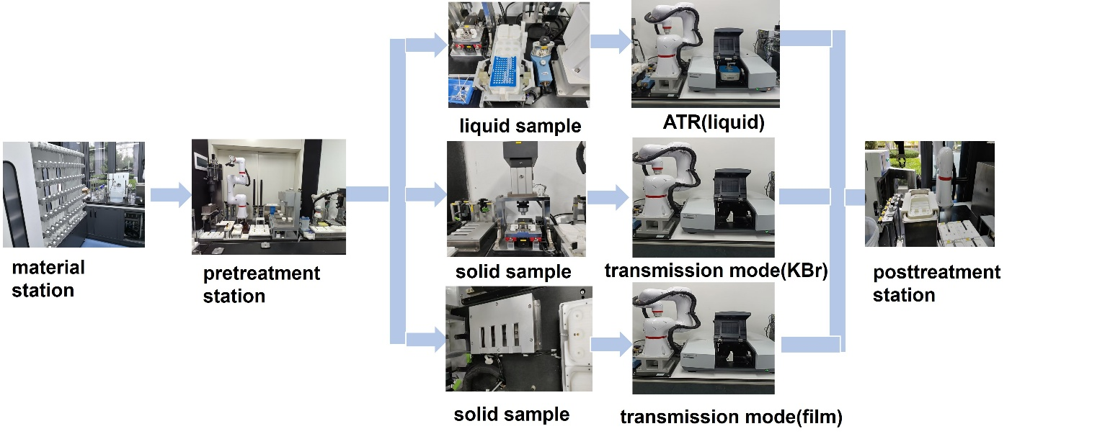
Figure S1. Automated High-Throughput Infrared Spectroscopy Workflow for liquid and solid samples.

Cipher Book for Word–Code Mapping

To connect English words with spectral codes in a deterministic way, we built a cipher book (a one-to-one dictionary) using frequency matching.

First, we collected the occurrence frequencies of common English words from Google-based statistics and ranked words from high to low frequency. In parallel, we converted all spectra in our database into spectral codes and counted how often each code appears, then ranked codes from high to low frequency. Finally, we aligned the two ranked lists: the most frequent word is mapped to the most frequent code, the second to the second, and so on. This produces a simple and reproducible word–code mapping used throughout the word-guided generation pipeline.

Spectral Code to Vibrational Spectrum Generation Using CVAE (C2S model)
We employed a Conditional Variational Autoencoder (CVAE) model¹ to generate vibrational spectra from spectral codes, named C2S (Codes to Spectra) model. The C2S model is designed to learn a latent representation that captures the underlying distribution of spectral codes. The architecture of the C2S model and the methods employed for training and inference are described in detail below.
The architecture of the C2S model seamlessly combines Transformer-based layers with fully connected layers to enable efficient encoding and decoding of vibrational spectra. The encoder processes the 4000-dimensional vibrational spectrum by dividing it into 200-dimensional tokens, which are concatenated with a 10-dimensional spectral code. These inputs are first passed through a multi-head self-attention mechanism and subsequently through two Transformer layers, each equipped with four attention heads, to effectively capture long-range dependencies in the data. The output is then transformed by two fully connected layers: the first consists of 1024 neurons, followed by 512 neurons, both incorporating Batch Normalization and ReLU activation functions to ensure stability and nonlinearity. The encoder ultimately generates two 50-dimensional vectors, representing the mean (𝜇) and the log variance (log 𝜎²) of the latent space distribution. These outputs enable the reparameterization process, which samples latent vectors from a Gaussian distribution, ensuring a smooth and continuous latent space representation.
The decoder reconstructs the vibrational spectrum by integrating the latent vector with the spectral code. This combined input is processed through two Transformer layers, each with four attention heads, to extract structural patterns essential for spectrum generation. It is then refined by two fully connected layers, comprising 512 neurons and 1024 neurons with Batch Normalization and ReLU activations. Finally, the output layer, consisting of 4000 neurons with a sigmoid activation function, ensures that the generated spectrum values are constrained within the range [0, 1]. The model is trained using a composite loss function that incorporates three components: a reconstruction loss to ensure the generated spectrum faithfully replicates the input spectrum, a Kullback-Leibler(KL) divergence term to maintain a well-regularized latent space, and a constraint loss to enforce consistency between the spectral code and the generated spectrum. This architecture effectively captures both global and local spectral features, enabling precise reconstruction and facilitating the generation of chemically valid molecules guided by vibrational spectra.
Training and Inference
The C2S model employs a composite loss function to optimize its performance, combining reconstruction loss and KL divergence. The total loss function is expressed as:
,
where 𝑥 represents the vibrational spectrum, an input vector; 𝑦 denotes the spectral code, a discrete representation of the spectrum. The latent vector 𝑧 is sampled from the approximate posterior distribution 𝑞_{𝜙}(𝑧∣𝑥, 𝑦) parameterized by 𝜙. The prior distribution 𝑝(𝑧) is assumed to follow a standard normal distribution, 𝑁 (0, 𝐼), which regularizes the latent space. The conditional distribution 𝑝_{𝜃}(𝑥∣𝑧, 𝑦), parameterized by 𝜃, represents the likelihood of reconstructing the input spectrum 𝑥 given the latent vector 𝑧 and the spectral code 𝑦. During training, the model minimizes the reconstruction loss, represented by the first term, 𝐸𝑞_{𝜙}(𝑧∣𝑥, 𝑦)[log 𝑝_{𝜃}(𝑥∣𝑧, 𝑦)], which ensures that the generated spectra 𝑥 closely match the input spectra. The second term, the KL divergence, 𝐷_{𝐾𝐿}(𝑞_{𝜙}(𝑧∣𝑥, 𝑦) || 𝑝(𝑧)), aligns the approximate posterior distribution 𝑞_{𝜙}(𝑧∣𝑥, 𝑦) with the Gaussian prior 𝑝(𝑧), facilitating efficient and meaningful latent space representation. The C2S model ensures accurate spectrum generation and effective latent space regularization by minimizing a combined loss of Mean Squared Error (MSE) and KL divergence during training. The model is trained using the Adam optimizer with an initial learning rate of 0.001 and an exponential decay factor of 0.996 per step. A total of 80,000 training steps is performed with a batch size of 1024. The model employs a multi-head attention mechanism and Transformer layers to process 4000-dimensional spectra, which are divided into 20 tokens, each with 200 dimensions, combined with conditioning spectral codes as inputs. The latent space is represented by a 50-dimensional vector. The decoder combines the spectral codes 𝑦 and latent vectors 𝑧 sampled from the latent space to generate vibrational spectra. The generated spectra are evaluated using MSE and Pearson correlation to ensure high fidelity and alignment with the target spectral characteristics.
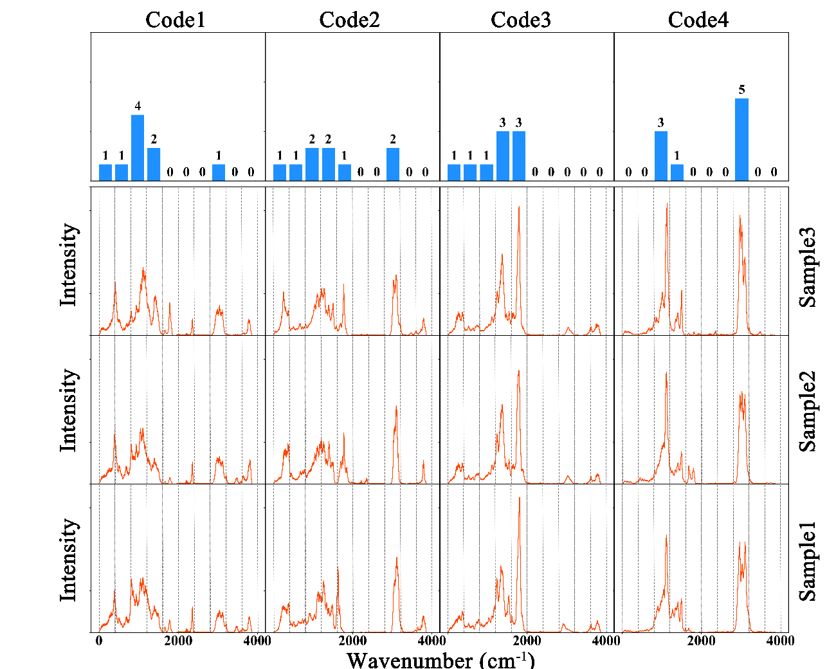
Figure S2. Vibrational spectra generated by the C2S model based on different spectral codes. The top row shows the spectral codes used as inputs, with each bar representing one of the ten code dimensions. The bottom three rows display the generated spectra for three samples (Sample1, Sample2, and Sample3).

Molecular Structure Generation from Vibrational Spectra (S2M model)
The S2M model uses a BART-based² architecture to map vibrational spectra to SELFIES strings, representing molecular structures. Instead of processing the entire spectrum directly, the 4000-dimensional input spectrum is first divided into 40 tokens, each containing 100 dimensions. These tokens are passed through a 4-layer Multilayer Perceptron (MLP) with a hidden size of 640, which uses LeakyReLU activation for enhanced stability. The output dimensionality is transformed to 768, matching the latent space dimension of the BART model. The BART model itself comprises 12 encoder layers and 12 decoder layers, each utilizing multi-head self-attention with eight heads and a hidden size of 768. Specifically trained with a SELFIES vocabulary³ constructed through a word-level tokenization approach, to generates valid molecular strings. During inference, the model utilizes beam search⁴ to generate diverse SELFIES candidates directly based on the input spectra. These candidates are subsequently evaluated for spectral similarity to the input spectra using the Spearman correlation coefficient, ensuring that the generated molecular structures align with the spectral requirements.
Training and Inference
The S2M model is trained on a dataset constructed using QM9 molecules, for which infrared vibrational spectra were calculated using Density Functional Theory (DFT). The dataset is randomly split into a training set and a test set at an 8:2 ratio. During training, the AdamW optimizer is employed with a PolyLR learning rate schedule, starting at an initial learning rate of 0.001 and a weight decay coefficient of 0.1. A warmup strategy is applied for the first 200 steps, with the model trained for a total of 80,000 steps. To improve robustness, the spectra undergo data augmentation techniques, including spectral regularization (maximum intensity set to 300), random shifting (maximum displacement of 10), and random scaling (maximum ratio of 0.005). The S2M model uses a BART-based architecture to map vibrational spectra to SELFIES strings, representing molecular structures. Instead of processing the entire 4000-dimensional spectrum directly, it is divided into 40 tokens, each containing 100 dimensions, and processed through a 4-layer Multilayer Perceptron (MLP). The BART model comprises 12 encoder and decoder layers, leveraging multi-head self-attention with eight heads and a hidden size of 768. During inference, the model utilizes beam search with a maximum length of 32 and a minimum length of 1 to generate diverse SELFIES candidates. These candidates are ranked based on the Spearman correlation coefficient, ensuring the selected molecular structures align with the spectral characteristics of the input spectra.
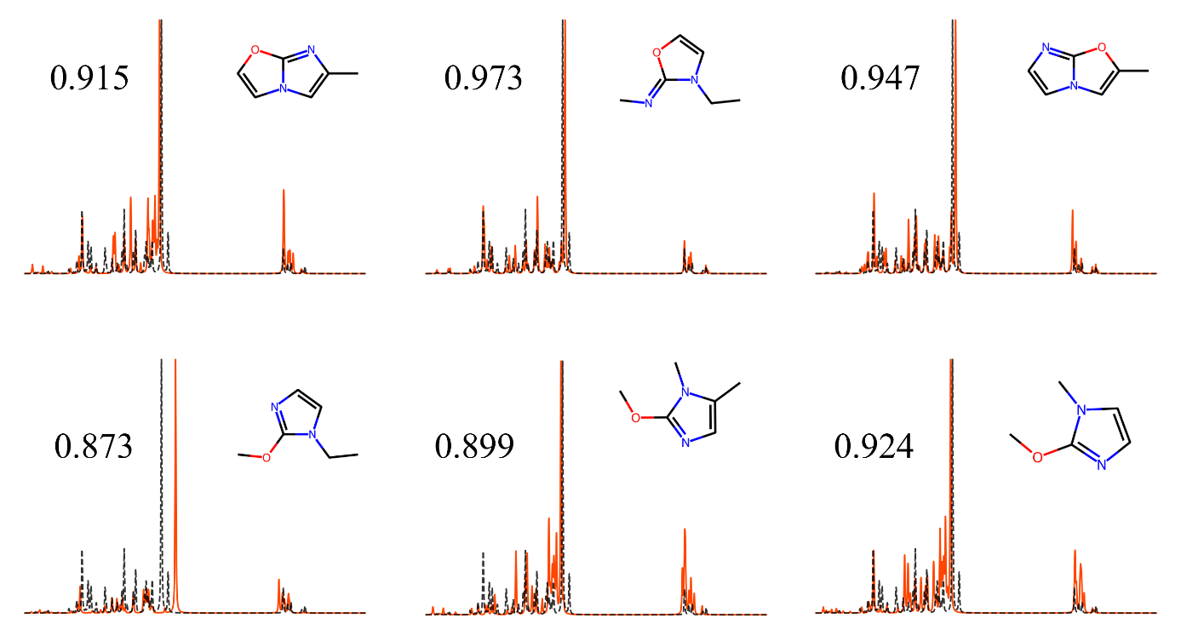
Figure S3. The DFT spectra of the generated molecules (orange) and the input spectrum (black). Each panel presents the Spearman correlation coefficient between the input spectrum and the DFT spectrum of the corresponding generated molecule, alongside its molecular structure.
We validated the accuracy of our molecule generation model by comparing the DFT spectra of the generated molecules with the input spectrum. Figure S3 shows the DFT spectra of six molecules generated by our model, along with their corresponding vibrational spectra, and the calculated Spearman correlation coefficients between the input spectrum and the DFT spectra are labeled. The Spearman coefficients are all close to 1, demonstrating a strong correlation between the input and DFT spectrum. This high correlation indicates that the generated molecular structures are chemically plausible candidates capable of reproducing the input spectral characteristics. Furthermore, the diversity in the generated molecular structures highlights the model’s ability to explore the chemical space effectively.

New Molecules Generated by Our S2M Model
Figure S4. a t-SNE plot comparing the distribution of generated molecules with those originally selected from the QM9 dataset, highlighting the discovery of new molecular structures. b New molecules generated from vibrational spectra (absent from the original training dataset).

Spectra-to-Code (S2C)
Figure S5. Fidelity verification of workflow. a Predicted versus target codes for all segments; point-density coloring, identity line, and ±2σ band; metrics: MAE of 0.169, RMSE of 0.234, R² of 0.954. b Residual distribution (predicted−target) with normal fit (μ of 0.004, σ of 0.138). c Four word-driven examples; top labels denote the words. Rows (top→bottom): target codes (blue), C2S-generated spectra (red), S2M-generated molecules and their DFT spectra (orange), and S2C-constructed codes (purple).

Relative Error Calculation for Spectral Code Matching
To assess the accuracy of the generated spectrum, we introduced an error metric that quantifies the discrepancies between the spectral code derived from the DFT spectrum and the target spectral code. The process of generating the spectral code from the DFT spectrum involves dividing the spectrum into segments and integrating the intensity values within each segment. The resulting integrated intensities can then be normalized into discrete integer values, with a total sum equal to 9, which defines the final spectral code. The relative error is measured by the required adjustments to the integrated intensities, and the target spectral intensities are those can be normalized to generate the target code. This metric allows for the quantification of the deviation between the generated and target spectral codes.

Validation Examples of Molecules Generated from the Same Word
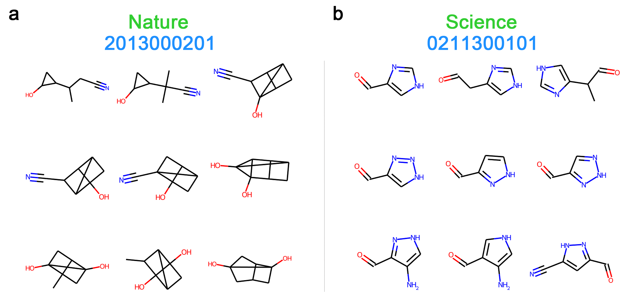
Figure S6. Molecular structures generated using the words "Nature" and "Science" as inputs, illustrating the diversity and complexity of the resulting molecules. a Molecules generated from the word "Nature" showing a preference for complex ring structures and three-dimensional configurations, with common substituents such as hydroxyl and cyano groups. b Molecules generated from the word "Science" displaying primarily five-membered heterocyclic structures, characterized by planar configurations and simpler chemical modifications like amides and nitriles.
By comparing the molecular structures generated from these different target words, we were able to identify similarities and differences in their elemental composition, ring types, and structural complexity. The observed similarities can be attributed to the fact that these molecules are derived from the same spectral codes. As the spectral codes are simplified versions of the original spectra, they retain some of the chemical information present in the full spectra. However, the differences indicate that different spectra may occasionally generate identical spectral codes, resulting in molecules with comparable characteristics but not identical structures. Consequently, the progression from words to spectral codes, to spectra, and ultimately to molecules can yield compounds with related properties but distinct structures. This observation shifts our perspective on molecular generation, suggesting that molecules generated from the same spectral codes may share similar properties while exhibiting structural diversity. This inherent flexibility offers significant advantages for the design of new molecular structures.

References
1. Pol, A. A., Berger, V., Germain, C., Cerminara, G. & Pierini, M. Anomaly Detection with Conditional Variational Autoencoders. in 2019 18th IEEE International Conference On Machine Learning And Applications (ICMLA) 1651–1657 (2019).
2. Schwaller, P. et al. Inferring experimental procedures from text-based representations of
chemical reactions. Nat. Commun. 12, 2586 (2021).
3. Krenn M, Häse F, Nigam A K, et al. Self-referencing embedded strings (SELFIES): A 100% robust molecular string representation[J]. Machine Learning: Science and Technology. 1(4): 045024 (2020).
4. Moebel, E. et al. Deep learning improves macromolecule identification in 3D cellular cryo-electron tomograms. Nat. Methods 18, 1386–1394 (2021).

