Supplementary information
Table S1. Prevalence of anemia and thrombocytopenia among study participants (n = 400) by age and sex, classified by WHO standards and measured using Sysmex XN-31 at Shashemene and Meki hospitals, Oromia, Ethiopia (2024).
WHO Age Category | Sex | Total (N) | No Anemia n (%) | Mild n (%) | Moderate n (%) | Severe n (%) | Thrombocytopenia n (%)
0–4 years | Male | 42 | 29 (69.0%) | 5 (11.9%) | 3 (7.1%) | 5 (11.9%) | 10 (25.0%)
 | Female | 37 | 26 (70.3%) | 2 (5.4%) | 5 (13.5%) | 4 (10.8%) | 3 (8.3%)
5–11 years | Male | 23 | 17 (73.9%) | 1 (4.3%) | 1 (4.3%) | 4 (17.4%) | 9 (39.1%)
 | Female | 25 | 17 (68.0%) | 4 (16.0%) | 2 (8.0%) | 2 (8.0%) | 11 (45.8%)
12–14 years | Male | 8 | 5 (62.5%) | 2 (25.0%) | 1 (12.5%) | 0 (0.0%) | 2 (25.0%)
 | Female | 4 | 4 (100.0%) | 0 (0.0%) | 0 (0.0%) | 0 (0.0%) | 0 (0.0%)
15+ years | Male | 115 | 79 (68.7%) | 22 (19.1%) | 3 (2.6%) | 11 (9.6%) | 46 (41.1%)
 | Female | 146 | 113 (77.4%) | 16 (11.0%) | 3 (2.1%) | 14 (9.6%) | 33 (22.9%)
Overall | Male | 188 | 130 (69.1%) | 30 (16.0%) | 8 (4.3%) | 20 (10.6%) | 67 (36.6%)
 | Female | 212 | 160 (75.5%) | 22 (10.4%) | 10 (4.7%) | 20 (9.4%) | 47 (22.6%)

Table S2. Comprehensive statistical tests including Cohen's Kappa for agreement between methods in detecting plasmodium parasites.
Method 1 | Method 2 | Kappa | Agreement (%) | Chi-square | p-value
Field Microscopist | Sysmex XN-31 | 0.678 | 89.8 | 180.78 | 3.28E-41
Field Microscopist | RDT | 0.741 | 92.5 | 215.88 | 7.16E-49
Field Microscopist | PCR | 0.629 | 88 | 155.72 | 9.73E-36
Field Microscopist | Expert Microscopist | 0.56 | 87 | 121.9 | 2.43E-28
Sysmex XN-31 | RDT | 0.712 | 91.2 | 203.31 | 3.96E-46
Sysmex XN-31 | PCR | 0.814 | 93.8 | 260.39 | 1.41E-58
Sysmex XN-31 | Expert Microscopist | 0.669 | 89.8 | 177.55 | 1.66E-40
RDT | PCR | 0.661 | 89.5 | 175.84 | 3.93E-40
RDT | Expert Microscopist | 0.534 | 87 | 110.38 | 8.07E-26
PCR | Expert Microscopist | 0.571 | 86.5 | 129.63 | 4.93E-30

Table S3. Participant’s information for usability test of Sysmex XN-31 test
Characteristics’ | Number | Percent
Sex Male  Female | 24 | 80
Sex Male  Female | 6 | 20
Age Mean | 30 | 35.8
Level of Education
BSc  MSc  Diploma | 15 | 50
BSc  MSc  Diploma | 11 | 36.7
BSc  MSc  Diploma | 4 | 13.3
Profession
Laboratory Technologist  Microbiologist  IT-Related Professionals (IT-TVET, HIS, ITIT-TVET  Lab and related supportive Staffs  Non-Lab Health Professional (Nurse, Emergency Surgeon) | 10 | 33.3
 | 9 | 30
 | 4 | 13.3
 | 4 | 10
 | 3 | 10
Total | 30 | 100.0

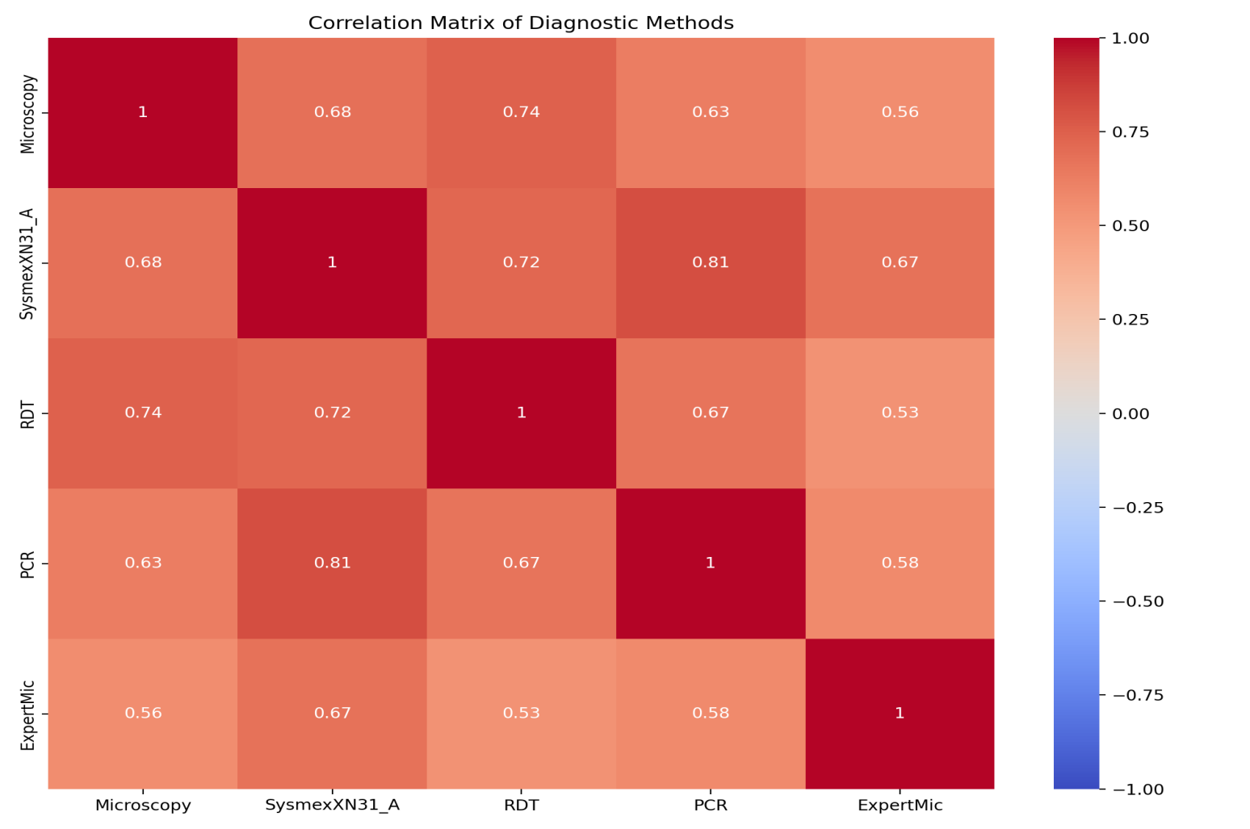
Fig S1. The correlation matrix heatmap provides a visual representation of the relationships between different diagnostic methods, indicating how closely related they are in terms of their results.

