Graphical Abstract
Mechanistic hypothesis derived from pilot in-vitro data
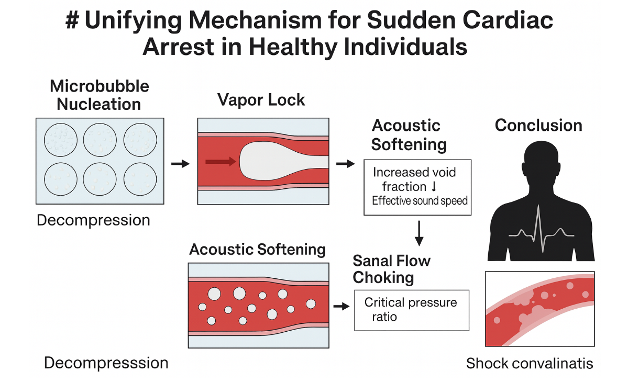

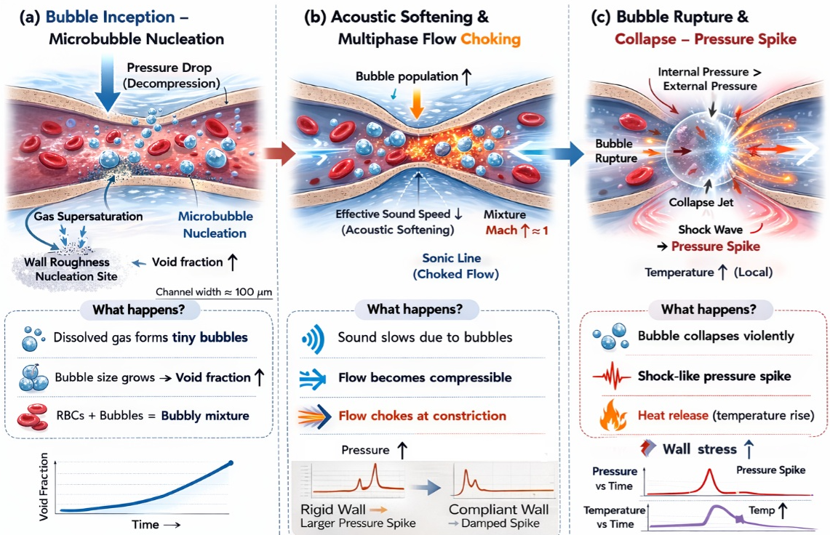
Graphical Abstract | A fluid-dynamic pathway to cardiovascular injury.
Decompression-induced microbubble nucleation transforms blood into a compressible bubbly mixture that reduces sound speed and promotes multiphase flow choking at vascular constrictions. Violent bubble collapse at the choking limit produces shock-like pressure spikes and localized heating, amplifying arterial wall stress and providing a potential physical mechanism for acute cardiovascular events.

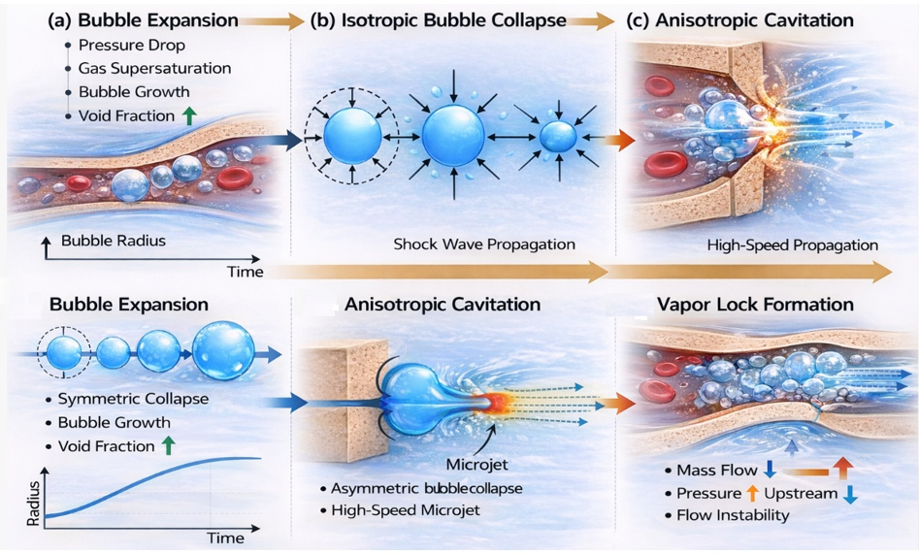
Graphical Abstract | Decompression-induced bubble growth, collapse, and cavitation drive shock waves and vapor-lock–like vascular flow in

