Supplementary Info.
Molecular evidence of autophagy impairment with elevated serum level of ATG13 in patients with myalgic encephalomyelitis and chronic fatigue syndrome: two independent case-control studies

Gunnar Gottschalk^{1,2}, Daniel Peterson¹, Konstance Knox³, Marco Maynard², Ryan J Whelan, Avik Roy^{1,2}

¹Simmaron Research Institute, 948 Incline Way, Incline Village, NV 89451; ²Simmaron R&D lab, Technology Innovation Center, 10437 W Innovation Drive, Wauwatosa, WI 53226, ³Coppe Laboratories, W229N1870 Westwood Dr, Waukesha, WI 53186.

Running title: Autophagy impairment in ME/CFS

To whom correspondence should be addressed:
Avik Roy, Ph.D.
Chief Scientific Officer
Simmaron Research Institute
Technology Innovation Center
10437 W Innovation Drive
Suite # 325
Wauwatosa, WI 53226
Email: aroy@simmaron.com
Ph: (773) 263 8182

Type | Cases | Slope ± SD (Liner) | Slope (significantly non-zero?) | Significance between groups
Healthy | 74 years old male | 17.72 ± 0.3806 | F_{1,88} =2167(***p<0.001); significant | F_{29,29} =15.99 (***p<0.0001); significant
Patients | 71 years old male | 70.70 ± 1.956 | F_{1,88} =1307 (***p<0.0001); significant | F_{29,29} =15.99 (***p<0.0001); significant
Healthy | 68 years old female | 19.36 ± 1.599 | F_{1,88} =146.7 (***p<0.0001); significant | F_{29,29} =15.99 (***p<0.0001); significant
Patients | 67 years old female | 59.68 ± 3.005 | F_{1,88} =394.4 (***p<0.0001); significant | F_{29,29} =15.99 (***p<0.0001); significant
Supplementary Table 1. Statistical analyses of ThT-based protein aggregation assay. Statistical analyses of two case-control studies (separated with a line). The significance of mean was tested with two-tailed unpaired t-test. Results are confirmed after three independent experiments.

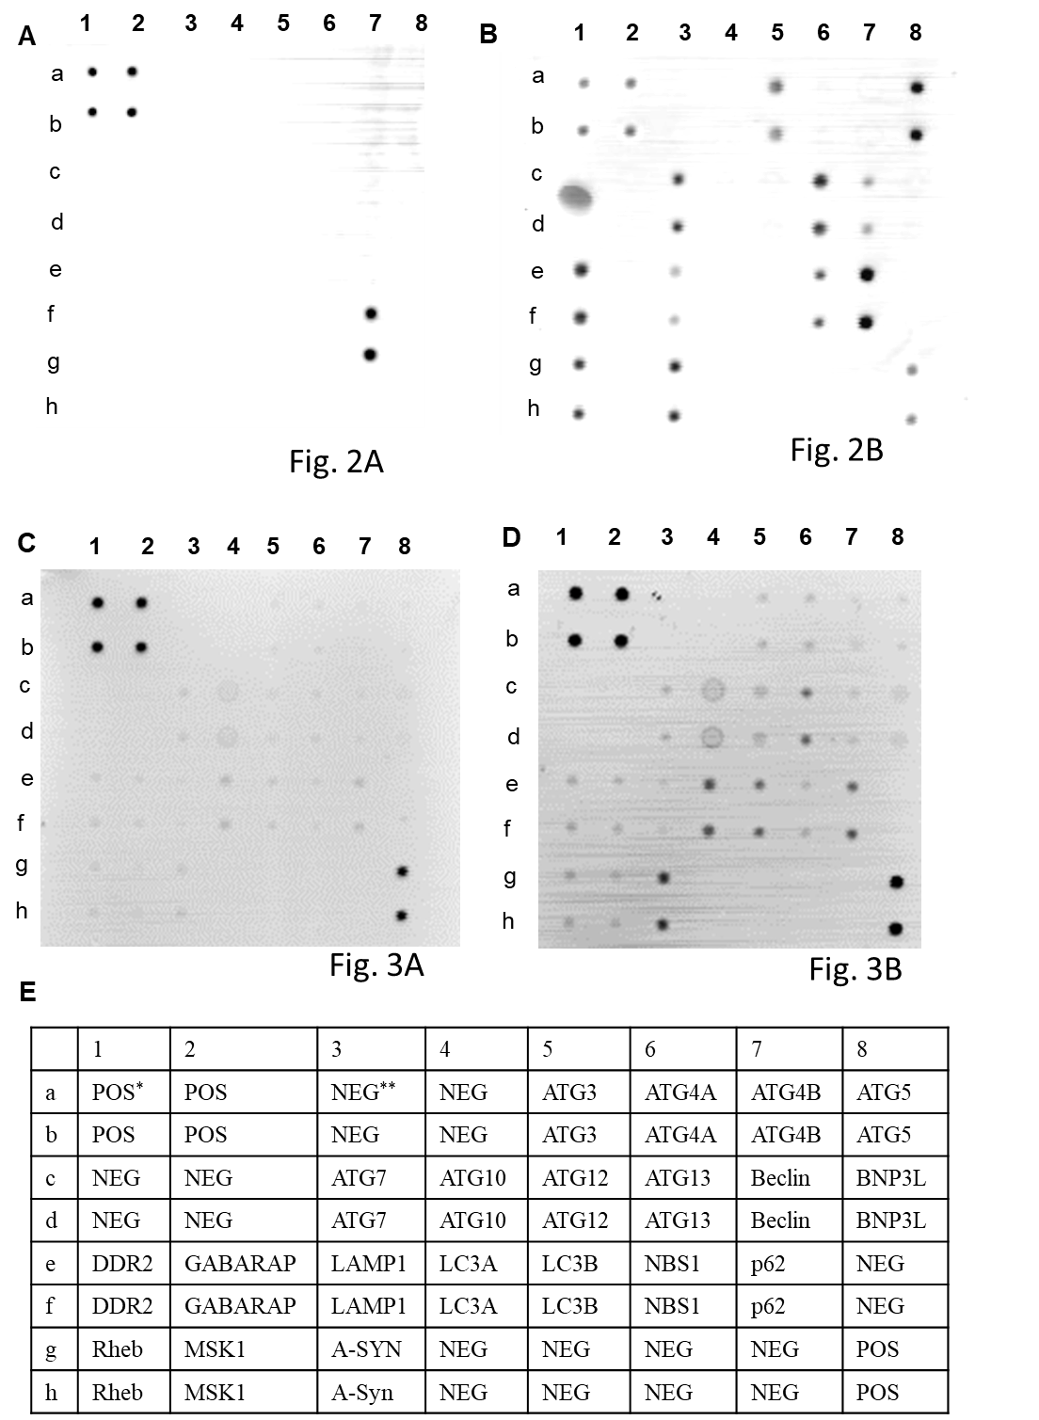

Supplementary Fig 1.

Supplementary Fig. 1. (A-B) Raw data of figure 2A and 2B; (C-D) Raw blot of figure 3A & 3B; and (E) Layout of the antibody array for autophagy proteins. * Positive control; **Negative control.

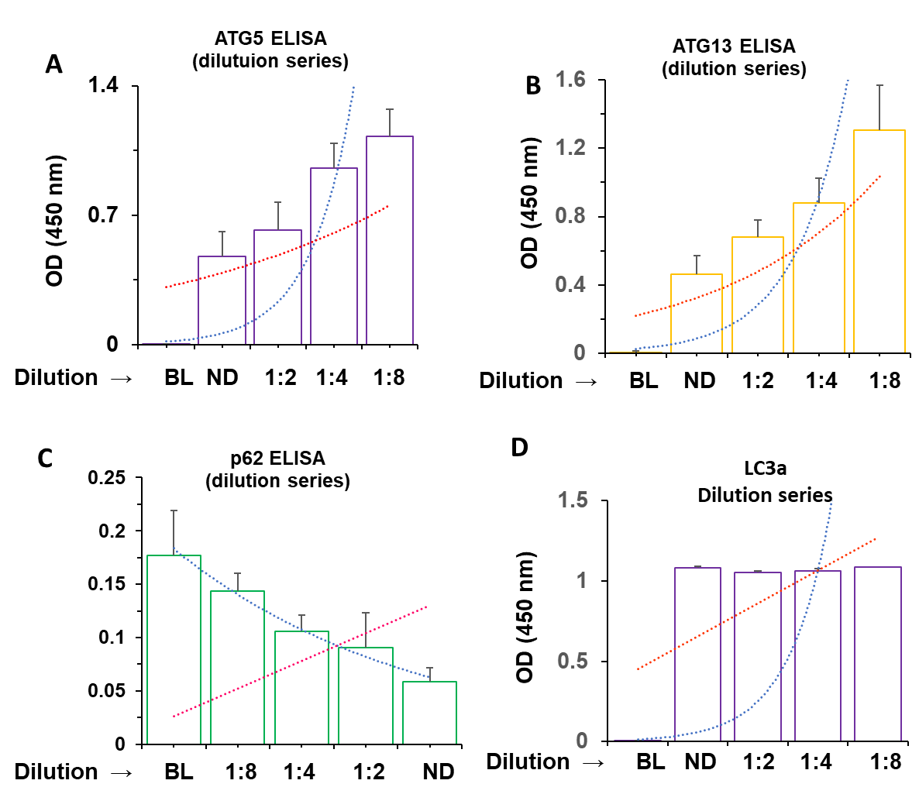
Supplementary Figure 2

Supplementary Fig. 2. Dilution series to identify the correct dilution of serum samples for colorimetric and near-infrared ELISA. Serum samples were diluted with assay diluent at different dilutions starting from no dilution (ND) to 1:2 to 1:4 and finally to 1:8. These diluted serum samples from male patient were assayed for (A) ATG5 (competitive ELISA), (B)ATG13 (Competitive ELISA), and (C) p62 (traditional ELISA). Optical density value were plotted as a function of respective dilutions and the optimum dilution was considered in which X and Y intercepts had crossed each other. (E) ELISA analyses for LC3a was performed in diluted serum samples of female ME/CFS patient. BL = blank. Results were confirmed after three independent experiments.

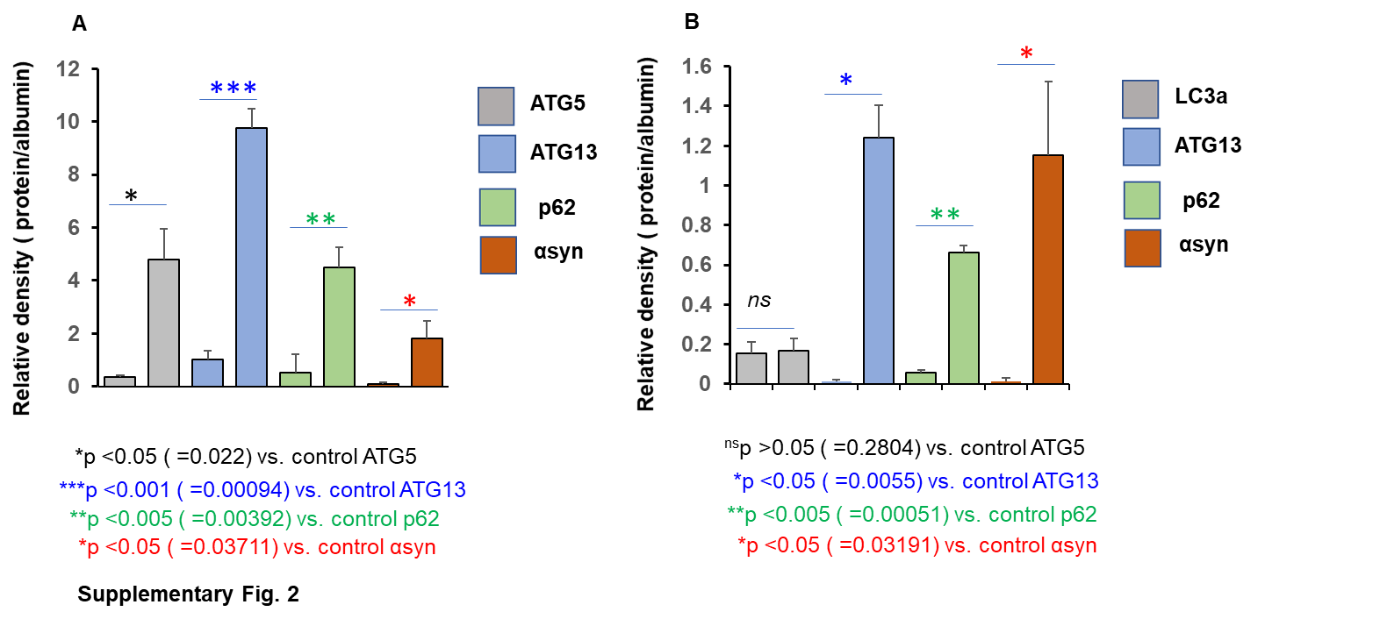
Supplementary Figure 3
Supplementary Fig. 3. Densitometric analyses for near-infrared ELISA. Integrated density value was recorded in the Li-cor Odyssey Sa imager. Relative density was monitored after calculating ratio of integrated density of protein to that of albumin. Relative densities of (A) ATG5 (gray), ATG13 (blue), p62 (green), and α-syn were calculated in sera of both control (first bar) and male ME/CFS patient (second bar). (B) relative densities of LC3a (gray), ATG13 (blue), p62 (green), and α-syn (red) in serum samples of healthy female (first bar) and female ME/CFS patient. Unpaired t-test was performed to test the significance of mean between groups and presented underneath.
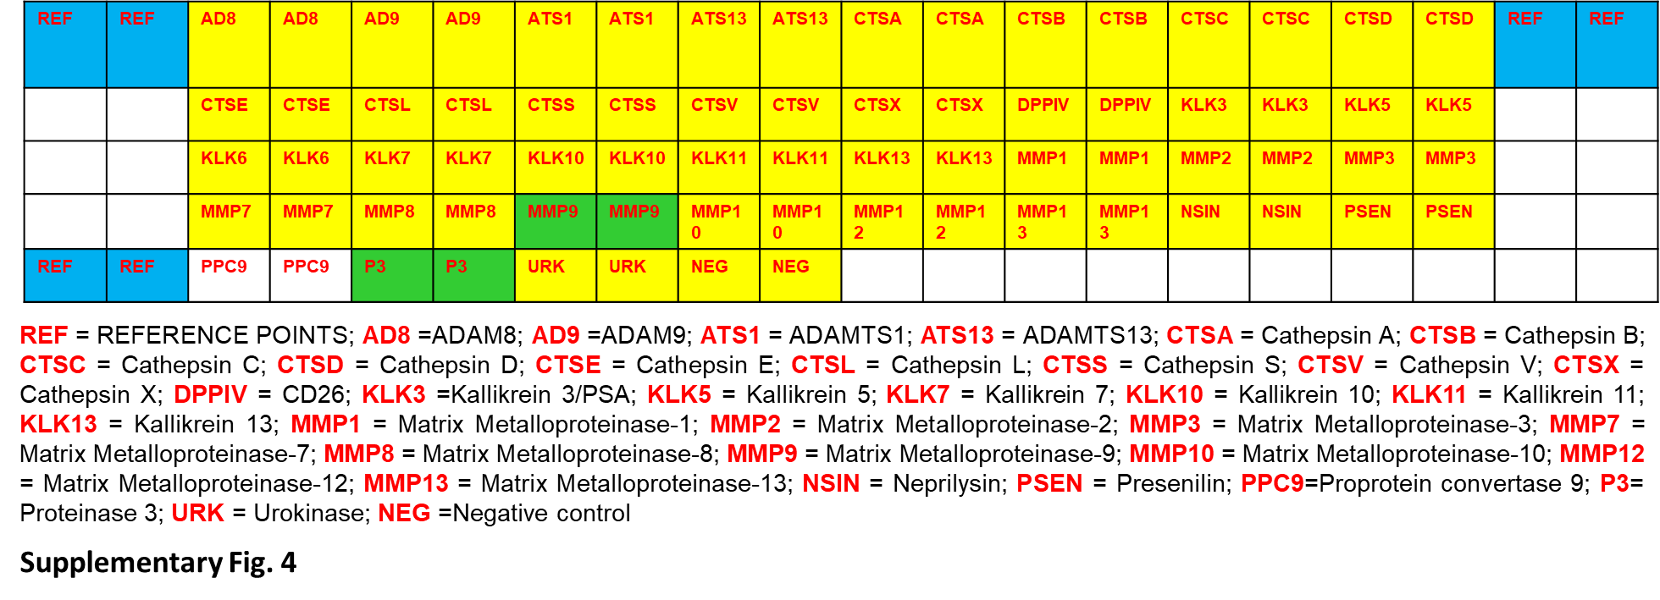
Supplementary Fig. 4. Layout of the antibody array for proteases. Layout of antibody array against 40 different protein markers that engraved in the human proteome profiler array blot. Acronyms of proteins were explained below. Only MMP-9 and P3 (shaded under green) displayed significant upregulations in serum sample of male patient.

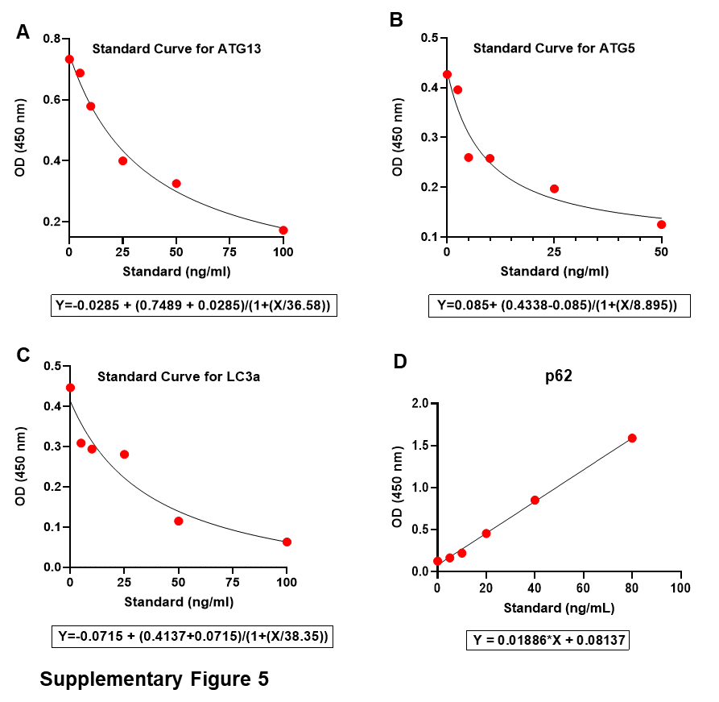
Supplementary Fig. 5. Derivation of non-liner standard curve for

autophagy proteins. standard curve analyses for 0, 6, 12, 25, 50, and 100 ng/mL of (A) ATG13; 0, 6, 12, 25, and 50 ng/mL of (B) ATG5; 0, 6, 12, 25, 50, and 100 ng/mL of (C) LC3a; and 0, 5, 10, 20, 40, and 80 ng/mL of (A) p62. Resultant regression curve indicate that in all case R2 >0.98 and associated curve equations were given underneath.

