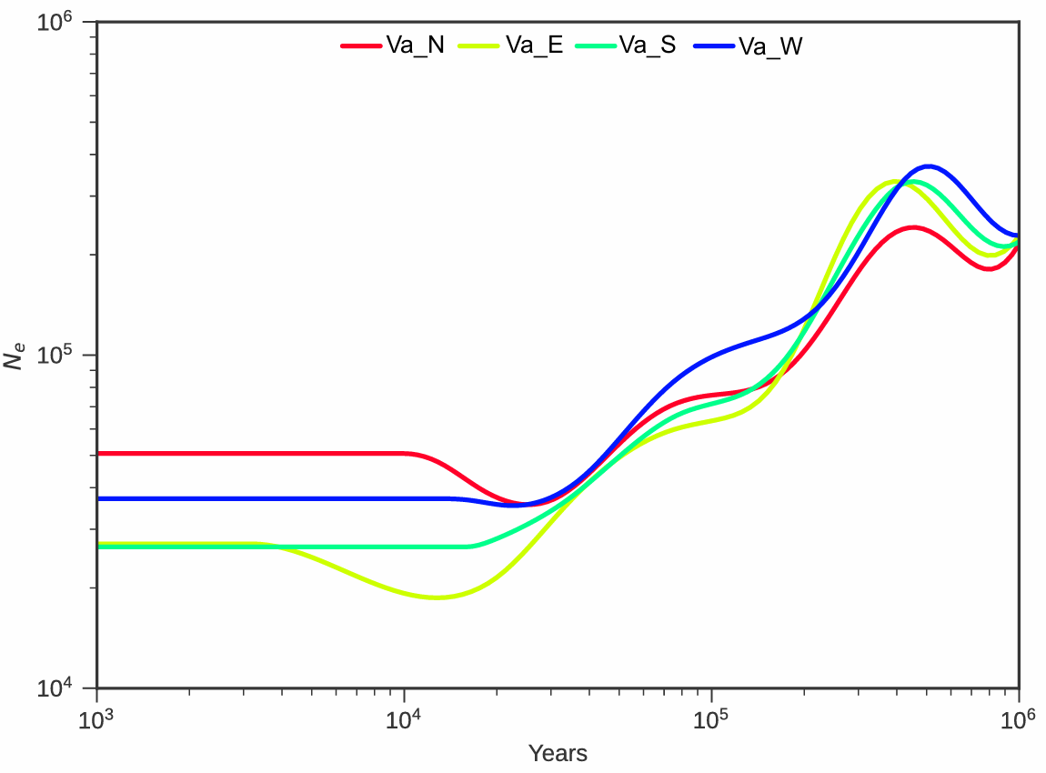
Fig. S1 Simulation of four wild populations of vitis amurensis based on SMC++.

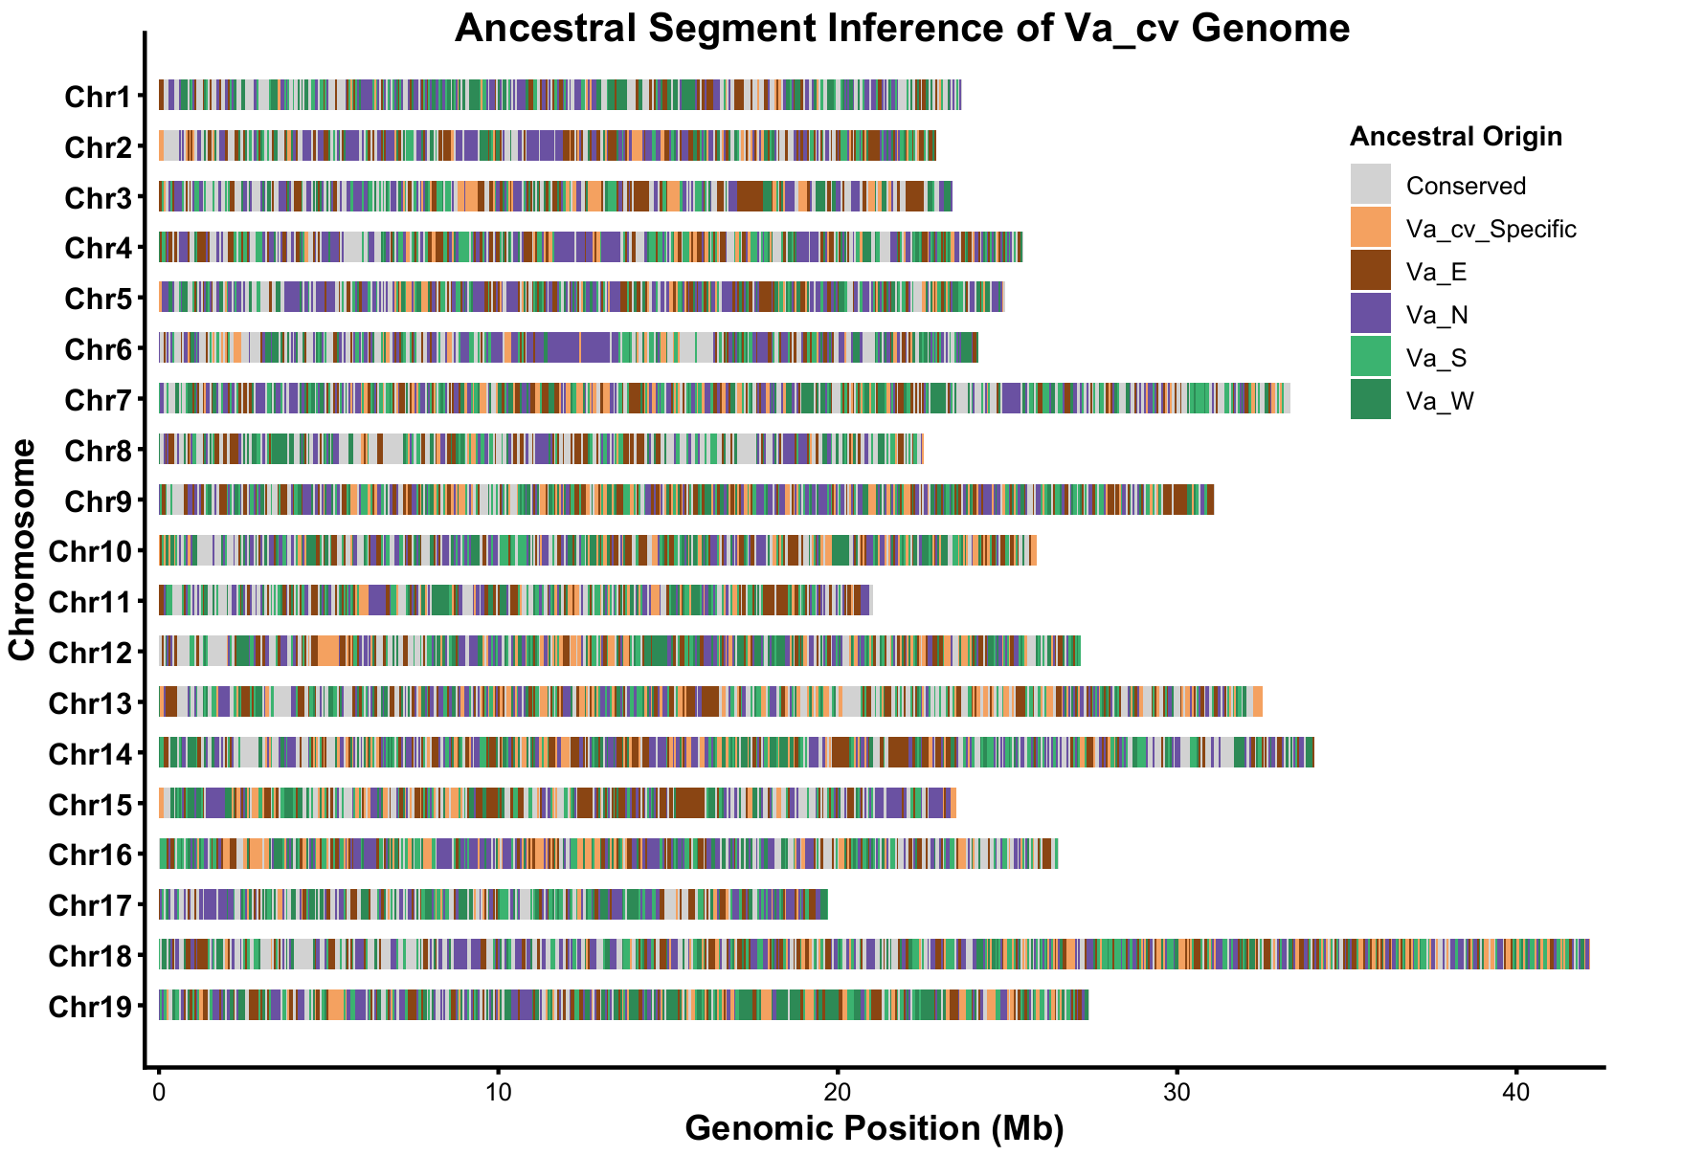
Fig. S2 Ancestral segment inference of Va_cv genome.
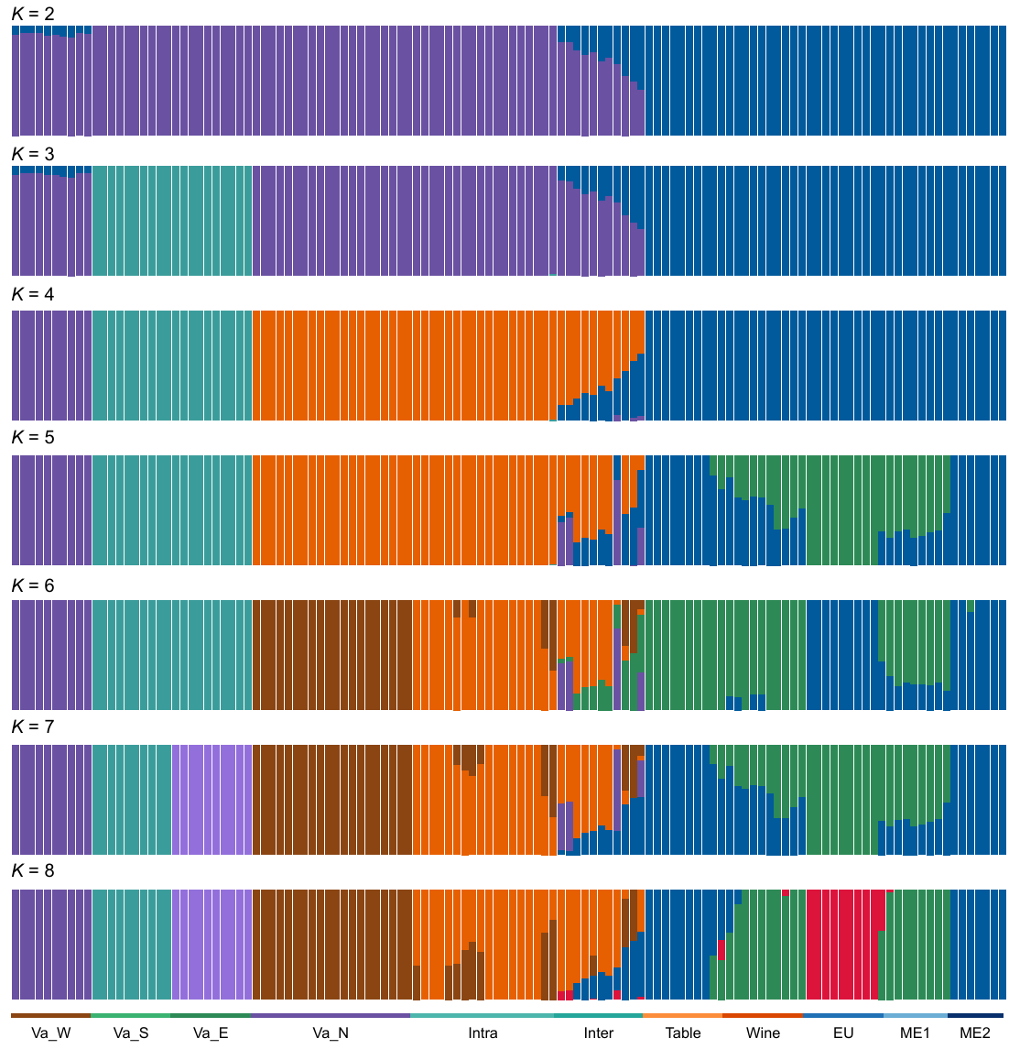
Fig. S3 Admixture analysis results for 130 resequencing samples (K ranging from 2 to 8).
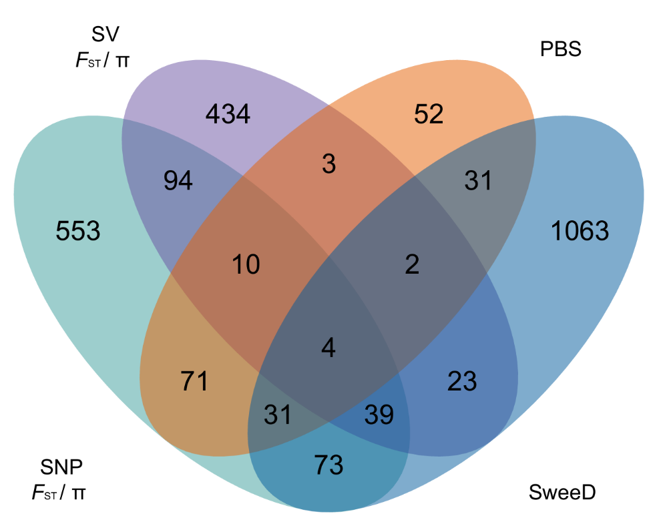
Fig. S4 Number of selected genes found by different methods in Vv_CV population.

