Measurement of DNA damage by Alkaline comet assay
It is a known fact that whenever there is oxidative stress in the body due to any cause there is overproduction of Reactive oxygen species (ROS) which ultimately leads to cellular damage and DNA breaks . The comet assay is done via Single cell gel electrophoresis(SCGE) and the ability of negatively charged DNA to be drawn on an agarose gel after application of electric field is studied . The extent of DNA migration is directly proportional to the DNA damage. In the comet structure, the undamaged DNA nucleoid part is referred to as the head and the trailing damaged DNA streak is referred to as the tail .The percentage of DNA in the tail is directly proportional to the percentage of DNA damage that has occurred in a particular cell.[Figure 1]
By using this assay in this study the extent of DNA damage in Post COVID patients was studied . The comet parameters recorded were
- Tail length (migration of the damage DNA from the nucleus)
- Tail DNA (%)
- Olive tail moment (arbitrary units) which may be defined as the product of tail length and tail intensity of image
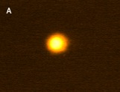
Images of comet-Nucleoid of control subject (400 x)
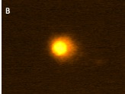
Images of comet-Nucleoid of Post COVID patients (400 x)

