Statistical optimization and ecotoxicological validation of a hydrolytic detoxification pathway for carbofuran using earthworm gut-associated Bacillus paralicheniformis PPH2

Journal: Biodegradation

Puspendu Shitª, Harekrishna Jana^{b}, Partha Pratim Chakravorty^{a*}, Priyanka Sarangi^{c}, Payel Sur^{b}, Samiran Sona Gauri^{d} and Yuji Sakai^{e}

ªDepartment of Zoology, Debra Thana Sahid Kshudiram Smriti Mahavidyalaya (Autonomous), Paschim Medinipur-721124, West Bengal, India
^{b}Department of Microbiology, Raja Narendra Lal Khan Women’s College (Autonomous), Paschim Medinipur-721102, West Bengal, India
^{c}Department of Zoology, Raja Narendra Lal Khan Women’s College (Autonomous), Paschim Medinipur-721102, West Bengal, India
^{d}Central Research Facility, Indian Institute of Technology, Kharagpur, West Bengal-721302, India
^{e}Department of Environmental Chemistry and Chemical Engineering, Kogakuin University, Tokyo, Japan

*Corresponding author: Dr. Partha Pratim Chakravorty
Email: parthapratimchakravorty@yahoo.in

Supplementary Information
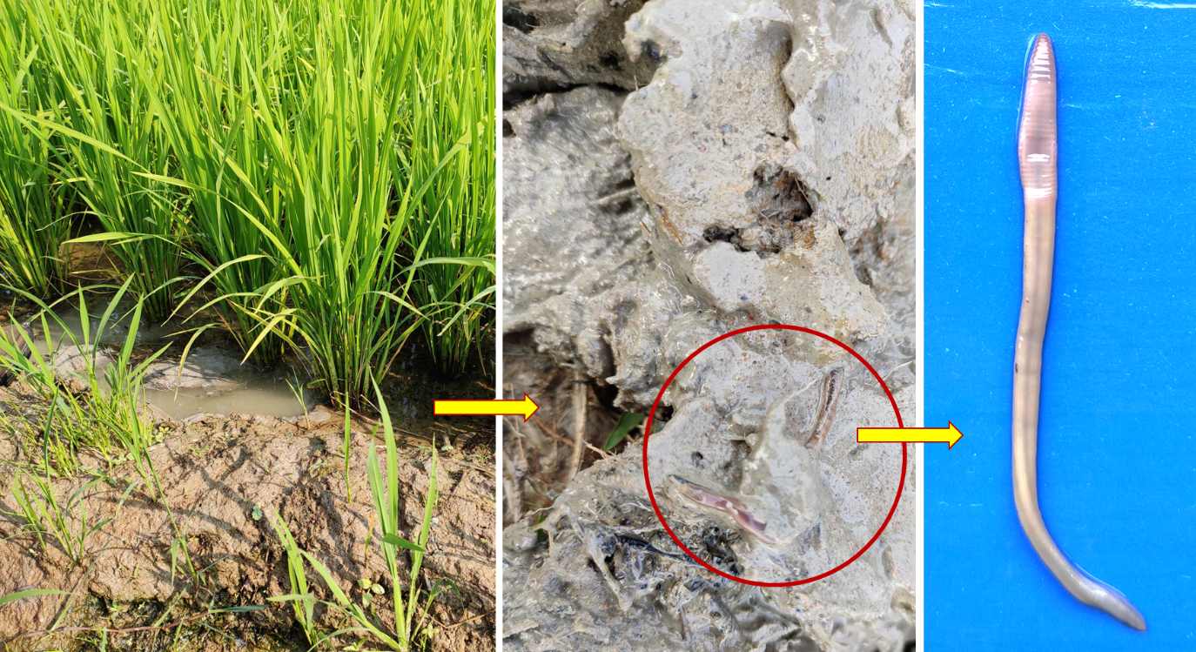
Fig. S1 Photographic Record of earthworm collection. Photos showing the collection of Glyphidrilus sp. from a submerged paddy field and earthworm morphology.
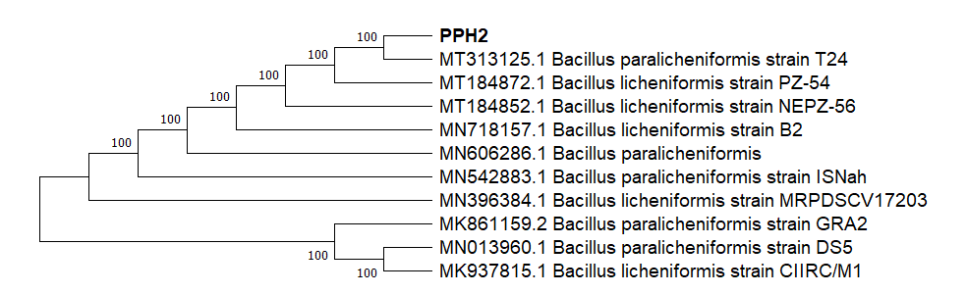
Fig. S2 Phylogenetic Tree of B. paralicheniformis PPH2. A neighbor-joining tree based on 16S rRNA gene sequences showing PPH2 and its closest relatives.
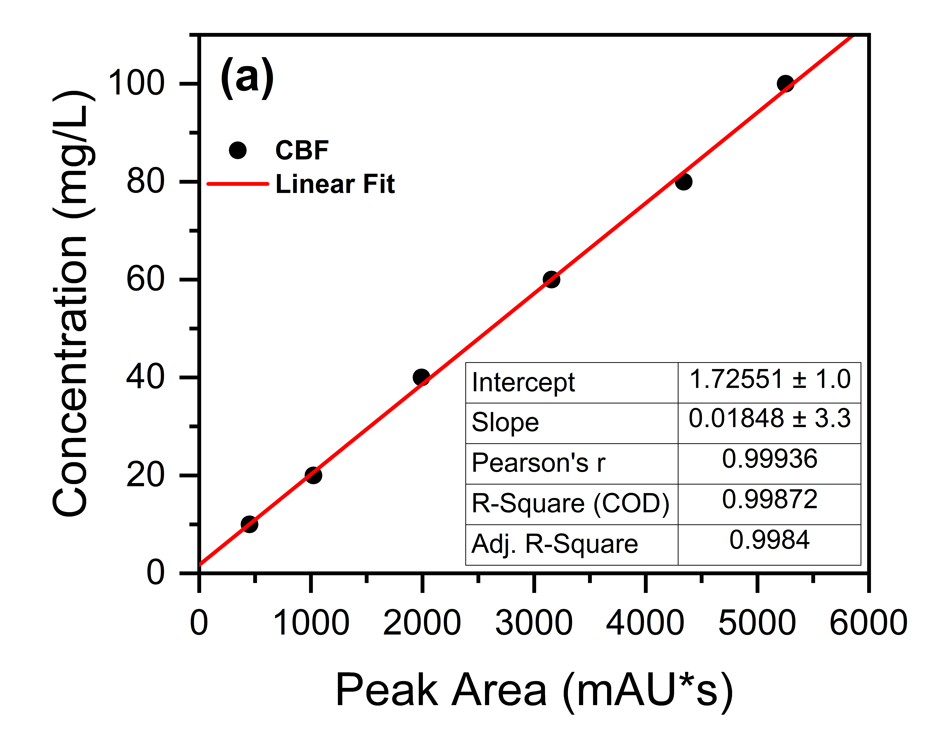
Fig. S3 HPLC Calibration Curve. The linear regression plot for carbofuran at different concentrations.

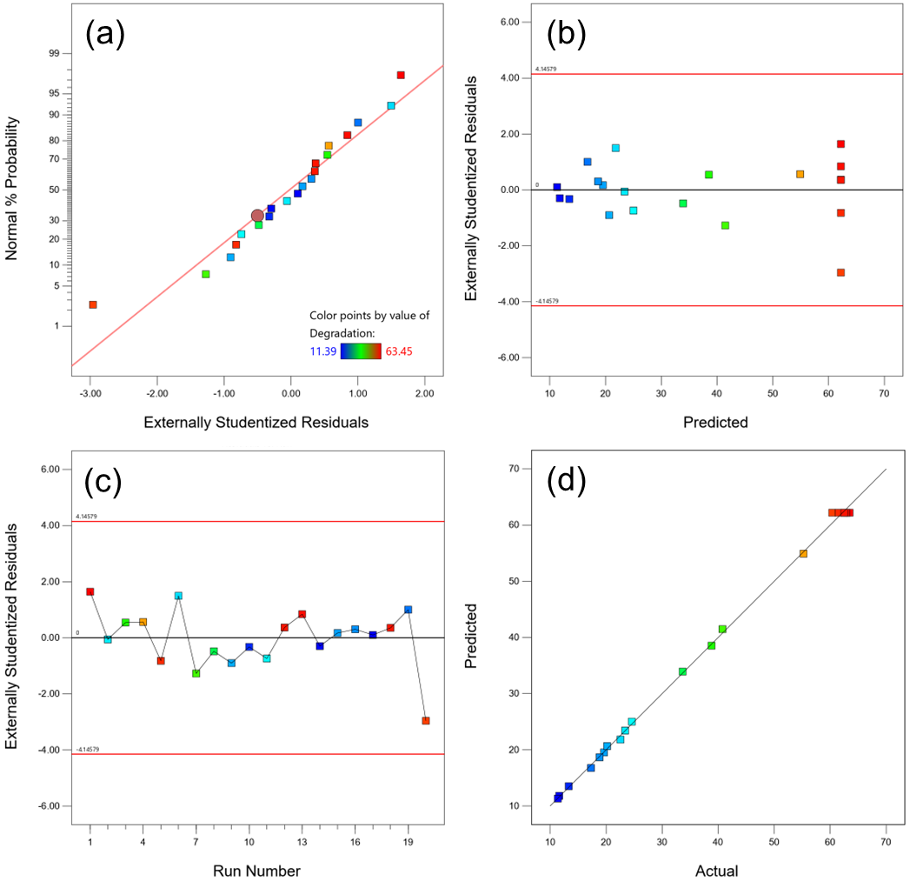Fig. S4 RSM Diagnostic Plots. A four-panel plot showing (a) Normal probability of residuals, (b) Residuals vs. Predicted values, (c) Residuals vs. Run, and (d) Predicted vs. Actual values.

