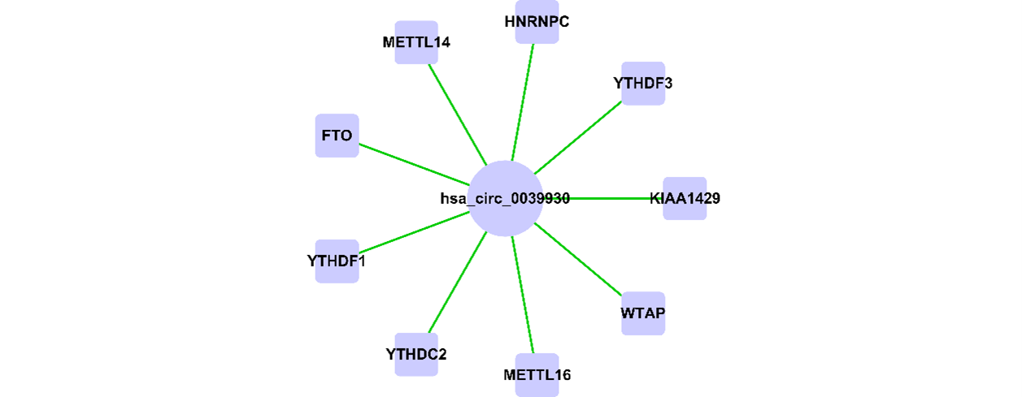
Supplementary Fig. S1 circNFATC3 (hsa_circ_0039930) targets m6A-regulated genes as predicted by miRanda. Circles represent circRNAs, squares represent coding genes, and green lines indicate the predicted binding relationships between them.

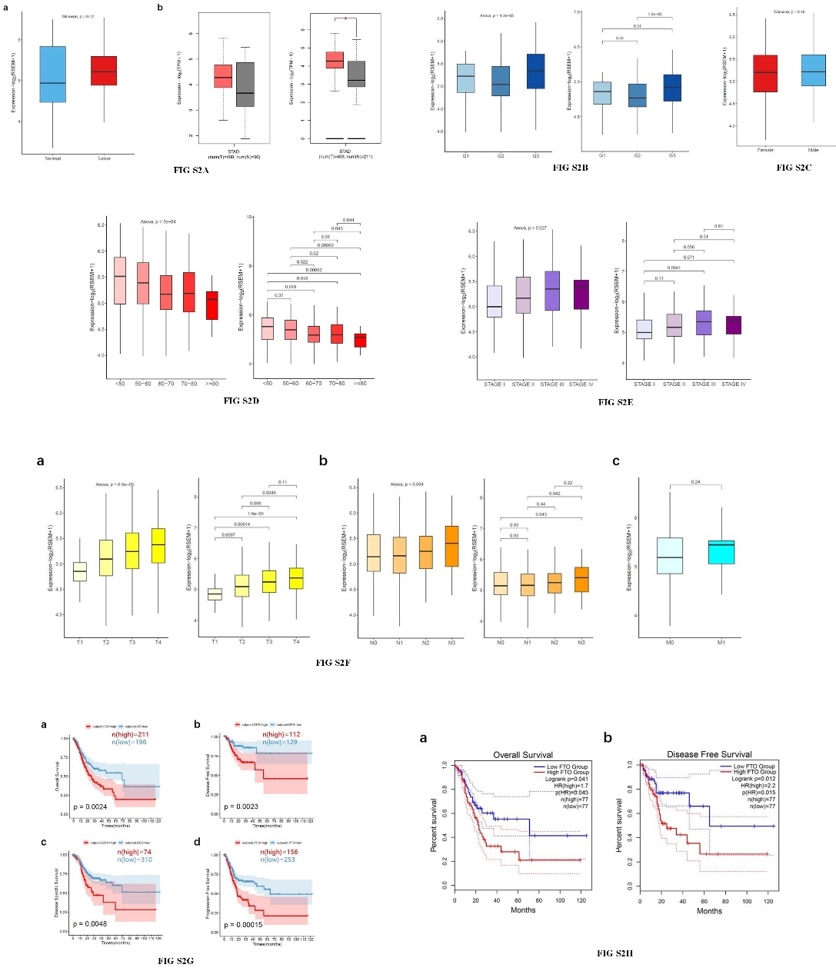
Supplementary Fig. S2 Expression of FTO in gastric cancer and its relationship with clinical features. Fig. S2A Expression levels of FTO in cancer tissues and adjacent non-cancerous tissues. FIG. S2B Expression of FTO in different tumor stages. FIG. S2C Expression of FTO in different genders. FIG.S2D Expression of FTO among different age groups. FIG. S2E Expression of FTO across different pathological stages. FIG. S2F Expression of FTO in relation to tumor size (T), lymph node metastasis (N), and whether the tumor has metastasized (M). FIG. S2G Overall survival (OS), disease-free survival (DFS), and disease-specific survival (DSS) in high and low expression groups of FTO. FIG.S2H Comparison of OS and DFS between the 80% and 20% groups of FTO gene expression.

