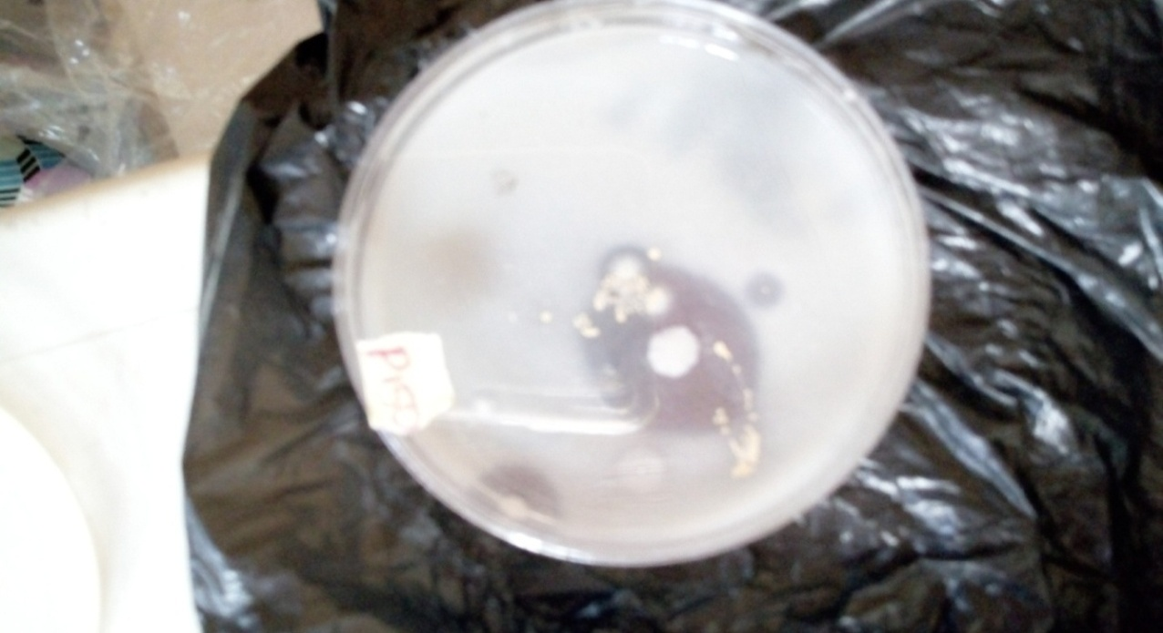

Clear zone Isolate growing at the center.

Plate 1: Hydrolysis of protease enzyme by C. tropicalis.

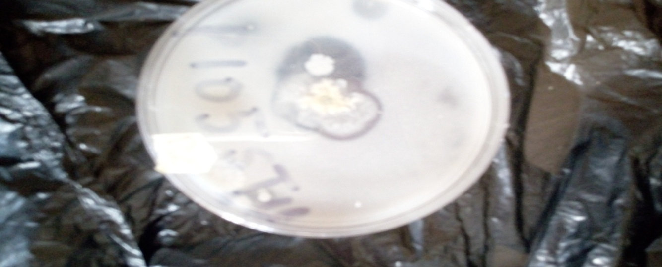

Clear zone C. haemuloni growing at the center Clear zone

Plate 2: Candida haemulonis showing protease activity.
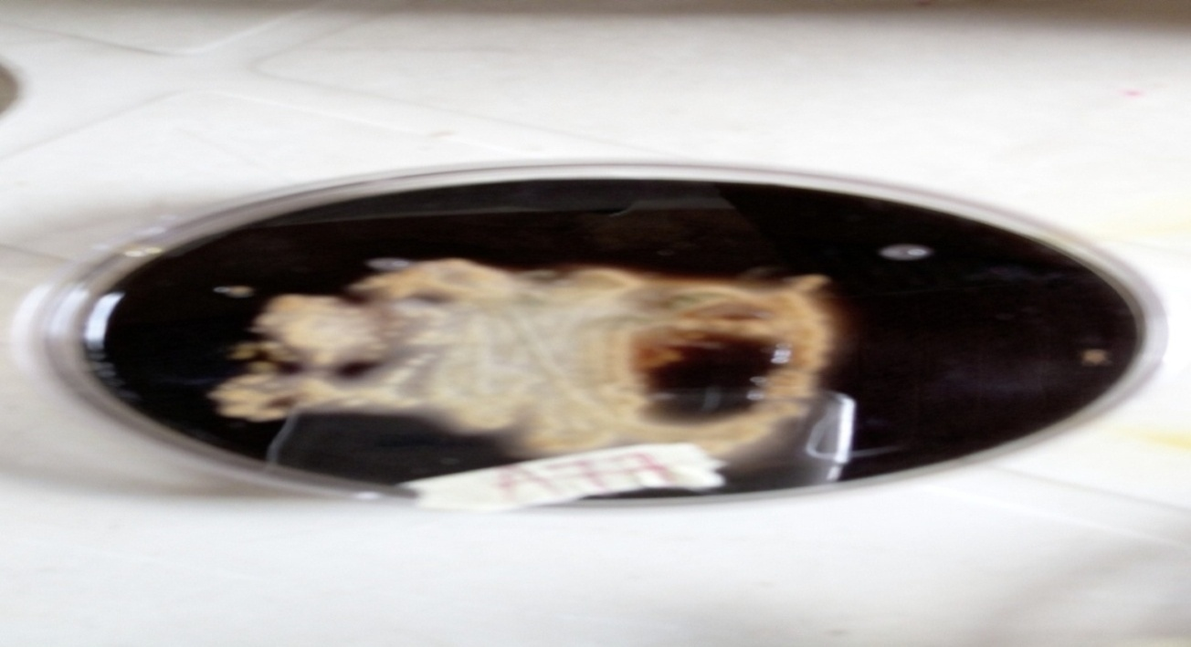
Plate 3: Amylolytic activity of Fusarium solani on starch agar showing clear zone around the organism.
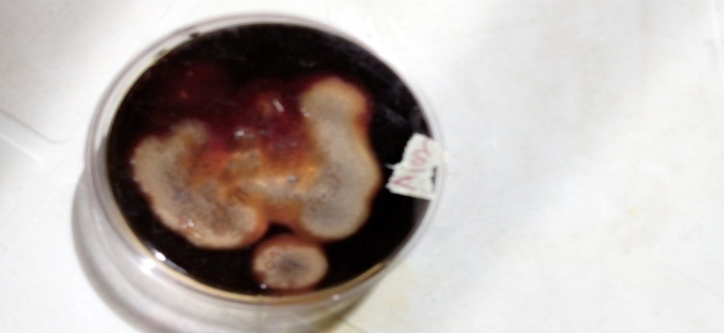

Plate 4: Amylolytic activity of Psedallescheria boydii showing hydrolysis.
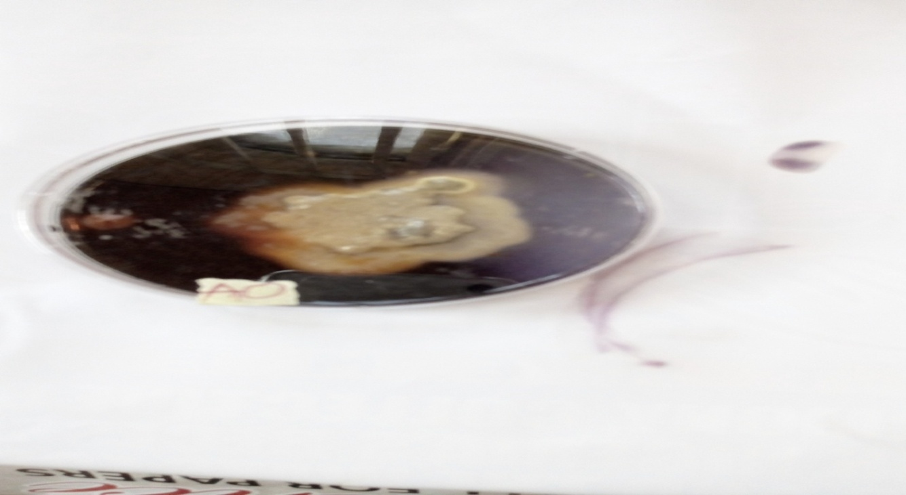

Plate 5: T. harzianum Clear zone around the colony showing amylolytic activity.
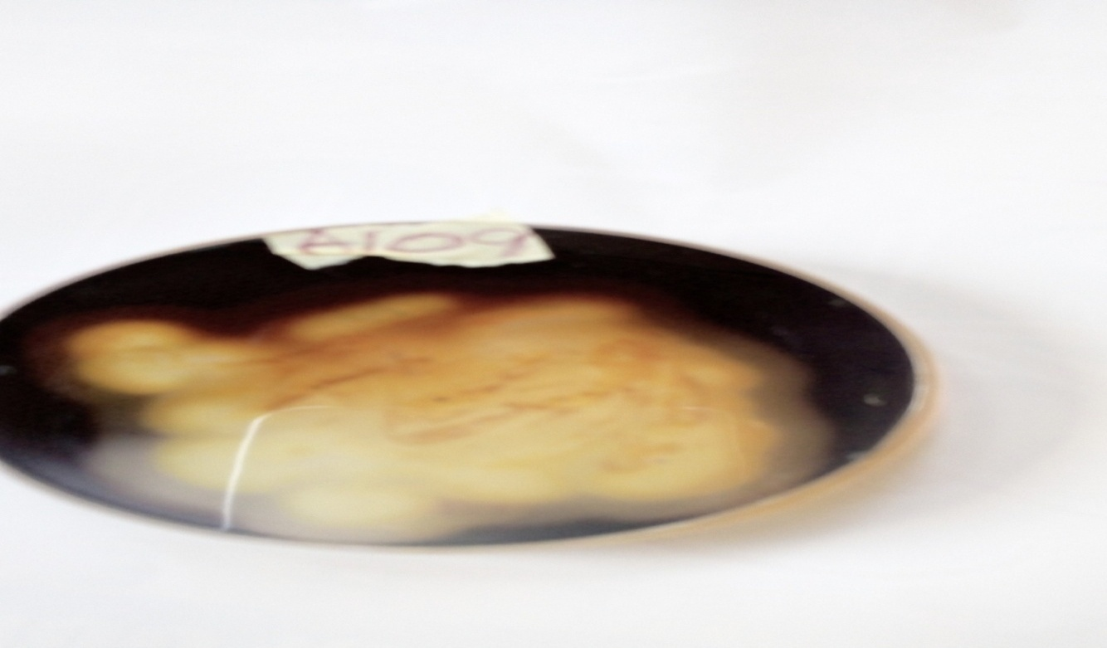
P. dacthylethromorp Clear zone
Plate 6: Amylolytic activity of P. dacthylethromorp showing hyrolysis of starch.

