Supplementary Material

Nucleic acid screening for 13 respiratory pathogens
nasopharyngeal aspirates(NPA)：The nasopharyngeal secretions of patients admitted to the hospital for no more than 24 hours were collected using the sterile negative pressure suction method, followed by laboratory testing. First, contraindications to suction (such as epistaxis, gastrointestinal bleeding, arrhythmia, etc.) were excluded. Then, the nasal cavity was cleaned, and the suction pressure was adjusted. The suction catheter was quickly and gently inserted into the pharynx through the nasal cavity of the patient to a depth of approximately 7-8 cm. Finally, suction was performed. The suction time should not exceed 15 seconds each time. After sucking 2 ml, it was placed in a test tube containing sterile saline, shaken and mixed, and sent for examination within half an hour for respiratory pathogen detection.

Sample pretreatment
For sputum samples, the sample should be mixed well. If the viscosity is too high and the sample cannot be aspirated, an equal volume of physiological saline can be added, mixed well, and the supernatant can be aspirated for nucleic acid extraction.

Nucleic acid extraction
A corresponding volume of the sample was aspirated and 2μL of RT-PCR was added for co-extraction.

RT-PCR amplification

Preparation of RT-PCR system
（1）After that, perform a brief centrifugation for 10 seconds and then place the tube upright on ice.
（2）Calculate the number of samples (N), and then sequentially add the corresponding volumes of reagents to the centrifuge tubes according to the table below.
N≤10 | 14μL×(N+1)of 13-plex respiratory premix + 1μL×(N+1) of RT-PCR enzyme solution
10＜N≤20 | 14μL×（N+2）of 13-plex respiratory premix +1 μL×（N+2）of RT-PCR enzyme solution
20＜N≤30 | 14μL×（N+3）of RT-PCR enzyme solution +1μL（N+3）of RT-PCR enzyme solution
30＜N≤40 | 14 μL×（N+4）of RT-PCR enzyme solution +1μL×（N+4）of RT-PCR enzyme solution
（3）Dispense 15 μL of the mixture into each PCR tube, perform a brief centrifugation for 10 seconds, and then place the PCR tubes upright on ice.

Sample loading
Add 5μL of the nucleic acid sample to be tested, along with 5μL of the extracted positive control and 5μL of e Sample loading xtracted negative control nucleic acid, to each of the PCR tubes described above. Then, perform a brief centrifugation of the PCR tubes for 10 seconds and place them upright on ice.

Amplification
the following amplification protocol on a PCR machine, you would typically follow these steps (note that the specific temperatures and times may vary depending on the protocol and the target being amplified):
Steps | Temperature | Time | Number of cycles
1 | 25℃ | 5 Minutes | 1 cycle
2 | 50℃ | 15 Minutes | 1 cycle
3 | 95℃ | 2 Minutes | 1 cycle
4 | 94℃ | 30 Seconds | 65-60°C with a 1°C decrement per cycle for a total of 6 cycles
5 | 65-60℃ | 30 Seconds
6 | 72℃ | 60 Seconds
7 | 94℃ | 30 Seconds | 29 cycles
8 | 60℃ | 30 Seconds | 29 cycles
9 | 72℃ | 60 Seconds | 29 cycles
10 | 72℃ | 10 Minutes | 1 cycle
11 | 4℃ | - | 1 cycle

Measurement of fluorescence signal intensity using capillary electrophoresis instrument
(1)Preparation of capillary electrophoresis buffer
Prepare standard electrophoresis buffer according to different capillary electrophoresis platforms.
3500Dx/3500xL Dx/T400 | Sample loading volume
AB Master Mix | 90μL
Standard sample | 10μL
Note: ABMasterMix is Hi-Di™ Formamide containing 2.5% SIZE-500 Plus.

GenomeLabTM GeXP | Sample loading volume
SLS sample loading solution | 287μL
SizeStandard-400/Size 420 | 3μL
Standard sample | 10μL
（2）Sample loading：
For 3500Dx, 3500xL Dx, and T400: Thoroughly vortex and mix the electrophoresis buffer, then pipette 10 μL of it into the corresponding wells of a 96-well sample plate and perform electrophoresis separation.

Capillary Electrophoresis Separation of PCR Products
Examples of 3500Dx, 3500xL Dx, and T400 Genetic Analyzers:
（1）Preparation of Electrophoresis Samples
3500 Dx/3500xL Dx/T400 | Volume/Well
AB Master Mix | 9μL
PCR Product | 1μL
AB Master Mix is Hi-Di™ Formamide containing 2.5% SIZE-500 Plus.
（2）Perform capillary electrophoresis separation of samples using the 3500Dx, 3500xL Dx, and T400 genetic analyzers. Select the "Fragment" electrophoresis method.
② Example of GenomeLabTM GeXP Genetic Analysis System：
（1）Prepare electrophoresis samples
GenomeLabTM GeXP | Volume/Well
SLS Sample Loading Buffer | 28.7μL
SizeStandard-400/Size 420 | 0.3μL
PCR Product | 1μL
Mineral Oil | 1 drop
（2）Prepare the separation solution: Add approximately 200 μL of separation solution to the appropriate number of wells on a 96-well separation plate.
（3）Perform capillary electrophoresis separation of samples using the GenomeLabTM GeXP Genetic Analysis System. Select the "Frag-3" sample separation method.

Detection of Nasopharyngeal Bacterial Metagenomics
Collection of throat swabs: ① Subjects are prohibited from eating and drinking within 1 hour before sampling; ② Hold the top end of the swab and quickly wipe the bilateral palatine arches and the pharynx for 2-3 rounds, avoiding contact with non-collection areas such as the tongue and buccal mucosa; ③ After sampling, place the swab head into a sterile cryopreservation tube and store it at -80°C; ④ Subsequently, the samples are transported on dry ice under cold chain conditions to Hangzhou LC-BIO Co., Ltd. for bacterial metagenomics testing.

Experimental Procedure for 16S rDNA

Microbial Community Total DNA Extraction
Microbial total DNA was extracted from each group of samples using the CTAB method. The quality of the extracted DNA was assessed through agarose gel electrophoresis, and the DNA was quantified using a UV spectrophotometer.

PCR Amplification
Table3：PCR Reaction System
Components of PCR Reaction | PCR Reaction Volume
Phusion Hot start flex 2X Master Mix | 12.5 ul
Forward Primer | 2.5 ul
Reverse Primer | 2.5 ul
Template DNA | 50 ng
Add ddH2O to | 25 ul
Table 4：PCR Reaction Conditions
PCR Reaction Temperature | PCR Reaction Time | Number of Cycles
98 ℃ | 30 s | —
98 ℃ | 10 s | —
54 ℃ | 30 s | 35 cycles
72 ℃ | 45 s | —
72 ℃ | 10 min | —
4 ℃ | ∞ | —

Table5：Primer sequences for each project
Amplified Fragment | Primer Sequence
V3-V4 [1] | 341F(5'-CCTACGGGNGGCWGCAG-3')  805R(5'-GACTACHVGGGTATCTAATCC-3')
Archaea [4] | F(5'-GYGCASCAGKCGMGAAW-3')  R(5'-GGACTACHVGGGTWTCTAAT-3')
V4 [2] | 515F(5'-GTGYCAGCMGCCGCGGTAA-3')  806R(5'- GGACTACHVGGGTWTCTAAT-3')
V4-V5 | F(5'-GTGCCAGCMGCCGCGG-3')  R(5'-CCGTCAATTCMTTTRAGTTT-3')

Using the primer pair sequences from the above figure for amplification, the PCR products were confirmed by 2% agarose gel electrophoresis. In DNA extraction, ultrapure water was used to rule out the possibility of false positive PCR results serving as negative controls.

Quantitative Analysis of PCR Products
The PCR products were further purified using AMPure XT beads and quantified using Qubit.

Recovery and Purification of Amplification Products
The PCR amplification products were detected by 2% agarose gel electrophoresis, and recovered using the AMPure XT beads kit.

Quantitative pooling of amplification products for sequencing on a machine
The purified PCR products were evaluated using the library quantification kit [Illumina (Kapa Biosciences, Woburn, MA, USA)] and the Agilent 2100 Bioanalyzer (Agilent, USA). Qualified libraries had a concentration greater than 2 nM. The qualified sequencing libraries were gradient diluted and mixed in the appropriate proportions according to the required sequencing volume. They were then denatured into single strands using NaOH for sequencing on the machine. Double-ended sequencing with 2×250 bp reads was performed on the NovaSeq 6000 sequencer using the NovaSeq 6000 SP Reagent Kit (500 cycles).

Bioinformatics analysis workflow

Data Splitting
The paired-end data were split based on barcode information to separate the samples, and the adapter and barcode sequences were removed.

Data Assembly and Filtering
① Remove the primer sequences and balancing base sequences from the Raw Data.
② Assemble each pair of paired-end reads into a longer tag based on their overlap region.
③ Perform quality scanning of the sequencing reads using a window method with a default size of 100 bp. If the average quality value within a window is less than 20, truncate the read from the window's start to the 3' end.
④ Remove sequences with a truncated length of less than 100 bp.
⑤ Remove sequences with a content of uncertain or ambiguous bases greater than 5% after truncation.
⑥ Remove chimeric sequences.

DADA2 Denoising
By invoking DADA2 through qiime dada2 denoise-paired, length filtering and denoising are performed. This results in the conceptual construction of an Amplicon Sequence Variants (ASV) table, which serves as a proxy for Operational Taxonomic Units (OTU) table. Ultimately, the final ASV feature table and feature sequences are obtained.

Diversity Analysis
Alpha diversity analysis and Beta diversity analysis were conducted based on the obtained ASV feature sequences and ASV abundance table.

Species Annotation
Species annotation was performed using the SILVA database with the NT-16S database based on the ASV sequence files. The confidence threshold was set at 0.7.

Software Version
Table6：Software Content
Analysis Content | Software Name
Sequence Assembly | FLASH(http://ccb.jhu.edu/software/FLASH/)
Filtering of Low-Quality Sequences | fqtrim(http://ccb.jhu.edu/software/fqtrim/)
Chimera Filtering | Vsearch(https://github.com/torognes/vsearch)
Denoising（DADA2） | qiime2(https://qiime2.org/)
Analysis Content | Software Name
Remove Sequencing Adapters | cutadapt(http://cutadapt.readthedocs.org/en/stable/guide.html)
Venn Diagram | R-3.4.4
Violin Plot | R-3.4.4
PCA | R-3.4.4
PCoA | R-3.4.4
Spearman | R-3.4.4
lefse | nsegata-lefse

Biological analysis

Observed species、Chao1 index
The Observed species index in the Recurrent Wheezing Group and the Non-Recurrent Wheezing Group were 193.49±47.27 and 193.49±47.27, respectively, and the Chao1 indices were 195.61±47.73 and 201.98±51.04, respectively. There was no statistically significant difference in the two indices between the two groups (P = 0.44 and 0.42, respectively). This indicates that there was no significant difference in the number of nasopharyngeal flora species between the two groups.

shannon、Simpson index
The Shannon indices for the Recurrent Wheezing Group and the Non-Recurrent Wheezing Group were 2.38±1.06 and 2.65±1.32, respectively, while the Simpson indices were 0.53±0.25 and 0.57±0.26, respectively. Comparison of the two indices between the two groups showed no statistically significant differences, with P values of 0.5 and 0.48, respectively. This indicates that there was no significant difference in the richness and evenness of nasopharyngeal flora species between the two groups.

Goods_coverage index
The Goods_coverage indices for the Recurrent Wheezing Group and the Non-Recurrent Wheezing Group were 0.9998±0.0001 and 0.9997±0.0001, respectively, both significantly close to 1. This suggests that the sequencing depth was reasonable, and the sequencing results can represent the true situation of the samples.

Beta Diversity Analysis
Using four distance methods of weighted_unifrac, unweighted_unifrac, bray_curtis, and jaccard, the sample points of the Recurrent Wheezing Group and the Non-Recurrent Wheezing Group were found to be relatively concentrated. The Anosim (Analysis of similarities) similarity analysis was applied to compare the Recurrent Wheezing Group and the Non-Recurrent Wheezing Group, and the results showed that there was no statistical significance under all four distance methods (P > 0.05), indicating that the four groups had high similarity in microbial community composition (Figure 2).
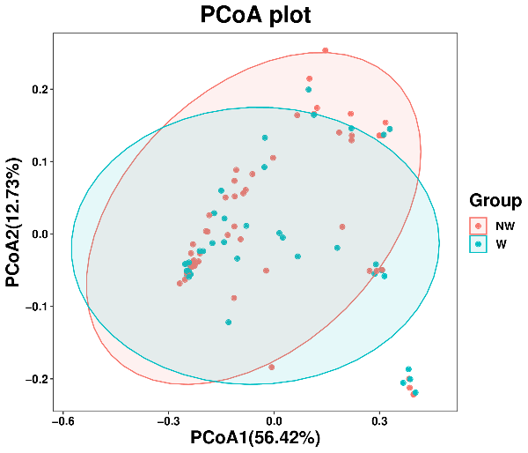  weighted_unifrac(P=0.701) | 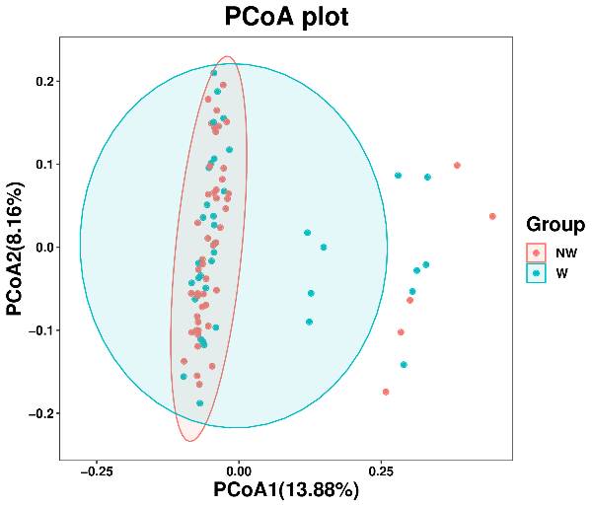  unweighted_unifrac (P=0.183)
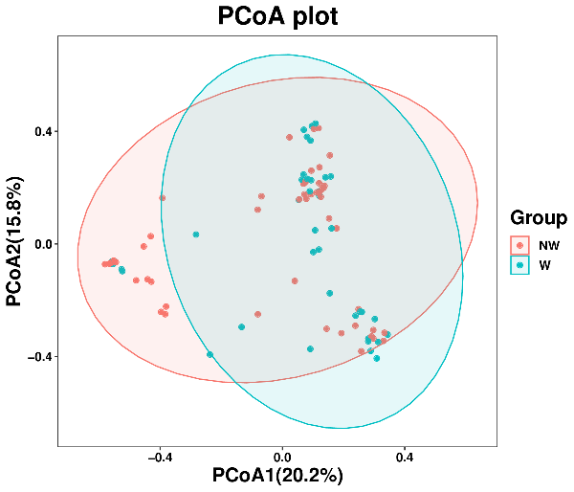  bray_curtis (P=0.183) | 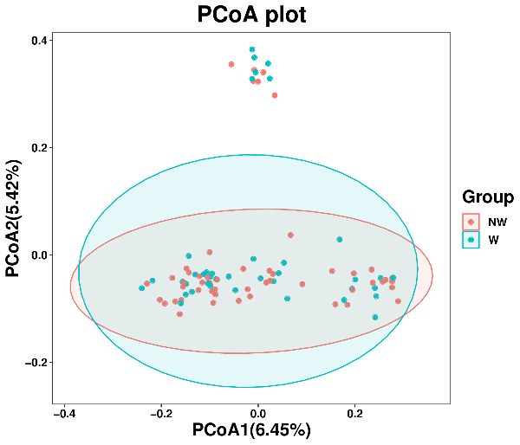  jaccard (P=0.574)
Figure 2: Beta diversity
Note: NW：Non-Recurrent Wheezing Group,W：Recurrent Wheezing Group

Biological analysis

Sequencing data statistics
A total of 120 samples were tested,yielding 10,177,008 raw sequencing reads.After paired-end merging,quality control,and chimeric sequence filtering,we retained 8,922,446 high-quality sequences(accounting for 87.6%),with sequence lengths mainly concentrated between 400 and 500 bp(Figure 3).After filtering and dereplication,4,184 Amplicon Sequence Variants(ASVs)were obtained.
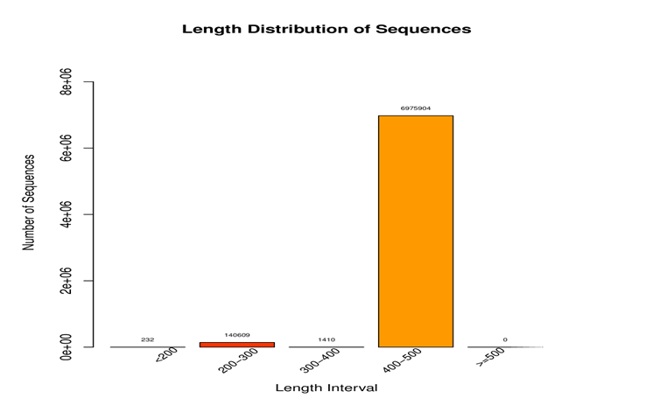
Figure 3:Distribution of sequence lengths
Note:The x-axis represents sequence length,and the y-axis represents the number of sequences.

Quality control
The rarefaction curve can directly reflect the rationality of the sequencing data volume and indirectly reflect the species richness in the samples.For the 120 samples tested,if the curve of each sample tends to flatten,it indicates that the sequencing data volume has reached saturation and is sufficient for further detection and analysis(Figure 4).
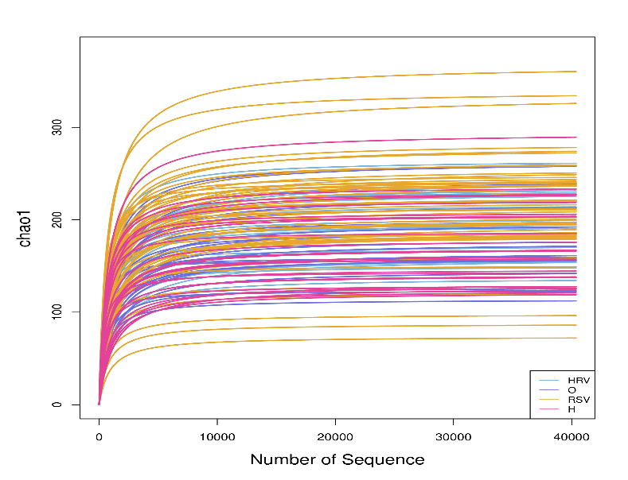
Figure 4:Rarefaction curve
Note:The y-axis represents the values of the indices for each sample when the same number of sequences are randomly selected,and the x-axis represents the number of sequences randomly selected.HRV:Human Rhinovirus group,O:Other Pathogens group,RSV:Respiratory Syncytial Virus group,H:Control group.

